BAJAJ ALLOYS | APPLICATION RESEARCH REPORT
Cast Copper Alloys
C97600 and C99700
Applications, products and how they are made
Where the two alloys are used, which products are cast from them, how each product is manufactured, how valves and pumps break down into sub-components, and what each product is used for.

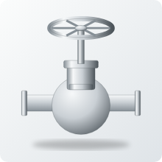 | 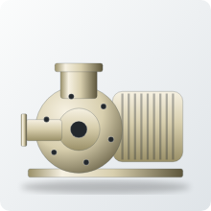 |  |  | 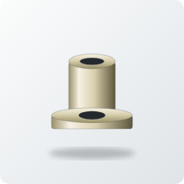 |  | 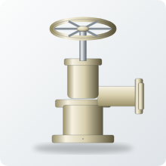 | 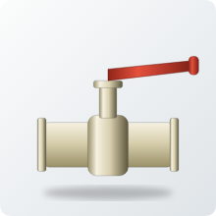
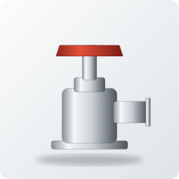 |  |  | 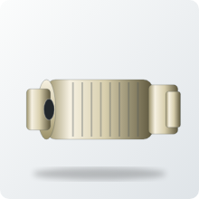 | 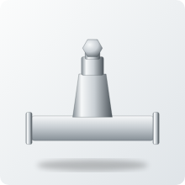 |  |  | 

Prepared for Bajaj Alloys by Research and Market Analysis | 19 October 2026
Metal values use LME cash settlement of 16 October 2026 at INR 96.5/US$. Product pictures are drawn illustrations in each alloy's typical colour (C97600 cool silver, C99700 pale warm white); they are not photographs.

Contents
Executive summary 3
Product atlas at a glance 4
1. Alloy profiles: C97600 and C99700 6
2. Market context and application map 8
3. How the alloys are made into products 11
4. Valves: deep dive 13
5. Pumps: deep dive 18
6. Product series by sector 22
7. From alloy to product: manufacturing chains 32
8. Selection, cost and standards 34
9. Risks, substitutes and outlook 36
10. Opportunity map for Bajaj Alloys 38
Glossary and sources 40

How to read this report
Item | What it means
Product picture | A drawn illustration of the part in the typical colour of its alloy. Real castings vary in shape and size by design; use the picture to recognise the product type.
Alloy tag | C97600 = leaded nickel bronze (cool silver); C99700 = white manganese brass (pale warm white); Both = either grade is used.
How it is made | The usual forming route and finishing operations for that part. These are typical foundry practice, not a named plant's process.
What it is used for | The function of the part and the industries or machines it goes into.
Evidence tag | Listed = a supplier page or data sheet names the use. Context = a patent or related document supports it. Inferred = engineering inference from the alloy's properties; check with the buyer before relying on it.
Major and minor | Tier 1 = major (best-documented or largest-volume uses), Tier 2 = secondary, Tier 3 = minor or niche. Tiers are analyst judgement.

Executive summary
This report maps where the two alloys are used, what is cast from them, how each product is manufactured and what it is used for. It is built around a product catalogue with a picture, an alloy tag, a manufacturing route and a use for every entry, so that sales and foundry teams can read across from alloy to product to customer.
Measure | Value
Products, assemblies and sub-components catalogued | 102 (up from 44)
Sectors covered | 14 (up from 8)
Valve families assessed / valve sub-components | 16 / 14
Pump families assessed / pump sub-components | 11 / 16
Entries for C97600 / C99700 / either | 53 / 42 / 7
Listed by a supplier or data sheet / patent context / inferred | 18 / 5 / 79
Metal value, C97600 | INR 1,436 per kg
Metal value, C99700 (Mn at an assumed US$2,000/t) | INR 999 per kg (INR 974 excl. Mn)
C99700 metal saving against C97600 | 30% per kg; more per part because it is 9% less dense
India valves market, 2025 to 2034 (IMARC) | US$2.77 bn to US$4.77 bn, 6.05% a year
India pumps market, 2025 to 2034 (IMARC) | US$7.2 bn to US$8.8 bn, 2.17% a year
Table 1. Headline numbers

Seven things to know
- Valves and pumps are the core market. Both data sheets name them. The report breaks them into 14 valve and 16 pump sub-components, and 16 valve and 11 pump families, each with its manufacturing route and use.
- Sub-components, not finished valves, are the product list. A DN50 globe valve carries about 4 kg of castings across 11 parts; a 3 kW end-suction pump about 11.5 kg across 10 copper-alloy parts. The body or casing is over half the metal in each.
- The two alloys split the work. C97600 wins where corrosion, hygiene and a bright finish decide (seat rings, seal gland plates, sea-water and dairy bodies, visible hardware). C99700 wins where strength and sliding decide (stem nuts, wear rings, shaft sleeves, lobe rotors, gears, bushes).
- Manufacturing follows the shape. Sand casting for bodies and casings, die casting for small C99700 parts, continuous and centrifugal casting for rings, bushes and sleeves, investment casting for impellers and decorative hardware, then machining, pressure testing and finishing.
- C99700 is about a third cheaper in metal. INR 999 against INR 1,436 per kg, and the part is lighter because the alloy is 9% less dense.
- Lead rules are the hard ceiling. Neither grade meets the US 0.25% weighted-average lead limit for drinking-water parts, and stainless steel holds 55% of the hygienic pump and valve market. Growth is in non-potable valves, fire protection, marine, wear parts and hardware.
- Evidence is thin outside valves, pumps and dairy. Only 18 of 102 entries are named by a supplier or data sheet; 79 are engineering inference and are tagged so. Use the inferred list to plan customer enquiries, not as a confirmed order book.

Product atlas at a glance
One picture of each main product family, with the alloy normally used. The following sections give the manufacturing route and the use of every item. Pictures are drawn illustrations in each alloy's typical colour.

Valves
Globe valve  Both | 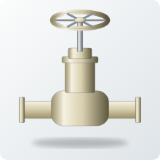  Gate valve  C99700 |   Swing check valve  C99700 | Ball valve  C99700
Dairy plug valve  C97600 | Fire landing valve  C99700 | Sea-water seacock  C97600 | 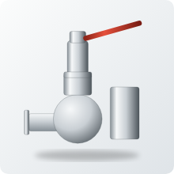  Safety valve  C97600

Pumps
  Milk pump  C97600 | End-suction pump  C99700 | 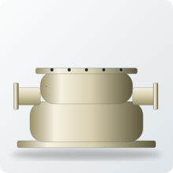  Split-case fire pump  C99700 | 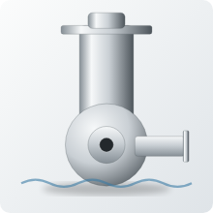  Sea-water pump  C97600
  Lobe pump  C99700 |   Gear pump  C99700 | 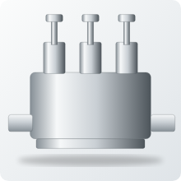  Plunger pump  Both |   Sprayer pump  C99700

Valve and pump sub-components
Stem nut  C99700 |   Seat ring  C97600 | Handwheel  Both | 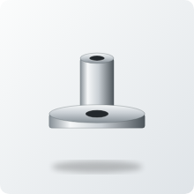  Gland follower  Both
Wear ring  C99700 | 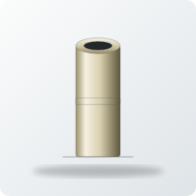  Shaft sleeve  C99700 | Impeller  Both | 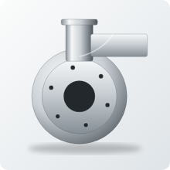  Pump casing  Both
Lobe rotors  C99700 |   Pump gears  C99700 | 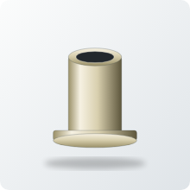  Bush  C99700 |   Seal gland plate  C97600

Hardware, fittings and other products
Door lever  C97600 |   Lock case  C97600 |   Tap and faucet trim  C97600 | Hose coupling  C99700
Padlock body  C99700 |   Deck cleat  C97600 |   Instrument bezel  C97600 | Decorative lamp  C97600

1. Alloy profiles: C97600 and C99700
Composition drives use. Nickel (19-21.5%) and lead (3-5%) define C97600, a leaded nickel bronze often called 20% nickel silver or 'dairy metal'. Manganese (11-15%), zinc (19-25%) and nickel (4-6%) together define C99700, a white manganese brass that looks similar for far less nickel. Both are pale, tarnish-resistant and free machining because they contain lead.
Element (weight %) | C97600 | C99700
Copper (Cu) | 63.0-67.0 | 54.0-60.0
Nickel (Ni) | 19.0-21.5 | 4.0-6.0
Zinc (Zn) | 3.0-9.0 | 19.0-25.0
Manganese (Mn) | 1.0 max | 11.0-15.0
Tin (Sn) | 3.5-4.5 | 1.0 max
Lead (Pb) | 3.0-5.0 | 2.0 max
Aluminium (Al) | - | 0.5-3.0
Iron (Fe) | 1.5 max | 1.0 max
Table 2. Typical specified composition ranges (standard ranges; confirm against the current ASTM edition)
Property | C97600 | C99700 | Source
Tensile strength, MPa | 276 min (40 ksi) | 380 typ. (55 ksi) | Concast B505; MakeItFrom
Yield strength, MPa | 138 min (20 ksi) | 170 typ. (25 ksi) | Concast B505; MakeItFrom
Elongation, % | 10 min | 25 typ. | Concast B505; MakeItFrom
Brinell hardness | 80 typ. | Not found | Concast
Density, g/cm3 | 8.9 | 8.1 | Concast; MakeItFrom
Melting range, deg C | 1108-1143 | 880-900 | Concast; MakeItFrom
Freezing range, deg C | 35 | 20 | Derived from melting range
Electrical conductivity, % IACS | 5 | 3 | Concast; MakeItFrom
Thermal conductivity, W/m.K | 22.6 | Not found | Concast
Machinability rating (C36000 = 100) | 70 | Not found | Concast
Elastic modulus, GPa | Not found | 120 | MakeItFrom
Embodied carbon, kg CO2/kg | Not found | 3.3 | MakeItFrom
Main specification | ASTM B505 (also listed in B584/B271; verify) | ASTM B176 die castings | Concast; ICAST
Table 3. Mechanical and physical properties (published values; "Not found" = no source located)

What the numbers mean for valves and pumps
- Strength: C99700's typical tensile strength (380 MPa) is about 38% above C97600's specified minimum (276 MPa). Compare like with like before thinning a wall: one is typical, the other a guaranteed minimum.
- Ductility: 25% elongation for C99700 against a 10% minimum for C97600 means C99700 tolerates impact and over-tightening of threaded parts better.
- Density: C99700 is 9% lighter, so the same casting weighs less and the per-part metal saving is larger than the per-kg saving.
- Pouring: C99700 melts about 240 deg C lower and freezes over a narrower range (20 against 35 deg C). That suits die casting (ASTM B176) and gives fewer scattered pores, but needs good feeding to avoid concentrated shrinkage.
- Machinability: C97600 rates 70 against free-cutting brass at 100, helped by its 3-5% lead. No rating was found for C99700; its lower lead suggests somewhat harder cutting.
- Conductivity: both are poor electrical conductors (3-5% IACS), so neither is an electrical alloy.
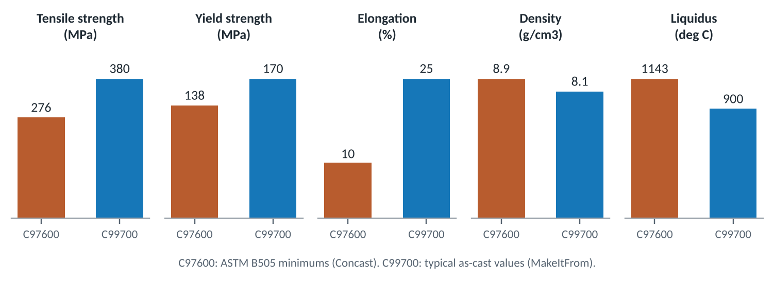
Figure 1. Published property values side by side

Where each alloy wins
If the part... | Lean to | Because
touches drinking water or food | Certified lead-free alloy or stainless | Both grades contain lead
sits in seawater, chlorides or soft water | C97600 | 19-21.5% Ni, only 3-9% Zn
slides on stainless (nut, ring, rotor, bush) | C99700 | Patent context on anti-galling; 380 MPa
carries high load or impact | C99700 | Higher strength and 25% elongation
is visible and must stay silver | C97600 | Higher nickel holds colour
is bought mainly on price | C99700 | About 30% less metal value per kg
sees ammonia or acid cleaning | Neither without testing | Stress-corrosion and acid attack
Table 4. First-pass alloy selection for a valve or pump part (judgement)

2. Market context and application map
No source sizes the market for these two grades. The useful numbers are for the equipment they go into. Valves and pumps in India alone are worth about US$10 billion a year, and the hygienic segment where copper alloys once led is growing faster than pumps overall.
Market | Base | Forecast | CAGR | Source
Global pumps | US$79.5 bn (2025) | US$101.5 bn (2034) | 2.67% | IMARC
Global industrial valves | US$86.74 bn (2025) | US$201.55 bn (2032) | 12.8% | Coherent MI
Global dairy processing equipment | US$12.5 bn (2025) | US$20.6 bn (2034) | 5.59% | IMARC
Global hygienic pumps and valves | US$7.1 bn (2025) | US$13.5 bn (2035) | 6.6% | Future Market Insights
India pumps | US$7.2 bn (2025) | US$8.8 bn (2034) | 2.17% | IMARC
India valves | US$2.77 bn (2025) | US$4.77 bn (2034) | 6.05% | IMARC
India industrial valves | US$1.56 bn (2025) | US$2.34 bn (2031) | 6.96% | Mordor Intelligence
Table 5. Equipment markets (forecasts as published; the 12.8% global valve CAGR is an outlier against other forecasts)
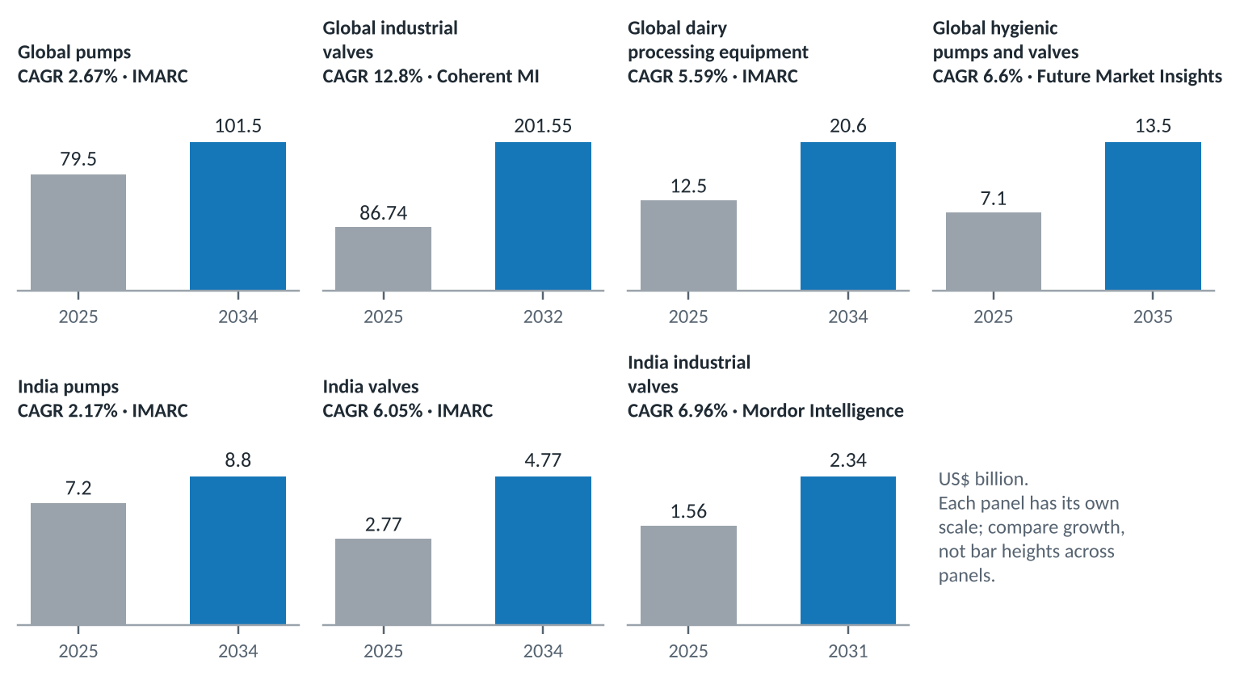
Figure 2. Market size now and forecast for the equipment that uses these alloys

Market facts that matter for copper alloys
- Quarter-turn valves lead India at 39.8% of industrial valves, ball valves alone 25.2%. Ball-valve bodies and end caps are a natural C99700 product; the ball itself is usually wrought and plated.
- Centrifugal pumps are two-thirds of the world pump market. Their copper-alloy content sits in impellers, wear rings, sleeves and small-pump casings.
- Stainless holds 55.4% of hygienic pumps and valves. This is the share C97600 lost in dairy; it will not return while lead rules and acid cleaning apply.
- Water and wastewater is the biggest pump application (18.5%), but much of it is potable, where leaded alloys are excluded. Non-potable water, irrigation and fire service remain open.
- India produced over 247 million tonnes of milk in 2024-25, about a quarter of world output. New dairy plant is mostly stainless; the copper-alloy opening is in village collection, spares for older plant and non-product-contact parts.

Major and minor applications
The catalogue holds 102 entries in 14 sectors. Tiers rank each sector by how well documented it is, how many products it supports and how large the equipment market behind it is. Tier 1 is the major business, Tier 2 is secondary and Tier 3 is minor or niche.
Tier | Sector | Entries | Main alloy | Example products
Tier 1 | Valves | 19 | Both | Valve bodies, bonnets, seats, stem nuts, handwheels, fittings (Section 4)
Tier 1 | Pumps | 14 | Both | Casings, impellers, wear rings, sleeves, rotors, gears (Section 5)
Tier 1 | Dairy and food | 12 | C97600 | Milk pump casings and components; Milk pump impellers; Dairy valves
Tier 1 | Architectural and building hardware | 11 | C97600 for the silver finish; C99700 as a colour match | Ornamental castings; Builders' hardware; Door and window hardware
Tier 1 | General engineering and wear parts | 7 | C99700 | General engineering castings; Bearings and bushings; Gear and worm-wheel blanks
Tier 2 | Plumbing and sanitary | 5 | C97600 | Sanitary plumbing fittings; Decorative faucet trim; Bathroom brackets and accessories
Tier 2 | Marine | 5 | C97600 | Marine furniture and fittings; Portlight and hatch hardware; Marine hardware
Tier 2 | Fire protection | 4 | C99700 | Landing valve bodies; Hose couplings and branch pipes; Sprinkler and deluge valve trim
Tier 2 | Automotive and transport | 5 | C99700 | Automotive parts (data-sheet listing); Housings and brackets; Fuel-system fittings
Tier 3 | Beverage and dispensing | 4 | C97600 | Beverage and dispensing taps; Beer tap shanks and fonts; Keg couplers and coupler bodies
Tier 3 | Agricultural equipment | 3 | C99700 | Sprayer pump bodies and valves; Irrigation valve and coupling bodies; Spray nozzle bodies
Tier 3 | Instrumentation and metering | 4 | C97600 | Pressure-gauge sockets and cocks; Sampling valves; Instrument housings and bezels
Tier 3 | Consumer, music and giftware | 6 | C97600 | Piano keys; Musical instrument castings; Decorative consumer castings
Tier 3 | Locks and security | 3 | Both | Padlock bodies; Cylinder lock housings; Security and prison-door hardware
Table 6. Application map: major (Tier 1), secondary (Tier 2) and minor (Tier 3) sectors
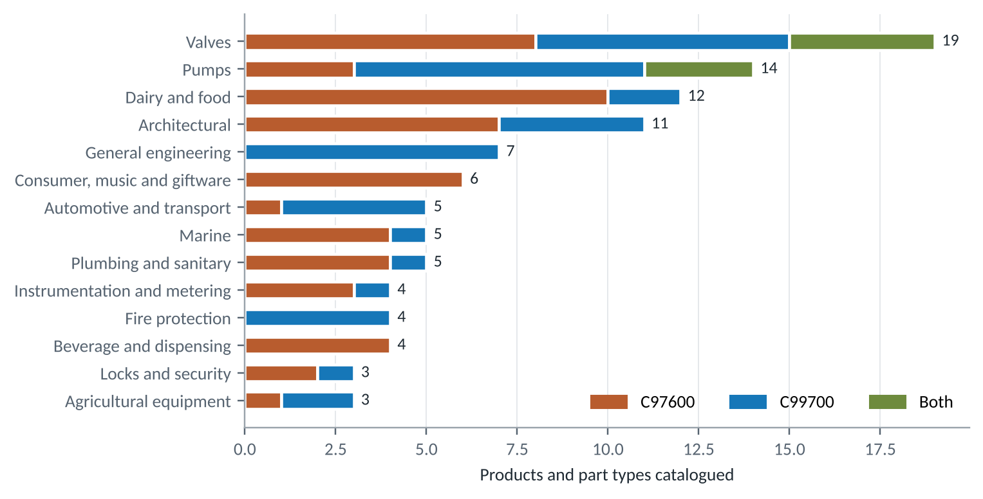
Figure 3. Entries per sector, split by alloy

3. How the alloys are made into products
Both alloys become valve and pump parts by casting first and machining second. The route depends on part size, shape and volume, and on the alloy: the specifications tie C97600 to continuous, sand and centrifugal castings and C99700 to die castings. The route diagram below shows the typical sequence from raw metal to dispatch; the tables that follow describe each step. The routes are general foundry practice for these alloy families, not data from a named plant.
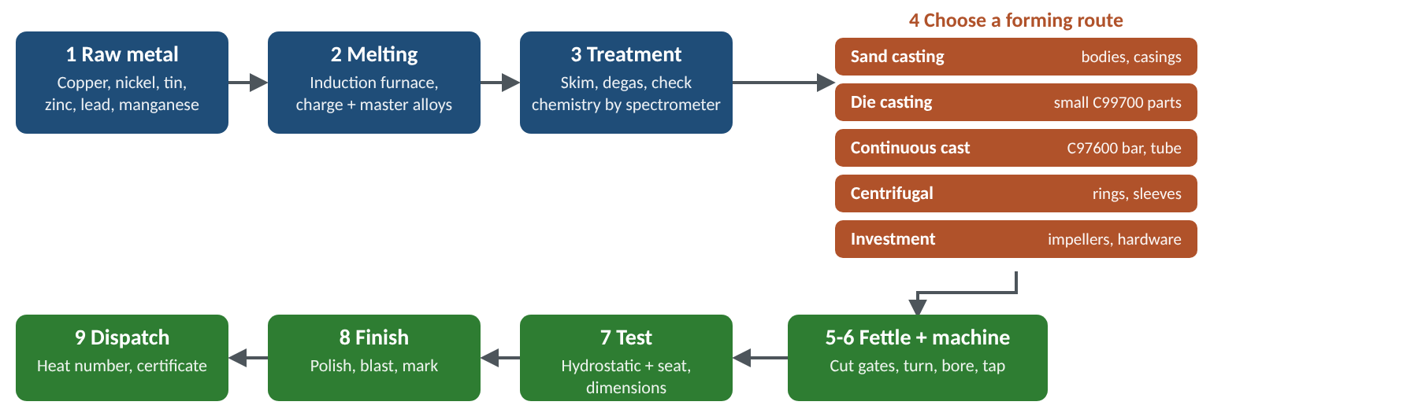
Figure 4. Typical production route for a valve or pump casting

3.1 Melting and alloy practice
Aspect | C97600 (leaded nickel bronze) | C99700 (white manganese brass)
Typical product forms | Continuous-cast bar and tube (ASTM B505); sand and centrifugal castings (B584, B271; confirm the grade is in the current edition) | Die castings (ASTM B176); also sand and gravity-die castings
Melting range | 1108-1143 deg C; freezing range 35 deg C | 880-900 deg C; freezing range 20 deg C
Charge | Cathode copper, nickel, tin, zinc, lead and clean returns (runners, risers, machining swarf of known grade) | Copper, zinc, manganese (as master alloy or electrolytic), nickel, aluminium and clean returns
Melt control | Hold nickel and tin in range; keep lead evenly mixed so it does not segregate; guard against hydrogen pick-up | Replace zinc and manganese lost to the furnace; skim oxide; aluminium in the alloy forms a tough film that must stay out of the casting
Pouring | About 240 deg C hotter than C99700; wider freezing range needs generous risers and chills | Cooler and faster; well suited to permanent moulds and dies; feed carefully to avoid concentrated shrinkage
Machining | Rated 70 against free-cutting brass at 100; short chips because of lead | Lead is lower (2% max) so cutting is somewhat harder; sharp tools and good coolant help
Quality checks | Spectrometer analysis of every heat; hydrostatic test of pressure parts; heat numbers for traceability | Same, plus check zinc and manganese on every heat because both drift
Table 7. Melting and casting practice compared (general practice; confirm with the foundry's own procedures)

3.2 Forming methods and the products they make
Picture | Method | How it works | Typical valve and pump products | Alloy | Strengths and limits
 | Sand casting | Metal is poured into a mould packed from bonded sand around a pattern; sand cores form the inside passages | Valve bodies and bonnets, pump casings and covers, large impellers, marine and fire valves | Both | Cheap tooling, any size, complex shapes. Rougher surface and more machining stock.
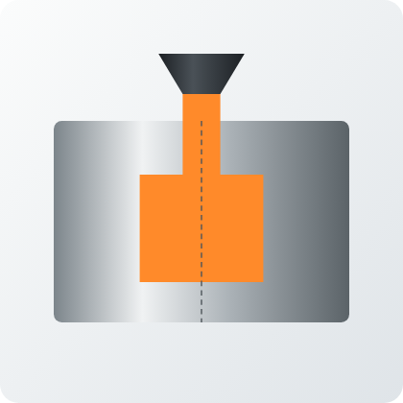 | Gravity (permanent-mould) die casting | Metal is poured by gravity into a reusable steel mould | Small valve bodies DN15-DN80, ball-valve bodies and end caps, mid-volume fittings, tap bodies | Both | Finer finish, better repeatability. The lower melting point of C99700 gives longer die life.
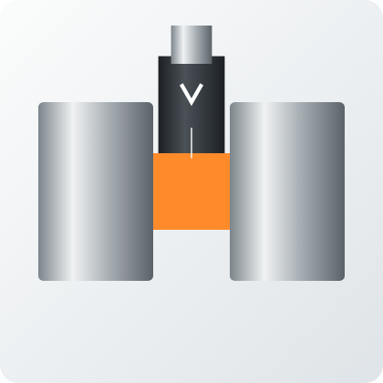 | Pressure die casting (ASTM B176) | Metal is injected into a steel die under pressure and solidifies in seconds | Gland nuts, caps, handwheels, small hardware and fittings | C99700 | Highest volume and lowest unit cost for small parts. Costly dies; needs thin, simple shapes.
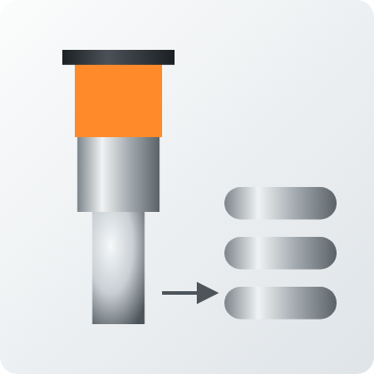 | Continuous casting (ASTM B505) | Molten metal is drawn through a cooled die as bar or tube of fixed section, then cut to length | Stock for wear rings, bushes, sleeves, seat rings, stem nuts and gear blanks | C97600 | Dense, uniform, little porosity and low scrap. Fixed section only; parts are finished by machining.
 | Centrifugal casting | A mould spins while metal is poured; the metal is thrown outward and solidifies as a dense tube | Rings, sleeves, bushes, tube blanks, worm-wheel rims | Both | Very sound walls, so good for pressure and wear parts. Round shapes only.
 | Investment (lost-wax) casting | A wax pattern is coated in ceramic, the wax is melted out and metal is poured into the shell | Impellers, decorative and lock hardware, fine-detail parts | Both | Excellent detail and finish, little machining. Highest cost per part, so suited to small and complex shapes.
Table 8. Primary forming methods, with the products each makes

3.3 After casting: from rough casting to finished part
Picture | Step | What happens | Why it matters
 | Melting and treatment | Induction furnace melts the charge; the melt is skimmed, degassed and checked by spectrometer before pouring | Sets composition; every heat gets a number for traceability
 | Fettling and machining | Gates and risers are cut off, flash is ground away, then turning, boring, drilling, tapping and milling bring seats, bores, flanges and threads to size | Lead gives free cutting in both grades; C97600 has the published rating of 70
 | Pressure testing | Hydrostatic shell test (typically 1.5 times rating) and a seat or closure test per API 598 or ISO 5208 practice | The main check for porosity; essential for every valve and pump casing
 | Finishing and inspection | Polishing or barrel finishing, marking, dimensional gauging and a final analysis check | The silver colour needs no plating; polishing brings it out
Table 9. Melting, machining, testing and finishing steps

Tests a valve or pump casting usually passes before dispatch
- Chemistry: spectrometer check against the ranges in Table 2; look-alike white alloys are easy to mix up.
- Hydrostatic shell test: typically 1.5 times rated pressure under API 598 or ISO 5208 practice; this is where porosity shows.
- Seat or closure test: typically 1.1 times rated pressure, or a low-pressure air test, for leakage past the seat.
- Dimensions and threads: gauges for end connections and stem threads.
- Lead certification: for any potable product, third-party NSF/ANSI 372 or equivalent; neither grade in this report will pass.

4. Valves: deep dive
Valves are the first product group both data sheets name. The report assesses 16 valve families and 14 valve sub-components. Fit scores run from 1 (poor) to 5 (strong) and are analyst judgement from composition, published properties and common practice.

4.1 Anatomy of a valve and where the metal sits
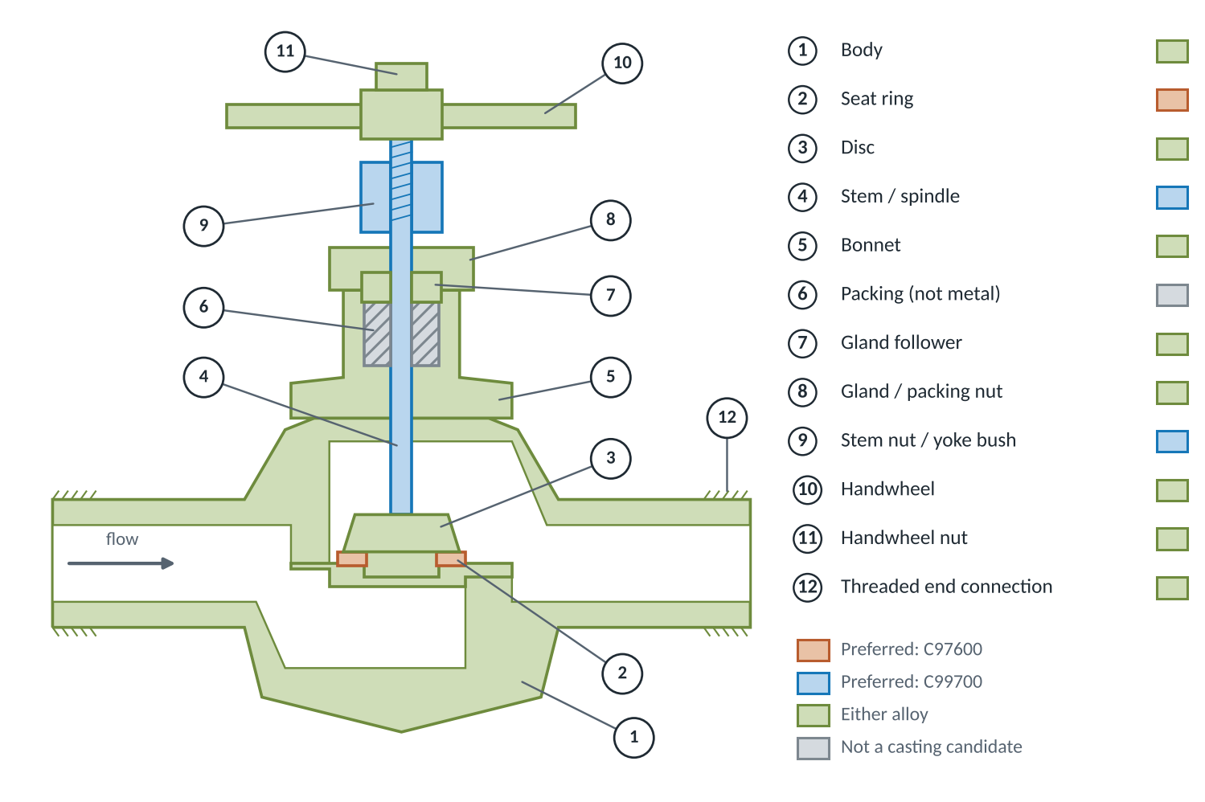
Figure 5. Cut-away schematic of a threaded globe valve with its sub-components
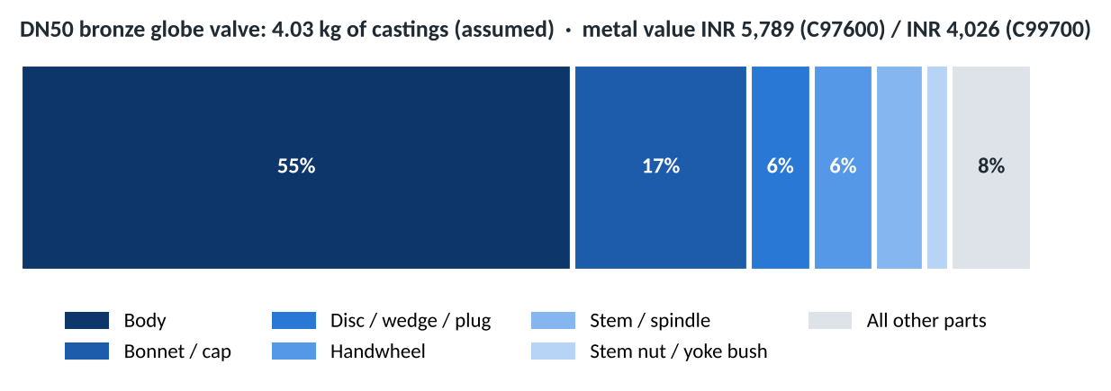
Figure 6. Where the metal sits in a DN50 globe valve (assumed masses)

4.2 Valve families
Picture | Valve family | Sizes | C97600 | C99700 | How it is made | What it is used for
 | Globe and angle valve | DN8-DN65 | 4 | 4 | Sand-cast body and bonnet (gravity die for DN15-DN40 runs); disc and seat ring machined | Throttling and isolation on steam, water, oil and process lines in boilers, process plants, compressors and engine rooms
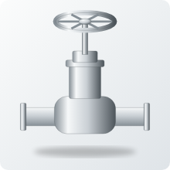 | Gate valve (wedge) | DN15-DN80 | 3 | 4 | Sand-cast body and bonnet; wedge cast or forged then machined and lapped to the seats | Full-bore isolation in building services, irrigation mains, low-pressure steam and general plant water
 | Swing check valve | DN15-DN80 | 3 | 4 | Sand-cast body and cap; hinge arm cast or machined; disc faced | Stops back-flow at pump discharge and in water-supply risers
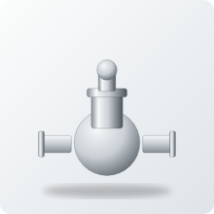 | Lift / spring check valve | DN8-DN50 | 4 | 4 | Gravity-die or sand-cast body; poppet and guide machined from cast bar | Compressor discharge, instrument-air and hydraulic lines where small precise castings are needed
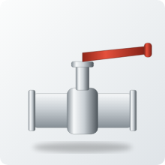 | Ball valve (2- and 3-piece) | DN8-DN100 | 3 | 4 | Body and end caps gravity-die or sand cast; ball and stem usually wrought and plated | Utility water, compressed air and general isolation; quarter-turn valves lead the Indian market
 | Plug valve / dairy cock | DN15-DN80 | 5 | 3 | Sand or gravity-die cast body; tapered plug turned and lapped into the body | Dairy, beverage and chemical lines; the classic use that gave C97600 the name dairy metal
 | Needle / instrument valve | DN6-DN25 | 3 | 3 | Machined from cast bar or small castings; fine thread cut on the stem | Pressure-gauge isolation, sampling points and instrumentation
 | Safety / relief valve | DN15-DN50 | 4 | 3 | Cast body; nozzle and disc machined and lapped; spring set on test bench | Over-pressure protection on boilers, compressors and pumps
 | Butterfly valve disc | DN50-DN300 | 3 | 3 | Sand or investment cast disc, stem bores machined; bodies are normally iron | Water, HVAC and sea-water lines (disc only)
 | Marine sea-water valve | DN15-DN150 | 4 | 2 | Sand-cast body; machined and pressure tested to marine practice | Hull intakes, ballast and fire-main isolation on ships and boats
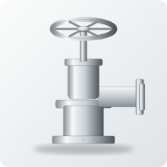 | Fire landing / hydrant valve | DN50-DN65 | 2 | 4 | Sand-cast angled body; flange faces and outlet coupling machined | Landing valves on building fire mains and hydrant outlets (non-potable)
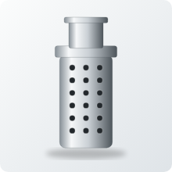 | Foot valve and strainer | DN25-DN150 | 2 | 4 | Sand-cast body and cage; flap or poppet machined | Pump suction in wells, tanks and irrigation, holds the prime
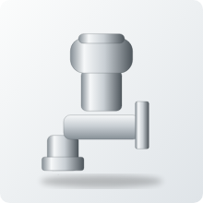 | Radiator / heating valve | DN10-DN25 | 3 | 3 | Gravity-die cast body; cap and union nut machined; polished | Hydronic heating and visible trim where a silver look is wanted
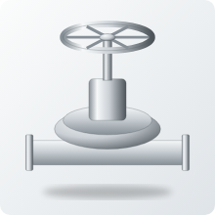 | Diaphragm valve body | DN15-DN100 | 3 | 2 | Sand-cast body, saddle machined; bonnet and diaphragm assembled | Process and slurry service (niche for copper alloys)
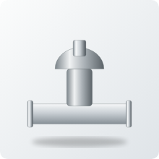 | Mix-proof / aseptic valve | DN25-DN100 | 1 | 1 | Stainless dominates; shown for completeness | Dairy and pharma CIP lines: lead and acid cleaning rule both alloys out
 | Potable float / ball cock | DN15-DN50 | 1 | 2 | Small cast body and arm; machined thread | Drinking-water tanks: needs certified lead-free alloy instead
Table 10. Sixteen valve families: fit by alloy (1 to 5), manufacturing route and use

4.3 Valve sub-components
The sub-components are the real product list. Many of them are small, so a foundry can quote them in volume to valve makers, spares dealers and repair shops. The alloy column shows the preferred grade; Both means either is used.
Picture | Sub-component | Alloy | Evidence | How it is made | What it does and where it is used
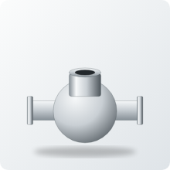 | Valve body | Both | Listed | Sand cast (gravity die for small sizes); ends threaded or flanged; seat pocket bored | Holds the pressure and carries the pipe connections; the heaviest casting in the valve (about 2.2 kg in a DN50 globe)
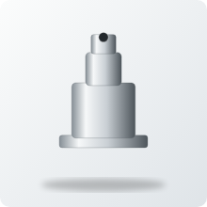 | Bonnet / cap | Both | Listed | Sand cast in the same heat as the body; stem bore and gland thread machined | Closes the body and guides the stem; bolted or screwed on so the valve can be serviced
 | Disc / wedge / plug | Both | Inferred | Cast then turned or milled; sealing faces lapped | The moving element that shuts or throttles the flow
 | Seat ring (renewable) | C97600 | Inferred | Cut from continuous-cast bar or centrifugal tube; turned, faced and pressed or screwed in | The sealing face the disc closes on, where velocity and wear are highest; replaceable so the body lasts
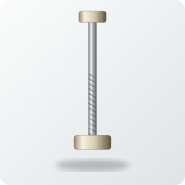 | Stem / spindle | C99700 | Inferred | Mostly machined from wrought bar; cast stem is a niche; thread rolled or cut | Transmits torque and thrust from handwheel to disc
 | Stem nut / yoke bush | C99700 | Context | Cut from continuous-cast bar or cast and bored; internal thread cut | Threaded nut the stem runs through; anti-galling against stainless stems
 | Gland / packing follower | Both | Inferred | Small casting or bar, turned and bored | Compresses the packing to stop stem leakage
 | Gland nut / packing nut | Both | Inferred | Hex bar or casting, tapped and faced | Holds the gland down on the packing
 | Handwheel | Both | Inferred | Sand or investment cast, hub bored and keyed; polished | Operator interface; keeps a bright finish without plating
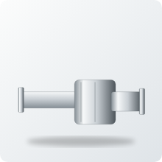 | Union nut and tailpiece | Both | Inferred | Cast or bar blanks, threads cut, seats faced | Pipe connection that lets the valve be removed without cutting the line
 | Hinge arm and pin (check) | C99700 | Inferred | Cast or machined arm, pin turned from bar | Lets the check-valve disc swing open and closed
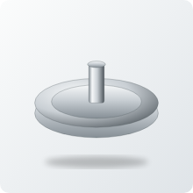 | Butterfly disc | Both | Inferred | Sand or investment cast; stem bores and edge machined | Rotating closure element in a butterfly valve
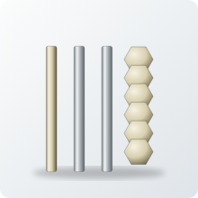 | Body studs and nuts | C99700 | Inferred | Usually wrought bar, threads rolled; cast nuts are possible | Bolts the bonnet to the body under pressure
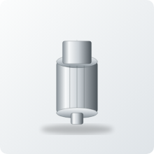 | Drain plug / cap / indicator | Both | Inferred | Small casting or bar, threaded and faced | Closes drain and test ports; position flags on visible valves
Table 11. Fourteen valve sub-components: alloy, manufacturing route and use

4.4 Metal value by valve size
Metal value is the LME price of the metals inside the alloy on 16 October 2026 at INR 96.5 per US$. Assumed masses are for a threaded globe valve body and bonnet set; real designs vary.
Size | Assumed mass (kg) | C97600 (INR) | C99700 (INR) | Saving with C99700 (INR)
DN15 | 0.45 | 646 | 450 | 197
DN20 | 0.70 | 1,005 | 699 | 306
DN25 | 1.10 | 1,580 | 1,099 | 481
DN32 | 1.70 | 2,442 | 1,698 | 744
DN40 | 2.40 | 3,447 | 2,397 | 1,050
DN50 | 4.00 | 5,746 | 3,996 | 1,750
DN65 | 6.50 | 9,337 | 6,493 | 2,844
DN80 | 9.50 | 13,646 | 9,489 | 4,156
Table 12. Metal value of a valve body and bonnet set by size

Rules of thumb for valve makers
- Seats and sealing faces: use C97600; the nickel resists erosion and corrosion at the highest-velocity point.
- Anything the stem threads through or slides on: use C99700; patent context points to better resistance to galling on stainless.
- Bodies and bonnets: either grade; choose C97600 for aggressive, hygienic or sea-water duty and C99700 for strength per rupee.
- Marine immersed duty: C97600 only; zinc-rich C99700 risks dezincification.

5. Pumps: deep dive
The report assesses 11 pump families and 16 pump sub-components. Centrifugal pumps are two-thirds of the world pump market, and their copper-alloy content sits in the casing, impeller, wear rings, sleeves and seal parts. Positive-displacement pumps (lobe and gear) use the alloys for rotors, gears and bushes that run against stainless steel or steel.

5.1 Anatomy of a centrifugal pump
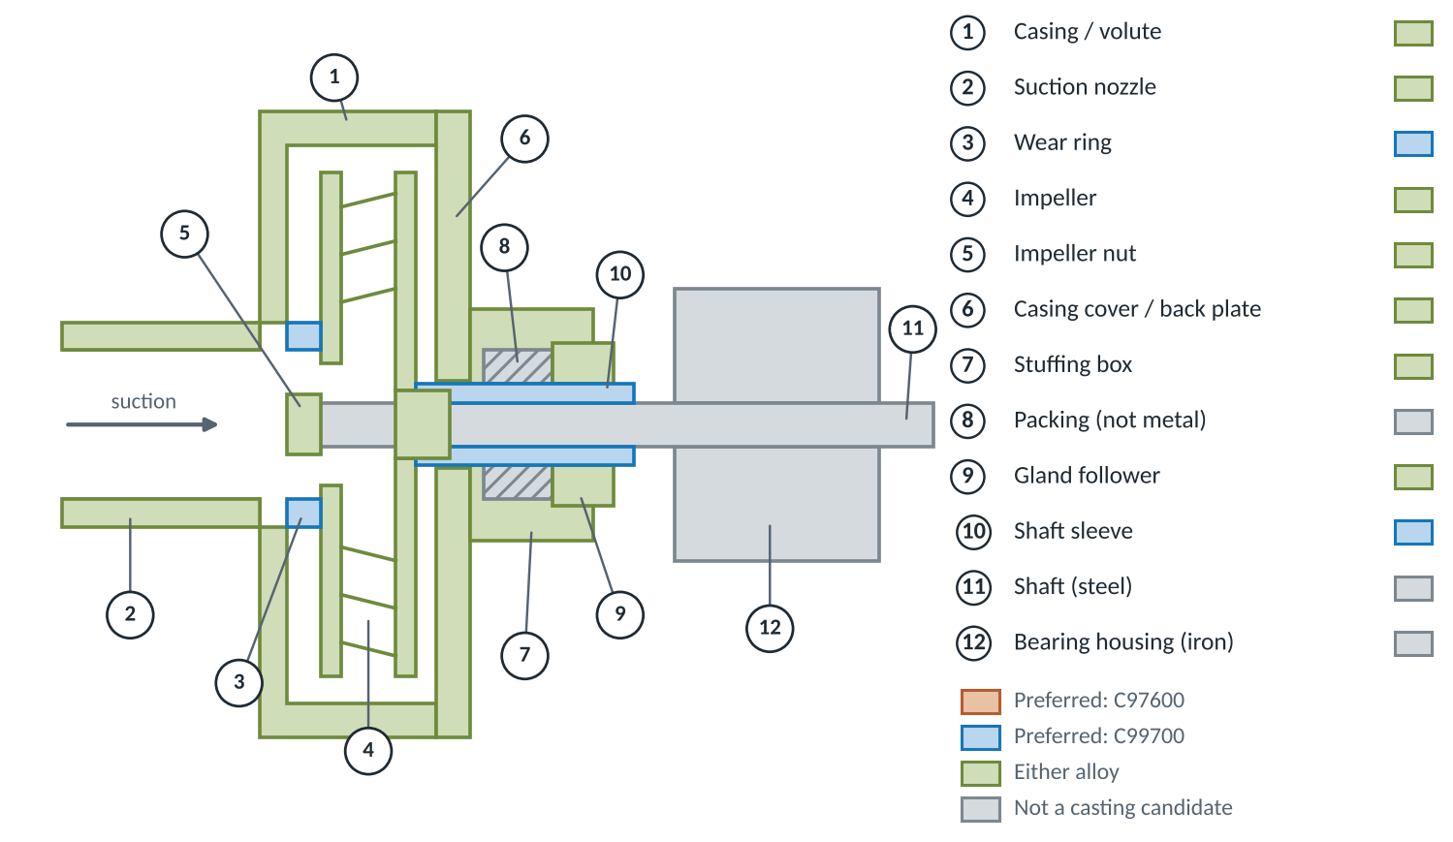
Figure 7. Section through an end-suction centrifugal pump with its sub-components
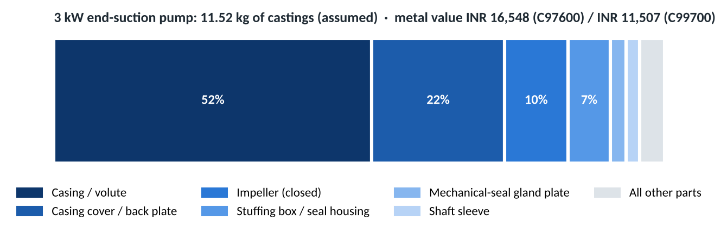
Figure 8. Where the metal sits in a 3 kW end-suction pump (assumed masses)

5.2 Pump families
Picture | Pump family | C97600 | C99700 | How its parts are made | What it is used for
 | Sanitary centrifugal (milk) pump | 4 | 2 | Sand-cast casing and impeller; shaft sleeve and wear rings machined from cast bar | Raw-milk reception, transfer and CIP return in dairies and chilling centres
 | End-suction centrifugal (water) | 3 | 4 | Sand-cast casing and cover; impeller sand or investment cast; wear rings from bar | Building services, irrigation, boosters and general water supply (bronze-fitted pumps)
 | Split-case fire pump | 3 | 4 | Large sand-cast casing halves; impeller and wear rings machined | Fire protection, industrial cooling water and large water transfer
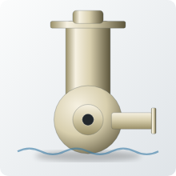 | Marine / sea-water pump | 4 | 2 | Sand-cast casing and impeller; sleeves turned from bar | Cooling water, bilge and ballast service on ships
 | Rotary lobe pump | 3 | 4 | Rotors cast or machined from bar, ground to close clearance; housings often stainless | Food, dairy and viscous products; rotors run against stainless casings
 | External gear pump | 3 | 4 | Gear blanks from cast bar, hobbed; bushes turned from bar | Oil, fuel and lubrication circuits
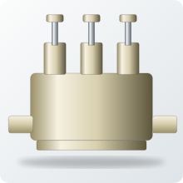 | Plunger pump / homogeniser | 3 | 3 | Valve seats and guides turned from bar; heads sand cast | Dairy homogenising and other high-pressure duties
 | Agricultural sprayer pump | 2 | 4 | Gravity-die or sand-cast body; machined bores | Knapsack and power sprayers for crop protection
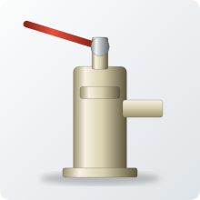 | Hand and well pump fittings | 2 | 3 | Sand-cast body and spout; machined bores and threads | Rural water supply (drinking-water use brings lead rules)
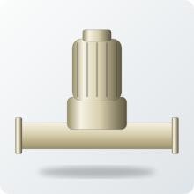 | Hot-water circulator | 1 | 2 | Sand-cast body; impeller and flanges machined | Heating loops; potable hot water needs certified lead-free bodies
 | Fuel transfer pump | 1 | 3 | Gravity-die or sand-cast body; gear or vane parts machined | Diesel and lubricant transfer in depots and workshops
Table 13. Eleven pump families: fit by alloy (1 to 5), manufacturing route and use

5.3 Pump sub-components
Pump parts split cleanly by duty. The casing, cover and impeller are large castings suited to either grade. The rings, sleeves, bushes and rotors are sliding parts where C99700 has the technical edge. The seal gland plate and plunger seats sit in corrosive wetted duty where C97600 is preferred.
Picture | Sub-component | Alloy | Evidence | How it is made | What it does and where it is used
 | Casing / volute | Both | Listed | Sand cast with cores for the volute; flanges and bores machined; hydro-tested | The largest casting; converts speed to pressure and holds the liquid (about 6 kg in a 3 kW end-suction pump)
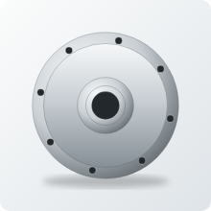 | Casing cover / back plate | Both | Listed | Sand cast with the casing; spigot and seal bore machined | Closes the casing and carries the seal or stuffing box
 | Impeller (closed) | Both | Inferred | Sand or investment cast; hub bored, keyway cut, balanced | Adds energy to the liquid; the heart of every centrifugal pump
 | Diffuser / guide vanes | C99700 | Inferred | Sand cast, vanes finished by grinding | Recovers pressure between stages in multistage pumps
 | Casing and impeller wear rings | C99700 | Context | Cut from centrifugal tube or continuous-cast bar; turned and pressed in | Keeps the small running clearance that limits leakage; cheap to replace
 | Shaft sleeve | C99700 | Inferred | Turned from centrifugal tube or bar; ground and polished | Protects the shaft under the packing or seal
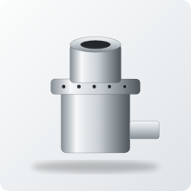 | Stuffing box / seal housing | Both | Inferred | Sand cast or machined from heavy bar; bores and threads cut | Holds the packing or mechanical seal around the shaft
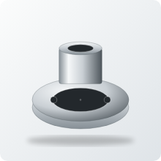 | Gland follower and lantern ring | Both | Inferred | Small castings or bar, turned and drilled | Compress and flush the packing
 | Mechanical-seal gland plate | C97600 | Inferred | Cast plate or plate stock; faces ground flat; slots milled | Clamps the stationary seal face and carries flush ports
 | Impeller nut | Both | Inferred | Turned from bar or cast, tapped; domed for flow | Locks the impeller on the shaft
 | Rotary lobe rotors | C99700 | Context | Cast or cut from bar, profile milled and ground to close clearance | Displace product in lobe pumps; resist galling against stainless
 | Gear-pump gears | C99700 | Inferred | Blanks from cast bar, hobbed and finished | Displace oil or fuel in external gear pumps
 | Sleeve bearings / bushes | C99700 | Inferred | Continuous or centrifugal cast tube, turned and bored | Support the shaft with low friction against steel and stainless
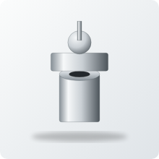 | Plunger-pump valve seats and guides | C97600 | Inferred | Turned from continuous-cast bar; faces lapped | Check valves inside the pump head at high cycle counts
 | Priming / air-release valve body | Both | Inferred | Small gravity-die or sand casting, tapped | Vents air during start-up so the pump primes
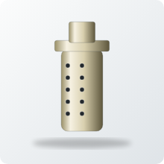 | Suction strainer / foot valve | C99700 | Inferred | Sand cast cage, holes cored or drilled | Keeps debris out and holds the prime
Table 14. Sixteen pump sub-components: alloy, manufacturing route and use

Why wear rings, sleeves and bushes are a good first product
- Replaceable by design: every pump overhaul needs a new ring set, so demand repeats without new pump sales.
- Made from bar: continuous or centrifugal cast tube is cut, turned and pressed in; one foundry route serves many pump sizes.
- Technical fit: C99700's lubricity and anti-galling behaviour against stainless suit running clearances.
- Low weight, low risk: 0.15 to 0.25 kg per part, a low capital value for a customer to trial.

6. Product series by sector
This section is the product catalogue outside valves and pumps. Each sector gets a short fact box and a table that follows the series the report is built on: product picture, alloy, how it is manufactured and what it is used for. Tier 1 sectors are the major business; Tier 2 and Tier 3 are secondary and minor uses.

Tier 1: major applications

Dairy and food
Main alloy | Main driver | Evidence summary | Main constraint
C97600 (C99700 for sliding parts) | Corrosion resistance and a cleanable silver surface; the origin of the name dairy metal | 5 listed, 2 context, 5 inferred | Lead in food contact, stainless steel, acid CIP cleaning

The oldest use of C97600. Today stainless steel takes most new hygienic plant, so the live opportunity is village collection, spares for older plant and non-product-contact parts.
Picture | Product or part | Alloy | Evidence | How it is made | What it is used for
 | Milk pump casings and components | C97600 | Listed | Sand cast casing and cover; seal bores and ports machined | Raw-milk reception, transfer and CIP-return pumps in dairies and chilling centres
 | Milk pump impellers | C97600 | Inferred | Sand or investment cast, balanced, bore and keyway machined | Impellers for the same pumps; same corrosion duty as the casing
 | Dairy valves | C97600 | Listed | Sand or gravity-die cast body; tapered plug lapped to the body | Milk-line isolation, tank outlets and tanker discharge
 | Dairy pipe fittings and couplings | C97600 | Listed | Gravity-die or sand cast, or turned from cast bar; threads cut | Joins milk lines, tanker hoses and chilling-tank outlets
 | Sanitary ferrules and unions | C97600 | Inferred | Cast or turned from bar, faces ground for gaskets | Hygienic line joints that can be opened for cleaning
 | Dairy equipment gears | C97600 | Listed | Blanks from cast bar, then gear-cut and finished | Drives in separators, churns and filling machines
 | Food-handling machine parts | C97600 | Listed | Sand cast then machined to size | Guides, plates and covers on food machinery
 | Sight-glass frames and flanges | C97600 | Inferred | Gravity-die or sand cast; glass seat machined | Inspection windows on tanks and pipelines
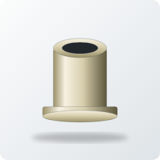 | Sliding parts running on stainless | C99700 | Context | Continuous or centrifugal cast bush, turned and bored | Bushes and guides against stainless shafts and rails (patent context)
 | Food-equipment structural parts | C99700 | Context | Sand or die cast, machined at the mounting points | Housings and brackets in food equipment (patent context)
 | Bulk milk cooler outlet valves | C97600 | Inferred | Gravity-die cast body, machined and assembled | Drain valves on village bulk milk coolers; check lead rules with the buyer
 | Milking-machine claw and pulsator parts | C97600 | Inferred | Small castings, machined and polished | Wetted parts in milking machines; stainless and polymer compete
Table 15. Dairy and food: products, manufacturing and uses

Architectural and building hardware
Main alloy | Main driver | Evidence summary | Main constraint
C97600 for the silver finish; C99700 as a colour match | Silver colour, tarnish and wear resistance without plating | 3 listed, 0 context, 8 inferred | Cost against brass, zinc die cast and stainless hardware

The best documented non-fluid use. A white metal that keeps its colour makes sense on handles, locks, plaques and visible fittings that people touch every day.
Picture | Product or part | Alloy | Evidence | How it is made | What it is used for
 | Ornamental castings | C97600 | Listed | Sand or investment cast, hand-finished and polished | Decorative building and furniture castings that keep a silver finish
 | Builders' hardware | C97600 | Listed | Sand or gravity-die cast, bores machined | Hinges, brackets and fixings for general building work
 | Door and window hardware | C97600 | Listed | Sand or investment cast, drilled and polished | Door levers, window stays and fittings, including prison-door hardware
 | Lock and latch castings | C97600 | Inferred | Gravity-die or sand cast, bores and slots machined | Lock cases and latch bodies that need precise machining
 | Nameplates and plaques | C97600 | Inferred | Sand or investment cast with raised lettering, polished | Building plaques and equipment nameplates that stay bright
 | Door knobs and pulls | C97600 | Inferred | Sand or investment cast, tapped, polished | Doors in hospitals, hotels and offices where wear and tarnish matter
 | Stair and rail brackets | C97600 | Inferred | Sand cast, drilled and polished | Handrail and balustrade supports in public buildings
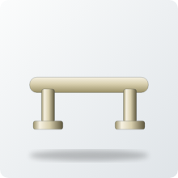 | White decorative hardware | C99700 | Inferred | Gravity-die or investment cast, polished | Cabinet and door pulls matching nickel-silver finishes
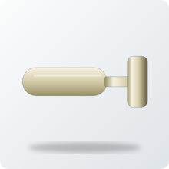 | Cabinet and furniture castings | C99700 | Inferred | Die or sand cast, tapped, polished | Furniture handles and fittings in a white finish at lower metal cost
 | Panic-bar and closer housings | C99700 | Inferred | Sand or die cast, bores machined | Emergency-exit hardware and door-closer bodies in high-traffic doors
 | Glazing patch fittings and spiders | C99700 | Inferred | Investment or sand cast, holes machined | Visible load-carrying fittings for frameless glass facades
Table 16. Architectural and building hardware: products, manufacturing and uses

General engineering and wear parts
Main alloy | Main driver | Evidence summary | Main constraint
C99700 | Strength near 380 MPa, lubricity and machinability | 1 listed, 0 context, 6 inferred | Cost against steel, aluminium and zinc die castings; no manganese price hedge

C99700 is listed for general engineering castings. Sliding duty against stainless and steel is the technical strong point, which makes bushes, nuts and guides the natural products.
Picture | Product or part | Alloy | Evidence | How it is made | What it is used for
 | General engineering castings | C99700 | Listed | Sand or die cast, machined to drawing | Housings, covers and brackets in machinery (named in the data sheet)
 | Bearings and bushings | C99700 | Inferred | Centrifugal or continuous cast tube, turned and bored | Plain bearings and bushes for slow, heavily loaded sliding duty
 | Gear and worm-wheel blanks | C99700 | Inferred | Centrifugal or sand cast blank, teeth hobbed | Worm gears in lifts, hoists, conveyors and valve actuators
 | Nuts and fasteners | C99700 | Inferred | Turned from cast bar or cast and tapped | Corrosion-resistant white-metal nuts for harsh environments
 | Wear plates and slide guides | C99700 | Inferred | Sand cast or cut from bar, faces ground flat | Sliding faces under presses, machine tables and gates
 | Textile and paper machine guides | C99700 | Inferred | Cast or bar, finished smooth | Guides where yarn, paper or film slides over a smooth metal surface
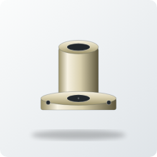 | Lead-screw and press nuts | C99700 | Inferred | Cast or bar, internal thread cut | Threaded sliding duty in presses, jacks and positioning screws
Table 17. General engineering and wear parts: products, manufacturing and uses

Tier 2: secondary applications

Plumbing and sanitary
Main alloy | Main driver | Evidence summary | Main constraint
C97600 (C99700 for drain and waste) | Bright finish and corrosion resistance | 1 listed, 0 context, 4 inferred | Lead limits for drinking-water contact

Listed for sanitary fittings. Anything touching drinking water needs a certified lead-free alloy, so the realistic scope is decorative trim and non-potable waste fittings.
Picture | Product or part | Alloy | Evidence | How it is made | What it is used for
 | Sanitary plumbing fittings | C97600 | Listed | Gravity-die or sand cast body, machined and polished | Taps and bathroom fittings (non-potable or trim use only)
 | Decorative faucet trim | C97600 | Inferred | Die or sand cast, polished | Handles, spouts and escutcheons that keep a silver colour
 | Bathroom brackets and accessories | C97600 | Inferred | Sand or die cast, polished | Towel rings, rails and hooks in bathrooms
 | Shower arms and escutcheons | C97600 | Inferred | Cast or bar, bored and polished | Non-wetted visible trim around shower connections
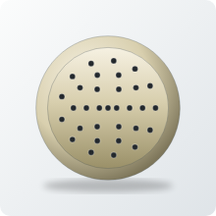 | Drain and waste fittings | C99700 | Inferred | Sand or die cast, drilled | Floor drains and waste fittings (non-potable)
Table 18. Plumbing and sanitary: products, manufacturing and uses

Marine
Main alloy | Main driver | Evidence summary | Main constraint
C97600 (C99700 inferred) | Corrosion resistance near seawater | 1 listed, 0 context, 4 inferred | Zinc-rich brasses can dezincify

Nickel gives C97600 an edge in seawater, while zinc-rich C99700 needs testing before immersed use.
Picture | Product or part | Alloy | Evidence | How it is made | What it is used for
 | Marine furniture and fittings | C97600 | Listed | Sand cast, ground and polished | Deck and cabin fittings, rails and handles
 | Portlight and hatch hardware | C97600 | Inferred | Sand or investment cast, machined seats | Opening ports, hatches and dogs in salt air
 | Marine hardware | C99700 | Inferred | Sand cast, drilled | General deck hardware (verify seawater behaviour first)
 | Through-hull fittings and seacocks | C97600 | Inferred | Sand cast body, tapered plug lapped, pressure tested | Hull openings for cooling and bilge water
 | Fairleads, chocks and cleats | C97600 | Inferred | Sand cast, ground smooth | Mooring and rope handling gear that resists abrasion and salt spray
Table 19. Marine: products, manufacturing and uses

Fire protection
Main alloy | Main driver | Evidence summary | Main constraint
C99700 | Strength and cost; lead is not a drinking-water issue here | 0 listed, 0 context, 4 inferred | Fire-service type approval; dezincification in stagnant water

A new sector in this edition. Landing valves, couplings and branch pipes are rugged non-potable castings where C99700 strength and lower metal cost both count.
Picture | Product or part | Alloy | Evidence | How it is made | What it is used for
 | Landing valve bodies | C99700 | Inferred | Sand cast, flange faces and outlet machined, hydro-tested | Fire-main landing valves on each floor of a building
 | Hose couplings and branch pipes | C99700 | Inferred | Gravity-die or sand cast, threads and lugs machined | Joins hoses to hydrants and pumps and directs the water stream from the nozzle
 | Sprinkler and deluge valve trim | C99700 | Inferred | Gravity-die cast, small parts machined | Frames, deflectors and trim in sprinkler and deluge systems
 | Fire-pump wear rings | C99700 | Inferred | Cut from centrifugal tube or bar, turned | Anti-galling ring pairs in fire-pump casings and impellers
Table 20. Fire protection: products, manufacturing and uses

Automotive and transport
Main alloy | Main driver | Evidence summary | Main constraint
C99700 | Strength near 380 MPa with machinability | 1 listed, 0 context, 4 inferred | Cost against steel, aluminium and zinc die castings

The C99700 data sheet lists automotive parts without naming them. These entries are engineering inference and should be confirmed with buyers.
Picture | Product or part | Alloy | Evidence | How it is made | What it is used for
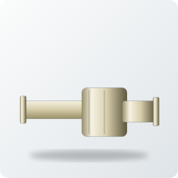 | Automotive parts (data-sheet listing) | C99700 | Listed | Die or sand cast, machined | Parts the data sheet names only in general terms
 | Housings and brackets | C99700 | Inferred | Sand or die cast, machined at bores and faces | Mounting and cover housings with strength and machinability
 | Fuel-system fittings | C99700 | Inferred | Die or sand cast, drilled and tapped | Banjo and union fittings on fuel lines (colour is irrelevant)
 | Railway coach fittings and bushes | C99700 | Inferred | Centrifugal or continuous cast tube, turned | Bushes and wear parts in coach undergear and fittings
 | Bus and coach interior hardware | C97600 | Inferred | Sand or investment cast, polished | Grab handles and touch points that keep a silver look
Table 21. Automotive and transport: products, manufacturing and uses

Tier 3: minor and niche applications

Beverage and dispensing
Main alloy | Main driver | Evidence summary | Main constraint
C97600 | Silver finish without plating; corrosion resistance | 0 listed, 0 context, 4 inferred | Lead in beverage contact

A new minor sector. Visible bar fittings suit C97600; anything wetted must now be lead-free.
Picture | Product or part | Alloy | Evidence | How it is made | What it is used for
 | Beverage and dispensing taps | C97600 | Inferred | Gravity-die cast body, bored and polished | Dispensing taps on bar counters and vending equipment
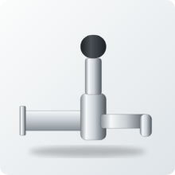 | Beer tap shanks and fonts | C97600 | Inferred | Cast or bar, bored, threaded and polished | Visible bar fittings that keep a bright finish
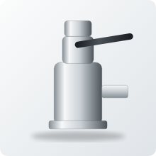 | Keg couplers and coupler bodies | C97600 | Inferred | Sand or die cast, machined and assembled | Connects the keg to the gas and beer lines; lead-free versions are now expected
 | Water-cooler and dispenser fittings | C97600 | Inferred | Die cast, machined | Fittings in water coolers and dispensers (lead limits apply)
Table 22. Beverage and dispensing: products, manufacturing and uses

Agricultural equipment
Main alloy | Main driver | Evidence summary | Main constraint
C99700 | Low-cost strength | 0 listed, 0 context, 3 inferred | Chemical attack by some agrochemicals; competition from plastics

Rugged, low-cost castings for field equipment. Check chemical compatibility before committing.
Picture | Product or part | Alloy | Evidence | How it is made | What it is used for
 | Sprayer pump bodies and valves | C99700 | Inferred | Gravity-die or sand cast, bores machined | Knapsack and power sprayers
 | Irrigation valve and coupling bodies | C99700 | Inferred | Sand or die cast, threaded | Field-rugged connectors and valves in irrigation lines
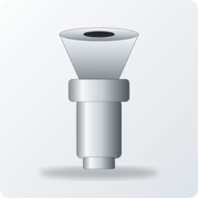 | Spray nozzle bodies | C97600 | Inferred | Cast or turned from bar, orifice machined | Nozzle bodies that resist agrochemicals (verify)
Table 23. Agricultural equipment: products, manufacturing and uses

Instrumentation and metering
Main alloy | Main driver | Evidence summary | Main constraint
C97600 | Free machining with corrosion resistance | 0 listed, 0 context, 4 inferred | Potable meters need lead-free alloys

Small, precise, free-machining parts suit the leaded nickel bronze.
Picture | Product or part | Alloy | Evidence | How it is made | What it is used for
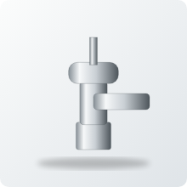 | Pressure-gauge sockets and cocks | C97600 | Inferred | Cast or bar, drilled and tapped | Connection points for pressure gauges
 | Sampling valves | C97600 | Inferred | Small castings, fine thread cut | Take-off points for process samples
 | Instrument housings and bezels | C97600 | Inferred | Die or sand cast, faced and polished | Dial surrounds and housings in a silver finish
 | Industrial (non-potable) meter bodies | C99700 | Inferred | Sand or gravity-die cast, hydro-tested | Process and industrial flow meters; potable meters need lead-free alloys
Table 24. Instrumentation and metering: products, manufacturing and uses

Consumer, music and giftware
Main alloy | Main driver | Evidence summary | Main constraint
C97600 | Silver look and fine detail | 1 listed, 0 context, 5 inferred | Small volumes; lead in anything used for food

Small-volume decorative work, including India's 'German silver' decorative market. Avoid food-contact items.
Picture | Product or part | Alloy | Evidence | How it is made | What it is used for
 | Piano keys | C97600 | Listed | Normally wrought nickel silver; cast route unlikely | Listed by one supplier; treat with care
 | Musical instrument castings | C97600 | Inferred | Investment cast, polished | Extension of the piano-key use
 | Decorative consumer castings | C97600 | Inferred | Sand or investment cast, polished or plated | Trophies, ornaments and giftware
 | 'German silver' decorative and puja ware | C97600 | Inferred | Sand cast, turned and polished | Lamps and decorative ware (avoid food contact)
 | Cutlery and hollowware handles | C97600 | Inferred | Sand or investment cast, plated base | Non-food-contact handles and finials
 | Belt buckles, badges and insignia | C97600 | Inferred | Investment or die cast, polished | Fine-detail fashion and uniform items
Table 25. Consumer, music and giftware: products, manufacturing and uses

Locks and security
Main alloy | Main driver | Evidence summary | Main constraint
Both | Strength (C99700); free machining and finish (C97600) | 1 listed, 0 context, 2 inferred | Zinc die castings and brass dominate on price

Listed for prison-door hardware. Other lock parts rely on the alloys' machinability and corrosion resistance.
Picture | Product or part | Alloy | Evidence | How it is made | What it is used for
 | Padlock bodies | C99700 | Inferred | Sand or die cast, bores machined | Heavy outdoor padlocks
 | Cylinder lock housings | C97600 | Inferred | Cast or bar, precise bores machined | Lock cylinders and housings
 | Security and prison-door hardware | C97600 | Listed | Sand cast, machined and polished | Hasps, locks and door furniture for secure buildings
Table 26. Locks and security: products, manufacturing and uses

7. From alloy to product: manufacturing chains
This section ties the report together. Each row follows one product family from alloy to melt, forming route, finishing steps and end customer. It answers the question a sales team needs to ask first: what route does this part take, and who buys it?
Picture | Product family | Alloy | Manufacturing chain | Customer and use
 | Wear rings, shaft sleeves and bushes | C99700 | C99700 ingot → induction melt → centrifugal or continuous cast tube → cut to length → turn and bore → press-fit or sleeve | Pump OEMs, valve makers and repair shops: ring sets for every overhaul
 | Valve seat rings | C97600 | C97600 ingot → melt → continuous-cast bar → cut → turn, face and thread → screw or press into body | Valve makers: renewable sealing face where erosion is highest
 | Valve bodies, DN15 to DN80 | Both | Alloy → melt → sand or gravity-die cast with cores → fettle → machine ends, seat pocket and bonnet thread → hydro test | Valve makers for steam, water, oil and process lines
 | Ball-valve bodies and end caps | C99700 | C99700 → melt → gravity-die cast → trim → bore, thread and face → assemble with plated ball | Utility and compressed-air ball valves, the largest Indian valve segment
 | Stem nuts and yoke bushes | C99700 | C99700 → melt → continuous-cast bar → cut → turn and tap → finish | Valve makers using stainless stems: anti-galling nut that is cheap to swap
 | Pump casings and covers | Both | Alloy → melt → sand cast with volute cores → fettle → machine flange faces, bores and seal spigot → hydro test | Pump makers for building services, irrigation and fire pumps
 | Impellers | Both | Alloy → melt → sand or investment cast → grind vanes → machine hub and keyway → balance | Bronze-fitted pumps; C97600 for corrosive or hygienic duty, C99700 for strength
 | Lobe rotors and pump gears | C99700 | C99700 → melt → cast bar or rough cast → mill or hob profile → grind to clearance | Food plants running lobe pumps; oil and fuel gear pumps
 | Dairy valves and fittings | C97600 | C97600 → melt → sand or gravity-die cast → machine → lap plug into body → test | Dairies, bulk milk coolers and village collection centres
 | Small valve parts: gland nuts, caps, handwheels | C99700 | C99700 → melt → pressure die cast (ASTM B176) → trim → tap → deburr or polish | High-volume parts supplied to valve assemblers at low unit cost
 | Fire landing valves, hose couplings, branch pipes | C99700 | C99700 → melt → sand or gravity-die cast → machine → pressure test → type-approval sample | Fire-service equipment makers; non-potable, strength and cost lead
 | Marine sea-water valves and fittings | C97600 | C97600 → melt → sand cast → machine → pressure test to marine practice | Shipyards, ship-repair and boat builders
 | Architectural and security hardware | C97600 | C97600 → melt → sand or investment cast → drill and tap → polish | Hardware makers for premium, hospital and secure-door markets
 | Decorative and giftware castings | C97600 | C97600 → melt → sand or investment cast → turn → polish | Small-volume decorative and German-silver ware (non-food-contact)
Table 27. Alloy-to-application manufacturing chains for 14 product families

7.1 Which forming method makes which product
Filled circles mark the usual route; open circles mark a possible one. Every route is followed by machining, pressure testing where the part holds liquid, and finishing.
Product group | Sand | Gravity die | Pressure die | Continuous or bar | Centrifugal | Investment
Valve bodies and bonnets | ● | ● | ○
Ball-valve bodies and end caps | ○ | ● | ○
Small valve parts (gland nuts, caps, handwheels) | ○ | ○ | ● |  |  | ○
Seat rings, stem nuts, bushes |  |  |  | ● | ●
Pump casings and covers | ● | ○
Impellers | ● |  |  |  |  | ●
Wear rings and shaft sleeves |  |  |  | ● | ●
Lobe rotors and gears | ○ |  |  | ●
Dairy fittings and ferrules | ● | ● |  | ○
Architectural hardware | ● | ○ | ○ |  |  | ●
Locks and padlocks | ● | ○ | ●
Marine fittings | ● |  |  |  |  | ○
Fire valves and couplings | ● | ●
Decorative and giftware | ● |  |  |  |  | ●
Instrument parts | ○ | ● |  | ●
Table 28. Forming route by product group (primary and possible routes)

Reading the matrix
- Big, complex and internal passages: sand casting with cores. Valve bodies and pump casings all start here.
- Small, high volume: die casting, which favours C99700 because it melts about 240 deg C lower and freezes quickly.
- Round and sliding: continuous or centrifugal cast bar and tube, then machined. This is where C97600 and C99700 compete with bronze bar and stainless.
- Detailed and visible: investment casting, used for impellers and decorative hardware.

8. Selection, cost and standards

8.1 What a part costs in metal
Metal value is the LME price of the metals inside the alloy on 16 October 2026 at INR 96.5 per US$: copper US$14,595/t, nickel US$15,170/t, tin US$50,700/t, zinc US$3,739/t, lead US$1,854/t, aluminium US$3,014/t. Manganese has no LME contract and is taken at an assumed US$2,000/t. Metal value excludes melting loss, casting, machining, margin and tax.
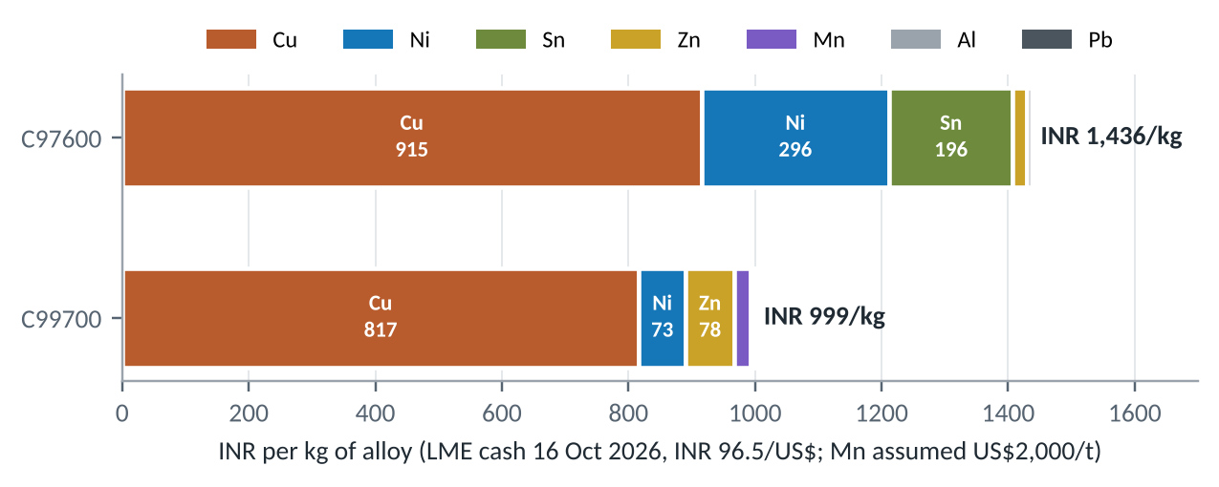
Figure 9. Metal value per kg, split by element
- C97600: copper 915, nickel 296 and tin 196 INR per kg. Tin is only 4% of the alloy but 14% of its metal value.
- C99700: copper is 82% of the value; manganese and zinc replace most of the nickel, which is why it is cheaper.
Picture | Example part | Assumed mass (kg) | C97600 (INR) | C99700 (INR) | Difference (INR)
 | Gland nut, DN25 valve | 0.06 | 86 | 60 | 26
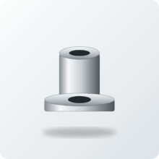 | Stem nut / yoke bush | 0.10 | 144 | 100 | 44
 | Sanitary ferrule | 0.25 | 359 | 250 | 109
 | Door handle | 0.35 | 503 | 350 | 153
 | Valve handwheel | 0.25 | 359 | 250 | 109
 | Gear blank | 0.80 | 1,149 | 799 | 350
 | Impeller, 3 kW pump | 1.20 | 1,724 | 1,199 | 525
 | Valve body, DN50 globe | 2.20 | 3,160 | 2,198 | 963
 | Cleat | 1.50 | 2,155 | 1,498 | 656
 | Rotary lobe rotor pair | 1.50 | 2,155 | 1,498 | 656
 | Pump casing, 3 kW | 6.00 | 8,619 | 5,993 | 2,625
Table 29. Metal value of eleven example parts (masses are assumptions)

8.2 Standards a valve or pump buyer is likely to cite
Standard | Scope | Why it matters here
ASTM B505 | Copper alloy continuous castings | C97600 chemistry and properties (Concast cites B505-23)
ASTM B584 / B271 | Sand and centrifugal castings | Other routes for C97600; confirm the grade is in the current edition
ASTM B176 | Copper alloy die castings | C99700 (ICAST data sheet)
MSS SP-80 | Bronze gate, globe, angle and check valves | Pressure ratings and design of bronze valves
MSS SP-110 | Ball valves, threaded and socket-weld | Ball-valve bodies in copper alloys
IS 778 | Copper-alloy gate, globe and check valves for waterworks | Indian standard for the same valve families
API 598 / ISO 5208 | Valve inspection and pressure testing | Shell and seat tests before dispatch
NSF/ANSI 61 and 372 | Drinking-water components; lead content | Certification route for potable products
US Safe Drinking Water Act | 'Lead-free' = 0.25% weighted-average Pb on wetted surfaces | Rules out both leaded grades for US potable use
IS 10500 | Indian drinking-water quality; Pb limit 0.01 mg/L | Drives Indian utility specifications
3-A Sanitary Standards | Dairy equipment hygiene design | Generally specify stainless for product contact; check before quoting
Table 30. Standards and testing references
Buyers in India usually write IS 778 or MSS SP-80 into valve enquiries and API 598 or ISO 5208 into test requirements. Ask for the specification at the first enquiry so the grade, test pressure and certification are quoted correctly.

9. Risks, substitutes and outlook

9.1 Failure modes and design checks
Exposure scores run from 1 (low) to 5 (high). They are judgement from composition and common practice, not test results.
Failure mode | Where it bites | C97600 | C99700 | Mitigation
Dezincification | Valve bodies, impellers in soft or chloride water | 1 | 4 | Specify C97600 or a DZR alloy for immersed service; test in the actual water
Erosion-corrosion | Seat rings, impeller eyes, elbows | 2 | 3 | Keep velocity within supplier limits; harder trim at the seat
Cavitation pitting | Impeller suction side | 3 | 3 | Raise NPSH margin; consider nickel-aluminium bronze impellers
Galling and seizure | Stem nuts, wear rings, lobe rotors | 3 | 1 | Use C99700 against stainless mating parts
Lead leaching | Potable water and food contact | 4 | 3 | Restrict to non-potable duty or move to a certified lead-free grade
Shrinkage porosity / leaks | Thick-to-thin body sections | 3 | 2 | Feeding and chill design; 100% hydrostatic shell test
Ammonia stress-corrosion cracking | Refrigeration, fertiliser plant | 2 | 4 | Avoid C99700 in ammonia service; stress-relieve
Acid cleaning attack (CIP) | Dairy and food lines | 4 | 4 | Check the plant's CIP chemistry before quoting
Table 31. Exposure of each alloy to eight failure modes (1 to 5)

9.2 What could replace them
Substitute | Where it competes | Trade-off
316 stainless steel | Dairy, food, sanitary, valves, pumps | Hygienic and lead-free; harder to machine, costlier to cast, can gall against itself
Lead-free bronze (bismuth or silicon) | Plumbing, potable valves, meters | Meets lead rules; machines less freely; the most direct threat in water
Aluminium bronze | Marine, pumps, wear parts | Strong, cavitation-resistant; not silver; harder to machine
Leaded red brass C83600 | General valves and fittings | Similar metal value to C97600; not white; less corrosion-resistant
Lead-free white manganese bronze | Food equipment, hardware | Patented replacement for C99700-type alloys where lead is a problem
Engineering polymers | Light-duty food, agri and hardware parts | Low cost; limited strength, temperature and creep
Table 32. Substitute materials

9.3 Risk register
# | Risk | Likelihood | Impact | Comment
1 | Lead rules | 4 | 4 | Both grades contain lead; food and drinking-water contact are the exposed uses
2 | Copper price and tariff | 5 | 3 | LME copper US$14,595/t on 16 Oct 2026; US Section 232 tariff on copper content
3 | Stainless substitution | 4 | 3 | Holds 55% of the hygienic pump and valve market by material
4 | Nickel and tin price swings | 3 | 3 | C97600 carries both; tin is US$50,700/t
5 | Manganese supply | 2 | 3 | Matters for C99700; no LME benchmark
6 | Specification mix-ups | 2 | 3 | Look-alike white alloys are easy to confuse without analysis
7 | Foundry capacity | 2 | 2 | Niche grades, few specialist foundries
8 | CIP chemistry in dairy | 3 | 3 | Acid cleaning attacks copper alloys
Table 33. Risk register (1 to 5)

9.4 Outlook
The parent copper-alloy market is forecast to grow about 5.6-5.8% a year, but no source gives growth for these two grades. Outlook by application is judgement: steady to growing in non-potable valves, pump wear parts, fire protection, marine and architectural hardware; declining in food and potable-water contact as lead rules tighten; open to a lead-free white manganese bronze if one can be sourced or developed.

10. Opportunity map for Bajaj Alloys
Plotting technical fit against market attractiveness turns the catalogue into a shortlist. Fit comes from the alloy properties and the sub-component analysis in Sections 4 to 6; attractiveness weighs market size, growth and how few rules stand in the way. Both axes are analyst judgement on a 1 to 5 scale. The recommendations below are an analyst view for discussion, not a forecast of orders.
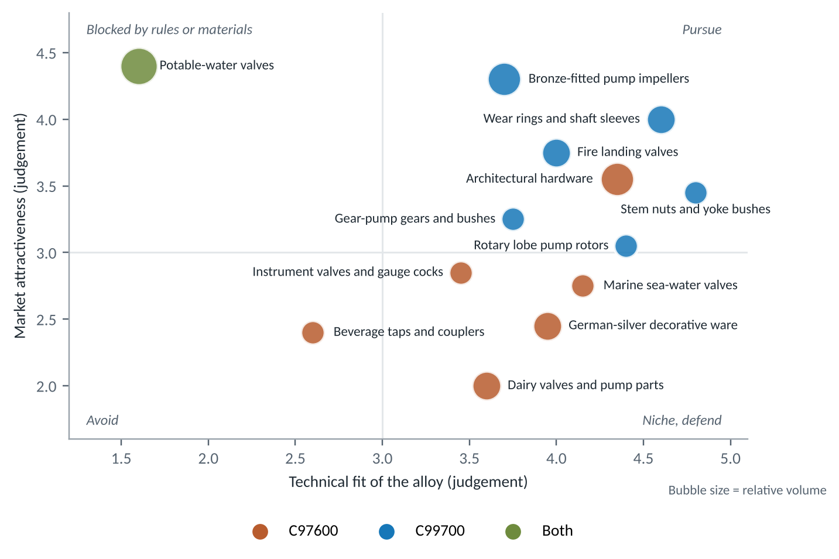
Figure 10. Opportunity map: technical fit against market attractiveness (judgement)
Picture | Application | Alloy | Fit | Attract. | Who buys | Suggested next step
 | Pump wear rings and shaft sleeves | C99700 | 4.6 | 4 | Pump OEMs, pump repair shops, irrigation and municipal pump users | Approach with a drop-in ring set for the five most common pump sizes; offer free samples for a trial
 | Bronze-fitted pump impellers | C99700 | 3.7 | 4.3 | End-suction pump makers and spare dealers | Quote against C83600 and C90300 on metal value; test a small batch
 | Fire landing valves | C99700 | 4 | 3.8 | Fire-equipment makers and building contractors | Check the type-approval route; prototype one size
 | Stem nuts and yoke bushes | C99700 | 4.8 | 3.5 | Valve makers using stainless stems | Offer a nut machined from cast bar to the largest valve makers
 | Architectural hardware | C97600 | 4.4 | 3.6 | Premium and secure-door hardware makers, architects | Target hospital, hotel and secure-door segments
 | Rotary lobe rotors | C99700 | 4.4 | 3.1 | Food plants and lobe-pump makers (spares) | Supply spare rotors to plants running lobe pumps
 | Marine sea-water valves | C97600 | 4.2 | 2.8 | Shipyards, ship-repair yards, boat builders | Run shipyard and ship-repair enquiries
 | Potable-water valves | Both | 1.6 | 4.4 | Large market but excluded by lead rules | Not a target for these grades; needs a lead-free alloy
Table 34. Shortlist with buyers and suggested next steps

10.1 Who to approach and what to offer
Customer type | What they buy | What to offer | Why it works
Valve manufacturers | Bodies, bonnets, seat rings, stem nuts, small parts | Machined, tested castings against their drawings; stem nuts and seat rings from bar | Valve sub-components are the real product list
Pump manufacturers | Casings, impellers, wear rings, sleeves | Cast and machined parts plus ring sets | Both alloys are named for pump parts in data sheets
Pump and valve repair and spares dealers | Wear rings, sleeves, bushes, stem nuts | Ready-to-fit sets in the most common sizes | Overhaul demand repeats every year
Dairies and village collection centres | Valves, fittings, spare pump parts | C97600 parts for older plant and non-product-contact items | Existing copper-alloy plant needs spares
Fire-protection contractors | Landing valves, couplings, branch pipes | C99700 castings to the buyer's approval route | Non-potable, strength and cost lead
Shipyards and ship repairers | Sea-water valves, seacocks, deck hardware | C97600 castings tested to marine practice | Nickel resists seawater
Hardware and lock makers | Door hardware, lock cases, padlock bodies | Polished castings that keep a silver finish | No plating needed
Food-machinery builders | Sliding guides, bushes, non-contact parts | C99700 parts that slide on stainless | Patent context on resistance to galling
Table 35. Customer segments and offers

10.2 Questions to settle before quoting
- Specification: which standard and which alloy grade does the buyer name? Check for look-alike white alloys.
- Contact: does the part touch drinking water or food? If so, these grades are excluded and a lead-free alloy is needed.
- Route: sand, die or bar? Agree tooling, minimum order and machining allowance up front.
- Testing: what pressure test and certification does the buyer require?
- Price basis: quote on LME copper, nickel and tin (and an agreed manganese price) so that metal moves are passed through.
- Evidence: for any entry tagged Inferred, confirm the use with the customer before building stock.

Glossary and sources
Term | Meaning
Nickel silver | Copper-nickel-zinc alloy that looks silver but contains no silver; 'German silver' in India
White manganese brass | Brass with enough manganese and nickel to look white
Dairy metal | Trade name for C97600, from its dairy-plant use
Bronze-fitted pump | Iron-cased pump with copper-alloy impeller, wear rings and sleeve
Wear ring | Renewable ring that sets the small clearance between impeller and casing
Stem nut / yoke bush | Threaded nut in the valve yoke that the stem screws through
Dezincification | Selective loss of zinc from a brass in some waters
Galling | Surface seizure between sliding metals
CIP | Clean-in-place: circulating caustic and acid cleaning in food plants
DN | Nominal pipe size in millimetres
LME | London Metal Exchange
Table 36. Glossary

Sources
- C97600 composition, properties and uses: Concast data sheet, concast.com/files/C97600.pdf; Metaltek; Aviva Metals.
- C99700 composition and uses: ICAST ASTM B176 C99700 data sheet, icastllp.com; properties: MakeItFrom, makeitfrom.com (UNS C99700).
- Food-equipment context: US patent 6,149,739.
- LME cash settlement prices, 16 Oct 2026: Westmetall, westmetall.com.
- India pumps and India valves: IMARC Group, imarcgroup.com/india-pumps-market and /india-valves-market.
- India industrial valves and segment shares: Mordor Intelligence, mordorintelligence.com.
- Global pumps: IMARC Group. Global industrial valves: Coherent Market Insights, coherentmi.com.
- Hygienic pumps and valves: Future Market Insights. Dairy processing equipment: IMARC Group.
- India milk production: All India Radio News (newsonair.gov.in), citing Government of India data.
- US Safe Drinking Water Act lead-free definition: Copper Development Association, copper.org; NSF.
- Manufacturing routes, part masses, fit, exposure and opportunity scores and the major/minor tiers are the analyst's assumptions and judgement from general foundry practice, not data from a named plant.
- Product pictures are drawn illustrations, not photographs.

