**IWR Website Instructions For Use and Updates**

**Gmail**

A Gmail was created in order to establish create the Github account.

**Email**: [iwrcharity@gmail.com](mailto:iwrcharity@gmail.com)

**Password**: iwr_charity

**Github**

Github is where the website’s code is stored (called a repository). Changes made to this repository are immediately reflected on the live website (+/- 1 minute to repopulate)

**Username:** iwrcharity

**Password:** @iwr_charity2017

Github provides a single free domain (the URL) for the website to live on (<https://iwrcharity.github.io/)>.

Ideally, you should buy a domain from vendors such as [GoDaddy](https://www.godaddy.com/), or [Namecheap](https://www.namecheap.com/). This should cost around $10-15 a year.

Once acquired, you can “point” the new domain to the Github repository by going to

<https://github.com/iwrcharity/iwrcharity.github.io/settings> (note this may change if you switch the domain, just look for “Settings”) and following the directions at **“Custom domain”**. See image below

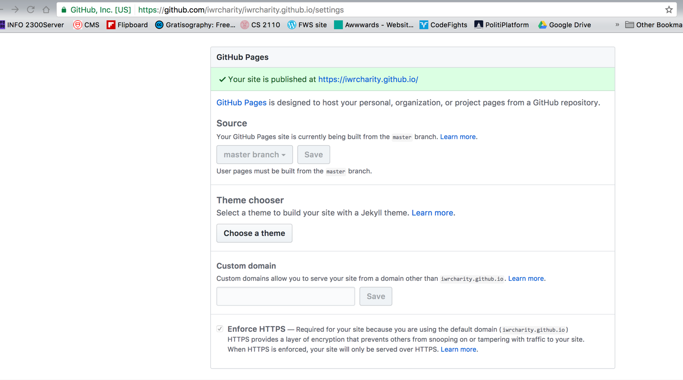

**Repository Structure**

Key folders:

**css:** Contains most website styling features. The website uses the popular grid framework [Foundation](http://foundation.zurb.com/sites/docs/v/5.5.3/components/grid.html). This is almost identical in structure to bootstrap and is incorporated directly into index.html. For individual styling, modify style.css

**img:** all image assets are stored here

**js:** Most JavaScript elements (besides the map) are stored here in script.js. This file has many comments to explain what each section is doing. A key note is the first section concerning the tabletop.js. This library allows the use of a [Google Sheet](https://docs.google.com/spreadsheets/d/1eRJDZIT8cCOH-cLCdnL_szUqskf81yDCRBF5Kb0Ku5A) as a cloud database. The [iwrcharity@gmail.com](mailto:iwrcharity@gmail.com) should have edit access to this spreadsheet. This sheet dynamically populates the last section of the website.

Modification of the map occurs in the index.html. To add additional slider options, simply add an object to the JSON occurring at line 254.

**How to make code modifications**

To communicate with Github, you need to install “git”. I’m pretty sure that this comes preinstalled on MacOS and Linux but Windows will require [installation](https://git-for-windows.github.io/). There are graphical user interfaces but for the sake of simplicity I will only explain the way to do so from the command prompt. (Note: this requires that git be included in the “PATH” variable, it will likely be an option when going through the installer)

1. Open command prompt

2. Clone the repository using

*git clone* [*https://github.com/iwrcharity/iwrcharity.github.io.git*](https://github.com/iwrcharity/iwrcharity.github.io.git)

3. Change into this directory with

*cd iwrcharity.github.io*

4. From here make any changes to the code

5. Once all changes have been made, execute the commands in order in the command prompt, with these exact characters and spacing

*git pull* (this checks to make sure your current code is most up-to-date)

*git add .*

*git commit –m “ <INSERT A MESSAGE TO DESCRIBE CHANGES WITHIN THESE QUOTES> “*

*git push*

You can check if your changes were successful by reloading the repository page and seeing the new message