Request for Internet Service purchase for Hosting PU-developed website applications

## Driver for Request

All PU (PURRS) developed website applications must be migrated within about a year from old servers as requested by ComIT. These old servers are unsupportable and are a security risk. All applications must receive a PU-determined outcome of “retire” or “redevelop”. For each app to be redeveloped, remote hosting or internal City hosting must be selected.

## The Request

Request – Request the purchase of Internet website service from an Internet Service Provider (ISP) to host some PU developed website applications on a PU-owned Internet service platform (remote hosted).

Reason – Provide higher functionality at lower cost.

Not included – This request does not include any additional applications or functionality. No new applications or increased functionality of existing applications is anticipated.

Cost – Approximately $100 per year which includes: internet service, enhanced security, and domain name registration. An unlimited number of applications can be hosted without increasing the cost of the service.

Cost Avoidance – ComIT estimated the charge to PU as $4000 to setup service plus $1000 per year.

Security – Independent Internet site with all application functions are encrypted password protected and the website will be protected with enhanced security provided by the Internet Service Provider (ISP).

Enhanced Access – Main beneficiaries are remote access PU users and non-PU users such as vendors. PU users will not have to remotely connect to the City network to use the remote hosted websites. Authorized non-PU users will not need an Active Directory account to use the remote hosted websites. The ProductsLists website is expected to be used by authorized vendors.

No Reduced Access – There will be no reduction of access or functionality for the remote hosted version of the website applications as compared to current internally hosted website applications.

Enhanced Technology – Higher and easier use of website software development technologies are available on remote hosted websites.

Better support – Direct access to production servers and database allow real-time improvements of production applications not possible on internally hosted applications due to ComIT restrictions.

Hosting

The hosting is provided by an Internet Service Provider (ISP). The lowest service level, with selected options, is sufficient for the expected needs of the targeted applications. “Hosting” means the service that is needed to allow access to the website from the Internet. HostGator is the preferred ISP based on PU staff experience with several ISPs. Only the purchase of hosting is requested; all website development will be completed by PU staff.

Justification

Benefits of Remote Hosting compared to internal/City hosting

* Accelerates the migration of applications from the old servers
* Easy access by in-field staff, contractors, and vendors at less cost
* Instant bug-fixes to live app, if needed and allows full access to production server. .
* Reduced restrictions of app development, documentation, testing, access, and installation.
* Flexibility of PU Change Management, stream-lined approval and
* Reduced administrative burden.
* Flexibility of technology choices.

Technology

The technology that will be used for remote hosting is that which is used on 85% of Internet websites. The programming language used on the web server will be PHP and the database is MySQL. Programmed browser functions will use JavaScript, jQuery, AJAX, Bootstrap, web services, and json.

Website Security

Security layers – Website security includes the following layers:

ISP-provided security – The ISP provides website server security called SiteLock which protects your website with features including:

* Malware Scanning - prevents hackers from using the website to distribute virus-infected software to our users.

• TrueShield Web Application Firewall - TrueShield WAF protects websites from malicious traffic and blocks harmful requests.

• TrueSpeed Content Delivery Network (CDN) - gives users the fastest and most secure experience when visiting the website

Database protection – Databases have additional password protection

Application protection – Application password protection is designed and developed into the applications

Function protection – Each web page and function is protected

Password encryption – Passwords are stored in the database using encryption so real password cannot be determined if the contents of the database are stolen by a hacker.

Antispyware – Applications are designed and developed to prevent unauthorized spyware or malicious robot access.

Website backups – Daily files and data backups ensure quick recovery of the website to a recent state.

Criteria for Application selection for remote hosting

Remote hosting is indicated for applications that meet the following criteria:

* The app must not require access to internally-access data sources like Hansen
* The app will have significant remote (field) staff access
* The app does not use or store any sensitive information
* The app is not overly-complex
* The app functionality can be performed using remote hosting technology

Targeted Applications

The new domain name could be [www.vaBeachPU.com](http://www.vaBeachPU.com) and the following applications have been selected for consideration for remote hosting.

PIP.vaBeachPU.com – Permit Information Program – Right-of-way permit management; heavy remote user access.

ProductsList.vaBeachPU.com – Products list maintained by the PU Product Selection Committee; Need for contractor and vendor access.

HydrantDefect.vaBeachPU.com – Hydrant defects as reported by Fire; need for remote access by Fire.

PSE.vaBeachPU.com (Pump Station Electrical) – Highly detailed pump station electrical information; need for remote access by Electricians.

Programming Support

All software application websites are comprehensively documented and programmed using standard, common technology. All applications are mature and significant functional changes are not expected. Any bugs found after redevelopment and User Acceptance Testing will be fixed at the highest priority. Long-term, another software developer should be able to easily learn the intended function of any application website from review of the documentation. Using this information another software developer should be able to easily add additional functionality or fix bugs. The new PURRS website will provide access to all support and development information.

Application Life Cycle Maintenance

The overall goal is to have the minimum amount of functionality, applications, and cost without having any unmet technology needs. Commercial applications are preferred over PU applications.

PU developed applications are not indicated for development if:

* The business process can be provided by an existing commercial app
* The best practice method of a business process is not very well known by staff
* No staff are available to participate in an app development team

Existing PU developed applications are retired if:

* The business process can be provided by an existing commercial app or is no longer needed

PU developed applications are developed for business process support that cannot otherwise be achieved via commercial applications.

PU developed application expectations

Most PU applications are mature and stable with ages ranging from about 10 to 20 years. There are, however, two new applications planned to be developed.

Please purchase of Internet website service from an Internet Service Provider (ISP) to host some PU developed website applications on a PU-owned Internet service platform (remote hosted).

### PIP – As seen from a PC:

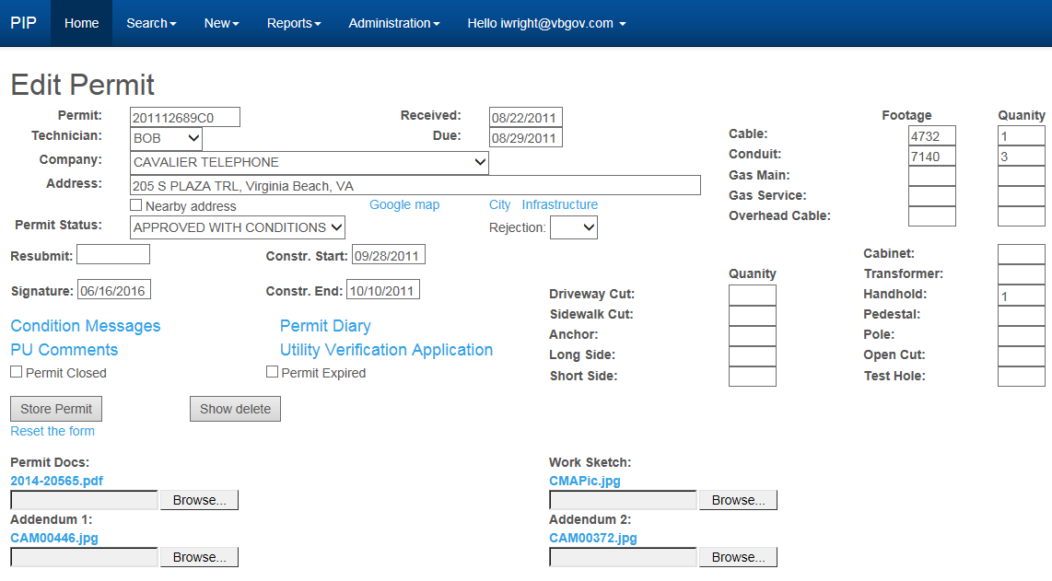

### From iPad:

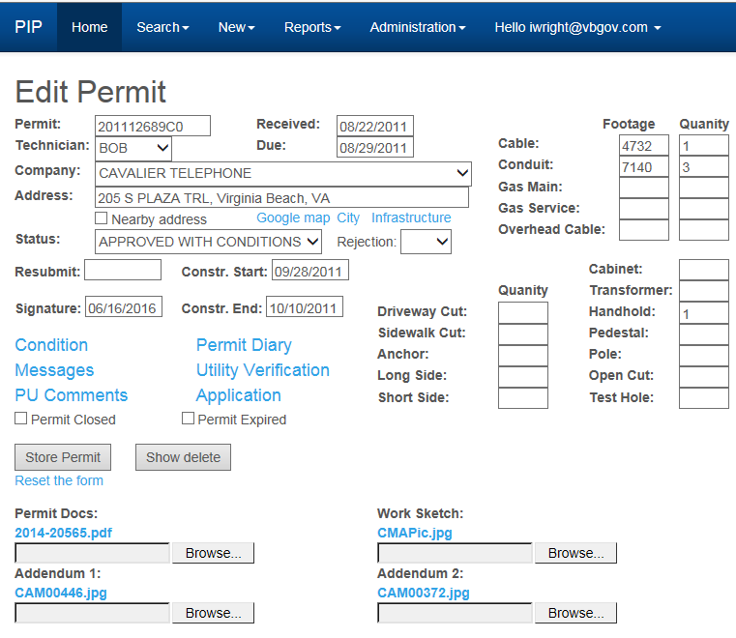

### From smart phone:

