Predicting Diabetes Risk Using a Neural Network
Name: _Bonkiyung kelly_____________ supervisor: Gita Fonyuy______________ Date: __05/10/2026____________

1. Topic
This project builds a model that predicts whether a person is likely to have diabetes, using health measurements such as glucose, BMI, and blood pressure. It uses an Artificial Neural Network (ANN), a type of machine learning model.

2. Problem Statement
Diabetes can cause serious health problems if not caught early, but many people are not tested until symptoms appear. This project asks: can we predict diabetes risk from simple health data? The dataset (Pima Indians Diabetes Dataset) has 768 patients: 500 without diabetes and 268 with diabetes.

3. Proposed Solution
The plan: (1) explore the data, (2) clean it and engineer new features, (3) build and train an ANN, and (4) evaluate it on unseen data. An ANN was chosen because it can learn how risk factors combine, not just look at each one alone.

4. Implementation Details
The 768 records were split into training (537), validation (115), and test (116) sets. Biologically impossible zero values (in Glucose, Blood Pressure, Skin Thickness, Insulin, BMI) were replaced with the training median. Six new features were engineered, including Glucose_x_BMI, Age_x_BMI, and risk flags like is_obese, bringing the total to 14 input features, all standardized.
Model architecture (“DiabetesANN”):
Layer | Details
Hidden 1 | Dense(128) + BatchNorm + ReLU + Dropout 0.3
Hidden 2 | Dense(64) + BatchNorm + ReLU + Dropout 0.3
Hidden 3 | Dense(32) + ReLU + Dropout 0.2
Output | Dense(1) + Sigmoid
Trained with Adam optimizer (lr = 0.00025), binary crossentropy loss, and L2 regularization to reduce overfitting on this small dataset. Tools: Python, Pandas, Scikit-learn, TensorFlow/Keras.

5. Key Findings and Evaluation
Glucose has the strongest link to diabetes (correlation 0.50), followed by Insulin (0.38) and BMI (0.32). The data is imbalanced (65% no diabetes, 35% diabetes), so accuracy alone isn't enough — AUC, precision, and recall were also tracked.
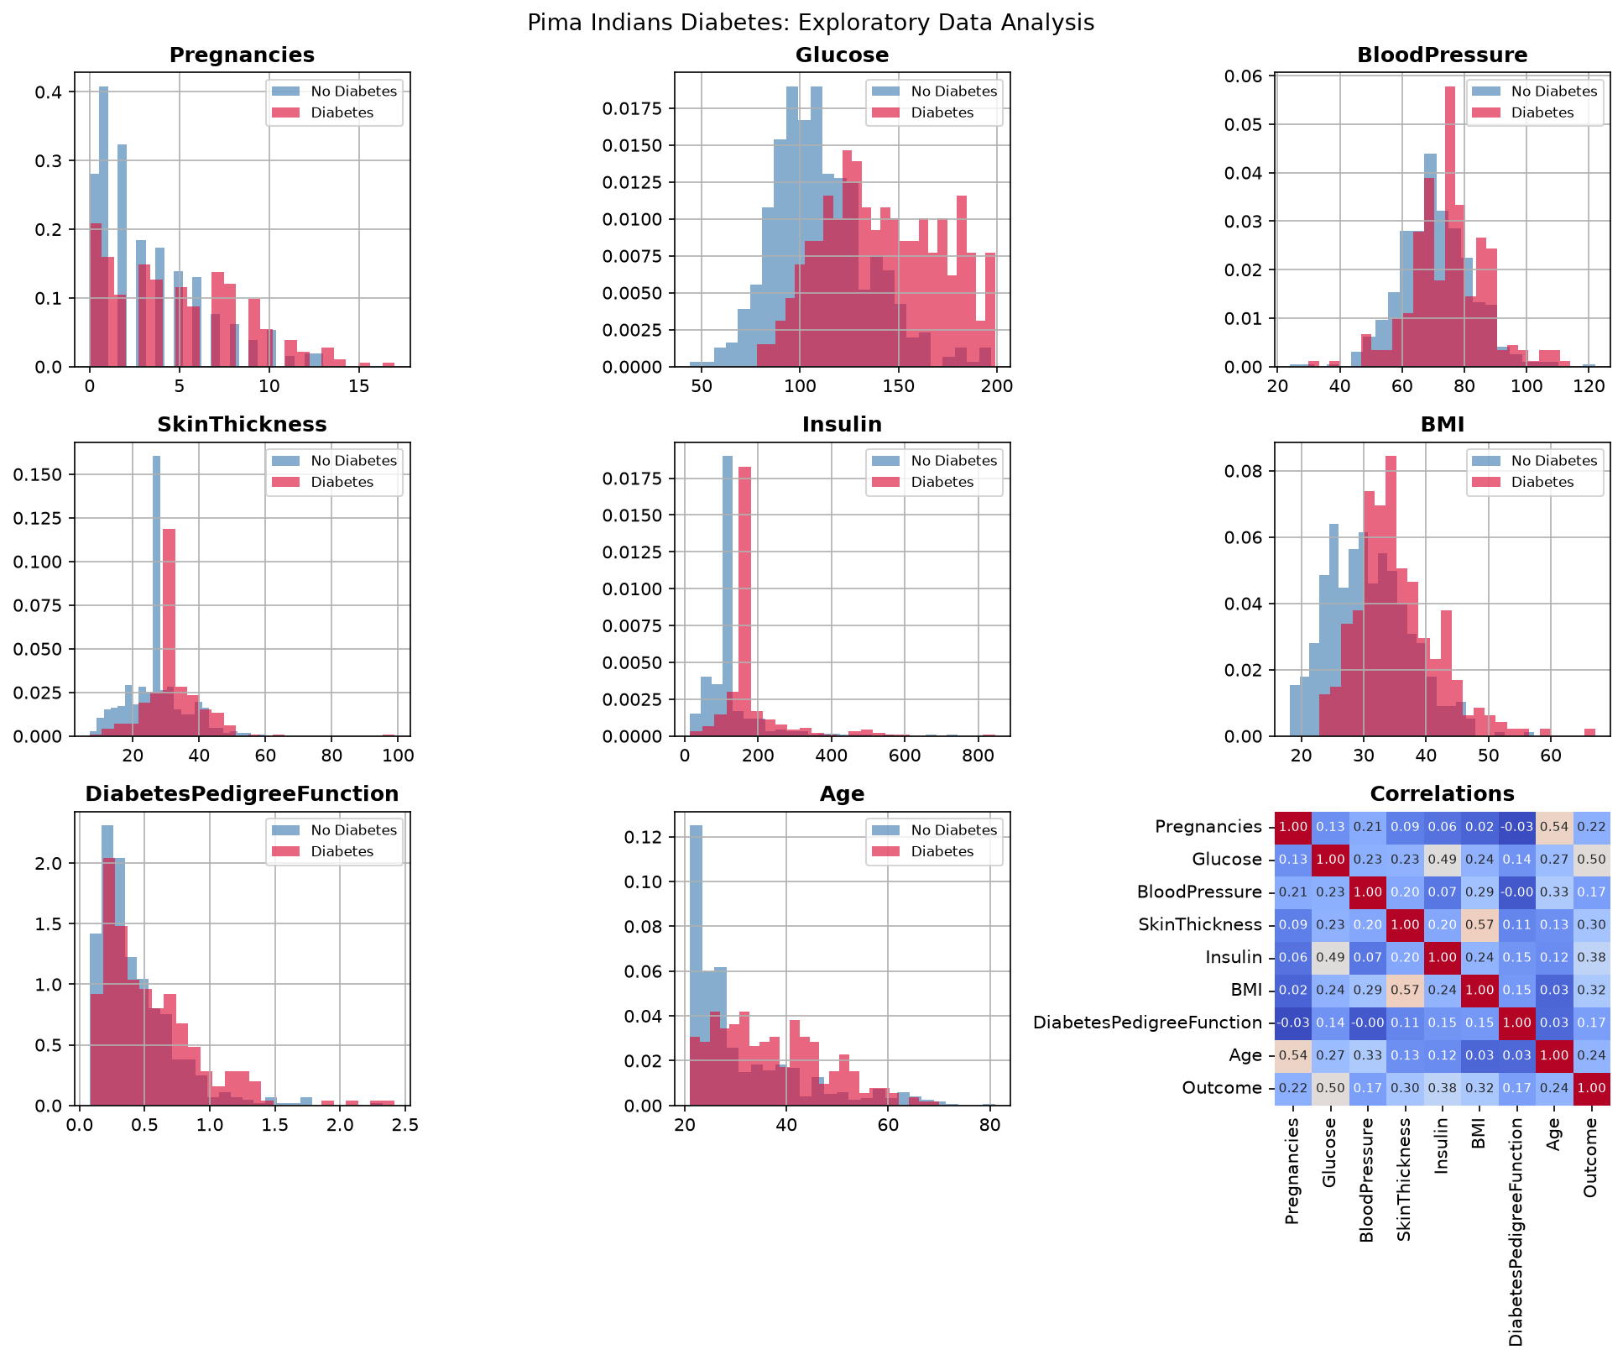
Figure 1: EDA – feature distributions and correlation matrix
Metric | Score
Accuracy | [insert value]
AUC (ROC) | [insert value]
Precision | [insert value]
Recall | [insert value]
(Fill in from your notebook's model.evaluate() results on the test set.)

6. Challenges
- Hidden missing data: invalid zero values had to be found and fixed with median imputation.
- Small dataset: only 768 patients meant a real risk of overfitting, managed with Dropout, BatchNorm, and L2.
- Class imbalance: more “no diabetes” cases could make accuracy misleading, so recall and AUC mattered too.

7. Conclusion
This project showed that an ANN can predict diabetes risk fairly well using simple health data, with glucose as the strongest single predictor. With more data and tuning, such a model could help flag patients for early testing — though it is not a replacement for a real medical diagnosis.

