HEART DISEASE RISK PREDICTOR
A Simple AI Tool to Predict Heart Disease Risk

Project Report
Prepared by: Bongkiyung Kelly
Supervisor: Fonyuy Gita

1. Topic
This project uses an Artificial Neural Network (ANN), a type of AI model, to predict whether a person is likely to have heart disease. The prediction is based on simple health information, such as age, blood pressure, cholesterol, and lifestyle habits. The model is connected to an easy-to-use web app (built with Streamlit) so anyone can enter their details and get a quick result.

2. Problem Statement
Heart disease often develops quietly over many years before it is noticed. Many people do not get checked regularly, and doctors have limited time to review every risk factor by hand. There is a need for a fast, simple tool that can look at a person's health data and flag possible heart disease risk early, without needing a hospital visit.

3. Proposed Solution
The solution is an AI model that learns patterns from past patient data and uses them to predict heart disease risk in new patients. It has three parts:
- Data: health records with 20 features (age, weight, blood pressure, cholesterol, smoking, and more).
- Model: a neural network trained to tell apart patients with and without heart disease.
- App: a Streamlit web page where users type in their health details and get an instant prediction.

4. Implementation Details
The full dataset has 50,000 patient records. It was split into three parts so the model could be trained and then fairly tested:
Data Split | Records | Purpose
Training | 35,000 | Used to teach the model
Validation | 7,480 | Used to fine-tune the model while training
Test | 7,500 | Used only at the end, to check performance

Before training, all numbers (like age and cholesterol) were rescaled to a similar range. This helps the model learn faster and more evenly. This scaling method was saved so the app can prepare new user input the exact same way.
The model's structure, taken directly from the saved file, is:
Layer | Size | What it does
Input | 20 | Takes in the scaled health data
Hidden layer 1 | 128 neurons | Learns patterns; uses ReLU + Dropout
Hidden layer 2 | 64 neurons | Learns deeper patterns; ReLU + Dropout
Hidden layer 3 | 32 neurons | Narrows down the patterns; ReLU + Dropout
Output | 1 | Gives a probability of heart disease (0 to 1)

The model was trained with the Adam optimizer and a small learning rate (0.0005). Dropout layers (which randomly switch off some neurons during training) were used to stop the model from memorising the training data instead of truly learning.
The web app (built with Streamlit, TensorFlow, and Python) loads this trained model. When a user enters their health details, the app scales the numbers the same way as during training, then asks the model for a prediction.
Before building the model, the data was explored visually to see which features looked different between people with and without heart disease. Two of these charts are shown below.
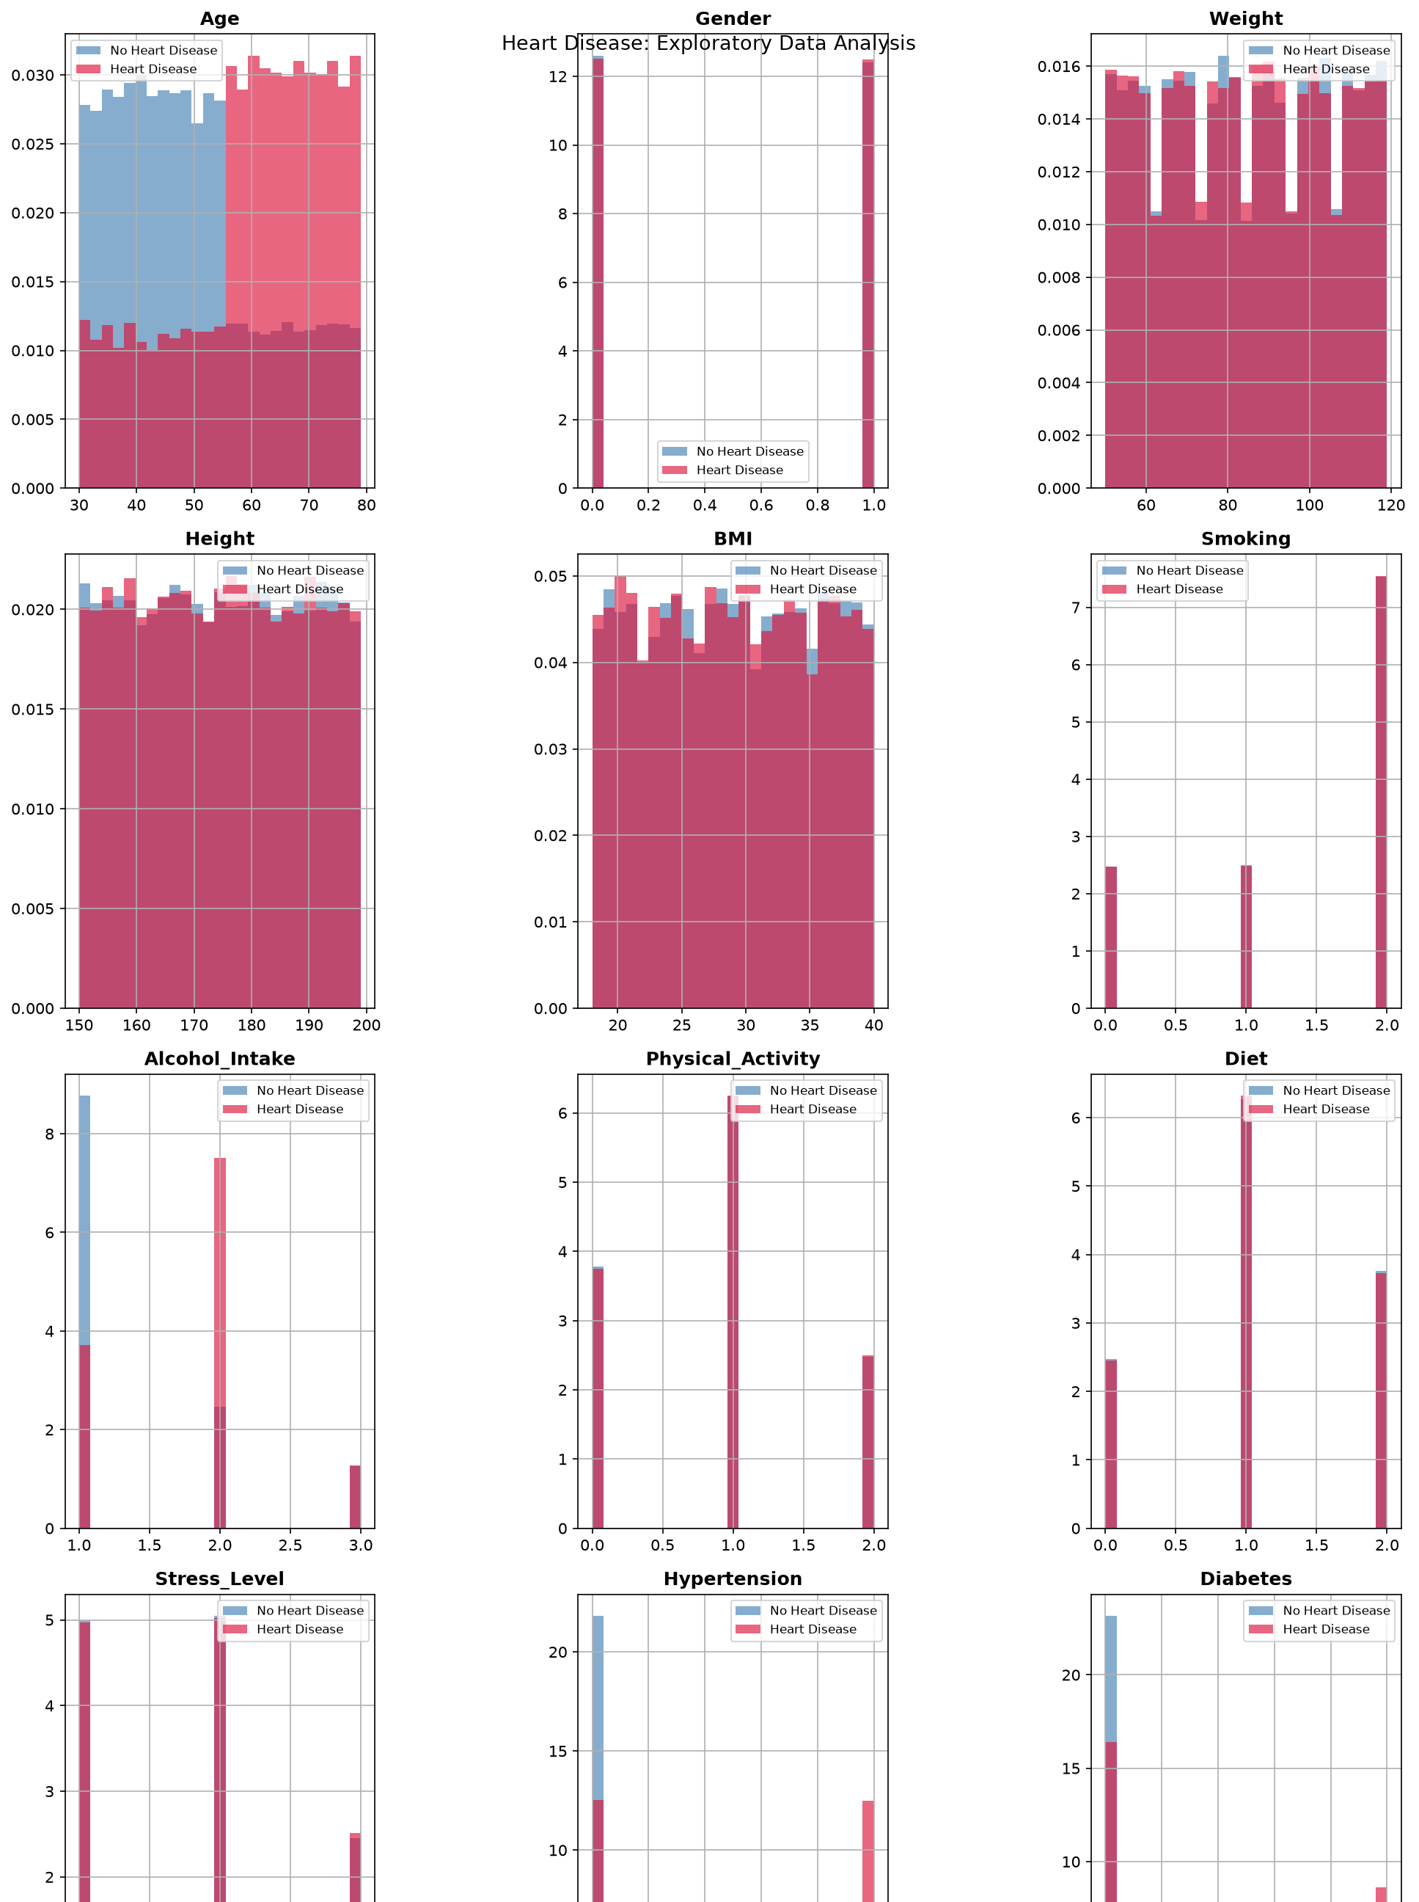
Figure 1. Age, gender, weight, height, BMI, and smoking, compared for people with and without heart disease.
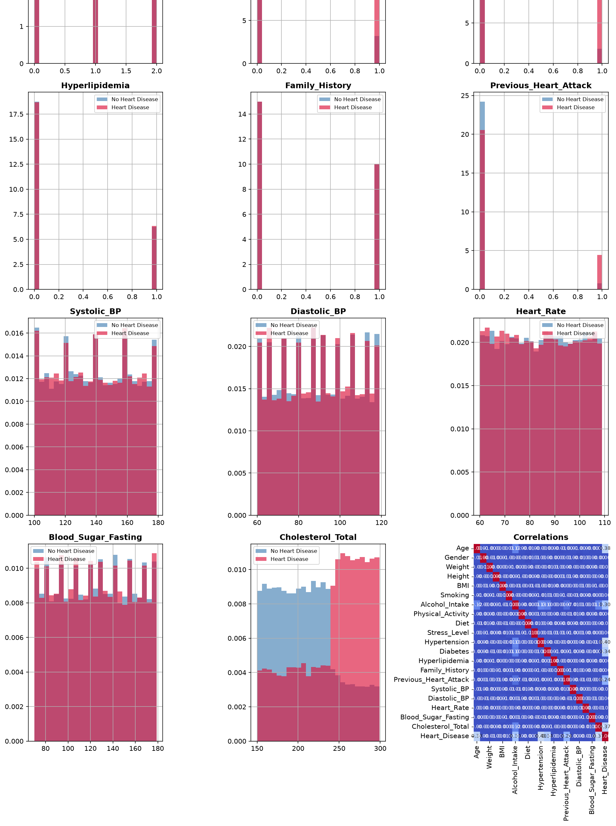
Figure 2. Blood pressure, blood sugar, cholesterol, and other risk factors, plus how each feature relates to heart disease.
The charts show that age, blood pressure, blood sugar, cholesterol, hypertension, diabetes, and past heart attacks all differ clearly between the two groups. This matches what doctors already know about heart disease risk, so it was a good sign that the model had real patterns to learn from.

5. Key Findings and Evaluation
The project documentation reports two main results on the test data:
~98.3%  Accuracy | ~0.925  ROC-AUC

Accuracy of 98.3% means the model got most predictions right. The ROC-AUC score of 0.925 (a measure of how well the model tells the two groups apart) is also strong, though a bit lower than the accuracy. This gap is worth watching, because very high accuracy combined with a lower AUC can sometimes hint at problems like data imbalance.
Note: exact precision, recall, F1 score, and confusion matrix values were not available in the files shared for this report, and this report was written without internet access, so TensorFlow could not be installed to re-run the test and recalculate them. Only the accuracy and ROC-AUC figures above are quoted, as they come directly from the project's own README.
- The features most linked to heart disease were hypertension, diabetes, high cholesterol, high blood pressure, high blood sugar, and a past heart attack.
- Training was tracked over time using loss, accuracy, and AUC, to check the model was learning properly and not overfitting.

6. Challenges
- Possible data leakage: the project notes this itself. Because the data is synthetic, some features may be too closely linked to the answer, which could make accuracy look better than it would on real patients.
- Synthetic data: the training data is artificially generated, not from real patients, so results may not fully match real-world cases.
- Accuracy vs. AUC gap: the two scores don't fully agree, which suggests the test set may be imbalanced or the results need closer checking.
- Basic interface: the current app works but is simple; a more guided form would help avoid input mistakes.
- Not a medical tool: this app cannot replace a doctor. Results must always be treated as educational, not a diagnosis.

7. Conclusion
This project shows that a neural network can predict heart disease risk from basic health data with high accuracy (98.3%) and a strong AUC score (0.925), and that this can be delivered through a simple, easy-to-use web app. The risk factors the model relies on match what is already known in medicine, which is a good sign.
At the same time, the possible data leakage and the accuracy/AUC gap mean these results should be treated carefully, not as a final answer. Next steps should include checking the data more closely, testing on real patient data if possible, and improving the app's design, all while keeping the app clearly labelled as an educational tool, not a medical device.

