Predicting Malaria from Patient Symptoms Using a Neural Network
By [Bongkiyung kelly] | For [Gita Fonyuy] | [04/10/2026]

1. Topic
This project uses an Artificial Neural Network (ANN) to predict whether a patient has malaria based on their symptoms (like fever, chills, and headache).

2. Problem Statement
Malaria is usually confirmed with a lab blood test, but these tests are not always quickly available in some areas. This project asks: can we predict malaria just from a patient's symptoms, without a lab test?

3. Proposed Solution
Train a neural network on past patient records (symptoms + actual result) so it learns the pattern of malaria cases. Then test it on new patients to see if it predicts correctly. If it works well, it could help quickly flag patients who need urgent testing.

4. Implementation Details
Data: 800 patient records with 10 symptoms (age, fever, chills, headache, vomiting, diarrhea, muscle pain, fatigue, sweating, nausea), plus a few extra combined features, giving 15 total inputs.
Data split | Records | Use
Training | 560 | Teach the model
Validation | 120 | Tune while training
Test | 120 | Final, fair check
Model: 3 hidden layers (128 → 64 → 32 neurons) with dropout and batch normalization to prevent overfitting, and 1 output neuron giving a probability of malaria.
Training: Adam optimizer, binary cross-entropy loss, batch size 32, with early stopping (training stopped automatically around epoch 26 once it stopped improving).
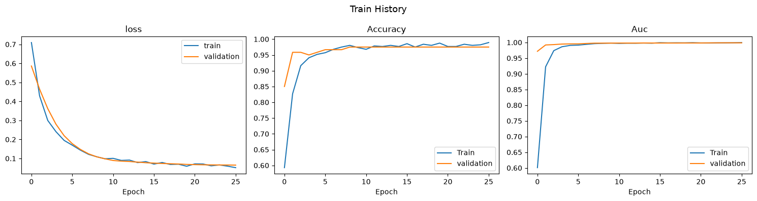
Figure 1: Training curves — training and validation lines stay close, meaning the model learned well without overfitting.

5. Key Findings
Metric | Result | Meaning
Accuracy | 85.8% | Correct for ~86 of 100 patients
ROC-AUC | 0.974 | Very strong at telling cases apart
Precision (malaria) | 0.97 | Rarely a false alarm
Recall (malaria) | 0.68 | Misses about 3 in 10 real cases
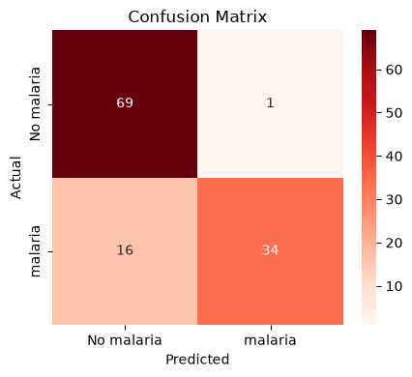
Figure 2: Confusion matrix — correct vs. incorrect predictions on the test set.

6. Evaluation
The model is strong overall (ROC-AUC 0.974) and rarely gives false alarms. Its main weakness is missing some real malaria cases, which matters in healthcare since a missed case means no treatment.

7. Challenges
- Small dataset (only 800 records) limits how well the model generalizes.
- Model misses more real malaria cases than ideal for a medical tool.
- Risk of overfitting had to be managed with dropout and early stopping.
- Uses symptoms only — not a replacement for a real lab test.

8. Conclusion
The neural network predicts malaria from symptoms with 85.8% accuracy and a strong ROC-AUC of 0.974. It is reliable at ruling out healthy patients but should be improved at catching more true cases before real-world use. With more data and tuning, it could become a helpful low-cost screening tool to prioritize patients for testing.

