THE UNIVERSITY OF BAMENDA


NATIONAL HIGHER
POLYTECHNIC INSTITUTTE
COMPUTER ENGINEERING

INDUSTRIAL PROJECT AND INTERNSHIP IN IT

An Industrial Project and Internship in IT, Submitted to the Department of Computer Engineering in the National Higher Institute Polytechnic of the University of Bamenda in Partial Fulfillment of the Requirements for the Award of a Bachelor of Engineering Degree in Computer Engineering80

BY:
BONGMOYONG GAD FOMONYUY
REGISTRATION NUMBER: UBa23PB007

SUPERVISOR(S):
MR. ANTONIO GARCIA TITUS

MARCH 2024

DEDICATION

To the Cxxxx’s Fxxxxx and The CivilSalt Initiative.

ACKNOWLEDGEMENTS
Glory is returned to God for this work which was carried out with the assistance of several people to which I address my sincere thanks here. In particular I express my acknowledgement to:
- The Director of COLTECH, Pr. MATHIAS FRU FONTEH, who did not spare any effort for the good walk of our establishment;
- The Head of department of Computer Engineering Dr JEAN PIERRE. , for the particular attention he paid to our training;
- All lecturers of the College of Technology , who contributed to our training through the different courses taught to us by them;
- My team at CivilSalt, for all their willingness and contributions for all projects and collaborations;
- My Elder brother and his wife MR/MISS NSAIDZENYUY, who supported me morally and financially throughout my training session;
- All those who directly or indirectly contributed to the success of this internship session.

TABLE OF CONTENTS
i
DEDICATION i
ACKNOWLEDGEMENTS ii
LIST OF ILLUSTRATION v
LIST OF ABBREVIATIONS vii
CHAPTER 1 1
INTRODUCTION 1
1.1 Background 1
1.2 Presentation of Host Institution 2
1.3 Location of Host Institution 6
1.4 History of Institution 6
1.5 Mission of Organization 7
1.6 Objectives 7
1.6.1 Objectives of the organization 7
1.6.2 Objectives of the intern 7
1.7 Organizational Structure of the Institution 7
1.8 Literature Review 12
CHAPTER 2 20
ACTIVITIES CARRIED OUT DURING INDUSTRIAL TRAINING AND ENTREPRENEURSHIP 20
Week 1 (3rd August 2021 – 6th August 2021) 22
Week 2 (10th August 2021 – 13th August 2021) 24
Week 3 (17th August 2021 – 20th August 2021) 26
Week 4 (24th August 2021 – 27th August 2021) 30
Week 5 (31st August 2021 – 3rd September 2021) 32
Week 6 (7th September 2021 – 10th September 2021) 34
Week 7, 8, 9 (14th September 2021 – 1st October 2021) 36
Week 10, 11, 12, 13 (5th October 2021 – 29th October 2021) 37
CHAPTER 3 40
OUTCOME OF INDUSTRIAL TRAINING 40
3.1 Difficulties Encountered 40
3.2 Solutions/Recommendations 42
3.3 Relation to Class Work 43
CONCLUSION 44
REFERENCES 45
APPENDICES 46
Annex 1: Localization of CivilSalt 46

LIST OF ILLUSTRATION
Figure 1: Organigram of the organization. 8
Table 1: Outline schedule of activities. 21
Figure 2: Use case diagram of battery saver application. 26
Figure 3: Class diagram of battery saver application. 27
Figure 4: Domain model diagram of battery saver application. 28
Figure 5: Sequence diagram of battery saver application. 29
Screenshot 1: Obfuscated polymorphic assembler. 31
Screenshot 2: Source code to be obfuscated. 32
Screenshot 3: Obfuscated source code. 32
Figure 6: Wireframe diagram of ecommerce platform. 33
Figure 7: Use case diagram of ecommerce platform. 34
Figure 8: Sequence diagram of ecommerce platform. 35
Figure 9: Class diagram of ecommerce platform. 35
Figure 10: Domain model diagram of ecommerce platform. 36
Figure 11: Class diagram of real estate platform. 38
Figure 12: Use case diagram of real estate platform. 38
Figure 13: Sequence diagram of real estate platform. 39
Figure 14: Domain model diagram of real estate platform. 39

LIST OF ABBREVIATIONS
B2B –Business to Business
B2C – Business to Customer
IOT – Internet of Things
SEO – Search Engine Optimization
CEO – Chief Executive Officer
PC – Personal Computer
PMM - Performance Monitoring Matrix
AIG – Automatic Item Generation
ISP – Internet Service Providers
WWW – World Wide Web
SQL – Structured Query Language
AIG – Automatic Item Generation
SDBMS – Spatial Database Management Systems
GIS – Geographic Information System
RPA – Robotic Process Automation
IT – Information Technology
ICT – Information Computer Technology
MVC – Model View Controller
UML – Unified Modelling Language
CRUD – Create Read Update Delete

CHAPTER 1

INTRODUCTION

Background
In recent years, the establishment of information technological infrastructures for the purpose of storing and efficiently manipulating data to produce useful information was very difficult to establish due to the XXXXXXXXXXXX maintain these facilities. However, the advancement in the era XXXXXXXXXXX of infrastructures which can perform desired tasks. This evolution has brought about the implementation of management systems in certain XXXXXXXX many more.
Internship is XXXXXXXXXXXXXXX conflicted with the concepts that the school provide according to them. This mind set XXXXXXX rejected at the end of the day due to this mind set.
However, internships can now be considered as a period where by students hunt for opportunities in XXXXXXXXXXXXXXXXXXXXXXXXXX
Consequently, the concepts which have been realised to be done in industries are quite complex which XXXXXXXXXXXXXXXXXXXanging and advancing to a more sophisticated era of XXXXXXXXXXXXX session was quite ready to be implemented with the expectation of adapting to the dynamics the organization was going to be offering.

Presentation of Host Institution
CivilSalt LLC, is a global conglomerate that consist of a network of individuals who aim at making the world a better place, by using technology to solve problems that are realized on a daily basis. Our primary objectives are based on automation to combat ergonomics and renewable energy to combat climate change. We at CivilSalt do not see ourselves as a technology company, but we rather see ourselves as a company that uses technology to solve day-to-day problems in real life situations. Our mindsets are built on the understanding that; One mind can change the world, but two can make it a better place. We base our innovation not only on the concept of doing the right thing, but on the understanding of doing the thing right differently. That’s why we say; Have the skills people need. And if you can't afford that, learn the skills people are looking for.
We offer various services which are based on a B2B (Business to Business) and B2C (Business to Customer) regulation, which are services narrowed down and categorized based on the following categories;
    - Software
Software is a set of instructions, data or programs used to operate computers and execute specific tasks. Software is a generic term used to refer to applications, scripts and programs that run on a device. It can be thought of as the variable part of a computer.
Our software solutions are based on SaaS, IaaS and PaaS matrices, which are cultivated to achieve automation within organizations and clients. We deploy on platforms like desktop, web, mobile and embedded systems.
    - Artificial Intelligence
Artificial Intelligence is the branch of computer science that deals with the making of intelligent machines. These machines have the capability of performing actions that would otherwise require human intelligence.
Artificial Intelligence as a service is outperforming humans in many ways. Artificial Intelligence is helping us achieve the automating of the tasks in businesses, industries, manufacturing sectors and many more. We integrate based on project complexity with respect to; Narrow or Weak Artificial Intelligence and Strong Artificial Intelligence.
- Narrow AI: Narrow or weak Artificial Intelligence (AI) is the phenomena in which machines are programmed to perform some specific task only. Narrow Artificial Intelligence machines are not that intelligent; as they can perform single specific task only.
- Strong AI: Strong Artificial Intelligence, on the other hand, is the phenomena in which machines are built that can actually simulate the human intelligence. These machines can adapt themselves to the environment and various types of inputs. These can react differently to different situations. Machine Learning and Deep Learning are two subcategories of Artificial Intelligence.
    - Internet
The most basic yet sophisticated form of the internet which is a heterogeneous worldwide network consisting of a large number of host computers and local area networks.
We carryout online activities by integrating other technologies such as Internet of Things (IOT) and Search Engine Optimization (SEO), and other internet services to make accessibility across the globe more effective.
    - Hardware
Hardware is the most visible part of any information system: the equipment such as computers, scanners and printers that are used to capture data, transform it and present it to the user as output.
Our hardware solutions are based on the future of renewable energy and consumer electronics. We engage in activities like; the assembling of machinery, drones and assembly lines in order to achieve automation. We integrate back up power with the use of renewable energy solutions like solar technology. This helps maintain and act as a backup system for industries to keep operating in the cause of black outs.
    - Branding
Branding is the method of researching, producing, and implementing a unique feature or set of features to your business so that customers can start to connect your brand with your services or products. Branding is a repetitive process and needs to get in touch with your customers’ feelings and business.
Reputation means a lot to us at CivilSalt, and we engage in a lot of branding with respect to our corporate standards, personal, product, online and offline, service, and co-branding with other collaborators. This is done in order to raise more brand awareness and reputation management.
    - Advertisement
A successful advertising campaign will spread the word about your products and services, attract customers and generate sales. Whether you are trying to encourage new customers to buy an existing product or launching a new service, there are many options to choose from. The most suitable advertising option for your business will depend on your target audience and what is the most cost effective way to reach as many of them as possible, and as many times as possible. The advertising option chosen should also reflect the right environment for your product or service. For example, if you know that your target market reads a particular magazine, you should advertise in that publication.
We perform advertisements which are based on inbound and outbound with a targeted and non-targeted audience category.
Our services are based on these categories, and can also reach out to other categories such as; investment, cyber security, and many others across a wide variety of disciplines.

Location of Host Institution
CivilSalt is located in Bamenda, Cameroon, at Ghana street entrance from Mile 2 Nkwen.

History of Institution
    - History and Status
CivilSalt is a limited liability company (LLC) registered and recognized by the government with respect to the relevant provisions of the OHADA Uniform Act on General Commercial Law. CivilSalt is incorporated under the Trade and Personal Property Rights Register of the Court of First Instance Bamenda, under the registration number: RC.BDA.2023B000024.
The journey to achieve an established company started in the year 2020, by Mr. Chuye Titus Ndi, who is known by title as the Founder and CEO. This was realized after a few years working underground to gain certain insights, standardization and awareness required to create a sustainable impact to humankind.
In the course of realizing a common ground for the initiative of CivilSalt being in effect today, he was anchored by his brother Mr. Chuye Njechu Emmanuel, who runs the In3rsia subsidiary side by side other initiatives, and his friends Mr. Tatou Joseph Desire and Mr. Ndangle Akondi Junior who came in as the call to serve humanity became a necessity for global impact. In the fresh entry of the year 2021, the CEO, included Mme. Bih Noella Nsoh to the initiative, and thereby making a 5-man work force to overcome humanity’s greatest worries.
Today, CivilSalt is heading towards establishing a super ocean of companies by ensuring that the services they offer are not just solutions being implemented by first world countries, but are rather solutions that involves the dignity of third world countries.

Mission of Organization
Since the establishment of CivilSalt, the focus has been on making the world a better place by utilizing technology to solve daily problems being encountered in the society for domestic purposes, and advancing towards global opportunities, by interacting in several categories of solutions in order to enhance existing technology or bring forth a new one.

    - Objectives
- Bringing solutions to daily problems.
- Utilizing technology to advance mankind to the next revolutionary era.
- Producing efficient systems which are better, faster and cheaper.
- Creating a network of determined citizens.
- Standardization and regulation for humanity’s adaptation.

Objectives of the intern
- Implement XXXXXXXXXXXXXXXXXXXXXXXXXXXXXXXXXXXXXXXXXXXXXXXXXXXXXXXXXXXXXXXXXXXXXXXXXXXperience on software and its engineering.
- Engage in problem solving skillsets and methodology.

Organizational Structure of the Institution
The hierarchical order of the organization consists of this main disclosed categories such as;
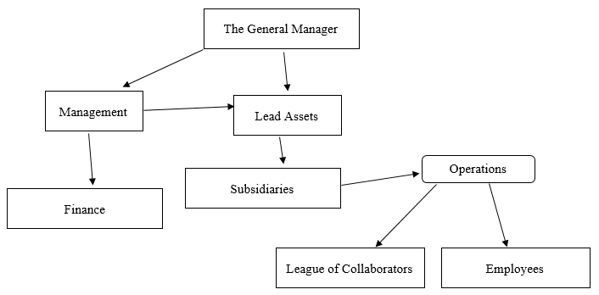

Figure 1: Organigram of the organization.

- General manager
The general manager which practically is considered as the Chief Executive Officer (CEO) in the organization is responsible for all or part of a department’s operations or the company’s operations, which includes generating revenue and controlling costs. In small companies, the general manager may be one of the top executives. In hierarchical organizations, general managers rant above most employees but below corporate-level executives. Also, the responsibility and importance associated with the position may vary among companies and often depend on the organization’s structure. However, at CivilSalt, we consider the general manager as the high ranking official considering scalability factors and public interests. The general manager is responsible for the following;
- Improve efficiency and increase profits while managing the overall operations of the company.
- Managing staff, overseeing the budget, employing marketing strategies, and many other facets of the business.
- Supervise lower-level managers.
- Sanctioning projects and deployments.

- Management
At CivilSalt, management is the lower-level ranking officials of the organization after the general manager. And they focus on almost similar roles to ensure the proper management of the organization and its subsidiaries like;
- Planning: When you think of planning in a management role, think about it as the process of choosing appropriate goals and actions to pursue and then determining what strategies to use, what actions to take, and deciding what resources are needed to achieve the goals.
- Organizing: This process of establishing worker relationships allows workers to work together to achieve their organizational goals.
- Leading: This function involves articulating a vision, energizing employees, inspiring and motivating people using vision, influence, persuasion, and effective communication skills.
- Staffing: Recruiting and selecting employees for positions within the company (within teams and departments).
- Controlling: Evaluate how well goals are being achieved, improving performance, taking actions. Put processes in place to help establish standards, in order to measure, compare, and make decisions.

- Finance
In the agency, the division of finance is aimed at drawing a financial plan and forecasting financial needs, raising necessary funds and putting funds into proper use. The functioning of this division is based on the following factors;
- Financial planning.
- Forecasting cash inflows and outflows.
- Raising funds.
- Allocation of funds.
- Effective use of funds.
- Financial control (budgetary and non-budgetary.

- Lead Asset
Lead Assets are considered as management division as some management assets can actually participate in leading products and initiatives. In other scenarios, they may not be part of the management team but are tasked with this purpose. They are responsible for the following activities;
- Technical quality of the product created for production.
- Work closely with employees to ensure that all the products are pipeline friendly, cheaper, better and faster.
- Plan and implement the asset build, props and sets for a specific product.
- Work closely with employees to implement the asset builds of production from the initiative perspective.
- Troubleshoot and provide technical support on assets for different departments of production.
- Responsible for clear lines of communication both with and between departments, and will attend meetings and address modeling comments and issues with ranking officials of the organization.
- Responsible for modeling workflow, mentoring, documentation and information dissemination.
- Quality control on all Hero and Key assets that need to be published and delivered to the consumer.

- Subsidiary
CivilSalt subsidiaries operates as a separate and distinct corporation from its parent company (CivilSalt). This benefits the company for the purposes of taxation, regulation and liability. By having a holding company, the exercise of control in company decision-making is done to ensure that they function without causing a fault to the overall production line of the initiative. They function based on the following;
- Improved production line of products and services.
- Proper organization and functioning.
- Interchange of resources for utilization.
- Facilitation of production lines and multi-tasking of similar and dissimilar projects.
- Proper decision making and standardization.
- Better operational efficiency and flexibility.

- Operations
This division manages the day to day functioning of the organization to ensure that everything is being put into place as desired by the initiative. Planning and implementing manufacturing plants.
- Managing projects.
- Planning information systems.
- Helping to design and develop products and services.
- Managing inventory through the supply chain.
- Managing delivery to customers in a timely manner.
- Optimizing quality control.
- Employees
- Provide and maintain workplaces, plant and systems of work so that they and other workers are not exposed to hazards.
- Work in the production and assembly line of products.
- Provide information about the hazards and risks from their job.
- Provide instructions, training (including an induction) and supervision so they are able to work safely.
- Offer skill sets to accomplish services and work ethics.
- Consult and co-operate with safety and health representatives and other employee categories about safety and health.
- Where it is not practicable to avoid the presence of hazards, provide adequate personal protective clothing and equipment without any cost to the projects.

- Collaborators
- Share resources and stratagems for product growth and scalability.
- Optimize communication for better infiltration to market.
- Facilitates higher retention rates.
- Acts as investment opportunities and growth revenues.
- Effective production of variable services for global consumption.

    - Human resources
As employees go about their daily routines in the organization, they are monitored by our Performance Monitoring Matrix (PMM) to ensure that they don’t fluctuate or go below production margin. This division monitors their functionalities and the activities and stress rates they encounter within and out of the organization, in order to help them perform better and become more productive at work.
This division is categorized into three factors;
- Administrative: They engage in hiring and monitoring of employees, managing payroll and benefits, and development of policies and guidelines
- Change management: Their tasks pertain to the human resource professional’s role in maintaining organizational culture, execution of any major changes as companies move forward, and assisting employees to adapt to new environment.
- People management: Takes charge of human resource personnel which can contribute to employee development, conflict resolution, and even employee motivation and engagement.

Literature Review
In organizations nowadays, they focus on a common goal of satisfying the customer by providing products and services which are better, faster and cheaper in order to gain a competitive XXXXXXXXXXXXXXXXXXXXXXXXXXXXXXXXXXXXXXXXXXXXXXXXXXXXXXXXXXXXXXXXXXXXXXXXXXXXXXXXXXXXXXXXXXXXXXXXXXXX difficulty of the items, based on the student’s performance, by querying for more or less difficult models and their associated items. In this way, the Test site could begin dynamically discover the limits of XXXXXXXXXXXXXXXXXXXXXXXXXXXXXXXXXXXXXXXXXXXXXXXXXXXXXXXXXXXXXXXXXXXXXXXXXXXXXXXXXXXXXXXXXXXXXXXXXXXXprogramming tasks and makes avoiding of understanding concepts more di-cult. Along with introduction of the on-line solution, some open questions about correctness of exercises, controlling the solutions and the whole teaching process are also discussed. This results in learning to program XXXXXXXXXXXXXXXXXXXXXXXXXXXXXXXXXXXXXXXXXXXXXXXXXXXXXXXXXXXXXXXXXXXXXXXXXXXXXXXXXXXXXXXXXXXXXXXXXXXXXXXXXXXXXXXXXXXXXXXXXXXXXe preparation of maps but also their use, and this is based on automated workflows with respect to map production. Consequently, automated map production workflows can be understood by parsing the term into its constituent words. According to Buckley and Watkins: '“Automation” is the operation or control of equipment, a process, or a system by a machine rather than by hand. “Map production” includes map compilation, or “assembling XXXXXXXXXXXXXXXXXXXXXXXXXXXXXXXXXXXXXXXXXXXXXXXXXXXXXXXXXXXXXXXXXXXXXXXXXXXXXXXXXXXXXXXXXXXXXXXXXXXXXXXXXXXXXXXXXXXXXXXXXXXXX. Spatial Database Management Systems (SDBMS) linked computer mapping capabilities with traditional database management capabilities. In these systems, identification numbers are assigned to each geographic feature, such as a timber harvest unit or wildlife management parcel. For example, a user is able to point to any location on a map and instantly retrieve information about that location. Alternatively, a user can specify a set of conditions, such as a specific vegetation and soil combination, and all locations meeting the criteria of the geographic search are displayed as a map (Berry). There is, as yet, no completely automated process for making maps. However, a great deal of progress in the XXXXXXXXXXXXXXXXXXXXXXXXXXXXXXXXXXXXXXXXXXXXXXXXXXXXXXXXXXXXXXXXXXXXXXXXXXXXXXXXXXXXXXXXXXXXXXXXXXXXXXXXXXXXXXXXXXXXXXXXXXXXXXXXXXXXXXXXXXXXXXXXXXXXXXXXXXXXXXXXXXXXXXXXXXXXXXXmanufacturing automation solution in place, you can see increased productivity, improved worked safety and satisfaction, and a better bottom line.
Today’s fast and flexible
Our expectation at the organization is based on leveraging technology to help solve society’s most advanced and pressing problems that become sophisticated over the years. We implement technological and automated processes to perform these tasks better as man can become exhausted due to ergonomic concerns and injuries sustained from tedious tasks. Also, with this understanding, we narrow our understanding to simplify the complexities of systems so they can easily be understood by the average mind in the society.

CHAPTER 2

ACTIVITIES CARRIED OUT DURING INTERNSHIP

For the activities carried out during the internship we used the; .Net XXXXXXXX, entity framework, C# programming language, Java programming language, HTML, CSS, visual studio IDE, Android Studio IDE and other tools as need aroused. Also, we used starUML software for various implementation of models.

Outline Schedule of Activities

Table 1: Work/Activities scheduled during internship program.
WEEK | ACTIVITY
Week 1  22nd February 2024  To  1st March 2024 | - Orientation of carrier paths  - Installations of IDEs software programming tools.  - Learning fundamental and basic concepts in visual studio.  - Using visual studio to build desktop applications such as calculator, phone book.
Week 2  4th March 2024  To  8th March 2024 | - Introduction into SQL and building Database system.  - Introduction to UML (Unified Modeling Language) Diagrams and Types.  - Using Star UML to do the analysis of UML diagrams.
Week 3  16th August 2022  To  19th August 2022 | - Introduction to web developement and Web Design.  - XXXXXXXXto Mobile Development.  - Guidance on XXXXXXXXand Template XXXXXXXX.  - More XXXXXXXXon XXXXXXXXapplications.  - Building a XXXXXXXXAndroid XXXXXXXXusing android studio.
Week 4  23rd August 2022  To  26th August 2022 | - Introduction to web XXXXXXXXand Web XXXXXXXX.  - Introduction to XXXXXXXXApplications.  - Tutorials on XXXXXXXXa simple Android application.  - Tutorials on Web XXXXXXXX.  - More XXXXXXXXon Android XXXXXXXX.  - Guidance on Scaffolding and XXXXXXXXintegration.
Week 5  30th August 2022  To  2nd August 2022 | - XXXXXXXXa XXXXXXXXAndroid XXXXXXXXXXXXXXXXstudio.  - Project XXXXXXXX; XXXXXXXXthe CivilSalt companion application.

Detail on Work Done Properly

Week 1 (2nd August 2022 – 5th August 2022)
The internship started with a general welcome and orientation given by the company’s CEO (Mr. Titus Ndi). We (the interns) were oriented on the various skill sets that we will be learning throughout the internship program. The skill sets were Software Engineering, Computer Network Engineering, Embedded Systems Engineering Cybersecurity and Digital marking. This was said to take place in three phases where, we started with Embedded systems where we to learn how to build applications like a calculator and a phone book. The second phase is to involve software engineering and here, we are to learn front end and back end development and also how to secure websites being built. There was introduction of the various staffs and hierarchies and we also did self introductions. Their working days and hours (Tuesday to Friday, 8:00am to 4:00pm) with a break time from 12noon to 1pm, the program started immediately after the orientation where we were given the setup for the IDE's we would be using (Visual Studio 2013, SQL Server 2014, SQL Management Studio, .net framework) which we installed and used it in programming carrying certain operations like how to create a desktop application using VS (Visual Studio), How to handle events (e.g., click events in the application), how to create a database in SQL server using SQL management, creating a calculator which could perform some operations (addition, subtraction, multiplication, division and factorial of a number) with CRUD operations (screenshot 2) using visual studio IDE, SQL server, and the C# programming language.
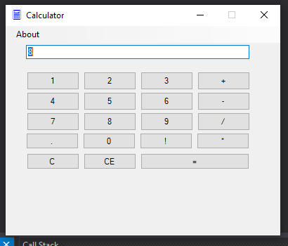
Screenshot 1: Simple Calculator Desktop application.

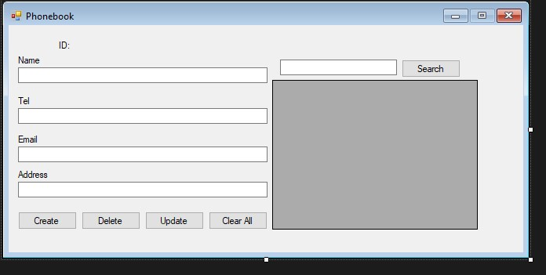

Screenshot 2: Phone book application

Week 2 (9th August 2022– 12th August 2022)
Week 2 began with final touches on Desktop applications which were the calculator and the phone book applications. We also had a session on UML and the various types and also how to represent UML diagrams using star UML software application. I further analyzed an online library management system using various UML diagram types and how the various actors interact with each other.
We covered the various model like Use Case diagram, Object Diagram, Class diagram, Sequential Diagrams and many others. I further used the knowledge of the various diagram models to analyse an online library management system. Here are the various diagrammatic representations of the various diagrammatic models.
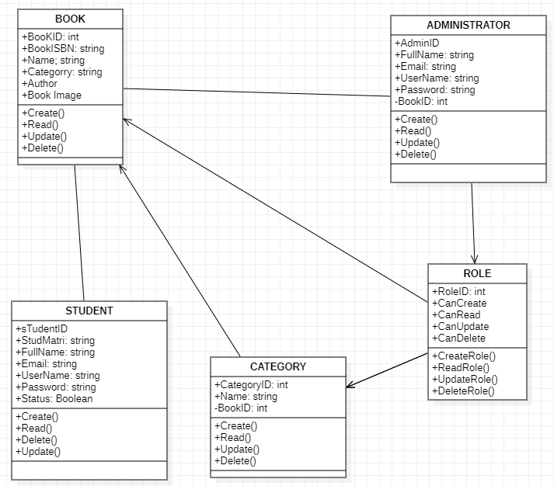
Screenshot 1: Class diagram
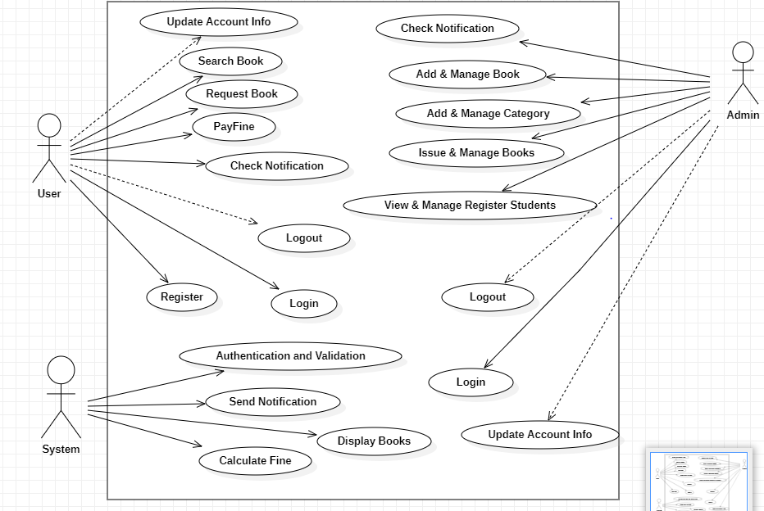
Screenshot 1: Use Case Diagram

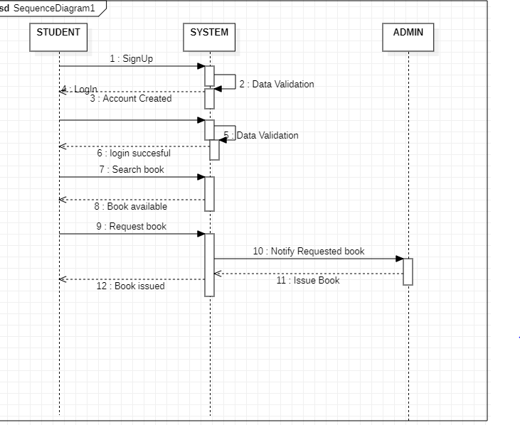
Screenshot 1: Sequential Diagram
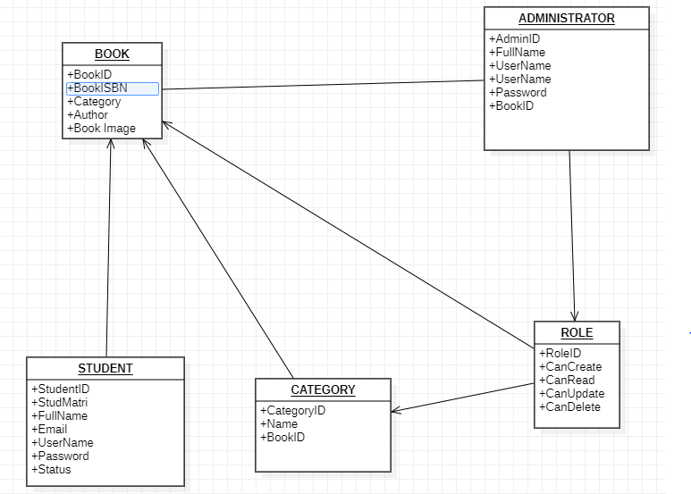
Screenshot 1: Object Diagram

