REPUBLIC OF CAMEROON
Peace-Work-Fatherland
REPUBLIQUE DU CAMEROUN
Paix-Travail-Patrie




THE UNIVERSITY OF BAMENDA
UNIVERSITE DE BAMENDA

COURSE TITLE: INFORMATION SYSTEM
COURSE CODE: CENP2205

INFORMATION SYSTEM ASSIGNMENT

BY:
BONGMOYONG GAD FOMONYUY
REGISTRATION NUMBER: UBa23PB007
ACADEMIC YEAR: 2023/2024
INFORMATION SYSTEM ASSIGNMENT
Exercise 1
- In the context of the school mentioned, the elements that are part of different systems are as follows:

a) The piloting system:
- School council: The assembly of the school council, chaired by the principal, determines the dates that define the beginning and end of each term of the school year. They play a crucial role in setting the academic calendar and making important decisions related to the school's operation.

b) The information system:
- Registration file: Students submit a registration file that contains their personal information, academic records, and other relevant details. This file is studied by the school administration to evaluate and process the student's registration.
- Mail system: The school uses a mail system to send confirmation and validation notifications to students after their registration is approved.
- Progress records (report cards): Teachers fill out end-of-term progress records that contain students' academic performance and evaluations. These records are a part of the information system used for tracking students' progress.
- Absences records: Teachers establish records of student absences and forward them to the admission service. These records are part of the information system used for monitoring attendance.

c) The operating system:
- Class councils: The principal schedules class councils for each term. Teachers are required to submit the progress records three days before the class council meetings. The class council is responsible for discussing students' progress, identifying any issues, and making decisions accordingly. The class council is an important component of the operating system for managing the school's academic processes.

2. External actors to the organization of the school can include:
- Students: The primary beneficiaries of the school's services and education system.
- Parents or guardians: They play a vital role in the registration process, receiving report cards, and confirming their child's chosen future course of study.
- School district or educational authorities: They provide oversight and guidance to the school and may set policies and regulations that the school must adhere to.
- Government agencies: They may have regulatory authority over the school and can influence policies and funding.
- Community: The local community may have an interest in the school's activities and can provide support through volunteering, donations, or participation in school events.
- External service providers: These can include vendors who provide services to the school, such as transportation, catering, or maintenance.
- Higher education institutions: Universities or colleges may interact with the school for activities like college fairs, admissions, or educational partnerships.

Exercise 2
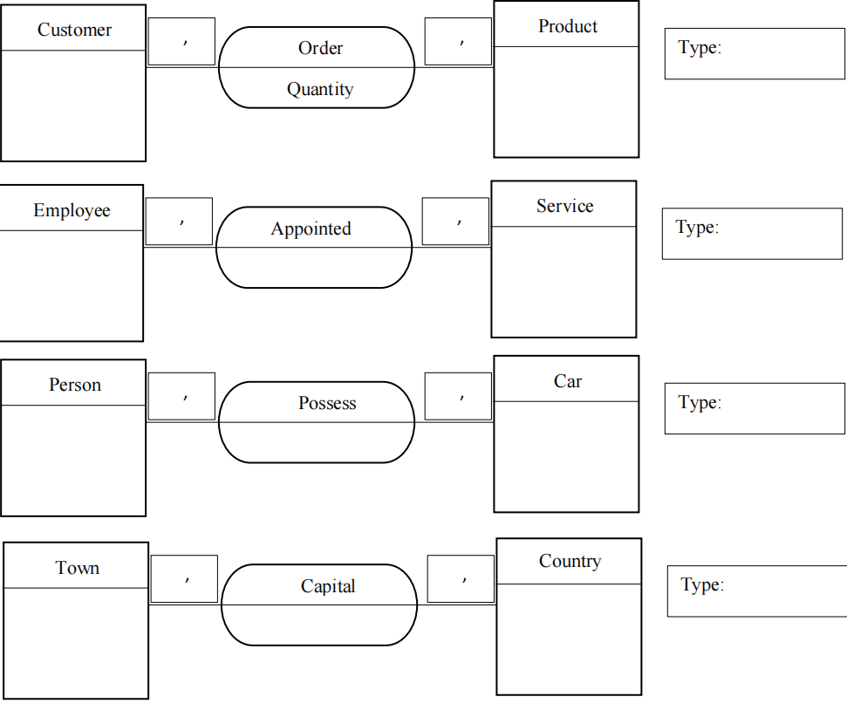
1:1
1:1
0:1
1:N
0:1
1:1
One is to one
One is to many
One is to One
One is to many
1:N
0:1

Exercise 3
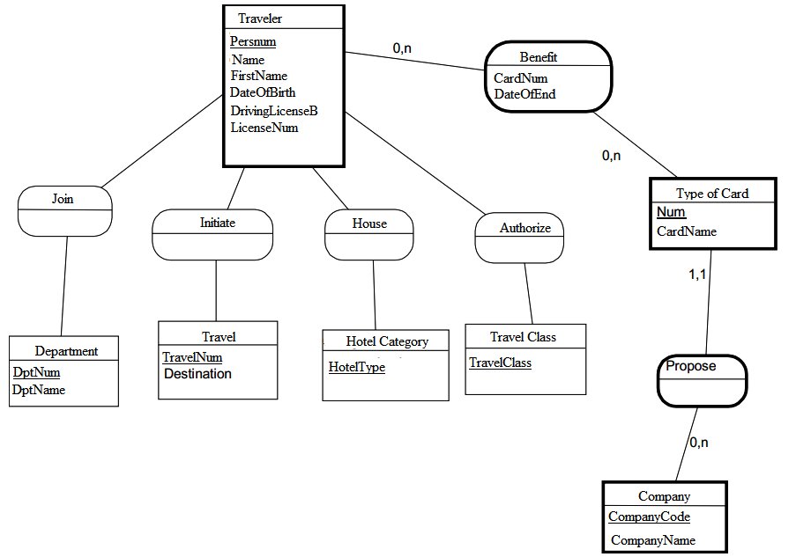
1,1
1,1
1,1
1,1
0,1
0,1
0,1
0,1

Exercise4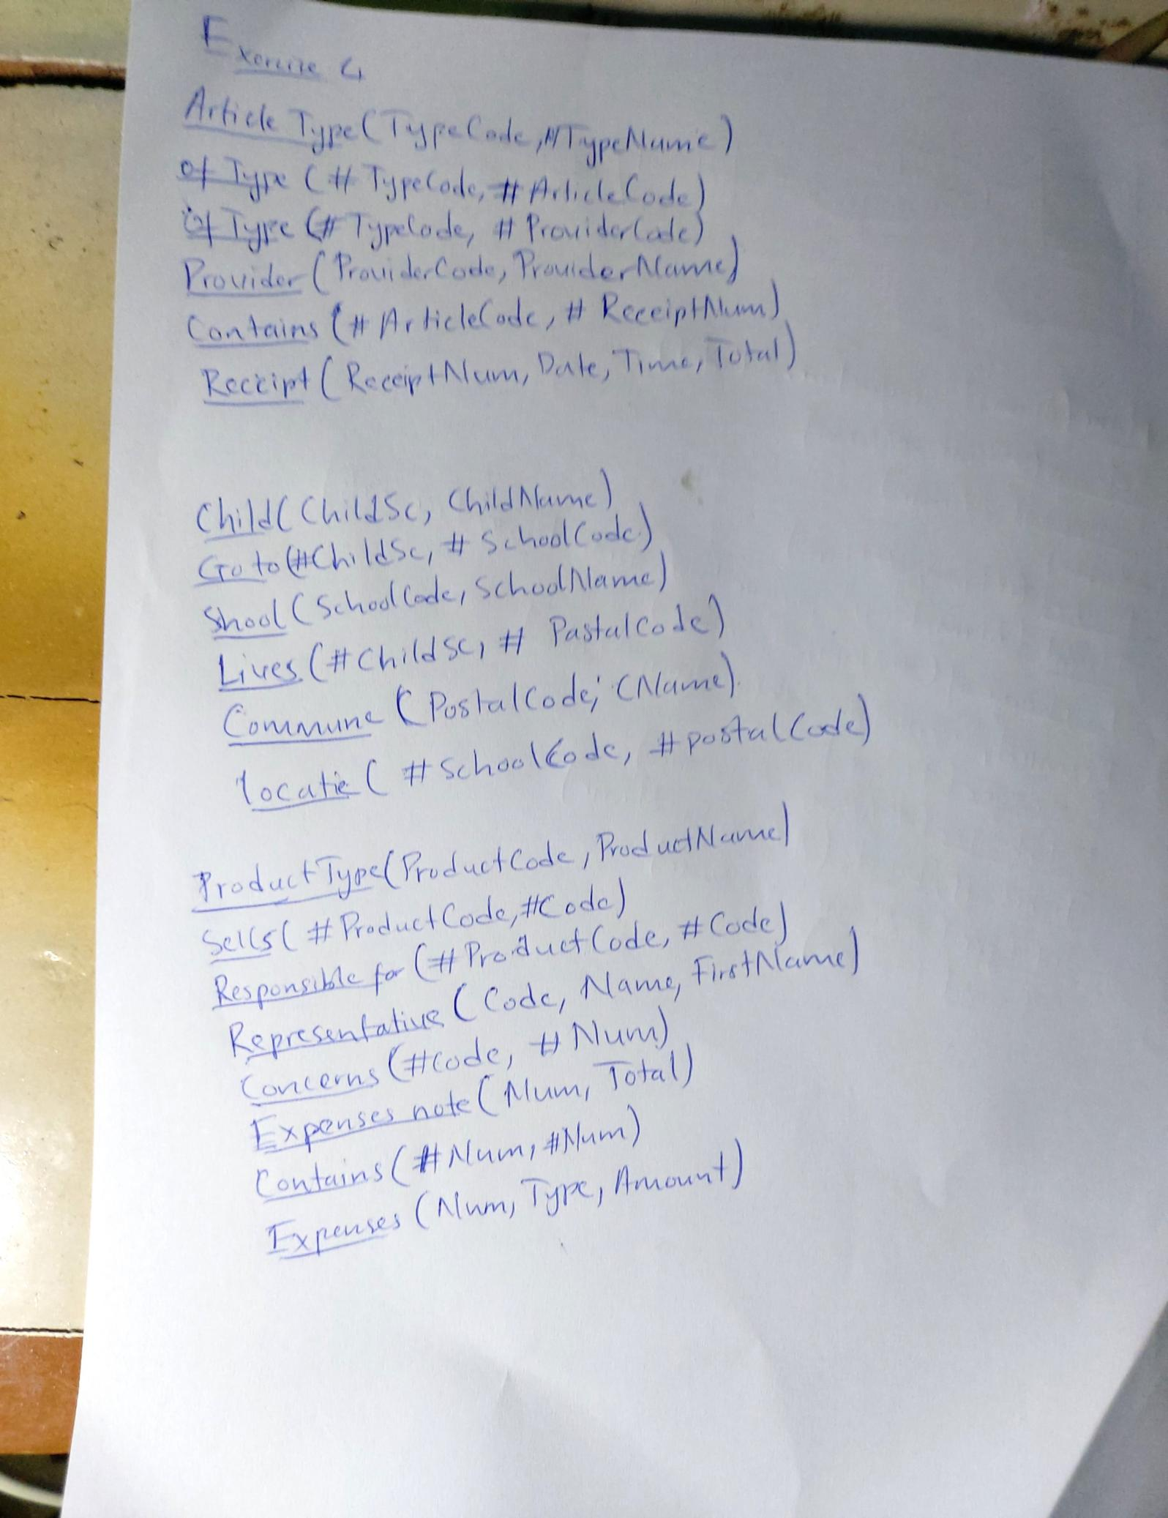

Exercise 5
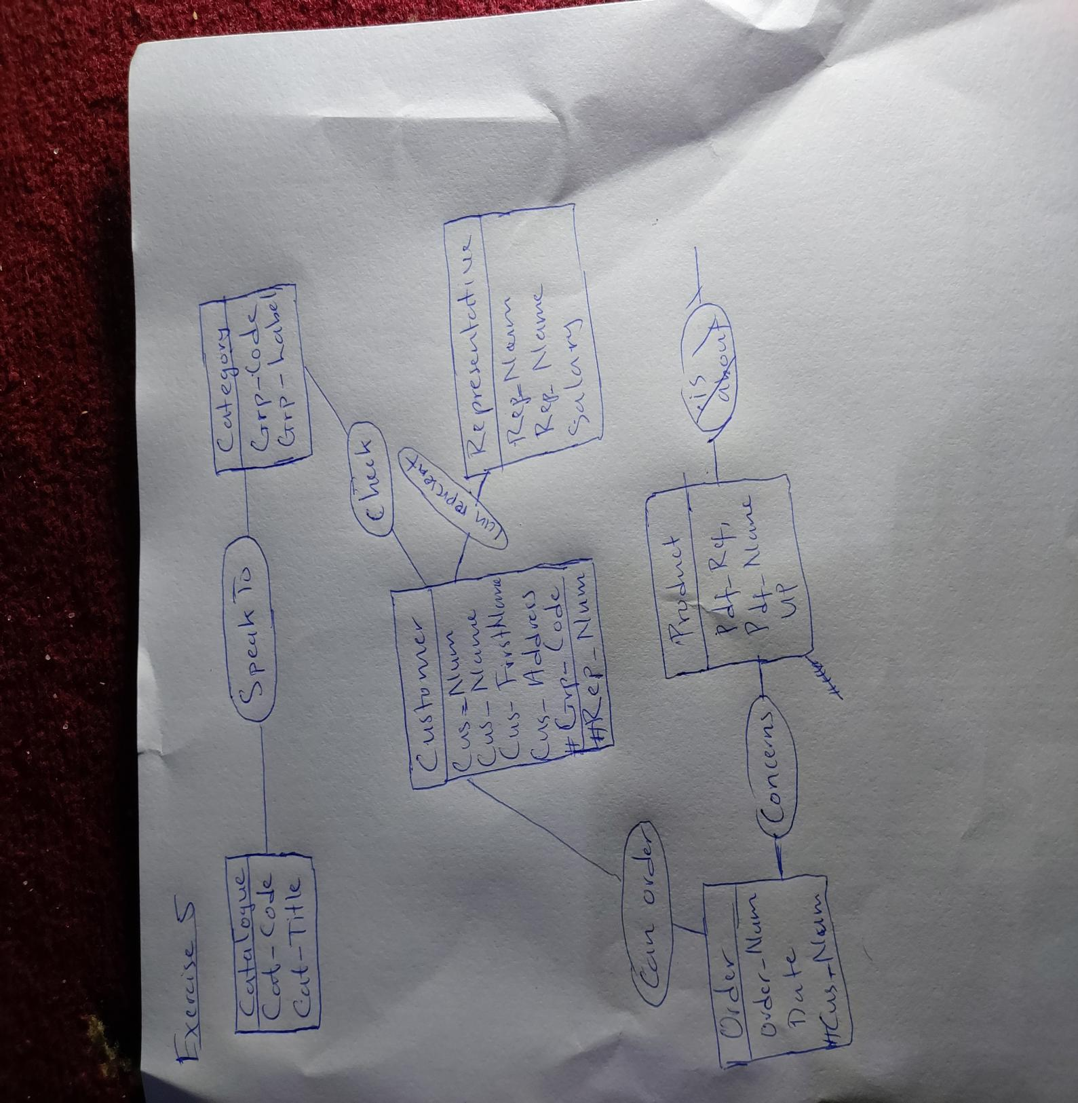

Exercise 6
- Information System of HandyBus:
- Components: The HandyBus system comprises buses equipped for individuals with reduced mobility, a reservation system accessible via a toll-free number, predefined transport zones, and schedules based on user reservations.
- Functions: Its purpose is to facilitate transportation for elderly and disabled individuals within Bamenda by providing door-to-door service, managing reservations, calculating routes, and ensuring accessibility.
- Objectives: The system aims to offer convenient and accessible transportation tailored to the specific needs and preferences of elderly and disabled individuals in Bamenda.

- Actors in Reservation Process:
- Internal Actors: Staff members from the council responsible for managing reservations, drivers, and potentially maintenance personnel.
- External Actors: Users who reserve seats, individuals requesting new bus stops, and possibly third-party service providers for maintenance or technological support.

- Trigger Event:
- The trigger event for initiating the reservation process occurs when a user contacts the toll-free number to reserve a seat on the HandyBus for the following day.

- Tasks in First Activity of Process:
- Assigning the requested seat to the user.
- Recording reservation details, including the user's name, pick-up location, drop-off location, and time.
- Adjusting the route and schedule based on the new reservation.

- Activities Carried out by the Council:
- Managing reservations and scheduling routes.
- Maintaining and servicing HandyBus vehicles.
- Collecting transportation fees.
- Planning and implementing expansions or enhancements to the HandyBus service.

- Nature of Second Trigger Event:
- The second trigger event could be an upsurge in demand, particularly on market days, prompting the council to consider adding a second HandyBus to meet the increased need.

- Repetition Frequency and Nature of Process:
- Activities such as managing reservations and scheduling routes occur on a daily basis, with adjustments made as necessary based on user demand. The process is iterative and responsive to user needs, indicating that it is an ongoing operational process.

- Beneficiaries of Circuit Planning:
- The beneficiaries include elderly and disabled individuals who depend on the HandyBus service, as well as other residents who benefit from reduced congestion or improved accessibility within the town.

- Establishing Circuits Not Possible:
- This occurs when the driver cannot physically be present in two different quarters simultaneously to pick up users at the same time. To address this issue, the council could explore options such as optimizing routes, adjusting schedules, or hiring additional drivers.

- Benefits of Online Reservation:
- For the Council: Online reservations can streamline the reservation process, alleviate the workload of call center staff, and provide valuable data for route planning purposes.
- For Users: Online reservation offers convenience, potentially faster response times, and 24/7 accessibility. However, it may not entirely replace the toll-free number option, as some users may prefer phone reservations due to accessibility limitations or lack of internet access.

Exercise 7
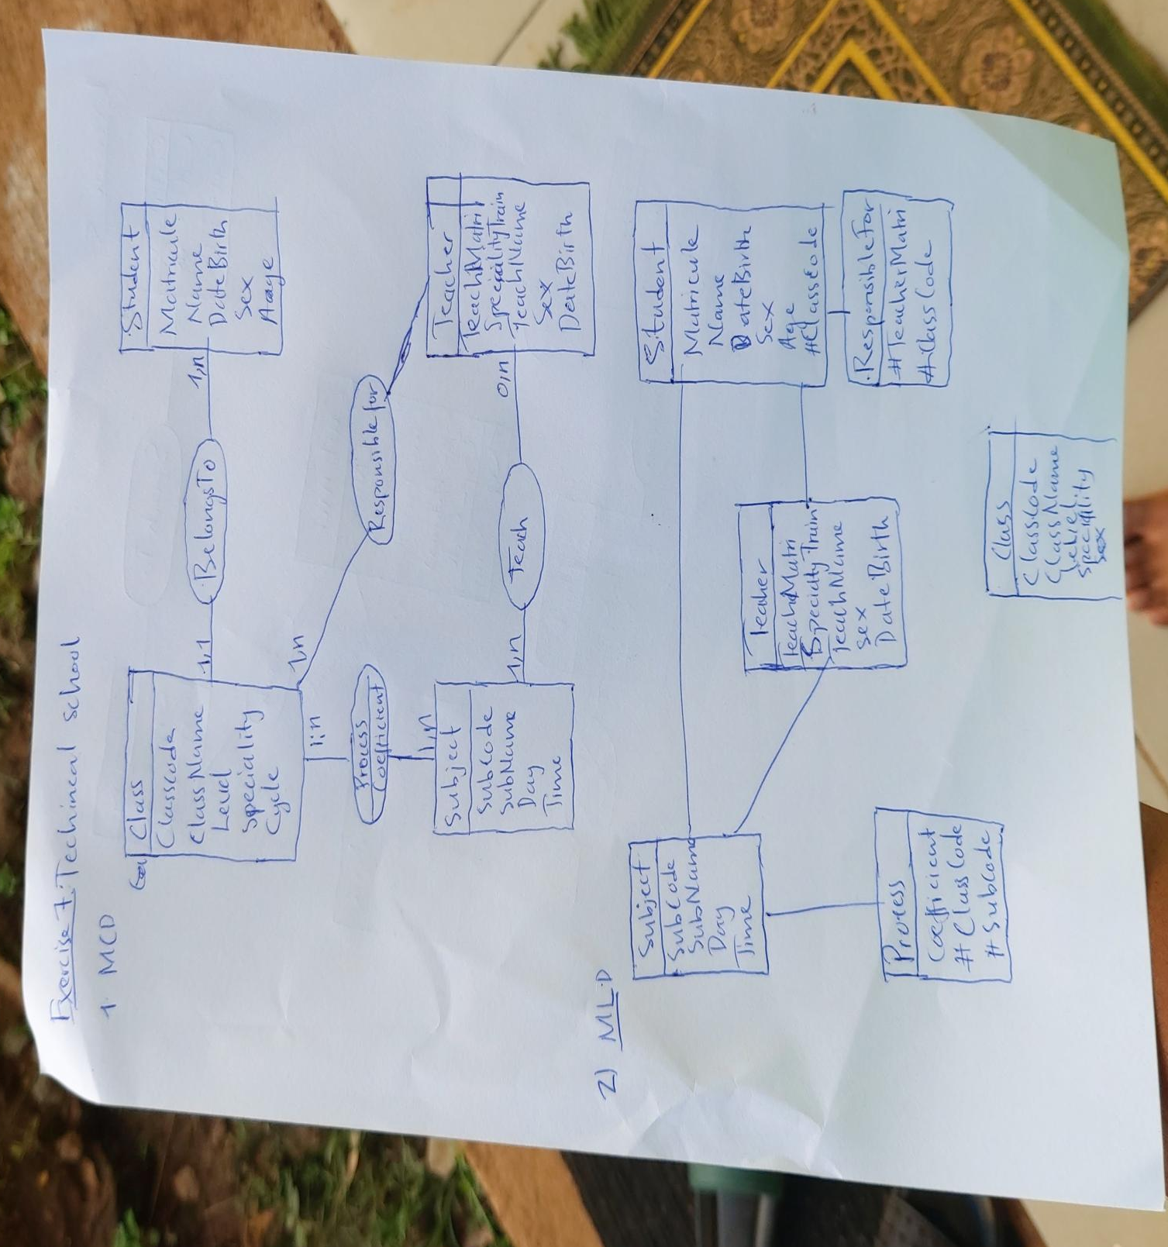

Relational Schema(model)

Subject(SubCode,SubName,Day,Time)
Teacher(TeachMatri,SpecialityTrain,TeachName,Sex,DateBirth)
Class(ClassCode,ClassName,Level,Speciality,Cycle,#TeachMatri)
Student(Matricule,Name,DateBirth,Sex,Age,#ClassCode)
ResponsibleFor(#TeacherMatri,#ClassCode)
Process(Cofficient, #ClassCode,#SubCode)

