**Buying the best meal prep containers for the kitchen**

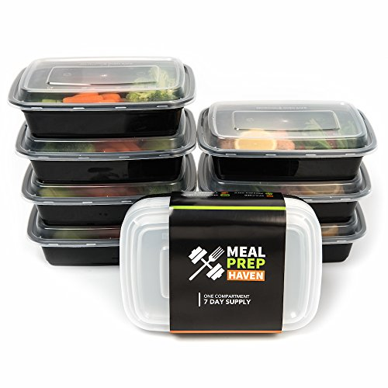

Food containers are as important as kitchen knives in a kitchen because they help when preparing foods, heating food and storing. When you purchase meal prep containers of the best quality, then you do not have to stack your kitchen with different containers for storage, another set for heating and others for preparing meals.

At the most affordable price, you get the best quality multiple use meal prep containers. These containers are safe to use with your dishwasher. Meal prep containers come in stackable sets. You are easily able to separate the foods that you want to put in your containers.

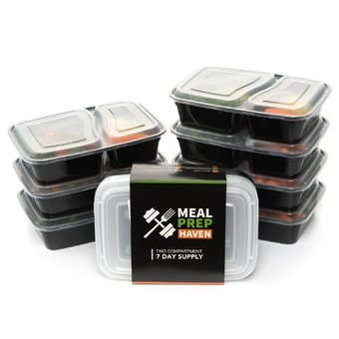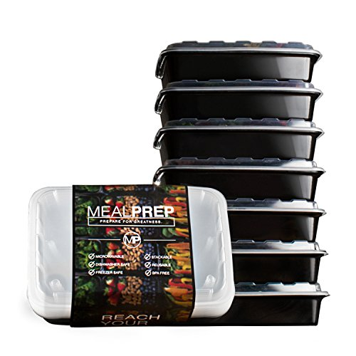

You can use meal prep containers to pack lunches and use different containers for lunch and another for fruits. You will not eat your food cold because they are microwaveable and very easy to carry around. Meal prep containers also have the extra advantage of helping you place foods into portions. This helps you be able to fit all your leftover food in your fridge.

Meal prep containers portions also help you be able to regulate your intake especially when you are exercising and on a diet. You can make the right amount for each portion and be able to stick to your diet. This will help you keep healthy and also help parents be able to give the right portions to their children.

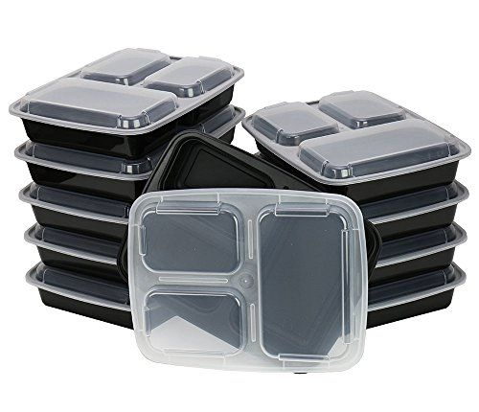 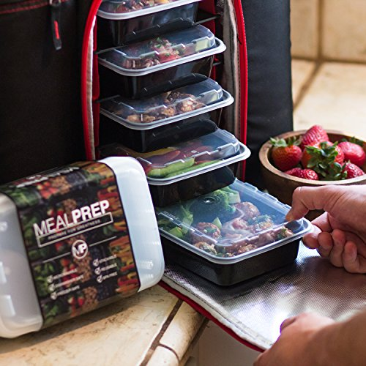

Anyone who has used meal prep containers before knows all their advantages. All these advantages come at a price that does not sweat you. You can easily find these containers on amazon. Ensure you get these containers if you do not have them yet. They will help you with organizing your refrigerator too.

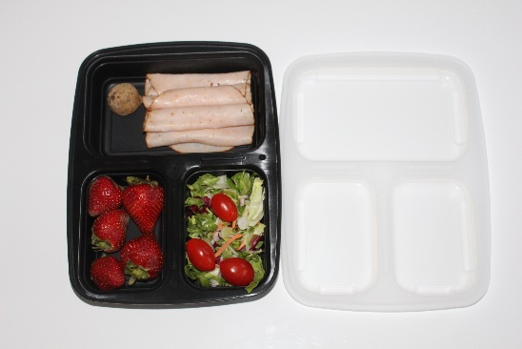 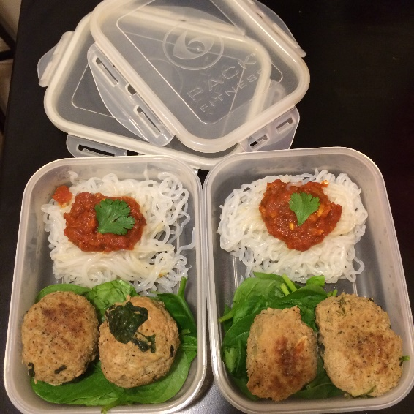

The kind of plastic that is used with the meal prep containers is BPA free meaning that it does not cause any harm to your health when you heat or store food in them. This makes them a very sought after brand of food containers. When you buy any other type of containers, ensure that you get enough information on them so that they give you the best service and you are able to choose what will serve you better.

