**Choosing the best from Affordable pressure cookers**

A pressure cooker makes cooking so much easier and allows for your foods to slow cook at the right pace and temperature. Your foods will cook faster than when using other cookware. There are many different pressure cookers from different manufacturers all with different features and pricing.

**Power pressure cooker**

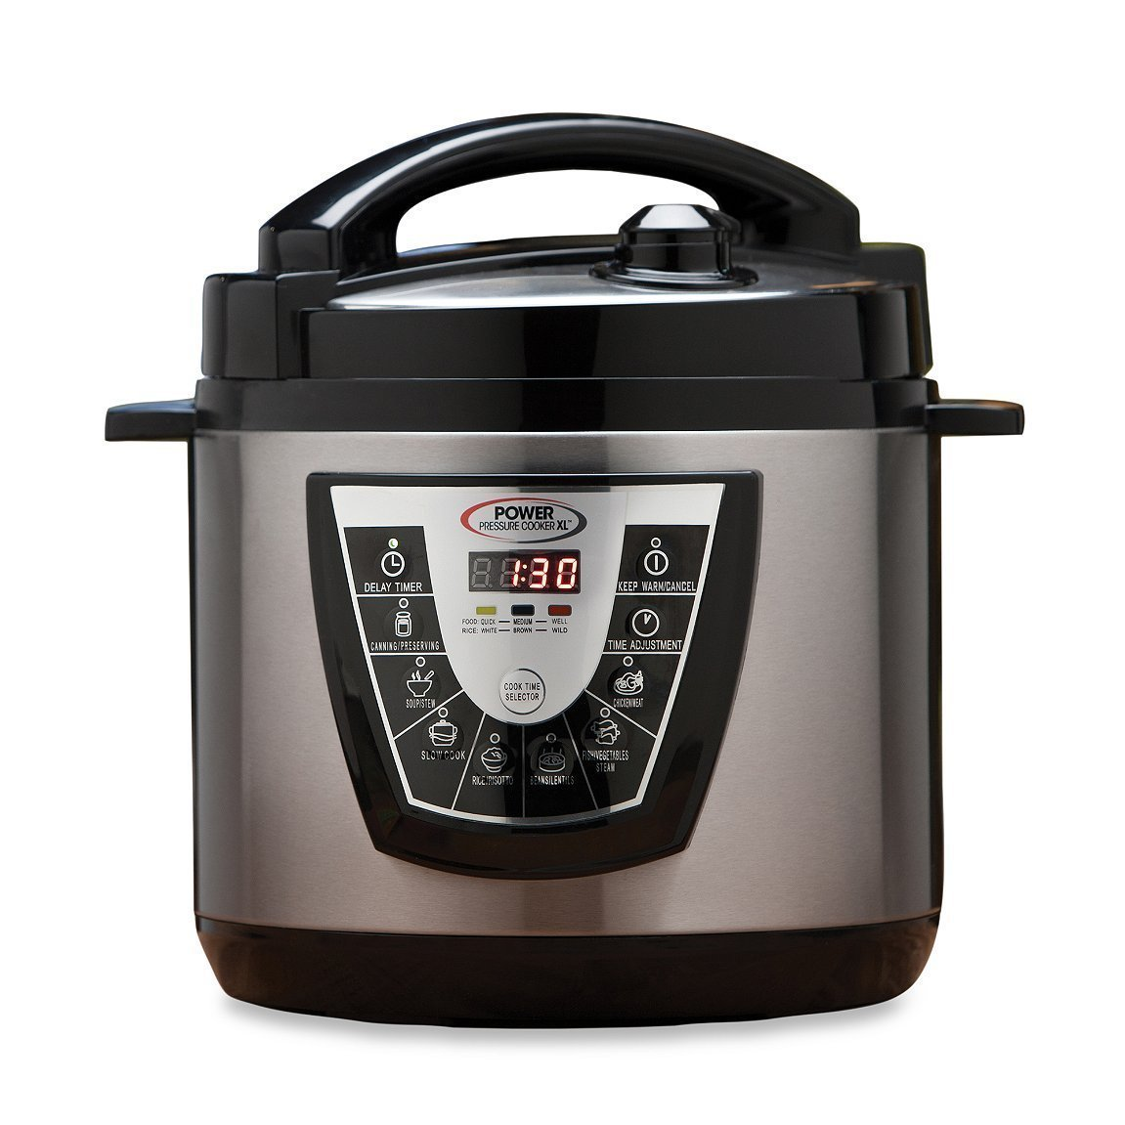

Power pressure cookers are popular. They trap all the steam inside and speed up cooking. They are a fairly affordable pressure cooker at Amazon. It has a digital display panel that is very easy to use, and you can also set it to slow cook as required by the recipe.

Besides comparing the prices of this affordable pressure cookers, compare their different features to be able to choose the one that serves all your needs.

**Hohm pressure cooker**

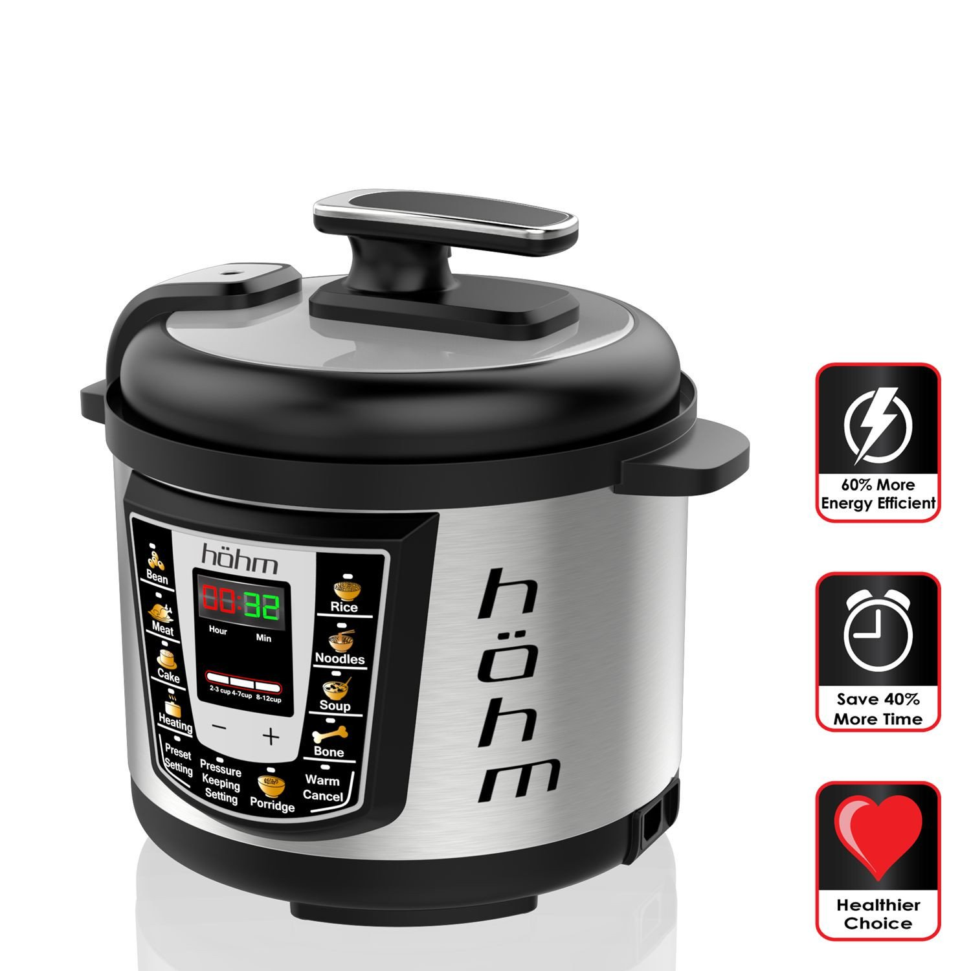

This electric Hohm pressure cooker is not only used as a pressure cooker it brings along six more important features including steamer, rice cooker, warmer, browning and slow cooker. Hohm pressure cookers are large and can easily cook enough food for a large family. It also has an added feature of 24-hour warmer that will keep your food warm for 24 hours

**Instant Pot**

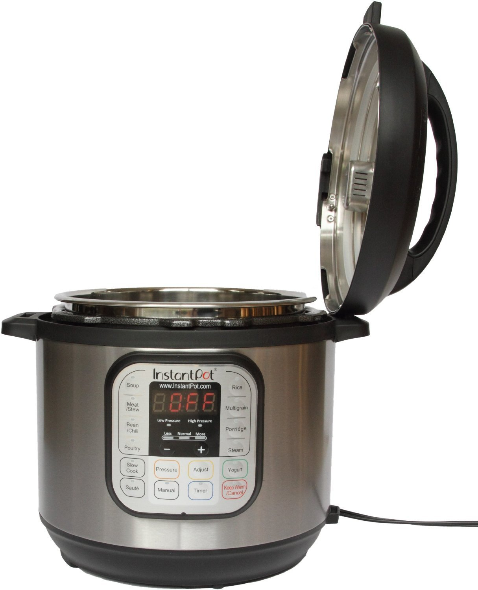

Instant pot is a reliable cooker that is safe that will serve as a pressure cooker, slow cooker, yogurt maker, steamer, and warmer. It is easy to operate to get the setting that you require and has a range of settings that you can choose from. Instant pot is a durable cooker that is also very energy efficient.

**Cuisinart**

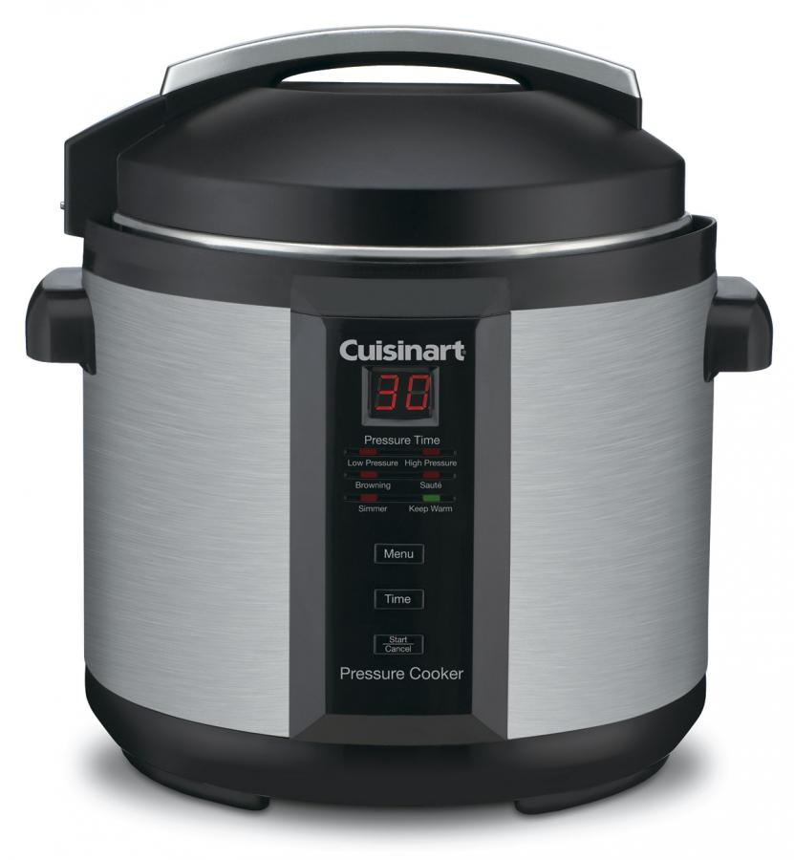

The Cuisinart cooker is large and has side handles for easy handling. It has a nonstick pot that you can use with your dishwasher. This very advanced cooker has a LED display countdown and is readily available for purchase on Amazon.

**Midea MY-CS6004W Electric Pressure Cooker**

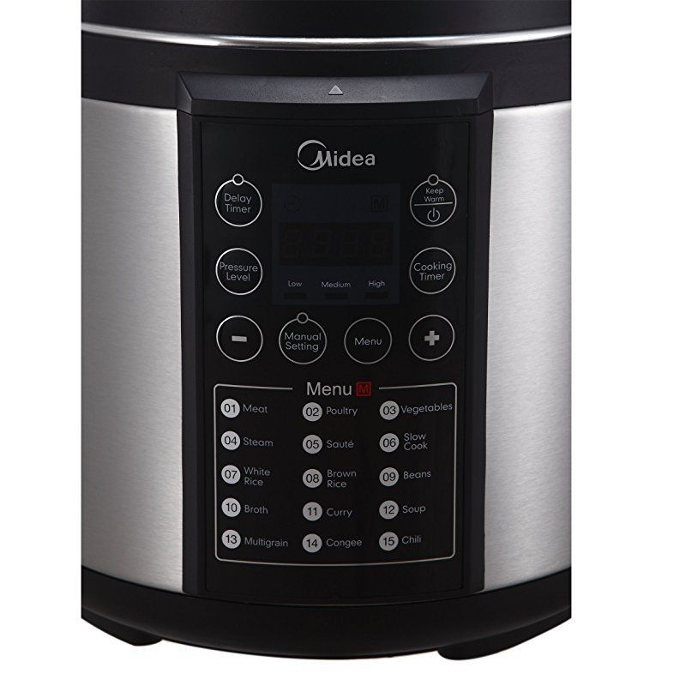

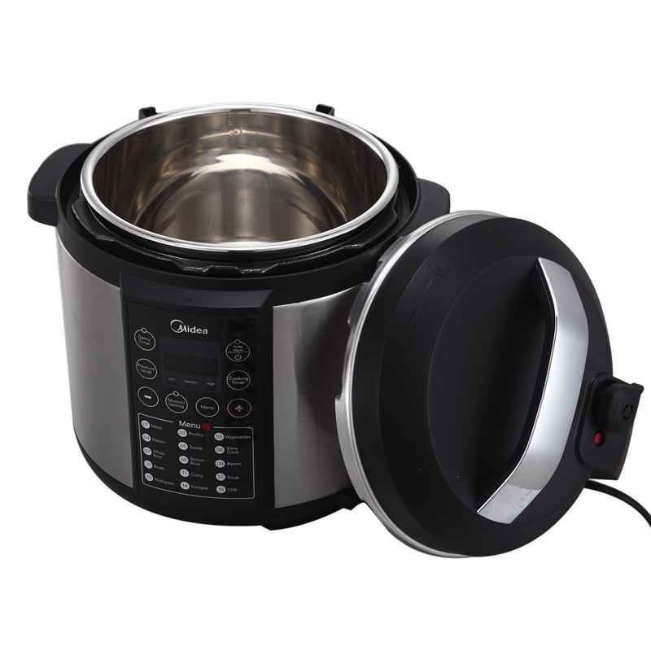

Midea pressure cooker is a large six liters cooker. It is the easiest to operate as it is fully automatic and also has a 24 hour warmer setting. Enjoy up to 15 cooking programs with this pressure cooker ranging from poultry, soup, curry, sauté, broth, vegetables among many others.