**How repel lemon eucalyptus works for you**

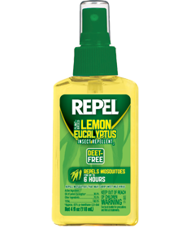

You no longer have to put up with annoying mosquitoes that rule your house in the night when you have the repel lemon eucalyptus. This is an exceptional repellant that has bugs scattering and leaving your home. This repellant kills mosquitoes fast and protects your family from mosquito bites.

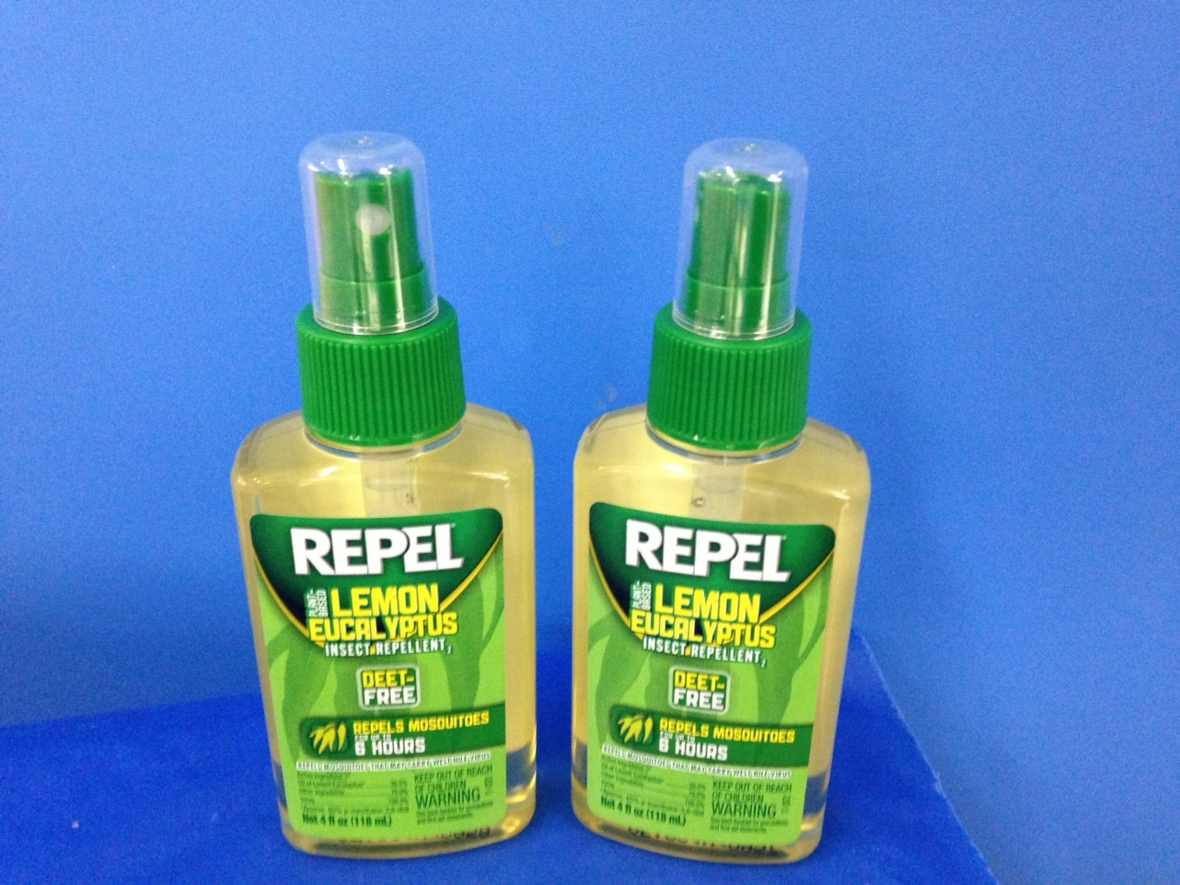

Mosquitoes are the cause of malaria which is a dangerous disease when not properly treated. You can protect yourself and your family from this disease by eradicating all mosquitoes from your home. One can of repel lemon eucalyptus will give you a long time of protection, peaceful night’s sleep at an affordable price.

**What it is made of**



The main ingredient that is active in the repellant is extracted from eucalyptus leaves and added to lemon. This repellant contains oil of lemon eucalyptus. It is a plant-based repellant that is a natural product. It does not damage your skin or gear on contact as it is made from natural products and especially for mosquitoes.

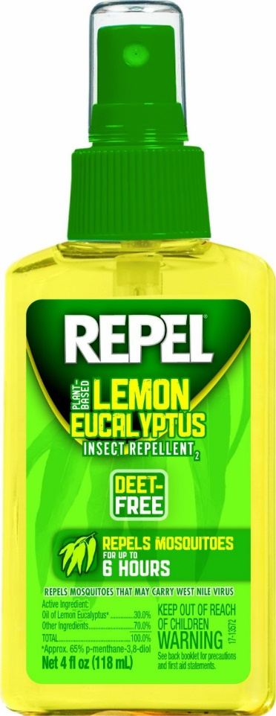

The repel lemon eucalyptus will also help you to eradicate deer ticks in your home. One application lasts up to six hours after which you need to apply again to prevent the mosquitoes and bugs from coming back in to your home. Lemon eucalyptus will repel mosquitoes that carry the Nile west virus.

**How it works**

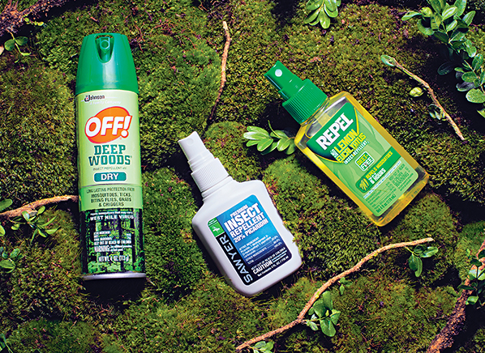Repel lemon eucalyptus works very effectively to repel mosquitoes and bugs in a matter of minutes. It is made with a strong scent that is anti-mosquitoes. Once the repellant is released into the air, mosquitoes cannot survive in the strength of the scent and the repelling ingredient in the lemon eucalyptus.

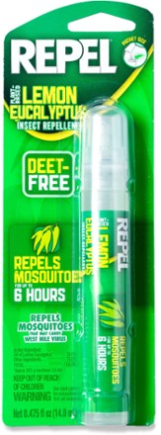

You need to apply this repellant to all exposed skin and clothing twice every day. Use your hands to apply the repellant on your skin and clothes and do not directly spray it on yourself. Do not use this repellant more than twice a day.

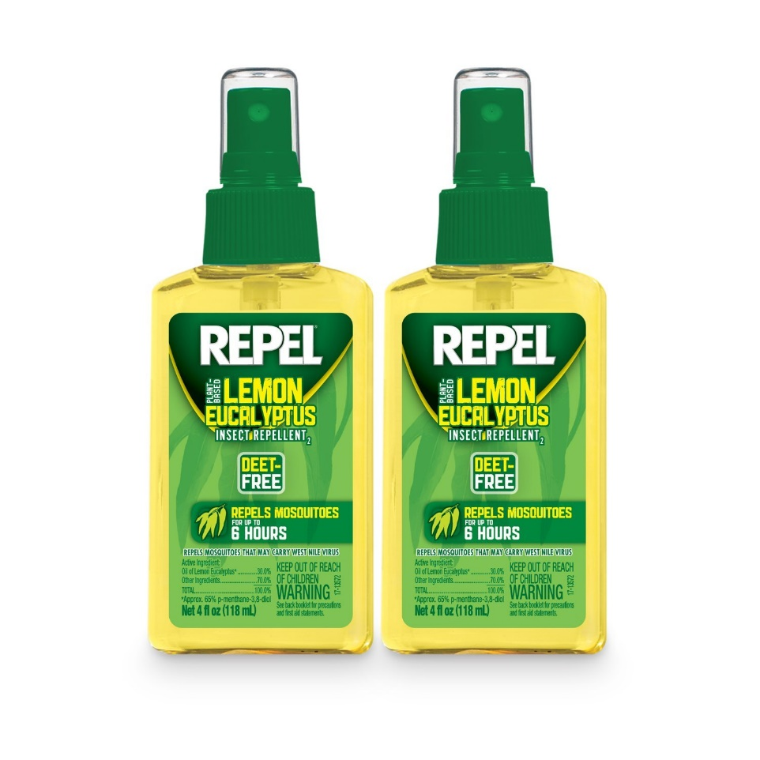

Repel lemon eucalyptus causes temporary harm to your eyes when you spray into your eyes. It is important to ensure that you do not swallow. If you do, visit a doctor immediately. Ensure that before you use this product, you have read all the instructions and then follow this instructions to the letter.

