**How to use Johnson baby creamy oil**

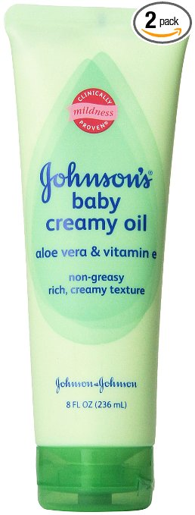

Children are adorable, and that adorableness needs to be maintained. Baby skin is delicate and cannot be used with any chemicals. It is important that you pick out the best baby products that give your baby a natural glow. Natural baby care products are the most suited products to use in this case.

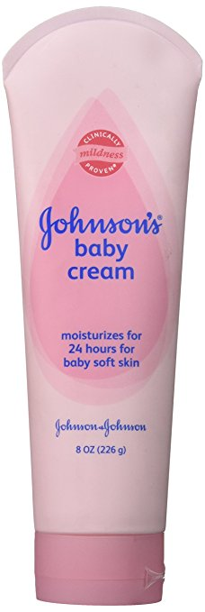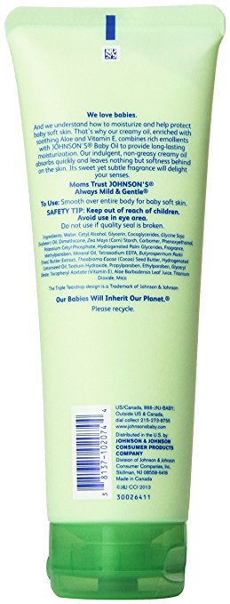

Johnson baby cream oil is a natural baby care oil that is made specially to take care of baby skin, keep it moisturized and nourished. Johnsons is dedicated to creating products that will absorb into the skin and leave the skin smooth.

**What Johnson’s cream oil is made of?**

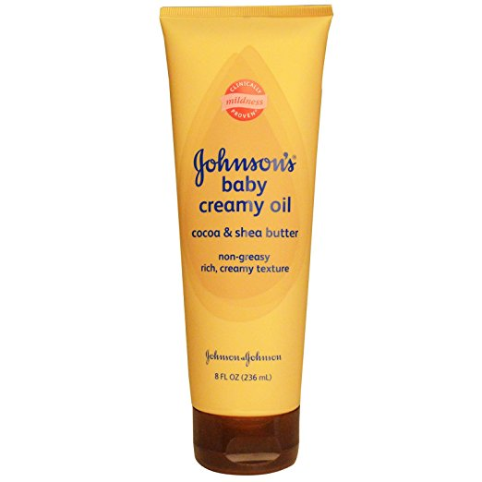

Besides being great for baby skin, Johnson’s baby cream oil is enriched with Aloe Vera for extra skin care and vitamin E. it has a sweet scent that is mild enough so that it does not affect the baby. It is made to be gentle on the baby’s skin and make the skin creamy.

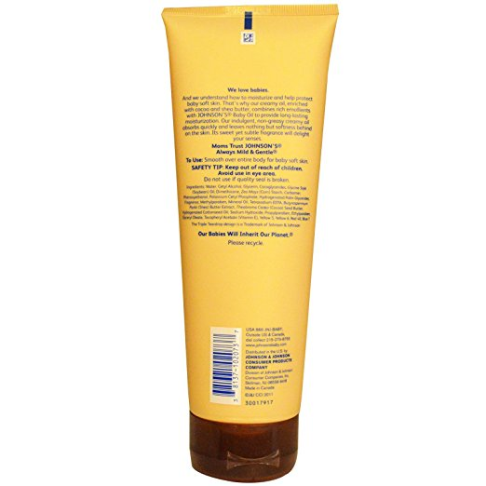

You can choose from a wide range of products that you want for your baby skin like Aloe Vera, Cocoa, and Shea butter and sweet baby rose all of which also have the added magic touch of vitamin E for your baby’s skin nourishment.

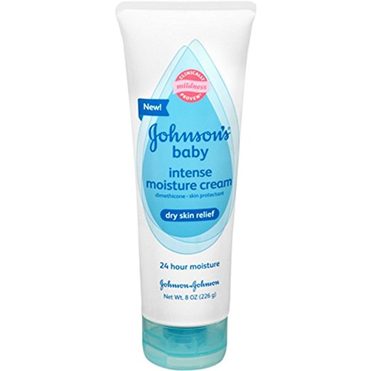

Natural herbs are what Johnson’s baby creamy oil is gotten out of. Mothers all over the world have seen the result in using this cream on their babies. With every bottle comes a bouncy baby with rich, soft and nourished skin from the herbs in the oil

**How to use the baby creamy oil**

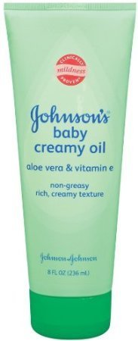

Johnson’s baby creamy oil is very easy to use as you just need to apply it on your baby’s skin after you have bathed them. This oil is both a moisturizer and a nourishing oil and will immediately be absorbed in the body and leave behind soft smooth skin.

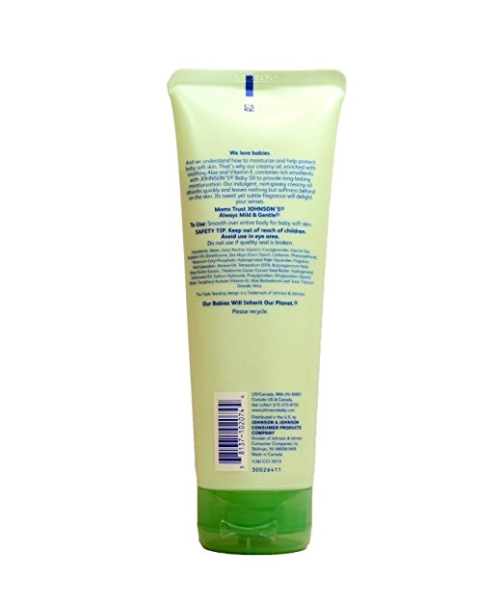

You can use the oil as many times as you please because the oil has no side effects or health issues to your baby’s skin. One application of the creamy oil on your baby’s skin can, however, last a whole day and keep your baby skin protected.