**How to watch Amazon Prime movies with no hassle**

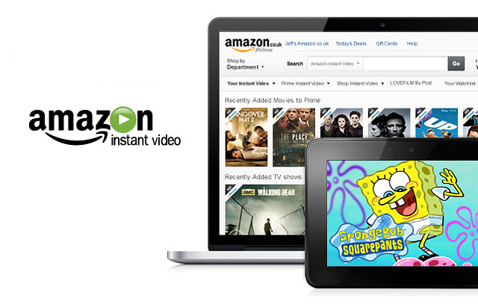

There are so many ways that you can use to watch Amazon Prime movies with no excessive strain, all you need is an Amazon account and enjoy all the Prime benefits that come with it. You can download or stream movies from our television, phone and even tablet from the comfort of your home.

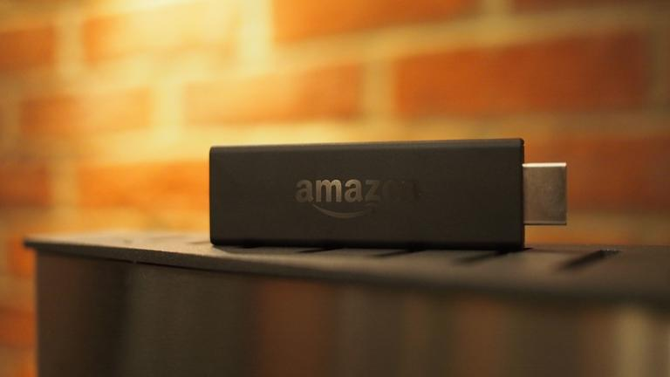Do not let yourself be limited by the thought that accessing videos on Amazon Prime is a difficult thing because Amazon Prime is an easy nut to crack and you will be enjoying hours on end of video streaming and downloads in no time when you use the Amazon Prime instant video app.

**How to watch on your TV**

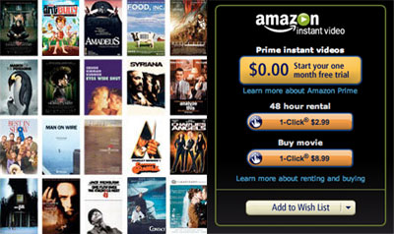

Smart TVs are a new era technological advancement that allows you to be able to download the Amazon Prime instant video app on your television. With this app, you are able to gain access to what you want to watch on Amazon Prime. The Amazon Prime instant video app is free in your TVs play store. Image result for how to watch amazon prime movies

If your television is not a smart TV, Amazon still has you in mind, and you too can be able to watch Amazon Prime on your television. This can be done by purchasing some additions to your television that are internet connected, and you get instantaneous access to Amazon Prime.

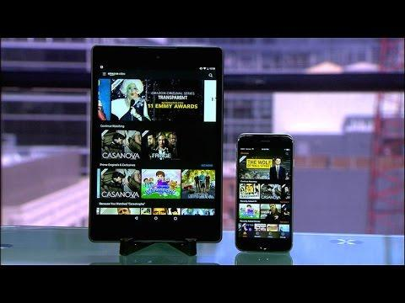

**How to watch Amazon Prime on your phone and tablets**



Watching videos and doing anything else that is internet related is so much easier on phones and tablets than on any other device. The same goes for Amazon Prime videos. Your phone gives you instant access to videos, you can choose to stream or download this videos.



The first thing you need to do is download the Amazon Prime instant video app onto your phone or tablet, then you put in your account password and immediately gain access to videos. All Android devices are compatible with this app.



There are many different videos that you can watch on Amazon Prime it all depends on what you feel suits you. From music videos to movies, your favorite show and even all kinds of documentaries and short clips.