**The best travel coffee mugs for a morning cup of coffee**

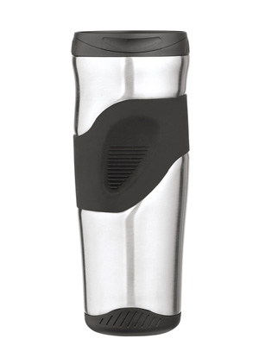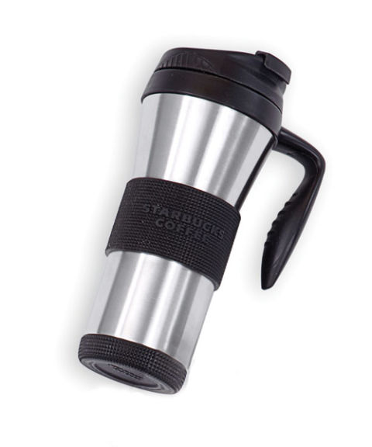

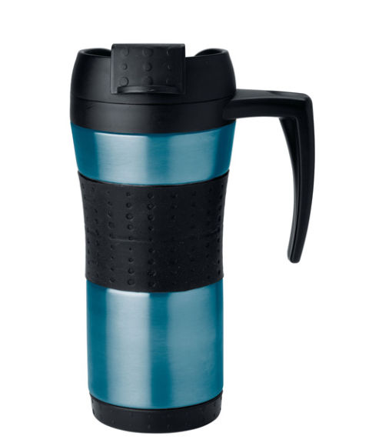When your coffee gets cold, it loses its taste and makes your face shrug. Coffee is a known universal wake up alarm for many people, and a cold cup of coffee can start your day on the wrong foot. When you are looking to take a walk or a drive to the office with your coffee, a good coffee mug is the way to go.

A coffee mug that will keep your coffee the right temperature is a coffee mug that is worth recognition. It is easy to get this mugs at great prices at most retail stores so that you can start your morning with the right kind of energy every single day.

There are different kinds of different coffee mugs that each has different unique features and you get to choose from the variety. They are:

**Thermos tumbler with infuser**

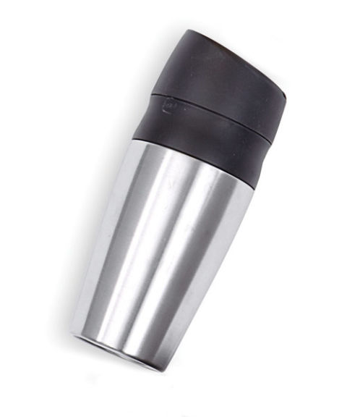

This coffee cup has great insulation that helps your coffee remain hot for hours and any chilled drink will remain ice cold for a long time. The infuser on these mugs is removable. You can use to use them or still use the mug without the infuser

**Zojirushi tuff mug**

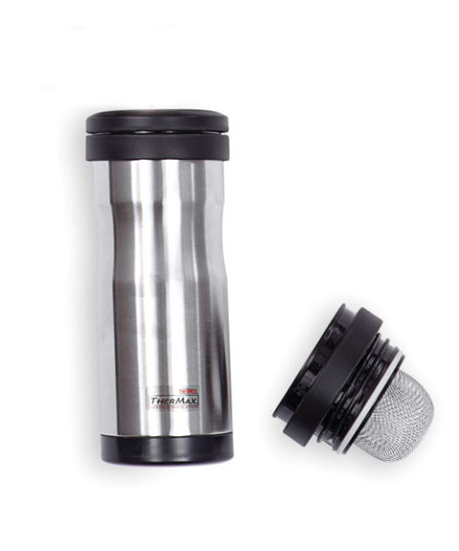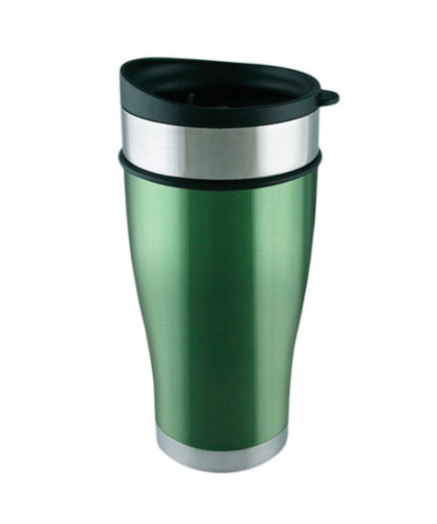

Once you fill this mug with your hot coffee, this mug is able to keep the coffee hot for two hours. With an extra two hours of hot coffee, you can get a good start to your day. This mug has a tight seal that prevents any spills when you are moving or sipping.

**Planetary designs mug**

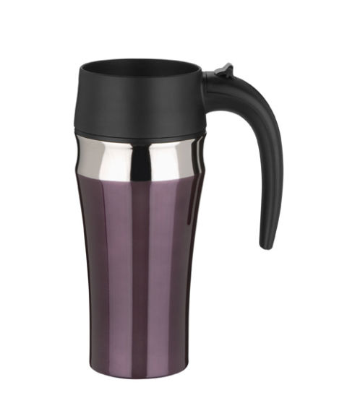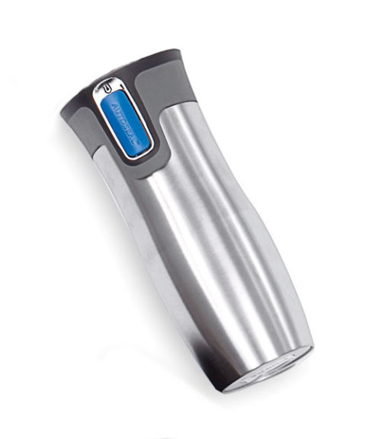

This mug is a slim and sleek mug but will still hold a good amount of coffee. It is easy to hold because of its slim nature. It is insulated to keep your hot drinks hot for longer. This mug is however designed more for iced. This mug will keep iced drinks chilled longer than it will keep drinks hot.

Normal coffee mugs are more appropriate when you take your coffee at home or at the office. They can also be styled by coloring, branding and also buying magic mugs to cheer you up in the morning. If you prefer to commute to work or any other place with your coffee, then invest in a travel coffee mug.