**Which is the most durable refrigerator?**

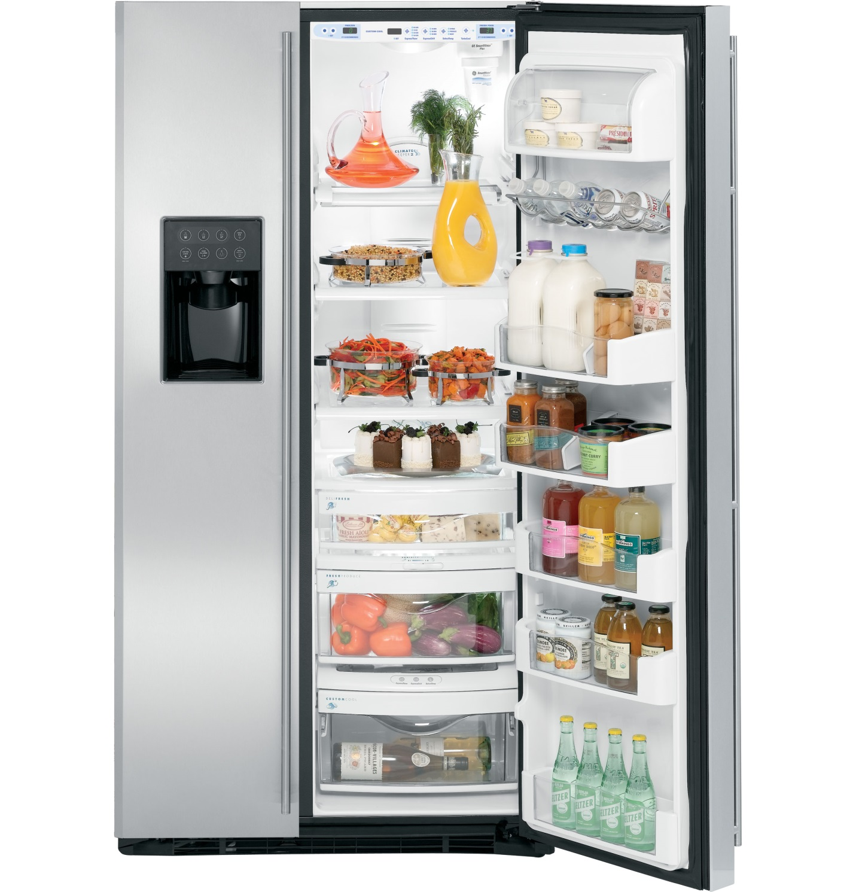

There are some refrigerators that you can choose from when you are in the market for one. The main reason why people look to change their fridge is the durability of the fridge. When the food spoils so fast, and the lifespan of the fridge is limited.

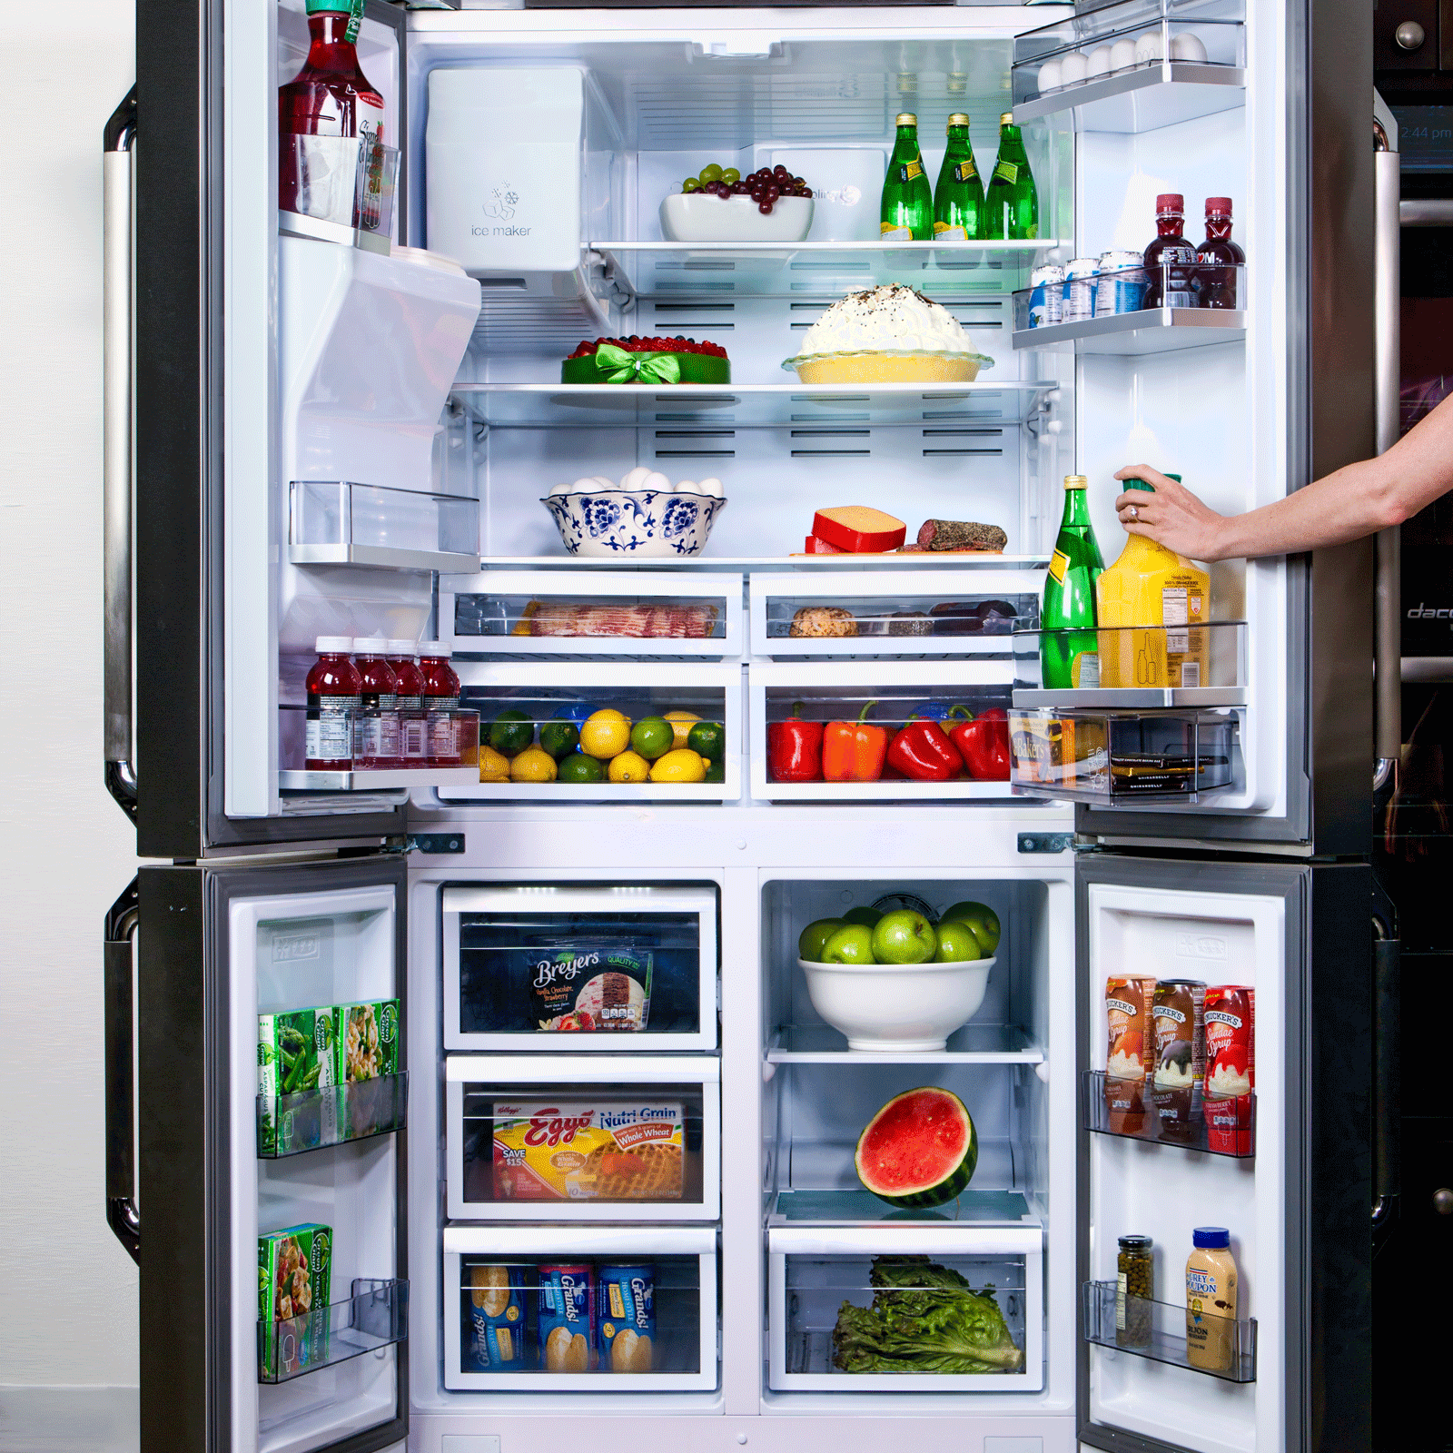

Before selecting one and settling on it, there are some factors that you need to consider besides the durability like pricing and the features of the fridge. French door fridges are very popular in the market because of the features that they offer and their sophistication.

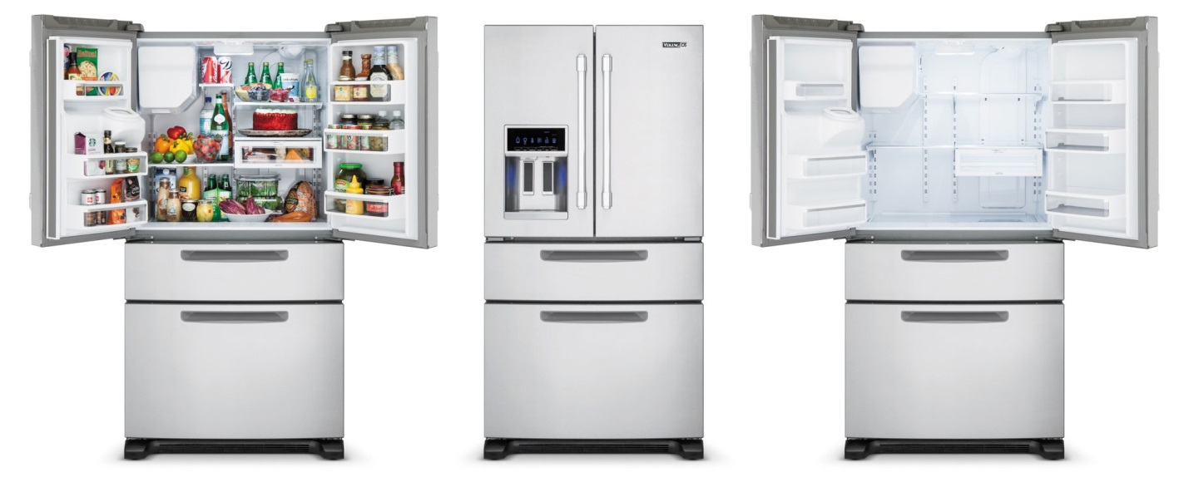

You must be committed to what you are looking for so that you do not compromise once you see the variety of refrigerators in the market. For durability, the most suitable refrigerator when you are looking for a durable refrigerator regarding food storage is the Amana AFI2539ERM French door refrigerator that not only ensures all foods have the right temperature but also has a water filter system that gives you pure water.

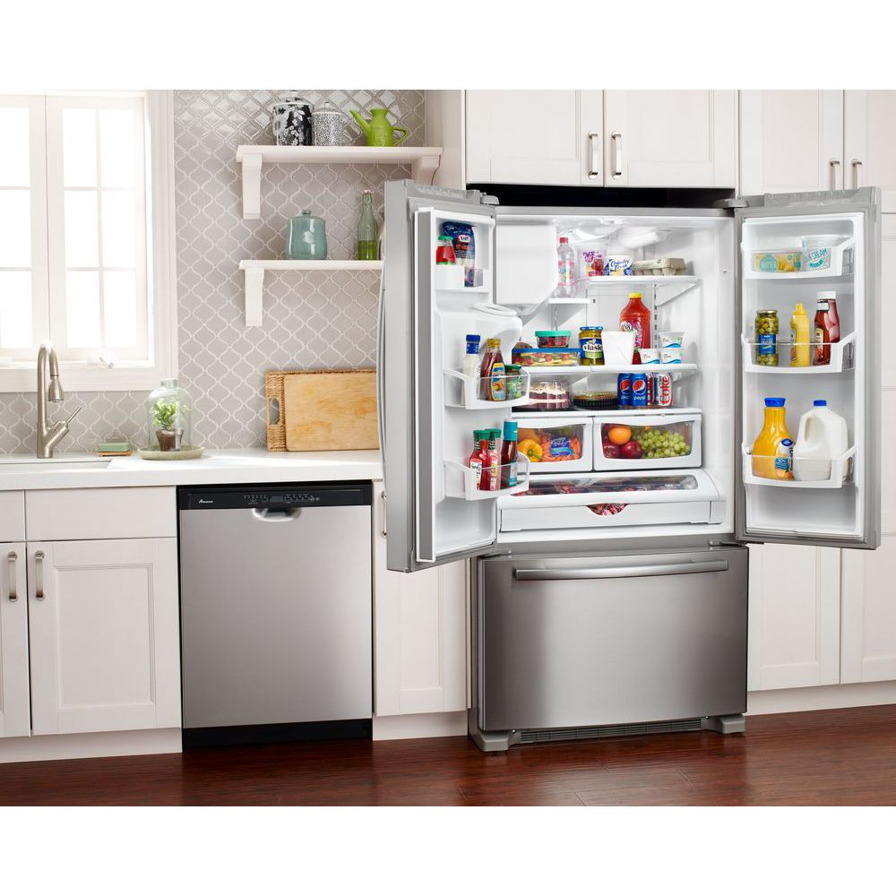

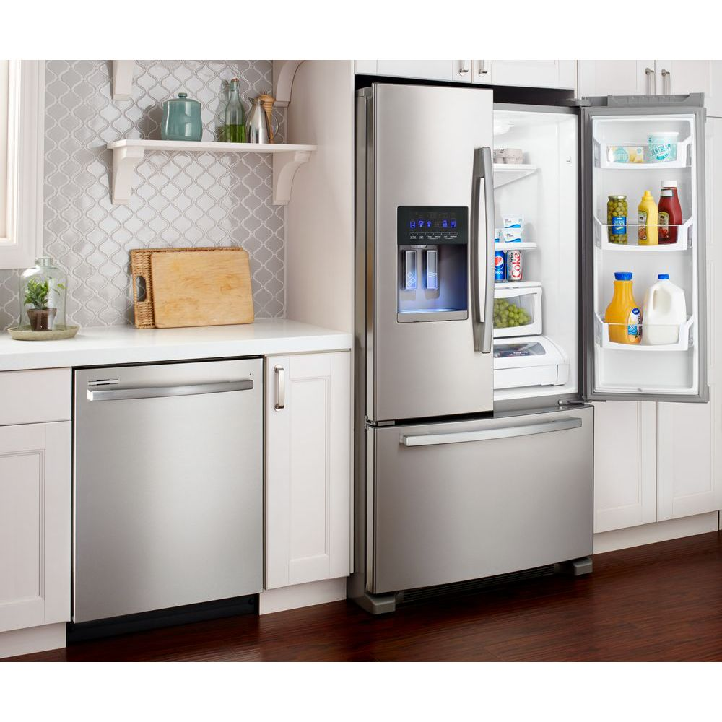

Kitchen KRFF305EWH Aid French door refrigerator is a simple fridge, but it will give you value for your money.

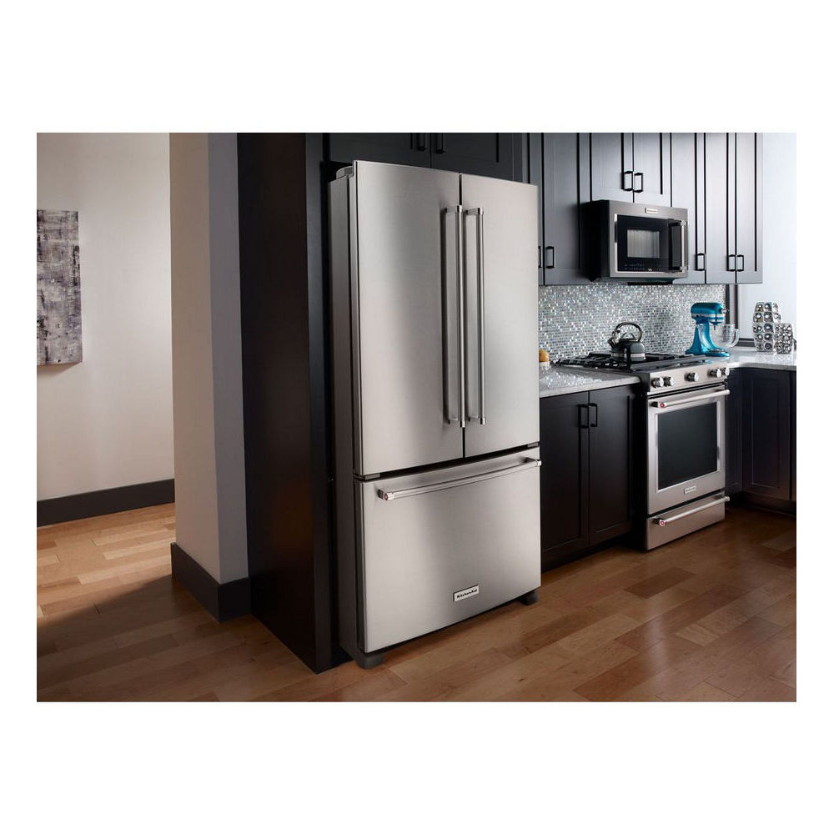 It is built to serve you for a long time and ensure that your food is kept cool and fresh. You can easily find this refrigerator on Amazon. It has a dedicated pantry for all meats. This refrigerator will not only give you durable service, but it will also help you be able to organize your foods in an easy to follow the order and give easier access to foods.

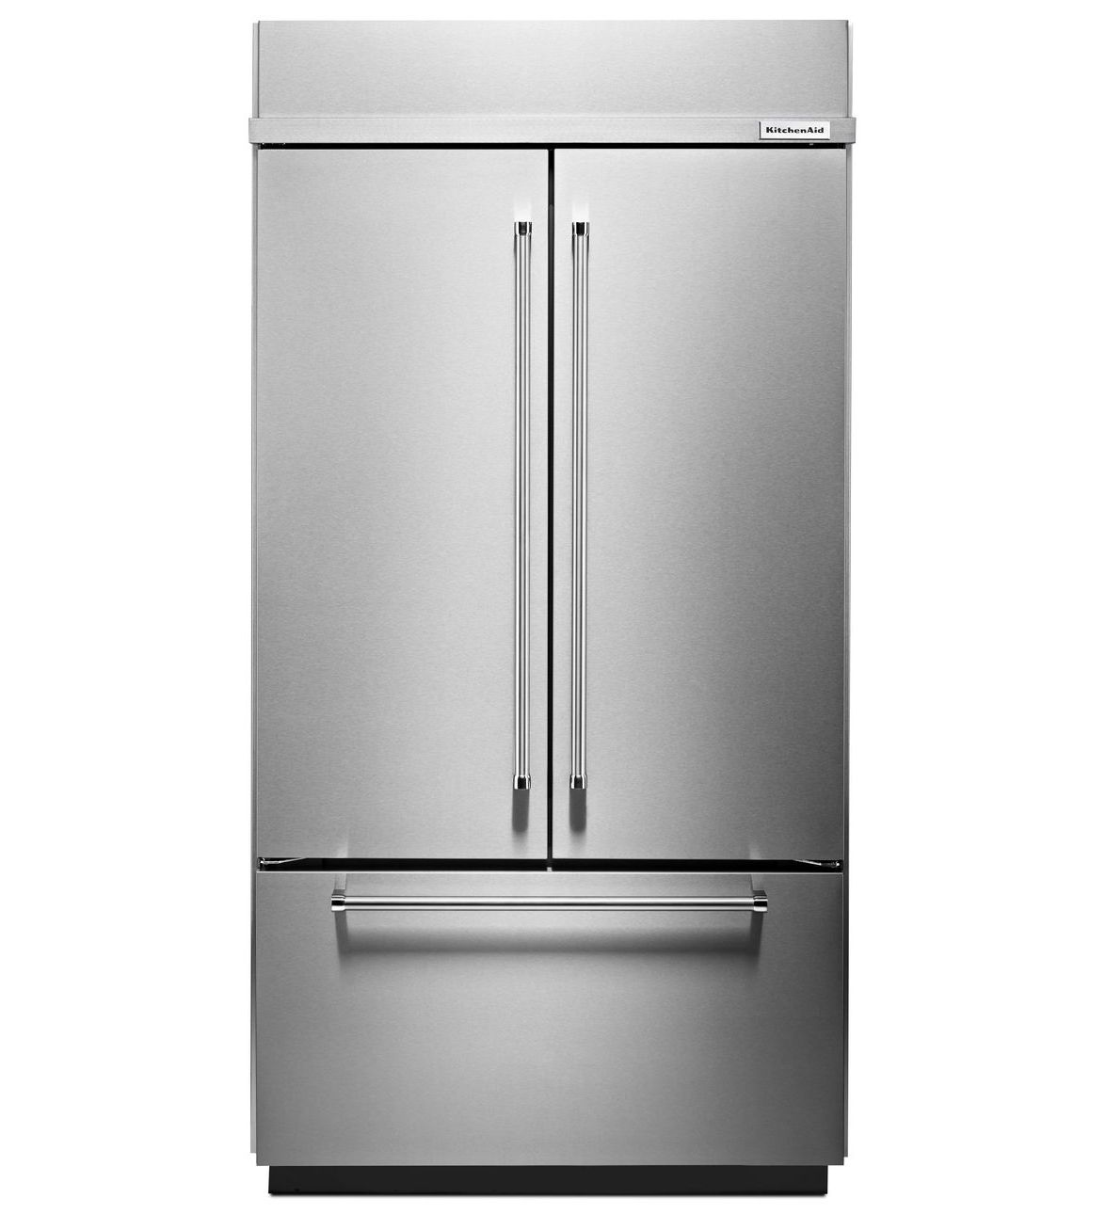

Each refrigerator is built with a unique feature that sets it apart from others. There cannot be a specific most durable refrigerator because, in as much as the kitchen aid and Amana refrigerators give durability, it also depends on the kind of handling you give to your refrigerator.

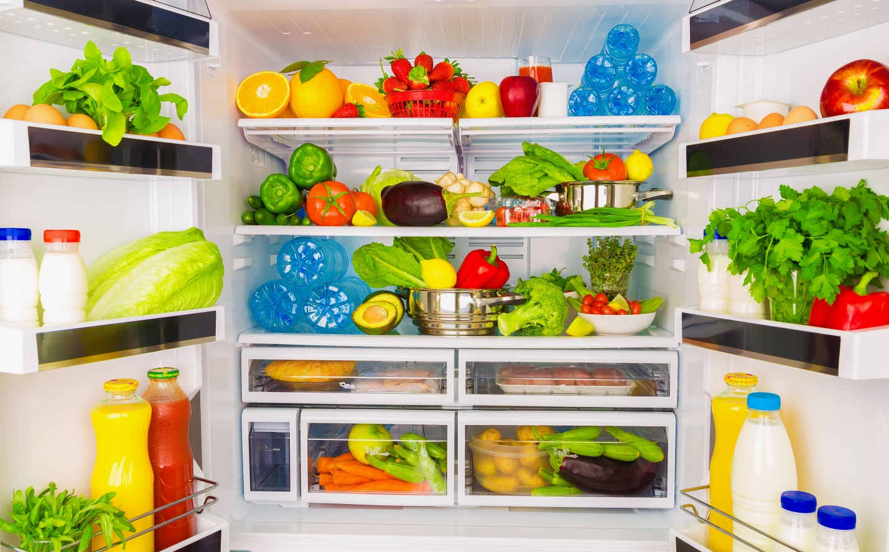

Ensure that you do not store overflowing foods that may cause spills inside your fridge and causing rots. Do not overly stuff the refrigerator also. When a refrigerator's door is not properly shut, the food will not be properly protected, and the fridge will also suffer damages.