**Why colored Yeti cups are the best for cups yet**

Yeti cups have a great following from people who love outdoors since this cups add to the magic of adventuring out in the wild.

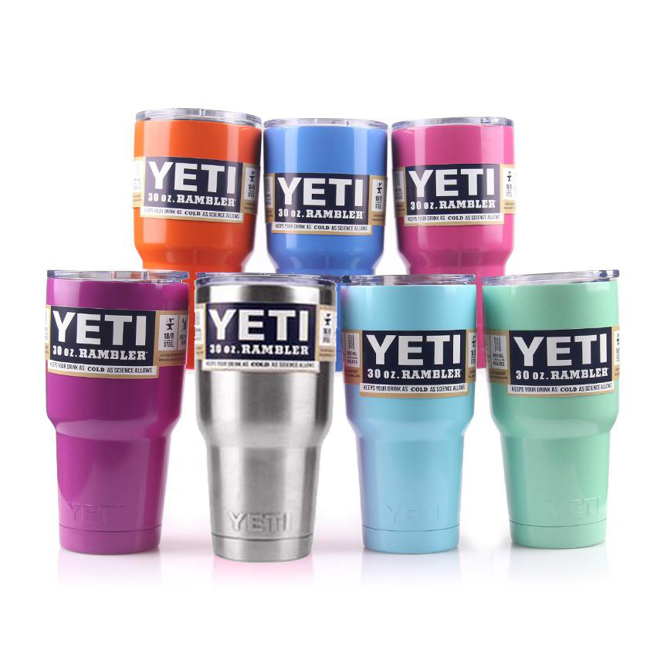

These cups are built to help you in any temperature situation that you may be in and ensure that you are victorious.

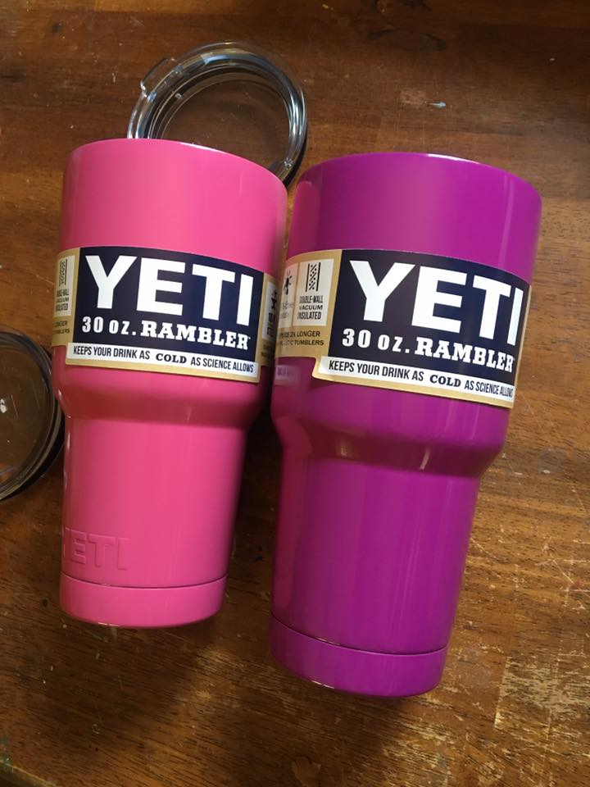

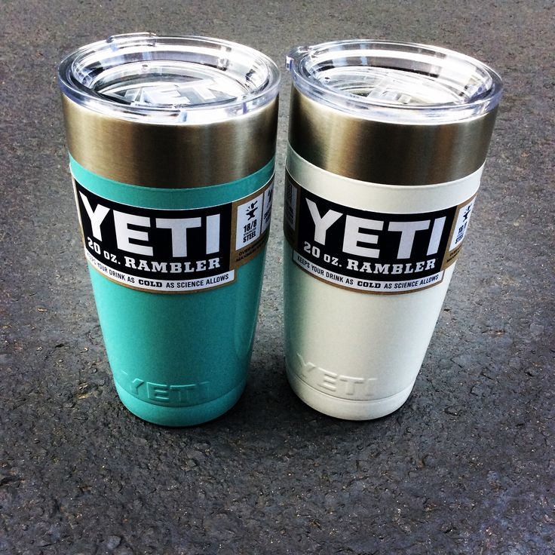

When you are taking a jog or a hike. Staying hydrated is important. While you run with your water, the temperature on your water rises and your cool water gets warmer with time. Warm water on a jog when you are sweaty will not help cool your body. The chill feature of the yeti cup ensures that your water remains chilled for longer.

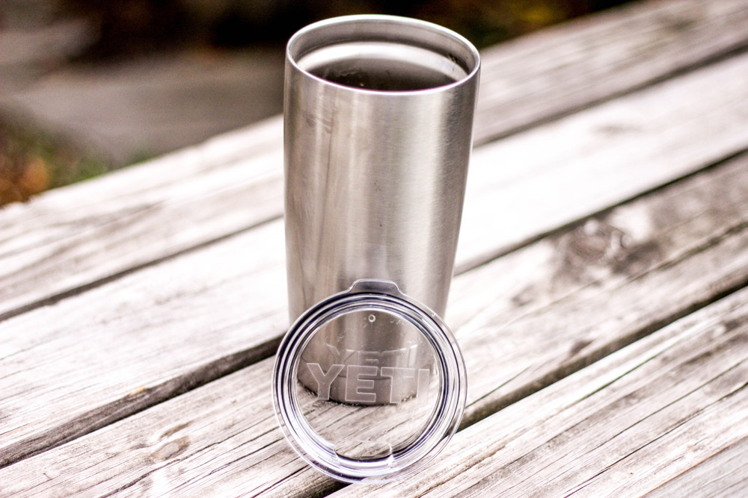

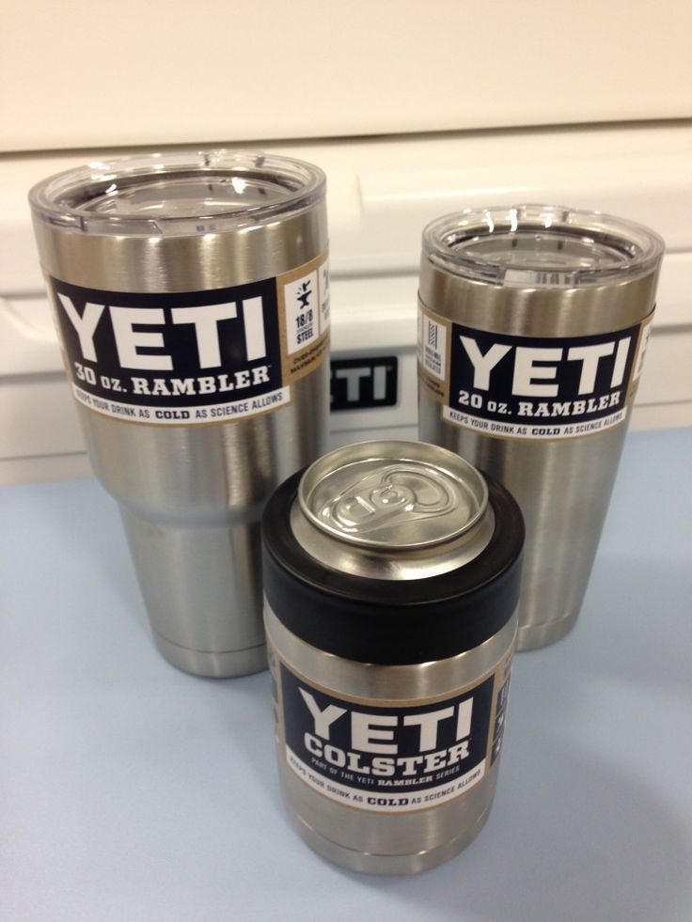

Normal yeti cups that have not been added the color are stainless steel cups that protect the outside of your cup from rusting and also provides insulation so that your coffee stays hotter and your iced water remains chilled.

**Colored yeti cups**

Colored yeti cups have the same features as the normal yeti cups, but they are much better because they bring color with you out in the wild when you are out for adventures.

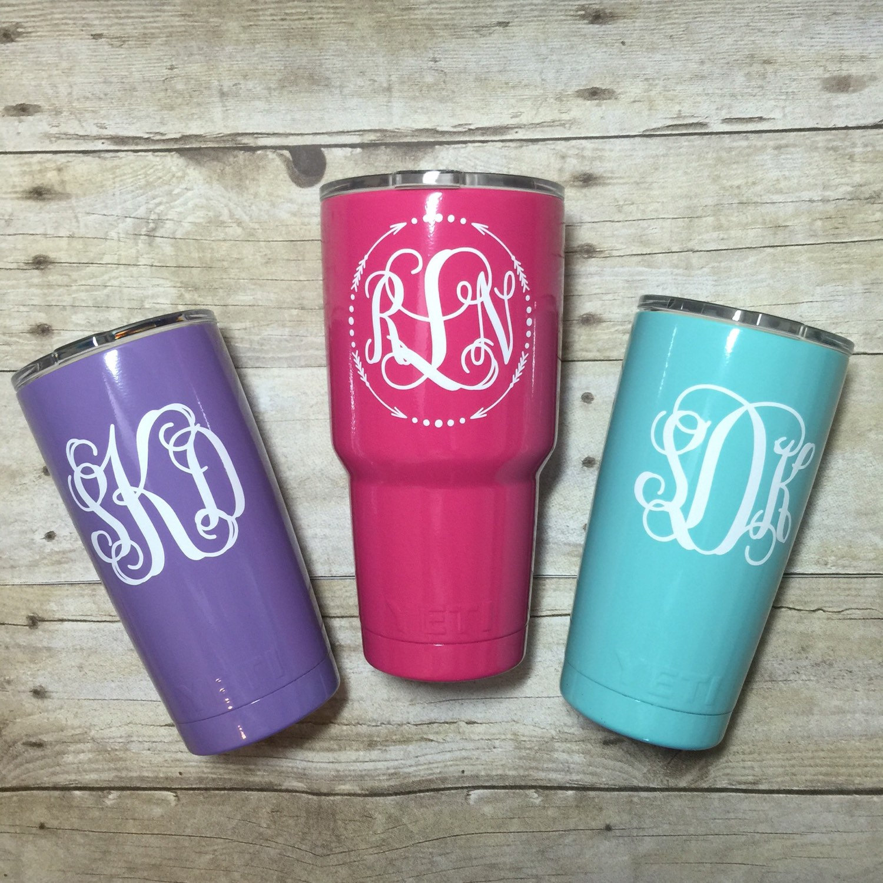

The cooling on a colored yeti cup and the heating is all the same.

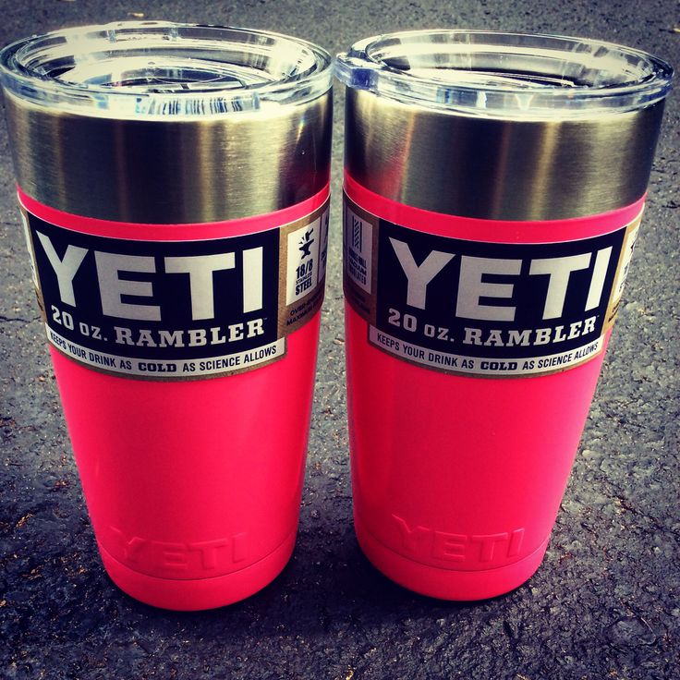

Some of the newly introduced colored yeti cups have a much slimmer feel that makes it easy to comfortably hold your yeti cup. This addition has not compromised on the size of the yeti cup as it is still the same size.

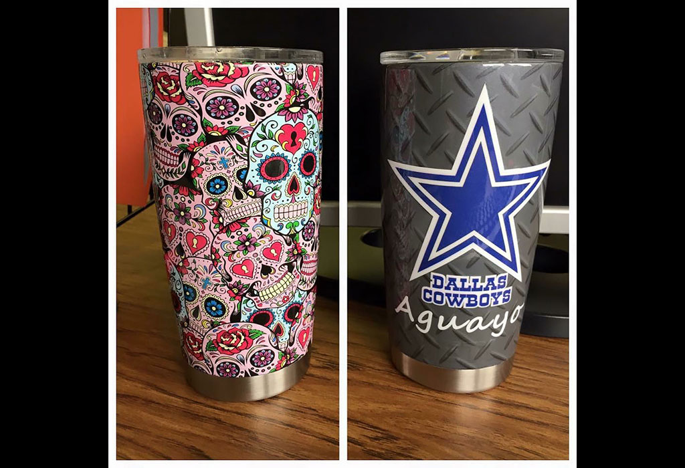

When you are getting outdoor cups for your family, you can easily tell them apart by buying different colors of cups. This will ensure that everyone takes care of their cup and you can also tell whose cup is not very well maintained. Yeti cups are easy to clean, and the color on your cup will not come off when you clean.

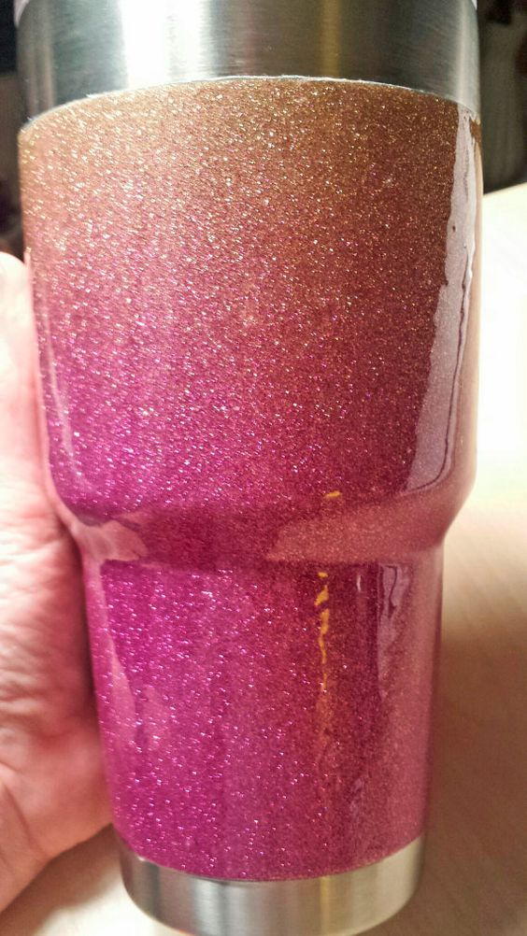

Colored yeti cups are much more sought after because you can choose your favorite color and you can also have them easily customized when they already have color. Let your next trip to the wild or your next cup of commute coffee be in a yeti cup and enjoy the yeti cup experience.

