**How to apply Aztec clay mask on your face**

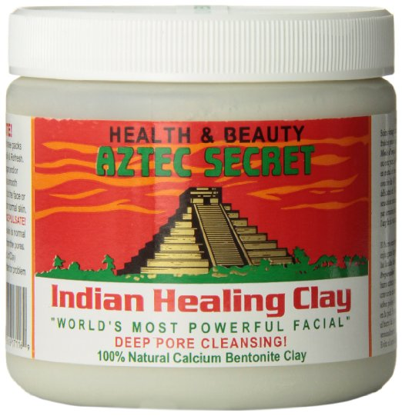

Aztec clay face mask is the most powerful facial treatment in the world that has been tested and proven by experts and doctors to work effectively. This mask will give your pores a detailed and thorough cleaning that leaves your face clean, refreshed and all bacteria eliminated.

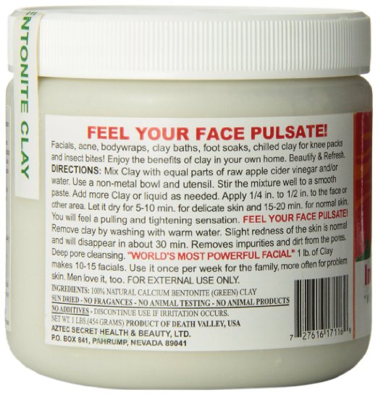

Aztec clay is a natural product that is created from calcium bentonite clay. There are no additives on this clay mask which may cause corrosion on your face or nay other health issues. When you use the Aztec clay facial mask, you are guaranteed of no side effects.

**How Aztec clay mask is made**

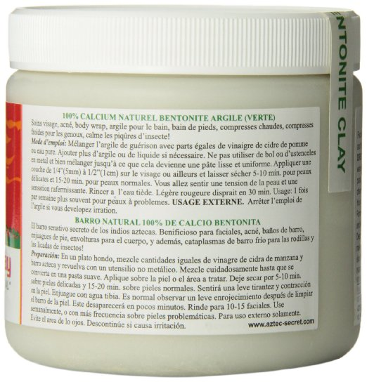

The process of making Aztec clay mask is an easy one since there are no chemicals being added to it. The first step is to mix the Aztec clay with apple cider vinegar. Carefully and thoroughly mix until they have both properly been mixed in.



This powder that is formed from this two products is what you will then apply on your face. There is no complicated processes with Aztec clay mask the method and the results are both easy. The result is exceptional and everyone who has used Aztec clay mask can attest to that.

**How to apply Aztec clay mask on your face**

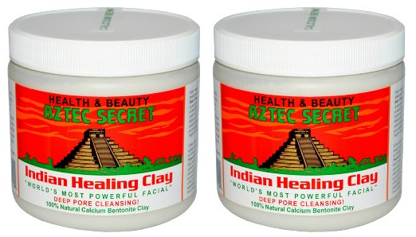

There is no particular process of applying Aztec clay on your face, once you have mixed the Aztec clay and the vinegar, you can then smear the resulting powder on your face using any method that you choose. You can use your hands and start from the chin up or from the forehead down, it is all up to you.

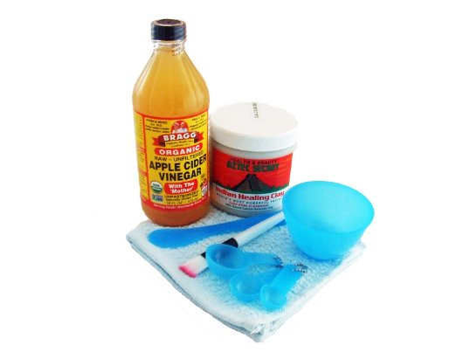

The most important thing to know is that once you apply the mask, you should let it sit for the advised time so that it has the expected effect on your dace then you can wash it off and remain with amazing refreshed skin.

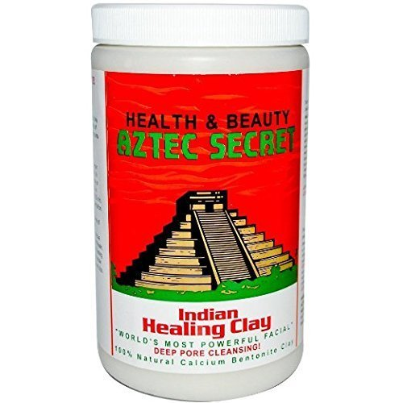

You can use Aztec clay to cleanse your face anytime that you feel you need to refresh your face. It is however very advisable that to follow all the instructions stated in the product so that you are able to use the product in the right way.