**Which is the best Bluetooth speaker for that quality sound**

Get rid of all the wires that you always have to untangle and go wireless with these Bluetooth 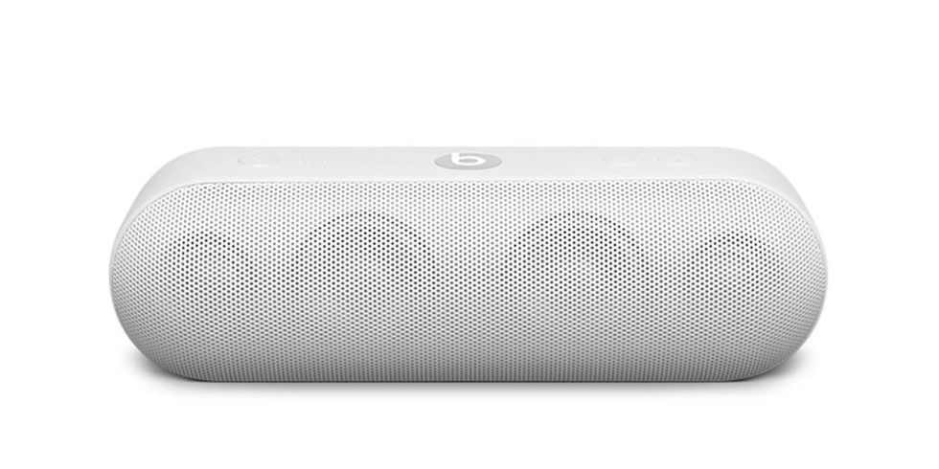speakers available at bestfinds.com. With sleek designs and quality sounds, you get top quality speakers minus the hassle of dealing with wires dangling anywhere and everywhere. You will get a wide range of the best Bluetooth speakers from different manufacturers across the market. Some of the best Bluetooth speakers you will find include:

**UE BOOM 2 by Logitech**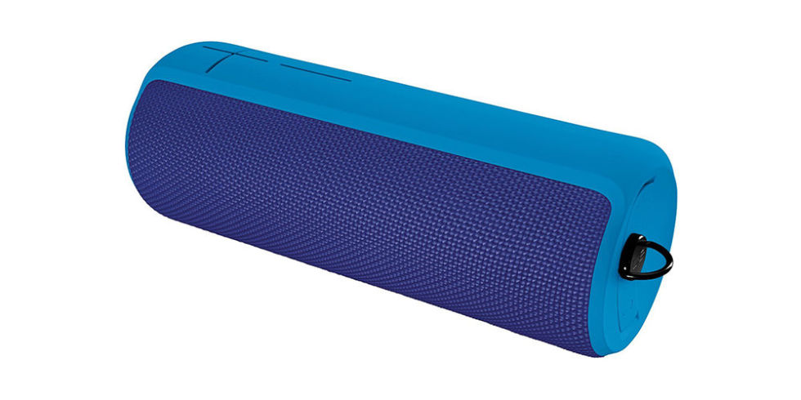

With a battery life of 15 hours, this is one of the best Bluetooth speakers in the market. It is waterproof, stain resistant and also shock proof which makes it a very durable Bluetooth speaker. This is a very compact and wireless speaker that can be paired with a second UE speaker for a stereo sound.

**KEF Muo**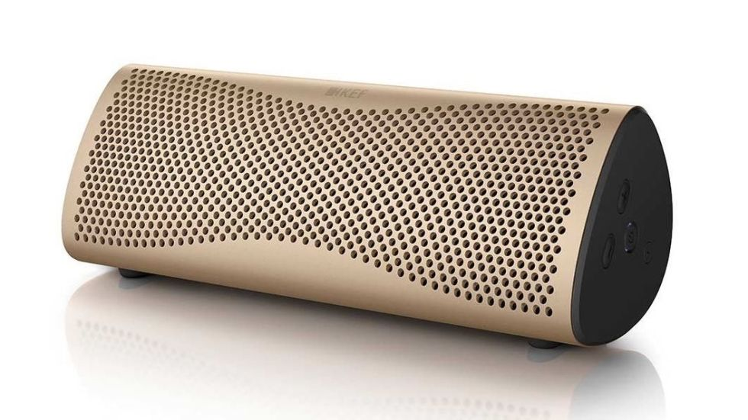

Small in size but with a very good top volume, this speaker can easily fit into your handbag or backpack. You can easily synchronize two Muo speakers for a quality stereo sound. This wireless speaker can be used in a horizontal or in an upright position without compromising its quality sound. It easily pairs with android devices in seconds and streams your music easily.

**JBL Clip 2**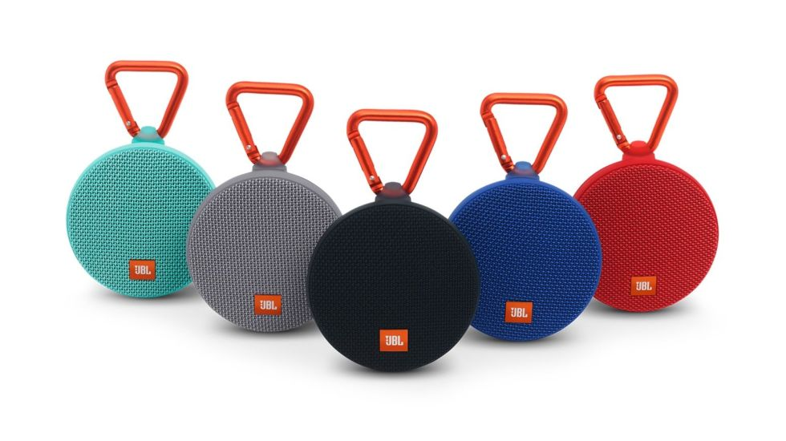

With speakerphone capabilities, this Bluetooth device is among the best in this category. Small in size, it offers you a decent sound. It has a battery life of 8 hours which is also quite decent.

**Libratone ZIPP**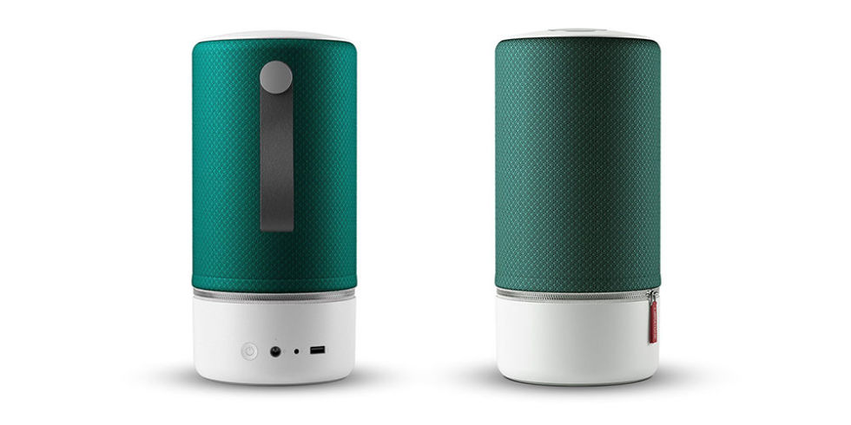

This Bluetooth speak can connect directly with iOS mobile device, PC or Mac. Fitted with a USB port, it can also act as charger for smartphones. It also has a stylish eye-catching design and of course excellent sound quality.

**Creative Sound Blaster Roar 2**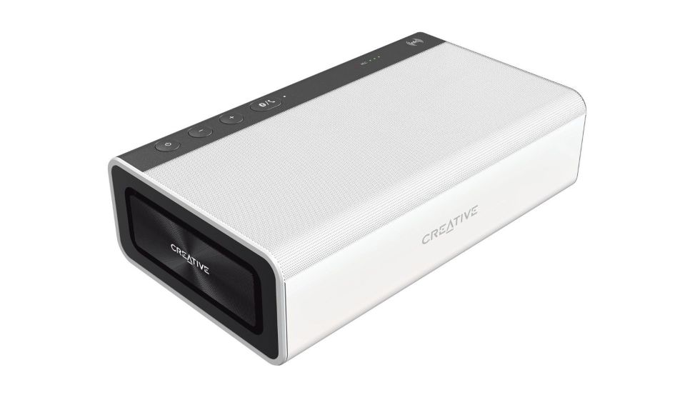

Smaller, sleeker and more streamlined than its predecessor, this Bluetooth speaker has excellent sound quality. It has an 8-hour long battery life and simple and straightforward connectivity to Bluetooth devices.

**B & O Play Beolit 15**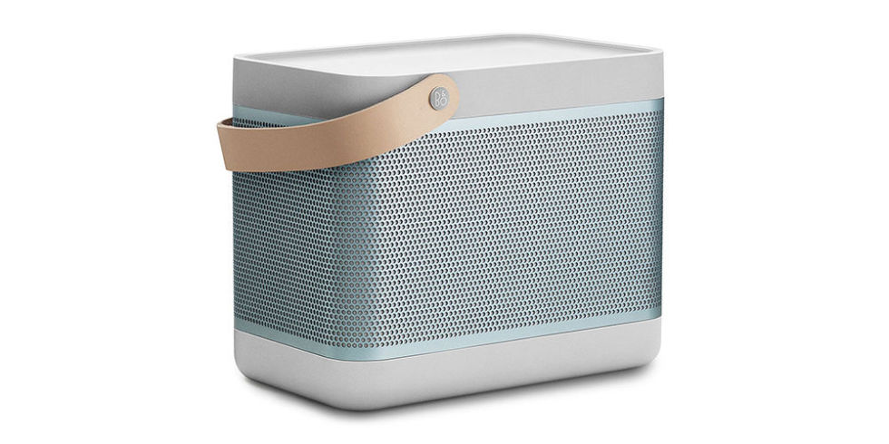

It has amazing sound quality and quite the bass. It is easy to connect with Bluetooth devices and has an astonishing 24 hour battery life.

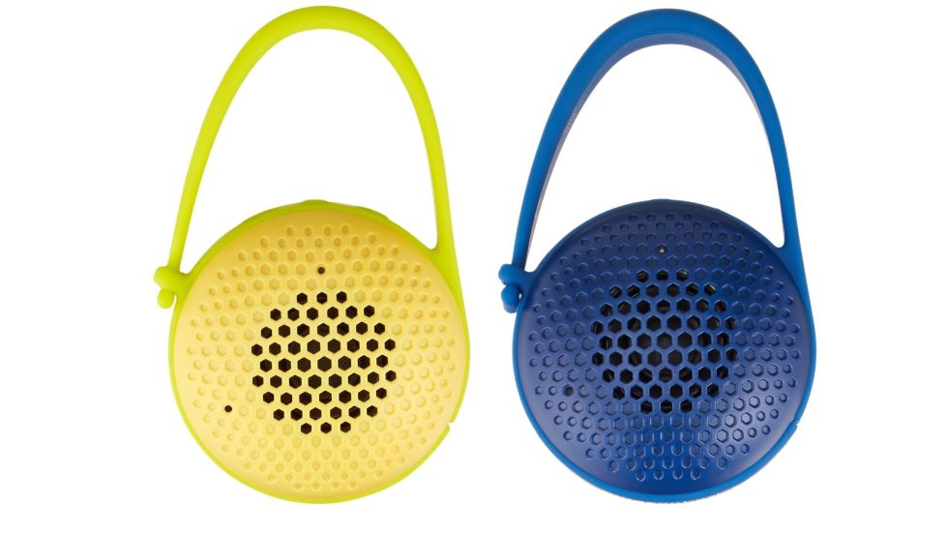

Other Bluetooth speakers are also available at bestfinds with various options across the different price ranges.