**Which is the best tower fan for the kitchen?**

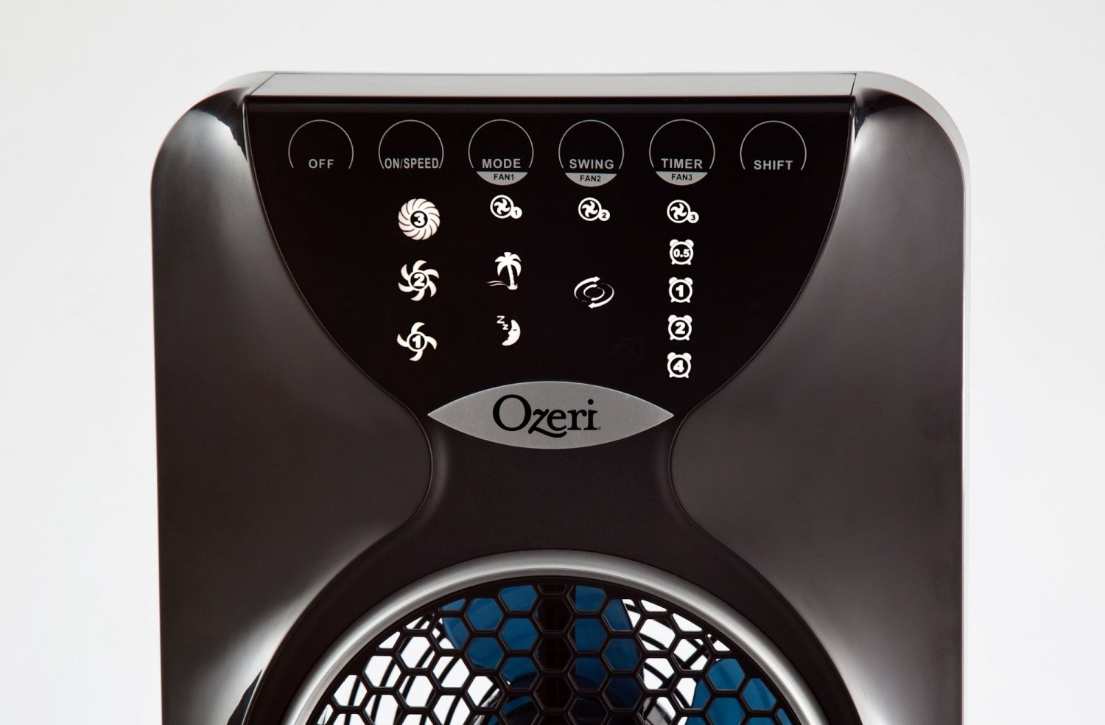

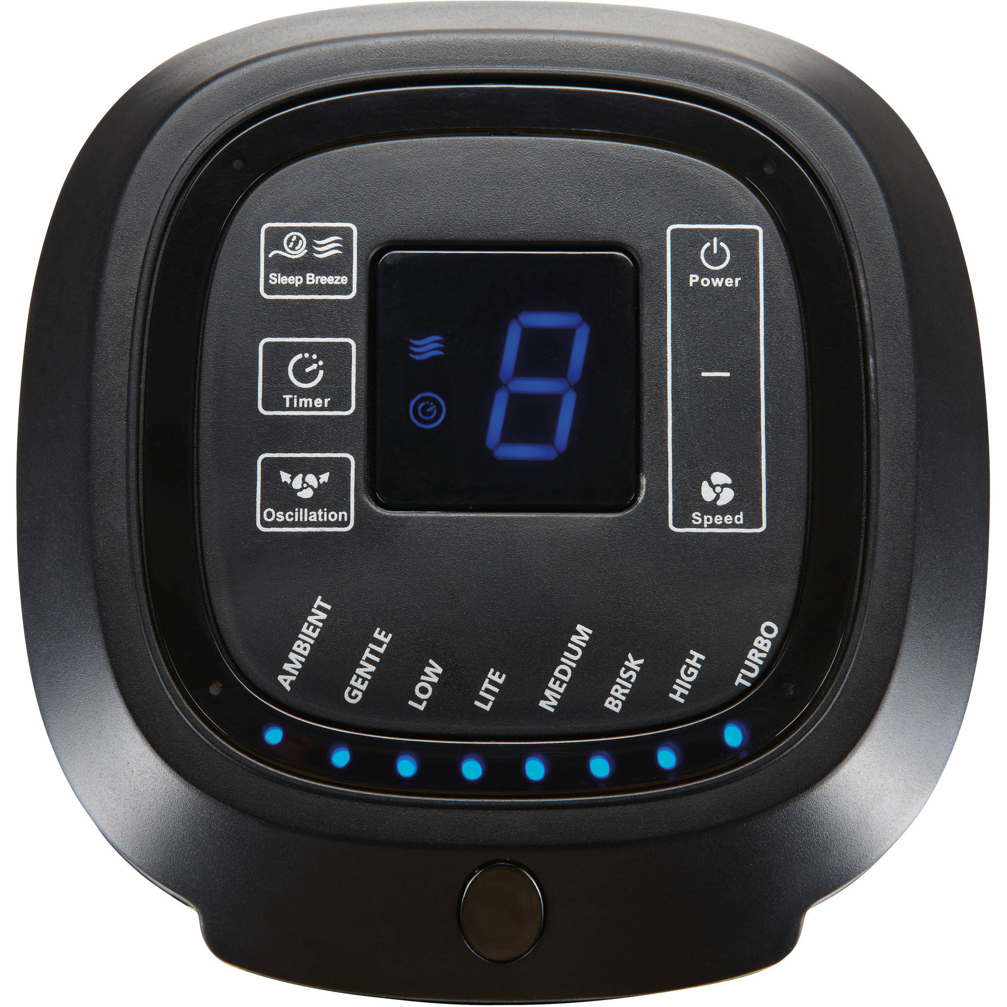

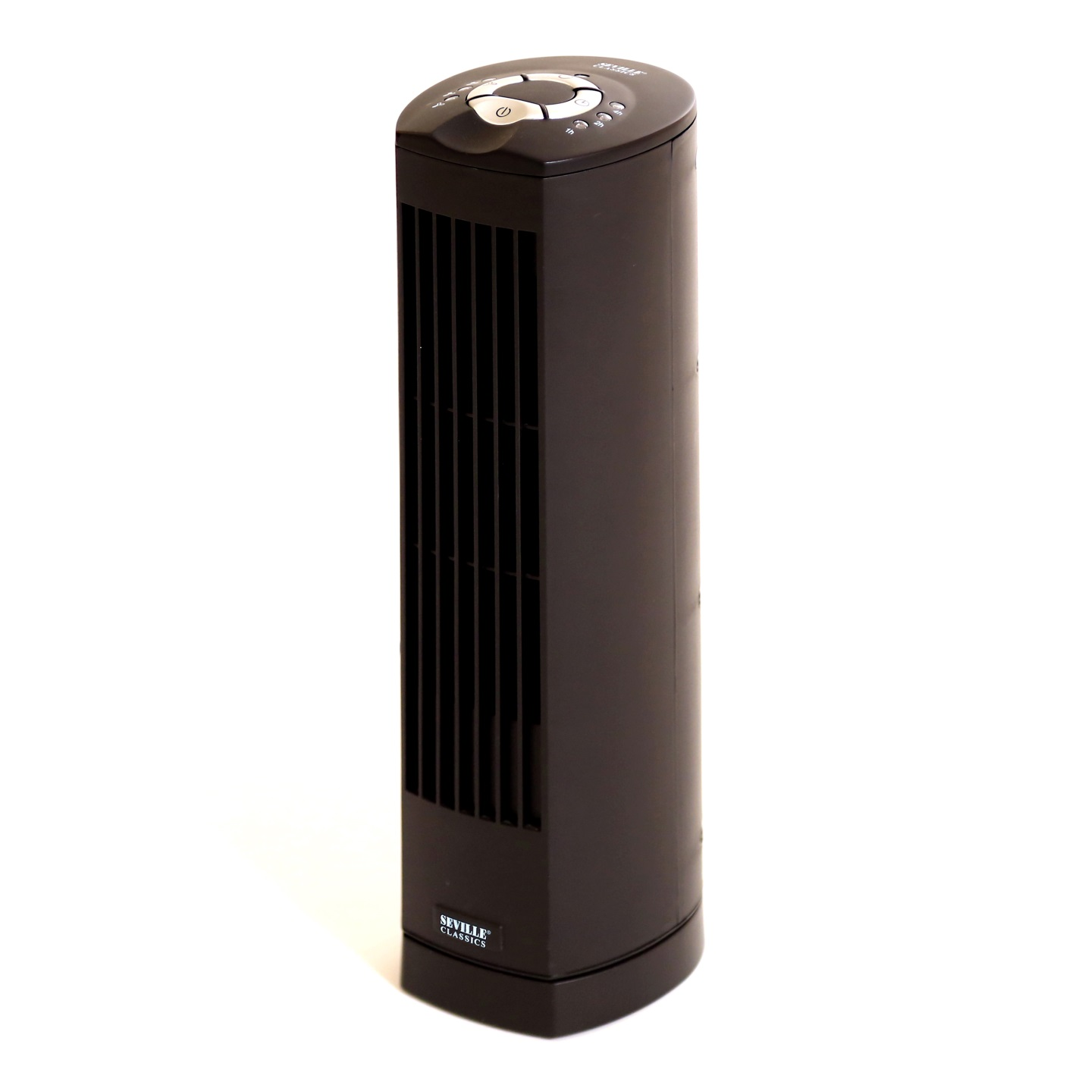The kitchen is a very busy room in the house and requires that you have a fan that will help cool the room fast so that your foods, fruits, and supplies do not go bad so fast. Having a tower fan for your kitchen is not a bad idea, especially when it is a strong enough fan to cool the whole of your kitchen.

Depending on the size and style of your kitchen plus your preferences, you can choose from a wide variety of tower fans that may be suitable for your kitchen which include:

[**Ozeri Tower Fan**](http://www.amazon.com/Ozeri-Tower-Passive-Reduction-Technology/dp/B005I5KSMM?tag=digitalp0f-20)

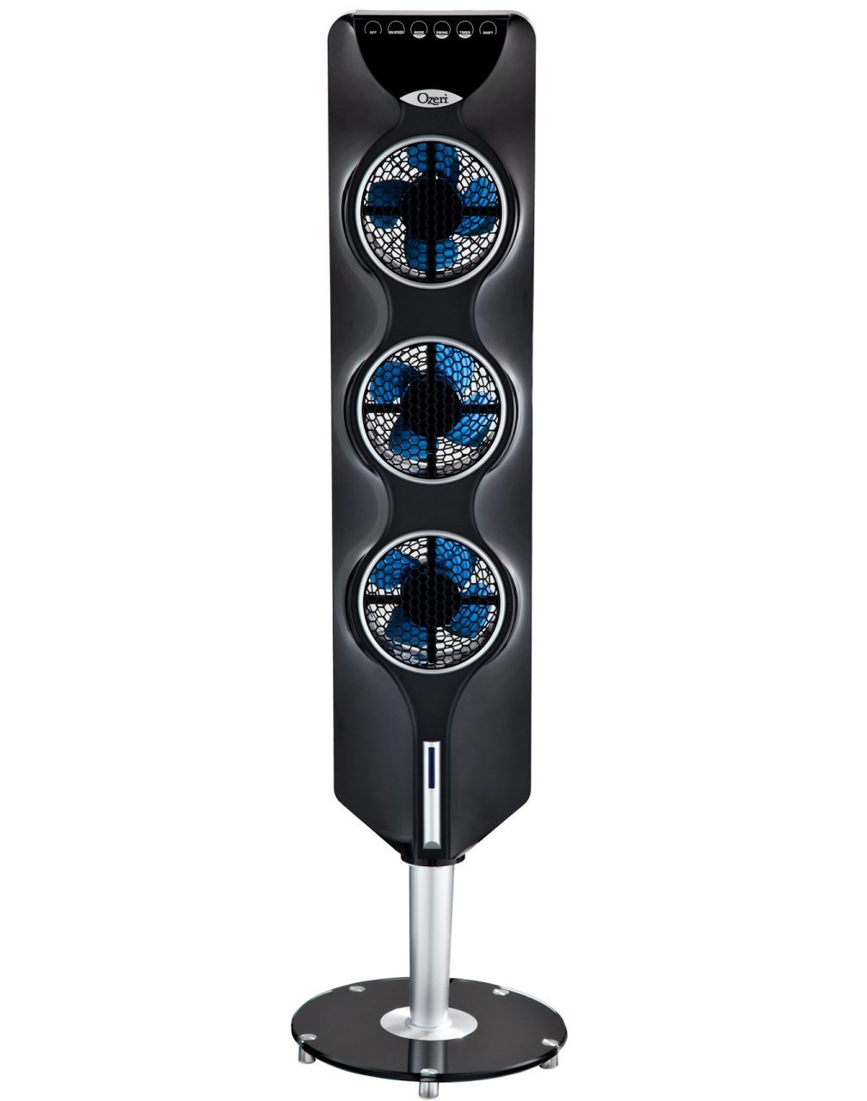

This tower fan is not only going to cool your kitchen speedily, it is also developed with technology that allows it to reduce the noise it makes when operating. Noise is the biggest issue with fans and that is why the ozeri fan has advanced, as you increase the speed of the fan, the noise also significantly reduces. It has a touch sensitive light emitting panel fitted to its design.

**Soleus Air Tower fan**

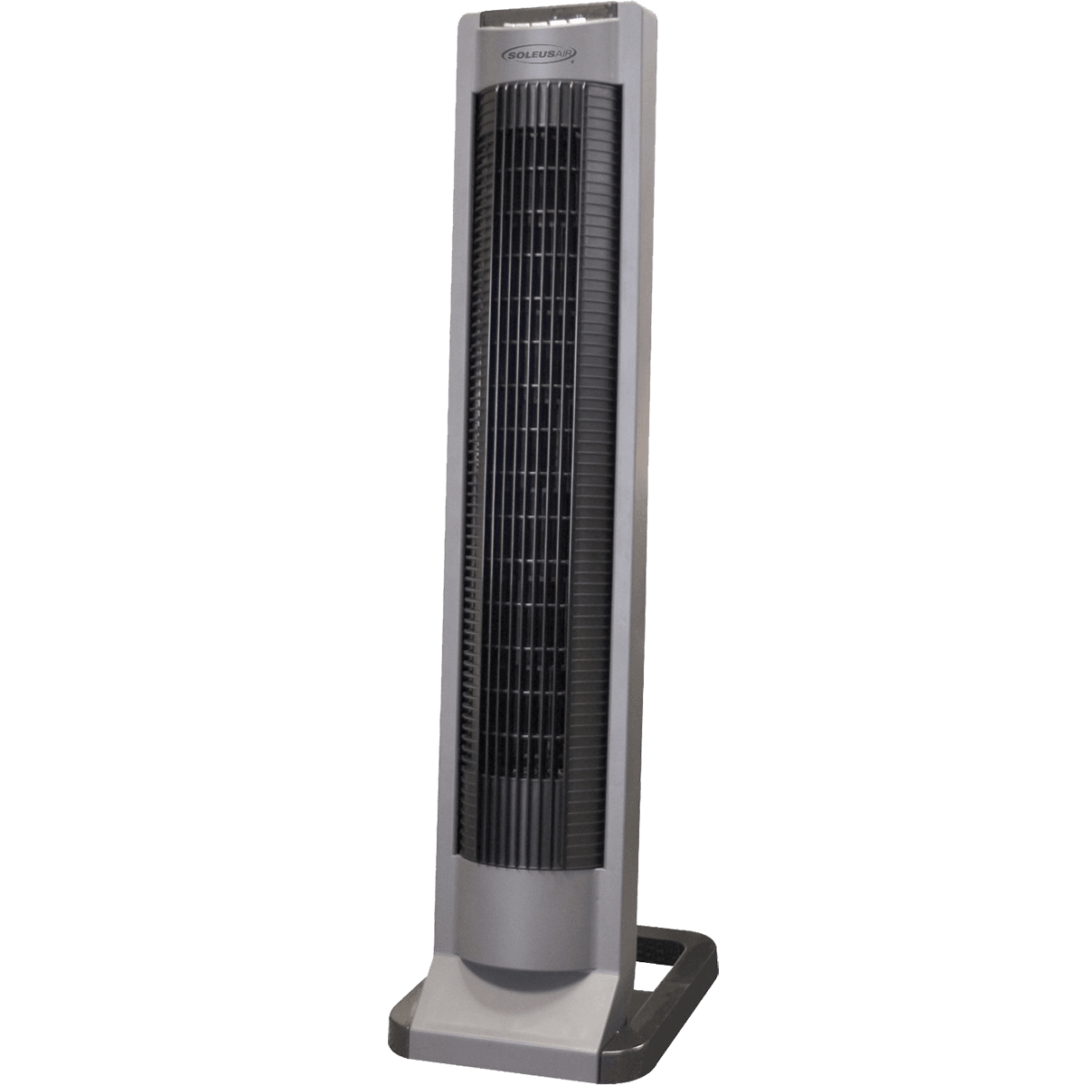

The soleus air tower fan is your best kind of tower fan for your kitchen because you do not have to manually change the setting on the fan, you can easily use its remote control to increase or decrease speeds on the fan. It has a LED indicator that shows you all the settings available.

[**Honeywell Tower Fan**](http://www.amazon.com/Honeywell-HY-280-QuietSet-Whole-Tower/dp/B00B4BJZ9G?tag=digitalp0f-20)

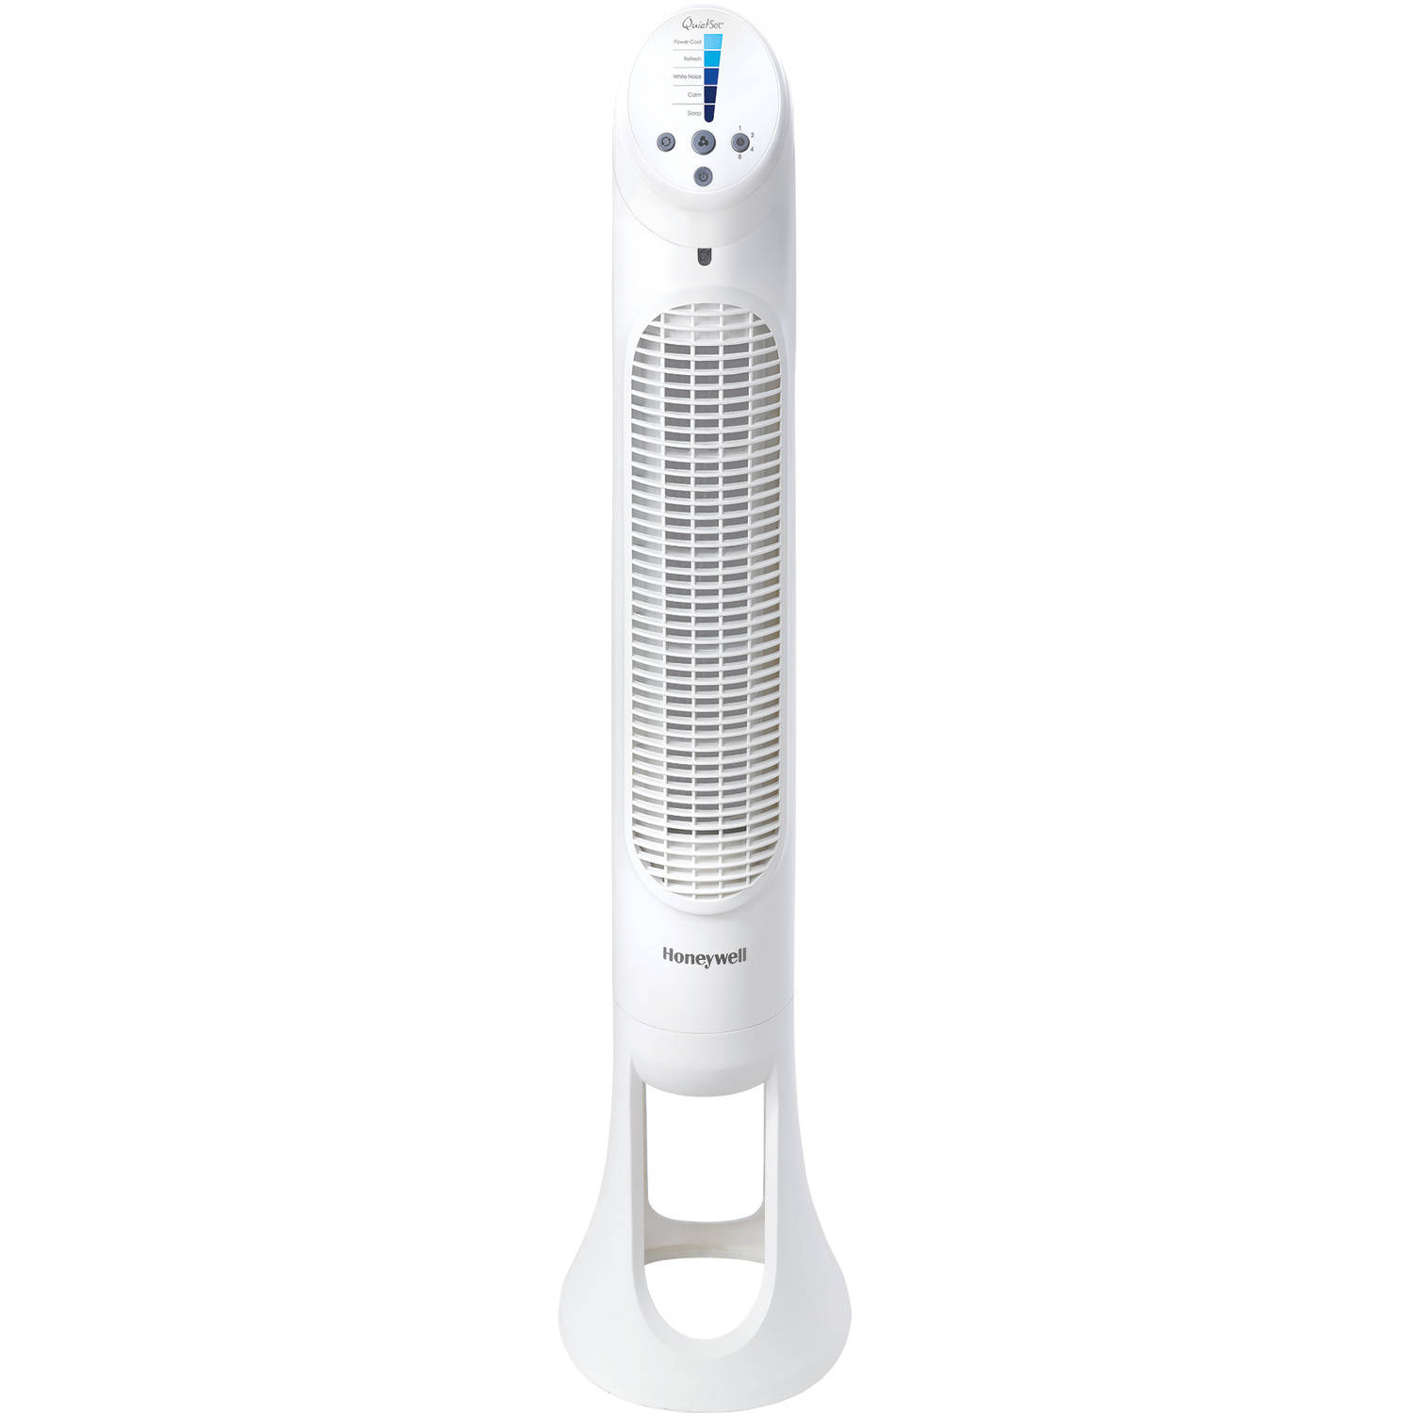

With up to 8 different speed settings on the Honeywell tower fan, the fan is so powerful that it will cool the whole room in a matter of minutes.

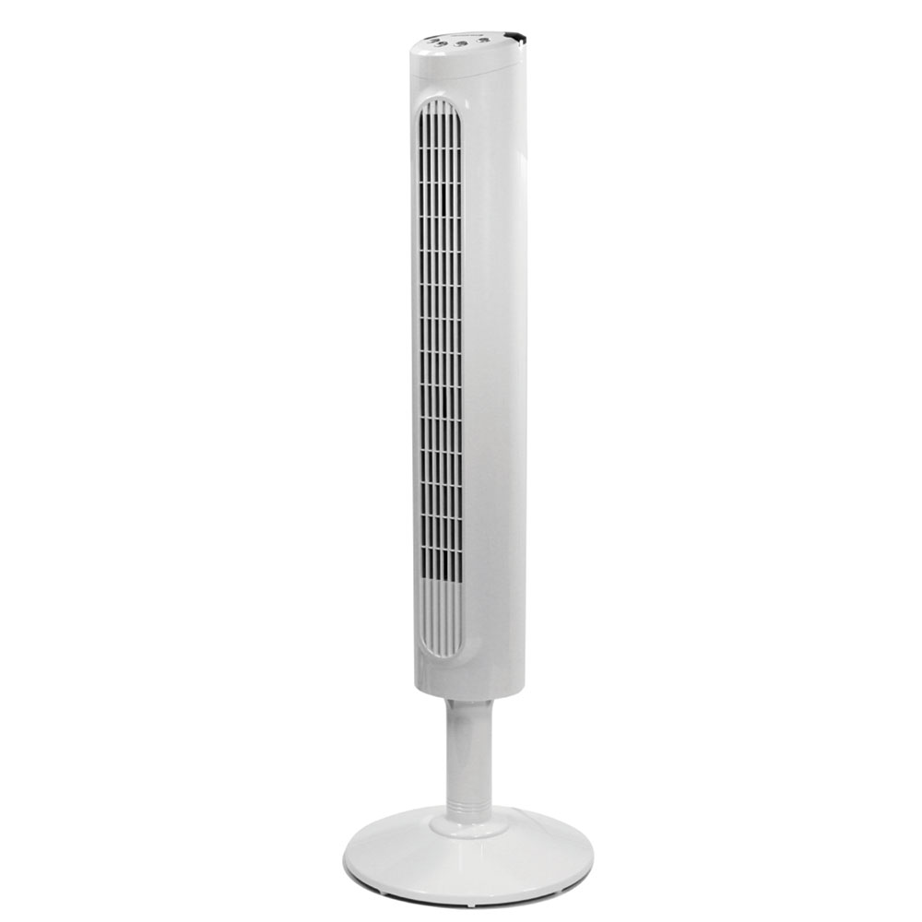

The fan is also able to control its noise when operational.

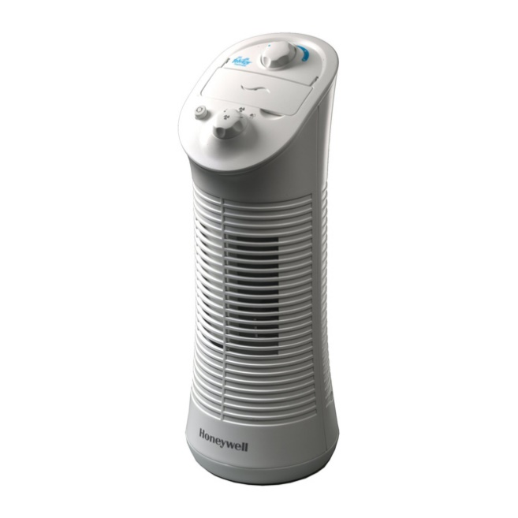

Honeywell tower fan operates by the touch of a button and comes with a breeze setting and an oscillation setting.

[**Holmes Tower Fan**](http://www.amazon.com/Holmes-Oscillating-Tower-Remote-Control/dp/B000BOB658?tag=digitalp0f-20)

This is another remote controlled tower fan that gives you three different settings to choose from and also has a LED panel. 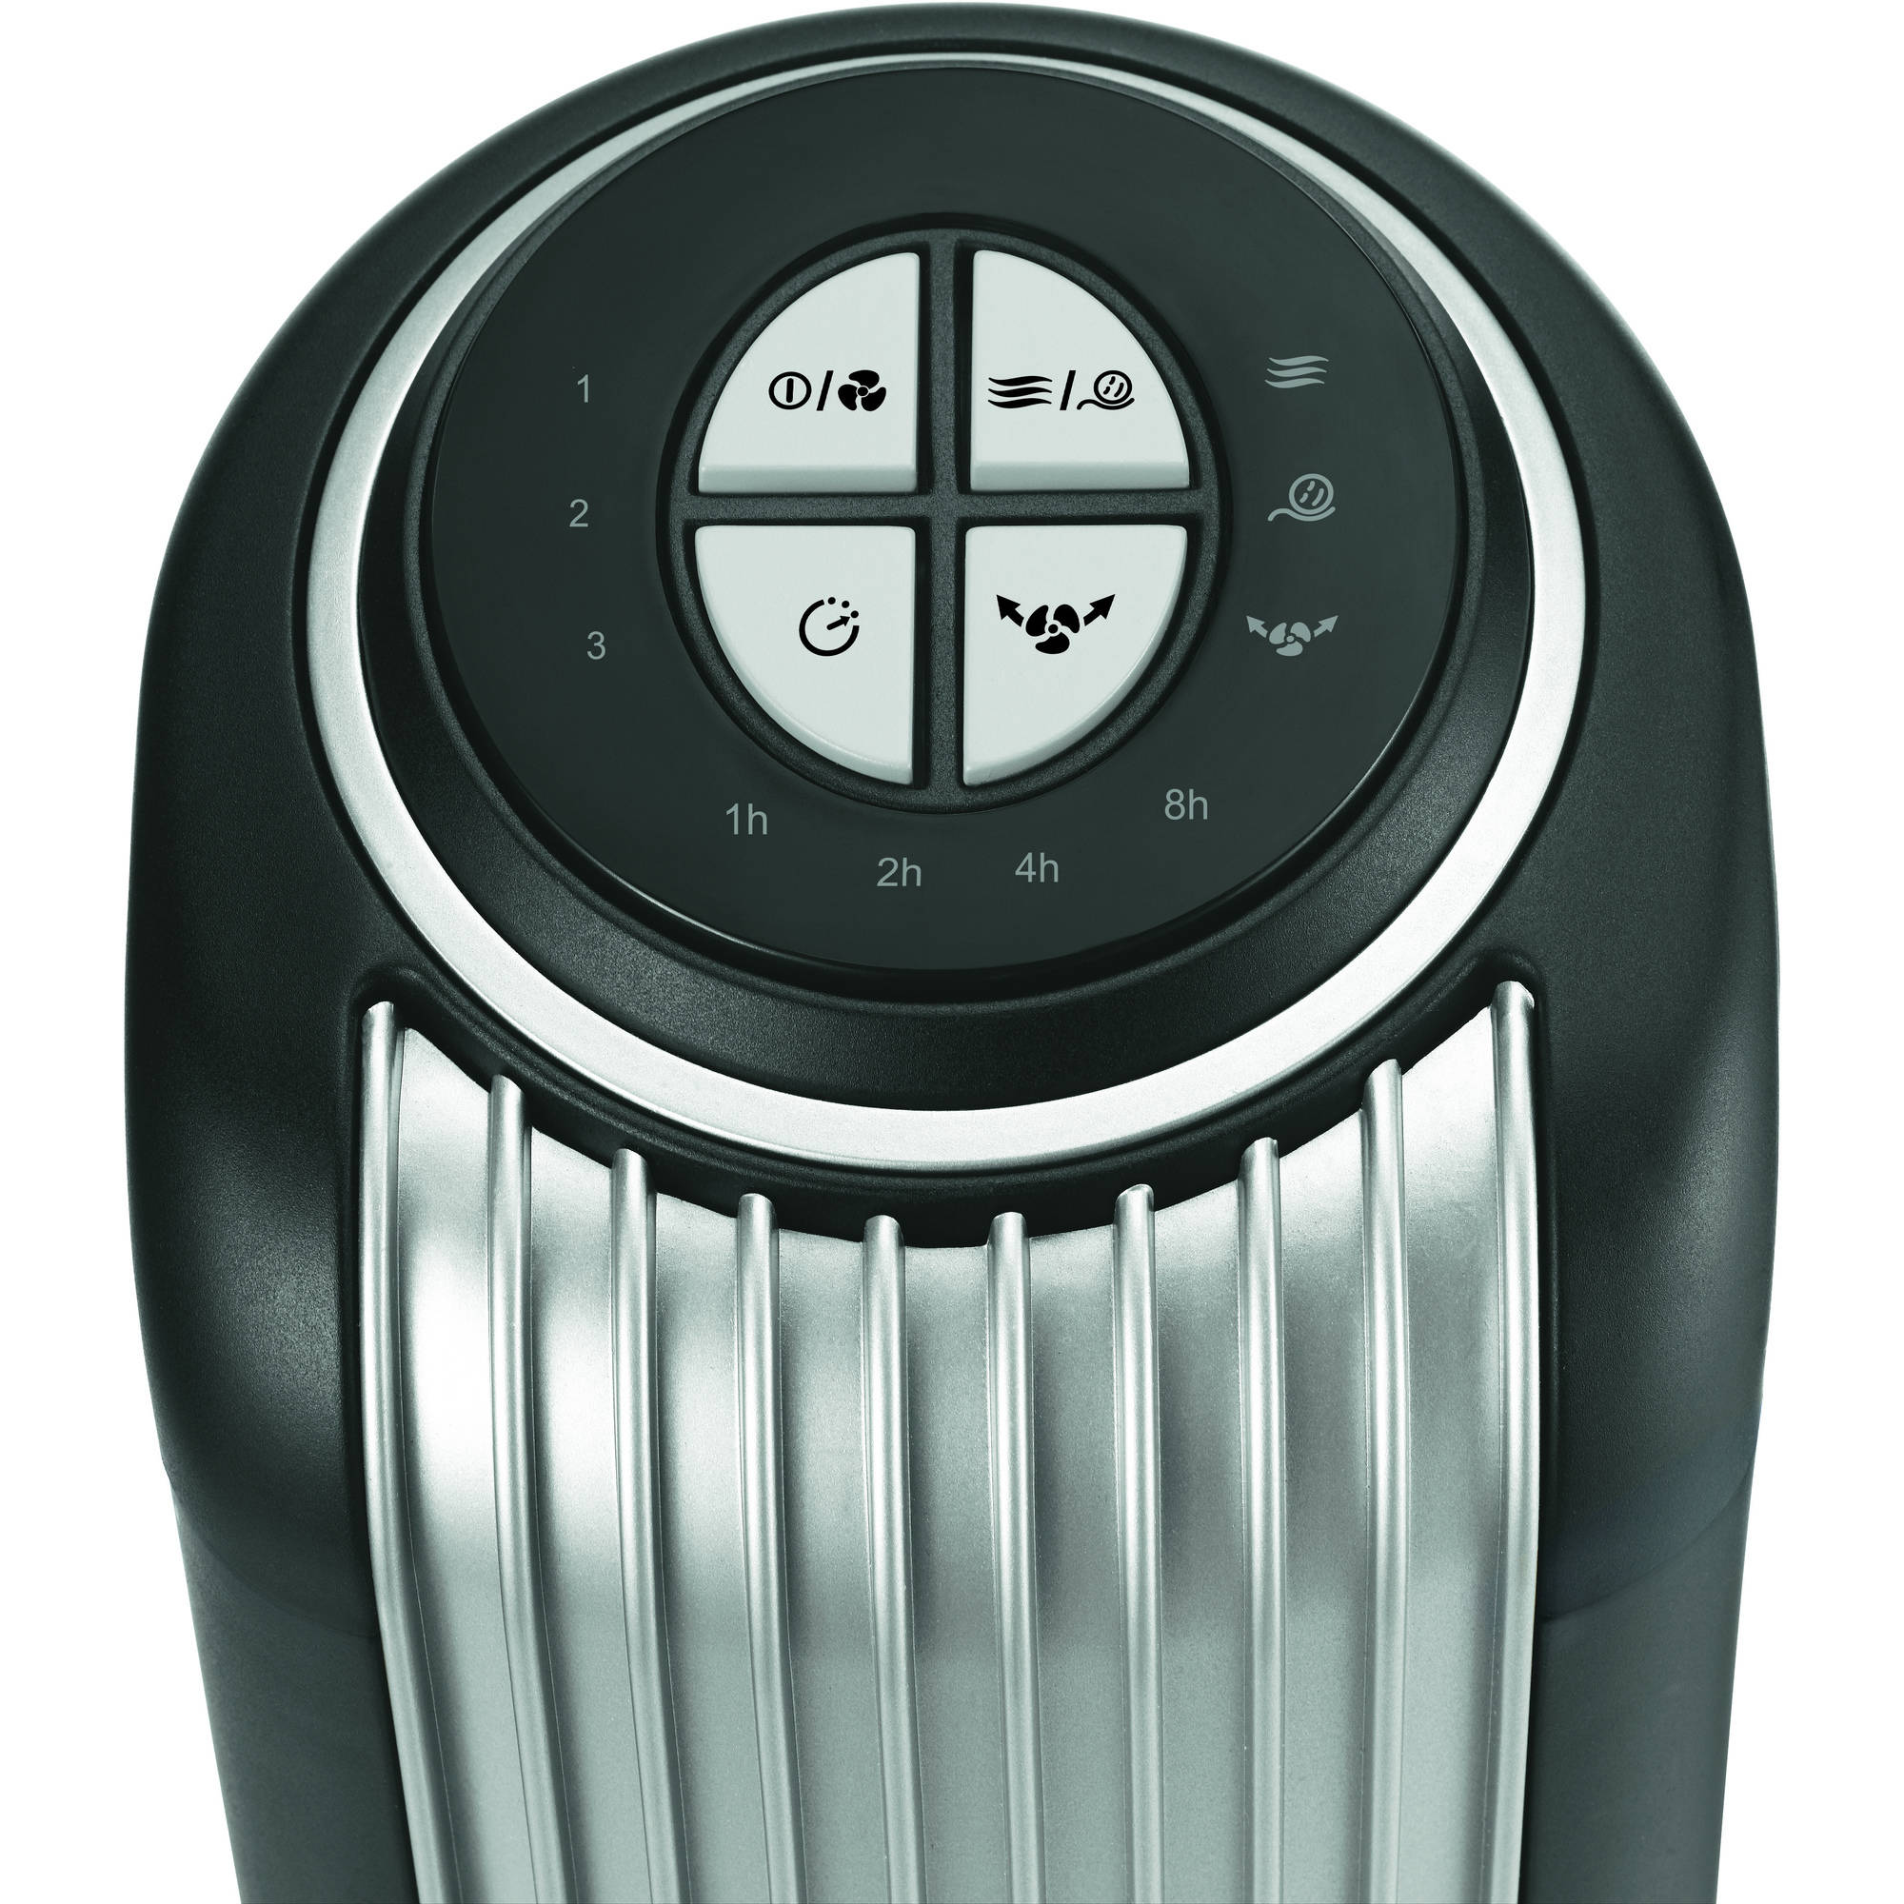

It is an oscillating tower fan that has an automatic shut off timer. This fan is big enough and strong enough to be able to cool the whole room fast and then shut off when it is not in use.

