Sports, Resistance, and Civil Rights:

Come to a book discussion and signing with Dennis Brutus, author of Poetry and Protest, and Dave Zirin, author of What’s My Name Fool?, to discuss how we can use sports to stop sweatshop labor here and abroad!


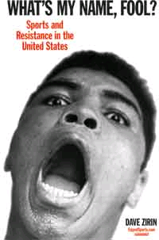

Wednesday, May 24th
7:00pm-9:00pm
Hill House Kaufmann Auditorium (Canteen)
1835 Centre Ave., Pittsburgh, PA 15219
Admission is FREE! Books will be available for purchase.

Sponsored by Azania Heritage International, the Pittsburgh Anti-Sweatshop Community Alliance, B-PEP Black Political Empowerment Project and Haymarket Books.
Contact Kenneth at 412.241.1339 or Michelle at 412.464.0768.

