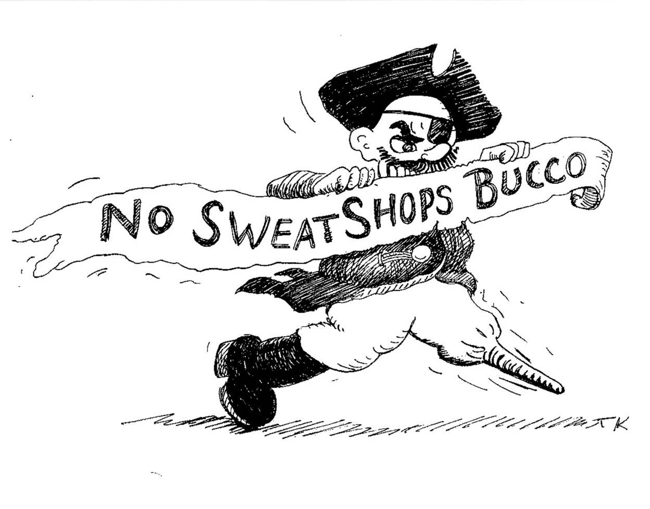

Sweatshop Meetings with Dennis Brutus
------------------
Wednesday May 17th and Wednesday May 24th

Wednesday May 17th at 7 PM at the Friends Meeting House - 4836 Ellsworth Ave.
Dennis Brutus will be leading the Pittsburgh Anti Sweatshop Community Alliance in a discussion about effective non-violent direct action at PNC Park on July 11. Dennis Brutus is the person who organized the expulsion of apartheid South Africa from the Olympic Games. Dennis now teaches at the University of Pittsburgh, serves on the Advisory Committee of the Thomas Merton Center, is a founder of Azania Heritage International and the Pittsburgh Anti Sweatshop Community Alliance. There is no one, in the world perhaps, more qualified to help Pittsburghers use our baseball team to protect workers’ rights. Dennis’s office is in Posvar Hall at the University of Pittsburgh. It not a coincidence that Posvar Hall is located on the site of Forbes Field… one of the places where Pittsburgh became the City of Champions. You are invited to join members of PASCA at the Friends Meeting House at 4836 Ellsworth Ave, close proximity to the University of Pittsburgh, Carnegie Mellon and many faith groups, to be a part of the planning of a diverse, effective, and safe, GLOBAL ACTION at the 2006 All Star Game. Professor Brutus has chosen to discuss the writings of Martin Luther King, Mohandas Ghandi and several of the athletes he worked with during the apartheid era. We will also be reviewing the testimony from workers in Haiti and Bangladesh and a letter to PASCA from Major League Baseball (4/21/06).

Wednesday May 24th at 7 PM at the Hill House - 1825 Centre Ave.
There will be discussion between Dennis Brutus and David Zirin at the Hill House. David Zirin is the foremost sports writers in America today. His recent book, What’s My Name Fool? has been described:
"Dave Zirin's 'What's My Name, Fool?' is the opening shot in our battle to reclaim sports." - Jim Bouton, former NY Yankee and author of Ball Four
"Beautifully illustrates the connection between sports, struggle, politics, and resistance." -Chuck D; Public Enemy
"I am a baseball fan, and I love this book. It is so refreshing to have a sports writer who writes with such verve and intelligence, who also has a social conscience, and who refuses to keep those parts of his life separate. This is a rare contribution to social history, something I have been looking for, a sports history which understands how the issues of race and class are inextricable from the world of sports." -Howard Zinn, third baseman, switch hitter.

David Zirin’s weekly sports column, including “The Value of a Number” about the retiring of #21 and “Stained Uniforms” about our SweatFree Baseball initiative can be read at www.edgeofsports.com

www.sweatfree.org ∙ www.nlcnet.org ∙ www.afscme2459.org

On July 11, 2006 Pittsburghers will set a new standard for accountability and disclosure in the sports apparel industry – led by the testimony of workers who sew Pirates apparel in SWEATSHOPS – we will be a Civil Rights Bridge from PNC Park to the floor of the global sweatshop.

Demonstrate the high standards for workers rights in the City of Champions for ourselves and the world at the 2006 All Star Game.
Nosweatshopsbucco@yahoo.com - No Sweatshops Bucco!

