


King Abdulaziz University
College of Engineering
Electrical and Computer Engineering

EE 424 (Antenna)
Project Part 1
(Microstrip Transmission Line)

Name: Waleed Khalid Al-Hubaishi
ID no: 2237324

Objective: Design and simulate a 50Ω microstrip transmission line with 1.2GHz and parameters values given by instructor substrate material FR4 ( εr = 4.3), and thickness (0.7) with electrical length (pi/4).
Starting with calculations we need to calculate effective dielectric constant so we can get the right length:
Hight = 0.7
Width = 1.36mm
Length = 17.293mm
effective dielectric constant = 3.265
All the calculations performed by hand on last page**

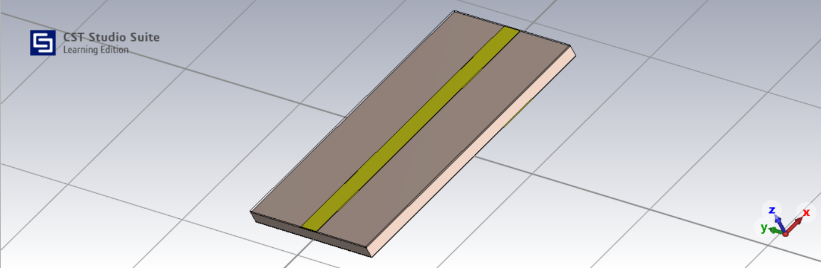

Microstrip Transmission Line

After designing and simulating microstrip line we got S11 and S22 very low around -54 dB and that shows perfect transmitting power with no loses. S12 and S21 close to 0dB indicate strong power transmitting. All results show an ideal performance of matched microstrip TL.

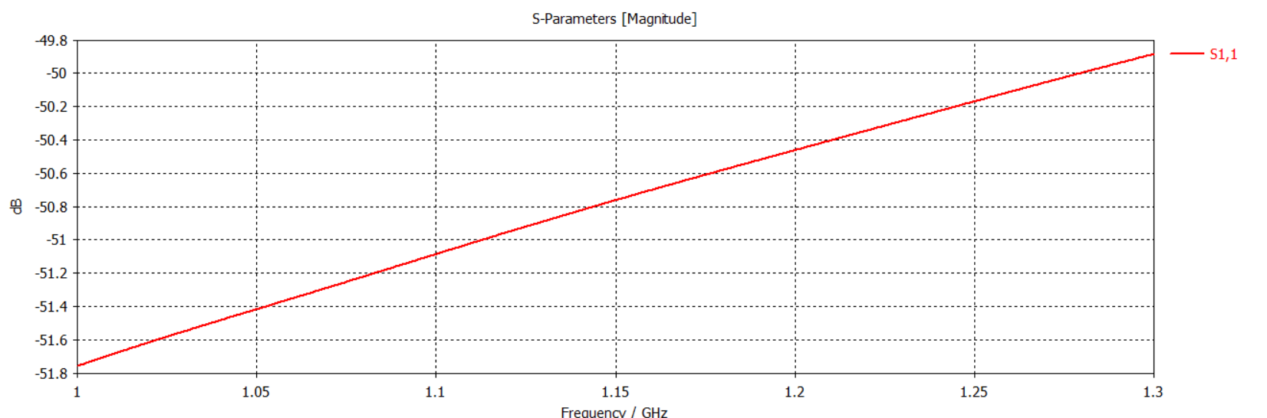
S11

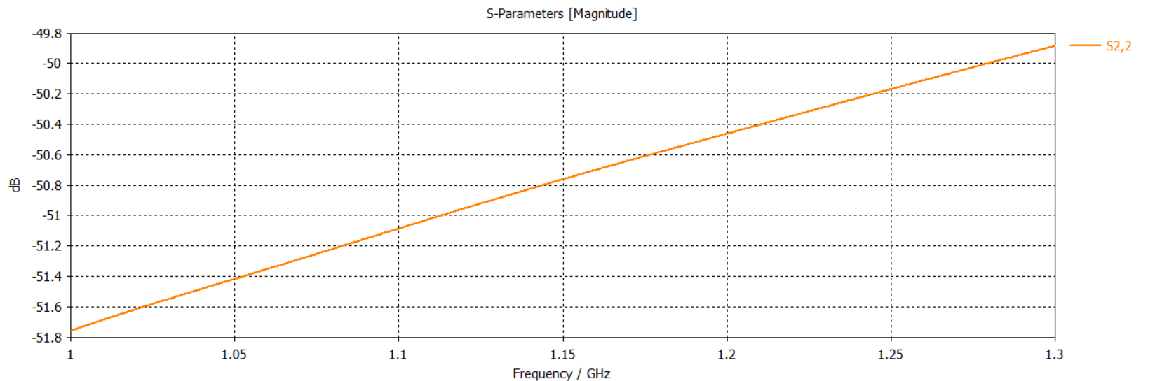
S22
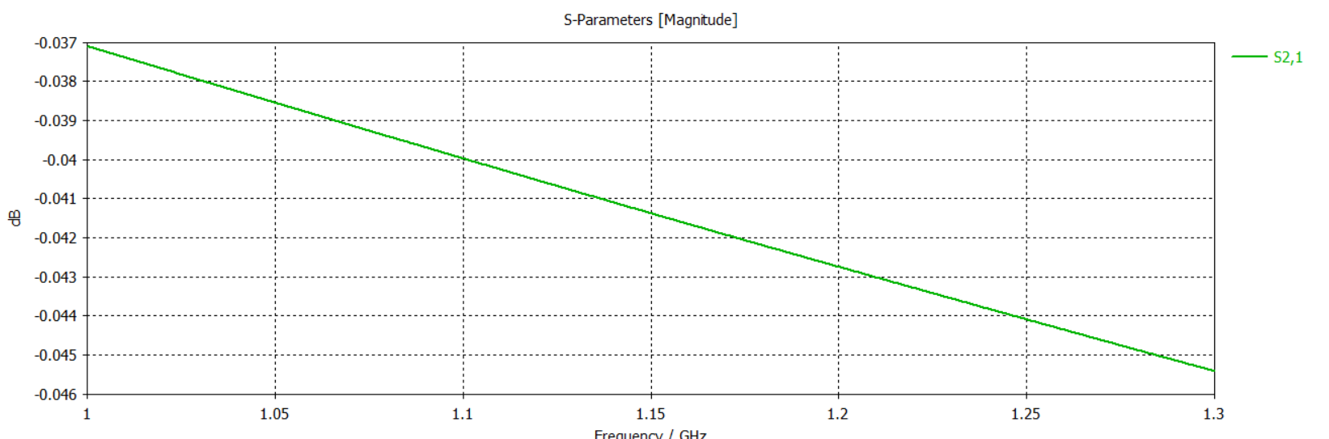

S21

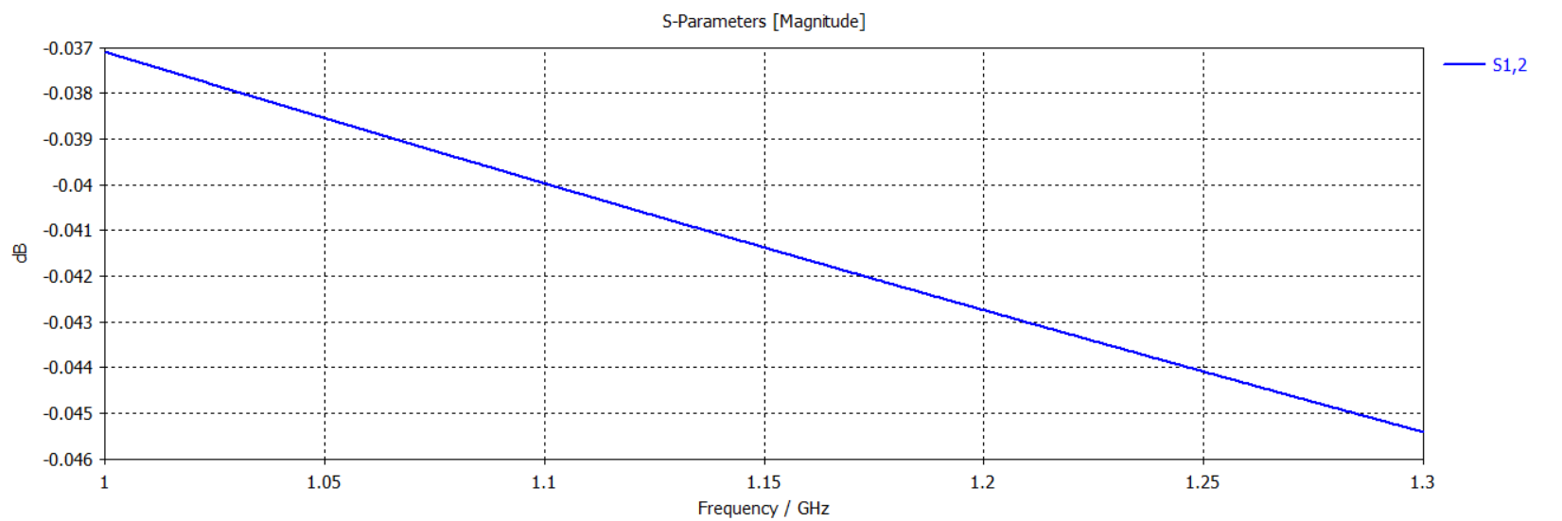
S12

References:
1- Lecture 16
2- Calculations done by hand:

