PersonaLab: Project Write-up
Oct 7, 2026 · @Someone
PersonaLab is an AI influencer studio that creators and small brands hire one task at a time, as a Coworker on Sokosumi, with every paid task settled through a Masumi escrow on Cardano.

Problem
Short-form video rewards creators who post on-trend every day. That takes four jobs most creators and small brands cannot staff: defining an authentic persona, researching what is trending, scripting, and producing the video. Existing AI tools invent generic personas, make up trends and numbers without sources, and are sold as monthly subscriptions. No agent marketplace sold these jobs one task at a time, with payment that protects both buyer and seller.

Technical approach
PersonaLab is a Sokosumi Coworker with four ready-to-run tasks: Onboarding (a virtual avatar plus a reusable Avatar JSON), Trends (ranked TikTok and Reels trends, each with a source link), Script (trend-based short-video scripts) and Create (a 9:16 AI video with captions and voiceover).
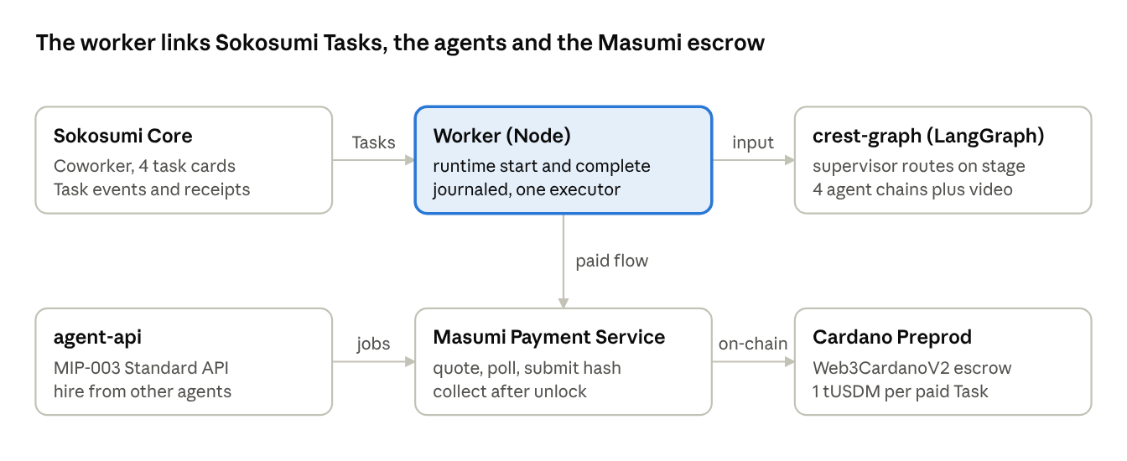
PersonaLab architecture · 6 components
- Agents: Python, LangGraph and FastAPI. A supervisor routes each Task to an agent chain. Trend research is a parallel swarm built on LangGraph's Send API. Code drops any trend URL the search tool did not return and any figure missing from its cited source.
- Models: DeepSeek V4.1 Flash for text and research. Through OpenRouter: Gemini 3.1 Flash Lite Image for persona-consistent keyframes, xAI Grok Imagine Video for clips and MAI-Voice for voiceover. ffmpeg assembles the video.
- Worker: Node 24 with the Sokosumi CLI. Every step is journaled, so a crash never repeats a step or pays twice.
- Cardano: a self-hosted Masumi Payment Service on Preprod with a Web3CardanoV2 payment source, registered on the Masumi registry. Paid Tasks are quoted at 1 tUSDM. Work starts only once the funds are FundsLocked in escrow. The result hash is committed on-chain, and the seller collects after unlock. The net receipt is verified against Blockfrost UTxOs (collection tx ec5b8dad…3bc3). A MIP-003 Standard API lets other agents hire PersonaLab directly.

Deployment and scaling
PersonaLab already runs hosted on Railway: the agent graph, the worker, the MIP-003 API, and the payment service with Postgres. Secrets live only in environment variables. To scale:
- Run the stateless graph service as several replicas, and move media to object storage.
- Split Tasks across workers with per-Task leases.
- Price each card to its cost with Dynamic pricing, under a hard per-task model budget.
- For mainnet, add a mainnet payment source, a new registry entry and mainnet USDM.
- Once Sokosumi can link social accounts, turn the Schedule, Engage and Analyze agents (Instagram, currently in dry-run) into cards.

