Analyzing and improving the “Trainings management” examinees queues and questionnaires of Sulzer GmbH (through the introduction of customized algorithms).

At the Sulzer GmbH a training tool is newly introduced. It is called “Sulzer Trainingsverwaltung” (Eng. Sulzer Trainings management) and has the purpose of offering online training in diverse subjects to the employees of the company. The subjects include: information security, data security, occupational safety and Sulzer quality management. “Trainings management” was internally audited to ISO 9001 on 22.08.2018.

Because of its relatively large and ever growing staff of now more than 800 employees, Sulzer GmbH needed a virtual platform to school all its employees. Considering the personnel dimensions and the number of subjects that every individual has to take part in, schooling in classrooms wasn’t efficient anymore. The company uses SharePoint successfully as an intranet platform, which was also the ideal location to embed a training tool. And so was “Trainingsverwaltung” born. Since its Go Live on May 2018, this online training platform has schooled around 500 employees. Now it’s possible to school way more staff members on a batch, but also in the meantime save a lot of financial resources and logistical planning.

As a result of being used constantly from employees of such a relatively large enterprise, there is a lot of raw data on the company servers, which can be used to enhance the quality of this service. There are a lot of questions that have arisen and need an answer like:

-Who should be invited on the next training of a particular subject?

-What were the most difficult questions on the previous tests?

-Was the formulating of the question/-s that brought the respective rate of failure? If so, how can they be better formulated, so that the next time more examinees succeed at these particular queries?

By providing answers to the above questions through this thesis, the exam composing team would be able to construct better tests.

The end goal of this thesis is to empirically show the enhancement that the approach brings to the training tool. The approach would consist of accessing the data through REST API, analyzing them, synthesizing the open questions to use cases, developing algorithms to solve them and then prove the efficiency of the procedure. This enrichment of the tool kit through the introduction of the above mentioned algorithms, should increase the efficiency of the tool and the efficacy of the users, i.e. better formulated and less failed exams.

Visible to every user area with a link to the main page

Personal area with link to the user training view

Protected administrative area with links to different SharePoint lists and views, which can only be seen by authorized users.

\*Only for the exam composing team\*

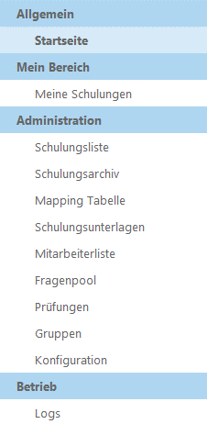

Protected area, where the logs are saved.

The image above is a screenshot of the “Trainings management” SharePoint site. A normal user sees just the top two areas. The third area can only be seen from the exam composing team, meanwhile the logs area serves to the DevOps department.