Development

-Write about Android Studio

At the start of the thesis, after the rough idea of the program was agreed upon, the next step was to choose an development environment. Because mobile apps are the hype in this day and age, it was decided to implement our solution using Android Studio. This was a very beneficiary because it also added another element to my development portfolio.

The first 3 weeks were designated for diving into AS world by reading the documentation, and also partaking into a lot of online tutorials. The first one was “Android - Studio”[1] from tutorialspoint.com(See Picture 1). After concluding that, the other one was “Android Developer Fundamentals Course”[2] from Google Developers. The third step was reading the documentation provided by developer.android.com. They helped myself tremendously and hopefully would come in handy when the development phase would begin.

-Write about Cocos Creator

After the Kick-Off Presentation and the completion of the Introduction, Related Work and Theory sections to almost their entirety, the development phase could start. A good idea was to find a framework that would aid with the animation of the game. The one who looked the most promising was CocosCreator[3]. So the next two weeks were used to get an introduction into the framework and to create an “Hello World” application.

-Game Design

The paradigm of the app is “Learning by playing”. It is the core value of a serious game and during the designing of the games, it was repeated constantly as to not lose sight of it. On that note, there are a lot of elements of gamification that sometimes get interchanged and regarded as serious game ones, but asking repeatedly “is the user learning by having fun?” always redirects to the right route.

The strategy behind this android app is pretty simple:

* Let the user play an easy minigame, initiating cognitive engagement
* KISS: Keep it(the game) short and simple, not mentally challenging
* Give instant feedback, especially negative one, to ignite a sense of competition user vs app
* After a successful attempt, give an relatively enthusiastic positive feedback and directly start with the teaching of a concept intended. Because of the small window between the positive feedback and the teaching, subconsciously a positive relationship will be created with the concept
* It is also very important to keep the teaching relatively small, as the user might be tempted to go to the next minigame and not read it. The feel good chemicals released from the brain during playing[4], make him/her crave the next minigame instead of a long boring chain of characters, that take a whole page. If however a small text is provided, containing just the essence, and enriched with bullet points lists, than the teaching has a very big chance to be read and understood.

As mentioned on the “Related Work” section, there is a plethora of apps to be found, which teach the same concepts and theory, but none of them in a very fun and engaging way. The mantra behind this project is to engage the user as much as possible, both intellectually but also to a certain degree, physically, i.e. by interacting with the screen of the device. Touching items, moving them around to their designated place, getting instantaneous positive or negative feedback, are all crucial components of the implementation.

- Where does the content come from?

The teachings of the app are extracted from the PMBOK(reference) but also from interesting pictures, charts, i.e. graphical representations of different concepts found online. Programmers know that reusing content available adds to the quality of the final product. The content found adds a nuance of humor, thus engaging the user more into playing.

The goal of the design is to subconsciously map inside the brain of the user, the game to an activity that brings fun, not one that merely shows concepts a software project manager should know at the tips of his fingers. That would create a sense of anxiety for the interactor with the app, especially if he/she is an aspiring PM, or an actual one which wants to learn new concepts or relearn the ones acquired sometimes ago.

By using content found online, designed not by not a single set of creators, adds a great deal of quality to the minigame.

-How does the app look(First View)

The first view of the app contains the name… talk about the first view(Game Logo, Name of the App, TUM logo, Lehrstuhl logo) Also

-Second View

On the second view, three chapters from the PMBOK Software Extension book were selected for the version 1.0 of the game, namely: “Introduction”, “Human Resource Management”, ”Time Management”. The user has the option of playing each one of the games by tapping at the labeled boxes, and by doing that the minigame of the chapter will start.

-Introduction chapter

This chapter on the book presents the reader with the core concepts of management of software projects. For the game a very popular and playful graphical representation of different points of view of a final product/software projects was chosen(see Figure[5] below).

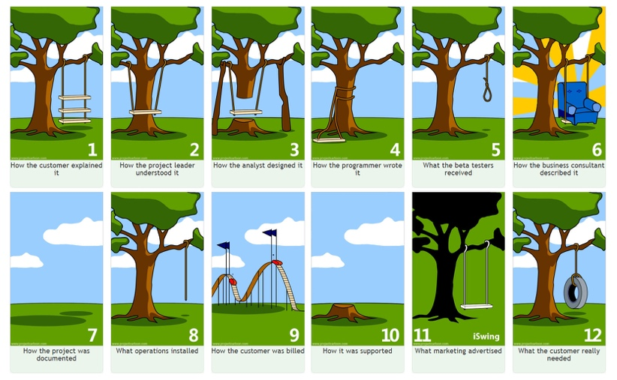

The twelve illustration sections show to a certain degree the real world actuality of a project, how it is understood, designed, sold etc. From this totality, four sets of three pictures were formed. By doing that, four minigames of Introduction chapter can be created. So the minigames are kept small, and four concepts can be taught after a successful attempt at each minigame.

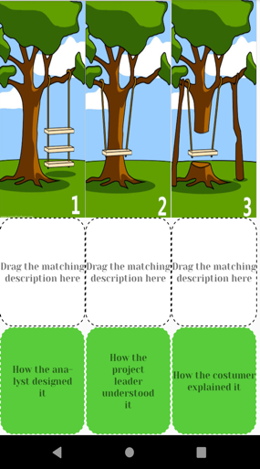The first minigame of the Introduction chapter is depicted on the figure 2(to the left). It has three main sections:

* The top one shows three pictures, with a similar background and entities, i.e. the tree and the swing. They all differ on the relationship between these two main actors.
* The middle one is a placeholder for the descriptions which match the picture above them. They are all labeled with the same text “Drag the matching description here”
* The bottom section contains three descriptions who ought to be mapped to each picture.

-None of the pictures of the upper section are interactable. There are no event listeners attached to them, as they direct the positioning of the description boxes.

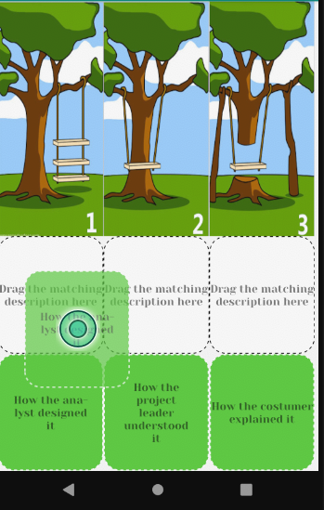-On each of the entities on the bottom section(called TextView on Android Studio), onLongClick-EventListeners were attached, so that when the user presses them for more than a fragment of a second, they become draggable. It was decided to use onLongClick instead of onTouch so that to be assured that the user intended to interact with the element, and it wasn’t an accidental contact.

As soon as an element of the bottom row is touched, the whole entity is movable, i.e. the box with the text centered (see figure on the left). It can be dragged to each of the rectangles on the middle section. There it will be proved if the description dragged matches the one expected, i.e. the one that correlates with the picture above it.

* If we don’t have a match then the box becomes red and a message “Not the right description” pops up. The box stays red and still accepts elements to be dragged in it.
* If we however have a match, then the middle box becomes green and barriers the text that was dragged from the rectangle below. This is simultaneously the text that correlates with the picture above. The element below becomes gray and is not draggable anymore. Also the now green middle box accepts no more draggable elements.

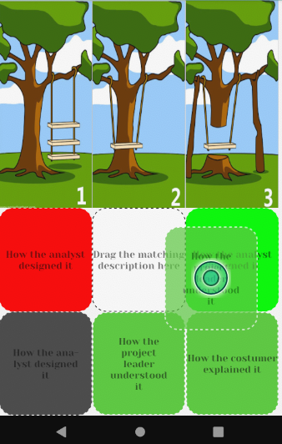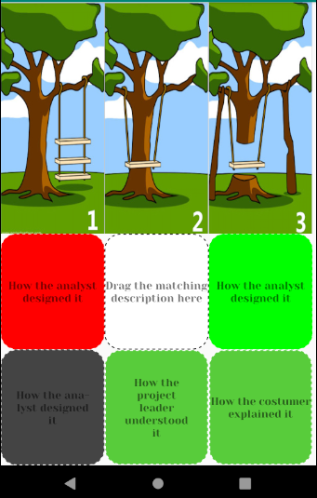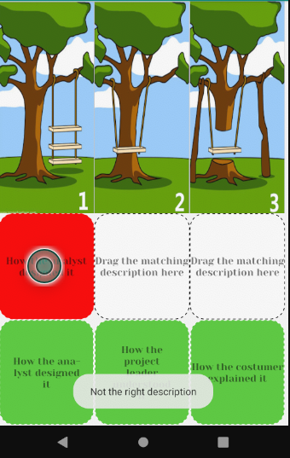

After the user has all the items to their respective places, then the

1. https://www.tutorialspoint.com/android/android_studio.htm
2. https://codelabs.developers.google.com/android-training/
3. https://cocos2d-x.org/creator
4. https://technologyadvice.com/blog/information-technology/activate-chemicals-gamify-happiness-nicole-lazzaro/
5. https://www.google.com/url?sa=i&rct=j&q=&esrc=s&source=images&cd=&ved=2ahUKEwjdrdm4kLzhAhWJ_qQKHTOECaoQjRx6BAgBEAU&url=https%3A%2F%2Fmedium.com%2F%40hj_chen%2Fgood-design-comes-from-overcoming-self-centredness-5b318950627a&psig=AOvVaw3U_6UYEpaV1sZjA7XJ0kn0&ust=1554662814701814