Introduction

* + ~~Timeframe of IT-Project-Management~~
  + Statistics (Failed Projects for example)
  + What is the problem and how are we going to address it with our project?
  + Write why fixing this problem is something of interest (write how me can progress faster if we manage projects properly, costs that saves for a company etc.)
  + Write about Gamification, Serious games, game elements injected in our app

*(Talk about the importance of IT/IT projects management and their evolution)*

With the ever growing evolution of technological components of our world, the importance of IT, the two being on a direct relationship, has also increased its significance. The number of IT projects, their contribution to the value chain of an enterprise, and also their magnitude has been taking giant leaps.

In this day and age of technological prosperity, we know that technological improvement is the engine bringing us forward, or better said UP into new heights, and what years ago was considered high tech is now mediocre at best.

(Brief history of (IT)-/Project management)

Project management is defined as the discipline of using established principles, procedures and policies to successfully guide a project from conception through completion[1].

Even though the process didn’t carry the above mentioned explicit name, civilizations have been managing projects[2] for quite some time. A few well known examples of completed projects of an enormous magnitude are: The Pyramids in Egypt, The Great Wall of China, The Colosseum etc.

“Project Management” as a term, started to be used in the early years of the previous century.

Its subset, “IT Project Management” was first used as a term during the late 1970s/early 1980s[3], a time when the software industry had a significant growth spurt. It is defined as [4] the process of planning, organizing and delineating responsibility for the completion of an organizations' specific information technology (IT) goals. Nowadays a lot of more progress is made on the software world, new dimensions are created, and the importance of IT is at an all-time high, and the tendency shows that this significance will magnify itself for years to come.

(Talk about successful IT projects)

Because of successful IT projects, we do not need any more to feed a punching card as input to a machine, but now we have to merely call her name followed by our order. We also don’t need to occupy a whole room in order to operate a computer, we can do it all and much much more on an as big as our palm piece of technology, known as a smartphone. As a result of good managed Information Technology projects a kid today can’t imagine having a device with only 64 KB of RAM, the amount of memory that sent Apollo 11 to the moon. As the saying goes “Information is the oil of the 21st century”, so being able to manage it the right way, is an amazing skill to be added to anybody’s skillset.

*(Talk about their failures)*

The enterprises know that outdated technology distinctly diminishes their market proportion, hence investing in the newest technology is paramount to them. They allocate their company resources into IT projects with the intention to at least maintain, but preferably improve their position towards their competition, and that’s why minimizing dissipation of these resources is vital. The Project Management Institute’s 2017 Pulse of the Profession report[5] found that “due to poor project performance, organizations waste an average of $97 million for every $1 billion invested.”

Unfortunately, even though their role is so essential, their failure rate is relatively high[6].

* According to IBM “only 40% of projects meet schedule, budget and quality goals. Further, they found that the biggest barriers to success are people factors.”
* Portland Business Journal concluded that “Most analyses conclude that between 65 and 80% of IT projects fail to meet their objectives, and also run significantly late or cost far more than planned.”
* KPMG New Zealand found that “…and incredible 70% of organizations have suffered at least one project failure in the prior 12 months and 50% of respondents indicated that their project failed to consistently achieve what they set out to achieve.”

The following 2014 Standish report depicts this failure problem. On it “a total of 365 respondents were surveyed, with a total of 8,380 software projects represented — only 16.2% of them turned out as “ideal projects." The following graph shows the overall breakdown of failed projects and imperfect projects. Keep in mind, the following categories are not mutually exclusive, and that over-time and over-budget were combined as they are closely linked together.”[7] 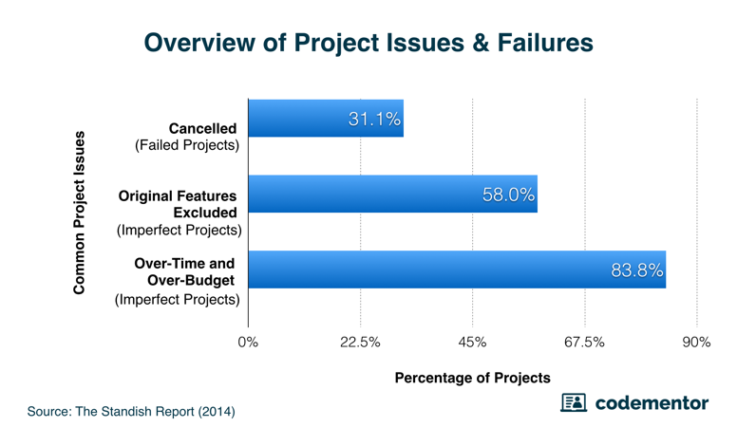

( See how you can reference this paper[8]).

As mentioned above a lot of importance is attached to IT on an enterprise nowadays, and to the management is clear that “putting their eggs on the wrong (IT) basket” can sometimes be detrimental to the firm.

With IT Project Management being a subset of Project Management, we can follow the breadcrumbs to the failure cause of a project similarly, but they differ in a lot of aspects too. So what are the failure factors related to IT projects? There is a large array of reasons influencing and causing so many IT projects to fail like “Inadequate resources, overly aggressive timelines, underestimated costs, overlooked requirements, unanticipated complications, poor governance and human mistakes such as bad code”[9](this is the same as reference 5), but the one, which we want to address with this project, is the management’s lack of knowledge, how to act in certain situations. There are also a lot of cases when the management is out of touch with the projects or not up to date with a lot of new terms and concepts, which we would think are outliers and exceptions to the rule, but actually it is one of the main causes of projects failures[10].

Even though the further training of the actual managers is part of the population this serious game intends to extend itself to, there is also another subset of society we want present ourselves to and that is the young generation, who are still on the crossroads and unsure which career path they want to take. According to a survey [11]there is shortage of STEM (Science, Technology, Engineering, Mathematics) jobs in USA. “As of 2016, the U.S. had roughly 3 million more STEM jobs available than it had skilled workers to fill them, according to Randstad data.”[12] So our goal with the app is to make sure that the magnitude of T(Technology) jobs shortage, is lowered on the near future, also as a consequence of a young lady or mister coming across our project, and after investing a bit of time reading and interacting with the app, found out that the “it” he/she was looking for was IT.

()

Why a serious game?

Firstly a few definitions: Serious games are defined as games designed for a primary purpose other than pure entertainment[(Wikipedia_Link)](https://en.wikipedia.org/wiki/Serious_game); Gamification is defined as application of game-design elements and game principles in non-game contexts[(Wikipedia_Link)](https://en.wikipedia.org/wiki/Gamification).

As it was proven here [13] “The results we obtained so far lead us to believe that serious game design has a direct and indirect effect over student’s perceived acquired competency, which is mediated by student's engagement”, which means for us, that designing and creating a serious game, “our” teachings would reach a large(r) audience, while simultaneously providing a better information acquisition. The broader the crowd, the lesser the shortage of technological jobs mentioned above. Also if the enterprises worldwide have better informed projects managers, that alone would significantly decrease the percentage of failed projects.

One of the main advantages of using an app to train employees is the reachability-effort ratio, i.e. a lot of users can be reached with very little effort. Training of the employees was before a process that required a lot of planning, a lot of logistics, to be able to teach a handful of people at a time, in contrast to remote training nowadays, which requires none of that, and simultaneously reaches far more members in a smaller timeframe.

The *ex-cathedra* way of schooling is outdated and the Gamification of project management is a far more superior way of teaching. As it was derived from this paper[14] “...the Gamification of the educational part of project management actually leads to better managed projects in the real business environment.”.

Write something else(Related Work)

The process of Gamification in teaching a concept was conducted also in an study published on this paper [(Link)](https://ieeexplore.ieee.org/document/7942932/authors#authors), where the agile project management technology, “Scrum” was taught to a group of 110 second year students. They all had different backgrounds (electrical engineering and computer science) but that was irrelevant, because the intention was to teach the participants the agile way of thinking, instead of diving deep into software or engineering related issues. As the conductors of the study found out “Gamification (or game-based learning) is motivating and helps bringing participants with different backgrounds together in project teams. The latter is what is needed in real development projects.” One of the other advantages noted on the paper was also the use of only one teacher.

There was a study[(Link for citation)](https://www.mendeley.com/viewer/?fileId=4ce67cb6-f159-cb6f-02ee-5bbf099106b1&documentId=cbbb225e-4f89-36dd-abd5-a0e94ddce58f) conducted that collected all the research papers describing the current state of the art of injecting Gamification in software management projects. In it there are a few take-home messages that would be used while designing this app:

1. It was concluded that “…half of the areas identified as project management areas evidence intervention with a Gamification approach…”, which means that teaching concepts of project management through a serious game is not a new concept, but nevertheless it is on it’s early stages.
2. Another conclusion of this study was that “…the software project management areas that explored Gamification more as an improvement strategy mainly propose improvement strategies, e.g (a) teamwork conditions, (b) interaction between stakeholders, and (c) participation of team members in a software development project…”, which means that we can address another area, which is (re)learning of IT project management concepts and methodologies.
3. It was also concluded that “…the table of positions, badges, and point systems improve results and user participation…”. That supports our intention of adding a point system to the game.

There was another study [(Link)](https://www.mendeley.com/viewer/?fileId=5da087e2-0f3c-e869-1f46-b86dccaeb395&documentId=b7d133c5-96eb-36bd-bd1a-ef3024d89a1c) which oversaw all the research published that studied the introduction of Gamification in education, the context in which was applied and the game elements used. The researchers concluded that “true empirical research on the effectiveness of incorporating game elements in learning environments is still scarce”, which may sound negative but there is a lot of hope because it was concluded that “Gamification hast the potential to improve learning if it is well designed and used correctly”. One of the main reasons because Gamification in education is not advancing as it should have, is because the course instructors lack the necessary technological skills to implement, maintain and direct these relatively high-tech entities. No wonder the field where Gamification of education found the biggest adoption rate is Computer Science/IT.

1. https://searchcio.techtarget.com/definition/project-management
2. https://www.projectmanager.com/blog/history-project-management
3. https://en.wikipedia.org/wiki/Software_project_management
4. https://searchcio.techtarget.com/definition/IT-project-management
5. https://www.cio.com.au/article/625522/why-it-projects-still-fail/
6. https://faethcoaching.com/it-project-failure-rates-facts-and-reasons/
7. https://www.codementor.io/blog/software-projects-failure-rate-success-factors-1nqch57orj
8. Tesch, D., Kloppenborg, T. J., & Frolick, M. N. (2007). IT PROJECT RISK FACTORS : THE PROJECT MANAGEMENT PROFESSIONALS PERSPECTIVE. *Journal of Computer Information Systems*, *47*(4), 61–70. https://doi.org/10.1080/08874417.2007.11645981
9. https://www.cio.com.au/article/625522/why-it-projects-still-fail/
10. https://www.objectstyle.com/agile/software-projects-failure-statistics-and-reasons
11. https://www.randstadusa.com/about/news/employers-must-redefine-stem-to-attract-future-talent-according-to-new-randstad-us-data/
12. https://www.cnbc.com/2017/08/23/why-we-have-a-shortage-of-tech-workers-in-the-u-s.html
13. Bonazzi, Riccardo & Missonier, Stéphanie & Jaccard, Dominique & Bienz, Pius & Fritscher, Boris & Fernandes, Emmanuel. (2011). Analysis of Serious Games Implementation for Project Management Courses. 10.1007/978-3-7908-2789-7_53.
14. Briers, B. (2013). The gamification of project management. Paper presented at PMI® Global Congress 2013—North America, New Orleans, LA. Newtown Square, PA: Project Management Institute.