CYBER PROTECTION TEAM 173
(CPT)

STANDARD OPERATING PROCEDURES (SOP)

Document Control

Issue Control
Document Title | CPT 173 SOP
Issue Date | June 6, 2022
Approved By | MAJ Richard Meehan
Document Location | MS Teams: VALEX 2022 > CPT 173 > Files  [After VALEX move to: CPT 173 > Incident_Response > Files]

Version History
Version # | Date | Author | Description of Change
1.0 | June 6, 2022 | Gifford | Initial consolidation and update of content
1.1 | June 7, 2022 | Gifford / Meehan | Clarifying edits

CPT 173 MISSION

CPT 173 team’s mission is to <insert mission here> using an organized, formal investigative process. The response process includes detection and analysis, containment, eradication, and recovery of affected systems.

Required Documents

CPT 173 will not operate on a host network without a Memorandum of Understanding (MOU) signed by the network owner and a designated representative of the CPT or NYARNG Judge Advocate General (JAG). MOU must be vetted by the NYARNG JAG or a qualified representative prior to signature by anyone in the CPT.

CPT 173 will not take any action on the host network without written approval.

Team Functions

Team is responsible for providing the following functions:

    - Threat Intelligence - Assess customer risks and how they align with threat actors. Coordinate with fusion cell to analyze indicators of compromise discovered.
    - Network security - Install taps and SIEM to collect and analyze network traffic for indications of compromise.
    - Host security - Perform in depth analysis of servers and clients identified by customers and analysis of user accounts and authentication systems.
    - Support – provide leadership, operations support, coordinate with customer, teams, media, and law enforcement as applicable.

Response Workflow

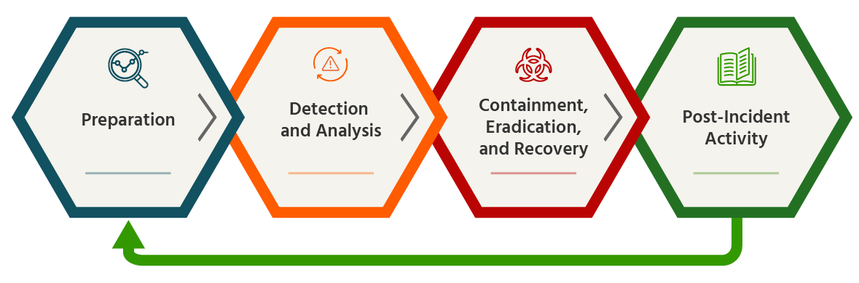

Incident Toolkit
The Cyber Protection Team will use the following tools during missions:
- Deployable Defensive Cyber Operations System Modular (DDSM) will be employed for information gathering and forensic collection activities,
- NextCloud will be used as the team Common Operating Picture tool.

Task Organization
Task organization will be modified to support specific responses as required. The figure below represents the default CPT organization prior to mission adjustments.
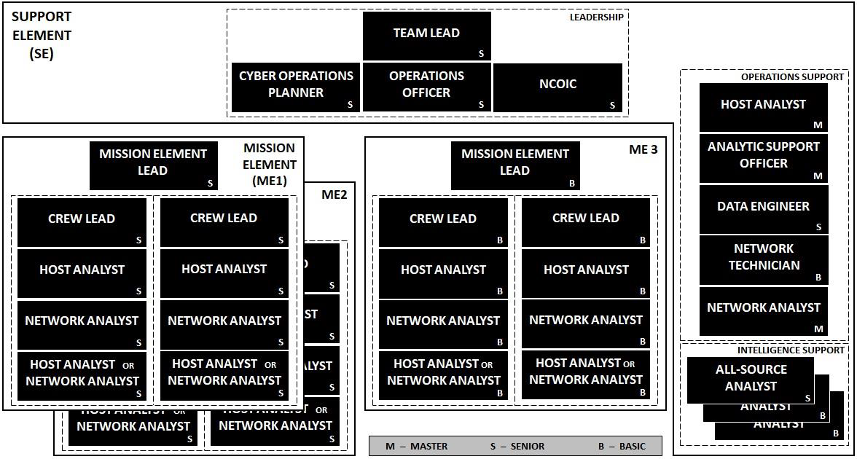

CPT Core Functions

Core functions for the Cyber Protection Team are as follows, as referenced in CWP 3-33.4:

- Hunt - the process of proactively and iteratively searching through networks to detect evidence of Malicious Cyber Activity (MCA) to gain and maintain contact with an adversary and develop the situation.
- Clear - an operation to target and engage MCA in order to eliminate or neutralize it from a network or system, and may include actions to interdict, contain, disrupt, or degrade MCA.
- Enable Hardening - maintain and update network or system hardening recommendations for the duration of hunting and clearing operations
- Assess - assess the effectiveness of clearing operations, hardening actions taken by local network defenders, and the overall network system security, and resilience.

CPT core functions are accomplished through the below actions:

Response and Recovery

Response and recovery are situation dependent and include:

      - Resolving the incident according to policy, procedures, written agreements, and quality requirements.
      - Implementing proactive and reactive defensive and protective measures to prevent similar incidents from occurring in the future.
      - Eradicating the risk or threat.
      - Restoring the integrity of the system and returning it to an operational state.

Eradication Actions

Eradication consists of the steps required to eliminate the root cause(s) of an intrusion. All threats and vulnerabilities should be removed from systems and networks before returning them to service. If a previously exploited vulnerability is not removed, then a system can be easily compromised or breached again. The primary objectives for eradication are to:

        - Ensure the removal of the cause(s) of the malicious activity and any associated files.
        - Ensure the elimination of any access methods used by the intruder, including vulnerabilities, physical security problems, or human error.

System Recovery

System recovery consists of the steps necessary to restore the integrity of affected systems, return the affected data, systems, and networks to an operational state, and implement follow-up strategies to prevent the incident from recurring. The main objectives of recovery are to:

        - Restore the integrity of the system by rebuilding it from trusted media when necessary.
        - Ensure all data and systems are operating in a normal fashion.
        - Ensure the complete resolution and closure of the incident.

No system should be rebuilt until the system data has been adequately preserved and the vulnerability has been mitigated. Systems having a Category 1, Category 2, and Category 7 must be rebuilt from trusted media. Categories are defined in Table A-A-1 below.

Also, as part of the recovery process, any containment activities completed may need to be removed. This can include removing any blocks that are no longer necessary, re-enabling services, and reconnecting systems and networks to the LAN or Internet.

CYBER INCIDENT AND REPORTABLE CYBER EVENT CATEGORIZATION

1. Introduction

Cyber Event Categorization is intended to assist in the prioritization of events and will directly relate to the allocation of resources and the tempo of reporting.

2. Reporting

- Mission Elements will report to Headquarters Element no less than once per operational period. Reports will include IOC’s found, recommended actions, actions performed, and any personnel or equipment changes at a minimum.
- Headquarters will coordinate with the network owner or their designated representative no less than once per day.
- IOCs and identified Malicious Cyber Activities will be categorized and reported with their associated top-level tactic as identified in the MITRE ATT&CK framework.

3. Categories

- In cases where more than one category applies, the category assigned should be determined using the following precedence in Table A-A-1. Lower precedence number indicates a more important event, with 1 being the most important event and 0 being the least important.
Precedence | Category | Description
1 | 1 | Root Level Intrusion (Incident)
2 | 2 | User Level Intrusion (Incident)
3 | 4 | Denial of Service (Incident)
4 | 7 | Malicious Logic (Incident)
5 | 3 | Unsuccessful Activity Attempt (Event)
6 | 5 | Non-Compliance Activity (Event)
7 | 6 | Reconnaissance (Event)
8 | 8 | Investigating (Event)
9 | 9 | Explained Anomaly (Event)
0 | 0 | Training and Exercises

Table A-A-1. Category Precedence
- For instance, an incident could be reported either as a User Level Intrusion (Category 2) or a Non-Compliance Event (Category 5). The User Level Intrusion takes precedence based on Table A-A-1, and the incident should be reported as a User Level Intrusion (Category 2) incident.

- Investigating (Category 8) reports will include an initial assessed incident category (Categories 1-7 or 9) and be re-categorized based on continued investigation. No reports will be closed as a Category 8.

- Table A-A-2 provides incident and reportable event categories.

Category | Description
0 | Training and Exercises—Operations performed for training purposes and support to exercises.
1 | Root Level Intrusion (Incident)—Unauthorized privileged access to an IS. Privileged access, often referred to as administrative or root access, provides unrestricted access to the IS. This category includes unauthorized access to information or unauthorized access to account credentials that could be used to perform administrative functions (e.g., domain administrator). If the IS is compromised with malicious code that provides remote interactive control, it will be reported in this category.
2 | User Level Intrusion (Incident)—Unauthorized non-privileged access to an IS. Non-privileged access, often referred to as user-level access, provides restricted access to the IS based on the privileges granted to the user. This includes unauthorized access to information or unauthorized access to account credentials that could be used to perform user functions such as accessing Web applications, Web portals, or other similar information resources. If the IS is compromised with malicious code that provides remote interactive control, it will be reported in this category.
3 | Unsuccessful Activity Attempt (Event)—Deliberate attempts to gain unauthorized access to an IS that are defeated by normal defensive mechanisms. Attacker fails to gain access to the IS (i.e., attacker attempts valid or potentially valid username and password combinations) and the activity cannot be characterized as exploratory scanning. Reporting of these events is critical for the gathering of useful effects-based metrics for commanders.  .
4 | Denial of Service (Incident)—Activity that denies, degrades, or disrupts normal functionality of an IS or DoD information network.
5 | Non-Compliance Activity (Event)—Activity that potentially exposes IS is to increased risk as a result of the action or inaction of authorized users. This includes administrative and user actions such as failure to apply security patches, connections across security domains, installation of vulnerable applications, and other breaches of existing DoD policy. Reporting of these events is critical for the gathering of useful effects-based metrics for commanders.
6 | Reconnaissance (Event)—Activity that seeks to gather information used to characterize ISs, applications, DoD information networks, and users that may be useful in formulating an attack. This includes activity such as mapping DoD information networks, IS devices and applications, interconnectivity, and their users or reporting structure. This activity does not directly result in a compromise.
7 | Malicious Logic (Incident)—Installation of software designed and/or deployed by adversaries with malicious intentions for the purpose of gaining access to resources or information without the consent or knowledge of the user. This only includes malicious code that does not provide remote interactive control of the compromised IS. Malicious code that has allowed interactive access should be categorized as Category 1 or Category 2 incidents, not Category 7. Interactive active access may include automated tools that establish an open channel of communications to and/or from an IS.
8 | Investigating (Event)—Events that are potentially malicious or anomalous activity deemed suspicious and warrant, or are undergoing, further review. No event will be closed out as a Category 8. Category 8 will be re-categorized to appropriate Category 1-7 or 9 prior to closure.
9 | Explained Anomaly (Event)—Suspicious events that after further investigation are determined to be non-malicious activity and do not fit the criteria for any other categories. This includes events such as IS malfunctions and false alarms. When reporting these events, the reason for which it cannot be otherwise categorized must be clearly specified.

Table A-A-2. Cyber Incident and Reportable Cyber Event Categories

Risk Assessment

CPT will categorize risk by assessing the probability and impact of MCA:
- Probability of occurrence:
  - Very likely: occurs often, continuously experienced
  - Probable: likely to occur or occurs several time
  - Improbable: unlikely, but could occur at some time
  - Highly unlikely: can assume it will not occur
- Impact/Consequence:
  - High: critical objectives cannot be achieved
  - Significant: only the most critical objectives can be achieved
  - Moderate: can partially achieve all objectives
  - Low: can fully achieve all objectives

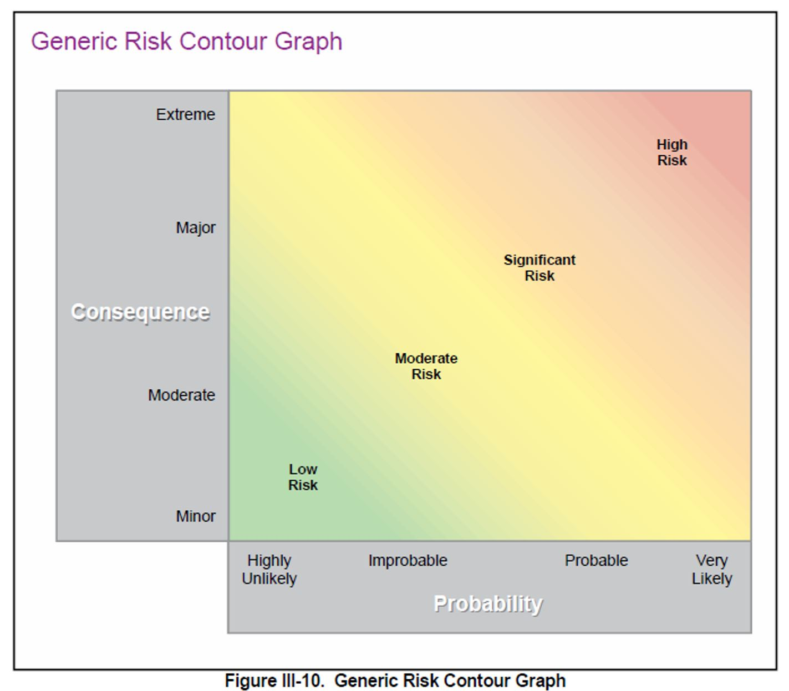

Cyber Threat Intelligence Cell INCIDENT RESPONSE REPORT

The following Priority Intelligence Requirements (PIR) should be used for most responses:
- What threat actor(s) were involved?
- Which vulnerabilities and tactics were used to gain access to the network?
- What tools and/or techniques were used to maintain persistence when the threat actor got onto the network?
- What were the objectives of the network intrusion?
- What were the C2 domains/IP addresses?
- What type of malware was used?
- What indicators of compromise were found within the network?
- What exploitable vulnerabilities were found within the network?
- What industry related cyber-attacks were identified?

Utilize the Mitre ATT&CK framework to organize tactics, techniques, and procedures corresponding to any identified MCA to create a holistic view of the cyber incident.

Fields identified below will not always be used and should be completed as needed to satisfy reporting requirements as defined by the local Threat Intelligence Cell.

Field | Description
Cyber Threat Intelligence Cell Incident Tracking Information
Incident Number | Identify the reporting Redmine reference number for tracking the incident.
Reporting Information
Name | The first and last name of the individual reporting the incident.
Telephone | The telephone or Defense Switch Network (DSN) number to be used to reach the reporting entity for additional information. The number can be for an individual’s number or the central number for the organization (e.g., operations center).
E-mail | The e-mail address that should be used to reach the reporting entity for additional information. This may be the e-mail address of an individual or central e-mail for the organization (e.g., operations center).
Alternative Contact | The name, telephone number, and e-mail of an alternative contact in the event the reporter is not available.

Categorization Information
Primary Incident Category | Identify the primary underlying cause of the incident being reported IAW CJCSM 6510.01B Appendix A to Enclosure B (Incident and Reportable Event Categorization).
Secondary Incident Category | Identify any secondary causes for which the incident is being reported, if more than one category applies, CJCSM 6510.01BIAW Appendix A to Enclosure B (Incident and Reportable Event Categorization).
Delivery Vector | Identify delivery vector CJCSM 6510.01B IAW Appendix A to Enclosure D (Delivery Vectors.)
System Weaknesses | Identify delivery vector CJCSM 6510.01B IAW with Appendix B to Enclosure D (System Weaknesses).
Incident Status
Status | Status of the incident (“OPEN,” “INVESTIGATING,” “MITIGATED,” or “CLOSED”).
Incident Start Date | ZULU date-time group (DTG) of the earliest event that was incorporated into the incident. Provide year/month/day/hour/minute/ seconds.
Incident End Date | ZULU DTG that incident actually ended. Provide year/month/day/hour/ minute/seconds.
Last Update | ZULU DTG of the last time the report was updated. Provide year/month/day/hour/minute/seconds.
Date Reported | ZULU DTG of when the incident was first reported to the CNDSP. Provide year/month/day/hour/minute/seconds.
System Classification | Report the classification of the IS under attack (i.e., Unclassified, Confidential, Secret, TS, SCI). This field is NOT used to classify the reported incident.
Action Taken | Indicates what action has been taken in response to the incident. Include notifications and associated reports. Additionally, include whether a copy of a media was taken (image hard drives), or logs collected and disposition of mediums and logs.

Technical Details
Event/Incident Description | Provide a narrative description of the incident with technical details. Include DTGs of significant events (start, stop, or change of activity). State the use of the targeted IS and whether the IS is online or offline. Indicate whether the incident is ongoing.
Root Cause(s) | Identify the IS specific cause(s) of the incident. The root cause expands upon the identified delivery vector(s) and IS weaknesses by precisely identifying the sets of conditions allowing the incident to occur. Indicate whether the DAA or CIO had accepted a risk that led to the incident.
Source IP and Port | Provide source IP with resolution data identifying owner and country of source IP machine. Note: The source IP could be a DoD IP. If the intruder is known, provide all identifying information to include the intruder’s objective, if known. Source IP is not necessarily indicative of true origin. Footnote the source of resolution/attribution data (i.e., ARIN.org). Insert “Not Applicable” for incidents that do not involve source IP or port.
Intruder(s) (if known) | Identify the intruder or group responsible for the incident, if known.
Origin (Country) | Identify the source IP’s country of origin.
Target IP(s) and Port | Provide target IP with resolution identifying responsible command and physical location of target IP machine (e.g., B/C/P/S, etc.). Footnote the source of resolution/attribution data (i.e., DDD NIC, nslookup, and whois). If machine is behind a network address translation enabled (NAT’ed) router or firewall then also provide the wide area network (WAN) routable address (i.e., the Internet/SIPRNET routable IP address).
Technique, Tool, or Exploit Used | Identify the technique, tool, or exploit used.
Operating System (OS) and OS Version | Record the OS and version number of the OS where the incident occurred.
Use of Target (e.g., Web Server, File Server, Host) | What the intruder/attacker used the target IS for, after it was exploited, if applicable.
Method of Detection | Identify how the intrusion was detected (e.g., external notification, log files, network monitoring, IDS, user).
Affected Unit or Organization | The name of the reporting affected unit or organization.
Impact Assessment
Systems Affected | Number of ISs affected by the incident.
Operational Impact | Identify any detrimental effects on ability to perform mission by organization directly affected. Include organizations affected (e.g., due to being network users). Include impact on the ability of other organization(s) to perform mission. This includes an operational impact assessment CJCSM 6510.01B IAW Appendix C to Enclosure D (Impact Assessment Matrix).
Technical Impact | Identify any detrimental effects on the technical capabilities of the organization (e.g., data loss, service degradation, effects on other systems). This includes a technical impact assessment IAW Appendix C to Enclosure D (Impact Assessment Matrix). If the technical impact cannot be determined for some reason (e.g., limited details or analysis), use Table C-B-2 (Initial Impact Assessment) for a limited impact assessment.
Additional Reporting or Coordination
Intel Reporting | State whether the incident was reported to the IC. If reported, identify the agency contacted and any specific actions that have been coordinated.
Other
Exercise Name | Name of the exercise, if applicable.
Operation Name | Name of the operation or focused operation, if applicable.

Network Analysis

Security Onion

Security Onion is the primary tool of CPT 173 for analysis of network traffic. It is a free and open Linux distribution for threat hunting, enterprise security monitoring, and log management. It includes tools for Alerts, Dashboards, Hunt, PCAP, and Cases, as well as other tools such as Playbook, FleetDM, osquery, CyberChef, Elasticsearch, Logstash, Kibana, Suricata, Zeek, and Wazuh.

References

- NIST: SP 800-61 Rev 1, Cyber Incident Handling Guide, http://nvlpubs.nist.gov/nistpubs/SpecialPublications/NIST.SP.800-61r2.pdf

- NIST: SP 800-100, Information Security Handbook, https://csrc.nist.gov/publications/detail/sp/800-100/final

- CJCSM 6510.01B: Cyber Incident Handling Program, http://www.jcs.mil/Portals/36/Documents/Library/Manuals/m651001.pdf?ver=2016-02-05-175710-897

- Security Onion: https://github.com/Security-Onion-Solution

- Cyber Warfare Publication 3-33.4, Cyber Protection Team (CPT) Organization, Functions and Employment (28 January 2020)

