What does React Native mean?

1. A single source, using javascritp (React Native)

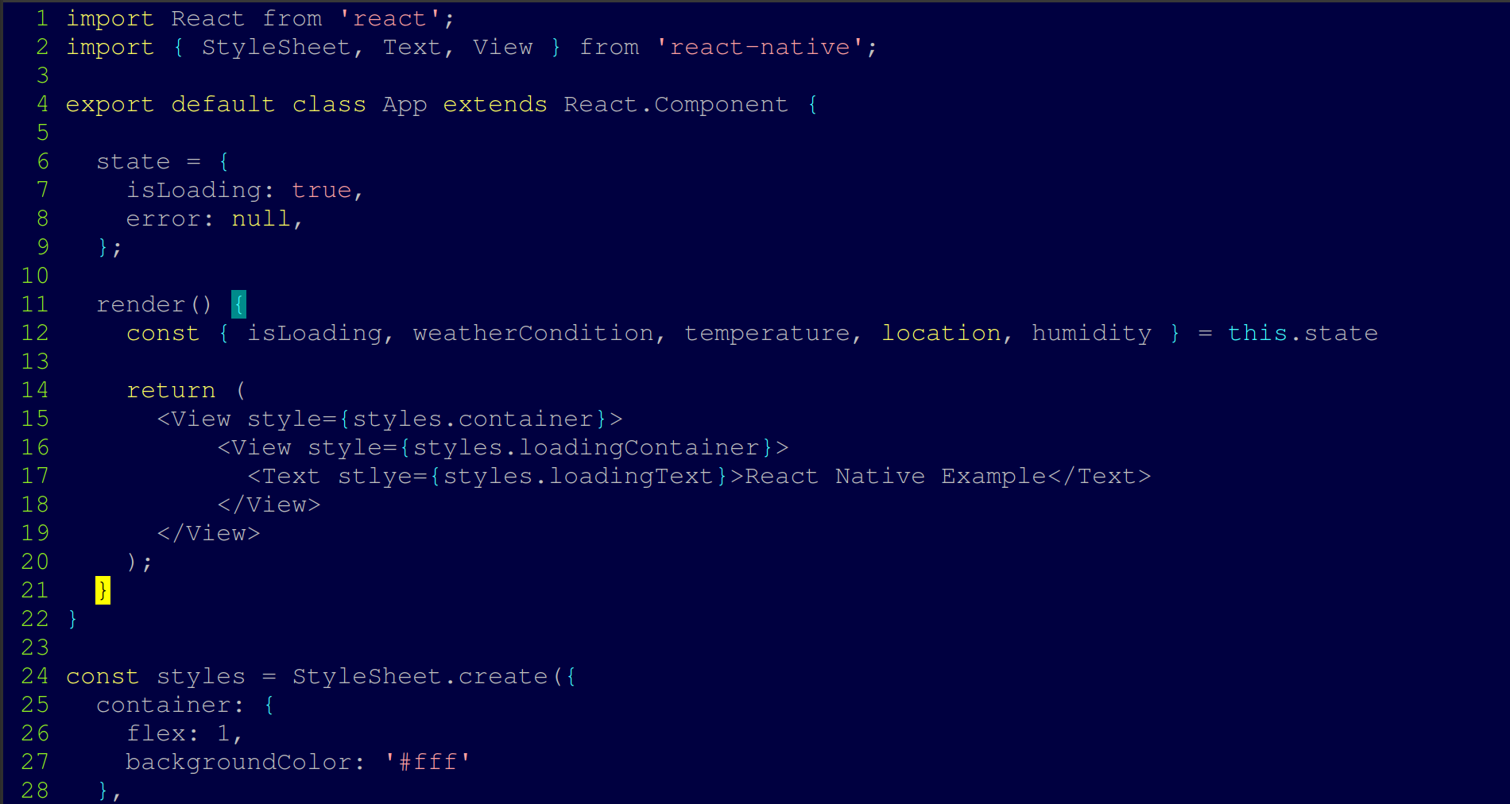

2. Several applications, using the same source, shown above: web, android, ios, microsoft mobile

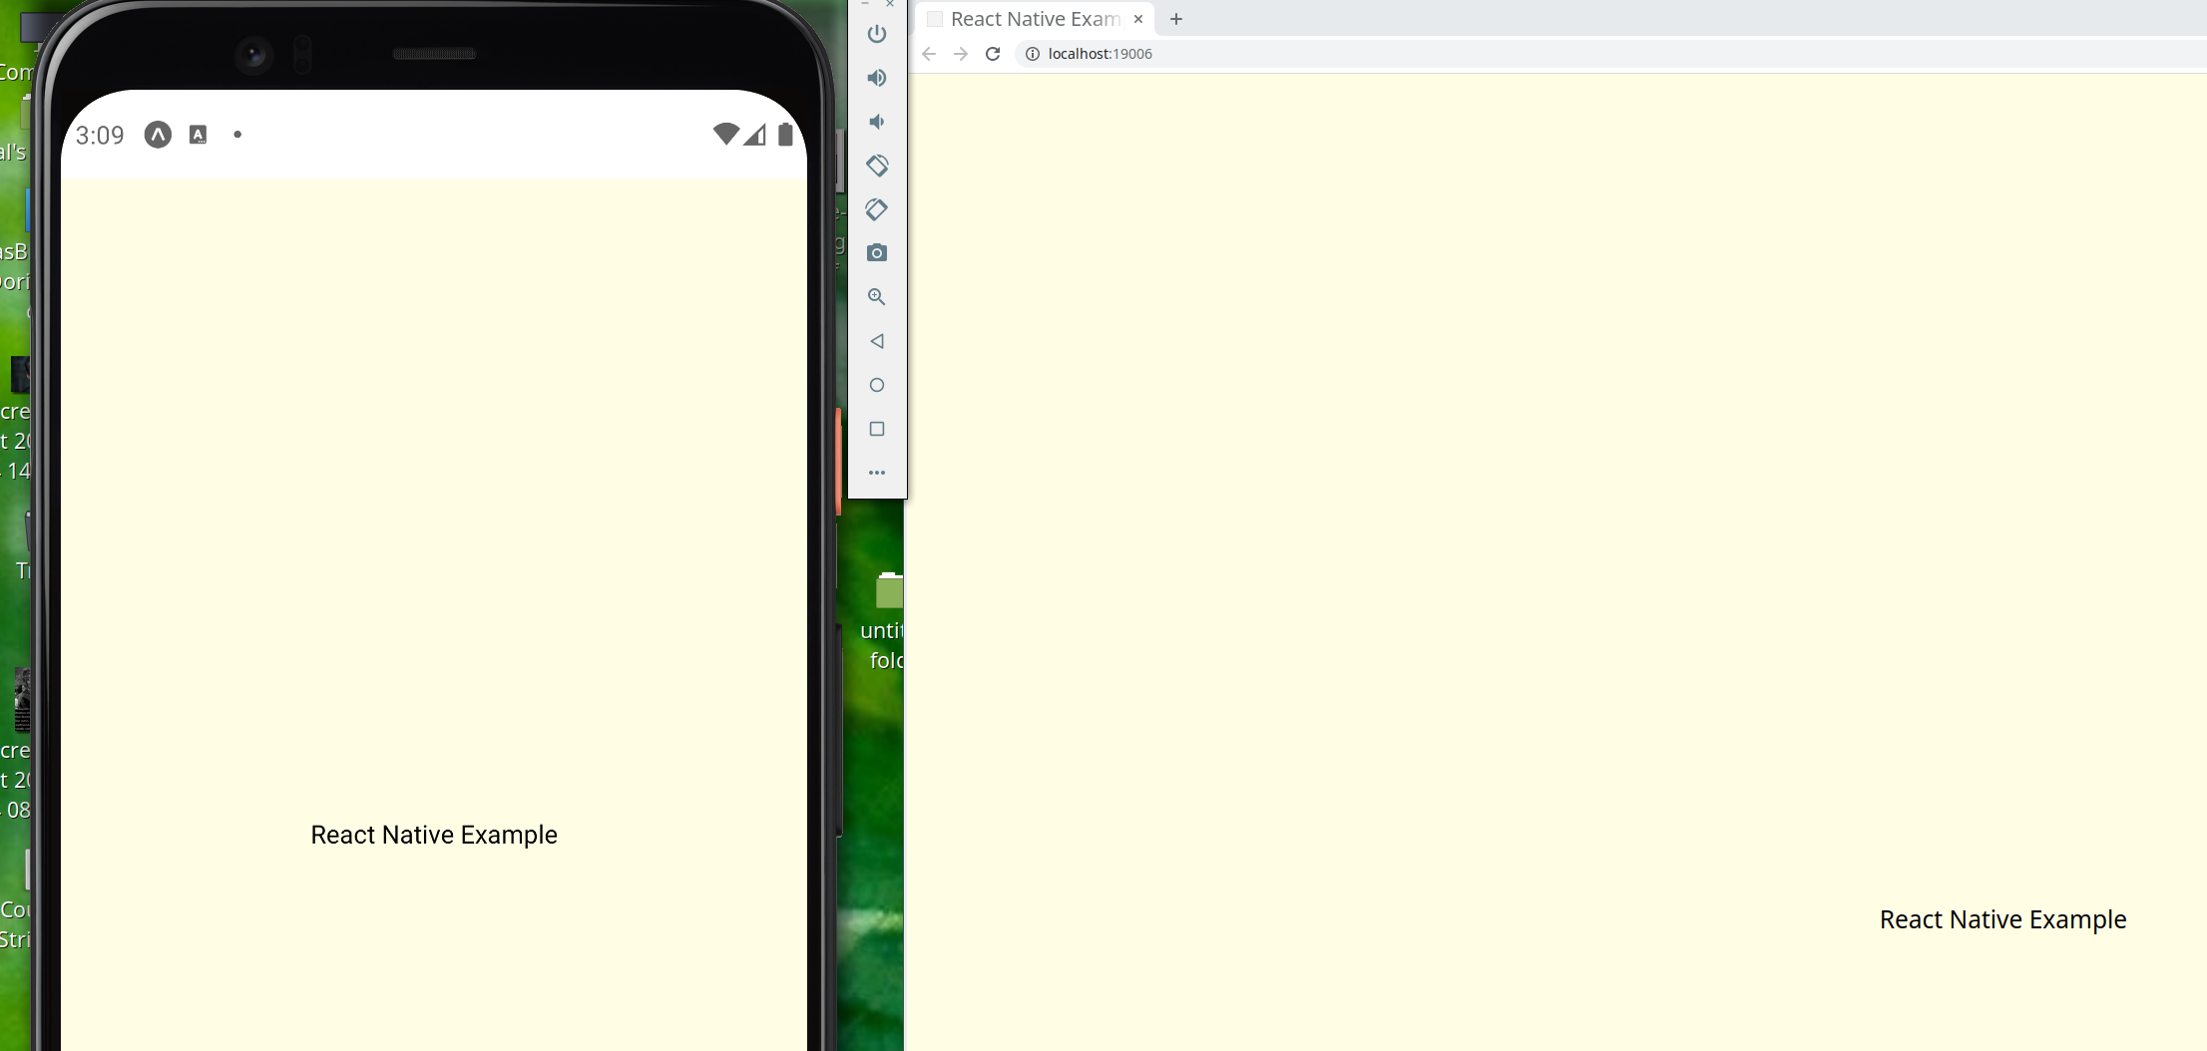

3. Why? To save deployment resource money
In 2012 Mark Zuckerberg commented, "The biggest mistake we made as a company was betting too much on HTML as opposed to native".

