Reinhard Aditta Mintanto

1601221300 / 44 PFT

1. Is it possible to begin coding immediately after an analysis model has been created? Explain your answer and then argue the counterpoint.

* Menurut saya, setelah analysis model dibuat, coding bisa saja langsung dilakukan. Tetapi tanpa kita menganalisis requirements lebih dalam lagi, nantinya akan terjadi banyak perubahan pada codingan kita sehingga akan memakan lebih banyak waktu.

1. An analysis rule of thumb is that the model “should focus on requirements that are visible within the problem or business domain.” What types of requirements are not visible in these domains? Provide a few examples.

* Jenis requirements yang tidak terlihat pada domain yang dimaksud adalah infrastructure requirements. Contohnya adalah fungsi-fungsi apa saja yang dibutuhkan untuk me-manage global data, fungsi-fungsi apa saja yang dibutuhkan untuk mengimplementasikan network communication, atau fungsi-fungsi apa saja yang dibutuhkan untuk mengimplementasikan user interface.

1. What is the purpose of domain analysis? How is it related to the concept of requirements patterns?

* Tujuan domain analysis adalah untuk mempercepat pembentukan analysis model sehingga waktu (mulai dari pembuatan hingga pemasaran software) dan development cost bisa dikurangi. Peran seorang domain analyst adalah untuk menemukan dan menentukan analysis patterns, analysis class, dan informasi yang berkaitan (yang mungkin digunakan banyak orang dalam me-ndevelop software, tetapi berbeda pengaplikasiannya). Melalui seorang domain analyst inilah-dengan melakukan domain analysis-requirements bisa ditentukan dengan mudah dan meningkatkan kualitas requirements tersebut.

1. Is it possible to develop an effective analysis model without developing all four elements shown in Figure 6.3? Explain.

It is possible to develop an effective analysis model without developing all four elements shown in Figure 8-3. However, each element presents a different view of the problem to be solved, and therefore provides the ability to see potential problems, inconsistencies or omissions more clearly. In addition, if all four elements of the analysis model are developed, the transition to design is simplified.

* Mungkin. Tetapi, setiap elemen menampilkan sudut pandang yang berbeda terhadap suatu permasalahan yang harus diselesaikan. Jika keempat elemen dikembangkan, design akan lebih mudah dan analysis model akan lebih efektif lagi.

1. You have been asked to build one of the following systems:

a. a network-based course registration system for your university.

b. a Web-based order-processing system for a computer store.

c. a simple invoicing system for a small business.

d. an Internet-based cookbook that is built into an electric range or microwave.

Select the system that is of interest to you and develop an entity-relationship diagram that describes data objects, relationships, and attributes.

* A web-based order-processing system for a computer store

Entity: Customer, Admin, Computer

Relationship:

|  |  |  |  |
| --- | --- | --- | --- |
|  | Customer | Admin | Computer |
| Customer |  | Served by | Buy |
| Admin | Serves |  | Managing Sales |
| Computer | Bought by | Managed Sales by |  |

Attributes: Customer Name, Customer Address, Customer’s Phone Number, Quantity Bought by Customer, Price, Admin Name, Admin ID, Computer Name, and Computer Type.

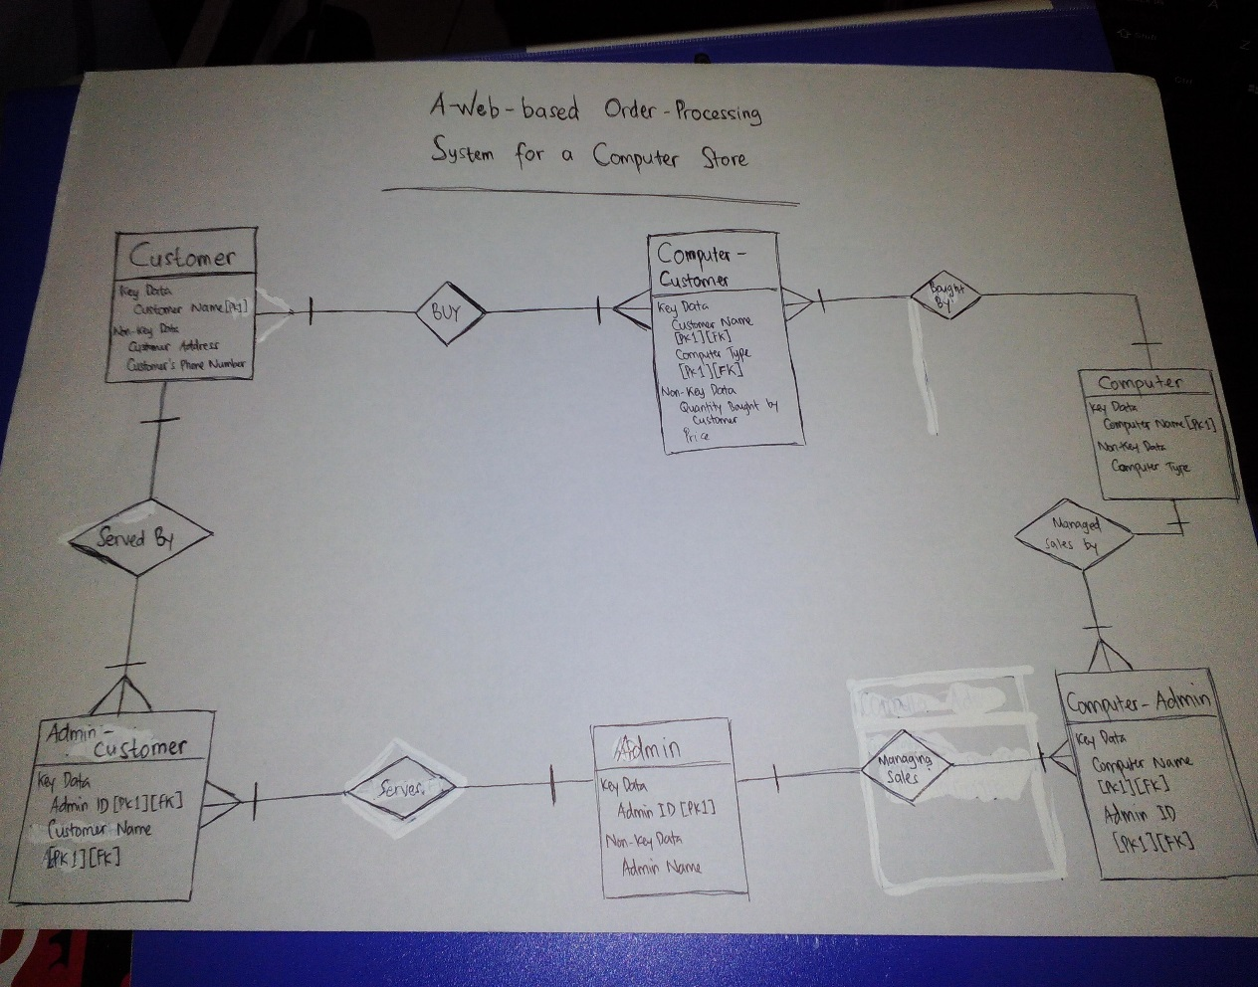ERD:

1. The department of public works for a large city has decided to develop a Web-based pothole tracking and repair system (PHTRS). A description follows:

Citizens can log onto a website and report the location and severity of potholes. As pot- holes are reported they are logged within a “public works department repair system” and are assigned an identifying number, stored by street address, size (on a scale of 1 to 10), location (middle, curb, etc.), district (determined from street address), and repair prior- ity (determined from the size of the pothole). Work order data are associated with each pothole and include pothole location and size, repair crew identifying number, number of people on crew, equipment assigned, hours applied to repair, hole status (work in progress, repaired, temporary repair, not repaired), amount of filler material used, and cost of repair (computed from hours applied, number of people, material and equipment used). Finally, a damage file is created to hold information about reported damage due to the pothole and includes citizen’s name, address, phone number, type of damage, and dollar amount of damage. PHTRS is an online system; all queries are to be made inter- actively.

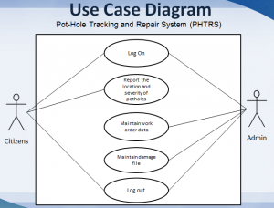a. Draw a UML use case diagram for the PHTRS system. You’ll have to make a number of assumptions about the manner in which a user interacts with this system.

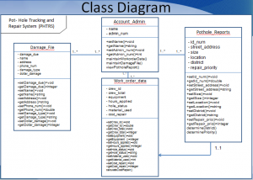b. Develop a class model for the PHTRS system.

1. Write a template-based use case for the SafeHome home management system described informally in the sidebar following Section 6.5.4.

|  |  |
| --- | --- |
| Use Case | SafeHome Security System |
| Description | SafeHome Security provides sensor security system to protect the owner’s house |
| Actors | House owner, sensor system, interface |
| Assumptions | Interface reports will always be recorded |
| Steps | 1. Install the security system  2. Configure the security system  3. REPEAT  Input number and type  Input master password  Input telephone number for when  sensor caught something  UNTIL no more empty record  4. Security system will keep an eye on every sensor connected  5. Interaction with the owner |
| Variation (Optional) | - |
| Non-Functional (Optional) | - |
| Issues | What will happen when the telephone number registered could not be contacted? |

1. Develop a complete set of CRC model index cards on the product or system you chose as part of Problem 6.5.

|  |  |
| --- | --- |
| Customer | |
| Login  Order a computer (online)  Pay for the computer  Fill the delivery form  Log Out | Computer  Admin |

|  |  |
| --- | --- |
| Admin | |
| Login  Save customer’s data  Manage computer’s stock  Logout | Customer  Computer |

|  |  |
| --- | --- |
| Computer | |
| Have a name  Have a price |  |

1. Conduct a review of the CRC index cards with your colleagues. How many additional classes, responsibilities, and collaborators were added as a consequence of the review?

* Customer can give feedback on the forum
* Customer can call the customer service for the problem occurred

|  |  |
| --- | --- |
| Customer | |
| Login  Order a computer (online)  Pay for the computer  Fill the delivery form  Logout  Give feedback  Call customer service | Computer  Admin  Admin |

1. What is an analysis package and how might it be used?

* Analysis package adalah kupulan dari berbagai elemen analysis model seperti use case dan analysis class, yang dikategorikan dan diberi nama khusus. Analysis package digunakan untuk mengelompokkan elemen-elemen yang memiliki tipe public dan bisa diakses dari package mana saja (+), tersembunyi dari semua package (-), dan elemen yang hanya bisa diakses dari yang sudah diizinkan saja (#).