SWEN Prixos Design Document

Isabella Sturm

Ivan Kovacevic

Srdan Lazarevic

22 April 2017

*Class Table*

|  |  |  |  |  |
| --- | --- | --- | --- | --- |
| Class Name | Class Description | Uses | Used By | Methods |
| ImageViewer | Main class; GUI. This class provides the user interface of the program. | ResizeCommand, CropCommand, RotateCommand,  MirrorCommand, CareTaker, Originator |  | main()  ImageViewer() |
| Command | Interface for commands that will control the functionalities allowed by the user |  | ResizeCommand, CropCommand, MirrorCommand, RotateCommand, EditCommand | execute() |
| ResizeCommand | Implements Command interface; when called by user, resize command prompts user to change size of image | Command interface | ImageViewer | resize()  execute() |
| CropCommand | Implements Command interface; when called, user can crop image | Command interface | ImageViewer | crop()  execute() |
| RotateCommand | Implements Command interface, when called upon, user can chose to rotate image by custom number of degrees or by the standard 90 or -90 degrees | Command interface | ImageViewer | rotate()  execute() |
| MirrorCommand | Implements Command interface, when called, user can mirror original image vertically or horizontally | Command interface | ImageViewer | mirror()  execute() |
| EditCommand | Implements Command interface; when user wants to edit page, EditCommand calls prototype to make copy of original photo before editing | Command interface,  ImagePrototype | ImageViewer | edit()  execute() |
| DeleteCommand | Implements Command interface; allows users to delete images and albums when called, but also can “cancel” the editing of an image, which will delete the cloned (edit) image | Command interface | ImageViewer | delete() execute() |
| OpenCommand | Implements Command interface; opens albums/ images. If the user opens an album, it will reveal the contents of the album in a 2x2 grid; if the user opens an image, the image will be displayed on its own. | Command interface, ImageAlbum/ Album/ Image | ImageViewer | open()  execute() |
| ImageAlbum | Interface for images and album/ labels (Composite Pattern) |  | Album, Image | open() |
| Album | Implements ImageAlbum; “Directory” level; Array or ArrayList to store images in a specific album | ImageAlbum interface | ImageViewer, Command | open()  add()  remove()  getChild() |
| Image | Implements ImageAlbum; “File” level; | ImageAlbum interface | ImageViewer, Command | open() |
| CareTaker | Stores mementos and can restore (redo/undo) to another state of the image | Memento | ImageViewer | checkpoint()  restore() |
| Originator | Creates and saves mementos of the image | Memento | ImageViewer | createMemento()  reset() |
| Memento | Keeps state of mementos of image when image is edited |  | CareTaker, Originator | save(State s)  retrieve() |
| ImagePrototype | Provides functionality to clone image that user wants to edit so the original can remain and the new edited image can be created |  | EditCommand | clone() |

*UML Diagrams*

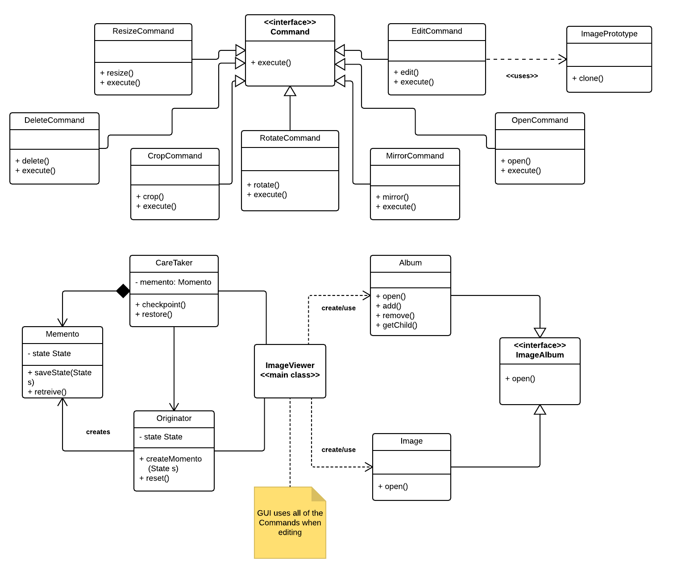

*Sequence Diagrams*

ImageAlbum/ Album/ Image -- Composite Pattern

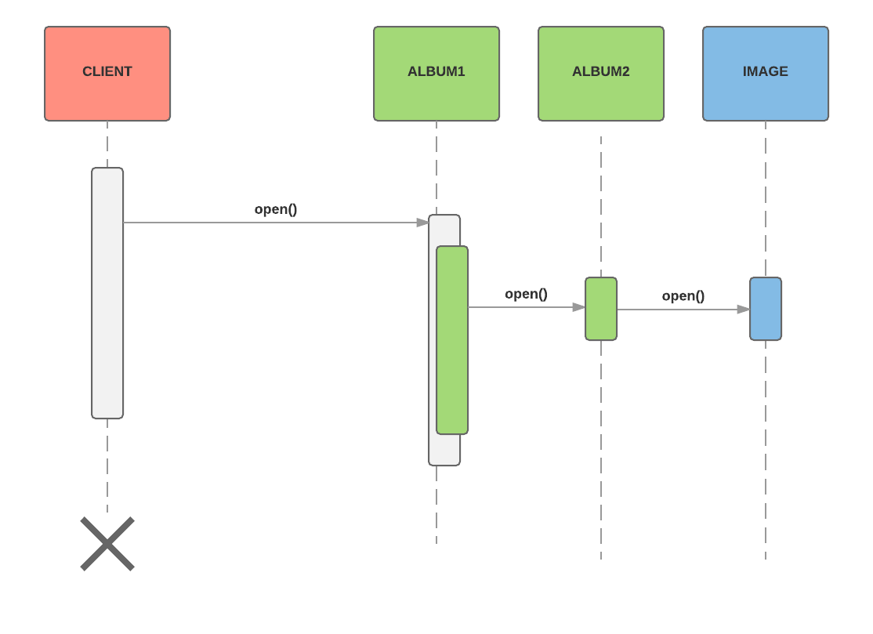

Command (DeleteCommand)

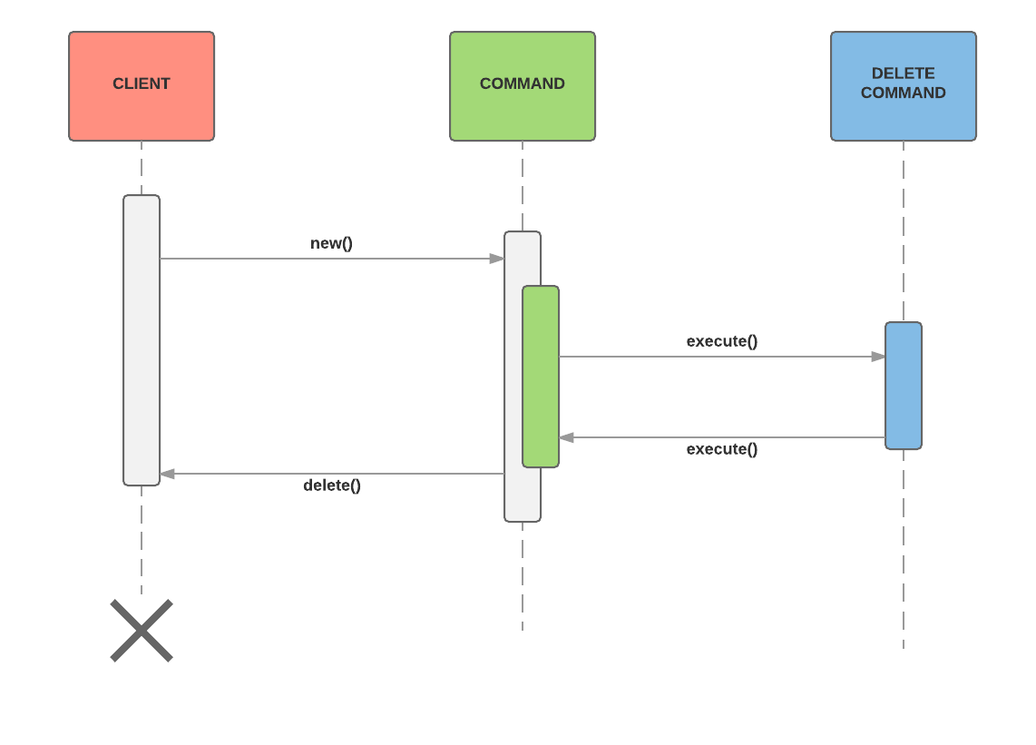

Prototype

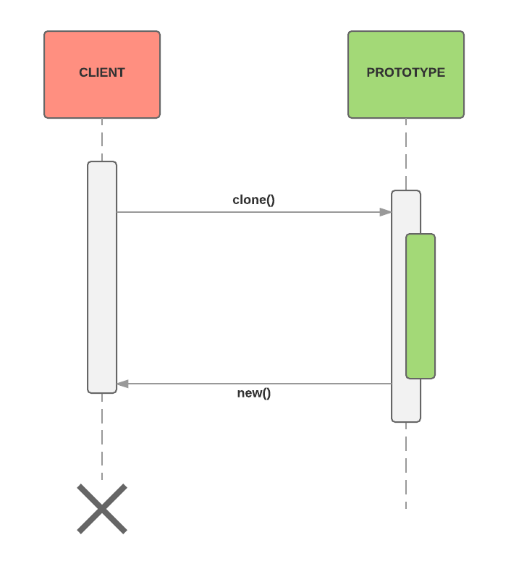

Memento

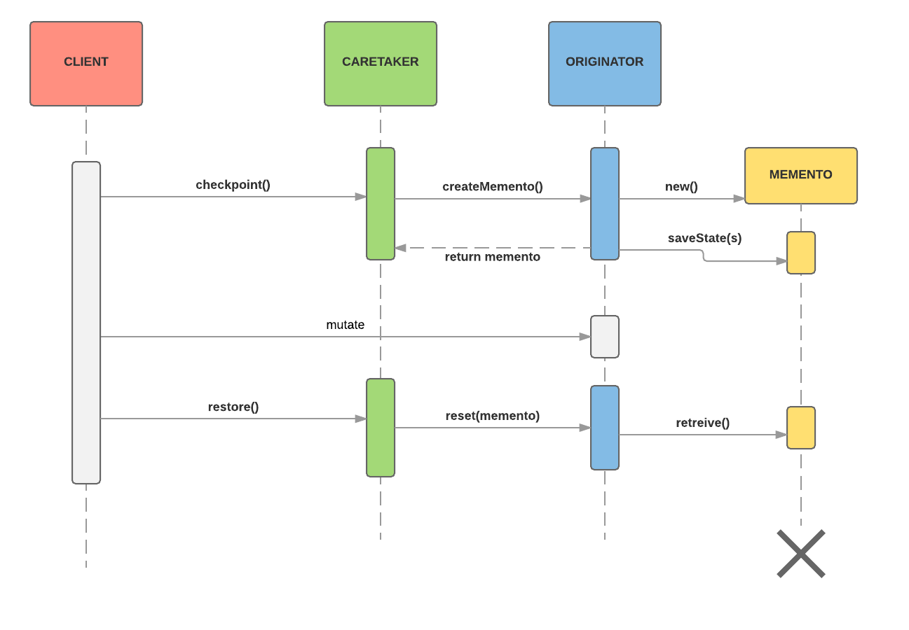

*Design Patterns*

Memento: Handles Undo and Redo functionality when editing images

Prototype [+ Factory]: Clones (makes copy) of original image and creates new image for editing

Command:  Handles functionality of JButtons in GUI

Composite: Organizes into and allows user to go through hierarchical collection of albums and images inside.

**Patterns that we are under consideration:**

*MVC* - On linking the GUI with Command and adding a Model.

*Virtual Proxy:* may having something to do with editing image or with displaying

*Facade*: We will probably use this if we ever run into any trouble with a lot of interfaces in our project. So for example if we want to provide our user with the cleanest experience we might consider using this, however at the current point we do not know if we will use so many interfaces.