CENG560 — Cloud Technology

Fall 2025 - Term Project
03.01.2026

Dockerizing an Application

Project Report and Specifications

Instructor: Asst. Prof. Dr. Metin BALCI

Report by
Mustafa SAĞLAM — 250802001

- Introduction
This report explains the steps taken to create and containerize a simple web application using Docker. The web application is simple e-commerce app that has a NodeJS backend, a React frontend with Vite framework as build system and a simple PostgreSQL database for persistent storage. The application then is conteinarized using Docker.
- Application Specification
The web application consists of 3 main parts;
- PostgreSQL Database
The database includes 2 tables, products and users. The products table has the name, rating, cost and resource paths to static product image files while the users table has email, name and password information. Since cloud security is not the scope of this report, the data is completely in the open.
- NodeJS Backend
Project backend has an initial seed file that will seed the database tables expalined above with initial data. The server file on the other hand includes API methods for logging in, signing up and getting a list of all the products.
- ReactJS + Vite Frontend
The frontend of the application is only one intereactive page that lists the products along with their images, allowing for sign in and sign up operations. There is also a my cart feature allowing items to be added and checked out.
Below is a secreenshot of the frontend of this e-coomerce web application.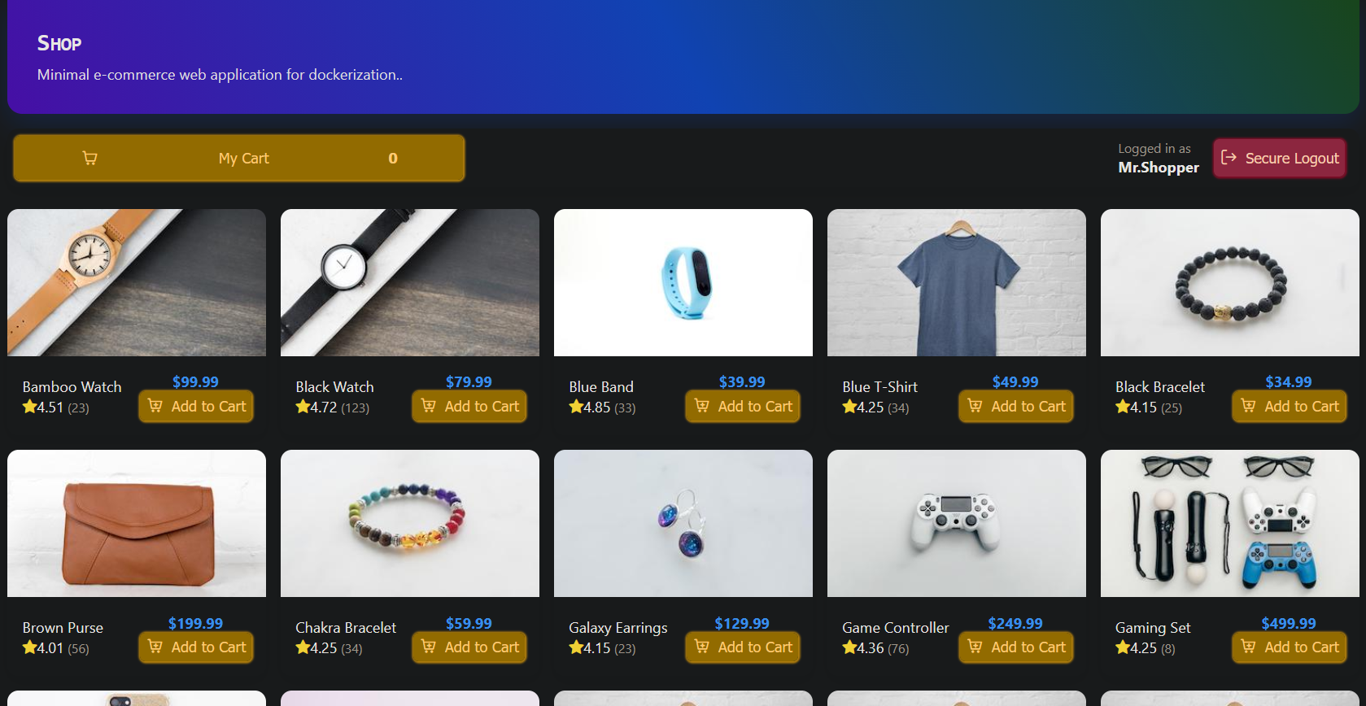
- Dockerization and Resources Used
The dockerizatioon of the application requires the creation of Dockerfiles and Docker Compose YAML file explained below. You can reach all the recources and project codes from below GitHub link.
https://github.com/ixtiyer/CENG560-DockerSimpleWebApp
Backend Dockerfile
FROM node:20-alpine
WORKDIR /app
COPY package*.json ./
RUN npm install
COPY . .
EXPOSE 4000
CMD ["npm", "start"]

Backend dockerfile uses node as base image and after installing the backend project dependencies listed in package.json exposes port 4000 to start an API server.
Frontend Dockerfile
# Build stage
FROM node:20-alpine AS builder
WORKDIR /app
COPY package*.json ./
RUN npm install
COPY . .

# Serve stage
FROM nginx:alpine
COPY --from=builder /app/dist /usr/share/nginx/html
# Optional: custom nginx config for SPA routing
COPY ./nginx.conf /etc/nginx/conf.d/default.conf
EXPOSE 80

Frontend dockerfile on the other hand consists of two seperate stages. In the build stage node is once again pulled as the base image and then the frontend project dependencies listed in package.json are installed. The second stage uses nginx as the base image and creates arouting tbale for the base localhost port 80 to start an Nginx application.
Docker Compose File
services:
db:
image: postgres:16-alpine
container_name: shopdb
environment:
POSTGRES_USER: postgres
POSTGRES_PASSWORD: postgres
POSTGRES_DB: shopdb
ports:
- "5432:5432"
volumes:
- db_data:/var/lib/postgresql/data

backend:
build: ./backend
container_name: api
environment:
DATABASE_URL: postgres://postgres:postgres@db:5432/shopdb
PORT: 4000
depends_on:
- db
ports:
- "4000:4000"

frontend:
build: ./frontend
container_name: web
depends_on:
- backend
ports:
- "80:80"

volumes:
db_data:

In this compose file there are 3 services and 1 volume is declared. The services are the postgres database service and its specifications, backend service that is tied to the database service and is baked using the previous dockerfile and frontend service that is tied to the backend and is baked using the previous dockerfile. The volume is created to make the postgres storage persistent.
The project can be run using the following command.
docker compose up -d
-d flag is used to detach the docker process from the terminal

