From Food Belt to Migration Belt:
Assessing the Socio-Spatial Impacts of the 2010 Drought on Agricultural Land Use and Rural Migration in Guizhou, China

Student Name: Xinyi Zeng
Student Number: 24038680
Program: MSc Urban Spatial Science
Module Code: CASA0010
Supervisor: Dr. Ollie Ballinger
Word Count: 11583
Date of Submission: 21/08/2025
Github Link

This dissertation is submitted in part requirement for the MSc in the Centre for Advanced Spatial Analysis, Bartlett Faculty of the Build Environment, UCL.

Abstract
This dissertation examines the socio-spatial impacts of the 2010 extreme drought in Guizhou Province, China, with a focus on agricultural productivity and rural population mobility. A county-level panel dataset was constructed for 88 counties (2008–2012), integrating remote sensing (Normalised Difference Vegetation Index, NDVI), climatic indices (Standardised Precipitation-Evapotranspiration Index, SPEI), and official demographic statistics. Using a two-way fixed-effects difference-in-differences design and an event study framework, the analysis estimates the causal impacts of drought across ecological and demographic dimensions.
The results show a sharp and persistent decline in cropland NDVI in drought-affected counties, emphasising the high sensitivity of rain-fed, mountainous agro-ecosystems to climatic shocks. In contrast, estimated effects on net migration per thousand residents were small, statistically weak, and unstable across specifications. Heterogeneity analysis indicates that high-altitude counties experienced the most severe ecological stress but did not exhibit commensurate increases in registered out-migration. These findings reveal a decoupling between ecological stress and demographic response, highlighting that climatic shocks may be a necessary but not sufficient condition for structural mobility, given institutional barriers, livelihood constraints, and measurement limits.
The study contributes new county-level, event-based evidence from an inland and under-researched context, demonstrating the value of integrating remote sensing and demographic data in quasi-experimental designs. Policy implications emphasise strengthening agricultural resilience in fragile settings, widening adaptive options through mobility-enabling institutions, and improving migration monitoring to capture short-term and circular flows. Limitations include the reliance on county-level indicators and assumptions of causal design, pointing to the need for household-level, longer-term, and comparative research.

Declaration
I hereby declare that this dissertation is all my own original work and that all sources have been acknowledged. It is 11583 words in length.

Acknowledgements
This dissertation was completed during the long daylight hours of a foreign summer, in this remote city. It marks not only the conclusion of a degree, but also the continuation of a personal journey of inquiry and growth.
I would first like to express my deepest gratitude to my supervisor, Dr. Ollie Ballinger, for his generous guidance and thoughtful feedback throughout this project. Our discussions, particularly on methodological design and spatial analysis strategies, were invaluable in shaping the structure and direction of this work. His patience and encouragement allowed me to develop both confidence and precision in my research.
I am equally indebted to my parents and close friends, whose quiet support and steadfast belief carried me through moments of uncertainty. Their presence, even at a distance, was an anchor that kept me steady.
I would also like to acknowledge CASA at UCL for providing an intellectually rich environment, outstanding resources, and a community that constantly pushed me to expand my horizons.
Finally, I wish to thank myself—for persisting in the practice of learning, for loosening attachments in the pursuit of freedom, and for allowing knowledge to transform into awareness. As I wrote these pages, I held onto a phrase that accompanied me throughout the year: “Avowing subject loosen its hold on itself.” This meant letting the world pass through me, recognising illusion, and moving toward a world of possibilities.

Table of Contents
1 Introduction - 8 -
1.1 Background - 8 -
1.2 Knowledge Gap and Research Motivation - 8 -
1.3 Research Aim and Questions - 9 -
1.4 Significance of Study - 9 -
2 Literature Review - 10 -
2.1 Climate Variability, Agricultural Vulnerability, and Measurement Approaches - 10 -
2.2 Climate Shocks, Migration: International Evidence - 11 -
2.3 Integration Migration Responses: Limits and “Trapped Populations” - 11 -
2.4 Climate-Migration Studies in China - 12 -
2.5 The Role of Spatial Heterogeneity - 13 -
2.6 Methodological Approaches - 14 -
2.7 Research Gap and Study Motivation - 14 -
3 Data & Research Area - 15 -
3.1 Study Area and Overview - 15 -
3.2 Data Sources and Processing - 16 -
3.3 Descriptive Statistics and Spatial Patterns - 19 -
4 Methodology - 21 -
4.1 Data Acquisition & Preprocessing - 21 -
4.2 Dataset Construction - 22 -
4.3 Variable Definitions and Transformations - 23 -
4.4 Empirical Strategy - 24 -
4.4.1 Difference-in-Differences Specification - 24 -
4.4.2 Event Study Design - 25 -
4.4.3 Heterogeneity Analysis - 25 -
4.5 Robustness Checks - 26 -
4.6 Interpretation & Mechanism Exploration - 27 -
4.7 Statement of Ethics - 27 -
5 Results - 28 -
5.1 Main Effects - 28 -
5.1.1 Cropland NDVI - 29 -
5.1.2 Net Migration Rate - 29 -
5.1.3 Comparative Insights - 29 -
5.2 Dynamic Effects - 30 -
5.2.1 NDVI Responses over Time - 31 -
5.2.2 Migration Dynamics - 32 -
5.2.3 Comparison and Implications - 32 -
5.3 Heterogeneity Results - 32 -
5.3.1 Vegetation Impacts Across Structural Conditions - 33 -
5.3.2 Limited Variation in Migration Responses - 34 -
5.3.3 Divergence Between Ecological and Demographic Effects - 34 -
5.4 Robustness Checks - 34 -
5.4.1 Alternative Drought Definitions - 35 -
5.4.2 Placebo Year - 35 -
5.4.3 Excluding Influential Units - 35 -
5.4.4 Alternative Fixed Effects - 35 -
5.4.5 Spatial Spillover - 35 -
5.4.6 Summary - 35 -
5.5 Summary of Results - 35 -
6 Discussion - 36 -
6.1 Summary of Key Findings and Emerging Questions - 36 -
6.2 Situating the Findings in International Climate-Migration Evidence - 37 -
6.3 Explanations in the Chinese Context - 37 -
6.3.1 Structural and Institutional Barriers to Migration - 37 -
6.3.2 Role of Geography and Livelihood Structure in Shaping Sensitivities - 38 -
6.3.3 Data and Measurement Considerations - 38 -
6.4 Interpreting Heterogeneity - 39 -
6.5 Policy Implications - 40 -
6.6 Limitations and Future Research - 41 -
7 Conclusion - 42 -
7.1 Summary of Findings - 42 -
7.2 Contributions - 42 -
7.3 Policy Implications - 43 -
7.4 Limitation and Future Research - 43 -
Bibliography - 45 -
Appendices - 49 -
Appendix A Data and Variables - 49 -
Appendix.A.1 Variable Definitions - 49 -
Appendix.A.2 Data Sources - 51 -
Appendix.A.3 Methodological Details / Codebook - 53 -
Appendix B Regression Results - 54 -
Appendix.B.1 Baseline Difference-in-Differences (DiD) Results - 54 -
Appendix.B.2 Variance Inflation Factors (VIF) Results - 55 -
Appendix.B.3 Event Study Estimates Results - 55 -
Appendix.B.4 Heterogeneity Analysis Results - 56 -
Appendix.B.5 Robustness Checks Results - 57 -
Appendix C Research Log - 57 -

List of Figures
Figure 3.1 Study Area in Guizhou Province and 2010 Drought Treatment Classification - 16 -
Figure 3.2 Workflow for Constructing the County-Level Panel Dataset (2008–2012) - 17 -
Figure 3.3 Annual Trends in Cropland NDVI and Net Migration Rates, 2008–2012 - 19 -
Figure 4.1 Methodological Framework for Assessing the Socio-Spatial Impacts of the 2010 Guizhou Drought - 21 -
Figure 5.1 Average Pre- and Post-Drought Trends in NDVI and Net Migration Rate - 28 -
Figure 5.2 Event study estimates for cropland NDVI and net migration rates before and after the 2010 drought in Guizhou - 31 -
Figure 5.3 Spatial Heterogeneity in Drought Impacts - 33 -

List of Tables
Table 5.4-1 Summary of Robustness Checks - 34 -
Table A-1 Description of Variables Used in the Study - 49 -
Table A-2 Data Source Summary - 51 -
Table B-1 Baseline Difference-in-Differences (DiD) Estimates - 54 -
Table B-2 Variance Inflation Factors (VIF) for Key Variables - 55 -
Table B-3 Event Study Estimates for Migration (Dep. Var.: Net Migration per 1,000) - 55 -
Table B-4 Event Study Estimates for NDVI (Dep. Var.: Cropland NDVI) - 56 -
Table B-5 Heterogeneity Analysis: Interaction Effects of Drought on Migration - 56 -
Table B-6 Robustness Check Results - 57 -

Introduction

Background
In recent decades, the frequency and severity of extreme weather events have increased, with clear consequences for agricultural systems and rural livelihoods (Intergovernmental Panel on Climate Change (IPCC), 2023). Mountainous and ecologically fragile regions are particularly exposed due to their reliance on rainfed farming, fragmented landholdings, and limited adaptive capacity (Black et al., 2011).
Southwest China exemplifies this vulnerability. In 2010, Guizhou Province experienced one of the most severe droughts in decades, linked to an El Niño–La Niña transition (Luo et al., 2019). The drought affected more than 1.5 million hectares of farmland, with crop disaster rates exceeding 70% in core counties such as Bijie and Dafang (Guizhou Provincial Bureau of Statistics, 2011). Agricultural losses were compounded by water shortages and long-term ecological stress.
Agriculture remains central to Guizhou’s economy and livelihoods: over 60% of the population is engaged in farming, yet irrigation infrastructure is underdeveloped due to the karst terrain. As a result, the province’s agricultural production is highly dependent on rainfall, making it exceptionally sensitive to climate shocks such as the 2010 drought.

Knowledge Gap and Research Motivation
The relationship between climate shocks, agriculture, and migration has been widely discussed. Environmental stressors may influence mobility both directly, when livelihoods become unsustainable, and indirectly, when declining agricultural productivity and income prompt labour reallocation (Black et al., 2011; McLeman, 2018). Yet migration responses are highly context-dependent, shaped by economic opportunities, migration costs, and household capacity (De Haas, 2021).
In China, most studies examine eastern provinces with strong infrastructure and higher agricultural productivity (Wang, Chen and Shen, 2024; Zheng et al., 2024). Evidence from underdeveloped mountainous regions, where migration may be constrained by poverty and limited access, remains scarce. Guizhou, one of the poorest provinces, was severely affected by the 2010 drought, yet it is still unclear whether this shock triggered rural out-migration, or whether households were “trapped” despite worsening conditions.
Existing literature also relies largely on national-scale econometric models or household surveys. Few studies apply spatially explicit methods to clearly defined climate events at the sub-provincial scale. Guizhou’s unique socio-ecological setting—karst topography, high rural dependence on agriculture, and limited non-agricultural employment—suggests that migration responses may differ markedly from more developed regions. These gaps highlight the need for case-specific, data-driven analysis to assess the causal pathways linking drought, agricultural viability, and population mobility.

Research Aim and Questions
This study aims to explore the socio-spatial impacts of the extreme drought in Guizhou Province in 2010, focusing on agricultural productivity, rural population migration, and the moderating effects of local geographical and socioeconomic characteristics.
The core research questions are:
1. Does extreme drought significantly affect agricultural productivity as measured by seasonal crop NDVI?
2. Does drought affect rural migration patterns?
3. How do county-level characteristics (e.g., altitude, urbanisation, and population density) influence these responses?
This study makes three contributions to the climate–agriculture–migration literature:
1. Data integration — Combining satellite remote sensing (NDVI), climate indices (SPEI) and census data to construct a county-level panel data set.
2. Causal inference — Using difference-in-differences (DiD) estimation and event study designs to determine the causal effects of drought on agricultural productivity and migration.
3. Focus on spatial heterogeneity — Link climate, agriculture and migration within a framework that considers geographical and socioeconomic diversity, with a focus on mountainous areas that are often subject to climate stress.

Significance of Study
This study contributes to climate-agriculture-migration literature in three ways.
First, it provides event-based empirical evidence from Guizhou, a mountainous and agriculture-dependent region that is largely absent from national and global analyses.
Second, it presents the integration of multi-source datasets (satellite NDVI, drought index (SPEI), and county-level demographic data) to enable spatially explicit assessments of drought impacts.
Third, it employs quasi-experimental methods (Difference-in-Differences and event studies) to strengthen causal inference, revealing spatial heterogeneity shaped by geographical and socioeconomic factors.
In addition to academic contributions, the findings are highly aligned with China's rural revitalisation strategy. The Rural Revitalisation Plan (2024–2027) emphasises agricultural resilience, food security, improvements to rural infrastructure, and differentiated support for ecologically fragile and underdeveloped regions (Central Committee of the Communist Party of China and State Council of the People’s Republic of China, 2025). By identifying the region’s most severely affected by drought and its underlying causes, this study supports the development of targeted adaptation measures, promotes agricultural modernisation, and advances rural livelihood diversification within the framework of the national revitalisation strategy.

Literature Review

Climate Variability, Agricultural Vulnerability, and Measurement Approaches
Chinese agriculture is particularly sensitive to changes in rainfall and extreme temperatures. Evidence from provincial and national datasets confirms that precipitation anomalies and heatwaves significantly reduce yields, especially in rain-fed areas (Huang, 2012; Liang et al., 2021). However, such macro-level analyses risk obscuring the heterogeneity of agricultural vulnerability. In ecologically fragile regions such as Guizhou, karst topography, limited irrigation, and uneven infrastructure exacerbate drought exposure (Yun, Jun and Hong, 2012; Luo et al., 2019). This suggests that national-level trends provide an incomplete picture of local risks.
Remote sensing has been widely used to address this limitation. Indicators based on the Normalised Difference Vegetation Index (NDVI) provide consistent, spatially explicit measures of cropland vitality (Kogan, 2001; Tucker et al., 2005). Recent studies further suggest that ecological restoration in southwestern China has partially offset climate pressures (Chen, Tan and Gruschke, 2021; Wei and Li, 2021). Yet much of this literature treats ecological interventions and climate change as separate domains, overlooking their combined effects. This separation underestimates the compound pressures rural households face in practice, where policy interventions and climatic variability interact.
Archival evidence from the 2010 drought in Guizhou illustrates this duality. Government reports emphasised emergency relief and crisis management, while contemporary media revealed ongoing livelihood disruptions and migration pressures (Guizhou Provincial Government, 2010a, 2010b). These short-term measures contrast sharply with structural strategies such as the Rural Revitalisation Plan (2024–2027) and the Guizhou Province 14th Five-Year Water Resources Plan (State Council of China, 2011; People’s Government of Guizhou Province, 2021). The coexistence of reactive crisis management and long-term development planning raises an unresolved question: how acute shocks intersect with structural policy agendas to shape long-term agricultural vulnerability—an issue insufficiently addressed in existing studies.

Climate Shocks, Migration: International Evidence
International literature has established multiple pathways through which climate shocks influence migration. Environmental pressures can directly undermine livelihoods or indirectly reduce agricultural productivity and income, thereby creating pressures to move (Black et al., 2011; McLeman, 2018). Empirical studies from Africa, Latin America, and South Asia consistently identify that drought is an important ‘push factor.’ In sub-Saharan Africa, for example, prolonged rainfall deficits have been shown to increase rural-to-urban migration, particularly in highly agricultural economies (Barrios, Bertinelli and Strobl, 2006). In rural Ethiopia, drought exposure altered household mobility, but outcomes varied by gender and household composition, underscoring the uneven nature of responses (Gray and Mueller, 2012). Similarly, in Mexico, precipitation variability accelerated outmigration, with the strongest effects in areas lacking irrigation and social safety nets (Nawrotzki and DeWaard, 2016).
Yet, these findings also demonstrate that climate-induced migration is not automatic or uniform. Beine and Parsons (2015) note that while climate variability contributes to international migration, its effect is mediated by labour demand and institutional settings. Nawrotzki et al. (2016) further reveal that drought and aridity influence domestic migration globally, but only under specific socioeconomic conditions. Such evidence highlights a key limitation: much of the existing research focuses on correlations at macro or national levels, which risks masking the heterogeneity of household strategies. Household-level studies point to the importance of assets, networks, and policy environments in shaping outcomes, but these dimensions remain under-explored in subnational analyses.
Overall, international research confirms the potential of climate shocks to generate migration pressures but also reveals the decisive role of context in shaping responses. Existing studies often overlook how ecological stress interacts with structural constraints—an omission particularly pronounced in inland China, where uneven infrastructure, limited safety nets, and strict institutional barriers may fundamentally reshape the relationship between migration and climate.

Integration Migration Responses: Limits and “Trapped Populations”
Although migration is often viewed as an adaptive strategy to climate stress, research increasingly highlights its limitations. The concept of “trapped populations” (Black et al., 2011; Government Office for Science, 2011) emphasises households that are highly exposed to environmental risks but unable to move due to poverty or institutional barriers. This perspective challenges the deterministic assumption that environmental shocks automatically trigger migration flows.
Empirical evidence supports this view. In Bangladesh, marginalised households recurrently exposed to floods often remain immobile, enduring escalating risks rather than relocating (Ayeb-Karlsson, Kniveton and Cannon, 2020). Similar dynamics are observed in Ethiopia, where poorer families affected by drought are less likely to migrate than wealthier households with the resources to relocate (Gray and Mueller, 2012; Lu and Xia, 2016). Such cases illustrate that migration is not simply a question of exposure, but of differential capabilities.
This debate reframes migration as a selective and unequal process. Adger et al. (2020) argue that climate change exacerbates existing inequalities by widening the divide between those who can move and those who are forced to stay. Moreover, mobility itself can generate new vulnerabilities: rural migrants often face housing insecurity, precarious labour markets, and limited access to services in destination areas (Warner et al., 2012). Thus, both immobility and mobility carry risks, complicating narratives of migration as straightforward adaptation.
For China, these insights are particularly important. The household registration (hukou) system limits rural migrants' access to welfare and urban services (Chan, 2010), while land tenure and income disparities restrict mobility options (Wang, 2013). In underdeveloped regions such as Guizhou, these structural barriers mean that many households may remain trapped in degraded agricultural systems despite severe climatic pressures—an institutional dimension that quantitative studies have rarely addressed. This underscores the need for China-specific studies that explicitly incorporate institutional constraints into climate–migration analyses.

Climate-Migration Studies in China
Research in China has increasingly examined how climate variability shapes rural livelihoods, particularly through its effects on agriculture and labour allocation. Recent studies show that temperature and precipitation anomalies affect crop yields and can reshape rural labour markets (Wang, Chen and Shen, 2024; Zheng et al., 2024). However, most of this work focuses on developed eastern and central provinces, where infrastructure and labour mobility are relatively advanced, leaving ecologically vulnerable and underdeveloped regions such as Guizhou under-researched (Luo et al., 2019; Chen, Tan and Gruschke, 2021). This regional imbalance risks producing an overly optimistic picture of adaptive capacity, while overlooking contexts where barriers are far more binding.
Evidence from China further reveals sharp regional disparities in responses to climate stress. In coastal provinces, diversified economies and lower migration costs have facilitated stronger outmigration, while inland rural households often face higher barriers, leading to weaker or more constrained responses. These findings resonate with international debates on “trapped populations” (Luo et al., 2019; Ayeb-Karlsson, Kniveton and Cannon, 2020), suggesting that those most exposed to environmental risks may also be those least able to move.
Methodologically, existing Chinese studies rely heavily on either national-scale econometrics or household surveys. While valuable, these approaches miss county-level heterogeneity and rarely focus on extreme events. As a result, the literature struggles to capture how acute climatic shocks translate into localised livelihood risks and mobility outcomes. This highlights the need for event-based, spatially disaggregated analyses in inland provinces such as Guizhou, where complex topography and weak infrastructure may intensify both vulnerability and constraints on adaptation. Addressing this gap is crucial for understanding the complex and uneven ways in which climate stress shapes migration in China’s inland provinces.

The Role of Spatial Heterogeneity
An increasing number of studies emphasise that the impacts of climate shocks are highly uneven, shaped by geographical and socioeconomic contexts rather than being uniform across space. Agricultural ecological factors such as altitude, land use, and water infrastructure significantly condition the extent to which drought undermines productivity. Rain-fed systems in mountainous or marginal areas are far more vulnerable to water scarcity than irrigated plains, and weak infrastructure further constrains adaptive capacity. Evidence from Ethiopia and Mexico shows that households in remote or poorly irrigated areas are more likely to suffer climate-induced livelihood losses and to adopt migration as a coping strategy (Gray and Mueller, 2012; Nawrotzki and DeWaard, 2016).
Spatial heterogeneity is equally visible in migration outcomes. Nawrotzki and DeWaard (2016) demonstrate that the influence of drought on internal migration varies widely depending on local socioeconomic conditions, while Beine and Parsons (2015) find that climatic stress interacts with labour demand and institutional settings in shaping international flows. De Haas (2021) further conceptualises migration as an outcome of both ‘aspirations and capabilities’, implying that even under comparable ecological pressures, responses diverge according to assets, networks, and opportunities. Where barriers to mobility are high, shocks may entrench immobility; in better-connected regions, they may accelerate labour reallocation.
When applying to China, these dynamics are especially revealing. Inland provinces such as Guizhou face sharper structural constraints—limited irrigation, karst ecosystems, and lower market accessibility—compared to coastal regions with more diversified economies and better transport infrastructure (Yun, Jun and Hong, 2012; Luo et al., 2019). Recognising spatial heterogeneity is thus essential not only for interpreting divergent impacts of drought but also for motivating the heterogeneity analysis in this study, which investigates how ecological and structural conditions shape both agricultural vulnerability and migration responses.

Methodological Approaches
Research on climate–migration linkages has employed a wide range of methodological approaches. Qualitative and survey-based studies provide valuable insights into household decision-making, but their findings often face challenges of representativeness and causal attribution (Hunter, Luna and Norton, 2015; McLeman, 2018). Macro-level econometrics can identify broader trends (Cattaneo et al., 2019), yet their reliance on aggregated data risks obscuring local heterogeneity and micro-level mechanisms. Remote sensing offers consistent, spatially explicit environmental indicators such as NDVI (Kogan, 2001; Tucker et al., 2005). Nevertheless, without integration with demographic data, such measures cannot fully capture the social dimensions of migration responses.
To strengthen causal identification, quasi-experimental designs have become increasingly prominent. Difference-in-differences (DiD), event studies, and instrumental variables are frequently employed to isolate the effects of climate shocks (Dell, Jones and Olken, 2012; Mueller, Gray and Kosec, 2014; Nawrotzki and DeWaard, 2016). These methods are particularly effective for discrete extreme events, which provide clear counterfactuals. However, their validity depends on strong assumptions such as parallel trends, and they often struggle to capture longer-term adaptive dynamics or spillover effects.

Research Gap and Study Motivation
Although climate-induced migration has received growing scholarly attention, several important research gaps remain, particularly in the context of inland China.
First, while event-based methods such as difference-in-differences and event studies have gained traction in global and national-level research (Gray and Mueller, 2012; Nawrotzki and DeWaard, 2016), they have been rarely applied below the provincial scale in China. Most existing studies continue to emphasise long-term climate trends—such as average temperature or precipitation anomalies rather than discrete extreme events. As a result, the specific impacts of acute shocks, such as the 2010 drought, on structurally constrained inland livelihoods remain poorly understood, even though geographical and institutional heterogeneity may critically shape responses.
Second, current analyses are constrained by limited spatial resolution. Household surveys and provincial aggregates either lack representativeness or obscure local differences, overlooking the uneven distribution of drought impacts. In regions such as Guizhou, characterised by karst topography, inadequate infrastructure, and sharp inter-county disparities, the absence of spatially disaggregated studies limits our understanding of how environmental pressures translate into differentiated livelihood risks.
Third, although theory suggests that agricultural decline drives population migration (Black et al., 2011), empirical evidence from underdeveloped mountainous China remains scarce. Few studies have explicitly tested whether declines in agricultural vitality —as proxied by remote sensing indicators such as NDVI—translate into measurable migration responses. Official statistics largely capture permanent residence changes and fail to reflect short-term or seasonal movements, leaving the agricultural–migration linkage underexplored in rural economies.
Finally, institutional dimensions are often overlooked. China's household registration (hukou) system, unequal access to urban services, and segmented labour markets constrain rural mobility in ways distinct from international cases. Yet these barriers are rarely integrated into quantitative models of climate-induced migration, limiting the explanatory power of existing studies.
This dissertation addresses these gaps through a quasi-experimental, spatially explicit study of the 2010 Guizhou drought. It integrated the Normalised Difference Vegetation Index (NDVI), the Standardised Precipitation-Evapotranspiration Index (SPEI), and census-based migration indicators into a county-level panel dataset, applying difference-in-differences and event study designs to estimate causal impacts. In doing so, the study provides new evidence on the drought–migration relationship. More broadly, it demonstrates how ecological stress interacts with institutional constraints, thereby linking global methodological debates to China’s specific national conditions. By focusing on an ecologically marginalised inland province, the study also contributes to a more detailed understanding of the uneven geography of climate-induced migration.

Data & Research Area

Study Area and Overview
Guizhou Province, located on the karst plateau of southwestern China, is characterised by mountainous terrain with an average elevation of around 1,100 metres. The prevalence of karst landscapes results in shallow soils and uneven water distribution, leaving agriculture highly dependent on rainfall and limiting the potential for large-scale irrigation infrastructure (Luo et al., 2019).
The province has a subtropical humid monsoon climate, with rainfall concentrated between May and September and strongly influenced by East Asian monsoon variability (Wei and Li, 2021). Extreme events such as droughts or floods can cause severe disruption to agriculture and rural livelihoods. Agriculture remains a key sector, with over 60% of the population engaged in farming. The main crops include rice, corn, potatoes and rapeseed, much of which is cultivated on sloping cropland in high-altitude areas.
This study covers all 88 county-level administrative units in Guizhou from 2008 to 2012, a period that includes the 2010 drought—widely considered the most severe in over a century. The drought led to below-average rainfall, above-average temperatures, and yield losses of over 30% in the worst-hit counties (Yun, Jun and Hong, 2012; Wei and Li, 2021).
Drought exposure was measured using the Standardised Precipitation Evapotranspiration Index (SPEI). Counties most severely affected in 2010 were designated as the treatment group, while the remainder formed the control group. As shown in Figure 3.1, the treatment counties are concentrated in the north-western and central high-altitude areas with shallow soils and poor irrigation, while the southeastern lowlands enjoy relatively more favourable agricultural conditions. These geographical and socioeconomic contrasts provide the basis for subsequent heterogeneity analysis.
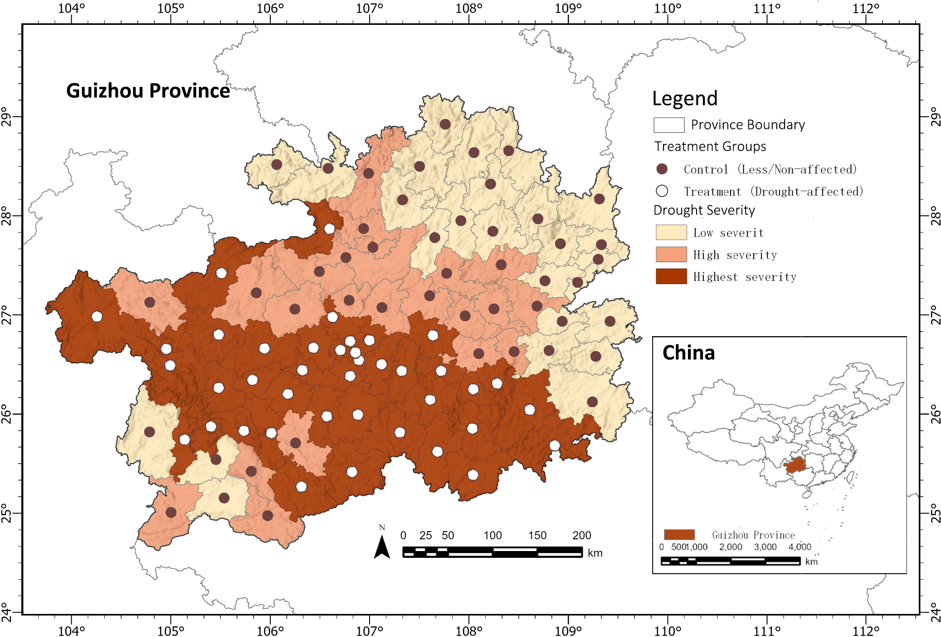
Figure 3.1 Study Area in Guizhou Province and 2010 Drought Treatment Classification
Map showing county-level boundaries, mean elevation, and drought treatment status in 2010.
Treatment counties are defined as those in the top quartile of median drought frequency (SPEI < –1.5, February–June 2010).
Data sources: SRTM DEM, SPEIbase v2.10, Guizhou county boundaries.

Data Sources and Processing
This study's empirical analysis combines climate, remote sensing, statistical, and topographical datasets to construct a balanced county-level annual panel dataset for Guizhou Province from 2008 to 2012. All geospatial processing was conducted using Google Earth Engine (GEE), while subsequent data integration, cleaning, and variable construction were performed using the Python programming language. Figure 3.2 provides a brief overview of the data integration workflow, with the complete methodological workflow detailed in Chapter 4.
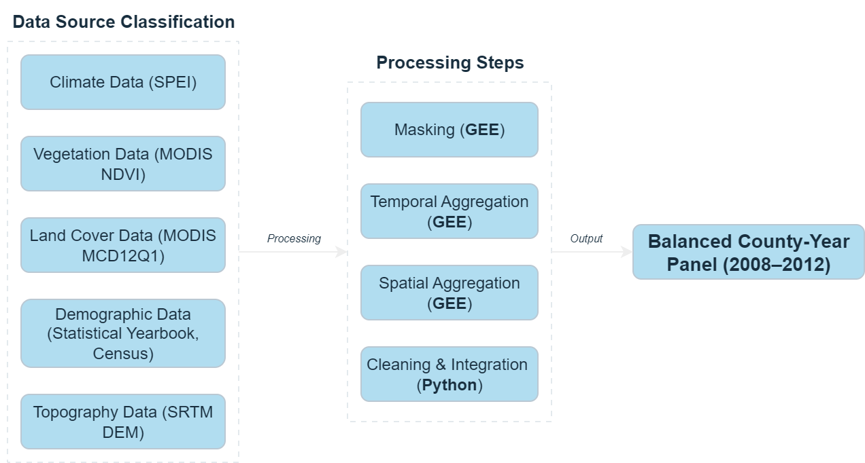
Figure 3.2 Workflow for Constructing the County-Level Panel Dataset (2008–2012)
Diagram showing the integration of climate (SPEI), vegetation (MODIS NDVI), land cover (MODIS MCD12Q1), demographic (Guizhou Statistical Yearbook, Population Census), and topographic (SRTM DEM) datasets.
Geospatial processing was conducted in Google Earth Engine (GEE); statistical integration and data cleaning were implemented in Python.
To construct the net migration indicator, the study adjusted the year-on-year change in total population based on natural growth (the difference between births and deaths). In cases where county-level birth and death data were unavailable, the crude birth and death rates from the provincial-level statistical yearbooks were used. The resulting net migration estimates were standardised per thousand people to facilitate comparisons between counties of different population sizes. Additionally, data quality markers were added to the panel data to distinguish between directly reported values and estimated values. Missing data were handled based on the extent of the gap: small gaps (≤1 year) were filled using linear interpolation, while structural gaps (e.g., urban core counties) were left as missing values to avoid introducing bias.
The severity of the 2010 drought was measured using the Standardised Precipitation Evapotranspiration Index (SPEI) from the SPEIbase v2.10 dataset, which integrates precipitation and potential evapotranspiration to provide a standardised drought indicator. The three-month SPEI from February to June 2010 was selected to capture the peak of the prolonged drought affecting southwestern China (Yun, Jun and Hong, 2012). Pixels with SPEI values below -1.5 were classified as drought-affected. For each county, the median pixel-level drought frequency during the five-month period was calculated to represent local drought conditions. The counties were then divided into four categories of relative severity based on the quartiles of this median drought frequency, enabling heterogeneity analysis in subsequent sections.
Vegetation productivity (used as a proxy indicator for agricultural performance) is measured using the normalised difference vegetation index specific to farmland obtained from MODIS MOD13Q1 images. This product provides 16-day composite images with a spatial resolution of 250 metres, scaled to reflectance values (0–1) and averaged over the growing season (April to September) for each year from 2008 to 2012. Cropland pixels are identified using the 2010 MODIS MCD12Q1 land cover product, applying the International Geosphere-Biosphere Programme (IGBP) classification (Class 12: Farmland). If the primary land cover category remains stable during the study period, this static mask is consistently applied across all years. The resulting variable reflects only the vegetation greenness of agricultural land, excluding forest and built-up areas.
Land use structure is expressed as the proportion of cropland, calculated from the 2010 MODIS MCD12Q1 data as the percentage of valid land pixels classified as cropland. Although this variable is not used as a direct control variable in the main regression model, it supports heterogeneity analysis because it allows for a comparison of counties with high and low proportions of cropland in terms of their response to drought and migration.
Data coordination involves aligning all datasets by county name (transliterated into English) and year to ensure consistency across different sources. Continuous variables are stored in standard units—the normalised vegetation index (NDVI) ranges from 0 to 1, migration rates are calculated per thousand people, and the proportion of cropland is expressed as a percentage—while categorical variables (such as treatment status and high-altitude classification) are coded uniformly across the panel. The final balanced dataset covers 88 counties over five years (440 observations), with each record containing adjusted environmental, land use, and demographic indicators for comprehensive analysis.
The panel structure is designed to support double difference and event study analyses, as well as heterogeneity tests based on geographical and land use characteristics. Detailed processing steps, including spatial aggregation, time window selection, and the complete data workflow, are documented in Chapter 4 (see Figure 4.1).

Descriptive Statistics and Spatial Patterns
To provide an overview of temporal dynamics, Figure 3.3 shows the annual trends in specific vegetation productivity and net flux for treated and control counties from 2008 to 2012.
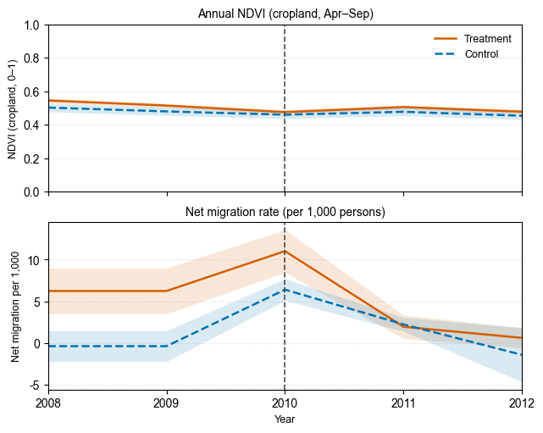
Figure 3.3 Annual Trends in Cropland NDVI and Net Migration Rates, 2008–2012
Two-panel plot showing trends in cropland-specific Normalised Difference Vegetation Index (NDVI) during the growing season (top) and net migration rates per 1,000 persons (bottom) for treatment and control counties. Shaded areas represent ±1 standard error. The vertical dashed line marks the onset of the 2010 drought.
Data sources: MODIS MOD13Q1, MODIS MCD12Q1, Guizhou Statistical Yearbook.
The figure above shows the average normalised difference vegetation index (NDVI) of agricultural pixels during the growing season (April to September). In 2010, during an extreme drought event, the NDVI in the treatment counties decreased from approximately 0.514 in 2009 to 0.475 in 2010 (-7.54%), while the NDVI in the control counties decreased from 0.479 to 0.460 (-4.12%). These changes indicate that the decrease in NDVI for the treatment group was relatively larger compared to the control group in that year.
The figure below shows the net migration rate per thousand people adjusted for natural population growth. Between 2008 and 2012, the annual migration rate for the experimental group ranged from -31.84‰ to 59.44‰, while the migration rate for the control group ranged from -93.12‰ to 79.44‰. Compared to these ranges, the annual differences between the two groups were small, and from a descriptive trend perspective, there were no obvious changes in 2010.
Overall, descriptive statistics show that the NDVI values for the experimental group in 2010 exhibited a downward trend relative to the control group, while net migration trends exhibited greater variability and lower consistency with the NDVI pattern. However, it is not yet possible to draw causal inferences; formal statistical analysis will be presented in Chapter 5.

Methodology
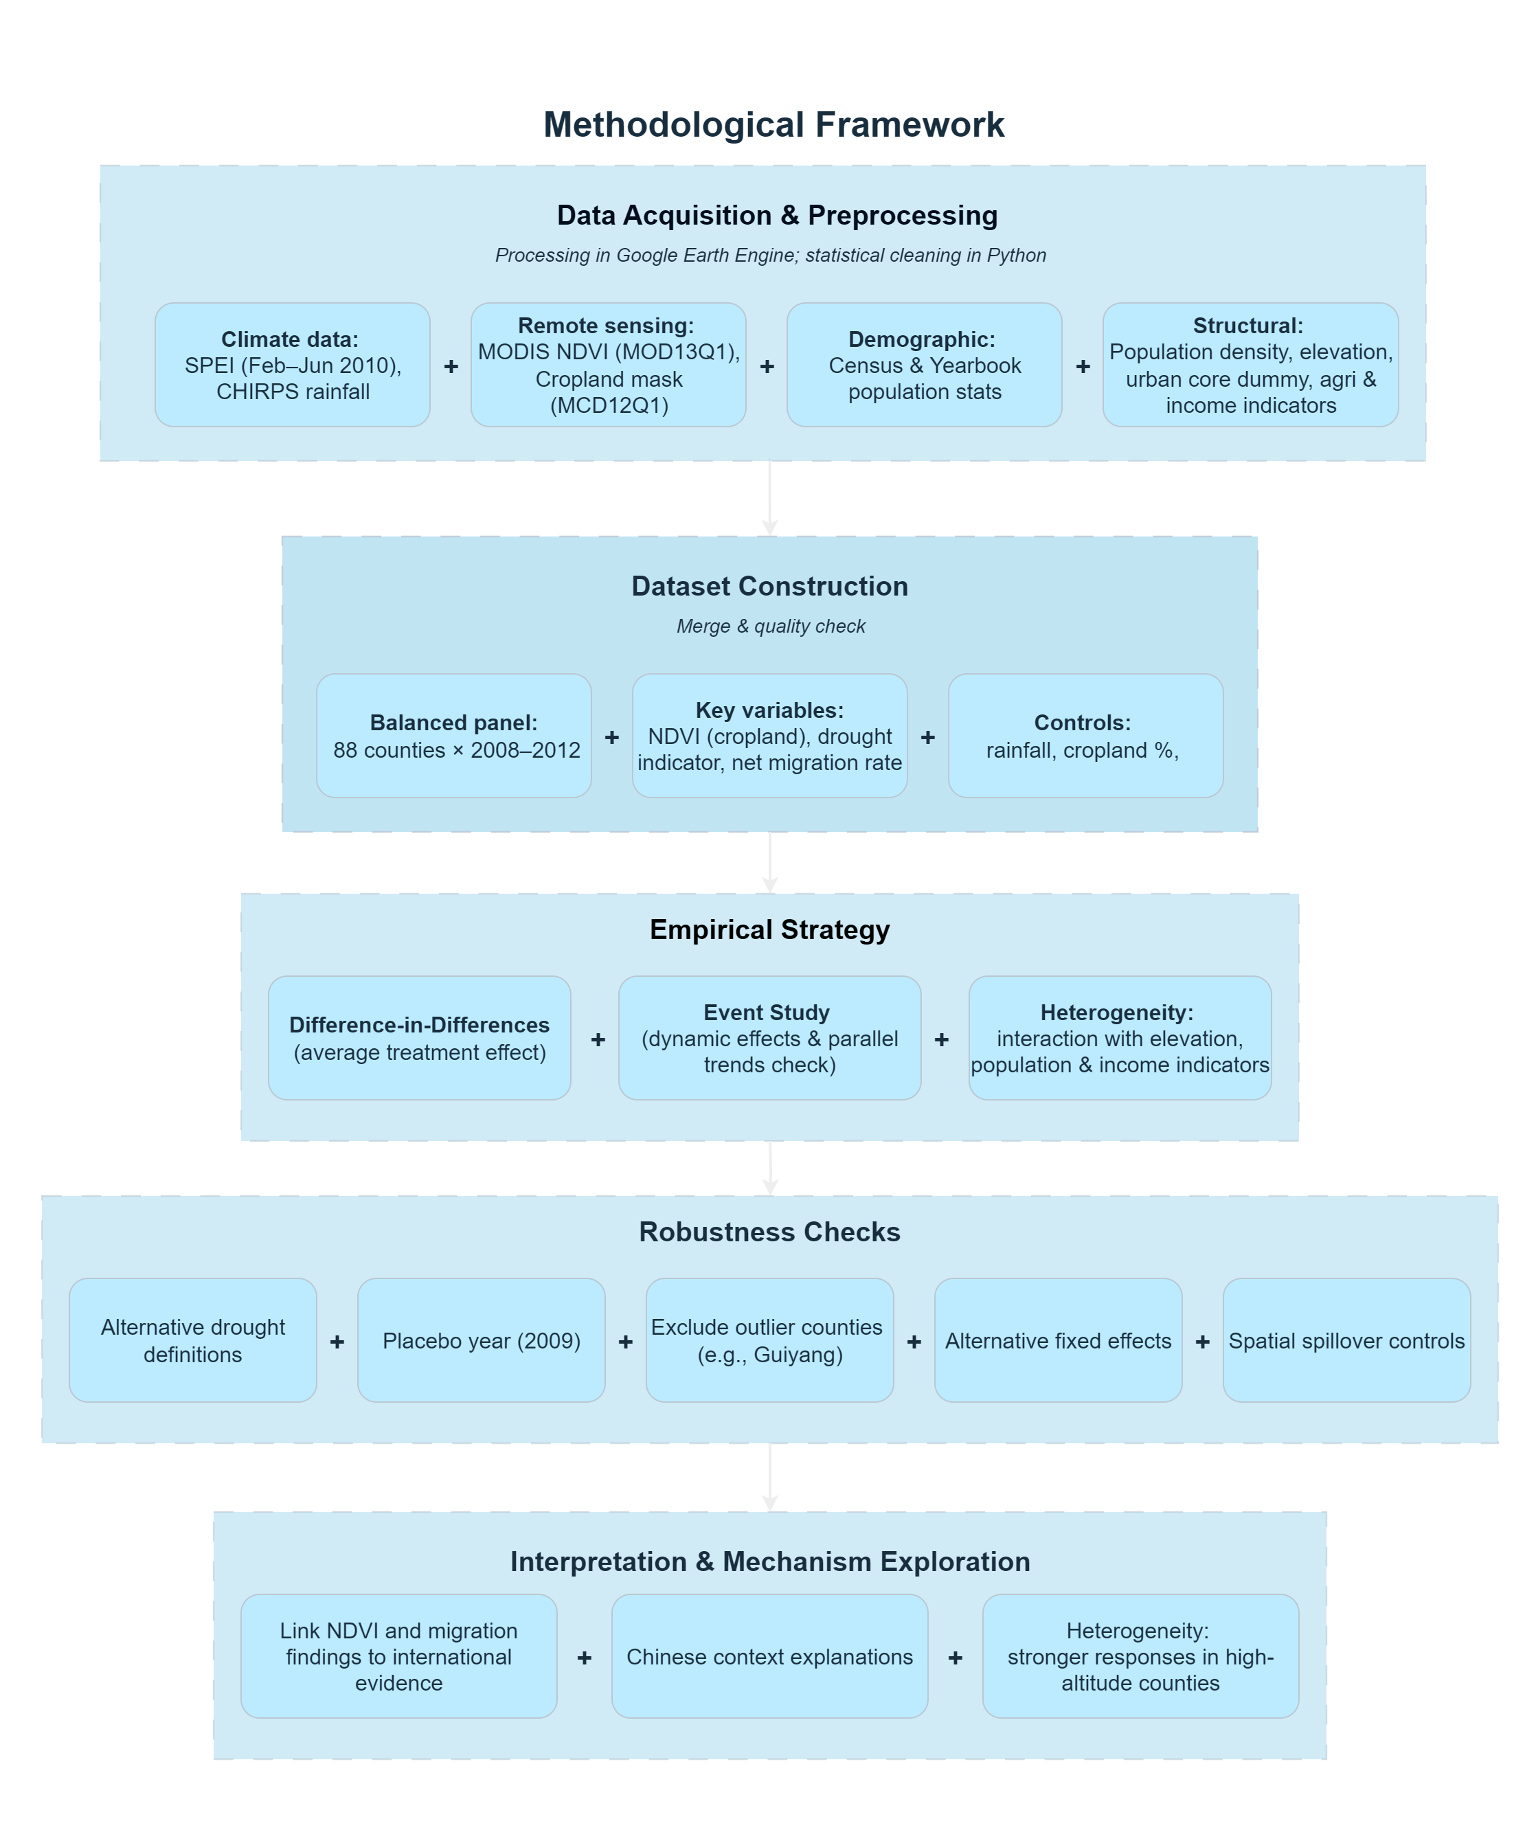
Figure 4.1 Methodological Framework for Assessing the Socio-Spatial Impacts of the 2010 Guizhou Drought

Data Acquisition & Preprocessing
This study integrated multi-source geospatial data and statistical data to construct a panel data set for 88 counties in Guizhou Province from 2008 to 2012. The data collection and pre-processing workflow followed a modular process (Figure 4.1), combining remote sensing, climate indices, demographic data, and terrain attributes.
Climate data were obtained from SPEIbase v2.10, a database based on the Standardised Precipitation Evapotranspiration Index (SPEI), which provides globally standardised measures of drought intensity. To reflect the peak of the drought in southwestern China during 2009–2010, the study selected three months of SPEI data from February to June 2010 (Yun, Jun and Hong, 2012). Pixels with values below -1.5 were classified as drought-affected. These binary mask data were averaged over five months to generate a pixel-level drought frequency layer, which was then aggregated into a county-level median drought frequency layer for further quartile division.
Vegetation data are derived from the MODIS MOD13Q1 product, which provides 16-day composite maps of the Normalised Difference Vegetation Index (NDVI) at a resolution of 250 metres. The images have been filtered to cover the annual growing season (April to September) and the annual average values have been taken. To isolate agricultural land, the NDVI composite images were masked using the MODIS MCD12Q1 (2010) land cover classification (IGBP 12 classes: cropland). A static cropland mask was uniformly applied to all years.
Population statistics are sourced from the Guizhou Statistical Yearbook (2009–2013) and the 2000 and 2010 census data. County-level permanent resident and agricultural population data were used to construct net migration indicators, which were adjusted for natural growth. For counties lacking birth/death data, provincial crude rates were used for estimation. Additionally, urban core counties (e.g., Guiyang) were marked, and the corresponding rural population values were set to zero.
Structural variables include topography and socioeconomic conditions. Average elevation was calculated based on SRTM DEM imagery (aggregated at the county level), and a high-elevation virtual variable was created for counties above the 75th percentile. Socioeconomic variables (e.g., population density, share of agricultural employment, share of agricultural GDP, rural income, and per capita GDP) were compiled from yearbooks and treated as time-invariant variables.
All grid data processing was performed in Google Earth Engine (GEE), including masking, aggregation, and regional statistics. Data merging, cleaning, and regression analysis were performed using Python (Pandas, GeoPandas). The spatial reference coordinate system was coordinated with the WGS84 (EPSG:4326) coordinate system, and consistency checks were performed to ensure accurate temporal and spatial alignment.

Dataset Construction
After data collection and pre-processing, a balanced panel dataset was constructed, covering five years of data from 88 counties (2008–2012). Each county's annual records included matching environmental, population, and structural indicators, ultimately forming a dataset containing 440 observations.
Time-varying variables include:
- NDVI (cropland): Mean NDVI for agricultural pixels during the April–September growing season.
- Net migration rate: Constructed as population change minus natural growth, standardised per 1,000 residents.
- Drought exposure: Median drought frequency in 2010, using both continuous and quartile-based specifications.
These annual indicators capture short-term climate and population dynamics and serve as dependent or treatment variables in regression models.
Time-invariant structural variables support heterogeneity and robustness analyses:
- Population density (persons per km², calculated using 2010 census data).
- Average elevation (derived from the SRTM DEM and treated as fixed).
- Cropland share (based on the 2010 MODIS MCD12Q1 classification).
- High-elevation dummy (equal to 1 if a county's average elevation exceeds the 75th percentile).
- Urban core dummy (assigned based on administrative classifications and held constant across years).
- Agricultural employment share, agricultural GDP share, rural per capita income, and county-level per capita GDP (all extracted from the 2010 statistical yearbooks and treated as cross-sectional indicators).
These structural variables are treated as time-invariant and used to explore potential heterogeneity in drought and migration responses (see Sections 4.4 and 0).
Missing data were carefully processed: gaps of ≤1 year were filled using linear interpolation; structural gaps (e.g., urban counties with no rural population) were retained as missing values to avoid bias. Quality flags were created to track which migration variables were directly reported and which were estimated.
All datasets were harmonised using county names and years as merging keys. Outliers and inconsistencies in data ranges were reviewed and corrected as necessary. This unified panel structure supports the empirical strategy outlined in Section 4.4.

Variable Definitions and Transformations
This section presents an overview of the key variables included in the panel data set, which are divided into outcome variables, treatment variables, and structural covariates used for heterogeneity and robustness analyses. The variables are either directly derived from statistical or remote sensing data sets or obtained through the transformation and aggregation procedures described in Sections 4.1–4.2, and detailed metadata are provided in the variable list in the Appendix.
The two outcome variables are:
- Vegetation index on cropland (ndvi_crop): Defined as the mean NDVI value during the April–September growing season for cropland pixels, based on MODIS MOD13Q1 and cropland mask from MODIS MCD12Q1 (2010).
- Net migration rate (net_migration_per_1000): Calculated by subtracting estimated natural population growth (births − deaths) from total population change, then standardised per 1,000 persons.
The treatment variables for identifying drought impacts include:
- Drought treatment dummy (treated): Equal to 1 for counties with above-median drought exposure, based on the proportion of pixels with SPEI <-1.5 during Feb–Jun 2010 (drought_pixel_rate).
- Post-treatment indicator (post): Equals 1 for years 2010–2012.
- Interaction term (drought_post): Product of treated and post, representing the DiD estimator.
Control variables include:
- Annual precipitation (rainfall), derived from CHIRPS data.
- Cropland share (cropland_pct), based on MODIS land cover data.
Structural covariates used for heterogeneity analysis include elevation (elev_mean), a high-elevation dummy (high_elevation), and socioeconomic indicators such as the agricultural employment share, agricultural GDP share, rural income, and per capita GDP (see the Appendix.A.1 for full definitions).

Empirical Strategy
To determine the causal effects of drought on agricultural vegetation and population mobility, this study adopted a multi-step empirical strategy, integrating a difference-in-differences (DiD) design, event studies for dynamic effect estimation, and heterogeneity analysis through interaction terms.

Difference-in-Differences Specification
The baseline identification relies on the canonical two-way fixed effects (TWFE) difference-in-differences (DiD) model, specified in Equation (1):
$$\begin{aligned}Y_{it}=α+β_{1}Treated_{i}+β_{2}Post_{t}+β_{3}\left(Treated_{i}×Post_{t}\right)+γ_{i}+δ_{t}+ε_{it}\#\left(1\right)\end{aligned}$$
where 𝑌_{𝑖𝑡} denotes the outcome variable for county_{𝑖} in year_{𝑡} (i.e., ndvi_crop or net_migration_per_1000); Treated_{𝑖} is a county-level indicator for high drought exposure (treated), Post_{𝑡} is a post-treatment dummy (post), and 𝛽_{3​} captures the average treatment effect on the treated (ATT). County fixed effects (𝛾_{𝑖}) absorb time-invariant unobservables, while year fixed effects (𝛿_{𝑡}) control for common shocks. Standard errors are clustered at the county level, which is the level of treatment and variation in exposure, following best practice in spatial panel DiD settings.
Identification assumes that, under the circumstances with no drought, there are parallel trends between treated and control counties, no spillover effects across counties, and the Stable Unit Treatment Value Assumption (SUTVA). The robustness of these assumptions is assessed through pre-trend inspection and spillover controls in Section 5.

Event Study Design
To explore dynamic treatment effects and validate the parallel trends assumption, an event study specification is estimated in Equation 2:
$$\begin{aligned}Y_{it}=\sum_{τ=-2}^{2}{β_{τ}}⋅1\left(t-2010=τ\right)⋅\text{Drough}{\text{t}}_{\text{i}}+γ_{i}+δ_{t}+ε_{it}\#\left(2\right)\end{aligned}$$
where 𝐷_{𝑖, 𝑡=𝜏​} is a set of year-relative dummies indicating the number of years before or after the drought peak (2010), with 𝜏 = -1(year 2009) omitted as the baseline. This specification allows tracing the full temporal trajectory of outcomes, and visualisation of coefficients 𝛽_{𝜏} provides a graphical check for pre-treatment trend balance.

Heterogeneity Analysis
To assess spatial and structural changes in drought impacts, the empirical strategy included interaction terms between the treatment indicator (drought_post) and six time-invariant county characteristics reflecting demographic, economic, and environmental factors.
The heterogeneity dimensions include:
- Population density: Counties with higher population densities may experience weaker migration responses due to stronger labour market absorption capacity and more diversified livelihoods (Beine and Parsons, 2015).
- Agricultural employment share: Counties that are heavily dependent on agriculture are expected to be more sensitive to climate shocks, given their reliance on vulnerable rural labour and rain-fed crop systems (Intergovernmental Panel on Climate Change (IPCC), 2023; Wang, Chen and Shen, 2024).
- Agriculture's share of GDP: Agriculture accounts for a high proportion of GDP, indicating structural dependence on agriculture, which may exacerbate vegetation loss and migration pressures during drought events (Cattaneo et al., 2019).
- Per capita GDP: Higher economic development levels may buffer the effects of drought through infrastructure, financial reserves, or access to insurance and credit (De Haas, 2021).
- Rural per capita income: At the household level, higher rural income may enhance adaptive capacity (e.g., irrigation, input investment), but may also facilitate planned migration in response to stress (Liang et al., 2021).
- Altitude: High-altitude areas are typically more ecologically fragile and lack infrastructure, making them more susceptible to agricultural pressure and long-term population migration (Liang et al., 2021; Intergovernmental Panel on Climate Change (IPCC), 2023).
These theoretical expectations guided the empirical tests of heterogeneous treatment effects, with coefficient estimates presented in Section 0.

Robustness Checks
To assess the reliability and stability of the estimated treatment effects, the study conducted a series of robustness tests. These tests assessed the sensitivity of the results to other drought definitions, model specifications, sample restrictions, and potential spatial spillover effects.
First, other drought definitions were analysed and tested. In addition to the benchmark threshold of SPEI <-1.5 for defining drought exposure, a stricter threshold of −2.0 was also used to capture more severe climate stress. Additionally, non-climate proxy indicators were used to identify counties with the lowest quartile of 2010 farmland NDVI as drought-affected counties. These variables were used to assess the robustness of the results to climate and vegetation-based classifications.
Second, a placebo test was conducted by artificially designating the treatment year as 2009, which was prior to the actual drought period. This fabricated test helped to verify whether there were any false effects or pre-existing trends that could cause bias in the DiD estimate.
Third, outlier exclusion is applied by removing Guiyang, the provincial capital and an urban outlier, from the sample. Given its atypical economic and demographic structure, this exclusion tests the sensitivity of estimates to influential cases.
Fourth, this study explored other fixed-effects model settings. In addition to the two-way fixed-effects model used in the baseline model, three additional variables were tested: (1) considering only county-level fixed effects; (2) considering only year-level fixed effects; and (3) including county-specific linear trends to explain potential differentiated trends.
Finally, to address potential spatial spillover effects, a spatial lagged drought exposure variable was constructed based on first-order adjacency. This variable was added to the regression model to control unobserved shocks from neighbouring counties.

Interpretation & Mechanism Exploration
In addition to estimating average treatment effects, this study adopted a dual outcome strategy—simultaneously examining the normalised difference vegetation index (NDVI) and net migration—to explore potential underlying mechanisms linking environmental stress and population mobility. As an indicator of agricultural vitality, the normalised difference vegetation index (NDVI) can reflect the ecological and economic consequences of drought at the local level. International research indicates that vegetation loss is often associated with declines in agricultural productivity and household income, which may be drivers of population migration (Cattaneo et al., 2019).
However, the link between environmental degradation and population migration is not necessarily inevitable. In China, certain structural and institutional characteristics may mitigate this relationship. First, households may adopt in-situ adaptation strategies, such as livelihood diversification or temporary migration, rather than permanent migration. Second, policy interventions, including post-disaster subsidies or public works, may cushion the direct economic impacts of drought (Yun, Jun and Hong, 2012; Intergovernmental Panel on Climate Change (IPCC), 2023). Third, institutional constraints—particularly the household registration system, rural land use rights, and urban employment opportunities—may suppress population mobility even under ecological stress (Liang and Ma, 2004; Chan, 2010).
To capture dynamic spatial heterogeneities, the analysis incorporates interaction terms between drought exposure and structural covariates—including altitude, agricultural dependency, and income level. This approach assesses whether the impacts of environmental shocks vary according to counties' economic capacity, ecological vulnerability, and adaptive space.

Statement of Ethics
This study has been reviewed and approved by the University College London Research Ethics Committee. This study relies entirely on secondary data sources, including publicly available satellite imagery, climate indices, and aggregated county-level statistical data. No personal-level or personally identifiable information is involved. All data processing and analysis comply with University College London's ethical guidelines and the approved application.

Results

Main Effects
This section presents the average impacts of the 2010 Guizhou drought on cropland vegetation and population mobility. Using a two-way fixed effects difference-in-differences (DiD) model, the analysis estimates changes in NDVI and net migration rates between drought-affected and unaffected counties before and after 2010. Standard errors are clustered at the county level. Figure 5.1 summarises the main findings using pre- and post-drought group means with 95% confidence intervals. Detailed regression outputs are reported in Appendix.B.1
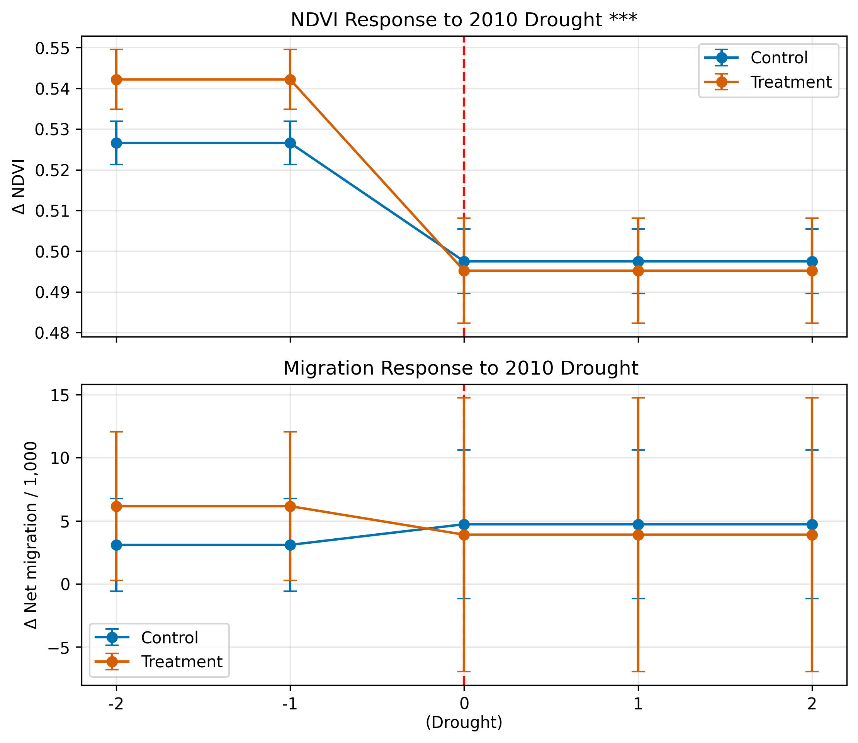
Figure 5.1 Average Pre- and Post-Drought Trends in NDVI and Net Migration Rate
Two-panel plot comparing the pre- and post-2010 averages for treated (drought-affected) and control counties. Top: Average cropland NDVI during the growing season. Bottom: Net migration rate per 1,000 people. Error bars represent 95% confidence intervals.
Data sources: MODIS MOD13Q1, MODIS MCD12Q1, Guizhou Statistical Yearbook.

Cropland NDVI
The top panel of Figure 5.1 shows that after the drought, the NDVI decreased significantly in both the treatment counties and the control counties, but the decrease was greater in the treatment counties. Before 2010, the average NDVI value for farmland in the treatment counties was approximately 0.541, while that for the control counties was 0.528. After 2010, the NDVI values decreased to 0.496 and 0.498, respectively, effectively eliminating the initial difference.
The average treatment effect of the DiD regression estimate was -0.0179 (p < 0.01), which was statistically significant, indicating that drought exposure had a significant decline on agricultural vegetation. Also, the R-squared value of the NDVI model was as high as 0.976, reflecting the model's strong explanatory power given the spatial and temporal coverage of the panel data.

Net Migration Rate
The lower panel of Figure 5.1 shows the estimated impact of net migration per thousand residents. Before 2010, the average net migration rate in the treatment counties (6.2) was higher than that in the control counties (3.1), indicating a potential trend of population outflow in drought-prone regions. After the drought, migration levels across groups converged, both groups converged at ~4.0 per 1,000, suggesting weaker outflow in treated counties.
The DiD coefficient is -3.89, indicating that drought may have suppressed net migration or accelerated outflow. However, this estimate is not statistically significant (p = 0.208) and has a wide confidence interval. The R-squared value of the migration model is 0.459, which is moderate, reflecting greater heterogeneity and noise in population responses compared to environmental indicators.

Comparative Insights
Variance Inflation Factor (VIF) tests were conducted to assess potential multicollinearity among explanatory variables, since collinearity could bias coefficient estimates in fixed-effects regressions. Results indicated no serious issues (all VIF < 5), confirming the robustness of the model specification (Appendix.B.2).
These findings reveal significant differences between ecological and population effects. Vegetation responses were significant, negative, and accurately estimated, indicating that agricultural landscapes will suffer widespread and sustained damage following drought. In contrast, migration responses were weaker and inconclusive. Although point estimates were substantial, they lacked statistical significance, suggesting caution in explaining population changes by climate triggers alone.
Despite obvious ecological pressures, the weakening of migratory responses may indicate limited capacity or willingness to migrate, consistent with broader findings in the climate and mobility literature. The study will further explore this contrast through temporal dynamics (Section 5.2), heterogeneity analysis (Section 5.3), and mechanism exploration (Section 6).

Dynamic Effects
To assess the temporal dynamics of drought impacts and validate the parallel trends assumption, this study adopts an event study framework, estimating year-specific treatment effects from 2009 (baseline year) to 2012. These dynamic coefficients trace pre- and post-drought effects in the aftermath of the 2010 drought. Figure 5.2 plots the estimated coefficients with 95% confidence intervals for both cropland NDVI and net migration rates. Full coefficient estimates with standard errors are provided in Appendix.B.2.

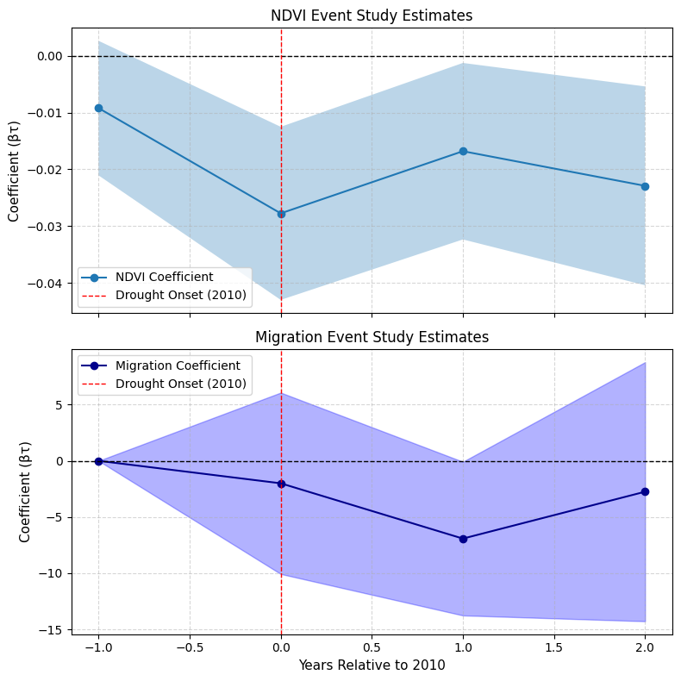
Figure 5.2 Event study estimates for cropland NDVI and net migration rates before and after the 2010 drought in Guizhou
Top pane: βτ coefficients and 95% confidence intervals from the event study regression for cropland NDVI during the growing season; Bottom panel: corresponding estimates for net migration rates per 1,000 persons. The vertical dashed line: the 2010 drought onset (Year 0).
The analysis covers a three-year window around the drought event (2008–2012) and assesses both the presence of pre-drought parallel trends and post-drought effects.
Data sources: MODIS MOD13Q1, MODIS MCD12Q1, Guizhou Statistical Yearbook.

NDVI Responses over Time
The top panel of Figure 5.2 reports the estimated effect of drought exposure on farmland vegetation (NDVI). The 2009 coefficient (τ = –1) is statistically indistinguishable from zero, suggesting no systematic difference in vegetation trends between treatment and control counties prior to the drought. This supports the parallel trends assumption and strengthens the credibility of the DiD design. In 2010 (τ = 0), NDVI dropped sharply by about –0.029, with confidence intervals excluding zero, indicating a significant vegetation loss in drought-affected areas. The negative effect persisted in 2011 (τ = +1), albeit with slightly reduced magnitude, and partially rebounded in 2012 (τ = +2), though NDVI levels remained below the pre-drought baseline. Overall, these results suggest that the 2010 drought had an immediate and lasting adverse impact on farmland conditions.

Migration Dynamics
The lower panel of Figure 5.2 displays the corresponding event studies for net migration per thousand residents. The pre-treatment coefficient for 2009 is again close to zero, further supporting the parallel trends assumption. 2010 estimates were negative but statistically insignificant, with wide confidence intervals. However, the confidence interval includes zero, and the estimate is not statistically significant.
In the following years (2011 and 2012), the coefficient remained negative, but the magnitude decreased, and the precision was even lower. This pattern suggests that any migration response to drought was either small in scale, varied greatly between counties, or was masked by other factors.

Comparison and Implications
Overall, NDVI responses were immediate and persistent, while migration responses were weak and statistically inconclusive. This difference reflects the average treatment effect discussed in Section 5.1 and further indicates that agricultural impacts do not automatically translate into population migration—at least not in the short term.
Section 0 will further explore possible explanations for this decline, including structural constraints, policy interventions, and alternative coping strategies that may limit large-scale migration responses under ecological stress.

Heterogeneity Results
To further explore the spatial and structural changes in drought impacts, this section conducts a heterogeneity analysis based on time-varying county-level characteristics. Heterogeneity was assessed across structural covariates (altitude, agri-dependency, income, etc.) (Cattaneo et al., 2019; Liang et al., 2021; Intergovernmental Panel on Climate Change (IPCC), 2023). To examine this, interaction terms were introduced between the treatment variable and six time-invariant covariates: mean elevation, population density, share of agricultural GDP, share of agricultural employment, rural income, and per capita GDP. The results are summarised in Figure 5.3. Complete regression results for subgroup interactions are available in Appendix.B.3.
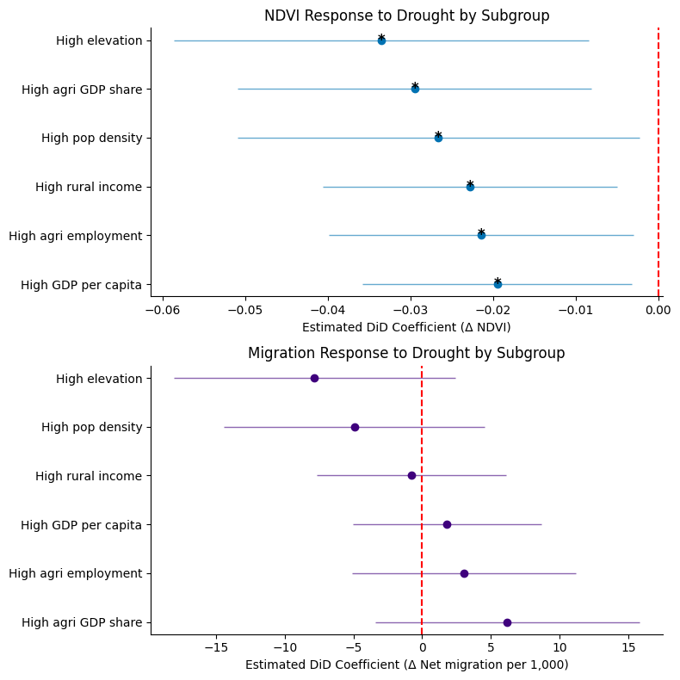
Figure 5.3 Spatial Heterogeneity in Drought Impacts
Top panel: DiD coefficient estimates (with 95% confidence intervals) for NDVI by subgroup; Bottom panel: corresponding estimates for net migration rate.
Subgroups are defined by whether counties fall above the sample median (or 75th percentile for elevation) for each structural variable. * indicates significance at p < 0.1.
Data sources: MODIS MOD13Q1, MODIS MCD12Q1, Guizhou Statistical Yearbook.

Vegetation Impacts Across Structural Conditions
The figure above shows the different effects of drought on the NDVI of different subgroups of cropland. All estimated coefficients are negative and statistically significant at the 10% level, indicating that vegetation loss is consistent but not uniform. The largest decline was observed in high-altitude counties, followed by counties with a higher proportion of agricultural GDP and higher population density. While the NDVI findings confirm widespread environmental degradation, the differences among these subgroups highlight how ecological fragility and structural dependence on agriculture may exacerbate vulnerability to drought shocks.

Limited Variation in Migration Responses
In contrast, the net migration response shown in the figure below is less conclusive. Although the point estimates vary widely—coefficients varied in sign and magnitude but none were significant with a higher share of agricultural GDP—none of the migration coefficients are statistically significant. This suggests that even in areas with greater ecological impact (such as higher-altitude regions), population mobility may not necessarily increase.

Divergence Between Ecological and Demographic Effects
Heterogeneity analysis reinforces two key insights. First, drought-induced vegetation loss has a particularly severe impact on structurally vulnerable counties (especially those at higher altitudes or with higher agricultural dependency). Second, the lack of obvious subgroup effects in migration patterns suggests that ecological stress alone is insufficient to trigger large-scale demographic changes. The decoupling of vegetation shocks from population mobility highlights the importance of understanding the potential mechanisms underlying population responses to climate stress. This divergence highlights that ecological shocks do not automatically translate into migration.

Robustness Checks
To assess the reliability of the estimated treatment effects, a series of robustness tests were conducted. These tests addressed potential issues related to drought classification, model specification, sample composition, and spatial dependence. The main results are presented in Table 5.4-1.
Table 5.4-1 Summary of Robustness Checks
Specification | Coefficient | Significance
Baseline (Full FE) | -3.89 | n.s.
Alternative drought definitions | ~2.5 | n.s.
Placebo year (2009) | ~0 | n.s.
Excluding urban counties | -3.27 | n.s.
Spatial lag of drought | -3.89 | n.s.
Notes: n.s. = not statistically significant. Full results are reported in Appendix.B.5.

Alternative Drought Definitions
To test sensitivity to drought classification, two alternative definitions were applied: (i) raising the pixel-level drought threshold to 0.4, and (ii) classifying counties with an average NDVI below 0.2 in drought years as treated. In both cases, the estimated effect on migration remained statistically insignificant and aligned in direction with the baseline, suggesting that findings are not driven by the choice of drought indicator.

Placebo Year
A falsification test shifted the treatment year to 2009, prior to the actual drought. Coefficients were close to zero and statistically insignificant, supporting the validity of the identification strategy and confirming the absence of pre-existing trend differences between treatment and control counties.

Excluding Influential Units
To account for potential outliers, estimates were recalculated excluding Guiyang and other core urban counties. Results remained negative in sign and similar in magnitude to the baseline, indicating that findings are not driven by specific county shocks.

Alternative Fixed Effects
Model specifications were adjusted by including only county or only year fixed effects. Although these reduced models fit compared to the full specification, the overall direction of estimates remained consistent. This reinforces the robustness of results to alternative FE structures.

Spatial Spillover
Finally, a spatial lag term was introduced to capture potential spillover from neighbouring drought-affected counties. The coefficient was insignificant, and the main treatment effect remained stable, suggesting that spatial autocorrelation does not substantially bias the results.

Summary
Across all specifications, the estimated treatment effects were stable in direction and statistically insignificant for migration, while vegetation impacts remained robust. These tests confirm that the empirical framework is not overly sensitive to modelling choices, lending confidence to the reliability of the core findings.

Summary of Results
This chapter presents empirical findings on the impact of the 2010 drought in Guizhou on agricultural vegetation and population mobility. The analysis shows that the drought had a significant and statistically significant negative impact on the normalised difference vegetation index (NDVI) of cropland, with particularly significant declines in high-altitude areas and agriculture-dependent counties. In contrast, migration responses were weak and inconsistent. Temporal analysis confirmed the direct and sustained impact of the drought on the ecological environment, while population responses were limited and transient. A series of robustness tests validated the stability of the core findings under alternative specifications. These results align with the literature emphasising the uneven geography of climate vulnerability (Gray and Mueller, 2012; Nawrotzki and DeWaard, 2016)) and support the view that in inland China, institutional and structural barriers may weaken migration responses despite ecological stress.
In summary, these results highlight the decoupling between ecological stress and population adjustment, prompting further exploration of its underlying mechanisms in the next chapter.

Discussion

Summary of Key Findings and Emerging Questions
This study explores the impact of the 2010 drought in Guizhou Province on cropland vitality and population mobility. Empirical results show a clear ecological response: drought exposure caused a statistically significant decline in cropland NDVI, indicating high sensitivity of local agroecosystems to climatic shocks. The NDVI drop was immediate and persistent, and strongest in rain-fed, mountainous settings.
In contrast, the estimated effect of net migration is consistent in direction with outward migration but is statistically weaker and less robust under different specifications. This decoupling of ecology and population challenges the linear narrative that climate shocks directly translate into migration and highlights the role of institutional, socioeconomic, and environmental constraints in shaping population mobility decisions.
Heterogeneity analysis reinforces this asymmetry: high-altitude counties experienced greater NDVI losses, but differences in migration among subgroups were limited and statistically insignificant across most structural dimensions (e.g., population density, share of agricultural employment). In other words, areas with the most severe ecological damage did not necessarily exhibit stronger measurable migration responses.
In summary, the research findings raise two interrelated questions that guide the remainder of this chapter. First, under what conditions do climate shocks cross the threshold required to trigger structural population change? Second, to what extent do institutional barriers and livelihood constraints (consistent with the ‘trapped populations’ and ‘aspirations–capabilities’ perspectives) inhibit or delay population mobility, even in ecologically fragile environments? The following sections analyse these findings within the context of international evidence and China's specific institutional framework.

Situating the Findings in International Climate-Migration Evidence
Placing the Guizhou case in a wider perspective helps to assess whether the observed decoupling reflects broader empirical patterns or is context-specific. Numerous international studies describe a typical causal chain: climatic shocks reduce agricultural production, which in turn stimulates migration (Black et al., 2011; Cattaneo et al., 2019). However, the findings from Guizhou challenge this narrative. Despite clear evidence that drought reduced cropland vitality—captured by a significant fall in the NDVI—demographic responses were statistically weak. This divergence indicates that the climate–agriculture–migration linkage is conditional rather than universal.
Two interpretations are particularly salient. First, threshold effects: climate shocks may need to surpass context-specific thresholds to induce migration (McLeman, 2018), and the 2010 drought may not have crossed that threshold for most households. Second, binding constraints: migration is filtered by capabilities and institutions, as emphasised by the “aspirations–capabilities” framework (De Haas, 2021) and by work on “trapped populations” (Black et al., 2011; Government Office for Science, 2011). These perspectives imply that even substantial ecological stress may not translate into movement where access to resources, networks, or permissive institutions is limited.
Recent micro-level evidence from China is consistent with this reading. Studies show that climatic anomalies reallocate rural labour—toward local non-farm work or off-farm diversification—without necessarily producing large permanent moves (Wang, Chen and Shen, 2024; Zheng et al., 2024). Such adjustments can mitigate income shocks while remaining invisible to county-level net-migration statistics, helping to explain why strong NDVI effects coexist with muted registered mobility in Guizhou.
The findings from the Guizhou case temper the widespread claim that climate drives migration: agricultural stress appears to be a necessary condition for mobility, but not a sufficient one. The transformation into population movement depends on institutions, labour demand, and social security, especially in a moderately regulated middle-income country like China. This aligns with cross-national research findings that climate impacts are influenced by structural conditions (Beine and Parsons, 2015; Nawrotzki and DeWaard, 2016) and also complements evidence from sub-provincial levels in inland ecologically fragile regions.

Explanations in the Chinese Context

Structural and Institutional Barriers to Migration
A principal reason for the muted migration response lies in the structure of China’s rural economy and its institutional migration regime. By 2010, Guizhou had experienced over a decade of net rural out-migration, particularly among working-age cohorts (Huang, 2012). Against this backdrop, the marginal push from the 2010 drought may have been limited because the scope for further labour outflow had already been partly exhausted. In parallel, emergency relief and reconstruction helped buffer livelihood shocks: subsidised water supply, food distribution, public employment programmes and housing recovery (Guizhou Provincial Government, 2010a, 2010b), alongside infrastructure and basic-service investments under the Rural Poverty Alleviation and Development Outline (2011–2020) (State Council of China, 2011), reduced the immediacy of migration as an adaptation.
More fundamentally, the hukou system restricts access to urban education, healthcare and welfare for non-locals (Liang and Ma, 2004; Chan, 2010), raising the institutional costs of permanent relocation—especially for households with older or less mobile members. Consequently, even under ecological stress, households may favour in-situ adjustments over long-distance moves, consistent with “trapped populations” and “aspirations–capabilities” perspectives. Temporary or circular migration remains common but is not captured by county-level net migration statistics, further complicating measurement.

Role of Geography and Livelihood Structure in Shaping Sensitivities
Guizhou's geographical and agricultural characteristics also play an important role in shaping the local response to climate shocks. Guizhou is predominantly mountainous, with extensive sloping cropland, poor soil-water retention and a reliance on rain-fed agriculture; high-altitude areas also have lower irrigation coverage and mechanisation (Luo et al., 2019). These features amplify ecological vulnerability to drought, aligning with the pronounced NDVI declines observed.
However, ecological exposure does not necessarily lead to migration. In many high-altitude areas, households are land-rich but cash-poor, face practical and financial barriers to relocation, and therefore adopt in-situ strategies—borrowing, shifting into non-farm activities, or taking short-term local employment (Chen, Tan and Gruschke, 2021). In 2010, township-level public employment programmes absorbed surplus rural labour (Guizhou Provincial Government, 2010a). National policy at the time prioritised stability and resilience-building rather than encouraging outward movement (State Council of China, 2011). This geography–policy interplay helps explain why areas with the greatest ecological losses did not exhibit proportionate registered mobility.

Data and Measurement Considerations
In addition to structural and geographical factors, the slow response to population migration may partly reflect the limitations of the methods used to measure population mobility. The primary outcome variable used in this study—net migration per thousand people—is based on annual population registration data from the Guizhou Statistical Yearbook. While this indicator helps capture long-term population trends, it only reflects permanent or semi-permanent changes in household registration status. It does not account for temporary, seasonal, cyclical, or unrecorded forms of mobility, which are prevalent in rural China (Liang and Ma, 2004; Lu and Xia, 2016).
In many rural counties, especially during periods of environmental stress, families may send one or two members to nearby towns or urban centres for short-term work while retaining their original village household registration and residency rights. This pattern was confirmed during the 2010 drought, when county-level governments in Guizhou Province implemented short-term public employment programmes to absorb surplus rural labour (Guizhou Provincial Government, 2010a). These programmes provided a form of local adaptation that was both economically meaningful and administratively invisible in demographic data.
Similar limitations also apply to the measurement of agricultural impacts. The Normalised Difference Vegetation Index (NDVI) reflects surface greenness rather than crop yields or farmer responses and therefore cannot serve as a perfect proxy for agricultural impacts (Kogan, 2001; Tucker et al., 2005). It cannot capture behavioural adjustments such as fallowing or labour shifts, which often occur during droughts but are not reflected in remote sensing data (Wang, Chen and Shen, 2024; Zheng et al., 2024). These data constraints help account for the observed decoupling between significant ecological impacts and weak registered migration.

Interpreting Heterogeneity
The heterogeneity results suggest that local agricultural vulnerability conditions the magnitude of drought impacts—strongly for ecological outcomes, weakly for demographic ones. During the 2010 event, high-altitude counties recorded the largest NDVI losses. These areas rely more heavily on rain-fed agriculture, have steeper slopes, poorer soil-water retention and lower irrigation and mechanisation, which heighten sensitivity to precipitation shortfalls (Luo et al., 2019). These ecological and infrastructure disadvantages exacerbate the impacts of insufficient precipitation, leading to more severe crop yield reductions caused by drought. Consistent with recent evidence from China, households facing agricultural income declines tend to reallocate labour towards non-farm or short-term activities rather than undertake permanent moves (Wang, Chen and Shen, 2024).
By contrast, subgroup differences in net migration were limited and statistically insignificant across most structural dimensions (e.g., population density, income levels, agricultural employment shares). Point estimates varied in sign and magnitude but did not coalesce into a robust pattern, indicating that ecological exposure does not straightforwardly translate into measurable out-migration at the county scale.
Taken together, these findings indicate that migration responses are more likely where environmental exposure and livelihood dependence are jointly high, yet even in such settings the response may be muted by binding constraints and data granularity. Possible explanations include structural similarity across counties, unobserved barriers (e.g., hukou-related access to services, market connectivity), and measurement limits that miss short-term or circular mobility. These issues, particularly structural homogeneity and omitted resilience factors, are further discussed in Section 6.6.

Policy Implications
The findings of the study suggest that policy should combine place-based resilience with mobility-enabling institutions and improved evidence. To highlight areas that may be particularly worthy of policy attention, this paper proposes four directions.
- Resilience in ecologically fragile and agriculturally dependent areas.
The concentration of NDVI losses in high-altitude, rain-fed counties indicates that resilience efforts may need to be prioritised where exposure and livelihood dependence are jointly high. Interventions such as drought-tolerant crops, water-saving irrigation systems, and strengthened agricultural extension services are already emphasised in Guizhou Province 14th Five-Year Water Development Plan (2021) and China’s Administrative Measures for the Construction of Modern Agricultural Industry Technology System (2021).
- Enable adaptive labour mobility alongside local adjustment.
The limited migration response observed here suggests that, where agricultural productivity remains persistently low, policies that expand households’ adaptive options—whether through in-situ diversification or safe and voluntary mobility—may merit further consideration. Existing programmes such as public employment schemes (Yun, Jun and Hong, 2012) illustrate how counter-cyclical labour absorption can buffer shocks, while vocational training and job-matching could complement longer-term strategies (The State of Food and Agriculture 2021: Making Agrifood Systems More Resilient to Shocks and Stresses, 2021).
- Modernise migration monitoring to capture short-term and circular flows.
Because official statistics mainly capture permanent moves, they may miss adaptive short-term or circular migration that is often critical during climatic stress. The results point to the value of complementing yearbook data with administrative sources (e.g., temporary registration), carefully governed aggregates (e.g., telecommunications or electricity data), and periodic household (Lu and Xia, 2016; Wang, Chen and Shen, 2024). Such improvements would enhance the evidence base for evaluating climate–mobility linkages.
- Strengthen inter-regional labour coordination and portability of services.
Finally, the weak demographic effects in Guizhou underline the importance of institutional conditions. Cross-regional labour coordination and the portability of basic services (education, healthcare, social protection) may help reduce the frictions that constrain mobility. This is consistent with the aspirations–capabilities perspective and complements recent calls for stronger integration of labour and social policy within The Rural Revitalisation Plan (2024–2027) (2025).
Overall, the policy implications point towards a combined agenda: reinforcing resilience in ecologically fragile areas, easing institutional barriers to mobility, and modernising migration monitoring. Such a mix does not prescribe specific outcomes but broadens the adaptive options available to rural households. By linking agricultural support, labour institutions and evidence systems, policy can reduce vulnerability and enhance the state’s capacity to respond more equitably to future climatic shocks.

Limitations and Future Research
While this study offers new evidence on drought and mobility in south-western China, several limitations qualify the findings and suggest avenues for further work.
First, migration measurement. The outcome—net migration per thousand—is derived from annual registration data and therefore captures mainly permanent or semi-permanent moves. It undercounts short-term, seasonal and circular mobility that is widespread in rural China (Liang and Ma, 2004; Lu and Xia, 2016). Such adaptive movements are likely to be most salient during climatic shocks and may help explain the muted registered response. Future research should triangulate yearbook indicators with complementary sources (e.g., temporary registration records, carefully governed aggregates from telecommunications or electricity use, and household panel surveys) to recover more dynamic mobility patterns.
Second, agricultural impact measurement. NDVI is a useful, spatially consistent proxy, but it reflects surface greenness rather than yields or farmer behaviour (Kogan, 2001; Tucker et al., 2005). It cannot detect farm-level adjustments such as crop switching, early harvesting, fallowing or labour reallocation (Zheng et al., 2024). Subsequent work could combine remote sensing with crop-specific yield statistics, agricultural surveys and higher-resolution sensors to validate mechanisms and distinguish ecological loss from strategic land-use responses.
Third, covariates and structural heterogeneity. Socio-economic conditions across Guizhou counties are relatively homogeneous (Huang, 2012), limiting power to detect conditional effects. In addition, key resilience-related variables (e.g., irrigation coverage, mechanisation, land-tenure security, access to social protection) are unavailable in a consistent county-year panel. As noted by Akbari et al. (2023), including such moderators can bias spatial causal inference and obscure heterogeneous treatment effects. Building richer panels that incorporate these factors—and explicitly interacting them with climatic shocks—would sharpen interpretation.
Finally, research design and identification strategies. Future research could use longer time spans, which would help capture lagged adaptation and recovery dynamics beyond the post-shock window. At a finer scale, causal designs at the household level (e.g., linked survey-administrative panels) and mixed methods could elucidate whether, how, and why environmental changes affect mobility decisions in different institutional environments. At the aggregate level, sensitivity analyses that relax the two-way fixed effects assumption, allow for heterogeneous treatment effects, and more fully account for spatial spillover effects will further strengthen inferences.

Conclusion

Summary of Findings
This study examined the socio-spatial impacts of the 2010 extreme drought in Guizhou using a county-level panel that integrates remote sensing (NDVI), climate indices (SPEI), and official statistics. A two-way fixed-effects difference-in-differences framework, complemented by an event-study design, revealed a clear ecological response and a muted demographic response. Drought exposure led to a sharp and persistent decline in cropland NDVI, indicating high sensitivity of rain-fed, mountainous agro-ecosystems to climatic shocks.
By contrast, estimated effects on net migration per thousand were small, statistically weak across specifications, and heterogeneous across space. Heterogeneity analysis showed that high-altitude counties—with steeper slopes, poorer soil-water retention and more limited irrigation/mechanisation—suffered disproportionate vegetation losses, while measurable out-migration did not rise commensurately. Taken together, the results point to a decoupling of ecological stress and registered mobility: climatic shocks appear to be a necessary but not sufficient condition for demographic change where institutional frictions, livelihood constraints and measurement limits are salient.

Contributions
This dissertation contributes to the climate–agriculture–migration literature in two main respects.
In terms of academic contribution, it provides new county-level evidence from Guizhou Province, a mountainous and agriculture-dependent region largely absent from both domestic and international studies. By examining the 2010 extreme drought, the research shows how an acute climatic event can generate substantial ecological stress without precipitating large, statistically robust changes in registered migration—clarifying that climate–agriculture–migration linkages are context-specific and conditional.
Methodologically, the study demonstrates the value of a spatially explicit, event-based approach at a meso-scale, integrating NDVI, SPEI and demographic indicators within a unified panel and using DiD plus event-study models to probe dynamics and heterogeneity. The framework—linking ecological signals to demographic outcomes while acknowledging institutional context—offers a transferable template for analysing climate shocks in other regions.

Policy Implications
The findings suggest policy attention may be most effective where place-based resilience, mobility-enabling institutions and improved evidence are considered together.
Strengthening resilience in fragile, agriculture-dependent counties remains a priority, particularly those reliant on rain-fed farming with steep terrain and limited irrigation infrastructure. Measures such as drought-tolerant varieties, water-saving irrigation technologies and strengthened agronomic extension services are consistent with ongoing provincial and national plans on water management and agricultural modernisation.
At the same time, policy should widen households’ adaptive options in areas where agricultural productivity is structurally low. Expanding skills training, job-matching initiatives, social protection and temporary public employment programmes can help smooth incomes during shocks and reduce the risk of households becoming structurally trapped, while still recognising the importance of in-situ coping strategies.
A further implication concerns migration monitoring: official registration data largely capture permanent moves but undercount short-term and circular flows, which often constitute crucial adaptive responses. Combining administrative sources with ethically governed aggregate data, such as telecommunications or electricity records, could provide more dynamic evidence to guide timely interventions.
Finally, greater inter-regional labour coordination and the portability of basic services would ease the institutional frictions that limit rural mobility, ensuring that temporary movers have access to education, healthcare and social protection. Taken together, such measures would support more equitable livelihoods, broaden adaptive choices, and enhance the state’s capacity to respond effectively to future climatic shocks.

Limitation and Future Research
This study faces several limitations that qualify its conclusions. A key constraint lies in data availability. The migration outcome—net migration per thousand residents—derives from county-level registration data, which primarily captures permanent or semi-permanent changes in residence. This inevitably omits short-term, seasonal, and circular mobility, which are common adaptive strategies in rural China and may be especially important during climatic shocks. Similarly, the use of NDVI as a proxy for agricultural performance reflects surface greenness but not crop yields, household income, or behavioural responses such as crop switching, fallowing, or labour reallocation. As a result, the ecological and demographic effects identified here should be interpreted as indicative rather than exhaustive.
Methodological limitations are also relevant. The difference-in-differences design relies on the assumption of parallel trends, which, despite supporting tests, cannot be fully verified. Moreover, potential spatial spillovers—such as the migration of labour across neighbouring counties or the diffusion of drought effects along market and social networks—are not fully incorporated. Although robustness checks suggest that these factors do not overturn the main findings, they indicate areas where more refined causal strategies could improve inference, including approaches that allow for heterogeneous treatment effects and spatial dependence.
Future research could extend this study in several directions. Longer time series and higher-resolution satellite products would allow a fuller assessment of the persistence of drought effects and interactions with subsequent climate events. Linking household surveys, micro-level administrative data, and remote sensing indicators could uncover how resource constraints, networks, and institutions shape adaptive choices. Comparative analyses across provinces with different ecological and socio-economic profiles would further clarify how geography, policy, and labour markets condition vulnerability and response. Collectively, such efforts could provide a more comprehensive understanding of the climate–agriculture–migration nexus in China and help refine the evidence base for adaptation policy.

Bibliography
Adger, W. N., Crépin, A.-S., Folke, C., Ospina, D., Chapin, F. S., Segerson, K., Seto, K. C., Anderies, J. M., Barrett, S., Bennett, E. M., Daily, G., Elmqvist, T., Fischer, J., Kautsky, N., Levin, S. A., Shogren, J. F., Van Den Bergh, J., Walker, B. and Wilen, J. (2020). ‘Urbanization, Migration, and Adaptation to Climate Change’. One Earth, 3 (4), pp. 396–399. https://doi.org/10.1016/j.oneear.2020.09.016.
Akbari, K., Winter, S. and Tomko, M. (2023). ‘Spatial Causality: A Systematic Review on Spatial Causal Inference’. Geographical Analysis, 55 (1), pp. 56–89. https://doi.org/10.1111/gean.12312.
Ayeb-Karlsson, S., Kniveton, D. and Cannon, T. (2020). ‘Trapped in the prison of the mind: Notions of climate-induced (im)mobility decision-making and wellbeing from an urban informal settlement in Bangladesh’. Palgrave Communications, 6 (1), p. 62. https://doi.org/10.1057/s41599-020-0443-2.
Barrios, S., Bertinelli, L. and Strobl, E. (2006). ‘Climatic change and rural–urban migration: The case of sub-Saharan Africa’. Journal of Urban Economics, 60 (3), pp. 357–371. https://doi.org/10.1016/j.jue.2006.04.005.
Beine, M. and Parsons, C. (2015). ‘Climatic Factors as Determinants of International Migration’. The Scandinavian Journal of Economics. Wiley, 117 (2), pp. 723–767. https://doi.org/10.1111/sjoe.12098.
Black, R., Adger, W. N., Arnell, N. W., Dercon, S., Geddes, A. and Thomas, D. (2011). ‘The effect of environmental change on human migration’. Global Environmental Change, 21, pp. S3–S11. https://doi.org/10.1016/j.gloenvcha.2011.10.001.
Cattaneo, C., Beine, M., Fröhlich, C. J., Kniveton, D., Martinez-Zarzoso, I., Mastrorillo, M., Millock, K., Piguet, E. and Schraven, B. (2019). ‘Human Migration in the Era of Climate Change’. Review of Environmental Economics and Policy, 13 (2), pp. 189–206. https://doi.org/10.1093/reep/rez008.
Central Committee of the Communist Party of China and State Council of the People’s Republic of China. (2025). The Rural Revitalisation Plan (2024–2027). Beijing, China: Government of the People’s Republic of China. Available at: https://www.gov.cn/zhengce/202501/content_7000493.htm.
Chan, K. W. (2010). ‘The Household Registration System and Migrant Labour in China: Notes on a Debate’. Population and Development Review, 36 (2), pp. 357–364. https://doi.org/10.1111/j.1728-4457.2010.00333.x.
Chen, Y., Tan, Y. and Gruschke, A. (2021). ‘Rural vulnerability, migration, and relocation in mountain areas of Western China: An overview of key issues and policy interventions’. Chinese Journal of Population, Resources and Environment, 19 (1), pp. 110–116. https://doi.org/10.1016/j.cjpre.2021.12.012.
De Haas, H. (2021). ‘A theory of migration: the aspirations-capabilities framework’. Comparative Migration Studies. Springer Science and Business Media LLC, 9 (1). https://doi.org/10.1186/s40878-020-00210-4.
Dell, M., Jones, B. F. and Olken, B. A. (2012). ‘Temperature Shocks and Economic Growth: Evidence from the Last Half Century’. American Economic Journal: Macroeconomics, 4 (3), pp. 66–95. https://doi.org/10.1257/mac.4.3.66.
Government Office for Science. (2011). Foresight: Migration and Global Environmental Change. Final Project Report. London: The Government Office for Science.
Gray, C. and Mueller, V. (2012). ‘Drought and Population Mobility in Rural Ethiopia’. World Development. Elsevier BV, 40 (1), pp. 134–145. https://doi.org/10.1016/j.worlddev.2011.05.023.
Guizhou Provincial Bureau of Statistics. (2011). Guizhou Statistical Yearbook 2011. Beijing: China Statistics Press.
Guizhou Provincial Government. (2010a). ‘Documentary Record of Drought Relief in Guizhou (2010)’.
Guizhou Provincial Government. (2010b). ‘Major Government Work Record of Guizhou Province (2010)’.
Huang, J. (2012). ‘Spatial changes of population and economic causes in Guizhou Province in the past decade’. Contemporary Economics, (8), pp. 94–96.
Hunter, L. M., Luna, J. K. and Norton, R. M. (2015). ‘Environmental Dimensions of Migration’. Annual Review of Sociology, 41 (1), pp. 377–397. https://doi.org/10.1146/annurev-soc-073014-112223.
Intergovernmental Panel on Climate Change (IPCC). (2023). Climate Change 2022 – Impacts, Adaptation and Vulnerability: Working Group II Contribution to the Sixth Assessment Report of the Intergovernmental Panel on Climate Change. 1st edn. Cambridge University Press. https://doi.org/10.1017/9781009325844.
Kogan, F. N. (2001). ‘Operational Space Technology for Global Vegetation Assessment’. Bulletin of the American Meteorological Society, 82 (9), pp. 1949–1964. https://doi.org/10.1175/1520-0477(2001)082%253C1949:OSTFGV%253E2.3.CO;2.
Liang, S., Wu, W., Sun, J., Li, Z., Sun, X., Chen, H., Chen, S., Fan, L., You, L. and Yang, P. (2021). ‘Climate-mediated dynamics of the northern limit of paddy rice in China’. Environmental Research Letters, 16 (6), p. 064008. https://doi.org/10.1088/1748-9326/abfac0.
Liang, Z. and Ma, Z. (2004). ‘China’s Floating Population: New Evidence from the 2000 Census’. Population and Development Review, 30 (3), pp. 467–488. https://doi.org/10.1111/j.1728-4457.2004.00024.x.
Lu, M. and Xia, Y. (2016). ‘Migration in the People’s Republic of China’.
Luo, Y., Tian, M., Wu, H., Wang, C. and Zhang, J. (2019). ‘Spatio-temporal distribution and climatic background of agricultural drought in Guizhou Province’. Jilin Agriculture, (10), pp. 108–112. https://doi.org/10.14025/j.cnki.jlny.2019.10.071.
McLeman, R. (2018). ‘Thresholds in climate migration’. Population and Environment. Springer Science and Business Media LLC, 39 (4), pp. 319–338. https://doi.org/10.1007/s11111-017-0290-2.
Ministry of Agriculture and Rural Affairs of the People’s Republic of China and Ministry of Finance of the People’s Republic of China. (2021). ‘Administrative Measures for the Construction of Modern Agricultural Industry Technology System’. Beijing, China.
Mueller, V., Gray, C. and Kosec, K. (2014). ‘Heat stress increases long-term human migration in rural Pakistan’. Nature Climate Change. Springer Science and Business Media LLC, 4 (3), pp. 182–185. https://doi.org/10.1038/nclimate2103.
Nawrotzki, R. J. and DeWaard, J. (2016). ‘Climate shocks and the timing of migration from Mexico’. Population and Environment, 38 (1), pp. 72–100. https://doi.org/10.1007/s11111-016-0255-x.
People’s Government of Guizhou Province. (2021). ‘The 14th Five-Year Plan for Water Conservancy Development of Guizhou Province’. Guiyang, China.
State Council of China. (2011). ‘Rural Poverty Alleviation and Development Programme (2011–2020)’.
The State of Food and Agriculture 2021: Making Agrifood Systems More Resilient to Shocks and Stresses. (2021). S.l.: Food and Agriculture Organization of the United Nations.
Tucker, C. J., Pinzon, J. E., Brown, M. E., Slayback, D. A., Pak, E. W., Mahoney, R., Vermote, E. F. and El Saleous, N. (2005). ‘An extended AVHRR 8‐km NDVI dataset compatible with MODIS and SPOT vegetation NDVI data’. International Journal of Remote Sensing, 26 (20), pp. 4485–4498. https://doi.org/10.1080/01431160500168686.
Wang, H., Chen, B. and Shen, X. (2024). ‘Extreme rainfall, farmer vulnerability, and labour mobility—Evidence from rural China’. Science of The Total Environment, 918, p. 170866. https://doi.org/10.1016/j.scitotenv.2024.170866.
Wang, X. (2013). ‘Different Roles of Land in Rural–Urban Migration: Evidence from China’s Household Survey’. China & World Economy, 21 (1), pp. 107–126. https://doi.org/10.1111/j.1749-124X.2013.12011.x.
Warner, K., Afifi, T., Henry, K., Rawe, T., Smith, C. and Sherbinin, A. D. (2012). ‘GLOBAL POLICY REPORT’. Climate Change.
Wei, W. and Li, X. (2021). ‘Changes of NDVI in Beipan River Basin of Guizhou Province and its relationship with terrain gradient and population distribution during 2000–2018’. Bulletin of Soil and Water Conservation, 41 (6), pp. 361–368. https://doi.org/10.13961/j.cnki.stbctb.2021.06.046.
Yun, S., Jun, Y. and Hong, S. (2012). ‘Social perception and response to the drought process: a case study of the drought during 2009–2010 in the Qianxi’nan Prefecture of Guizhou Province’. Natural Hazards, 64 (1), pp. 839–851. https://doi.org/10.1007/s11069-012-0274-6.
Zheng, W., Chen, X., Xu, W. and Wu, Z. (2024). ‘Heterogeneous and short-term effects of a changing climate on farmers’ labour allocation: An empirical analysis of China’. PLOS ONE. Edited by Z. Mushtaq, 19 (7), p. e0306260. https://doi.org/10.1371/journal.pone.0306260.

Appendices

Data and Variables

Variable Definitions
Table A-1 Description of Variables Used in the Study
Variable Name | Description | Unit / Type | Source / Notes
ENG_NAME | County name (English transliteration) | String | Standardised from Guizhou administrative shapefile
year | Calendar year | Integer | Common index across all datasets (2008–2012)
pop_total | Total resident population at year-end | 10,000 persons | Guizhou Statistical Yearbook (2009–2013)
pop_agri | Rural / agricultural population | 10,000 persons | Same as above; set to 0 for urban core counties
pop_density | Population per unit area | persons/km² | Derived from 2010 census population and county area
urban_core | Urban core county dummy | Boolean (True / False) | Defined from administrative classification
net_migration | Net migration (annual total) | Persons | Estimated as Δpop_total − (births − deaths)
net_migration_per_1000 | Net migration per 1,000 persons | Persons / 1,000 | Standardised migration measure
births | Annual births | Persons | From yearbook or estimated using provincial crude birth rate
deaths | Annual deaths | Persons | From yearbook or estimated using provincial crude death rate
births_source | Birth data source flag | String ("real"/"estimated") | Indicates whether value is directly reported or imputed
deaths_source | Death data source flag | String ("real"/"estimated") | As above
ndvi_crop | NDVI for cropland pixels (Apr–Sep mean) | Index (0–1) | MODIS MOD13Q1 + cropland mask from MODIS MCD12Q1 (2010)
drought_pixel_rate | Proportion of drought-affected pixels (Feb–Jun 2010) | Proportion (0–1) | SPEIbase v2.10 (SPEI < −1.5), pixel-level mean
drought_class | Relative drought severity | Ordinal (0–3) | Based on quartiles of drought_pixel_rate
median | County-level median drought frequency | Proportion (0–1) | Used to summarise drought exposure
cropland_pct | Cropland share among valid land pixels (2010) | % | MODIS MCD12Q1 (IGBP class 12); static
elev_mean | Average elevation of each county | Metres | From SRTM DEM, aggregated at county level
high_elevation | High-elevation dummy (≥ 75th percentile of elev_mean) | Boolean (0 / 1) | Constructed for heterogeneity analysis
treated | Drought treatment group dummy | Boolean (0 / 1) | 1 if county is in top 50% of drought_pixel_rate
post | Post-treatment period dummy | Boolean (0 / 1) | 1 for 2010–2012
drought_post | DiD interaction: treated × post | Boolean (0 / 1) | Main estimator in difference-in-differences models
agri_employ_ratio | Share of labour force in agriculture (2010) | Proportion (%) | Guizhou Statistical Yearbook (2010); time-invariant
agri_gdp_ratio | Share of GDP from agriculture (2010) | Proportion (%) | Same as above
income_rural | Rural per capita income (2010) | Yuan / person | Same as above
gdp_pc | County-level GDP per capita (2010) | Yuan / person | Same as above

Data Sources
Table A-2 Data Source Summary
Category | Dataset / Source | Variables / Indicators | Unit / Resolution | Processing / Notes
Climate | SPEIbase v2.10 (Vicente-Serrano et al., 2010) | Standardised Precipitation Evapotranspiration Index (SPEI); drought pixel rate; treatment classification | 0.5° monthly grid | Three-month average (Feb–Jun 2010); pixels with SPEI < –1.5 classified as drought-affected; aggregated to county-level median and quartiles
Vegetation | MODIS MOD13Q1 | NDVI for cropland pixels (April–September mean) | 250 m, 16-day composite | Cropland mask applied (from MODIS MCD12Q1, 2010); averaged across growing season; range 0–1
Land Use | MODIS MCD12Q1 (2010, IGBP classification) | Cropland share (%) | 500 m | Static cropland mask (Class 12: cropland) applied consistently for 2008–2012
Demographic & SocioEconomic | Guizhou Statistical Yearbook (2009–2013); China Population Census (2000, 2010) | Resident population, rural population, births, deaths, GDP, agricultural GDP share, agricultural employment ratio, rural income, per capita GDP | County-level statistics | Net migration estimated as Δpopulation − (births − deaths), standardised per 1,000 persons; provincial crude rates used if county-level birth/death data missing
Topography | SRTM DEM (NASA Shuttle Radar Topography Mission) | Mean elevation; high-elevation dummy (≥75th percentile) | 90 m | Aggregated to county level; elevation dummy constructed for heterogeneity analysis
Integration | Multi-source harmonisation | Panel dataset for 88 counties × 5 years (2008–2012) = 440 obs. | County-year panel | Data aligned by county name and year; ≤1 year gaps interpolated; structural gaps retained; processing in Google Earth Engine (spatial) + Python (cleaning, merging, regression)

Methodological Details / Codebook
This project combined Python scripts (for panel data construction and econometric analysis) with Google Earth Engine (GEE) (for remote sensing and climate data preprocessing).
1. Python Scripts
All Python scripts used for data cleaning, merging, regression modelling, and figure production are archived in the GitHub repository:
GitHub Repository: https://github.com/ixxiiris/CASA_Dissertation
This ensures full reproducibility of the empirical analysis.
2. Google Earth Engine (GEE)
This appendix documents the key geospatial data processing scripts used in Google Earth Engine (GEE) to construct variables for statistical analysis, including drought intensity, vegetation dynamics (NDVI), seasonal rainfall, cropland coverage, and elevation. Full repositories and Python scripts are available via the GitHub link.
CHIRPS Rainfall Panel (2008–2012):
- Purpose: To construct the pixel drought frequency for SPEI<–1.5 from February to June 2010 and aggregate it to the county level; quartile classification is drought_class.
- Input: CSIC/SPEI/2_10 (SPEI_03_month), county boundaries
- Output fields: median (county-level median drought frequency), drought_pixel_rate, drought_class (0–3)
- Complete script: /gee/drought_spei_2010.js
NDVI Variable Construction (MODIS NDVI, Apr–Sep)
- Purpose: To calculate the county-level average NDVI (ndvi_cropland) for cropland pixels during the growing season (April–September) from 2008 to 2012.
- Input: MODIS/006/MOD13Q1 (NDVI × 0.0001), MODIS/006/MCD12Q1 (2010; IGBP=12 mask)
- Output fields: ndvi_cropland, year
- Complete script: /gee/ndvi_cropland_panel_2008_2012.js
Rainfall Variable Construction (CHIRPS, Apr–Sep)
- Purpose: Calculate cumulative precipitation (rain_gs) for the growing season (April–September) from 2008 to 2012 and aggregate it to the county level.
- Input: UCSB-CHG/CHIRPS/DAILY (precipitation)
- Output fields: rain_gs, year
- Complete script: /gee/rain_chirps_gs_panel_2008_2012.js
Cropland Proportion (MCD12Q1, 2010)
- Purpose: Calculate the proportion of cropland at the county level in 2010 (cropland_pct) for structural heterogeneity.
- Input: MODIS/006/MCD12Q1 (2010; IGBP=12), county boundaries
- Output field: cropland_pct
- Complete script: /gee/cropland_pct_2010.js
Elevation (SRTM)
- Purpose: Extract county-level average (or median) elevation for use as a heterogeneity (high altitude) virtual variable.
- Input: USGS/SRTMGL1_003
- Output field: mean (or median)
- Full script: /gee/elevation_srtm_mean.js

Regression Results

Baseline Difference-in-Differences (DiD) Results
Dependent variables: Net migration rate per 1,000 persons (col.1) and Cropland NDVI (col.2). Clustered standard errors at county level in parentheses.
Table B-1 Baseline Difference-in-Differences (DiD) Estimates
Variables | (1) Net migration per 1,000 | (2) Cropland NDVI
Drought treated | 3.066 (2.346) | 0.0156*** (0.0026)
Post-2010 | 1.634 (2.342) | -0.0291*** (0.003)
Drought × Post (ATT) | -3.892 (4.010) | -0.0179*** (0.004)
Year FE | Yes | Yes
County FE | Yes | Yes
Observations | 416 | 416
R-squared | 0.459 | 0.976
Notes: *** p<0.01, ** p<0.05, * p<0.1. All regressions include county and year fixed effects. Robust standard errors clustered at the county level.

Variance Inflation Factors (VIF) Results
Table B-2 Variance Inflation Factors (VIF) for Key Variables
Variable | VIF
Constant | 4.727
Drought treated | 2.505
Post-2010 | 1.884
Drought × Post | 3.385
Notes: VIF values below 10 indicate that multicollinearity is not a major concern for the baseline DiD specification.

Event Study Estimates Results
Year-specific coefficients for NDVI and net migration (2008–2012)
Relative to the baseline year 2009
Table B-3 Event Study Estimates for Migration (Dep. Var.: Net Migration per 1,000)
Variable | Coefficient (Std. Error) | 95% CI
C(event_time)[-1] | -0.0000 (0.0000) | [-0.0000, 0.0000]
C(event_time)[0] | 3.3964 * (1.581) | [0.298, 6.495]
C(event_time)[1] | 1.3109 (1.261) | [-1.161, 3.783]
C(event_time)[2] | -1.4400 (2.346) | [-6.038, 3.158]
drought_treated × event_time[-1] | -0.0000 (0.0001) | [-0.0001, 0.0001]
drought_treated × event_time[0] | -2.0009 (4.118) | [-10.073, 6.071]
drought_treated × event_time[1] | -6.9234 * (3.490) | [-13.764, -0.083]
drought_treated × event_time[2] | -2.7508 (5.883) | [-14.282, 8.780]
Notes: Cluster-robust standard errors at the county level. (p < 0.05, ** p < 0.01, *** p < 0.001.)
Table B-4 Event Study Estimates for NDVI (Dep. Var.: Cropland NDVI)
Variable | Coefficient (Std. Error) | 95% CI
C(event_time)[-1] | -0.0108 *** (0.002) | [-0.016, -0.006]
C(event_time)[0] | -0.0207 *** (0.003) | [-0.027, -0.014]
C(event_time)[1] | -0.0118 *** (0.003) | [-0.018, -0.006]
C(event_time)[2] | -0.0224 *** (0.003) | [-0.028, -0.017]
drought_treated × event_time[-1] | -0.0092 (0.006) | [-0.021, 0.003]
drought_treated × event_time[0] | -0.0277 *** (0.008) | [-0.043, -0.013]
drought_treated × event_time[1] | -0.0168 * (0.008) | [-0.032, -0.001]
drought_treated × event_time[2] | -0.0229 ** (0.009) | [-0.040, -0.005]
Notes: Cluster-robust standard errors at the county level. (p < 0.05, ** p < 0.01, *** p < 0.001.)

Heterogeneity Analysis Results
Table B-5 Heterogeneity Analysis: Interaction Effects of Drought on Migration
Interaction Term | Coef. (Std. Err.) | Sig. | NDVI (Coef. & SE) | Sig.
drought_post × pop_density_dummy | -4.9260 (4.833) |  | 0.0003 (0.004)
drought_post × agri_employ_dummy | 3.0549 (4.144) |  | -0.0036 (0.005)
drought_post × agri_gdp_dummy | 6.2064 (4.903) |  | -0.0048 (0.005)
drought_post × gdp_pc_dummy | 1.8033 (3.499) |  | -0.0060 (0.004)
drought_post × income_rural_dummy | -0.7545 (3.513) |  | -0.0038 (0.004)
drought_post × elev_mean_dummy | -7.8197 (5.216) | * | -0.0112 (0.006) | *
Notes: Cluster-robust standard errors at the county level. (p < 0.05, ** p < 0.01, *** p < 0.001.)

Robustness Checks Results
Table B-6 Robustness Check Results
Specification | Coef | CI_lower | CI_top | P-value
Baseline (Full FE) | -3.892 | -11.728 | 3.944 | 0.33
NDVI < 0.2 | 2.574 | -3.114 | 8.263 | 0.375
Pixel rate > 0.4 | 2.506 | -3.551 | 8.563 | 0.417
Placebo year (2009) | -0.0032
Drop Guiyang & Urban | -3.267 | -10.063 | 3.528 | 0.346
County FE only | -1.714 | -6.601 | 3.174
Year FE only | 2.126 | -1.595 | 5.847
Spatial lag of drought | -3.8917 | -11.739 | 3.956 | 0.331
Notes: Cluster-robust standard errors at the county level. (p < 0.05, ** p < 0.01, *** p < 0.001.)

Research Log
Meeting 1 – Research Proposal (online)
- Discussed initial research idea: climate-induced agricultural migration in China.
- Defined research question, hypothesis, and potential datasets (NDVI, CHIRPS, SPEI, ERA5, statistical yearbooks).
- Supervisor suggested combining remote sensing with migration data for causal analysis.
Meeting 2 – Outline (at CASA)
- Presented refined project title: From Food Belt to Migration Belt.
- Confirmed focus on the 2010 Guizhou drought as case study.
- Discussed literature review gaps and contribution.
- Outlined methodology: DiD, event study, spatial heterogeneity.
- Supervisor approved overall framework.
Meeting 3 – Data Preparation (online)
- Built county-level balanced panel (2008–2012, 88 counties).
- Integrated NDVI, SPEI drought, CHIRPS rainfall, cropland ratio, and migration proxies.
- Discussed variable construction (e.g., drought classification, cropland NDVI).
- Supervisor advised ensuring data quality and preparing for regression analysis.
Meeting 4 – Interim Analysis (online)
- Presented preliminary regression results.
- Findings: drought significantly reduced NDVI; migration effect negative but weak.
- Discussed heterogeneity: only altitude showed stronger effects.
- Reviewed robustness tests (alternative drought definitions, placebo year, trimming, spillover).
- Supervisor recommended clearer interpretation of mechanism (NDVI → migration).
Meeting 5 – Final Brief (online)
- Summarised central claim: drought reduced NDVI but did not cause significant out-migration.
- Results contrasted with international literature but aligned with China-specific studies.
- Highlighted high-altitude sensitivity.
- Supervisor confirmed narrative structure was clear and results consistent with institutional context

