From Food Belt to Migration Belt:
Assessing the Socio-Spatial Impacts of the 2010 Drought on Agricultural Land Use and Rural Migration in Guizhou, China

Student Name: Xinyi Zeng
Student Number: 24038680
Program: MSc Urban Spatial Science
Module Code: CASA0010
Supervisor: Dr. Ollie Ballinger
Word Count: xxxxx
Date of Submission: 21/08/2025

Declaration of Authorship
I confirm that the work presented in this dissertation is my own. Where information has been derived from other sources, I confirm that this has been indicated in the dissertation.

Abstract
(150–300 words).

Acknowledgements

Table of Contents
1 Introduction - 6 -
1.1 Background - 6 -
1.2 Knowledge Gap and Research Motivation - 7 -
1.3 Research Aim and Questions - 7 -
1.4 Significance of Study - 8 -
2 Literature Review - 9 -
2.1 Climate-Agriculture-Migration Relations: Theoretical Foundations - 9 -
2.2 Climate Shocks and Agricultural Productivity - 10 -
2.3 Climate Shocks and Migration - 11 -
2.4 Methodological Approaches and Data Integration - 13 -
2.5 Research Gaps - 14 -
3 Data & Research Area - 15 -
3.1 Study Area and Overview - 15 -
3.2 Data Sources and Processing - 16 -
3.3 Descriptive Statistics and Spatial Patterns - 19 -
4 Methodology - 20 -
4.1 Data Acquisition & Preprocessing (400–450 words) - 21 -
4.2 Dataset Construction (300–350 words) - 22 -
4.3 Variable Definitions and Transformations (200–250 words) - 23 -
4.4 Empirical Strategy (450–500 words) - 23 -
4.5 Robustness Checks (300–350 words) - 23 -
4.6 Model Diagnostics and Validation (150–200 words) - 24 -
4.7 Interpretation & Mechanism Exploration (200–250 words) - 24 -
5 Results - 24 -
5.1 Main Effects (500–600 words) - 24 -
5.2 Dynamic Effects (400–500 words) - 25 -
5.3 Heterogeneity Results (400–500 words) - 25 -
5.4 Robustness Checks (400–500 words) - 26 -
5.5 Mechanism Exploration (300–400 words) - 26 -
6 Discussion - 27 -
6.1 Summary of Key Findings (200-250 words) - 27 -
6.2 Comparison with International Evidence (300-350 words) - 27 -
6.3 Explanations in the Chinese Context (550-600 words) - 27 -
6.4 Interpreting Heterogeneity (250-300 words) - 28 -
6.5 Policy Implications (250-300 words) - 28 -
6.6 Limitations and Future Research (250-300 words) - 29 -
7 Conclusion (600-800 words) - 29 -
References - 30 -
Appendices - 33 -

List of Figures
Figure 3.1 Location of the study area in Guizhou Province, China, showing county-level boundaries, mean elevation, and drought treatment status in 2010. Treatment counties are defined as those in the top quartile of median drought frequency (SPEI < –1.5, February–June 2010). Data sources: SRTM DEM, SPEIbase v2.10, Guizhou county boundaries. - 16 -
Figure 3.2 Simplified workflow for the construction of the county-level panel dataset (2008–2012), integrating climate (SPEI), vegetation (MODIS NDVI), land cover (MODIS MCD12Q1), demographic (Guizhou Statistical Yearbook, Population Census), and topographic (SRTM DEM) datasets. All geospatial processing was conducted in Google Earth Engine (GEE); statistical integration and cleaning were implemented in Python. - 17 -
Figure 3.3 Annual trends in cropland-specific Normalised Difference Vegetation Index (NDVI) during the growing season (upper panel) and net migration rates per 1,000 persons (lower panel) for treatment and control counties, 2008–2012. Shaded areas represent ±1 standard error. The vertical dashed line marks the 2010 drought year. Data sources: MODIS MOD13Q1, MODIS MCD12Q1, Guizhou Statistical Yearbook. - 19 -
Figure 4.1 Methodological Framework for Assessing the Socio-Spatial Impacts of the 2010 Guizhou Drought - 21 -

List of Tables

Introduction

Background
In recent decades, the frequency and severity of extreme weather events have become more pronounced, and human impact on the climate system is now clear and widespread, adversely affecting natural and human systems (Intergovernmental Panel On Climate Change (IPCC), 2023). These events, including droughts, floods, and heatwaves, pose an increasingly serious threat to agricultural systems, rural livelihoods, and socio-ecological resilience. Also, mountainous and ecologically fragile regions are particularly vulnerable due to terrain constraints, reliance on rain-fed agriculture, and limited adaptive capacity (Black et al., 2011).
Worldwide, the IPCC reports that compound extreme events are projected to become more frequent and severe under all future warming scenarios (Intergovernmental Panel On Climate Change (IPCC), 2023). In China, the annual mean surface air temperature increased by 0.31°C per decade from 1961 to 2024, exceeding the concurrent global average warming rate. In 2024, the national mean surface air temperature was 1.0°C above the 1991–2020 average, marking the warmest year since 1901 (National Climate Center, 2025).This trend poses a particular risk to agricultural sustainability in areas where more than half of the rural population is directly dependent on agricultural income for their livelihoods (The State of Food and Agriculture 2021: Making Agrifood Systems More Resilient to Shocks and Stresses, 2021).
Southwest China, including Guizhou Province, is highly susceptible to such risks. In 2010, the region experienced the most severe drought in decades, classified as an extreme El Niño-La Niña transition event (Luo et al., 2019). Official statistics from Guizhou Province indicate that the drought affected over 1.5 million hectares of farmland, with disaster rates exceeding 70% in core high-risk counties, including Bijie, Dafang, Jinsha River, and Qianxi (Guizhou Provincial Bureau of Statistics, 2011). This drought was one of the most severe in the past 30 years, second only to the 1992 drought, resulting in widespread crop yield reductions, water shortages, increased forest fires, power outages, and long-term ecological stress. Guizhou's karst terrain has constrained the development of irrigation infrastructure, with rain-fed agriculture dominating (Luo et al., 2019), exacerbating the impacts of insufficient rainfall.
Agriculture remains a key component of Guizhou's economy and livelihood, with over 60% of the population engaged in agricultural activities, and rural residents forming the bulk of the province's labour force (Guizhou Provincial Bureau of Statistics, 2011). The province is a major producer of corn, rice, and tuber crops, but its fragmented farmland and low level of mechanisation make it particularly vulnerable to climate change. As a result, climate shocks such as the 2010 drought not only severely impact agricultural production but also have adverse effects on household income security and migration decisions.

Knowledge Gap and Research Motivation
The relationship between climate shocks, agricultural production, and migration has long been recognised in academic and policy discussions. Existing research indicates that environmental stressors can influence migration through direct channels (when livelihoods become unsustainable) and indirect channels (when agricultural productivity and income decline, prompting labour reallocation) (Black et al., 2011; McLeman, 2018; Cattaneo et al., 2019). However, migration responses are highly context-dependent and influenced by economic opportunities, migration costs, institutional environments, and household capabilities (De Haas, 2021).
In China, evidence suggests that climate change affects rural labour allocation (Wang, Chen and Shen, 2024; Zheng et al., 2024), but most studies have focused on eastern provinces with convenient transportation and high agricultural productivity. For underdeveloped mountainous regions like Guizhou, where migration ability may be constrained, empirical research is scarce. Although the 2010 drought severely reduced agricultural output, it remains unclear whether and to what extent it triggered rural out-migration. Additionally, the spatial heterogeneity of drought impacts (potentially influenced by elevation, agricultural dependency, and infrastructure) has not been systematically evaluated.
Although existing literature on climate-induced migration in China provides valuable insights, it primarily employs national-scale econometric methods or household survey methods. Few studies have conducted spatially explicit analyses of agricultural and migration outcomes using clearly defined extreme climate events. Furthermore, Guizhou's complex socio-ecological environment—karst topography, high rural poverty rates, and limited non-agricultural employment opportunities—suggests that its migration response may differ significantly from patterns observed in more developed regions. This highlights the necessity of conducting case-specific, data-driven research to understand better the causal pathways linking climate shocks, agricultural viability, and population mobility.

Research Aim and Questions
This study aims to explore the socio-spatial impacts of the extreme drought in Guizhou Province in 2010, focusing on agricultural productivity, rural population migration, and the moderating effects of local geographical and socio-economic characteristics. Additionally, this study aims to investigate the potential relationship between agricultural decline and population migration, considering the context of spatial heterogeneity.
The core research questions are:
1. Does extreme drought significantly affect agricultural productivity as measured by seasonal crop NDVI?
2. Does drought affect rural migration patterns?
3. How do county-level characteristics (e.g., altitude, urbanisation, and population density) influence these responses?
4. To what extent is the observed decline in agricultural vitality related to drought occurrence and migration trends?
Research contributions include:
1. Data integration — Combining satellite remote sensing (NDVI), climate indices (SPEI) and census data to construct a county-level panel data set.
2. Causal inference — Using difference-in-differences (DiD) estimation and event study designs to determine the causal effects of drought on agricultural productivity and migration.
3. Focus on spatial heterogeneity — Link climate, agriculture and migration within a framework that considers geographical and socio-economic diversity, with a focus on mountainous areas that are often subject to climate stress.

Significance of Study
This study contributes to climate-agriculture-migration literature in three ways.
First, it provides event-based empirical evidence from Guizhou, a mountainous and agriculture-dependent region that is largely absent from national and global analyses.
Second, it presents the integration of multi-source datasets (satellite NDVI, drought index (SPEI), and county-level demographic data) to enable spatially explicit assessments of drought impacts.
Third, it employs quasi-experimental methods (Difference-in-Differences and event studies) to strengthen causal inference, revealing spatial heterogeneity shaped by geographical and socio-economic factors.
In addition to academic contributions, the findings are highly aligned with China's rural revitalisation strategy. The Rural Revitalisation Plan (2024–2027) emphasises agricultural resilience, food security, improvements to rural infrastructure, and differentiated support for ecologically fragile and underdeveloped regions (Central Committee of the Communist Party of China and State Council of the People’s Republic of China, 2025). By identifying the region’s most severely affected by drought and its underlying causes, this study supports the development of targeted adaptation measures, promotes agricultural modernisation, and advances rural livelihood diversification within the framework of the national revitalisation strategy.

Literature Review

Climate-Agriculture-Migration Relations: Theoretical Foundations
The link between environmental change, agricultural production, and migration has been widely discussed in the migration literature. Black et al. (2011) propose a "five drivers" framework, identifying environmental change as one of the key drivers of migration, alongside economic, political, social, and demographic factors. Within this framework, environmental change can directly affect migration (e.g., by rendering livelihoods unsustainable) or indirectly influence migration (e.g., by disrupting agricultural productivity and income, prompting families to seek alternative livelihoods elsewhere). McLeman (2018) expanded this discussion by introducing the concept of threshold effects, suggesting that climate shocks only trigger migration when they exceed socio-economic or psychological thresholds.
The ‘desire-ability’ framework (De Haas, 2021) offers another perspective, emphasising that migration decisions depend not only on push factors but also on the ability to realise migration desires. This highlights an important unevenness: even in the face of severe environmental shocks, not all affected households can migrate. Resource-constrained populations, particularly in rural or mountainous areas, may lack the funds, information, or social capital required for migration, leading to what De Haas refers to as ‘involuntary immobility.
This framework helps explain why some vulnerable groups show lower migration rates even when faced with repeated environmental pressures, shifting the analytical focus from ‘why people migrate’ to ‘who can migrate.’ Therefore, when understanding how migrants respond to climate change, it is essential to consider structural and institutional factors.
Cattaneo et al. (2019, 2020) synthesised these perspectives and systematically articulated climate-induced migration pathways. They emphasised that agricultural decline (typically manifested as reduced yields, crop failures, or livestock losses) is a key intermediary mechanism between climate events and labour mobility. This pathway is particularly prominent in countries or regions where a significant portion of rural households’ income derives from subsistence or semi-commercial agriculture.
Further literature also demonstrates that the relationship between climate and migration is not universally linear or automatic. For example, Beine and Parsons (2014) point out that when financial or institutional barriers hinder migration, adverse climate conditions may, in some cases, lead to ‘’trapped population". Conversely, favourable environmental shocks may create surplus income, enabling long-delayed migration. This further emphasises the need for contextualised and categorised analysis.
These frameworks are particularly relevant for ecologically fragile and economically marginalised regions such as Guizhou, where livelihoods are heavily dependent on rain-fed agriculture and formal migration opportunities are limited. However, institutional and environmental factors may mitigate these mechanisms, particularly in China, which will be explored in subsequent chapters.

Climate Shocks and Agricultural Productivity
Empirical studies consistently show that extreme weather events such as droughts, floods and heat waves significantly reduce agricultural productivity, especially in regions that rely on rain-fed agricultural systems. In China, this link is particularly pronounced in inland mountainous areas, where climate stress is compounded by environmental fragility and underdeveloped agricultural infrastructure.
At the national level, Wang, Chen, and Shen (2024) used longitudinal survey data and precipitation indices to examine how extreme rainfall affects crop yields and rural livelihoods. Their findings indicate that households in less affluent regions suffer more severe income losses and are more likely to reallocate labour after experiencing shocks. Although their study focuses on rainfall events rather than drought itself, it provides strong empirical support for the view that climate anomalies have significant impacts on rural production and economic behaviour.
Similarly, Zheng et al. (2024) analysed panel data from rural Chinese households and found that short-term climate variability—particularly changes in precipitation and temperature—affects farmers' labour allocation decisions. Importantly, they observed significant heterogeneity across regions, suggesting that poorer or ecologically fragile areas may be more vulnerable to agricultural disruptions. Their study provides micro-level evidence that climate indirectly affects agricultural labour decisions through income losses and uncertainty.
Focusing on Guizhou, multiple regional studies have confirmed that the province is particularly vulnerable to agricultural pressures caused by drought. Luo et al. (2019) studied the spatiotemporal characteristics of droughts in Guizhou and identified areas prone to persistent droughts, particularly in the northwestern part of the province. Their research highlighted how Guizhou's karst topography—with its thin soil layers and limited water retention capacity—exacerbates the effects of insufficient precipitation. These geographical constraints hinder the development of irrigation, leaving the region heavily reliant on rainfall and highly sensitive to hydrological anomalies.
Wei and Li (2021) used Normalised Difference Vegetation Index (NDVI) data to study vegetation dynamics in the Beipanjiang River Basin, linking topographic gradients and population distribution to vegetation responses. Their findings indicate that high-altitude areas exhibit more pronounced NDVI fluctuations in response to environmental stress. This spatial variability underscores the importance of using remote sensing vegetation indices to assess agricultural viability under climatic stress, particularly in areas where conventional yield statistics are unavailable.
In addition, NDVI has been shown to be of significant value in identifying interannual vegetation trends associated with major drought events. For example, Luo et al. (2019) and Wei and Li (2021) both observed a significant decline in NDVI during the 2010 Guizhou drought, supporting its use as an alternative indicator of crop vitality in drought assessments. Combined with climate indices such as the Standardised Precipitation Evapotranspiration Index (SPEI), these datasets enable researchers to construct time-sensitive, spatially explicit agricultural stress indices.
In summary, these studies support the use of normalised difference vegetation index (NDVI) and specific vegetation index (SPEI) in agricultural impact assessments and highlight the vulnerability of Guizhou's terrain and agricultural systems to climate change. This also lays the foundation for exploring how such environmental pressures trigger or inhibit population migration responses, which will be discussed in the next section.

Climate Shocks and Migration
The relationship between environmental shocks and population mobility has been widely studied, but its impact remains highly dependent on the specific environment. At the global level, studies by Nawrotzki and DeWaard (2016) and others have shown that drought and aridity are important predictors of internal migration in low- and middle-income countries. These environmental drivers are often amplified in socioeconomically vulnerable environments, where subsistence agriculture dominates and adaptive capacity is limited.
In China, Cai, Feng, and Oppenheimer (2016) provide one of the few national-level quantitative studies linking climate change to population migration. Using a difference-in-differences (DiD) design and meteorological panel data, they find that adverse climate conditions, particularly drought, reduce crop yields, thereby increasing out-migration from affected rural counties. However, they also noted that the strength of this relationship is moderated by local economic development and labour demand in urban receiving areas. This highlights a dual mechanism: agricultural crop failures ‘push’ migrants away, while economic pull factors and institutional screening determine whether migration is feasible.
Yun, Yin, and Shen (2012) focused more on the drought in Guizhou Province from 2009 to 2010 and provided valuable background insights. Based on field investigations and institutional analyses in Qianxinan Prefecture, they found that households were often the first to feel the impact of drought, while government responses lagged. However, they observed that most households did not opt for large-scale migration but instead chose local adaptation strategies, including water rationing, changing cropping patterns, and temporary relocation of some household members. Their research emphasised the importance of distinguishing between permanent and short-term mobility, as well as individual and household coping strategies.
When interpreting Guizhou's population migration statistics, this distinction is crucial. As Huang (2020) demonstrated in her spatial analysis of population changes in the province, rural out-migration is often constrained by structural economic factors. Unlike the more developed provinces in the east, Guizhou still has limited non-agricultural employment opportunities, and the region's economy lacks strong urban labour attraction. Therefore, even if environmental conditions deteriorate, out-migration may be relatively moderate or delayed.
Moreover, institutional factors also play an important role. Chan (2010) argues that the household registration system creates structural barriers for rural migrant populations, particularly in terms of access to education, healthcare, and urban housing. These restrictions limit long-term or permanent migration and encourage temporary or cyclical migration patterns. Liang and Ma (2004) support this view with census-based evidence showing that the number of China's ‘migrant population’—individuals living and working outside their household registration area but not formally changing their place of residence—increased at the beginning of the 21st century. This mobility is typically excluded from official population migration statistics, which are based on permanent household registration changes.
This statistical blind spot is particularly relevant to research on population migration induced by environmental factors in China. Migration datasets derived from census records or statistical yearbooks may fail to capture drought-induced temporary labour mobility, especially when households retain formal residency rights in their place of origin while engaging in short-term work elsewhere. In such cases, declines in the Normalised Difference Vegetation Index (NDVI) may signal agricultural distress, but translating this into statistically observable migration may be challenging.
In conclusion, although climate stress may reasonably trigger population migration by reducing agricultural viability, actual population movement depends on a range of economic, social, and institutional constraints. Taking Guizhou as an example, the interaction between climate vulnerability, local development constraints, and restrictive institutional frameworks may collectively suppress or delay population migration responses, particularly those reflected in net permanent migration data. These dynamic factors make empirical research complex and necessitate careful consideration of short-term, informal, or unregistered migration as potential adaptation mechanisms.

Methodological Approaches and Data Integration
Quantitative assessments of climate-induced migration increasingly rely on high-resolution data and quasi-experimental methods to establish causal inferences. An important advance in this field has been the combination of remote sensing data with population and climate indicators to assess how extreme weather events affect land use and population movements in space and time.
In the agricultural field, the Normalised Difference Vegetation Index (NDVI) has become a widely used proxy of crop health and productivity, particularly in studies lacking direct yield or income data. Studies by Liang et al. (2021) and Sun et al. (2023) have shown that NDVI can be used to monitor climate-induced land changes in China, including responses to drought, high temperatures, and changes in growing conditions. Similarly, the Standardised Precipitation Evapotranspiration Index (SPEI) has been widely used to monitor meteorological droughts of varying intensity and duration (Vicente-Serrano, Beguería and López-Moreno, 2010),enabling consistent spatial and temporal comparisons.
To identify the causal effects of climate shocks, difference-in-differences (DiD) and event study designs have been effectively applied. For example, Cattaneo et al. (2019) used these techniques to assess the migration effects of rainfall sudden-change bias. In China, Cai et al. (2016) employed a DiD framework to evaluate how adverse climate trends affect agricultural productivity and indirectly influence labour allocation decisions.
These methodological advances are particularly important in data-scarce environments, such as inland China, where reliable long-term household survey data are often unavailable. In such cases, combining satellite data with official statistics can fill in gaps in microdata, enabling impact analysis that is specific to events and spatially explicit.
Building on recent methodological developments, this study adopts a county-level, event-based spatial framework to assess the socio-environmental impacts of the 2010 extreme drought in southwestern China. By integrating MODIS NDVI, SPEI climate indices, and population panel data, it enables a fine-grained, temporally consistent analysis of drought-induced changes in agricultural productivity and population dynamics. This multi-source approach contributes to emerging research efforts that move beyond national-level aggregation, allowing for spatially explicit and policy-relevant interpretations in ecologically fragile and topographically complex regions.

Research Gaps
Although climate-induced population migration is receiving increasing attention, there are still some important research gaps, especially in China's inland regions. First, existing literature mostly focuses on long-term climate trends (e.g., average temperature or precipitation anomalies) rather than clearly defined extreme weather events. This limits the ability to isolate the causal effects of acute shocks such as droughts and assess specific time responses. Although some global and national-level studies have adopted event-based methods, these methods are rarely used at the sub-provincial level in China, as geographical and institutional heterogeneity may significantly influence research outcomes.
Secondly, there is a lack of spatially disaggregated analysis integrating county-level environmental and population data. Most empirical studies either rely on cross-sectional household surveys or provincial-level aggregated data, which obscures local differences and spatial spillover effects. In ecologically fragile regions such as Guizhou, where terrain is complex, infrastructure is unevenly distributed, and differences between counties are significant, more granular spatial analysis methods are crucial for revealing the unevenness of drought impacts.
Thirdly, although the relationship between agricultural decline and population migration has been thoroughly theorised, empirical evidence from underdeveloped mountainous regions in China remains scarce. Few studies have examined whether a decline in agricultural vitality (measured by vegetation indices such as the Normalised Difference Vegetation Index (NDVI)) translates into observable population migration outcomes. This is partly due to data limitations, as China's population migration statistics typically only reflect changes in permanent residence and fail to capture short-term or seasonal movements that may be driven by environmental pressures.
Finally, the moderating role of policy and institutional contexts is often overlooked. As mentioned earlier, China's household registration system, unequal access to urban services, and the structure of the rural labour market may inhibit or delay migrants' response to climate shocks. However, few quantitative studies systematically incorporate these constraints when assessing the link between climate and migration.
This study addresses these shortcomings by conducting a quasi-experimental, spatially explicit analysis of the 2010 drought in Guizhou, combining normalised difference vegetation index (NDVI), spatial index (SPEI), and census-based migration indicators. By applying county-level panel data and a difference-in-differences estimation, this study contributes to the emerging literature on the complexity and environmental dependence of climate-induced population mobility in developing regions, particularly in institutional contexts such as China.

Data & Research Area

Study Area and Overview
Guizhou Province is located in the karst plateau region of southwestern China (24°37′–29°13′N, 103°36′–109°35′E), bordering Sichuan to the north, Yunnan to the west, Guangxi to the south, and Hunan to the east. The province's terrain is predominantly mountainous and hilly, with an average elevation of approximately 1,100 metres (Guizhou Provincial Bureau of Statistics, 2011). The terrain slopes gradually from the high mountains in the west and north to the low hills and basins in the southeast. Due to the widespread distribution of karst topography, soils are generally shallow and nutrient-poor, and surface water resources are unevenly distributed in both space and time (Luo et al., 2019). This natural environment results in agriculture being highly dependent on rainfall, with limited capacity to construct large-scale irrigation infrastructure.
The province has a subtropical humid monsoon climate, with rainfall concentrated between May and September. Annual precipitation varies significantly, and the region is greatly affected by anomalies in the East Asian summer monsoon (Wei and Li, 2021). Extreme events such as prolonged droughts or excessive rainfall can cause severe damage to agricultural production and rural livelihoods. Agriculture remains the main economic sector in Guizhou Province, contributing more to the province's GDP than in coastal provinces, and the outflow of rural labour has long been a typical socio-economic phenomenon in the region (Huang, 2012). The main crops include rice, corn, potatoes and rapeseed, a large proportion of which are grown on sloping cropland, especially in high-altitude areas (Luo et al., 2019).
This study covers all 88 county-level administrative units in Guizhou Province from 2008 to 2012, including counties, county-level cities, and urban districts. The time window includes the severe drought that struck most of southwestern China from late 2009 to mid-2010, widely regarded as the most severe drought in over a century (Yun, Jun and Hong, 2012). The drought was characterised by precipitation levels far below average, temperatures above average, crop yields in the hardest-hit counties declining by over 30%, and severe shortages of drinking water in both urban and rural areas (Wei and Li, 2021).
According to the Standardised Precipitation Evapotranspiration Index (SPEI), in the double difference and event study analyses, the county’s most severely affected by drought in 2010 were designated as the treatment group, while the remaining counties served as the control group. As shown in Figure 3.1.1, the treatment group counties are mainly located in the northwestern and central high-altitude areas, where sloping cropland, shallow soil layers, and limited irrigation facilities are common, exacerbating vulnerability to water shortages (Luo et al., 2019). In contrast, counties in the southeastern lowland areas have relatively more favourable agricultural conditions, including deeper soil layers, more reliable precipitation, and relatively better water resource management systems, thereby mitigating losses to agriculture and livelihoods during the 2010 drought. The combination of these geographical, climatic, and socio-economic differences forms the basis for the heterogeneity analysis in subsequent chapters.
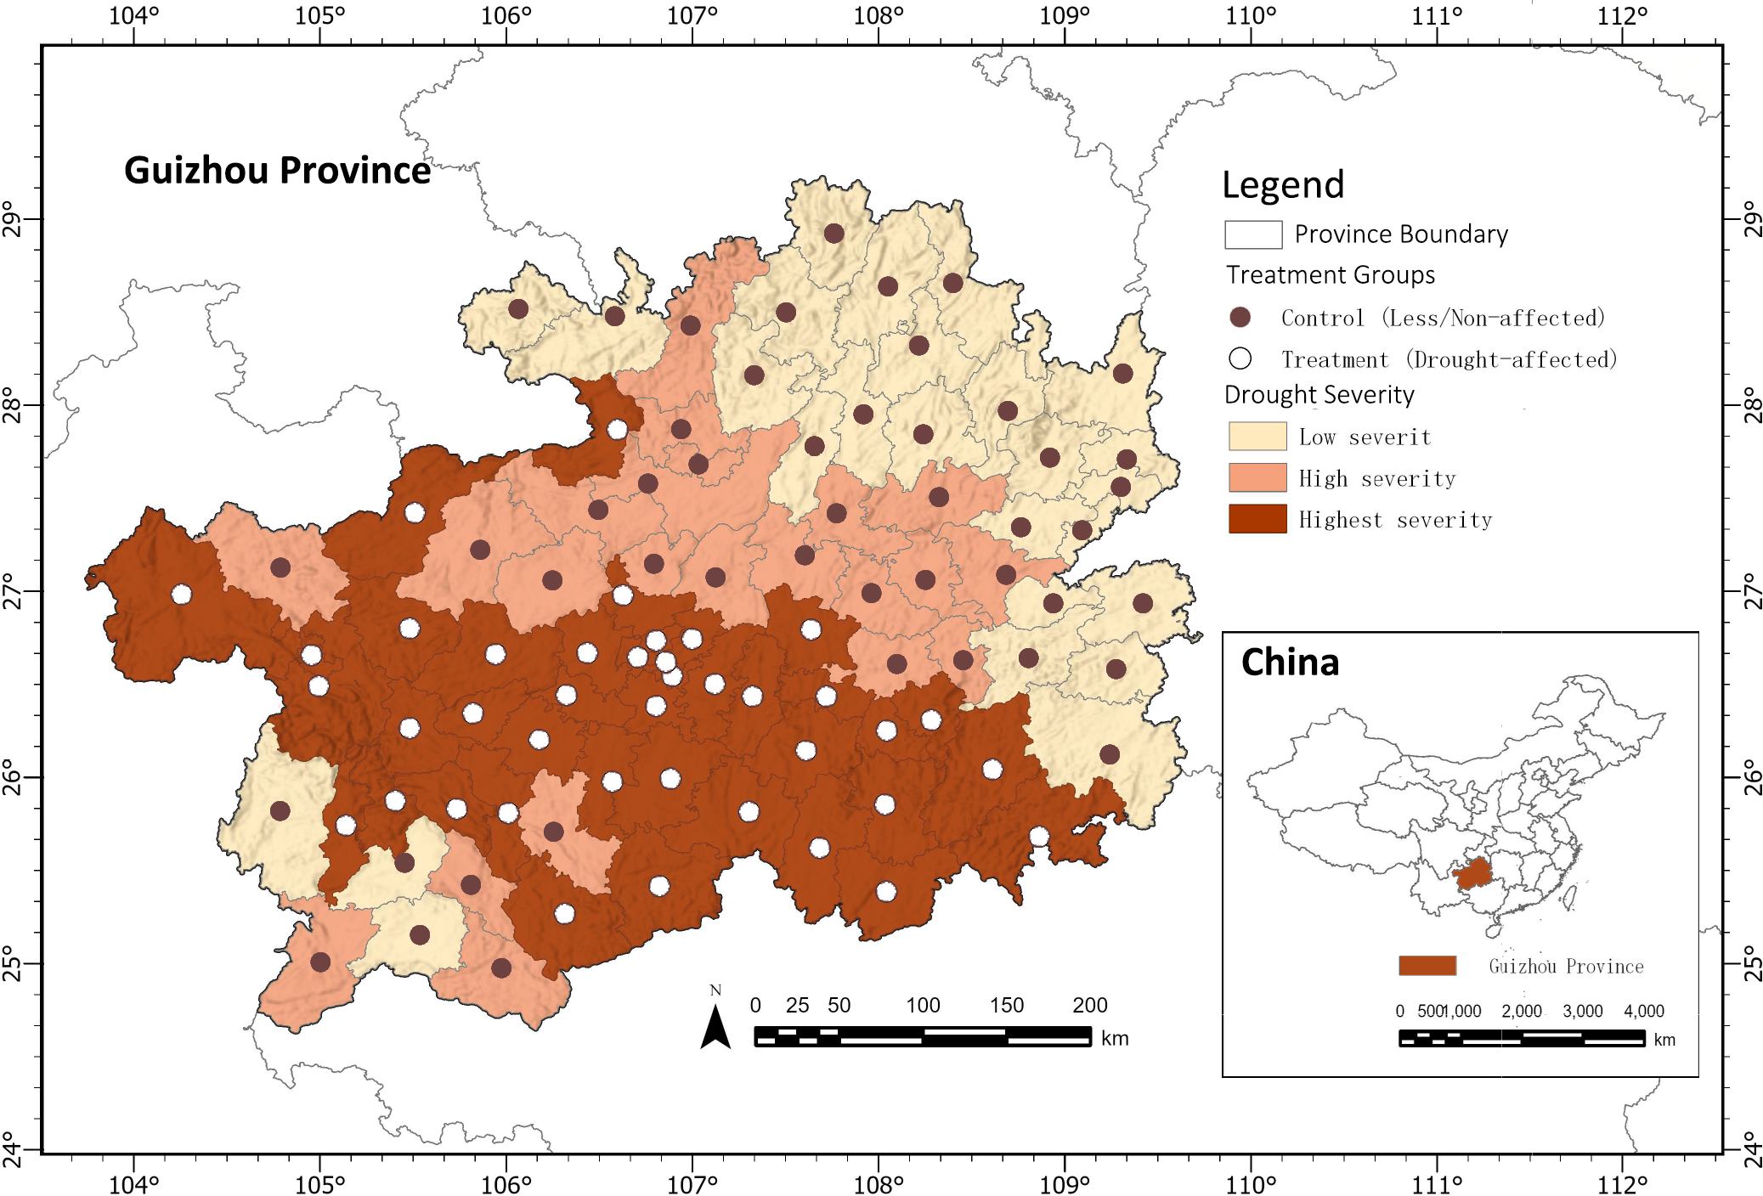
Figure 3.1 Location of the study area in Guizhou Province, China, showing county-level boundaries, mean elevation, and drought treatment status in 2010. Treatment counties are defined as those in the top quartile of median drought frequency (SPEI < –1.5, February–June 2010). Data sources: SRTM DEM, SPEIbase v2.10, Guizhou county boundaries.

Data Sources and Processing
This study's empirical analysis combines climate, remote sensing, statistical, and topographical datasets to construct a balanced county-level annual panel dataset for Guizhou Province from 2008 to 2012. All geospatial processing was conducted using Google Earth Engine (GEE), while subsequent data integration, cleaning, and variable construction were performed using the Python programming language. Figure 3.2 provides a brief overview of the data integration workflow, with the complete methodological workflow detailed in Chapter 4.
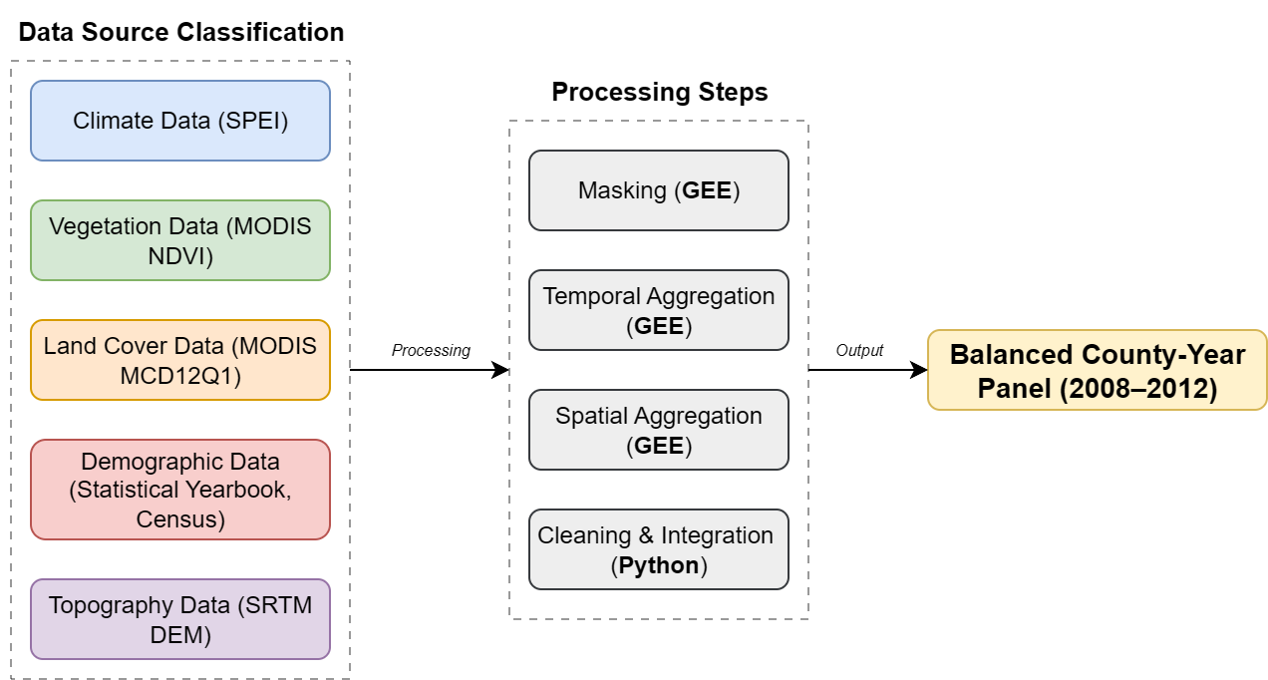
Figure 3.2 Simplified workflow for the construction of the county-level panel dataset (2008–2012), integrating climate (SPEI), vegetation (MODIS NDVI), land cover (MODIS MCD12Q1), demographic (Guizhou Statistical Yearbook, Population Census), and topographic (SRTM DEM) datasets. All geospatial processing was conducted in Google Earth Engine (GEE); statistical integration and cleaning were implemented in Python.
Population and migration data primarily come from the Guizhou Statistical Yearbook (2009–2013), supplemented by data from the 2000 and 2010 population censuses (Guizhou Provincial Bureau of Statistics, 2011). The total annual permanent resident population and rural population for each county are recorded at the end of the year. For counties classified as urban core areas (such as Guiyang, the provincial capital of Guizhou), the rural population total is designated as zero to reflect their population structure dominated by non-agricultural residents.
To construct the net migration indicator, the study adjusted the year-on-year change in total population based on natural growth (the difference between births and deaths). In cases where county-level birth and death data were unavailable, the crude birth and death rates from the provincial-level statistical yearbooks were used. The resulting net migration estimates were standardised per thousand people to facilitate comparisons between counties of different population sizes. Additionally, data quality markers were added to the panel data to distinguish between directly reported values and estimated values. Missing data were handled based on the extent of the gap: small gaps (≤1 year) were filled using linear interpolation, while structural gaps (e.g., urban core counties) were left as missing values to avoid introducing bias.
The severity of the 2010 drought was measured using the Standardised Precipitation Evapotranspiration Index (SPEI) from the SPEIbase v2.10 dataset, which integrates precipitation and potential evapotranspiration to provide a standardised drought indicator. The three-month SPEI from February to June 2010 was selected to capture the peak of the prolonged drought affecting southwestern China (Yun, Jun and Hong, 2012). Pixels with SPEI values below -1.5 were classified as drought affected. For each county, the median pixel-level drought frequency during the five-month period was calculated to represent local drought conditions. The counties were then divided into four categories of relative severity based on the quartiles of this median drought frequency, enabling heterogeneity analysis in subsequent sections.
Vegetation productivity (used as a proxy indicator for agricultural performance) is measured using the normalised difference vegetation index specific to farmland obtained from MODIS MOD13Q1 images. This product provides 16-day composite images with a spatial resolution of 250 metres, scaled to reflectance values (0–1) and averaged over the growing season (April to September) for each year from 2008 to 2012. Cropland pixels are identified using the 2010 MODIS MCD12Q1 land cover product, applying the International Geosphere-Biosphere Programme (IGBP) classification (Class 12: Farmland). If the primary land cover category remains stable during the study period, this static mask is consistently applied across all years. The resulting variable reflects only the vegetation greenness of agricultural land, excluding forest and built-up areas.
Land use structure is expressed as the proportion of cropland, calculated from the 2010 MODIS MCD12Q1 data as the percentage of valid land pixels classified as cropland. Although this variable is not used as a direct control variable in the main regression model, it supports heterogeneity analysis because it allows for a comparison of counties with high and low proportions of cropland in terms of their response to drought and migration.
Data coordination involves aligning all datasets by county name (transliterated into English) and year to ensure consistency across different sources. Continuous variables are stored in standard units—the normalised vegetation index (NDVI) ranges from 0 to 1, migration rates are calculated per thousand people, and the proportion of cropland is expressed as a percentage—while categorical variables (such as treatment status and high-altitude classification) are coded uniformly across the panel. The final balanced dataset covers 88 counties over five years (440 observations), with each record containing adjusted environmental, land use, and demographic indicators for comprehensive analysis.
The panel structure is designed to support double difference and event study analyses, as well as heterogeneity tests based on geographical and land use characteristics. Detailed processing steps, including spatial aggregation, time window selection, and the complete data workflow, are documented in Chapter 4 (see Figure 4.1).

Descriptive Statistics and Spatial Patterns
To provide an overview of temporal dynamics, Figure 3.3 shows the annual trends in specific vegetation productivity and net flux for treated and control counties from 2008 to 2012.
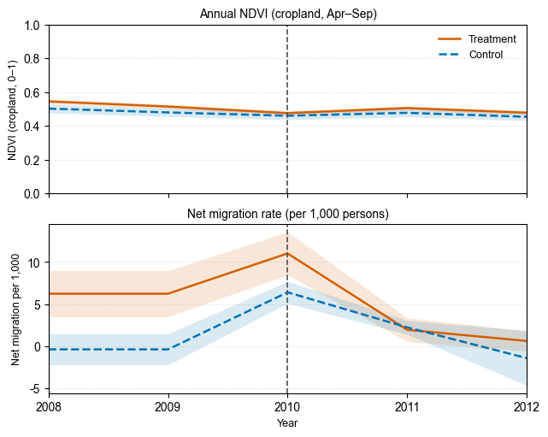
Figure 3.3 Annual trends in cropland-specific Normalised Difference Vegetation Index (NDVI) during the growing season (upper panel) and net migration rates per 1,000 persons (lower panel) for treatment and control counties, 2008–2012. Shaded areas represent ±1 standard error. The vertical dashed line marks the 2010 drought year. Data sources: MODIS MOD13Q1, MODIS MCD12Q1, Guizhou Statistical Yearbook.
The figure above shows the average normalised difference vegetation index (NDVI) of agricultural pixels during the growing season (April to September). In 2010, during an extreme drought event, the NDVI in the treatment counties decreased from approximately 0.514 in 2009 to 0.475 in 2010 (-7.54%), while the NDVI in the control counties decreased from 0.479 to 0.460 (-4.12%). These changes indicate that the decrease in NDVI for the treatment group was relatively larger compared to the control group in that year.
The figure below shows the net migration rate per thousand people adjusted for natural population growth. Between 2008 and 2012, the annual migration rate for the experimental group ranged from -31.84‰ to 59.44‰, while the migration rate for the control group ranged from -93.12‰ to 79.44‰. Compared to these ranges, the annual differences between the two groups were small, and from a descriptive trend perspective, there were no obvious changes in 2010.
Overall, descriptive statistics show that the NDVI values for the experimental group in 2010 exhibited a downward trend relative to the control group, while net migration trends exhibited greater variability and lower consistency with the NDVI pattern. However, it is not yet possible to draw causal inferences; formal statistical analysis will be presented in Chapter 5.

Methodology

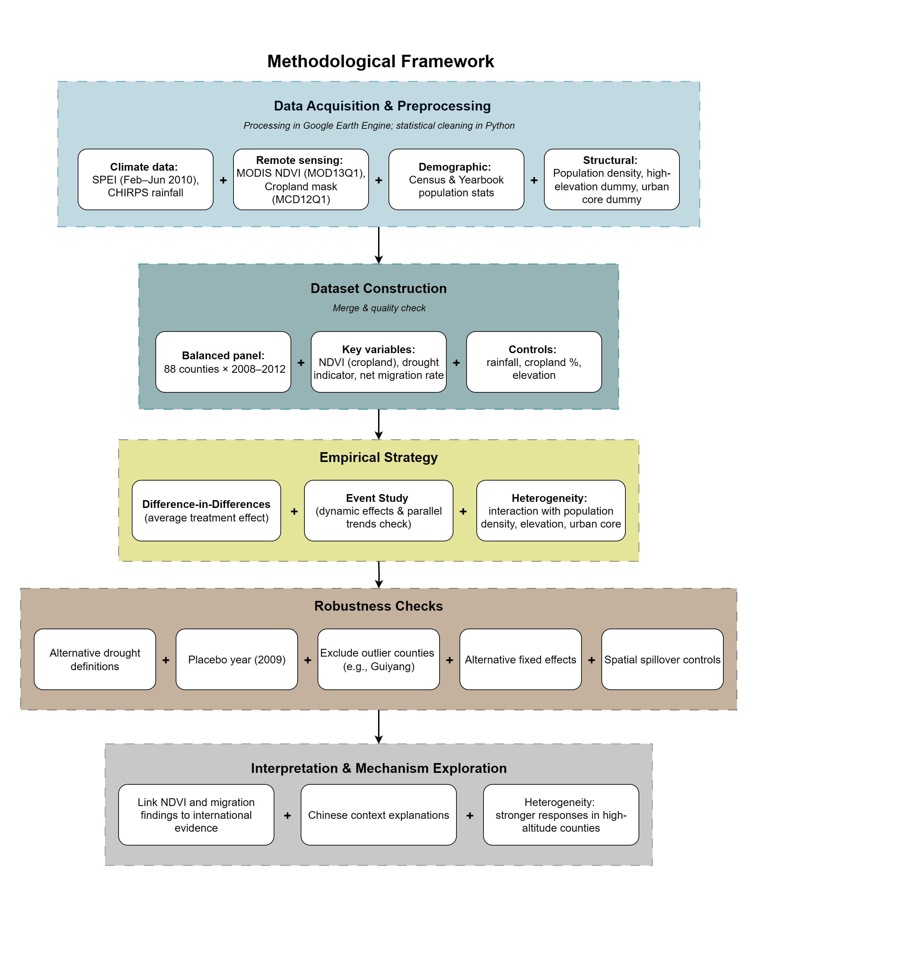
Figure 4.1 Methodological Framework for Assessing the Socio-Spatial Impacts of the 2010 Guizhou Drought

Data Acquisition & Preprocessing (400–450 words)
- Climate data:
- Source: SPEIbase v2.10 (3-month SPEI, Feb–Jun 2010).
- Justification for time window and scale (captures peak drought period in SW China).
- Aggregation: Pixel-level to county median drought frequency; quartile-based severity classification.
- Supplementary rainfall data from CHIRPS for growing season totals.
- Remote sensing data:
- MODIS MOD13Q1 NDVI, 16-day composites, 250 m resolution.
- Cropland mask from MCD12Q1 (IGBP class 12, 2010).
- Processing: Cropland masking, scaling, seasonal mean calculation.
- Demographic data:
- Population census (2000, 2010) and annual yearbooks (2009–2013).
- Calculation of net migration rate adjusted for births and deaths; estimation for missing counties.
- Structural variables:
- Population density, high-elevation dummy (≥ 75th percentile), urban core dummy.
- Source and processing method in GEE and GIS.
- Tools and processing:
- Spatial processing in GEE, statistical integration in Python.
- Coordinate system and projection consistency checks.

Dataset Construction (300–350 words)
- Design of a balanced panel: 88 counties × 5 years (2008–2012).
- Annual variables: NDVI (cropland), net migration rate, SPEI drought measure, rainfall totals.
- Time-invariant variables: cropland %, elevation, high-elevation dummy, urban core dummy.
- Control variables and rationale for inclusion (e.g., rainfall to account for non-drought precipitation variability).
- Missing data handling:
- Interpolation rules (≤1 year gap), handling of structural gaps (urban core counties).
- Quality flags for imputed vs. original values.
- Merging datasets and conducting quality control checks (outlier detection, range checks).

Variable Definitions and Transformations (200–250 words)
- Detailed definitions of dependent variables (NDVI, net migration rate).
- Independent variables: drought treatment, post-drought dummy, interaction terms.
- Control variables and transformations (e.g., log-transform of population density).
- Heterogeneity variables and coding schemes.

Empirical Strategy (450–500 words)
- Difference-in-Differences model:
- Equation, fixed effects specification, error clustering level.
- Identification assumptions (parallel trends, no spillovers, stable unit treatment value).
- Justification for clustering by county.
- Event Study:
- Equation with year-relative dummies, omitted base year, estimation of βτ.
- Graphical inspection of pre-treatment trends.
- Heterogeneity analysis:
- Interaction terms for population density, elevation, and urban core.
- Expected directions of effects based on the literature.
- Potential confounders and strategies to address them (e.g., rainfall control, excluding urban cores).

Robustness Checks (300–350 words)
- Alternative drought definitions: Different SPEI thresholds, NDVI-based classification.
- Placebo year (2009) treatment assignment to test for spurious effects.
- Excluding outliers (Guiyang) to test sensitivity to influential cases.
- Alternative fixed effects specifications: County FE only, Year FE only, adding county-specific linear trends.
- Spatial spillover control: Spatial lag of drought exposure to account for neighbouring impacts.

Model Diagnostics and Validation (150–200 words)
- Check for heteroskedasticity, serial correlation.
- Multicollinearity diagnostics for interaction terms.
- Residual distribution inspection.
- Validation of parallel trends assumption from event study pre-treatment coefficients.

Interpretation & Mechanism Exploration (200–250 words)
- Link between NDVI and migration results in light of international evidence.
- Chinese context explanations: economic background, policy interventions, institutional constraints.
- Heterogeneity interpretation: high-altitude counties’ greater sensitivity due to agricultural dependence and irrigation constraints.

Results

Main Effects (500–600 words)
1. NDVI results
- Table: DiD regression coefficients for treatment × post (2008–2012, county FE, year FE).
- Report sign, magnitude, and statistical significance.
- Compare treatment vs control group pre-post averages (brief descriptive link to Figure 3.3).
- Mention robustness to alternative standard errors (clustered by county).
2. Migration results
- Same regression format as NDVI.
- Note direction of effect: expected positive for out-migration but smaller in magnitude.
- Discuss statistical significance (or lack thereof).
- Highlight the difference in effect sizes between NDVI and migration, signalling possible attenuation in the agricultural–migration pathway.
3. Interpretation link
- Briefly connect to theory: strong agricultural effect but weaker migration effect may reflect capability constraints or alternative livelihoods.
- Defer detailed explanation to Discussion.
Figure 5.1 – NDVI and Migration Responses to the 2010 Drought
-A two-panel event study figure showing the dynamic effects of the drought.
Top panel: Average cropland NDVI (Treatment vs Control) during the growing season, with 2010 marked as the drought year.
Bottom panel: Net migration rate per 1,000 persons over the same period, using the same grouping and style.
Purpose: Visually compare the strength and timing of agricultural and migration responses.

Dynamic Effects (400–500 words)
1. NDVI event study
- Figure: Coefficients (βτ) with 95% CI for years τ = −2 to +2 relative to 2010.
- Check parallel trends in pre-drought years (coefficients ~ 0, not significant).
- Show sharp drop in 2010, partial rebound in later years.
2. Migration event study
- Similar plot for net migration rate.
- Examine pre-trends (should be flat if parallel trends hold).
- Effect in 2010 may be small; persistence (or lack thereof) in later years.
3. Comparison
- Contrast dynamics between NDVI and migration: NDVI shows immediate and lasting effect; migration response is muted/short-lived.
- Briefly speculate on reasons (link to 6.3 later).
Figure 5.1 – NDVI and Migration Event Study Estimates
Two-panel layout:
Top: Event study coefficients for cropland NDVI (Treatment vs Control), with 95% confidence intervals, baseline year omitted.
Bottom: Event study coefficients for net migration rate, same format.
Vertical dashed line at year 0 (2010 drought), shading to indicate the drought period.
Purpose: Show pre-treatment trends (parallel or not) and the persistence/decay of the post-treatment effect.

Heterogeneity Results (400–500 words)
1. By elevation (high vs low altitude)
- Define high altitude (≥ 1,500 m or top 25% mean elevation).
- Present regression table with treatment × post × high-altitude interaction.
- NDVI: larger decline in high-altitude areas.
- Migration: if significant, note magnitude; if not, discuss possible reasons.
2. By cropland proportion (above vs below median)
- Explain relevance: greater agricultural dependence may increase drought sensitivity.
- Present interaction results; note if patterns are significant.
3. Other socio-economic splits (population density, urban core status)
- Present results briefly; note if effects are minimal.
- Highlight small inter-county variation as a possible reason for weak differences.
4. Visualisation
- Bar plot or coefficient plot for subgroups.
Figure 5.3 – Spatial Heterogeneity and Mechanism Analysis
A combined visualisation linking heterogeneity and mechanism testing.
Left: Coefficient plots (with 95% CI) for sub-samples based on elevation and cropland share.
Right: Simplified regression path or coefficient plot showing the NDVI → migration link.
Purpose: Demonstrate which sub-groups are most sensitive to drought and whether agricultural decline mediates migration.

Robustness Checks (400–500 words)
1. Alternative drought definitions
- Different SPEI thresholds (e.g., -1.0, -2.0).
- Reclassification using continuous drought frequency.
2. Placebo year
- Assign “treatment” to 2009 and re-run models; expect no significant effects.
3. Excluding influential units
- Remove Guiyang or other urban cores, check the stability of coefficients.
4. Alternative fixed effects
- County FE only, year FE only, or adding county-specific trends.
- Report that the NDVI effect remains consistent.
5. Spatial spillover
- Include spatial lag of drought; check whether neighbouring counties’ drought affects results.
Table 5.4 – Robustness Checks (Summary)
A compact summary table of key robustness checks.
Columns: Test type (e.g., alternative drought threshold, placebo year, outlier exclusion, spatial spillover control) and main coefficient estimate.
All full regression outputs are placed in the appendix.
Purpose: Show that the main findings are consistent across alternative specifications.

Mechanism Exploration (300–400 words)
1. Conceptual pathway
- Drought → NDVI decline → reduced farm income → migration.
- Link to climate–migration literature (Black et al., 2011; Cattaneo et al., 2019).
2. Empirical approach
- Two-step model or mediation framework: NDVI as predictor in migration regression.
- Note controls, fixed effects, and robustness.
3. Results
- Report sign, magnitude, significance of NDVI effect on migration.
- Compare to literature, likely weaker in this case.
4. Interpretation
- If effect is weak: pre-existing migration saturation, policy buffers, data limitations.
- If significant: evidence supporting agricultural channel in Guizhou.
5. Optional visualisation
- Scatter plot of NDVI change vs migration change (treatment vs control).
- Regression table with NDVI coefficient.

Discussion

Summary of Key Findings (200-250 words)
- Concise restatement of the main empirical results:
- Significant negative impact of the 2010 drought on cropland NDVI.
- Net migration rates move in the expected direction but with weaker statistical significance.
- Heterogeneity results indicate stronger responses in high-altitude counties, with other subgroup effects limited.
- Avoid duplicating the Results chapter; focus on synthesising patterns.

Comparison with International Evidence (300-350 words)
- Contrast findings with international studies (e.g., Black et al., 2011; Cattaneo et al., 2019; Nawrotzki & DeWaard, 2016) that report stronger migration responses to climate shocks.
- Highlight how your results fit (or deviate) from the “climate–agriculture–migration” causal chain found elsewhere.
- Discuss the role of threshold effects (McLeman, 2018) and the aspirations–capabilities framework (de Haas, 2021) in explaining the weaker migration effect.

Explanations in the Chinese Context (550-600 words)
1. Economic and policy background
- Rapid economic growth around 2010; Guizhou already had high levels of rural out-migration (Huang, 2012), limiting the marginal effect of drought.
- National and provincial poverty alleviation and disaster relief programmes (Yun et al., 2012) may have buffered migration responses.
2. Institutional factors
- The household registration (hukou) system and social security arrangements (Chan, 2010; Liang & Ma, 2004) restricted long-term migration, favouring temporary or seasonal mobility that county-level net migration rates cannot fully capture.
3. Relative weight of climate shocks
- Migration decisions also influenced by market prices, mining and construction employment opportunities (Wang, 2013), making drought a secondary driver in some cases.
4. Data and measurement constraints
- Net migration metric measures permanent population change, not circular or undocumented flows.
- Agricultural shocks may induce non-observed mobility patterns.

Interpreting Heterogeneity (250-300 words)
- Why high-altitude areas show stronger NDVI and migration responses:
- Greater dependence on rain-fed agriculture, higher proportion of sloped farmland (Luo, 2019).
- Limited irrigation infrastructure and poorer soil water retention.
- Why other socio-economic subgroup differences are not statistically significant:
- Relatively small inter-county variation (Huang, 2012).
- Lack of key variables differentiating resilience (e.g., irrigation rate, mechanisation level)

Policy Implications (250-300 words)
- Strengthen agricultural resilience: drought-tolerant crops, water-saving irrigation, agricultural extension services.
- Targeted support for high-altitude and ecologically fragile areas.
- Improve migration and employment data collection to capture short-term and seasonal flows.

Limitations and Future Research (250-300 words)
- Data limitations: county-level migration rates may underestimate short-term responses.
- Temporal scope: relatively short study period (2008–2012); future research could examine longer-term patterns and multiple climate events.
- Methodological extensions: spatial spillover modelling, incorporation of social network effects, micro-survey validation.

Conclusion (600-800 words)

References
Beine, M. and Parsons, C. (2015). ‘Climatic Factors as Determinants of International Migration’. The Scandinavian Journal of Economics. Wiley, 117 (2), pp. 723–767. doi: 10.1111/sjoe.12098.
Black, R., Adger, W. N., Arnell, N. W., Dercon, S., Geddes, A. and Thomas, D. (2011). ‘The effect of environmental change on human migration’. Global Environmental Change, 21, pp. S3–S11. doi: 10.1016/j.gloenvcha.2011.10.001.
Bohra-Mishra, P., Oppenheimer, M., Cai, R., Feng, S. and Licker, R. (2017). ‘Climate variability and migration in the Philippines’. Population and Environment, 38 (3), pp. 286–308. doi: 10.1007/s11111-016-0263-x.
Cai, R., Feng, S., Oppenheimer, M. and Pytlikova, M. (2016). ‘Climate variability and international migration: The importance of the agricultural linkage’. Journal of Environmental Economics and Management. Elsevier BV, 79, pp. 135–151. doi: 10.1016/j.jeem.2016.06.005.
Cattaneo, C., Beine, M., Fröhlich, C. J., Kniveton, D., Martinez-Zarzoso, I., Mastrorillo, M., Millock, K., Piguet, E. and Schraven, B. (2019). ‘Human Migration in the Era of Climate Change’. Review of Environmental Economics and Policy, 13 (2), pp. 189–206. doi: 10.1093/reep/rez008.
Central Committee of the Communist Party of China and State Council of the People’s Republic of China. (2025). The Rural Revitalisation Plan (2024–2027). Beijing, China: Government of the People’s Republic of China. Available at: https://www.gov.cn/zhengce/202501/content_7000493.htm.
Chan, K. W. (2010). ‘The Household Registration System and Migrant Labor in China: Notes on a Debate’. Population and Development Review, 36 (2), pp. 357–364. doi: 10.1111/j.1728-4457.2010.00333.x.
De Haas, H. (2021). ‘A theory of migration: the aspirations-capabilities framework’. Comparative Migration Studies. Springer Science and Business Media LLC, 9 (1). doi: 10.1186/s40878-020-00210-4.
Gray, C. and Mueller, V. (2012). ‘Drought and Population Mobility in Rural Ethiopia’. World Development. Elsevier BV, 40 (1), pp. 134–145. doi: 10.1016/j.worlddev.2011.05.023.
Guizhou Provincial Bureau of Statistics. (2011). Guizhou Statistical Yearbook 2011. Beijing: China Statistics Press.
Hoffmann, R. (no date). ‘Drought and aridity influence internal migration worldwide’. Nature Climate Change. doi: doi.org/10.1038/s41558-024-02165-1.
Hoffmann, R., Abel, G., Malpede, M., Muttarak, R. and Percoco, M. (2024). ‘Drought and aridity influence internal migration worldwide’. Nature Climate Change. Springer Science and Business Media LLC, 14 (12), pp. 1245–1253. doi: 10.1038/s41558-024-02165-1.
Huang, J. (2012). ‘Spatial changes of population and economic causes in Guizhou Province in the past decade’. Contemporary Economics, (8), pp. 94–96.
Intergovernmental Panel On Climate Change (Ipcc). (2023). Climate Change 2022 – Impacts, Adaptation and Vulnerability: Working Group II Contribution to the Sixth Assessment Report of the Intergovernmental Panel on Climate Change. 1st edn. Cambridge University Press. doi: 10.1017/9781009325844.
Liang, S., Wu, W., Sun, J., Li, Z., Sun, X., Chen, H., Chen, S., Fan, L., You, L. and Yang, P. (2021). ‘Climate-mediated dynamics of the northern limit of paddy rice in China’. Environmental Research Letters, 16 (6), p. 064008. doi: 10.1088/1748-9326/abfac0.
Liang, Z. and Ma, Z. (2004). ‘China’s Floating Population: New Evidence from the 2000 Census’. Population and Development Review, 30 (3), pp. 467–488. doi: 10.1111/j.1728-4457.2004.00024.x.
Lu, M. and Xia, Y. (2016). ‘Migration in the People’s Republic of China’.
Luo, Y., Tian, M., Wu, H., Wang, C. and Zhang, J. (2019). ‘Spatio-temporal distribution and climatic background of agricultural drought in Guizhou Province’. Jilin Agriculture, (10), pp. 108–112. doi: 10.14025/j.cnki.jlny.2019.10.071.
McLeman, R. (2018). ‘Thresholds in climate migration’. Population and Environment. Springer Science and Business Media LLC, 39 (4), pp. 319–338. doi: 10.1007/s11111-017-0290-2.
Mueller, V., Gray, C. and Kosec, K. (2014). ‘Heat stress increases long-term human migration in rural Pakistan’. Nature Climate Change. Springer Science and Business Media LLC, 4 (3), pp. 182–185. doi: 10.1038/nclimate2103.
National Climate Center, C. M. A. (2025). China Climate Change Blue Book (2025). 9787030824820. Beijing, China: Science Press.
Sun, Y. (2023). ‘Temperature effects on rural household outmigration: Evidence from China’. Population and Environment, 45 (4), p. 25. doi: 10.1007/s11111-023-00441-4.
The State of Food and Agriculture 2021: Making Agrifood Systems More Resilient to Shocks and Stresses. (2021). S.l.: Food and Agriculture Organization of the United Nations.
Vicente-Serrano, S. M., Beguería, S. and López-Moreno, J. I. (2010). ‘A Multiscalar Drought Index Sensitive to Global Warming: The Standardized Precipitation Evapotranspiration Index’. Journal of Climate, 23 (7), pp. 1696–1718. doi: 10.1175/2009JCLI2909.1.
Wang, H., Chen, B. and Shen, X. (2024). ‘Extreme rainfall, farmer vulnerability, and labor mobility—Evidence from rural China’. Science of The Total Environment, 918, p. 170866. doi: 10.1016/j.scitotenv.2024.170866.
Wang, X. (2013). ‘Different Roles of Land in Rural–Urban Migration: Evidence from China’s Household Survey’. China & World Economy, 21 (1), pp. 107–126. doi: 10.1111/j.1749-124X.2013.12011.x.
Wei, W. and Li, X. (2021). ‘Changes of NDVI in Beipan River Basin of Guizhou Province and its relationship with terrain gradient and population distribution during 2000–2018’. Bulletin of Soil and Water Conservation, 41 (6), pp. 361–368. doi: 10.13961/j.cnki.stbctb.2021.06.046.
Yun, S., Jun, Y. and Hong, S. (2012). ‘Social perception and response to the drought process: a case study of the drought during 2009–2010 in the Qianxi’nan Prefecture of Guizhou Province’. Natural Hazards, 64 (1), pp. 839–851. doi: 10.1007/s11069-012-0274-6.
Zheng, W., Chen, X., Xu, W. and Wu, Z. (2024). ‘Heterogeneous and short-term effects of a changing climate on farmers’ labor allocation: An empirical analysis of China’. PLOS ONE. Edited by Z. Mushtaq, 19 (7), p. e0306260. doi: 10.1371/journal.pone.0306260.

Appendices

