**CS240A: Database and Knowledge Bases**

# **Project 1 – XQuery**

# **Report**

ZIHAO ZHANG

UID:004593253

November 30th, 2016

**Project Instruction**

The transaction-time history of employees and departments for the XYZ corporation are in the stored in the following XML documents: [v-emps.xml](http://web.cs.ucla.edu/classes/fall16/cs240A/XMLproject/v-emps.xml) and [v-depts.xml](http://web.cs.ucla.edu/classes/fall16/cs240A/XMLproject/v-depts.xml).

This project is to write the following queries using XQuery:

1. Selection and Temporal Projection. Retrieve the employment history of employee "Anneke Preusig" (i.e., the departments where she worked and the periods during which she worked there).
2. Temporal Snapshot. Retrieve the name, salary and department of each employee who, on 1995-01-06 was making less than $44000.
3. Temporal Slicing. For all departments, show their history in the period starting on 1994-05-01 and ending 1996-05-06.
4. Duration. For each employee, show the longest period during which he/she went with no change in salary and his/her salary during that time.
5. Temporal Join. For each employee show title history and his/her manager history.
6. Temporal Count. Print the history of employee count for (i) each department, and (ii) the whole company.
7. Temporal Max. For the employees in department d005, find the maximum of their salaries over time, and print the history of such a maximum.

In this project, I put all the self-defined functions into one file called “helperFunctions.xquery” with,

module namespace helperFunctions = "helperFunctionsforXML";

Thus every time we need to call the self-defined functions, just to import module namespace is fine.

**Summary:**

**To access to the result files directly, please click the links below:**

**Q1: Selection and Temporal Projection**

**xml:** <https://s3.amazonaws.com/zzhuclacsproj/CS240A_Proj1/RES/Query1.xml>

**sxl:** <https://s3.amazonaws.com/zzhuclacsproj/CS240A_Proj1/RES/Query1.xsl>

**Q2: Temporal Snapshot.**

**xml:** <https://s3.amazonaws.com/zzhuclacsproj/CS240A_Proj1/RES/Query2.xml>

**sxl:** <https://s3.amazonaws.com/zzhuclacsproj/CS240A_Proj1/RES/Query2.xsl>

**Q3: Temporal Slicing.**

**xml:** <https://s3.amazonaws.com/zzhuclacsproj/CS240A_Proj1/RES/Query3.xml>

**sxl:** <https://s3.amazonaws.com/zzhuclacsproj/CS240A_Proj1/RES/Query3.xsl>

**Q4: Duration**

**xml:** <https://s3.amazonaws.com/zzhuclacsproj/CS240A_Proj1/RES/Query4.xml>

**sxl:** <https://s3.amazonaws.com/zzhuclacsproj/CS240A_Proj1/RES/Query4.xsl>

**Q5:** **Temporal Join**

**Title history:**

**xml:** <https://s3.amazonaws.com/zzhuclacsproj/CS240A_Proj1/RES/Query5_view_Title_History.xml>

**sxl:** <https://s3.amazonaws.com/zzhuclacsproj/CS240A_Proj1/RES/Query5_title_history.xsl>

**Manager history:**

**xml:** <https://s3.amazonaws.com/zzhuclacsproj/CS240A_Proj1/RES/Query5_view_Manager_History.xml>

**sxl:** <https://s3.amazonaws.com/zzhuclacsproj/CS240A_Proj1/RES/Query5_manager_history.xsl>

**Q6-1: Temporal Count -** **history of employee count for each department**

**xml:** <https://s3.amazonaws.com/zzhuclacsproj/CS240A_Proj1/RES/Query61.xml>

**sxl:** <https://s3.amazonaws.com/zzhuclacsproj/CS240A_Proj1/RES/Query61.xsl>

**Q6-2: Temporal Count -** **history of employee count for the whole company**

**xml:** <https://s3.amazonaws.com/zzhuclacsproj/CS240A_Proj1/RES/Query62.xml>

**sxl:** <https://s3.amazonaws.com/zzhuclacsproj/CS240A_Proj1/RES/Query62.xsl>

**Q7: Temporal Max.**

**xml:** <https://s3.amazonaws.com/zzhuclacsproj/CS240A_Proj1/RES/Query7.xml>

**sxl:** <https://s3.amazonaws.com/zzhuclacsproj/CS240A_Proj1/RES/Query7.xsl>

**Project XQuery Implementation**

**Query1 - Selection and Temporal Projection.**

Retrieve the employment history of employee "Anneke Preusig".

**The .xquery code is as follows:**

**Results**:

<?xml version="1.0" encoding="UTF-8"?>

<?xml-stylesheet type="text/xsl" href="Query1.xsl"?>

<history><deptno tend="9999-12-31" tstart="1990-08-05">d005</deptno></history>

(:Query 1 - Selection and Temporal Projection. Retrieve the employment history of employee "Anneke Preusig" (i.e., the departments where she worked and the periods during which she worked there).:)

xquery version "1.0";

declare variable $employee-xml as xs:string := "v-emps.xml";

declare variable $department-xml as xs:string := "v-depts.xml";

element history

{

for $emp in doc($employee-xml)/employees/employee

where $emp/firstname="Anneke" and $emp/lastname="Preusig"

return $emp/deptno

}

With a .xsl stypesheet, it looks like this:

**To view the complete result on browser, please click**

<https://s3.amazonaws.com/zzhuclacsproj/CS240A_Proj1/RES/Query1.xml>

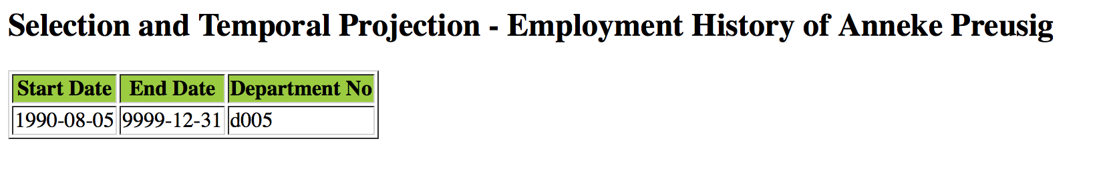

**Query2 - Temporal Snapshot.**

Retrieve the name, salary and department of each employee who, on 1995-01-06 was making less than $44000.

**The .xquery code is as follows:**

xquery version "1.0";

import module namespace helperFunctions = "helperFunctionsforXML" at "file:/Users/JohnZ/Desktop/Proj1/helperFunctions.xquery";

declare variable $employee-xml as xs:string := "v-emps.xml";

declare variable $department-xml as xs:string := "v-depts.xml";

declare variable $date := '1995-01-06';

element snapshot

{

for $emp in doc($employee-xml)//employee[@tstart <= $date and $date <= @tend]

let $salary := $emp/salary[@tstart <= $date and $date <= @tend], $deptno := $emp/deptno[@tstart <= $date and $date <= @tend]

where($salary and $deptno and $salary < 44000 )

return element

{node-name($emp)}

{

helperFunctions:snapshot(($emp/firstname, $emp/lastname, helperFunctions:deptNumber($deptno), $salary))

}

}

**Results :**

The format of query result is like below:

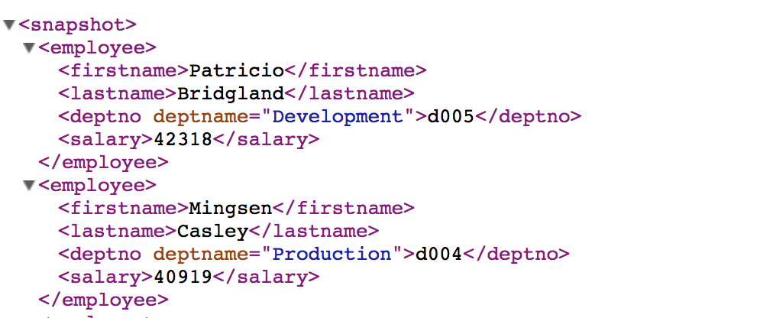

with the help of .sxl stypesheet, the result is as below:

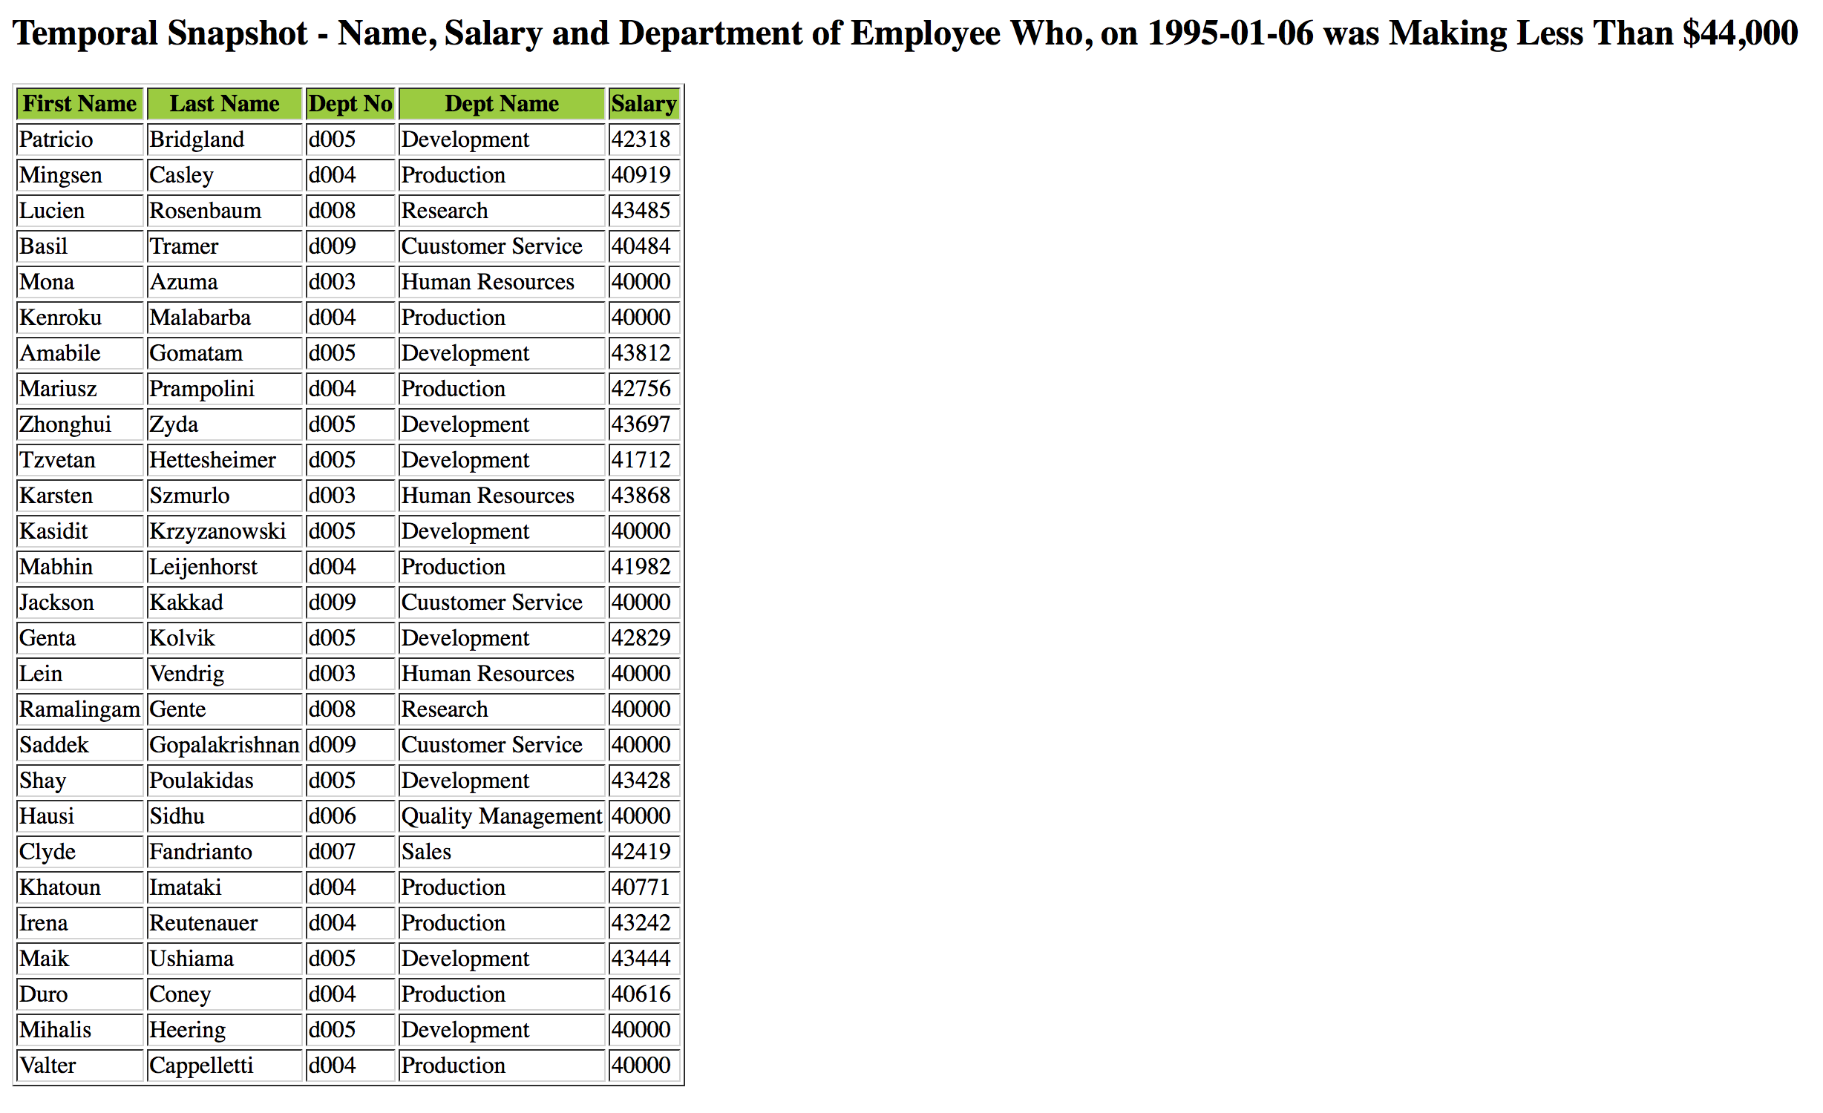

**To view the complete result on browser, please click**

<https://s3.amazonaws.com/zzhuclacsproj/CS240A_Proj1/RES/Query2.xml>

**And the corresponding key part of .sxl file is as below:**

<h2>Temporal Snapshot - Name, Salary and Department of Employee Who, on 1995-01-06 was Making Less Than $44,000</h2>

<table border="1">

<tr bgcolor="#9acd32">

<th style="text-align:center">First Name</th>

<th style="text-align:center">Last Name</th>

<th style="text-align:center">Dept No</th>

<th style="text-align:center">Dept Name</th>

<th style="text-align:center">Salary</th>

</tr>

<xsl:for-each select="snapshot/employee">

<tr>

<td><xsl:value-of select="firstname"/></td>

<td><xsl:value-of select="lastname"/></td>

<td><xsl:value-of select="deptno"/></td>

<td><xsl:value-of select="deptno/@deptname"/></td>

<td><xsl:value-of select="salary"/></td>

</tr>

</xsl:for-each>

</table>

**To view the complete .sxl file on browser, please click**

<https://s3.amazonaws.com/zzhuclacsproj/CS240A_Proj1/RES/Query2.xsl>

**Query3 - Temporal Slicing.**

For all departments, show their history in the period starting on 1994-05-01 and ending on 1996-05-06.

**The .xquery code is as follows:**

xquery version "1.0";

import module namespace helperFunctions = "helperFunctionsforXML" at "file:/Users/JohnZ/Desktop/Proj1/helperFunctions.xquery";

declare variable $employee-xml as xs:string := "v-emps.xml";

declare variable $department-xml as xs:string := "v-depts.xml";

declare variable $tstart := '1994-05-01';

declare variable $tend := '1996-05-06';

element slicing

{

for $dept in doc($department-xml)//department[not( @tstart > $tend or $tstart >= @tend)]

return element

{node-name($dept)}

{

helperFunctions:slice($dept, $tstart, $tend),

helperFunctions:sliceAll($dept/*[not( @tstart > $tend or $tstart >= @tend)], $tstart, $tend)

}

}

**Results:**

The format of query result is like below:

<slicing>

<department tstart="1994-05-01" tend="1996-05-06">

<deptno tstart="1994-05-01" tend="1996-05-06">d001</deptno>

<deptname tstart="1994-05-01" tend="1996-05-06">Marketing</deptname>

<mgrno tstart="1994-05-01" tend="1996-05-06">110039</mgrno>

</department>

<department tstart="1994-05-01" tend="1996-05-06">

<deptno tstart="1994-05-01" tend="1996-05-06">d002</deptno>

<deptname tstart="1994-05-01" tend="1996-05-06">Finance</deptname>

<mgrno tstart="1994-05-01" tend="1996-05-06">110114</mgrno>

</department>

With the help of .sxl stypesheet, the result is as below:

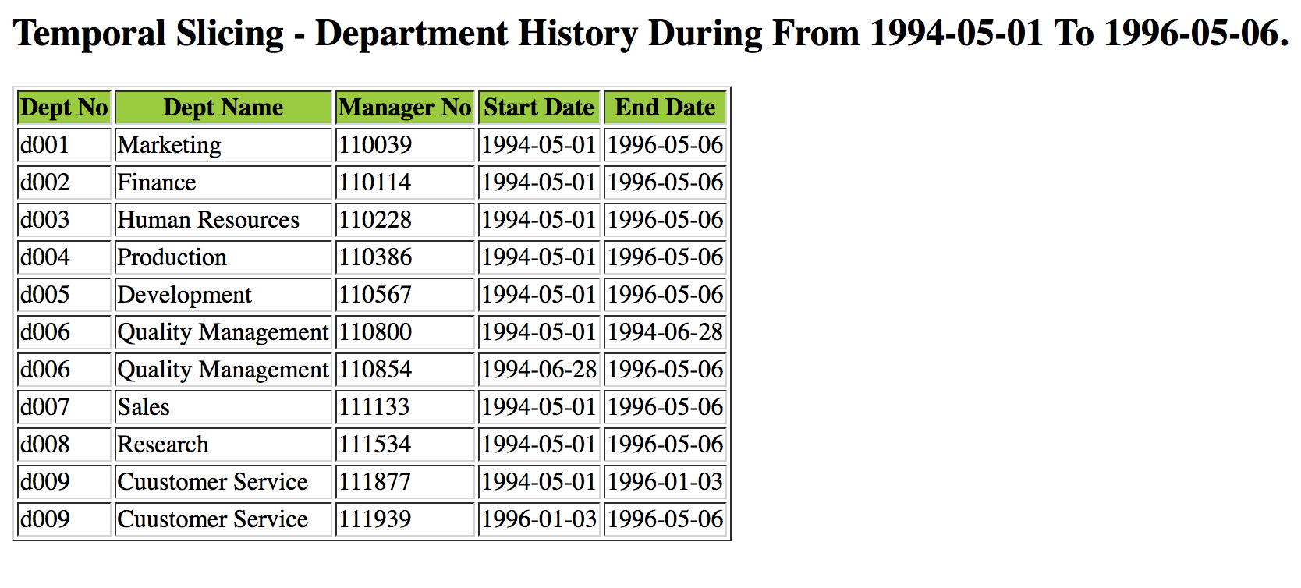

**To view the complete result on browser, please click**

<https://s3.amazonaws.com/zzhuclacsproj/CS240A_Proj1/RES/Query3.xml>

And the corresponding key part of .sxl file is as below:

<h2>Temporal Slicing - Department History During From 1994-05-01 To 1996-05-06.</h2>

<table border="1">

<tr bgcolor="#9acd32">

<th style="text-align:center">Dept No</th>

<th style="text-align:center">Dept Name</th>

<th style="text-align:center">Manager No</th>

<th style="text-align:center">Start Date</th>

<th style="text-align:center">End Date</th>

</tr>

<xsl:for-each select="slicing/department/mgrno">

<tr>

<td><xsl:value-of select="../deptno"/></td>

<td><xsl:value-of select="../deptname"/></td>

<td><xsl:value-of select="text()"/></td>

<td><xsl:value-of select="@tstart"/></td>

<td><xsl:value-of select="@tend"/></td>

</tr>

</xsl:for-each>

</table>

**To view the complete .sxl file on browser, please click**

<https://s3.amazonaws.com/zzhuclacsproj/CS240A_Proj1/RES/Query3.xsl>

**Query4 - Duration**

For each employee, show the longest period during which he/she went with no change in salary and his/her salary during that time.

**The .xquery code is as follows:**

xquery version "1.0";

import module namespace helperFunctions = "helperFunctionsforXML" at "file:/Users/JohnZ/Desktop/Proj1/helperFunctions.xquery";

declare variable $employee-xml as xs:string := "v-emps.xml";

declare variable $department-xml as xs:string := "v-depts.xml";

element durationCoalescing

{

for $emp in doc($employee-xml)//employee

let $durations :=

for $salary in $emp/salary

return helperFunctions:untilChangedToNow($salary/@tend) - xs:date($salary/@tstart)

return element

{node-name($emp)}

{

helperFunctions:slice($emp, '1900-01-01', helperFunctions:currentDate()),

helperFunctions:untilChangedToAll(($emp/firstname, $emp/lastname)),

element LongestPeriod {max($durations)},

for $salary in $emp/salary[helperFunctions:untilChangedToNow(@tend) - xs:date(@tstart)=max($durations)]

order by $salary/@tstart, $salary/@tend

{node-name($salary)}

{

helperFunctions:slice($salary, '1900-01-01', helperFunctions:currentDate()),

string($salary)

}

}

}

**Results:**

The format of query result is like below:

<durationCoalescing>

<employee tstart="1986-06-26" tend="2016-11-30">

<firstname tstart="1986-06-26" tend="2016-11-30">Joe</firstname>

<lastname tstart="1986-06-26" tend="2016-11-30">Doe</lastname>

<LongestPeriod>P5275D</LongestPeriod>

<salary tstart="2002-06-22" tend="2016-11-30">88958</salary>

</employee>

<employee tstart="1996-08-03" tend="2016-11-30">

<firstname tstart="1996-08-03" tend="2016-11-30">Bezalel</firstname>

<lastname tstart="1996-08-03" tend="2016-11-30">Simmel</lastname>

<LongestPeriod>P5599D</LongestPeriod>

<salary tstart="2001-08-02" tend="2016-11-30">72527</salary>

</employee>

The picture below **is part of the whole result**. To access to the whole result, please click the link below.

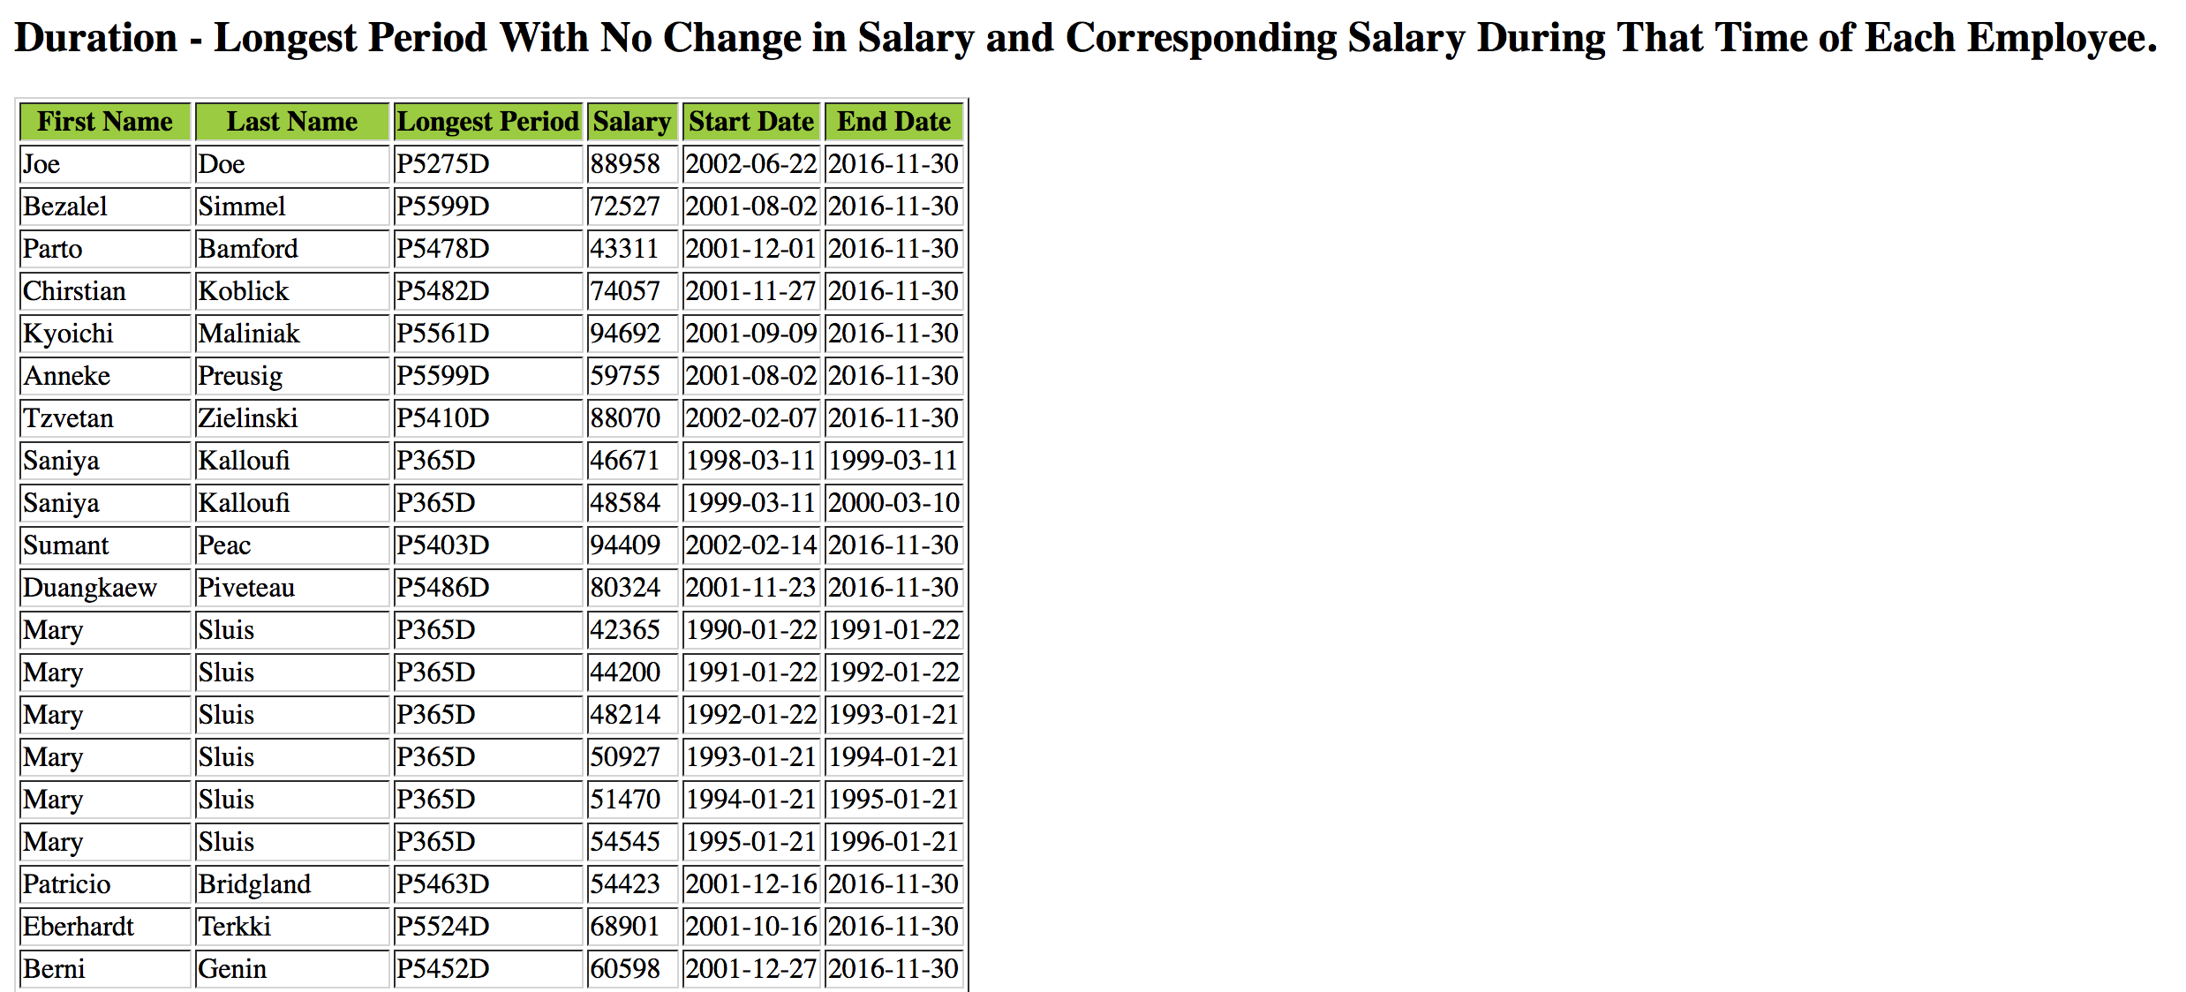

**To view the complete result on browser, please click**

<https://s3.amazonaws.com/zzhuclacsproj/CS240A_Proj1/RES/Query4.xml>

And the corresponding key part of .sxl file is as below:

<h2>Duration - Longest Period With No Change in Salary and Corresponding Salary During That Time of Each Employee.</h2>

<table border="1">

<tr bgcolor="#9acd32">

<th style="text-align:center">First Name</th>

<th style="text-align:center">Last Name</th>

<th style="text-align:center">Longest Period</th>

<th style="text-align:center">Salary</th>

<th style="text-align:center">Start Date</th>

<th style="text-align:center">End Date</th>

</tr>

<xsl:for-each select="durationCoalescing/employee/salary">

<tr>

<td><xsl:value-of select="../firstname"/></td>

<td><xsl:value-of select="../lastname"/></td>

<td><xsl:value-of select="../LongestPeriod"/></td>

<td><xsl:value-of select="text()"/></td>

<td><xsl:value-of select="@tstart"/></td>

<td><xsl:value-of select="@tend"/></td>

</tr>

</xsl:for-each>

</table>

**To view the complete .sxl file on browser, please click**

<https://s3.amazonaws.com/zzhuclacsproj/CS240A_Proj1/RES/Query4.xsl>

**Query5 - Temporal Join.**

For each employee show title history and his/her manager history.

**The .xquery code is as follows:**

xquery version "1.0";

import module namespace helperFunctions = "helperFunctionsforXML" at "file:/Users/JohnZ/Desktop/Proj1/helperFunctions.xquery";

declare variable $employee-xml as xs:string := "v-emps.xml";

declare variable $department-xml as xs:string := "v-depts.xml";

element temporalJoin {

for $emp in doc($employee-xml)//employee

return element

{node-name($emp)}

{

helperFunctions:slice($emp, '1900-01-01', '9999-12-31'),

helperFunctions:untilChangedToAll2(($emp/empno,$emp/firstname,$emp/lastname)),

helperFunctions:untilChangedToAll2(($emp/title, $emp/deptno)),

element managers

{

for $deptno in $emp/deptno, $manager in doc($department-xml)//department[deptno=$deptno]/mgrno[@tstart<=$deptno/@tend and $deptno/@tstart<=@tend]

let $deptDuration := helperFunctions:slice($deptno, '1900-01-01','9999-12-31')

return helperFunctions:sliceAll(($manager),string($deptDuration[1]),string($deptDuration[2]))

}

}

}

**Results:**

The format of query result is like below:

<temporalJoin>

<employee tstart="1986-06-26" tend="9999-12-31">

<empno tstart="1986-06-26" tend="9999-12-31">10001</empno>

<firstname tstart="1986-06-26" tend="9999-12-31">Joe</firstname>

<lastname tstart="1986-06-26" tend="9999-12-31">Doe</lastname>

<title tstart="1986-06-26" tend="9999-12-31">Senior Engineer</title>

<deptno tstart="1986-06-26" tend="9999-12-31">d005</deptno>

<managers>

<mgrno tstart="1986-06-26" tend="1992-04-25">110511</mgrno>

<mgrno tstart="1992-04-25" tend="9999-12-31">110567</mgrno>

</managers>

</employee>

**To show the Title History**. (The picture below **is part of the whole result**. To access to the complete result, please click the link below.)

<https://s3.amazonaws.com/zzhuclacsproj/CS240A_Proj1/RES/Query5_view_Title_History.xml>

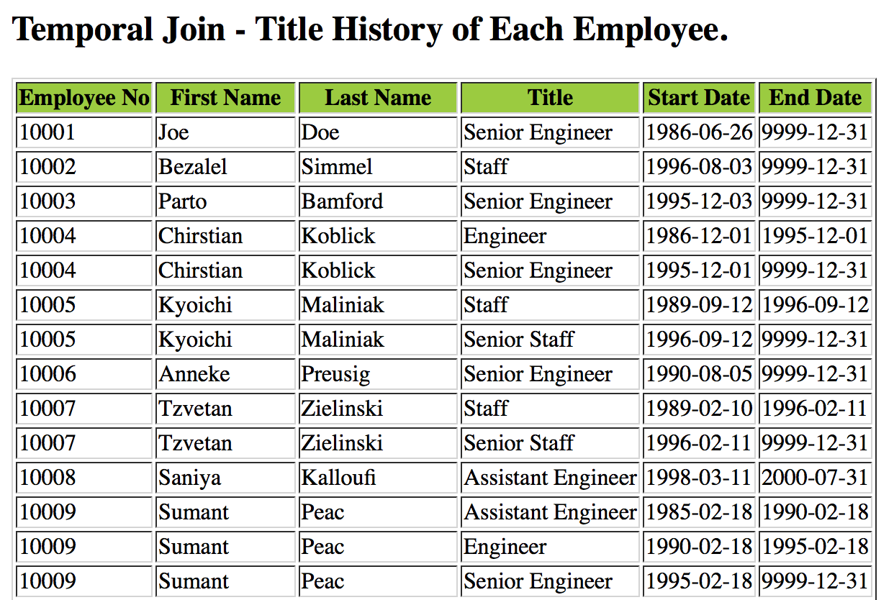

And the corresponding key part of .sxl file is as below:

<h2>Temporal Join - Title History of Each Employee.</h2>

<table border="1">

<tr bgcolor="#9acd32">

<th style="text-align:center">Employee No</th>

<th style="text-align:center">First Name</th>

<th style="text-align:center">Last Name</th>

<th style="text-align:center">Title</th>

<th style="text-align:center">Start Date</th>

<th style="text-align:center">End Date</th>

</tr>

<xsl:for-each select="temporalJoin/employee/title">

<tr>

<td><xsl:value-of select="../empno"/></td>

<td><xsl:value-of select="../firstname"/></td>

<td><xsl:value-of select="../lastname"/></td>

<td><xsl:value-of select="text()"/></td>

<td><xsl:value-of select="@tstart"/></td>

<td><xsl:value-of select="@tend"/></td>

</tr>

</xsl:for-each>

</table>

**To view the complete .sxl file on browser, please click**

<https://s3.amazonaws.com/zzhuclacsproj/CS240A_Proj1/RES/Query5_title_history.xsl>

**To show the Manager History**. (The picture below **is part of the whole result**. To access to the complete result, please click the link below.)

<https://s3.amazonaws.com/zzhuclacsproj/CS240A_Proj1/RES/Query5_view_Manager_History.xml>

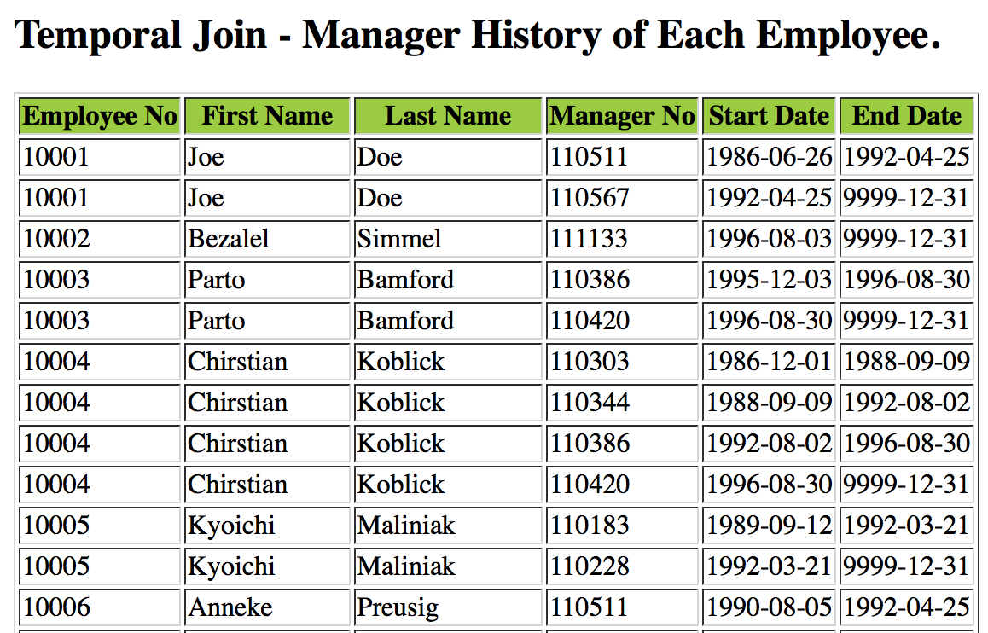

And the corresponding key part of .sxl file is as below:

<h2>Temporal Join - Manager History of Each Employee.</h2>

<table border="1">

<tr bgcolor="#9acd32">

<th style="text-align:center">Employee No</th>

<th style="text-align:center">First Name</th>

<th style="text-align:center">Last Name</th>

<th style="text-align:center">Manager No</th>

<th style="text-align:center">Start Date</th>

<th style="text-align:center">End Date</th>

</tr>

<xsl:for-each select="temporalJoin/employee/managers/mgrno">

<tr>

<td><xsl:value-of select="../../empno"/></td>

<td><xsl:value-of select="../../firstname"/></td>

<td><xsl:value-of select="../../lastname"/></td>

<td><xsl:value-of select="text()"/></td>

<td><xsl:value-of select="@tstart"/></td>

<td><xsl:value-of select="@tend"/></td>

</tr>

</xsl:for-each>

</table>

**To view the complete .sxl file on browser, please click**

<https://s3.amazonaws.com/zzhuclacsproj/CS240A_Proj1/RES/Query5_manager_history.xsl>

**Query6 - Temporal Count.**

Print the history of employee count for (i) each department, and (ii) the whole company.

**(i) Each department,** **the .xquery code is as follows:**

xquery version "1.0";

declare variable $employee-xml as xs:string := "v-emps.xml";

declare variable $department-xml as xs:string := "v-depts.xml";

declare variable $deptno := doc($department-xml)//deptno;

declare variable $emps := doc($employee-xml);

declare variable $departments := doc($department-xml);

declare variable $deptnos :=

for $i in distinct-values($deptno)

order by $i

return xs:string($i);

<company>

{

for $deptnumber in $deptnos

let $depts := $emps/employees/employee[deptno=$deptnumber]/empno

let $dates :=

for $date in distinct-values(($depts/@tstart, $depts/@tend))

order by $date

return ($date)

let $max := count($dates)

let $name := $departments/departments/department[deptno=$deptnumber]/deptname

return

<dept>

{

for $deptnocur in $deptno

where data($deptnocur) = $deptnumber

return $deptnocur

}

{$name}

{

for $tstart at $pos in ($dates)

let $y := $depts[@tstart <= $tstart and $tstart < @tend],

$tend := $dates[$pos + 1]

where $pos < $max and not($tstart = "9999-12-31")

return <count tstart="{$tstart}" tend="{$tend}">{count($y)}</count>

}

</dept>

}

</company>

**Results:**

The format of query result is like below:

<company>

<dept>

<deptno tend="9999-12-31" tstart="1985-01-01">d001</deptno>

<deptname tend="9999-12-31" tstart="1985-01-01">Marketing</deptname>

<count tstart="1986-01-16" tend="1987-03-28">1</count>

<count tstart="1987-03-28" tend="1987-07-25">2</count>

<count tstart="1987-07-25" tend="1988-03-30">3</count>

<count tstart="1988-03-30" tend="1988-04-25">4</count>

<count tstart="1988-04-25" tend="1988-09-24">5</count>

<count tstart="1988-09-24" tend="1989-08-24">6</count>

<count tstart="1989-08-24" tend="1990-01-17">7</count>

<count tstart="1990-01-17" tend="1991-03-14">8</count>

<count tstart="1991-03-14" tend="1991-06-24">9</count>

<count tstart="1991-06-24" tend="1992-04-27">10</count>

<count tstart="1992-04-27" tend="1992-12-22">11</count>

<count tstart="1992-12-22" tend="1993-08-03">12</count>

<count tstart="1993-08-03" tend="1995-02-05">13</count>

<count tstart="1995-02-05" tend="1995-05-24">14</count>

<count tstart="1995-05-24" tend="1995-07-22">13</count>

<count tstart="1995-07-22" tend="1996-05-04">12</count>

<count tstart="1996-05-04" tend="1996-07-31">13</count>

<count tstart="1996-07-31" tend="1996-10-04">14</count>

<count tstart="1996-10-04" tend="1999-01-06">15</count>

<count tstart="1999-01-06" tend="1999-03-20">14</count>

<count tstart="1999-03-20" tend="1999-05-15">15</count>

<count tstart="1999-05-15" tend="2001-10-20">14</count>

<count tstart="2001-10-20" tend="9999-12-31">13</count>

</dept>

With the help of stypesheet, (the picture below **is part of the whole result**. To access to the complete result, please click the link below.)

<https://s3.amazonaws.com/zzhuclacsproj/CS240A_Proj1/RES/Query61.xml>

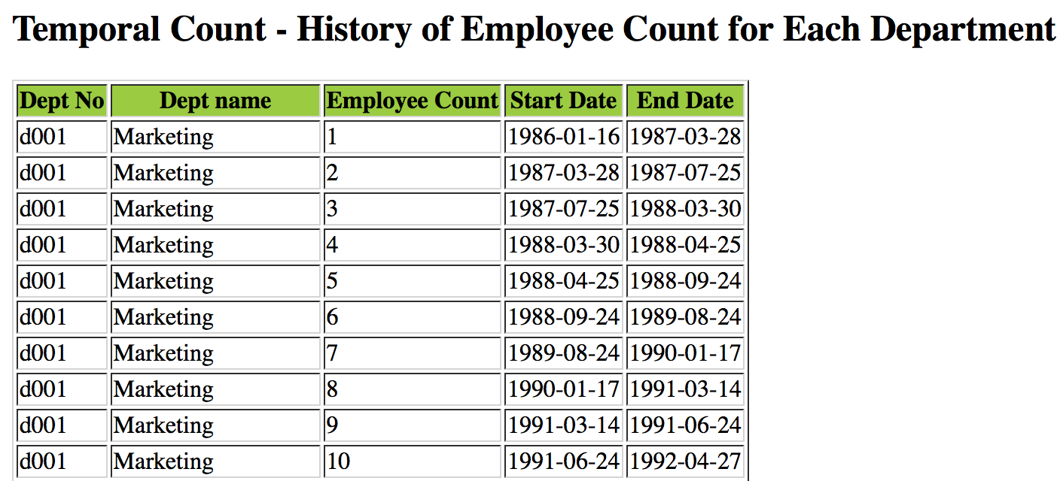

And the corresponding key part of .sxl file is as below:

<h2>Temporal Count - History of Employee Count for Each Department</h2>

<table border="1">

<tr bgcolor="#9acd32">

<th style="text-align:center">Dept No</th>

<th style="text-align:center">Dept name</th>

<th style="text-align:center">Employee Count</th>

<th style="text-align:center">Start Date</th>

<th style="text-align:center">End Date</th>

</tr>

<xsl:for-each select="company/dept/count">

<tr>

<td><xsl:value-of select="../deptno"/></td>

<td><xsl:value-of select="../deptname"/></td>

<td><xsl:value-of select="text()"/></td>

<td><xsl:value-of select="@tstart"/></td>

<td><xsl:value-of select="@tend"/></td>

</tr>

</xsl:for-each>

</table>

**To view the complete .sxl file on browser, please click**

<https://s3.amazonaws.com/zzhuclacsproj/CS240A_Proj1/RES/Query61.xsl>

**(ii)The whole company, the .xquery code is as follows:**

xquery version "1.0";

declare variable $employee-xml as xs:string := "v-emps.xml";

declare variable $department-xml as xs:string := "v-depts.xml";

declare variable $empno := doc($employee-xml)//empno;

declare variable $dept-no := doc($employee-xml)//deptno;

declare variable $start-dates :=

for $i in distinct-values($empno/@tstart)

order by $i

return xs:date($i);

declare variable $end-dates :=

for $i in distinct-values($empno/@tend)

order by $i

return xs:date($i);

declare variable $combined-dates :=

for $i in distinct-values(($start-dates, $end-dates))

order by $i

return $i;

declare variable $empolyee-num :=

for $start at $pos in $combined-dates

let $x := $empno[@tstart <= $start and $start < @tend]

let $cnt := count($x)

order by $start

return <count date="{$start}">{xs:decimal($cnt)}</count>;

declare variable $max := count($empolyee-num);

<whole-company>

{

for $tstart at $pos in $empolyee-num

let $tend := $empolyee-num[$pos + 1]

where( $pos < $max )

return <count tstart="{$tstart/@date}" tend="{$tend/@date}">

{string($empolyee-num[$pos])}</count>

}

</whole-company>

**Results:**

The format of query result is like below:

<whole-company>

<count tstart="1985-02-15" tend="1985-02-18">1</count>

<count tstart="1985-02-18" tend="1985-02-21">3</count>

<count tstart="1985-02-21" tend="1985-02-24">4</count>

<count tstart="1985-02-24" tend="1985-03-19">5</count>

<count tstart="1985-03-19" tend="1985-04-02">6</count>

<count tstart="1985-04-02" tend="1985-05-13">7</count>

<count tstart="1985-05-13" tend="1985-05-17">8</count>

<count tstart="1985-05-17" tend="1985-06-05">9</count>

<count tstart="1985-06-05" tend="1985-06-16">10</count>

<count tstart="1985-06-16" tend="1985-07-06">11</count>

<count tstart="1985-07-06" tend="1985-07-30">12</count>

<count tstart="1985-07-30" tend="1985-08-02">13</count>

……

</whole-company>

With the help of stypesheet, (the picture below **is part of the whole result**. To access to the complete result, please click the link below.)

<https://s3.amazonaws.com/zzhuclacsproj/CS240A_Proj1/RES/Query62.xml>

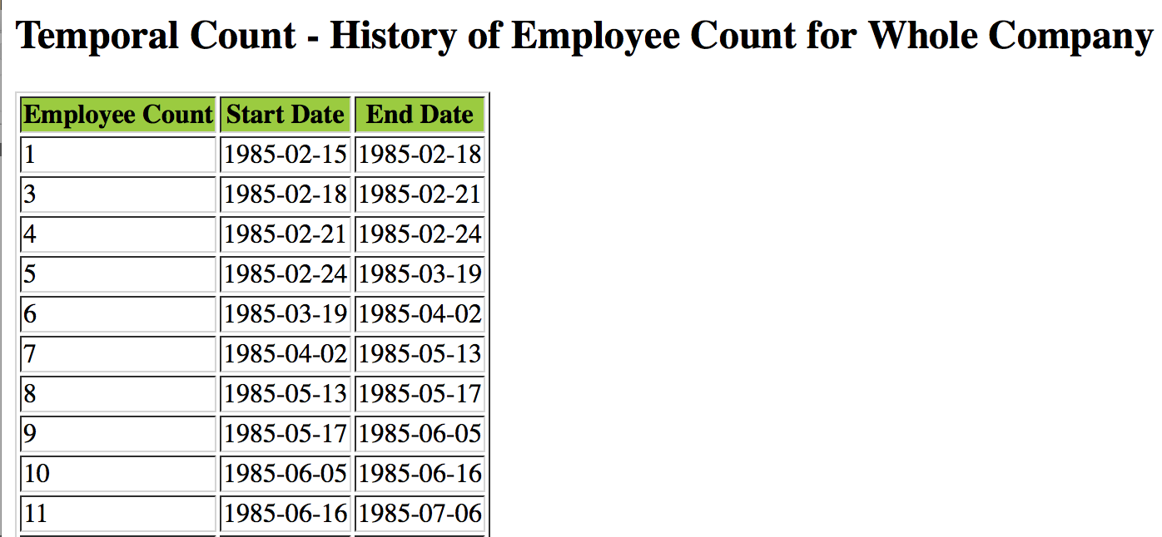

And the corresponding key part of .sxl file is as below:

<h2>Temporal Count - History of Employee Count for Whole Company</h2>

<table border="1">

<tr bgcolor="#9acd32">

<th style="text-align:center">Employee Count</th>

<th style="text-align:center">Start Date</th>

<th style="text-align:center">End Date</th>

</tr>

<xsl:for-each select="whole-company/count">

<tr>

<td><xsl:value-of select="text()"/></td>

<td><xsl:value-of select="@tstart"/></td>

<td><xsl:value-of select="@tend"/></td>

</tr>

</xsl:for-each>

</table>

**To view the complete .sxl file on browser, please click**

<https://s3.amazonaws.com/zzhuclacsproj/CS240A_Proj1/RES/Query62.xsl>

**Query7 - Temporal** Max

For the employees in department d005, find the maximum of their salaries over time, and print the history of such a maximum.

**the .xquery code is as follows:**

xquery version "1.0";

import module namespace helperFunctions = "helperFunctionsforXML" at "file:/Users/JohnZ/Desktop/Proj1/helperFunctions.xquery";

declare variable $employee-xml as xs:string := "v-emps.xml";

declare variable $department-xml as xs:string := "v-depts.xml";

declare variable $emps := doc($employee-xml)/employees/employee[deptno='d005'];

declare variable $start-dates :=

for $i in distinct-values($emps/salary/@tstart)

order by $i

return xs:date($i);

declare variable $end-dates :=

for $i in distinct-values($emps/salary/@tend)

order by $i

return xs:date($i);

declare variable $combined-dates :=

for $i in distinct-values(($start-dates, $end-dates))

order by $i

return $i;

declare variable $temporal-max :=

for $start at $pos in $combined-dates

let $x := $emps/salary[@tstart <= $start and $start < @tend]

let $max-salary := max($x)

order by $start

return <max date="{$start}">{xs:float($max-salary)}</max>;

declare variable $maxCount := count($temporal-max);

declare variable $max-date :=

for $tstart at $pos in $temporal-max

let $tend := $temporal-max[$pos + 1]

where( $pos < $maxCount )

return <max tstart="{$tstart/@date}" tend="{$tend/@date}">{string($temporal-max[$pos])}</max>;

declare variable $unique-salaries := distinct-values($max-date) ;

declare variable $coalesce :=

for $v in $unique-salaries

let $sal := $max-date[text()=$v]

let $start := '9999-12-31'

let $end := '1900-12-31'

let $s :=

for $x in $sal

let $start := helperFunctions:minDate($x/@tstart,$start)

return min($start)

let $e :=

for $x in $sal

let $end := helperFunctions:maxDate($x/@tend,$end)

return max($end)

return <max tstart="{min($s)}" tend="{max($e)}">{string($v)}</max>;

<company>

{

for $value in $coalesce

return $value

}

</company>

**Results:**

The format of query result is like below:

<company>

<max tstart="1985-02-24" tend="1985-05-17">40000</max>

<max tstart="1985-05-17" tend="1986-02-26">66280</max>

<max tstart="1986-02-26" tend="1986-05-17">69736</max>

<max tstart="1986-05-17" tend="1987-02-26">70375</max>

<max tstart="1987-02-26" tend="1987-03-23">72147</max>

<max tstart="1987-03-23" tend="1987-11-16">73259</max>

<max tstart="1987-11-16" tend="1988-02-26">74014</max>

<max tstart="1988-02-26" tend="1988-05-16">76616</max>

<max tstart="1988-05-16" tend="1989-02-25">76648</max>

<max tstart="1989-02-25" tend="1989-11-15">78885</max>

<max tstart="1989-11-15" tend="1990-02-25">79310</max>

<max tstart="1990-02-25" tend="1991-02-25">82819</max>

<max tstart="1991-02-25" tend="1992-02-25">84064</max>

<max tstart="1992-02-25" tend="1992-05-15">84161</max>

<max tstart="1992-05-15" tend="1993-05-15">86445</max>

<max tstart="1993-05-15" tend="1994-05-15">90341</max>

<max tstart="1994-05-15" tend="1995-05-15">89891</max>

<max tstart="1995-05-15" tend="1996-05-14">94064</max>

<max tstart="1996-05-14" tend="1997-05-14">97898</max>

<max tstart="1997-05-14" tend="1998-05-14">100587</max>

<max tstart="1998-05-14" tend="1999-05-14">102901</max>

<max tstart="1999-05-14" tend="2000-05-13">105128</max>

<max tstart="2000-05-13" tend="2001-05-13">105845</max>

<max tstart="2001-05-13" tend="2002-05-13">106912</max>

<max tstart="2002-05-13" tend="9999-12-31">110212</max>

</company>

With the help of stypesheet,

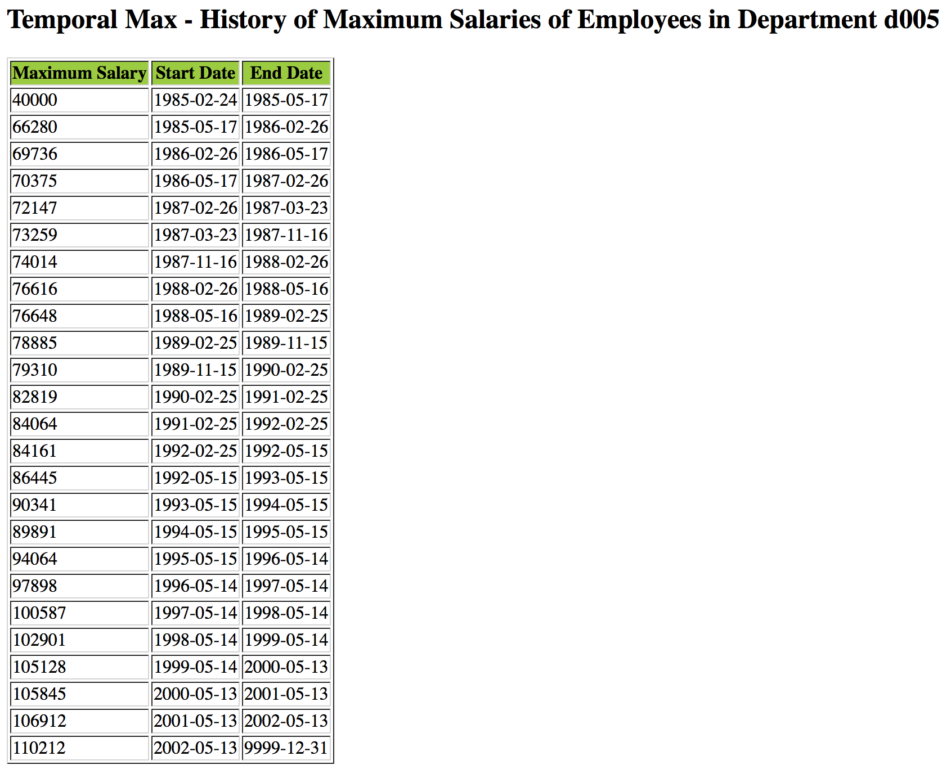

**To view the complete result on browser, please click**

<https://s3.amazonaws.com/zzhuclacsproj/CS240A_Proj1/RES/Query7.xml>

And the corresponding key part of .sxl file is as below:

<h2>Temporal Max - History of Maximum Salaries of Employees in Department d005</h2>

<table border="1">

<tr bgcolor="#9acd32">

<th style="text-align:center">Maximum Salary</th>

<th style="text-align:center">Start Date</th>

<th style="text-align:center">End Date</th>

</tr>

<xsl:for-each select="company/max">

<tr>

<td><xsl:value-of select="text()"/></td>

<td><xsl:value-of select="@tstart"/></td>

<td><xsl:value-of select="@tend"/></td>

</tr>

</xsl:for-each>

</table>

**To view the complete .sxl file on browser, please click**

<https://s3.amazonaws.com/zzhuclacsproj/CS240A_Proj1/RES/Query7.xsl>

**The code for helperFunctions.xquery is as below:**

module namespace helperFunctions = "helperFunctionsforXML";

(:Return the current date - timestamp:)

declare function helperFunctions:currentDate() as xs:string

{

xs:string(fn:adjust-date-to-timezone(current-date(), ()))

};

(:Convert 'Until Changed' to current timestamp:)

declare function helperFunctions:untilChangedToNow($x as xs:string) as xs:date

{

if( $x="9999-12-31" )

then xs:date(helperFunctions:currentDate())

else xs:date($x)

};

(:Return the minimum of two dates:)

declare function helperFunctions:minDate($x1 as xs:string, $x2 as xs:string) as xs:date

{

if(xs:date($x1)>xs:date($x2))

then xs:date($x2)

else xs:date($x1)

};

(:Return Maximum of two dates:)

declare function helperFunctions:maxDate($x1 as xs:string, $x2 as xs:string) as xs:date

{

if(xs:date($x1)>xs:date($x2))

then xs:date($x1)

else xs:date($x2)

};

(:Convert all elements from Until Changed to Current-Timestamp:)

declare function helperFunctions:untilChangedToAll($elements as element()*) as element()*

{

for $element in $elements

order by $element/@tstart, $element/@tend

return element

{node-name($element)}

{

helperFunctions:slice($element, '1900-01-01', helperFunctions:currentDate()),

string($element)

}

};

(:V2: Convert all elements from Until Changed to Current-Timestamp:)

declare function helperFunctions:untilChangedToAll2($elements as element()*) as element()*

{

for $element in $elements

order by $element/@tstart, $element/@tend

return element

{node-name($element)}

{

helperFunctions:slice($element, '1900-01-01', '9999-12-31'),

string($element)

}

};

(:Return the snapshot of the data:)

declare function helperFunctions:snapshot($elements as element()*) as element()*

{

for $element in $elements

return element

{node-name($element)}

{

$element/@*[name(.)!="tend" and name(.)!="tstart"],

data($element)

}

};

(:Get the department number of each element:)

declare function helperFunctions:deptNumber( $deptnos as element()* ) as element()*

{

for $deptno in $deptnos

return element

{node-name($deptno)}

{

$deptno/@*,

attribute deptname {string(doc("v-depts.xml")//department[deptno=$deptno]/deptname)},

string($deptno)

}

};

(:Return element which lie between start & end date:)

declare function helperFunctions:slice( $element as element(), $start as xs:string, $stop as xs:string ) as attribute()*

{

attribute tstart {helperFunctions:maxDate($start,$element/@tstart)},

attribute tend {helperFunctions:minDate($stop,$element/@tend)},

$element/@*[name(.)!="tend" and name(.)!="tstart"]

};

declare function helperFunctions:sliceAll( $elements as element()*,

$start as xs:string, $stop as xs:string ) as element()*

{

for $element in $elements

return

element {node-name($element)}

{

helperFunctions:slice($element, $start, $stop),

string($element)

}

};