PROJECT TITLE
Docker-Based CI/CD Pipeline for Python Web Application Deployment Using Jenkins, GitHub and Docker on AWS EC2

ABSTRACT
Continuous Integration and Continuous Deployment (CI/CD) have become essential practices in modern software development by enabling automated application building, testing, and deployment. Traditional deployment methods often involve manual installation, configuration, and execution of applications, which are time-consuming, error-prone, and difficult to maintain. Containerization using Docker simplifies application deployment by packaging applications and their dependencies into lightweight, portable containers that can run consistently across different environments.
This project presents the design and implementation of a Docker-based CI/CD pipeline for deploying a Python web application using Jenkins, GitHub, Docker, and Amazon Web Services (AWS) EC2. Jenkins is configured as the automation server to retrieve the latest source code from GitHub, execute Docker build commands, generate Docker images, and deploy Docker containers automatically. A Jenkins Freestyle Project with a Choice Parameter (BUILD/DEPLOY) is implemented to provide flexible automation of image creation and container deployment.
The complete implementation is hosted on an AWS EC2 instance running Amazon Linux 2023. Docker is used to build the application image, while Jenkins automates the complete workflow through shell scripts. The deployed Python application is executed inside a Docker container and accessed through a web browser.
The proposed system demonstrates the practical implementation of DevOps principles using containerization technologies. The automated pipeline reduces deployment time, minimizes human errors, improves consistency, and provides a scalable solution for cloud-based application deployment.

TABLE OF CONTENTS
ABSTRACT iv
LIST OF FIGURES vi
LIST OF TABLES vii
LIST OF ABBREVIATIONS viii
CHAPTER 1 INTRODUCTION 1
CHAPTER 2 LITERATURE SURVEY 3
CHAPTER 3 SYSTEM ANALYSIS 7
CHAPTER 4 SYSTEM DESIGN AND IMPLEMENTATION 13
CHAPTER 5 SYSTEM REQUIREMENTS 17
CHAPTER 6 SYSTEM ARCHITECTURE 21
CHAPTER 7 SYSTEM IMPLEMENTATION 25
CHAPTER 8 SYSTEM SECURITY 33
CHAPTER 9 SYSTEM TESTING 37
CHAPTER 10 CONCLUSION AND FUTURE ENHANCEMENTS 41
REFERENCES 44
APPENDICES 45

LIST OF FIGURES
Figure No. | Title | Page No.
3.1 | Existing System Architecture | 8
3.2 | Proposed System Architecture | 9
3.3 | Use Case Diagram | 10
3.4 | Class Diagram | 11
3.5 | Sequence Diagram | 12
6.1 | Docker-Based CI/CD Architecture | 22
7.1 | AWS EC2 Instance Running (Jenkins-Docker Server) | 26
7.2 | Jenkins Freestyle Project Creation (Python-WebApp) | 27
7.3 | Build with Parameters – ACTION = BUILD | 28
7.4 | Build with Parameters – ACTION = DEPLOY | 29
7.5 | Docker Images and Running Containers (Terminal Output) | 30
7.6 | Python Web Application Running in Browser | 31

LIST OF TABLES
Table No. | Title | Page No.
2.1 | Comparative Literature Review | 6
5.1 | Hardware Requirements | 17
5.2 | Software Requirements | 18
5.3 | Docker Components | 19
5.4 | Jenkins Plugins | 20
5.5 | Network Configuration | 20
9.1 | Test Result Summary | 39

LIST OF ABBREVIATIONS
Abbreviation | Meaning
AWS | Amazon Web Services
EC2 | Elastic Compute Cloud
CI | Continuous Integration
CD | Continuous Deployment
SCM | Source Code Management
VCS | Version Control System
Docker | Container Platform
API | Application Programming Interface
CLI | Command Line Interface
OS | Operating System
VM | Virtual Machine
CPU | Central Processing Unit
RAM | Random Access Memory

CHAPTER 1
INTRODUCTION

1.1 General
Modern software development requires applications to be deployed quickly, consistently, and reliably. Traditional deployment methods involve manually installing software dependencies, configuring servers, copying application files, and starting services. These repetitive tasks consume significant time and often introduce human errors.
Continuous Integration (CI) and Continuous Deployment (CD) automate software delivery by integrating source code management, build automation, and deployment processes. Docker enhances this workflow by packaging applications and all required dependencies into portable containers that execute consistently across development, testing, and production environments.
This project implements a Docker-based CI/CD pipeline using Jenkins, GitHub, Docker, and AWS EC2. Jenkins retrieves the latest Python web application from GitHub, builds a Docker image, and deploys the application inside a Docker container using automated shell scripts. A Jenkins Choice Parameter enables users to select either BUILD or DEPLOY, providing flexibility while maintaining automation.
The project demonstrates practical implementation of DevOps methodologies and containerization technologies using cloud infrastructure.

1.2 Objectives
The primary objectives are:
- Implement a Docker-based CI/CD pipeline.
- Automate Docker image creation.
- Automate Docker container deployment.
- Integrate Jenkins with GitHub.
- Deploy applications on AWS EC2.
- Reduce manual deployment effort.
- Improve deployment consistency.
- Demonstrate DevOps automation using Docker.

1.3 Scope
The proposed project can be extended by integrating:
- Kubernetes
- Docker Compose
- Jenkins Pipelines
- SonarQube
- Nexus Repository
- GitHub Webhooks
- Monitoring using Prometheus and Grafana

1.4 Summary
This chapter introduced Docker-based Continuous Integration and Continuous Deployment using Jenkins, GitHub, Docker, and AWS EC2. It explained the importance of automation, containerization, and cloud computing in modern software deployment while outlining the objectives and future scope of the proposed system.

CHAPTER 2
LITERATURE SURVEY

2.1 Introduction
Continuous Integration (CI) and Continuous Deployment (CD) have transformed the software development lifecycle by enabling faster, automated, and reliable software delivery. Modern organizations increasingly adopt DevOps practices to reduce manual intervention, improve software quality, and accelerate deployment. Containerization using Docker has further enhanced CI/CD by providing lightweight, portable, and consistent application environments across development, testing, and production.
Several automation tools such as Jenkins, GitHub Actions, GitLab CI/CD, Docker, and Kubernetes have become integral components of modern DevOps workflows. Jenkins is widely recognized for build automation, GitHub for source code management, and Docker for containerization. Together, these technologies simplify software deployment while reducing infrastructure inconsistencies.
This chapter reviews existing research and technologies related to Continuous Integration, Docker containerization, Jenkins automation, and cloud-based application deployment. It also compares their advantages and limitations to justify the proposed Docker-based CI/CD pipeline.

2.2 Literature Review

2.2.1 Jenkins Continuous Integration Server
Jenkins is one of the most popular open-source automation servers used to implement Continuous Integration and Continuous Deployment. It automates repetitive software development tasks such as source code retrieval, application building, testing, and deployment. Jenkins supports thousands of plugins, enabling seamless integration with version control systems, cloud platforms, and deployment tools. In modern DevOps environments, Jenkins reduces manual deployment effort and ensures consistent software delivery.
Advantages
- Open-source automation server
- Supports thousands of plugins
- Easy GitHub integration
- Supports Docker automation
- Cross-platform compatibility
Limitations
- Plugin management complexity
- Requires proper server maintenance
- Performance depends on server resources

2.2.2 Docker Containerization
Docker is an open-source containerization platform that packages applications along with their required dependencies into lightweight containers. Unlike virtual machines, Docker containers share the host operating system kernel, resulting in faster startup times and lower resource consumption. Docker enables developers to build once and run the same application consistently across multiple environments without compatibility issues.
Advantages
- Lightweight containers
- Fast deployment
- Platform independence
- Resource efficient
- Easy application portability
Limitations
- Requires Docker Engine
- Limited graphical interface
- Container security requires proper configuration

2.2.3 GitHub Source Code Management
GitHub is a cloud-based version control platform built on Git. It provides centralized source code management, collaboration, branch management, and version tracking. Developers can maintain project history, collaborate with teams, and integrate repositories with CI/CD tools such as Jenkins.
Advantages
- Version control
- Collaboration support
- Branch management
- Source code backup
- Easy Jenkins integration
Limitations
- Public repositories expose code if not configured properly
- Internet connection required
- Private repositories may require subscription plans

2.2.4 Amazon Web Services (AWS)
Amazon Web Services (AWS) provides cloud computing services that enable organizations to deploy scalable applications without investing in physical hardware. Amazon EC2 provides virtual servers for hosting Jenkins, Docker, and web applications. AWS Security Groups protect servers by controlling network traffic.
Advantages
- Cloud scalability
- High availability
- Secure infrastructure
- Flexible pricing
- Global accessibility
Limitations
- Requires cloud knowledge
- Incorrect configurations may increase cost
- Security must be managed properly

2.2.5 Jenkins with Docker Integration
The integration of Jenkins and Docker enables automated container creation and deployment. Jenkins retrieves source code from GitHub, executes Docker build commands, creates Docker images, and deploys Docker containers automatically. This integration significantly reduces deployment complexity and supports DevOps automation.
Advantages
- Automated image creation
- Automated container deployment
- Consistent application execution
- Faster deployment
- Improved productivity
Limitations
- Requires Docker knowledge
- Docker daemon permissions must be configured
- Resource usage increases with multiple containers

2.3 Comparative Literature Review
Year | Technology | Objective | Advantages | Limitations
2018 | Jenkins | Continuous Integration | Automated Build | Plugin dependency
2019 | Docker | Containerization | Lightweight Deployment | Requires Docker Engine
2020 | GitHub | Source Code Management | Version Control | Internet Dependency
2021 | AWS EC2 | Cloud Infrastructure | Scalability | Configuration Complexity
2022 | Jenkins + Docker | Automated Deployment | Complete CI/CD Automation | Docker Permission Configuration
Table 2.1 Comparative Literature Review

2.4 Existing Research Gap
The literature survey indicates that many existing systems focus on either Continuous Integration or containerization independently. Some solutions automate software builds but still require manual deployment, while others provide containerization without integrating a complete CI/CD workflow. The major research gaps identified are:
- Manual Docker image deployment in many environments.
- Lack of complete CI/CD automation.
- Limited integration between Jenkins and Docker.
- Manual server configuration.
- Increased deployment time.
- Higher possibility of human error.

2.5 Proposed Solution
The proposed system addresses these limitations by implementing a fully automated Docker-based CI/CD pipeline using Jenkins, GitHub, Docker, and AWS EC2. The workflow includes:
- Automatic source code retrieval from GitHub.
- Docker image creation through Jenkins.
- Automated Docker container deployment.
- Cloud-based execution using AWS EC2.
- Choice Parameter (BUILD/DEPLOY) for controlled automation.
- Elimination of manual deployment tasks.
This approach provides faster software delivery, improved reliability, and consistent deployment across environments.

2.6 Summary
This chapter reviewed existing technologies related to Continuous Integration, Docker containerization, GitHub version control, Jenkins automation, and AWS cloud infrastructure. Their advantages and limitations were analyzed to identify the need for a fully automated deployment solution. Based on the literature survey, the proposed Docker-based CI/CD pipeline using Jenkins, GitHub, Docker, and AWS EC2 addresses the limitations of existing deployment methods by automating the complete software delivery process.

CHAPTER 3
SYSTEM ANALYSIS

3.1 Introduction
System analysis is an important phase in software development that identifies the limitations of the existing deployment process and proposes an improved automated solution. Traditional software deployment methods require developers to manually build applications, create deployment packages, configure servers, and execute applications. These repetitive tasks consume time, increase deployment complexity, and often result in configuration errors.
With the adoption of DevOps practices, Continuous Integration (CI) and Continuous Deployment (CD) automate the software delivery lifecycle. Docker further simplifies deployment by packaging applications and their dependencies into portable containers, ensuring consistency across different environments.
The proposed project analyzes the shortcomings of traditional deployment methods and develops a Docker-based CI/CD pipeline using Jenkins, GitHub, Docker, and AWS EC2. The system automates Docker image creation and container deployment using Jenkins Freestyle Projects with Choice Parameters (BUILD/DEPLOY), thereby improving deployment speed, consistency, and reliability.

3.2 Existing System
In conventional software development environments, developers manually build applications, install dependencies, configure runtime environments, and deploy applications on target servers. Every software update requires rebuilding the application, transferring files, configuring the server, and restarting services manually.
These manual activities increase deployment time and introduce configuration inconsistencies between different environments. The existing deployment process generally consists of source code development, manual code compilation, manual dependency installation, manual application deployment, manual server configuration, and manual application verification. Because every deployment depends on manual intervention, the software delivery process becomes slow and error-prone.

3.2.1 Existing System Architecture
Developer → Develop Application → Manual Dependency Setup → Manual Application Build → Copy Files to Server → Configure Runtime Manually → Start Application → End User
Figure 3.1 Existing System Architecture

3.2.2 Limitations of Existing System
- Manual Deployment – Developers manually build applications and deploy them to servers, increasing deployment effort.
- Time Consuming – Every software modification requires rebuilding and redeploying the application manually.
- Environment Dependency – Applications may behave differently across systems because of inconsistent software versions and dependencies.
- Human Errors – Manual configuration frequently causes deployment failures and incorrect application behavior.
- Difficult Maintenance – Managing multiple application versions becomes difficult without automation.
- Limited Scalability – As the number of applications increases, manual deployment becomes increasingly complex.
- No Containerization – Applications are executed directly on the operating system without isolation, making dependency management difficult.

3.3 Proposed System
The proposed system implements a Docker-based Continuous Integration and Continuous Deployment (CI/CD) pipeline using GitHub, Jenkins, Docker, and Amazon Web Services (AWS). The source code is stored in a GitHub repository. Jenkins retrieves the latest source code, builds a Docker image, and deploys the application automatically as a Docker container.
The Jenkins Freestyle Project uses a Choice Parameter named ACTION, allowing users to select either BUILD or DEPLOY during job execution. This provides controlled automation while reducing manual deployment tasks.

3.3.1 Proposed System Architecture
GitHub Repository → Source Code Checkout → Jenkins Server → Choice Parameter (BUILD / DEPLOY) → Docker Engine → Docker Image / Docker Container → Python Web Application → End User
Figure 3.2 Proposed System Architecture

3.3.2 Advantages of Proposed System
- Automated Deployment – Jenkins automates Docker image creation and container deployment.
- Faster Software Delivery – Applications are deployed within minutes instead of requiring manual configuration.
- Containerization – Docker packages the application together with its dependencies, ensuring consistent execution.
- Consistent Environment – The same Docker image runs identically across development, testing, and production environments.
- Reduced Human Errors – Automation minimizes deployment mistakes caused by manual configuration.
- Better Resource Utilization – Docker containers consume fewer resources than traditional virtual machines.
- Cloud-Based Deployment – AWS EC2 provides scalable cloud infrastructure for hosting Jenkins and Docker.
- Easy Rollback – Previous Docker images can be redeployed quickly if required.

3.3.3 Use Case Diagram
The primary actor is the DevOps Engineer. The engineer performs the following operations: Login to Jenkins, Configure Job, Select BUILD or DEPLOY, Execute Build, Build Docker Image, Deploy Docker Container, and Verify Application.
Figure 3.3 Use Case Diagram

3.3.4 Class Diagram
The system consists of the following classes: Developer (Login, ExecuteJob); GitHub (Repository, Branch); Jenkins (Build, ExecuteShell); Docker (BuildImage, RunContainer, RemoveContainer); Application (Start, Execute).
Figure 3.4 Class Diagram

3.3.5 Sequence Diagram
Developer → Jenkins (Trigger BUILD/DEPLOY) → GitHub (Clone Repository) → Jenkins (Execute Shell Script) → Docker (Build Image / Run Container) → Python Application → End User (Browser Request).
Figure 3.5 Sequence Diagram

3.4 Functional Analysis
The proposed system performs the following functions:
- Retrieves source code automatically from GitHub.
- Executes shell scripts in Jenkins.
- Builds Docker images using the Dockerfile.
- Deploys Docker containers automatically.
- Hosts the Python web application inside a Docker container.
- Provides browser access through port 8000.
- Supports parameterized builds (BUILD and DEPLOY).

3.5 Summary
This chapter analyzed the limitations of traditional application deployment methods and proposed an automated Docker-based CI/CD pipeline using Jenkins, GitHub, Docker, and AWS EC2. The proposed system automates source code retrieval, Docker image creation, and container deployment through Jenkins, eliminating repetitive manual tasks and improving deployment consistency. The architecture, functional analysis, and UML diagrams presented in this chapter demonstrate how the system integrates modern DevOps tools to provide a reliable, scalable, and efficient application deployment solution.

CHAPTER 4
SYSTEM DESIGN AND IMPLEMENTATION

4.1 Introduction
The system design and implementation phase focuses on developing a Docker-based Continuous Integration and Continuous Deployment (CI/CD) pipeline using Jenkins, GitHub, Docker, and Amazon Web Services (AWS). The proposed system automates the complete application deployment lifecycle by integrating source code management, build automation, containerization, and deployment into a single workflow.
The implementation is carried out on an Amazon EC2 instance running Amazon Linux 2023. Jenkins acts as the automation server responsible for retrieving the latest source code from GitHub, executing Docker commands, building Docker images, and deploying Docker containers. Docker provides a lightweight containerization platform that packages the Python web application along with its dependencies, ensuring consistent execution across different environments.
A Jenkins Freestyle Project with a Choice Parameter (BUILD/DEPLOY) is implemented to automate image creation and container deployment. This design reduces manual intervention, improves software quality, and accelerates deployment.

4.2 Functional Modules
The proposed Docker-based CI/CD system consists of the following functional modules:
- AWS EC2 Infrastructure Module
- GitHub Repository Module
- Jenkins Automation Module
- Docker Engine Module
- Docker Image Build Module
- Docker Container Deployment Module
- Application Verification Module

4.3 Module Description

4.3.1 AWS EC2 Infrastructure Module
Amazon EC2 provides the cloud infrastructure required for hosting Jenkins and Docker. A virtual server running Amazon Linux 2023 is launched to implement the complete CI/CD environment. The EC2 instance hosts the Jenkins Automation Server, Docker Engine, and the Python Web Application.
Responsibilities
- Virtual server provisioning
- Cloud hosting
- Network configuration
- Secure remote access
- Resource management

4.3.2 GitHub Repository Module
GitHub serves as the centralized source code repository where the Python web application is stored. Whenever a Jenkins build is triggered, Jenkins automatically clones the latest version of the repository.
Responsibilities
- Source code storage
- Version control
- Branch management
- Project backup
- Collaboration

4.3.3 Jenkins Automation Module
Jenkins functions as the central automation server. Its responsibilities include connecting to GitHub, downloading source code, executing shell scripts, building Docker images, deploying Docker containers, and displaying build logs. The Jenkins Freestyle Project supports parameterized execution using the ACTION parameter with available choices BUILD and DEPLOY, enabling controlled execution of Docker operations.

4.3.4 Docker Engine Module
Docker Engine provides the runtime environment for containerized applications. It performs Docker image creation, Docker container execution, container lifecycle management, and image storage, ensuring application portability and consistent execution.
Responsibilities
- Docker image creation
- Docker container execution
- Container lifecycle management
- Image storage

4.3.5 Docker Image Build Module
The Docker Build Module packages the application and all required dependencies into a Docker image. Jenkins executes docker build, and the generated image serves as the deployment artifact.
Responsibilities
- Reading Dockerfile
- Building Docker image
- Image tagging
- Local image storage

4.3.6 Docker Container Deployment Module
The deployment module launches Docker containers from previously built Docker images. Jenkins automatically stops the previous container, removes the existing container, runs the new container, maps the port, and starts the application. Container deployment is fully automated using shell scripts.
Responsibilities
- Stop previous container
- Remove existing container
- Run new container
- Port mapping
- Application startup

4.3.7 Application Verification Module
After deployment, the Python web application is verified using a web browser.
Responsibilities
- Successful container startup
- Proper port mapping
- Application accessibility
- Successful deployment

4.4 Implementation Phases
The implementation is divided into eight phases.

Phase 1 – AWS Infrastructure Setup
The implementation begins by launching an Amazon EC2 instance using Amazon Linux 2023. Configuration includes public IP assignment, Security Group creation, SSH access, port 8080 for Jenkins and port 8000 for the Python Application. The cloud infrastructure provides the foundation for the CI/CD pipeline.

Phase 2 – Software Installation
The following software packages are installed: Java 21 Amazon Corretto, Git, Docker, and Jenkins. After installation, the Docker service is started and enabled, and the Jenkins service is started and enabled. Docker permissions are configured by adding the Jenkins user to the Docker group.

Phase 3 – Jenkins Configuration
The Jenkins dashboard is accessed through http://<Public-IP>:8080. The following tasks are completed: Unlock Jenkins, Install Suggested Plugins, Create Administrator Account, and Install Git Plugin. The Jenkins server becomes ready for automation.

Phase 4 – GitHub Integration
The Python web application source code is stored inside a GitHub repository. A Jenkins Freestyle Project is configured using the Repository URL, Branch Name, and Source Code Management → Git. Jenkins retrieves the latest project automatically whenever a build starts.

Phase 5 – Docker Image Creation
The BUILD option creates the Docker image. The shell script executes Docker Build, Image Tagging, and Image Storage. The generated image becomes available locally inside Docker (example image: python-webapp).

Phase 6 – Docker Container Deployment
The DEPLOY option stops the previous container, removes it, creates a new container, publishes the application port, and starts the application. The application becomes available inside a Docker container.

Phase 7 – Application Verification
After deployment, the application is verified through http://<Public-IP>:8000/demo/. The successful loading of the application confirms a successful Docker build, successful Docker deployment, a running Docker container, and a functional Python application.

Phase 8 – Complete CI/CD Workflow
Developer → GitHub Repository → Jenkins Freestyle Project → Choice Parameter (BUILD / DEPLOY) → Docker Image / Docker Container → Python Web Application → Browser. This workflow demonstrates complete automation from source code retrieval to application deployment.

4.5 Design Advantages
- Fully automated Docker deployment.
- Easy integration with GitHub.
- Reduced deployment time.
- Consistent application execution.
- Container portability.
- Cloud-based implementation.
- Simplified maintenance.
- Scalable architecture.
- Improved reliability.
- Better utilization of DevOps practices.

4.6 Summary
This chapter described the design and implementation of the Docker-based CI/CD pipeline. It presented the architecture, functional modules, and implementation phases used to automate application deployment. The system integrates AWS EC2, Jenkins, GitHub, and Docker to automate source code retrieval, Docker image creation, and container deployment. The modular design improves scalability, simplifies maintenance, and demonstrates an efficient DevOps workflow suitable for cloud-based application deployment.

CHAPTER 5
SYSTEM REQUIREMENTS

5.1 Introduction
The successful implementation of a Docker-based Continuous Integration and Continuous Deployment (CI/CD) pipeline requires suitable hardware resources, software tools, cloud infrastructure, and development technologies. The proposed project is implemented using Amazon Web Services (AWS), where an Amazon EC2 instance hosts Jenkins, Docker, Git, and the Python web application.
The implementation environment consists of Amazon Linux 2023 as the operating system, Jenkins as the automation server, Docker as the containerization platform, GitHub as the version control repository, and Python as the application development language. These technologies work together to automate application build and deployment while ensuring consistency, portability, and scalability.

5.2 System Requirements

5.2.1 Hardware Requirements
Component | Specification
Processor | Intel Core i3 (5th Generation) or Higher
RAM | 8 GB or Higher
Storage | 256 GB SSD or Higher
Display | 14-inch LCD Monitor
Internet Connection | Broadband Internet
Cloud Infrastructure | Amazon EC2 Virtual Machine
Table 5.1 Hardware Requirements

5.2.2 Software Requirements
Software | Version
Operating System | Amazon Linux 2023
Cloud Platform | Amazon Web Services (AWS)
Programming Language | Python 3.x
Automation Server | Jenkins
Container Platform | Docker
Version Control | Git
Repository | GitHub
Web Framework | Django
Browser | Google Chrome / Microsoft Edge
SSH Client | PuTTY / MobaXterm / Terminal
Table 5.2 Software Requirements

5.3 Technical Specification

5.3.1 Amazon Web Services (AWS)
Amazon Web Services (AWS) is a cloud computing platform that provides scalable and secure infrastructure for hosting applications. It offers on-demand computing resources without the need for physical hardware. In this project, AWS provides the virtual environment for Jenkins, Docker, and the Python web application.
Features / Advantages
- On-demand infrastructure
- High availability
- Secure cloud platform
- Pay-as-you-go pricing
- Easy scalability

5.3.2 Amazon EC2
Amazon Elastic Compute Cloud (EC2) provides virtual servers that host the complete CI/CD environment. The EC2 instance is used for the Jenkins Server, Docker Engine, and Python Application.
Features / Advantages
- Virtual server hosting
- Easy scalability
- Secure SSH access
- Flexible instance selection
- Cloud-based deployment

5.3.3 Amazon Linux 2023
Amazon Linux 2023 is the operating system used for implementing the project. It provides a secure and optimized environment for AWS services and supports Docker and Jenkins efficiently.
Features / Advantages
- Stable performance
- Enhanced security
- Long-term support
- Optimized for AWS
- Regular package updates

5.3.4 Jenkins
Jenkins is an open-source automation server used to implement Continuous Integration and Continuous Deployment. In this project, Jenkins clones source code from GitHub, executes shell scripts, builds Docker images, deploys Docker containers, and displays build logs.
Features / Advantages
- Open-source platform
- Easy GitHub integration
- Plugin-based architecture
- Automated build process
- CI/CD support

5.3.5 Docker
Docker is an open-source containerization platform that packages applications together with their dependencies into lightweight containers. Docker builds images, creates containers, runs applications, and manages containers. The project uses Docker to deploy the Python web application inside a container.
Features / Advantages
- Lightweight containers
- Fast startup
- Environment consistency
- Easy portability
- Resource efficient

5.3.6 Python
Python is a high-level programming language widely used for web development, automation, and scripting. The sample web application used in this project is developed using Python and the Django framework.
Features / Advantages
- Easy syntax
- Cross-platform support
- Extensive libraries
- Rapid development
- Open-source

5.3.7 Django
Django is a high-level Python web framework that simplifies web application development by providing built-in features for routing, authentication, and database management. In this project, Django is used to develop the Python web application that is containerized using Docker.
Features / Advantages
- Rapid development
- Secure framework
- Built-in authentication
- URL routing
- Scalable architecture

5.3.8 Git
Git is a distributed version control system that tracks source code changes. Git is used by Jenkins to retrieve the latest project files from GitHub before building the Docker image.
Features / Advantages
- Version control
- Branch management
- Source tracking
- Collaboration
- Fast operations

5.3.9 GitHub
GitHub is a cloud-based platform for hosting Git repositories. The Python application source code is stored in a GitHub repository, and Jenkins automatically clones the repository during every build.
Features / Advantages
- Source code hosting
- Version control
- Team collaboration
- Repository management
- Jenkins integration

5.4 Docker Components
Component | Purpose
Docker Engine | Container Runtime
Docker Image | Application Package
Docker Container | Running Application
Dockerfile | Image Build Instructions
Docker CLI | Container Management
Table 5.3 Docker Components

5.5 Jenkins Plugins Used
Plugin | Purpose
Git Plugin | GitHub Integration
Pipeline Plugin (Optional) | Pipeline Support
Docker Plugin (Optional) | Docker Integration
Credentials Plugin | Secure Credential Storage
Table 5.4 Jenkins Plugins

5.6 Network Configuration
The AWS Security Group allows only the required ports.
Port | Purpose
22 | SSH
8080 | Jenkins Dashboard
8000 | Python Web Application
Table 5.5 Network Configuration

5.7 Summary
This chapter described the hardware and software requirements necessary for implementing the Docker-based CI/CD pipeline. It explained the technical specifications of AWS EC2, Amazon Linux 2023, Jenkins, Docker, Python, Django, Git, and GitHub, along with the Docker components, Jenkins plugins, and network configuration used in the project. These technologies collectively provide a reliable, scalable, and automated environment for building and deploying containerized web applications.

CHAPTER 6
SYSTEM ARCHITECTURE

6.1 Introduction
The architecture of the proposed Docker-Based CI/CD Pipeline is designed to automate the complete software deployment process using GitHub, Jenkins, Docker, and AWS EC2. The architecture integrates source code management, build automation, containerization, and cloud deployment into a single workflow.
The system begins when the developer pushes the application source code to a GitHub repository. Jenkins automatically retrieves the latest version of the project and executes predefined shell scripts. Depending on the selected Choice Parameter (BUILD or DEPLOY), Jenkins either builds a Docker image or deploys the application inside a Docker container.
The complete implementation is hosted on an Amazon EC2 instance running Amazon Linux 2023. Docker provides application isolation by packaging the Python web application together with all required libraries and dependencies. The deployed application becomes accessible through a web browser using the configured application port.
The modular architecture improves deployment speed, minimizes manual intervention, and ensures consistent application execution across different environments.

6.2 System Architecture Diagram
Developer → GitHub Repository → Jenkins Freestyle Project → Clone Source Code (Git) → Choice Parameter, ACTION (BUILD / DEPLOY) → Docker Image Build / Docker Container Deploy → Docker Engine → Python Web Application → Web Browser (Port 8000)
Figure 6.1 Docker-Based CI/CD Architecture

6.3 Architecture Description

6.3.1 Developer
The developer develops the Python web application and stores the source code in a GitHub repository. Whenever modifications are made, the updated source code is pushed to GitHub.
Responsibilities
- Develop application
- Update source code
- Maintain project repository
- Push latest changes

6.3.2 GitHub Repository
GitHub acts as the centralized source code repository. The repository stores Python source files, the Dockerfile, the requirements file, and static resources. Whenever Jenkins executes a build, it clones the latest version of the repository.

6.3.3 Jenkins Server
Jenkins is the central automation server of the proposed architecture. It performs source code checkout, shell script execution, Docker image creation, Docker container deployment, and build logging, automating repetitive deployment activities.

6.3.4 Choice Parameter
The Jenkins Freestyle Project is configured with a Choice Parameter named ACTION, with available values BUILD and DEPLOY. When BUILD is selected, Jenkins creates the Docker image. When DEPLOY is selected, Jenkins launches the Docker container from the existing image.

6.3.5 Docker Engine
Docker Engine provides the runtime environment for containers, ensuring that the application executes consistently across environments.
Responsibilities
- Image creation
- Container execution
- Image management
- Container management
- Resource isolation

6.3.6 Docker Image
A Docker image is created during the BUILD phase. The image contains the Python Runtime, Django Framework, application source code, required libraries, and environment configuration. Once built, the image can be reused multiple times.

6.3.7 Docker Container
The Docker container is created from the Docker image during the DEPLOY phase. The container executes independently of the host operating system.
Responsibilities
- Run application
- Isolate execution environment
- Handle application requests
- Publish application port

6.3.8 Python Web Application
The deployed Python web application runs inside the Docker container. The application processes user requests and returns responses through the web browser, and becomes accessible using http://<Public-IP>:8000/demo/.

6.4 Working of the Proposed System
The workflow of the proposed system is divided into eight phases.

Phase 1 – Source Code Management
The developer uploads the latest source code to the GitHub repository, which stores the Python project, Dockerfile, and application files.

Phase 2 – Jenkins Job Execution
The Jenkins Freestyle Project is executed. The project downloads the latest application files from GitHub automatically.

Phase 3 – BUILD Selection
If ACTION = BUILD, Jenkins executes Docker Build, Image Creation, and Image Storage, and a new Docker image is generated successfully.

Phase 4 – DEPLOY Selection
If ACTION = DEPLOY, Jenkins stops the existing container, removes the previous container, creates a new container, and starts the container. The application becomes available immediately.

Phase 5 – Docker Image Creation
Docker reads the Dockerfile and creates the Base Image, Python Environment, Application Layer, and Final Image, which is stored locally.

Phase 6 – Docker Container Deployment
Docker launches the container and the application port is mapped 8000 → 8000. The Python application starts successfully.

Phase 7 – Browser Verification
The deployed application is verified through the browser, e.g. http://13.xxx.xxx.xxx:8000/demo/. Successful loading confirms that the deployment process has completed correctly.

Phase 8 – Continuous Deployment
Whenever the application source code is modified, GitHub stores updates, Jenkins retrieves the latest source, Docker builds a new image, and Docker deploys a new container. The complete deployment process is automated.

6.5 Algorithm
Algorithm: Docker-Based CI/CD Pipeline
Step 1: Start the system.
Step 2: Launch the Jenkins Freestyle Project.
Step 3: Connect to the GitHub repository.
Step 4: Clone the latest source code.
Step 5: Read the value of the ACTION parameter.
Step 6: If ACTION = BUILD – read Dockerfile, build Docker image, store image locally.
Step 7: If ACTION = DEPLOY – stop previous container, remove previous container, create new Docker container, start application.
Step 8: Publish application on Port 8000.
Step 9: Verify the application using a web browser.
Step 10: End.

6.6 Advantages of the Architecture
- Automated application deployment.
- Reduced deployment time.
- Consistent execution using Docker.
- Cloud-based implementation.
- Modular architecture.
- Easy maintenance.
- High portability.
- Scalable deployment.
- Improved reliability.
- Better resource utilization.

6.7 Summary
This chapter presented the architecture of the Docker-Based CI/CD Pipeline implemented using GitHub, Jenkins, Docker, and AWS EC2. It explained the roles of each architectural component and described the workflow from source code management to application deployment. The architecture leverages Jenkins automation and Docker containerization to eliminate manual deployment tasks, improve consistency, and provide a scalable cloud-based solution for Python web application deployment. The implementation phases and algorithm demonstrate how the complete CI/CD process is automated using modern DevOps practices.

CHAPTER 7
SYSTEM IMPLEMENTATION

7.1 Introduction
The implementation phase describes the practical development and deployment of the Docker-Based Continuous Integration and Continuous Deployment (CI/CD) Pipeline. The project was implemented on an Amazon EC2 instance running Amazon Linux 2023. Jenkins was installed as the automation server, Docker was used as the containerization platform, GitHub acted as the source code repository, and the Python web application was deployed inside a Docker container.
The complete deployment process was automated using a Jenkins Freestyle Project with a Choice Parameter (BUILD and DEPLOY). Based on the selected option, Jenkins either builds the Docker image or deploys the Docker container automatically. This implementation demonstrates how DevOps tools can simplify software deployment while reducing manual intervention and improving deployment reliability.

7.2 Implementation Environment
Component | Description
Cloud Platform | Amazon Web Services (AWS)
Virtual Server | Amazon EC2 (t2.medium)
Operating System | Amazon Linux 2023
Automation Server | Jenkins
Version Control | Git & GitHub
Container Platform | Docker
Programming Language | Python
Framework | Django
Browser | Google Chrome

7.3 AWS EC2 Configuration
The first step of implementation involved launching an Amazon EC2 instance named Jenkins-Docker using Amazon Linux 2023 with a t2.medium instance type, a Key Pair, a Public IP enabled, and a configured Security Group. The Security Group allowed port 22 for SSH, port 8080 for Jenkins, and port 8000 for the Python Application. The EC2 instance served as the deployment server for Jenkins and Docker, as shown in Figure 7.1.
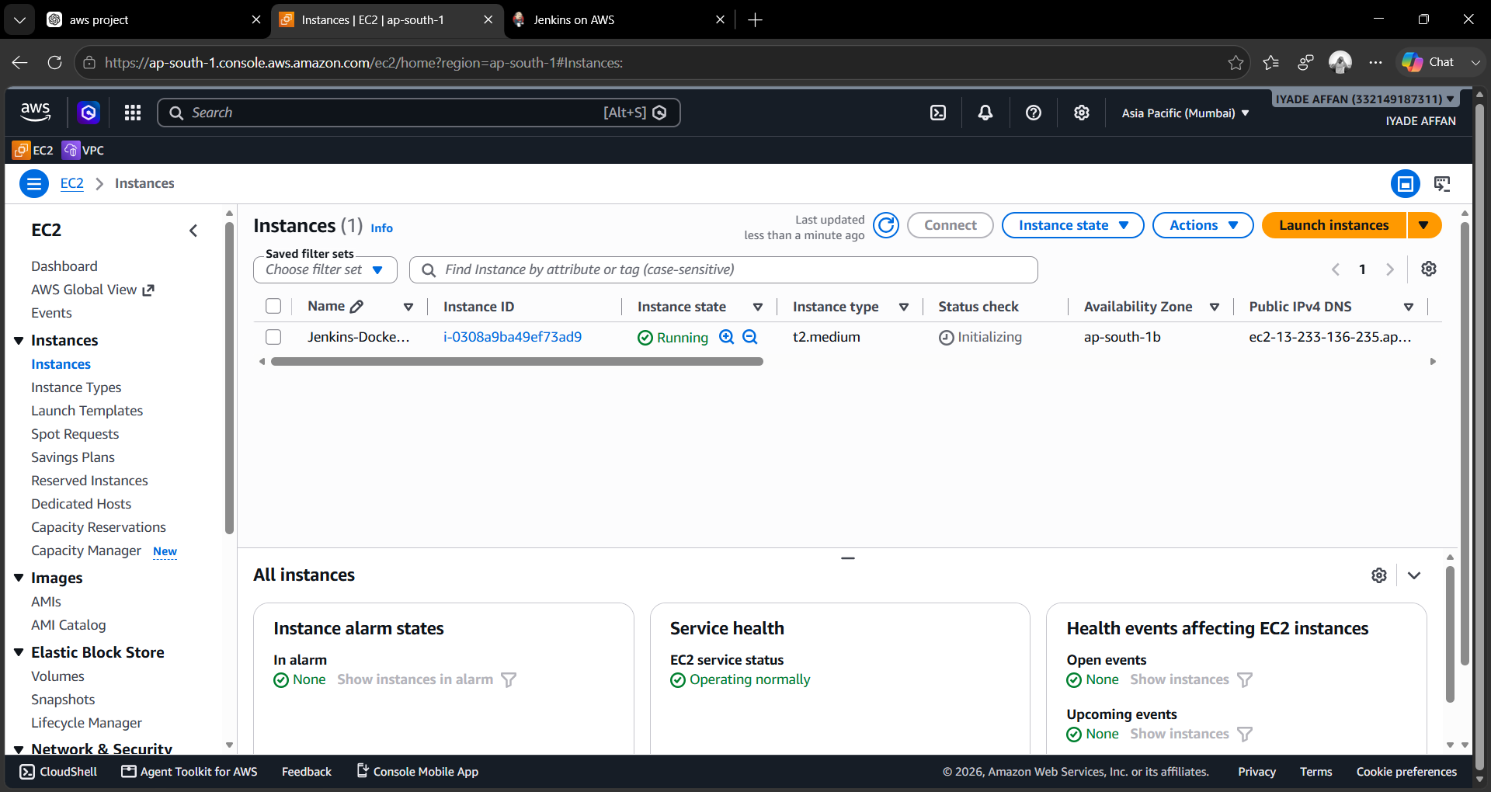
Figure 7.1 AWS EC2 Instance Running (Jenkins-Docker Server)

7.4 Software Installation
After launching the EC2 instance, the required software packages – Java, Git, Docker, and Jenkins – were installed. After installation, the Docker service was started and enabled, and the Jenkins service was started and enabled. The Jenkins user was added to the Docker group so that Jenkins could execute Docker commands without permission issues:
sudo systemctl start docker
sudo systemctl enable docker
docker --version
sudo usermod -aG docker ec2-user
sudo usermod -aG docker jenkins
sudo systemctl restart docker
sudo systemctl restart jenkins

7.5 Jenkins Configuration
The Jenkins dashboard was accessed using the EC2 public IP at http://<Public-IP>:8080. The following configuration steps were completed: Unlock Jenkins, Install Suggested Plugins, Create Administrator Account, Configure Jenkins URL, and Restart Jenkins. After configuration, Jenkins was ready for project creation.

7.6 GitHub Repository Configuration
The Python web application source code was maintained in a GitHub repository containing the Python source code, Dockerfile, requirements file, and project resources. Inside Jenkins, under Source Code Management → Git, the Repository URL was added and the branch (main) was selected. Whenever a build starts, Jenkins automatically clones the latest project files from GitHub.

7.7 Jenkins Freestyle Project
A Jenkins Freestyle Project named Python-WebApp was created as shown in Figure 7.2. The configuration steps were as follows:
- Open Jenkins at http://<Jenkins-IP>:8080.
- Click New Item.
- Enter the item name: Python-WebApp.
- Select Freestyle Project.
- Click OK.
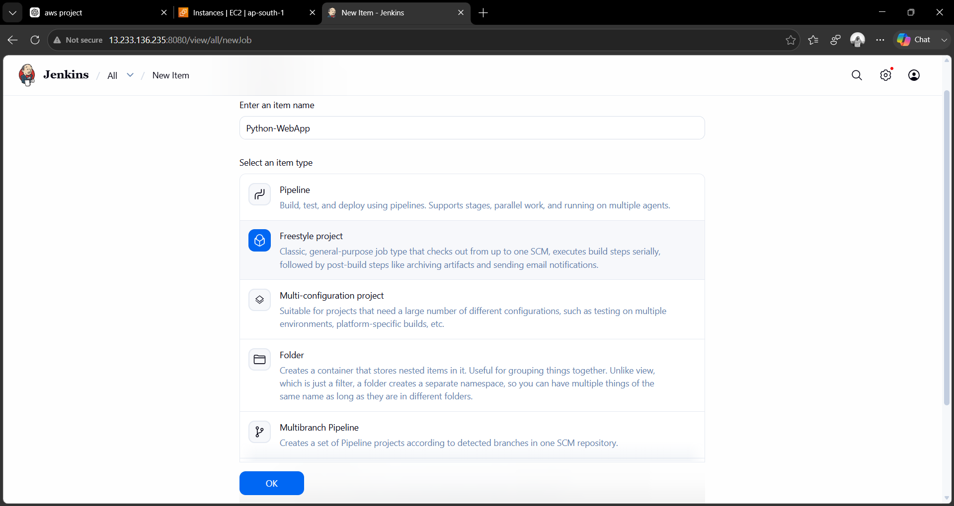
Figure 7.2 Jenkins Freestyle Project Creation (Python-WebApp)

7.8 Choice Parameter
A parameter named ACTION was created inside Jenkins by checking “This project is parameterized” and adding a Choice Parameter with the following configuration:
- Name: ACTION
- Choices: BUILD, DEPLOY
- Description: Choose BUILD to create the Docker Image; choose DEPLOY to run the Docker Container.
If BUILD is selected, a Docker Image is created. If DEPLOY is selected, a Docker Container is launched. This provides flexibility while keeping the deployment process automated.

7.9 Source Code Management (Git)
Under Source Code Management, Git was selected with the following configuration:
Repository URL: https://github.com/cloudbiteskarthik/Docker-Zero-to-Hero.git
Branch: */main
Jenkins automatically checks out the repository at the start of every build.

7.10 Build Shell Script
The Jenkins job executes a shell script (Execute Shell build step) that reads the selected ACTION parameter, navigates to the project directory, and performs the corresponding Docker operation automatically:
#!/bin/bash
IMAGE_NAME=python-webapp
CONTAINER_NAME=python-webapp-container
echo "Selected Action: $ACTION"

cd examples/python-web-app

if [ "$ACTION" = "BUILD" ]; then
echo "Building Docker Image..."
docker build -t $IMAGE_NAME .
if [ $? -eq 0 ]; then
echo "Docker Image Built Successfully."
else
echo "Docker Image Build Failed."; exit 1
fi

elif [ "$ACTION" = "DEPLOY" ]; then
echo "Deploying Docker Container..."
docker rm -f $CONTAINER_NAME 2>/dev/null
docker run -d --name $CONTAINER_NAME -p 8000:8000 $IMAGE_NAME
if [ $? -eq 0 ]; then
echo "Container Started Successfully."
else
echo "Container Deployment Failed."; exit 1
fi
else
echo "Invalid Action Selected."; exit 1
fi
echo "Job Completed Successfully."
This script automates the complete Docker deployment process without manual intervention. After adding the build step, the job configuration is saved.

7.11 Docker Image Creation (BUILD)
To build the image, Build with Parameters is opened, ACTION is set to BUILD, and Build is clicked, as shown in Figure 7.3. The console output confirms the successful creation of the Docker image, including the build steps and image tagging.
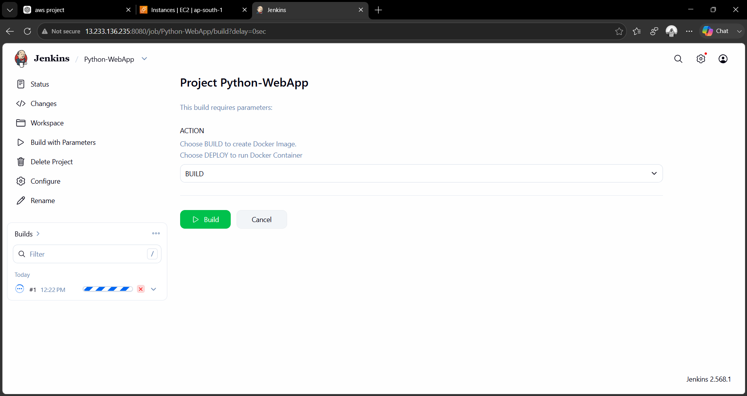
Figure 7.3 Build with Parameters – ACTION = BUILD
Verification:
docker images

REPOSITORY TAG IMAGE ID CREATED SIZE
python-webapp latest d258e7a34d80 44 seconds ago 250MB

7.12 Docker Container Deployment (DEPLOY)
After the image is created, Build with Parameters is opened again, ACTION is set to DEPLOY, and Build is clicked, as shown in Figure 7.4. Jenkins stops any existing container, removes it, creates a new container, publishes port 8000, and starts the Python application. Both builds (#1 and #2) completed successfully.
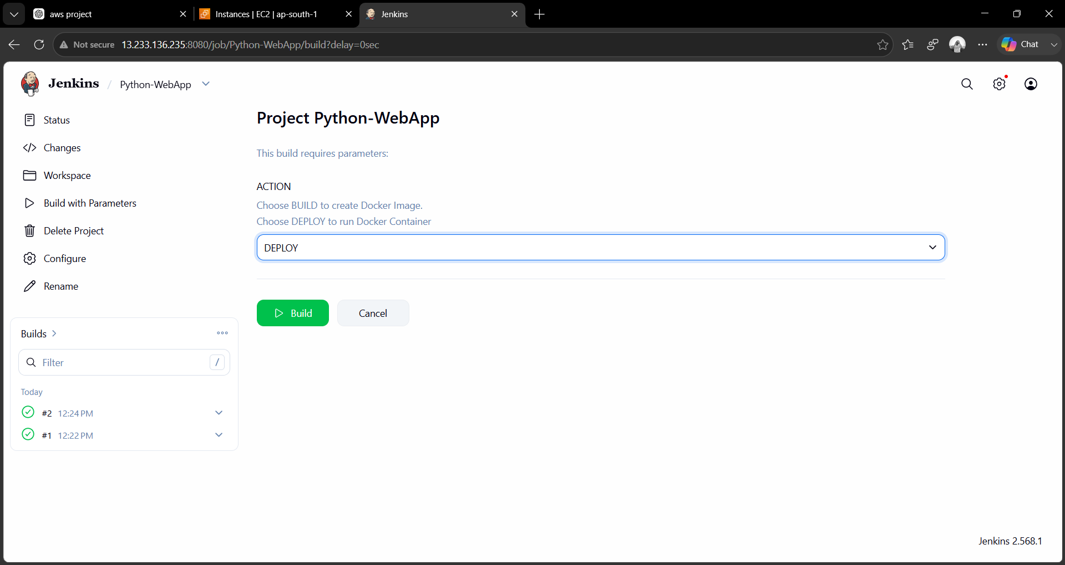
Figure 7.4 Build with Parameters – ACTION = DEPLOY

7.13 Verification via Terminal
The Docker image and the running container were verified directly on the EC2 instance terminal using docker images and docker ps, as shown in Figure 7.5. The output confirms that the python-webapp image was built successfully and the python-webapp-container is running with port 8000 mapped to the host.
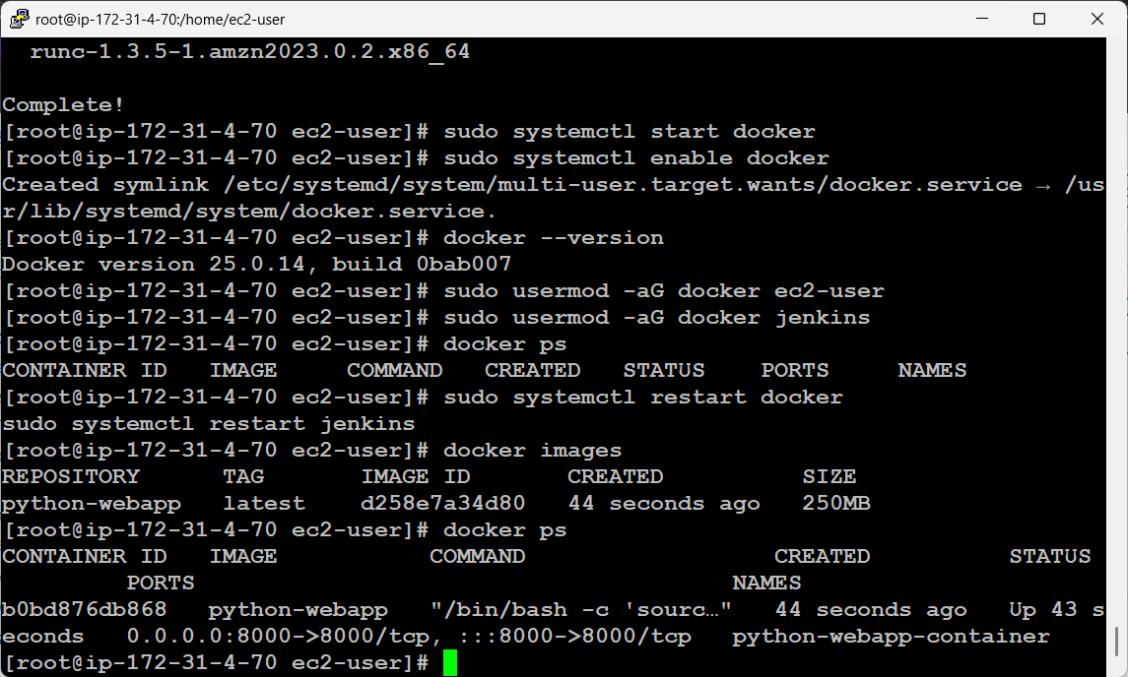
Figure 7.5 Docker Images and Running Containers (Terminal Output)
CONTAINER ID IMAGE COMMAND CREATED STATUS PORTS NAMES
b0bd876db868 python-webapp "/bin/bash -c 'sourc..." 44 seconds ago Up 43 s 0.0.0.0:8000->8000/tcp python-webapp-container

7.14 Application Testing
The deployed application was verified using a web browser at http://<Public-IP>:8000/demo/. The successful display of the application, as shown in Figure 7.6, confirms that the Jenkins build was successful, the Docker image was created, the Docker container is running, and the Python application is accessible.
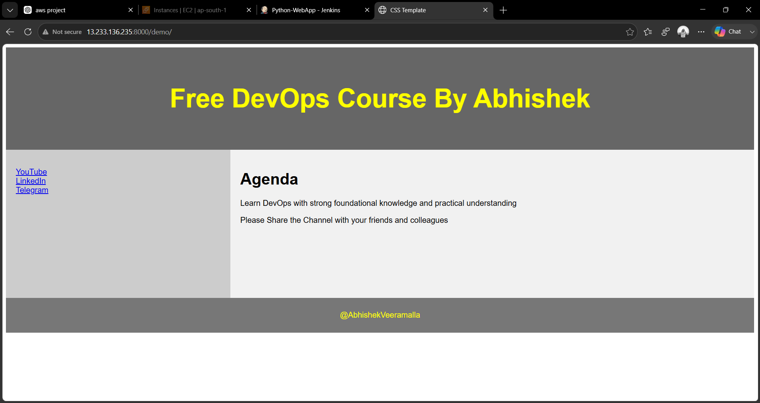
Figure 7.6 Python Web Application Running in Browser

7.15 Project Workflow
Developer → GitHub Repository → Jenkins Freestyle Project → Choice Parameter (BUILD / DEPLOY) → Docker Image / Docker Container → Python Web Application → Browser.

7.16 Summary
This chapter described the practical implementation of the Docker-Based CI/CD Pipeline. It covered the configuration of AWS EC2, installation of Java, Git, Docker, and Jenkins, creation of the Jenkins Freestyle Project, integration with GitHub, configuration of the BUILD and DEPLOY choice parameters, Docker image creation, and container deployment. The successful execution of the Python web application through a Docker container demonstrated that the proposed CI/CD pipeline effectively automates application deployment using Jenkins, Docker, GitHub, and AWS cloud infrastructure. The implementation validates the use of modern DevOps practices for reliable and efficient software delivery.

CHAPTER 8
SYSTEM SECURITY

8.1 Introduction
Security is one of the most important aspects of any cloud-based application deployment. Since the proposed project is implemented using Amazon Web Services (AWS), Jenkins, GitHub, and Docker, appropriate security mechanisms are required to protect the application, source code, server, and deployment process. The Docker-based CI/CD pipeline incorporates multiple layers of security, including cloud security, authentication, access control, container isolation, and network protection.

8.2 Security Objectives
- Protect the application source code.
- Secure the Jenkins automation server.
- Prevent unauthorized server access.
- Protect Docker containers from unauthorized modification.
- Secure communication between users and the application.
- Maintain application availability.
- Ensure deployment integrity.

8.3 AWS Security
Amazon Web Services provides multiple security mechanisms that protect the cloud infrastructure hosting the project, including Security Groups, SSH Authentication, Key Pair Authentication, Instance Isolation, and Firewall Rules.

8.3.1 Security Groups
Port | Purpose | Access
22 | SSH | Administrator
8080 | Jenkins Dashboard | Authorized Users
8000 | Python Web Application | End Users

8.3.2 SSH Authentication
Remote server administration is performed using SSH, which provides secure communication, encrypted login, user authentication, and protected remote access. Only users possessing the correct AWS Key Pair can log in to the EC2 instance.

8.4 Jenkins Security
Jenkins serves as the automation server and therefore requires proper access control through Administrator Login, User Authentication, Password Protection, Session Management, and Build Access Control.

8.4.1 Authentication
The Jenkins Administrator account is created during the initial setup, ensuring authorized login, secure access, job management, and plugin management.

8.4.2 Authorization
Authorization controls user permissions, including Read Jobs, Build Jobs, Configure Jobs, Delete Jobs, and Manage Plugins. Only administrators have full control over the CI/CD pipeline.

8.5 GitHub Security
GitHub securely stores the Python application source code using Repository Authentication, Branch Protection, Commit History, Version Control, and Access Permissions.

8.6 Docker Security
Docker provides application isolation through containers. Each container executes independently from the host operating system, reducing the possibility of application conflicts.

8.6.1 Docker Image Security
Only trusted Docker images are used. Images are verified, created in a controlled manner directly by Jenkins during the BUILD stage, and managed with proper version control.

8.6.2 Container Isolation
Docker containers isolate application processes, dependencies, runtime environment, and libraries, preventing interference between applications running on the same server.

8.7 Data Security
Although the project does not store sensitive user information, data security is maintained through controlled server access, secure source code storage, a protected deployment environment, and Docker container isolation.

8.8 Input Validation
Application inputs are validated before processing to prevent invalid user input, application errors, unexpected execution, and malformed requests, improving both security and application stability.

8.9 Backup and Recovery
- GitHub Repository Backup
- Jenkins Job Backup
- Docker Image Backup
- AWS Snapshot Backup

8.10 Security Best Practices
- Use strong administrator passwords.
- Restrict unnecessary network ports.
- Keep Docker images updated.
- Regularly update Jenkins plugins.
- Use trusted GitHub repositories.
- Secure AWS Key Pair files.
- Limit administrator privileges.
- Monitor Jenkins build logs.
- Remove unused Docker containers and images.
- Regularly update the operating system.

8.11 Feasibility Analysis

8.11.1 Technical Feasibility
The project uses widely adopted DevOps technologies such as Jenkins, Docker, GitHub, Python, and AWS EC2, which are open-source or cloud-based and compatible with modern software development environments. Result: Technically feasible.

8.11.2 Economic Feasibility
The implementation requires minimal infrastructure investment because AWS provides cost-effective virtual servers, and Jenkins, Docker, Git, Python, and Django are open-source software. Result: Economically feasible.

8.11.3 Operational Feasibility
The proposed CI/CD pipeline simplifies software deployment by automating repetitive tasks. It is easy to operate, maintain, and extend for future enhancements. Result: Operationally feasible.

8.12 Summary
This chapter presented the security mechanisms implemented in the Docker-Based CI/CD Pipeline, including AWS Security Groups, SSH authentication, Jenkins authentication and authorization, GitHub security, Docker container isolation, input validation, and backup strategies. The chapter also evaluated the technical, economic, and operational feasibility of the proposed system.

CHAPTER 9
SYSTEM TESTING

9.1 Introduction
System testing is an essential phase that verifies whether the developed system satisfies the specified functional and non-functional requirements. It ensures that all components of the proposed Docker-Based CI/CD Pipeline operate correctly when integrated, validating the interaction between GitHub, Jenkins, Docker, AWS EC2, and the Python web application.

9.2 Objectives of Testing
- Verify correct integration between GitHub and Jenkins.
- Validate Docker image creation.
- Verify Docker container deployment.
- Ensure the application is accessible through the browser.
- Detect and eliminate deployment errors.
- Improve system reliability and performance.
- Ensure the CI/CD pipeline functions as expected.

9.3 Types of Testing

9.3.1 Unit Testing
Unit testing verifies the functionality of individual components independently: GitHub Repository Connection, Jenkins Job Configuration, Docker Build Process, Docker Container Execution, and the Python Web Application. Each module functioned correctly before integration.

9.3.2 Integration Testing
Integration testing verifies communication between modules: GitHub → Jenkins, Jenkins → Docker, Docker → Python Application, and Docker → Browser. The integrated modules exchanged data successfully without errors.

9.3.3 System Testing
System testing validates the complete workflow: Developer → GitHub → Jenkins → Docker Image → Docker Container → Python Application → Browser. The entire deployment process executed successfully.

9.3.4 User Acceptance Testing (UAT)
UAT confirmed Jenkins Dashboard Accessibility, Build Execution, Docker Image Creation, Docker Deployment, and Browser Access, satisfying all expected functional requirements.

9.4 Test Cases
Test Case ID | Module | Objective | Input | Expected Result | Status
TC-01 | GitHub Integration | Verify repository cloning | GitHub Repository URL | Repository cloned successfully | Pass
TC-02 | Jenkins Build | Verify BUILD execution | BUILD Parameter | Docker Image Created | Pass
TC-03 | Docker Deployment | Verify DEPLOY execution | DEPLOY Parameter | Docker Container Running | Pass
TC-04 | Browser Verification | Verify Application Access | Browser URL | Application Opens Successfully | Pass
TC-05 | Docker Container | Verify Running Container | docker ps | Running Container Displayed | Pass

9.5 Test Result Summary
Test ID | Module | Result
TC-01 | GitHub Integration | Pass
TC-02 | Jenkins Build | Pass
TC-03 | Docker Deployment | Pass
TC-04 | Browser Verification | Pass
TC-05 | Docker Container | Pass
Table 9.1 Test Result Summary

9.6 Output Verification
- Jenkins Build – The Jenkins console displayed a successful build message after executing the BUILD parameter. Result: Docker image created successfully.
- Docker Images – The docker images command verified that the generated Docker image appeared in the image list. Result: Successful.
- Docker Container – The docker ps command verified the running python-webapp-container. Result: Successful.
- Browser Output – The application was accessed at http://<Public-IP>:8000/demo/ and loaded successfully. Result: Successful.

9.7 Performance Evaluation
The proposed Docker-Based CI/CD Pipeline demonstrated satisfactory performance during testing, including fast Docker image creation, automated deployment using Jenkins, minimal manual intervention, stable application execution, consistent deployment results, and quick application startup using Docker containers. The overall deployment time was significantly lower than traditional manual deployment methods.

9.8 Advantages Observed During Testing
- Automated software deployment.
- Reduced deployment time.
- Consistent application execution.
- Reliable Docker container deployment.
- Easy integration with GitHub.
- Simple Jenkins job execution.
- Improved productivity.
- Reduced human errors.
- Better maintainability.
- Cloud-based scalability.

9.9 Limitations
- Internet connectivity is required for GitHub access.
- Docker Engine must be installed on the deployment server.
- Jenkins requires periodic plugin updates.
- Single EC2 instance deployment does not provide high availability.
- Manual approval is required to choose BUILD or DEPLOY in the Freestyle project.

9.10 Summary
This chapter presented the testing procedures followed to validate the Docker-Based CI/CD Pipeline. Unit testing, integration testing, system testing, and user acceptance testing confirmed that the system functions correctly and meets the specified requirements. The successful execution of all test cases demonstrates that the proposed solution reliably automates Docker image creation, container deployment, and application hosting using Jenkins, GitHub, Docker, and AWS EC2.

CHAPTER 10
CONCLUSION AND FUTURE ENHANCEMENTS

10.1 Conclusion
The Docker-Based Continuous Integration and Continuous Deployment (CI/CD) Pipeline developed in this project successfully demonstrates the automation of software deployment using modern DevOps technologies. The project integrates GitHub for source code management, Jenkins for automation, Docker for containerization, and Amazon Web Services (AWS) EC2 for cloud hosting to provide a complete and efficient deployment solution.
The implementation automates the software delivery process by retrieving source code from GitHub, building Docker images, and deploying Docker containers through a Jenkins Freestyle Project. The use of the BUILD and DEPLOY choice parameters provides flexibility while maintaining automation and reducing manual effort. The Python web application is deployed successfully within a Docker container and accessed through a web browser, validating the effectiveness of the proposed solution.
Compared with traditional deployment methods, the proposed system significantly reduces deployment time, minimizes human errors, and ensures consistency across different execution environments. Docker containerization improves application portability by packaging all required dependencies together with the application, thereby eliminating environment-specific issues.
The testing results confirm that the proposed CI/CD pipeline functions reliably. All functional modules – including GitHub integration, Jenkins automation, Docker image creation, container deployment, and browser verification – performed successfully during implementation.
Overall, the proposed Docker-Based CI/CD Pipeline provides a secure, scalable, reliable, and automated deployment solution suitable for modern software development environments.

10.2 Project Achievements
- Designed and implemented a Docker-based CI/CD Pipeline.
- Configured Amazon EC2 as the deployment server.
- Installed and configured Jenkins for automation.
- Integrated GitHub with Jenkins for source code management.
- Automated Docker image creation.
- Automated Docker container deployment.
- Successfully deployed the Python web application.
- Reduced manual deployment effort.
- Improved deployment consistency.
- Demonstrated practical DevOps implementation using cloud technologies.

10.3 Advantages of the Proposed System
- Automated software deployment.
- Faster application delivery.
- Reduced manual intervention.
- Improved deployment consistency.
- Lightweight Docker containers.
- Cloud-based implementation.
- Easy maintenance.
- Better scalability.
- Improved software reliability.
- Reduced configuration errors.
- Efficient resource utilization.
- Simplified DevOps workflow.

10.4 Limitations
- The deployment is hosted on a single Amazon EC2 instance.
- Manual selection of the BUILD or DEPLOY parameter is required in Jenkins.
- Internet connectivity is required for GitHub integration.
- Docker must be installed on the deployment server.
- The project does not include automatic rollback functionality.
- Advanced monitoring and logging tools are not integrated.

10.5 Future Enhancements
- Implement Jenkins Pipelines (Pipeline as Code) using a Jenkinsfile.
- Configure automatic builds using GitHub Webhooks.
- Deploy applications to Kubernetes clusters for container orchestration.
- Use Docker Compose for multi-container applications.
- Integrate monitoring tools such as Prometheus and Grafana.
- Implement centralized logging using the ELK Stack (Elasticsearch, Logstash, and Kibana).
- Store Docker images in Docker Hub or Amazon Elastic Container Registry (ECR).
- Deploy applications using Amazon Elastic Kubernetes Service (EKS).
- Integrate Infrastructure as Code (IaC) using Terraform.
- Implement automated testing before deployment.
- Add SSL/TLS support using Nginx or AWS Application Load Balancer.
- Configure CI/CD notifications using email or Slack.
- Implement automatic rollback in case of deployment failures.
- Add SonarQube for code quality and security analysis.
- Enable high availability using Auto Scaling Groups and Load Balancers.

10.6 Overall Summary
The Docker-Based Continuous Integration and Continuous Deployment (CI/CD) Pipeline developed in this project demonstrates the practical implementation of DevOps practices using Jenkins, GitHub, Docker, and AWS EC2. The automated workflow simplifies application deployment, reduces manual effort, and improves software delivery efficiency. By integrating cloud computing, containerization, and automation technologies, the project provides a reliable, portable, and scalable deployment solution suitable for enterprise-level extension using Kubernetes, Terraform, and monitoring tools.

REFERENCES
1. Gene Kim, Jez Humble, Patrick Debois, and John Willis, The DevOps Handbook, IT Revolution Press, 2021.
2. Jez Humble and David Farley, Continuous Delivery: Reliable Software Releases through Build, Test, and Deployment Automation, Addison-Wesley, 2010.
3. Nigel Poulton, Docker Deep Dive, Leanpub, 2023.
4. Sam Newman, Building Microservices, O'Reilly Media, 2021.
5. Richard Hightower, Kelsey Hightower, and Brendan Burns, Kubernetes: Up and Running, O'Reilly Media, 2022.
6. AWS Documentation – Amazon EC2 User Guide.
7. Jenkins Documentation – Jenkins User Handbook.
8. Docker Documentation – Docker Engine Documentation.
9. Git Documentation – Git SCM Documentation.
10. Django Documentation – Official Django Documentation.

APPENDICES

Appendix A – Software Used
- Amazon Web Services (AWS)
- Amazon EC2
- Amazon Linux 2023
- Jenkins
- Docker
- Git
- GitHub
- Python 3.x
- Django
- Google Chrome

Appendix B – Hardware Used
- Intel Core i3 Processor or Higher
- 8 GB RAM
- 256 GB SSD
- Broadband Internet Connection

Appendix C – Screenshots Included in This Report
- AWS EC2 Instance Running (Jenkins-Docker Server) – Figure 7.1
- Jenkins Freestyle Project Creation (Python-WebApp) – Figure 7.2
- Build with Parameters – ACTION = BUILD – Figure 7.3
- Build with Parameters – ACTION = DEPLOY – Figure 7.4
- Docker Images and Running Containers (Terminal Output) – Figure 7.5
- Python Web Application Running in Browser – Figure 7.6

Appendix D – Source Code / Configuration
Refer to Section 7.10 (Build Shell Script) and Section 7.9 (Source Code Management) for the Jenkins shell script and GitHub repository configuration used in this project.

