Molecular simulation on ideal gas and van der Waals gas

Qian Ai, Ajay Upplili Arasanipalai

2021 Fall MSE 485 Atomistic scale simulation project

**Introduction**

In statistical mechanics, ideal gas is the most fundamental and well-studied system. Yet they are idealized models that can be derived mathematically. It’s hard for students to do experiment to validate the correctness of the law. With simulation tools, it’s easy compare the experimental values to the theoretical values predicted by the law under each condition.

Another part of the project is to simulation van der Waals gas, which is a good old model to analyze phase transition. However, equation of state was given under unclear atomistic assumption, e.g. what interaction particles have. Therefore, another goal of this project is to find the molecular level basis (the potential) that could lead to van der Waals equation.

Using this codes, statistical mechanics students could deepen the understanding of the whole subject, verify each derivation of the ideal gas law, e.g. Maxwell speed distribution and have an idea what kind of potential could lead to van der Waals equation.

In this project, we will simulation the ideal gas by hard spheres with no interaction. Pressure is extracted as the observable and plotted against volume or temperature, and compared to theoretical values. Speed distribution is also simulated and compared.

It was found that under low pressure condition, the hard sphere system behaves almost the same as an ideal gas. At higher pressure and temperature, the pressure is always slightly larger than predicted. This is likely due to the finite volume of spheres. It could be avoided by shrinking the particle size and increase the number.

**Technical approach and methods**

To simulate ideal gas, event-driven particle dynamics was used. N=64 particles were used in every simulation. T, V are also given as input. Initial velocities are drawn from a random uniform distribution multiplied by a factor to make root mean square speed is consistent with the temperature according to

$$\frac{1}{2}mv_{rms}^{2}=\frac{3}{2}kT$$

Then, the collision time between every pair of particles are calculated in the following way. Whenever a pair of particles will collide, the following equation has a solution.

$$\left|r_{ij}\left(t\right)+Δtv_{ij}\left(t\right)\right|=σ$$

By squaring both sides, it will become a quadratic equation, which will be easier to check the existence of solutions.

$$Δt^{2}v_{ij}^{2}+2Δtr_{ij}*v_{ij}+r_{ij}^{2}-σ^{2}=0$$

If there are two roots, this pair of particles will collide. If there is only one root, the two particles will only touch each other but will not collide. If there are no roots, they will not collide. (see Fig. 1) If this pair of particles are decided to collide, the lower $Δt$ will be the colliding time. Otherwise, $Δt$ is artificially set to 5000, which will likely to be much larger than most of the collision time.

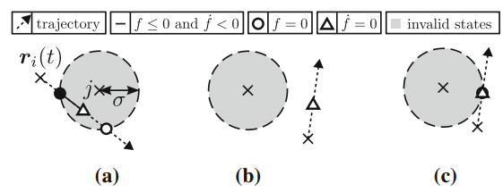

Figure 1: schematic of colliding and non-colliding particles. When Δ of Eq. ? is positive, the collision situation is (a), when Δ < 0, it’s (b), and when Δ = 0, it’s (c)

For each step in the loop, the collision time will be calculated for every pair. Then, the collision time table will be sorted from smallest to largest. Only the smallest one will be used as the time for this step. Since no collision will happen before smallest $Δt$, particles’ will be doing uniform linear motion, new positions can then be easily decided. All velocities will also remain the same except for the colliding objects.

If the collision happens between two particles i and j, a momentum is exchanged:

$$v_{i}^{'}=v_{i}+q/m$$

$$v_{j}^{'}=v_{j}-q/m$$

The energy must conserve:

$$\frac{1}{2}mv_{i}^{2}+\frac{1}{2}mv_{j}^{2}=\frac{1}{2}m{\left(v_{i}+\frac{q}{m}\right)}^{2}+\frac{1}{2}m{\left(v_{j}-\frac{q}{m}\right)}^{2}$$

Because the momentum change will only be in $r_{ij}$ direction, $q$ can be solved to be

$$q=-m\left[\hat{r_{ij}}v_{ij}\right]\hat{r_{ij}}$$

$$v_{i}^{'}=v_{i}-\left[\hat{r_{ij}}v_{ij}\right]\hat{r_{ij}}$$

$$v_{j}^{'}=v_{j}+\left[\hat{r_{ij}}v_{ij}\right]\hat{r_{ij}}$$

Where

$$\hat{r_{ij}}=\frac{r_{i}-r_{j}}{|r_{i}-r_{j}|}$$

If the collision happens between a particle and a wall, the velocity perpendicular to the wall plane will change sign, while the velocity parallel will remain the same. A momentum will be transferred to the wall and recorded.

The collision frequency will be calculated by dividing collision by the time they take. Collision frequency will be plotted with step to check whether the system is in equilibrium. The pressure of the system could be simulated by dividing momentum change on the walls by the time:

$$P=\frac{Δp}{ΔtA}$$

In pseudocode, the program could be presented as

[parameter setup: N, V, T, collision time, mass, particle radius = …]

[Initial position, initial velocity]

For [collision time]:

Calculate the event map and collision time

Indicate whether collision is particle-particle or particle-wall

If particle-particle collision:

Update vel and pos in part-part way

If particle-wall collision:

Update vel and pos in part-wall way

Calculate observables

Van der Waals gas has such an equation of state

$$\left(P+a\frac{N^{2}}{V^{2}}\right)\left(V-Nb\right)=NkT$$

This equation of state was very successful at early stages of phase transition studies because the corresponding PV curve could be non-monotonic, which could be further used to describe phase change. However, in his doctoral thesis in 1873, van der Waals didn’t state the molecular basis of this formula, i.e. what kind of interactions/potentials gas molecules have that could lead to this equation. Maybe because statistical mechanics didn’t exist at that time, people didn’t tend to derive things from molecular level. Therefore, the goal of this simulation is to find what potential could lead to this equation.

Examining the difference of this formula from PV=NkT, the ideal gas law, it could be told that $a\frac{N^{2}}{V^{2}}$ term is added to raise the pressure a bit, and $-Nb$ term is to lower the volume a bit. The molecular explanation for this could be there is attraction between molecules instead of no interaction, and the size of molecules are taken into consideration. Therefore, the potential in Fig. ? is naturally proposed to satisfy both observations. When distance is below rm, the particles bounce like hard spheres, and when they are away, they attract each other according to Lennard-Jones potential. This potential will be used to run the simulation and build the PV curve, which will be later compared to theoretical curves. (some are presented in Fig. ?)

To simulate van der Waals gas, normal time-stepping algorithm was used. The code is almost the same as the code in HW2, except that the potential is changed to semi-LJ potential. (see Fig. ?) The gas simulated is argon, so mass = 1, N = 64 particles was used. timestep = 0.003, and a total 12000 steps was run. It is decided to be enough to reach equilibrium by kinetic energy plot. Temperature will be kept 0.3 which is far below argon’s critical temperature. Anderson thermostat will be used to keep temperature constant. The pressure is calculated using virial equation[1]

$$P=\frac{NkT}{V}+\frac{1}{3V}<\sum_{i=1}^{N}{r_{i}f_{i}}>$$

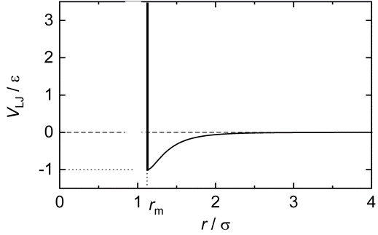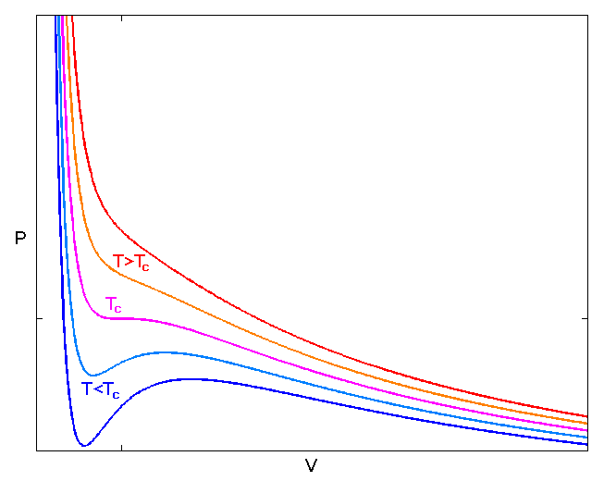

Fig. ? Left: the potential used to simulate van der Waals gas. For r > rm, the particles attract each other according to Lennard-Jones potential, for r < rm, the particles behave like hard spheres. Right: transition from above critical temperature to below it with van der Waals equation. When T<Tc, PV curve is not monotonic anymore, which means there is phase separation at certain pressure.

**Results and discussion**

Maxwell-Boltzmann speed distribution law

Statistical mechanics assumes ideal gas as point masses with no interaction and no volume. Thus, the partition function of the system is

$$Q=\sum_{all states}{e^{-\frac{mv^{2}}{2kT}}}$$

Suppose the velocity in each direction is equiprobable, and is continuous. Then, integrate speed using spherical coordinate:

$$Q=\int_{0}^{∞}{4πv^{2}*e^{-\frac{mv^{2}}{2kT}}dv}={\left(\frac{2πkT}{m}\right)}^{3/2}$$

Therefore, for any given speed, the probability should be

$$P\left(v\right)=4πv^{2}{\left(\frac{2πkT}{m}\right)}^{-3/2}e^{-\frac{mv^{2}}{2kT}}$$

This speed distribution is the Maxwell-Boltzmann speed distribution law.

By mapping the histogram of the speed and compare to this Maxwell distribution, a good match could be seen. Note that for a certain gas, Eq. ? is only dependent on temperature. This is verified in Fig. ?, where volume is changed but the distribution still matches the predicted shape.

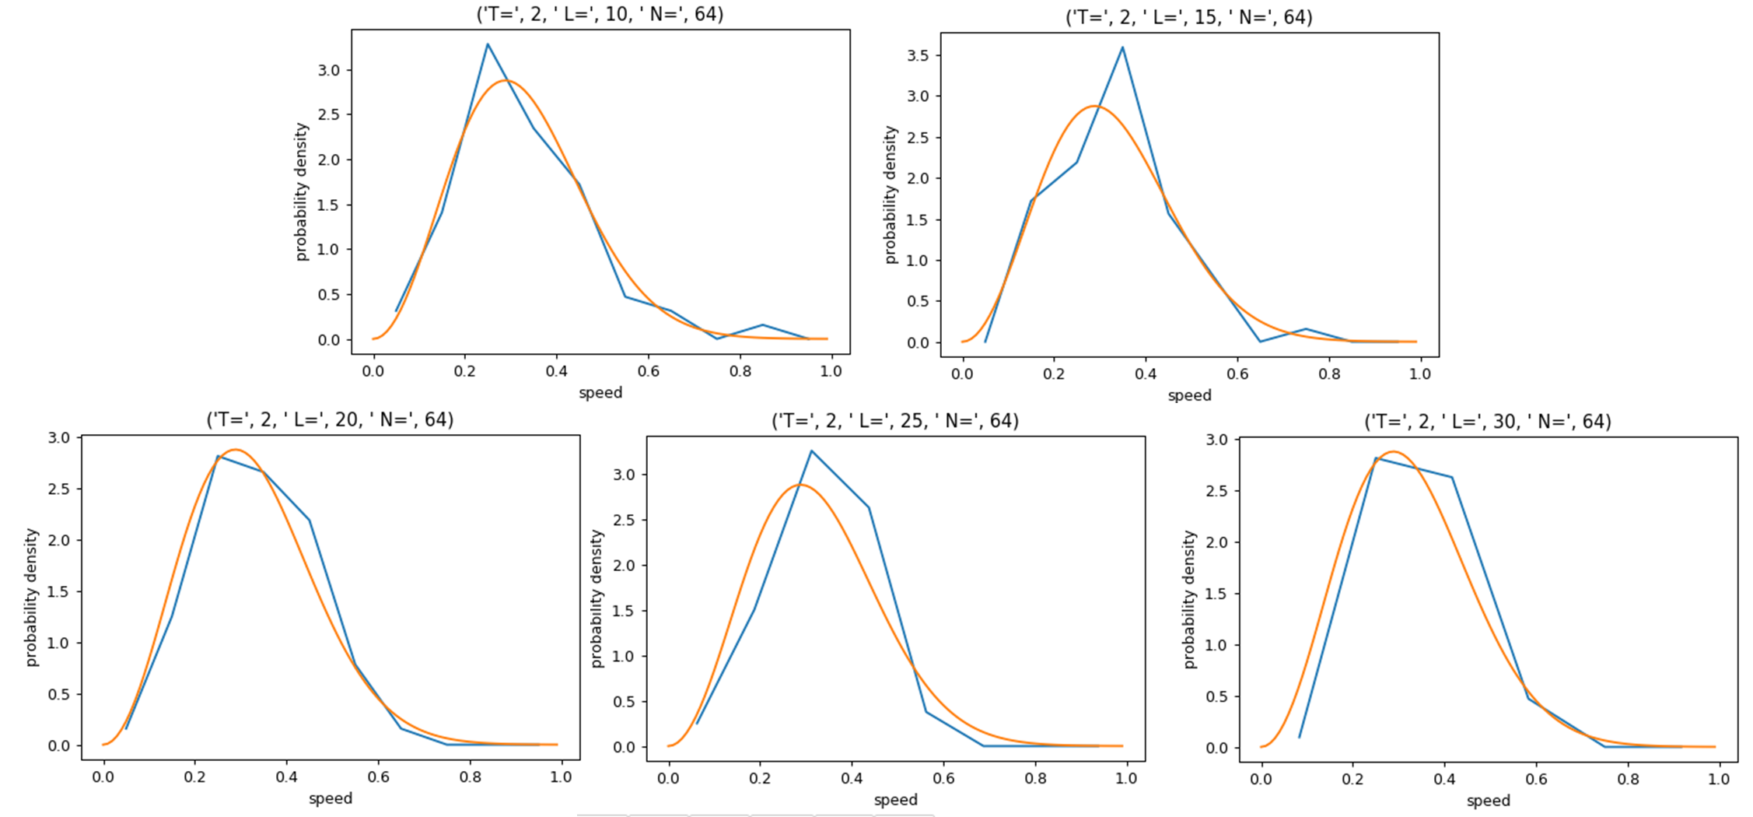

**Fig. ?** Maxwell-Boltzmann speed distribution theory vs experiment. This simulation is done in increasing box size from 10^3 to 30^3, experimental data all show good match. Other parameter is written on top of each graph. Volume is cubic of box length L

When increasing temperature from 0.5 to 4, the experimental data still shows good match, which validates Maxwell distribution law from an experimental perspective.

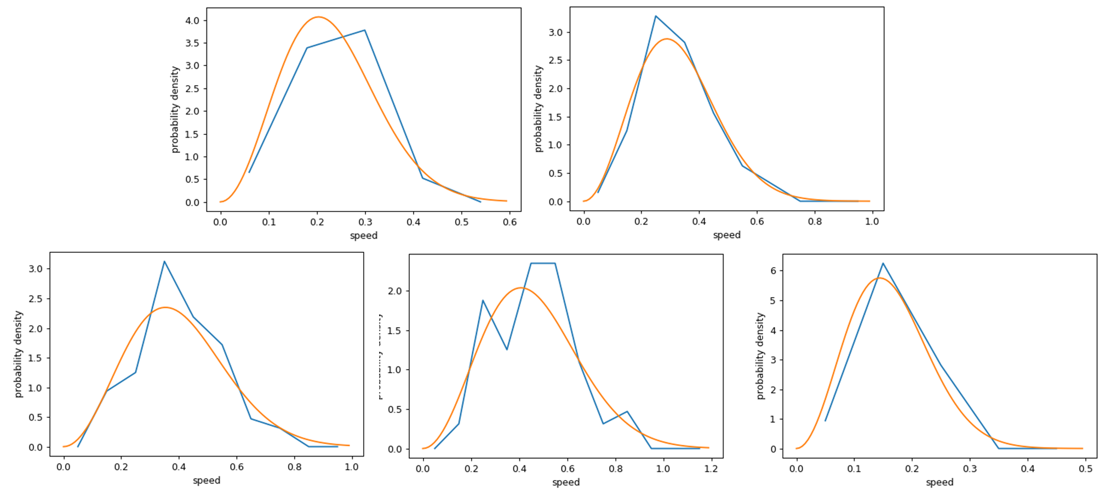

**Fig. ?** Speed distribution comparison under different temperature. Modelling parameters are N=64, V=20^3 for all simulations, T=0.5, 1, 2, 3, 4 in order.

According to Maxwell speed distribution law, the average speed should be:

$$v_{avg}=<v>=\int{v*P\left(v\right)dv}=\int_{0}^{∞}{v*4πv^{2}{\left(\frac{2πkT}{m}\right)}^{-3/2}e^{-\frac{mv^{2}}{2kT}}dv}=\sqrt{\frac{8kT}{πm}}$$

The average speed from theory and experiment are compared in table 1 and 2, at T=2, N=64. The only difference is that all experiments in Table. 1 are after 15000 collisions while the ones in Table. 2 are after 4000 collisions. The theoretical average speed at this temperature is 0.3257. The experimental average speed from Table. 1 is 0.32818±0.00328, while the one from Table. 2 is 0.33210±0.00486. Clearly, the results from Table. 1 is closer to theoretical value, likely resulting from more particle-particle collision to smeared out the energy distribution.

This could also be seen from the speed distribution plot in Fig. ?. The left figure is the initial velocity, and the right is the speed distribution after 1000 collision. The speed centers at the initial values instead of obeying the Maxwell distribution due to insufficient collision between the particles. The collision between particles and the wall will not change the energy of the particles. The speed distribution inconsistence has bothered me a long time before I realized they just haven’t reached equilibrium.

Table 1. data after 15000 collisions at T=2, N=64

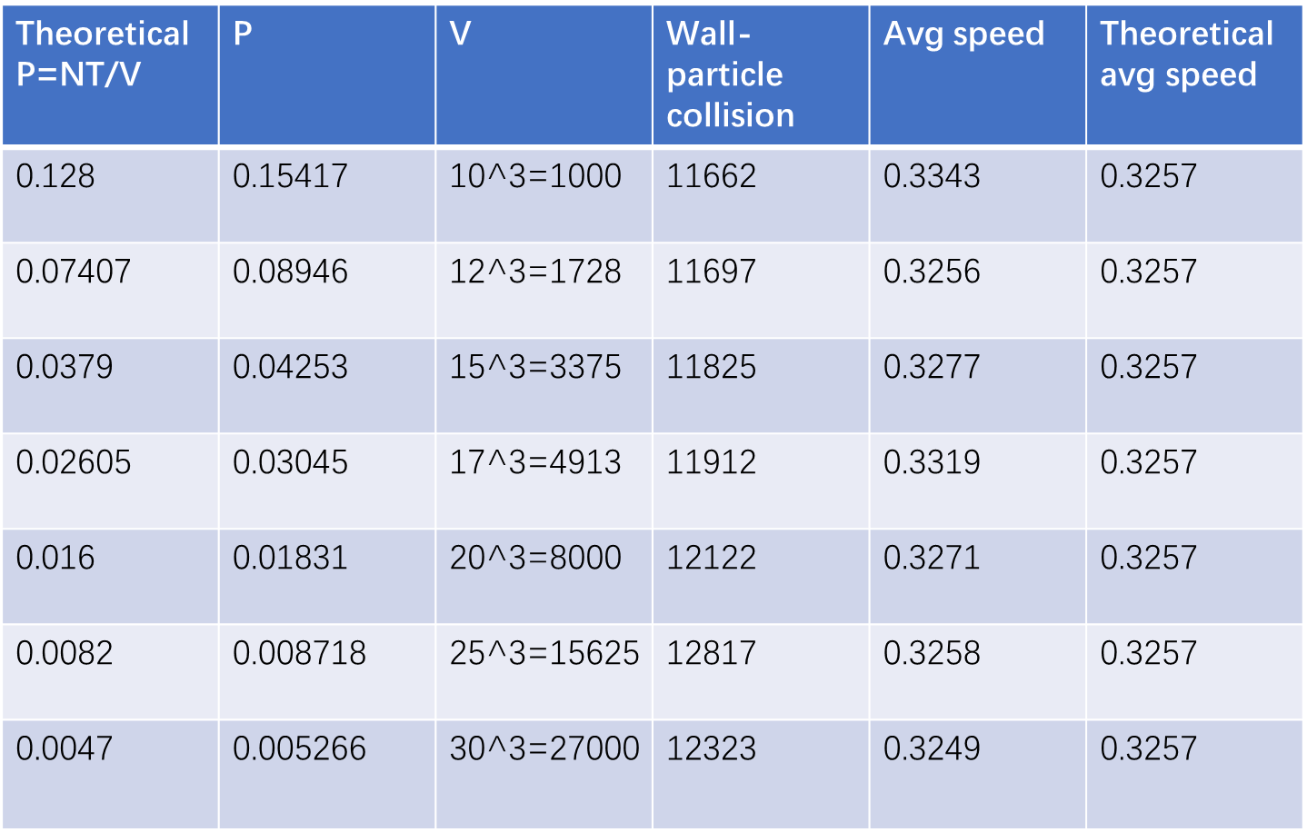

Table 2. data after 4000 collisions at T=2, N=64

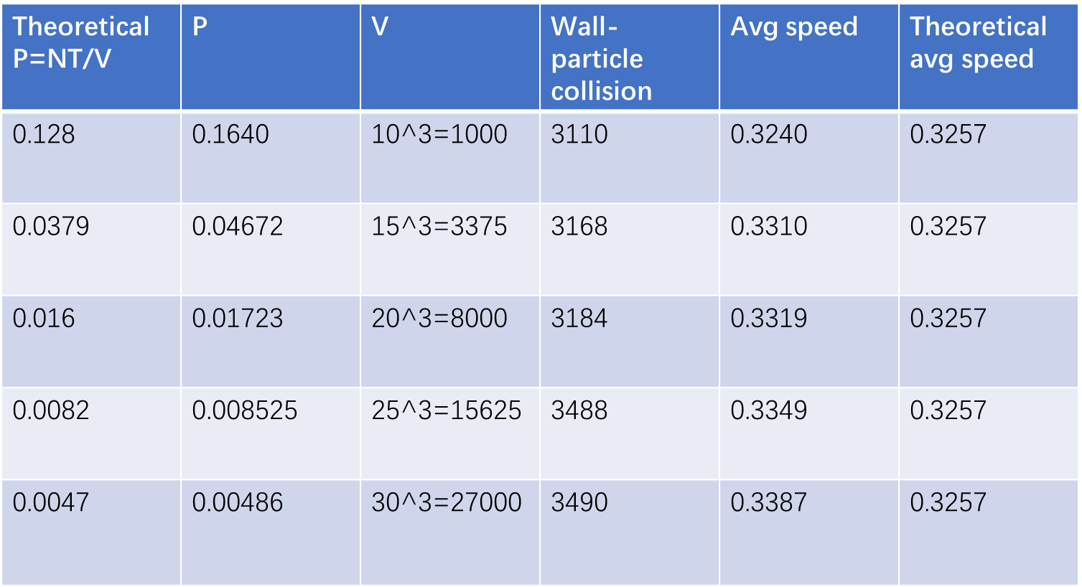

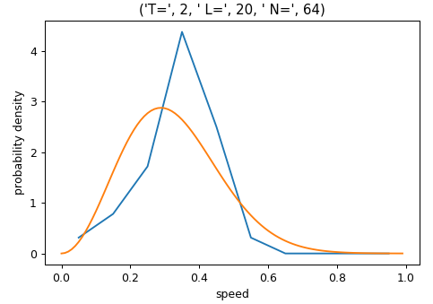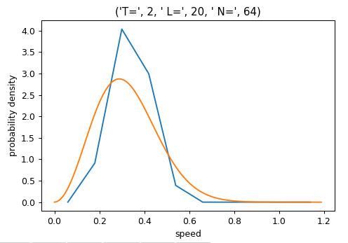

Fig. ? The speed distribution before the simulation (left) and after 1000 collision (right). The collision between particles is just 192 out of 1000 total collisions, which is not sufficient for the system to reach equilibrium.

Ideal gas law

Ideal gas law is the combination of many empirical laws including Gay-Lussac’s, Boyle’s, Charles’, and Avogadro’s law that has the form $PV=NkT$, where P is pressure, V is volume, N is the particle number, k is the Boltzmann constant, T is the temperature of the system. In this simulation, pressure as the observable was extracted and plotted against volume and temperature, and compared to ideal gas law.

In both P vs V and P vs T plots, data show overall match, but experimental pressure is always higher than theoretical one. This is likely because of the finite size of hard spheres, which is assumed to be zero in theoretical ideal gas. This is unlikely because the system has not reached equilibrium. In Fig. 2, pressure vs collision with walls are presented. Before (0:4000) and after (4000:end) equilibrium show no substantial difference in pressure distribution

In P vs V plot, there is a good match overall, but a better match at higher volume points. This may be because the relative volume of particles is higher if the overall volume is lower, causing the system deviates from ideal case. In the P vs T plot,

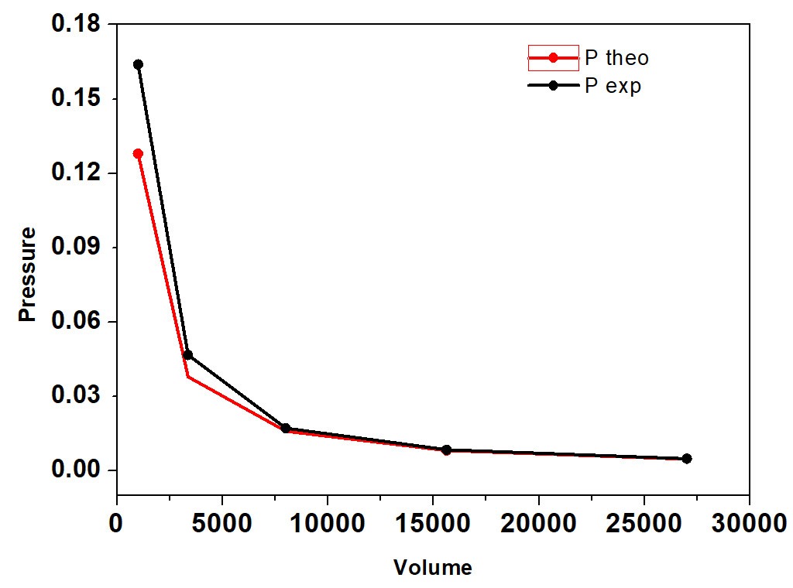 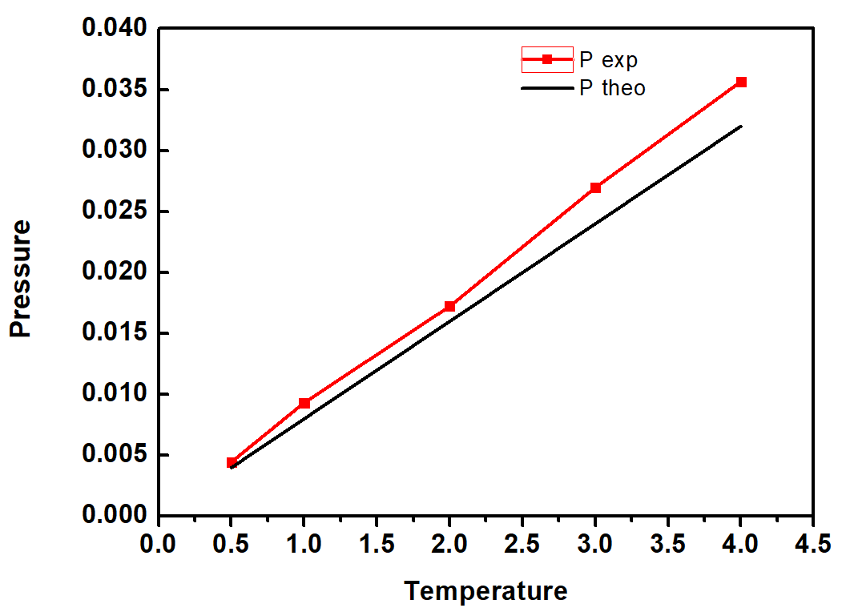

Fig ? P vs V and P vs T plots. Data show overall match, but the simulated pressure is always higher than theoretical values, likely due to finite size of hard spheres instead of 0. There is a better match at higher volumes and lower temperatures.

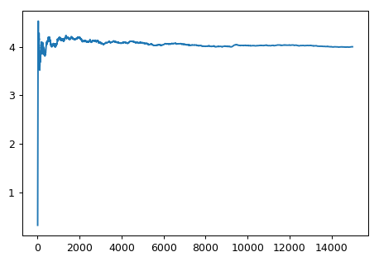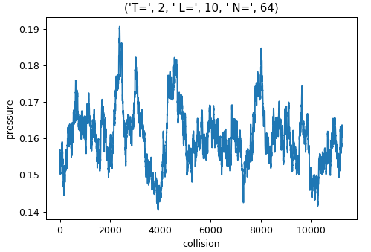

Fig ? Left: collision frequency vs collision. Collision frequency is plotted to monitor if the system is in equilibrium. From this plot, equilibrium has been reached after 4000 collision. Right: pressure vs collision. Pressure doesn’t show substantial change in distribution or in magnitude. Therefore, the larger pressure in experiment is not likely due to inequilibrium.

Van der Waals gas

~~According to Eq. ?, the equation of state could also be written as:~~

~~Since 1/V is smaller than 1, Taylor expansion could be used~~

~~If (kbT - a) > 0, the P vs V curve should be monotonic, at low enough temperature, (kbT - a) will surely be negative, then~~

~~What expected to happen is in Fig. ?, when temperature is lowered below the critical temperature, P vs V plot show a non-monotonic way instead of in a $P∝1/V$ way in the ideal gas law. This means for some P, there will be three corresponding volumes. Scientists realized later that this indicates phase separation.~~

The parameter a and b from Ref. 7 for argon are $1.35 L^{2}bar/mol^{2}$ and $0.032 L/mol$. Translating them into dimensionless unit, they are 5.75 and 1.35. In general, b is related to volume effect of real gas particles, and a is related to interaction between particles. It is assumed the proposed potential could reasonably describe the interaction between argon. Therefore, parameter a is fixed to 5.75 when fitting experimental data. The result is presented in Fig. ?. the equation of red line in reduced unit is

$$P=\frac{NT}{V-N*2.2}-5.75*\frac{N^{2}}{V^{2}}$$

Here, the experimental data show decent match to above formula, with higher pressure at some points. The source of higher pressure needs further exploration. Here, b = 2.2 > 1.35. This could because the radius of particles was set to be 1.123, instead of realistic value. The overall good match means the proposed potential could be the molecular basis for van der Waals equation. Note that the physical meaning of negative pressure could be retraction tendency of the gas.

Although not tested in this project, it is suspected that all kind of semi-hard-sphere-semi-attract potential could produce a van der Waals PV curve, with different a, b parameters, but only those with realistic potential should match a, b from the experiments.

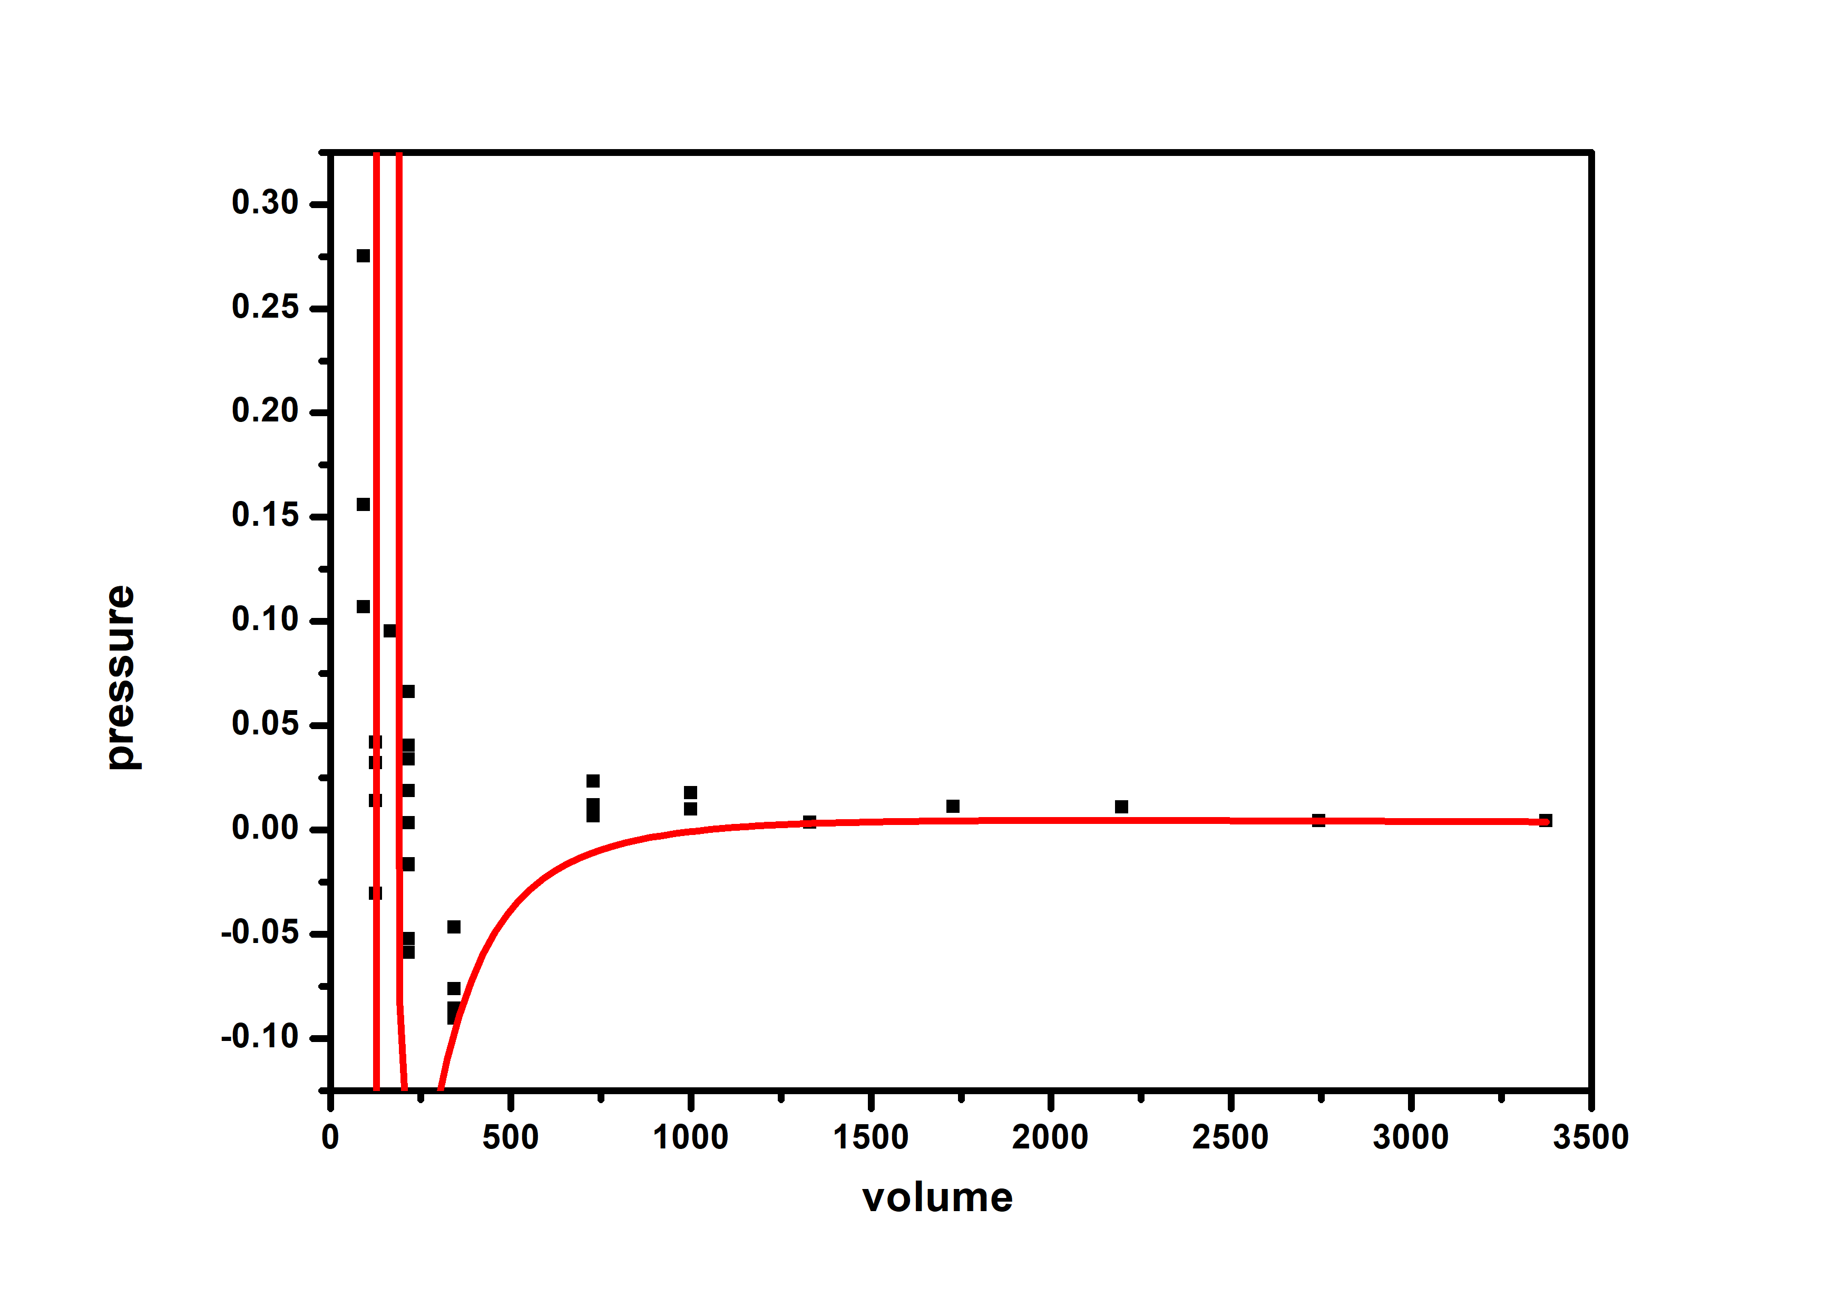

Fig. ? theoretical and experimental data for van der Waals gas. Decent match was found, indicating used potential could be the molecular basis of van der Waals gas.

Conclusions

A new method of simulating ideal gas, i.e. event-driven molecular dynamics was implemented. The average speed matches very well with Maxwell theory. Experimental data 0.32818±0.00328 is very close to 0.3257 predicted by the speed distribution law. For the equation of state, P vs V and P vs T plots are made and compared. It was found they have good match. However, pressure from simulation is consistently higher than predicted (on average ~10%). Finite size of ideal gas particles rather than zero size could be among the causes. The finding of other reasons needs further exploration.

Besides, van der Waals gas was simulated using semi-LJ potential. A good match with the van der Waals equation is found, although parameters a and b are not the same as experimental values. It could be due to the incorrect radius of the simulated particles and not precise form of attraction potential. To conclude, van der Waals gas could be simulated by finite size hard spheres with LJ potential. The wellness of simulation is dependent on attraction force form and precision of radius.

Acknowledgements

Prof. Statt’s demonstration code was modified and used to simulate van der Waals gas to optimize the speed. Ai’s code is for the force calculation and distance table calculation is functionable but slower.

Codes

Repository address: https://github.com/jasonqianai/MSE485.git

[1–6]

References

[1] Louwerse, M. J., and Baerends, E. J., 2006, “Calculation of Pressure in Case of Periodic Boundary Conditions,” Chemical Physics Letters, **421**(1), pp. 138–141.

[2] Bannerman, M. N., Strobl, S., Formella, A., and Pöschel, T., 2014, “Stable Algorithm for Event Detection in Event-Driven Particle Dynamics,” Comp. Part. Mech., **1**(2), pp. 191–198.

[3] Clerk-Maxwell, J., 1874, “O Ver de Continuiteit van Den Gas- En Vloeistofiocstand Academisch Proefschrift,” Nature, **10**(259), pp. 477–480.

[4] Chang, J., “Simulating an Ideal Gas to Verify Statistical Mechanics,” p. 10.

[5] Aiello-Nicosia, M. L., and Sperandeo-Mineo, R. M., 1985, “Computer Simulation of a Two-Dimensional Ideal Gas: A Simple Molecular Dynamics Method for Teaching Purposes,” Eur. J. Phys., **6**(3), pp. 148–153.

[6] Schehr, L. R., and Weast, R. C., 1970, *CRC Handbook of Chemistry and Physics : A Ready-Reference Book of Chemical and Physical Data*, Chemical Rubber Co., Cleveland, Ohio.

Author contribution

All the ideal gas and van der Waals gas simulation and analysis are done by Qian Ai. The acceleration and machine learning part are done by Ajay Upplili Arasanipalai.

Code repository

Repository address: https://github.com/jasonqianai/MSE485.git

Scientific research

Another way of simulation simple gas was found. Molecular basis for van der Waals gas was found. However, since the system this project studies is classic and old, many works have been done to understand and analyze it. Therefore, this project may not provide a lot of research insight. However, this will be a meaningful educational tool. Statistical mechanics students could experimentally verify what has been told in class, deepening their understanding. This will serve as a bridge between theoretical work and computer simulations.

Algorithm development

The main new implementation is the realization of event-driven particle dynamics. The details of this method is in the Technical Approach and Methods part. It’s completely written from scratch using the principles and is a good practice for molecular dynamics simulation students.