**Ruby Programming-lab:8**

**Name: S Kamalesh Kumar**

**Reg no: 18MIS1080**

1. Create Hash which stores phone number and name of the person ( phone number is the key). Assume that if the phone number starts with 9 it is airtel number, if it starts with ‘8’ means BSNL and If it starts with 7 and 6 mean jio number. Create separate list who got airtel, BSNL, Jio (3 list) and display the list who got the highest customer. Display all three list.

Code:

M=Hash["9597627228"=>"kamalesh","6381286785"=>"karthi" ,"9598325660"=>"jpk", "8838750367"=>"rio", "9944650320"=>"prasanna"]

airtel=[]

jio=[]

bsnl=[]

M.each do |key,v|

num=key.chr

if num.eql?("9")

airtel.push(v)

elsif num.eql?("8")

bsnl.push(v)

elsif num.eql?("7")

jio.push(v)

elsif num.eql?("6")

jio.push(v)

else

puts “Invalid number”

end

end

A=airtel.length

B=bsnl.length

J=jio.length

if(A>B && A>J)

puts "Airtel is highest customers"

elsif(B>A && B>J)

puts "BSNL is highest customers"

else()

puts "Jio is highest customers"

end

puts("JIO vadikayalar: #{jio}","Airtel Santhatharar: #{airtel}","Bsnl vadikayalar: #{bsnl}")

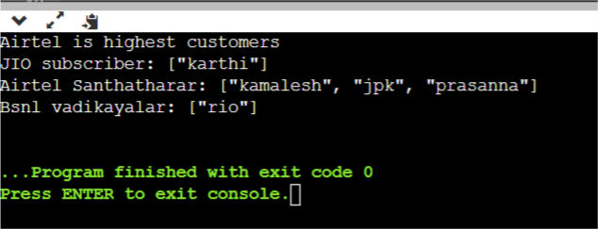

1. Create a hash for a student with regno, name, marks for five subjects. Compute the grades for all five subject and add it to dictionary.

>90 grade A

>80 grade B

>70 grade C

>60 grade D

>50 grade E

<50 grade ‘F’

Display in how many subjects a student got failed

Display each student record .

Repeat this process for N students.

Code:

puts"Enter number of students:"

n = gets().to_i

for i in 0...n do

print("Enter Name: ")

name = gets()

print("Enter Reg.no: ")

reg = gets()

print("Enter subj1 marks:")

s1 = gets().to_i

print("Enter subj2 marks:")

s2 = gets().to_i

print("Enter subj3 marks:")

s3 = gets().to_i

print("Enter subj4 marks:")

s4 = gets().to_i

print("Enter subj5 marks:")

s5 = gets().to_i

end

y = {}

M = Hash[[reg,name] => Hash["Subject 1" => s1,"subject 2" => s2,"subject 3" => s3, "subject 4" => s4, "subject 5" => s5],[reg,name] => Hash["Subject 1" => s1,"subject 2" => s2,"subject 3" => s3, "subject 4" => s4, "subject 5" => s5]]

M.each do |key,value|

x = {}

count = 0

value.each do |i,j|

if j>=90

x[i] = "A"

elsif j>=80 && j<90

x[i] = "B"

elsif j>=70 && j<80

x[i] = "C"

elsif j>=60 && j<70

x[i] = "D"

elsif j>=50 && j<60

x[i] = "E"

else

count+=1

x[i] = "F"

end

end

x["count of failed subjects"] = count

y[key] = x

end

puts(y)

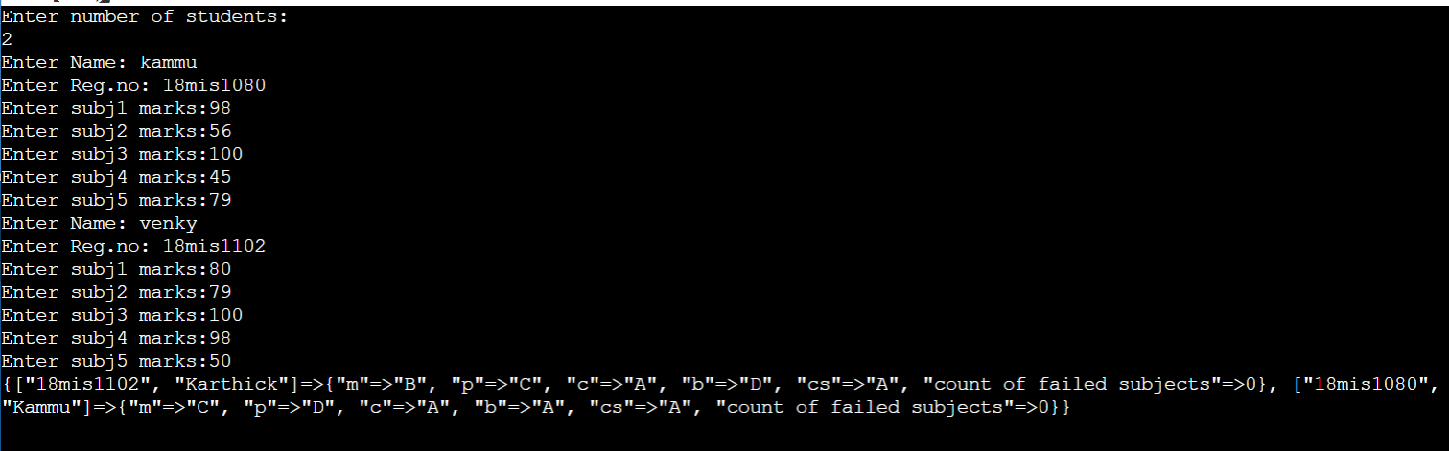

1. Create a hash with Reg number as key and Name and date of birth( use date format) as values.
2. Create N records
3. Display name in the ascending of their date of birth.
4. Display reg numbers of the student who born on “January”
5. Count and display the number of birthdays in each month.

Code:

require 'time'

print "No. of Students : "

n = gets.chomp.to_i

hash = Hash.new

for i in (0..n-1) do

puts "Studnet #{i+1}"

print "\tName : "

name = gets.chomp

print("\tReg. No. : ")

reg_no = gets.chomp

puts "\Date of Birth"

print("\t\tDay : ")

day = gets.chomp.to_i

print("\t\tMonth : ")

month = gets.chomp.to_i

print("\t\tYear : ")

year = gets.chomp.to_i

dob = Date.parse("#{year}-#{month}-#{day}")

hash[reg_no] = name, dob

end

key = hash.keys

value = hash.values

for i in (0..n-1) do

for j in (i+1..n-1) do

if(value[i][1]>value[j][1])

temp1 = value[i]

temp2 = key[i]

value[i] = value[j]

key[i] = key[j]

value[j] = temp1

key[j] = temp2

end

end

end

puts "\n\nNames of Student based on their DoB in assending order : "

for i in value do

puts "\t#{i[0]}"

end

puts "\nReg. No. of Student who born on Janauary : "

for i in (0..n-1) do

if value[i][1].month == 1

puts "\t#{key[i]}"

end

end

puts "\nDoB of Students in each month"

for i in (1..12) do

temp = []

count = 0

for j in (0..n-1) do

if(i==value[j][1].month)

temp.push(value[j][1])

count += 1

end

end

puts "\n\tMonth : #{i}"

puts "\t\tCount : #{count}"

for j in temp

puts "\t\t#{j}"

end

end

Output:

