Homework 5

Irene Yang

3/14/2018

#Load all packages  
library(phyloseq)  
packageVersion("phyloseq")

## [1] '1.22.3'

library(ggplot2)   
packageVersion("ggplot2")

## [1] '2.2.1'

library(RColorBrewer)  
packageVersion("RColorBrewer")

## [1] '1.1.2'

# Load HMP data  
# You will need to download the data from Canvas  
# You will need to change your path  
  
load("~/Desktop/N741/2018Week8/HMPv35.Rdata")  
  
HMPv35

## phyloseq-class experiment-level object  
## otu_table() OTU Table: [ 45336 taxa and 4743 samples ]  
## sample_data() Sample Data: [ 4743 samples by 9 sample variables ]  
## tax_table() Taxonomy Table: [ 45336 taxa by 6 taxonomic ranks ]  
## phy_tree() Phylogenetic Tree: [ 45336 tips and 45099 internal nodes ]  
## refseq() DNAStringSet: [ 45336 reference sequences ]

#### Problem 1

Subset the HMPv35 object to obtain only the samples from Tongue_dorsum. Call this new object HMPv35sub2

# Subset  
  
sub <- get_variable(HMPv35, "HMPbodysubsite") %in% c("Tongue_dorsum")  
  
sample_data(HMPv35)$sub <- factor(sub)  
  
HMPv35sub2 <- prune_samples(sample_data(HMPv35)$sub == TRUE, HMPv35)  
  
summary(sample_data(HMPv35sub2))

## X.SampleID RSID visitno sex   
## Min. :700014409 Min. :132902142 Min. :1.000 female:132   
## 1st Qu.:700033504 1st Qu.:159586626 1st Qu.:1.000 male :184   
## Median :700097802 Median :161250552 Median :1.000   
## Mean :700074079 Mean :389803522 Mean :1.415   
## 3rd Qu.:700106136 3rd Qu.:763638144 3rd Qu.:2.000   
## Max. :700114709 Max. :970836795 Max. :3.000   
##   
## RUNCENTER HMPbodysubsite Mislabeled Contaminated   
## WUGC :103 Tongue_dorsum:316 Mode :logical Mode :logical   
## BI : 68 FALSE:245 FALSE:245   
## JCVI : 64 NA's :71 NA's :71   
## BCM : 44   
## BCM,BI : 11   
## BCM,JCVI: 7   
## (Other) : 19   
## Description   
## HMP_Human_metagenome_sample_700014409_from_subject_158398106__sex_male_ : 1   
## HMP_Human_metagenome_sample_700014515_from_subject_158418336__sex_male_ : 1   
## HMP_Human_metagenome_sample_700014609_from_subject_158438567__sex_male_ : 1   
## HMP_Human_metagenome_sample_700014731_from_subject_158458797__sex_female_: 1   
## HMP_Human_metagenome_sample_700014785_from_subject_158479027__sex_male_ : 1   
## HMP_Human_metagenome_sample_700014911_from_subject_158499257__sex_male_ : 1   
## (Other) :310   
## sub   
## TRUE:316   
##   
##   
##   
##   
##   
##

HMPv35sub2

## phyloseq-class experiment-level object  
## otu_table() OTU Table: [ 45336 taxa and 316 samples ]  
## sample_data() Sample Data: [ 316 samples by 10 sample variables ]  
## tax_table() Taxonomy Table: [ 45336 taxa by 6 taxonomic ranks ]  
## phy_tree() Phylogenetic Tree: [ 45336 tips and 45099 internal nodes ]  
## refseq() DNAStringSet: [ 45336 reference sequences ]

#### Problem 2

Produce the geometric box plot of diversity measures for your object, HMPv35sub2

# Changing the background to my favorite  
theme_set(theme_bw())  
  
# The following commands plot the different diversity measures for the two different body sites.  
alpha_meas = c("Observed", "Chao1", "ACE", "Shannon", "Simpson", "InvSimpson")  
(p <- plot_richness(HMPv35sub2, "HMPbodysubsite", measures=alpha_meas))

## Warning: Removed 1264 rows containing missing values (geom_errorbar).

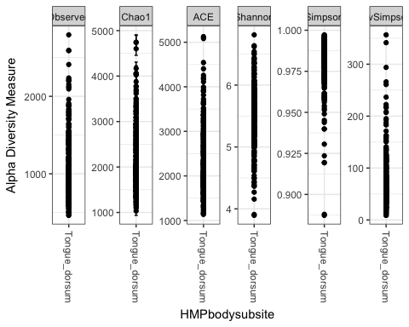

# Boxplot to display diversity  
  
p + geom_boxplot(data=p$data, aes(x=HMPbodysubsite, y=value, color=NULL), alpha=0.1)

## Warning: Removed 1264 rows containing missing values (geom_errorbar).

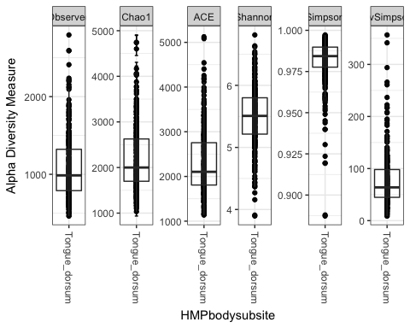

#### Problem 3

You see what taxa are most prevalent in your subset, HMPv35sub2

ntaxa(HMPv35sub2)

## [1] 45336

par(mar = c(10, 4, 4, 2) + 0.1) # make more room on bottom margin  
  
#Looking at top 20  
  
N <- 20  
  
barplot(sort(taxa_sums(HMPv35sub2), TRUE)[1:N]/nsamples(HMPv35sub2), las=2)

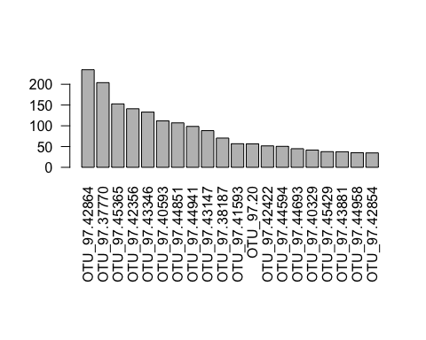

#### Problem 4

Using your HMPv35sub2 object, throw the rare taxa out of that object, then reduce to only taxa in the phylum Bacteroidetes. Call this new object HMPv35sub2frbac

#The next step filters out taxa with low occurrence throughout all samples  
  
HMPv35subsub = filter_taxa(HMPv35sub2, function(x) sum(x > 3) > (0.2*length(x)), TRUE)  
  
# The next step filters out all taxa that occur in less than .01% of samples  
  
HMPv35subr <- transform_sample_counts(HMPv35subsub, function(x) x / sum(x) )  
HMPv35subfr <- filter_taxa(HMPv35subr, function(x) mean(x) > 1e-5, TRUE)  
  
HMPv35subfr

## phyloseq-class experiment-level object  
## otu_table() OTU Table: [ 307 taxa and 316 samples ]  
## sample_data() Sample Data: [ 316 samples by 10 sample variables ]  
## tax_table() Taxonomy Table: [ 307 taxa by 6 taxonomic ranks ]  
## phy_tree() Phylogenetic Tree: [ 307 tips and 304 internal nodes ]  
## refseq() DNAStringSet: [ 307 reference sequences ]

#Finally subset to only bacteria in the phylum Bacteroidetes  
  
HMPv35sub2frbac = subset_taxa(HMPv35subfr, Phylum=="Bacteroidetes")  
HMPv35sub2frbac

## phyloseq-class experiment-level object  
## otu_table() OTU Table: [ 46 taxa and 316 samples ]  
## sample_data() Sample Data: [ 316 samples by 10 sample variables ]  
## tax_table() Taxonomy Table: [ 46 taxa by 6 taxonomic ranks ]  
## phy_tree() Phylogenetic Tree: [ 46 tips and 45 internal nodes ]  
## refseq() DNAStringSet: [ 46 reference sequences ]

#### Problem 5

Using your HMPv35sub2frbac object, what is the distribution of the top 20 OTU’s?

# Calculate number of taxa  
ntaxa(HMPv35sub2frbac)

## [1] 46

# Distribution of top 20 OTU's  
par(mar = c(10, 4, 4, 2) + 0.1) # make more room on bottom margin  
N <- 20  
barplot(sort(taxa_sums(HMPv35sub2frbac), TRUE)[1:N]/nsamples(HMPv35sub2frbac), las=2)

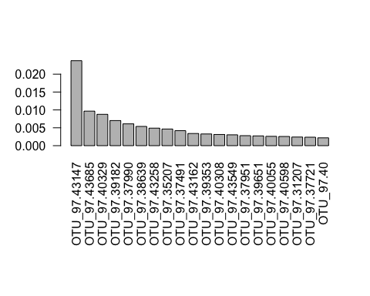

#### Problem 6

Plot sample abundance by body site for your object HMPv35sub2frbac

title = "plot_bar; by site; Bacteroidetes only"  
plot_bar(HMPv35sub2frbac, "HMPbodysubsite", "Abundance", title=title)

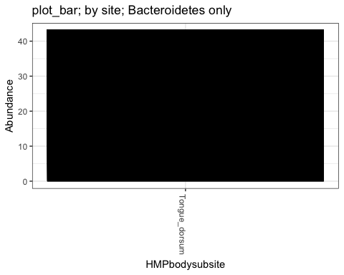

#### Problem 7

You try it with your HMPv35sub2frbac object

# Differentiating by Family  
  
plot_bar(HMPv35sub2frbac, "HMPbodysubsite", "Abundance", "Family", title=title)

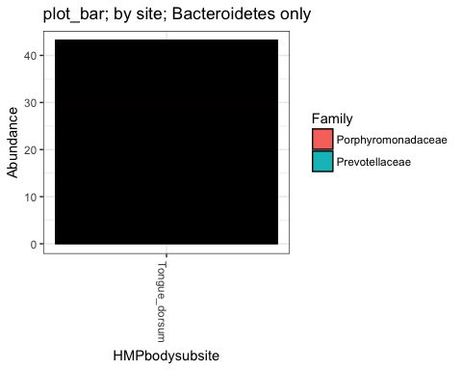

#Place your code for your plot with family here

We can use the techniques of network science to illustrate how similar or distant samples are.

Using our filtered object with all phyla, we use the plot_net function to illustrate the “proximity” (or similarity) of samples, while denoting site and the sex of the participant.

plot_net(HMPv35subfr, maxdist = 0.3, color = "HMPbodysubsite", shape="sex")

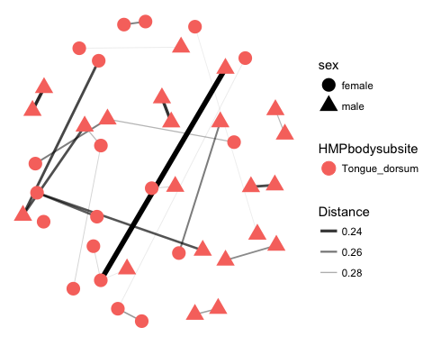

Let’s redo switching which variable is colored and which variable is differentiated by shape.

plot_net(HMPv35subfr, maxdist = 0.3, shape = "HMPbodysubsite", color="sex")

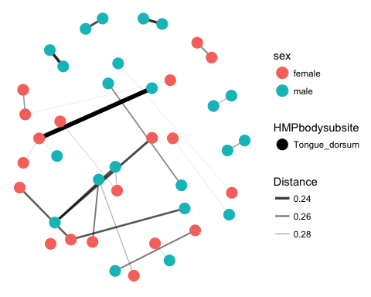 ####Problem 8

Which method of display do you like best and why?

#Place your answer here as another comment.  
  
# Definitely like the second display better. Differentiating sex by color makes the graphic much easier to visualize and interpret.