N741 Lecture 5: EDA with dplyr and ggplot2

Melinda Higgins & Vicki Hertzberg

February 14, 2018

## Packages needed for today’s lecture:

* car
* tidyverse - mainly using dplyr and ggplot2
* janitor *(optional)*

## Rmarkdown initial setup options

Create an initial R chunk with knitr options to control what is shown or not shown in your final output. Three options are useful to set to FALSE for the final version. These 3 options can be kept as TRUE when debugging initially.

* echo - set to TRUE to see your R code in the final document - set to TRUE for homework
* warning - set to FALSE so that warnings are hidden
* message - set to FALSE to hide messages like when loading packages and such

It is also a good idea to load the packages needed for all of the code run in this RMD (R markdown) document in this first R-code chunk.

# knitr options  
knitr::opts_chunk$set(echo = TRUE)  
knitr::opts_chunk$set(warning = FALSE)  
knitr::opts_chunk$set(message = FALSE)  
  
# packages needed for this RMD  
library(car)  
library(tidyverse)

## Loading tidyverse: ggplot2  
## Loading tidyverse: tibble  
## Loading tidyverse: tidyr  
## Loading tidyverse: readr  
## Loading tidyverse: purrr  
## Loading tidyverse: dplyr

## Conflicts with tidy packages ----------------------------------------------

## filter(): dplyr, stats  
## lag(): dplyr, stats  
## recode(): dplyr, car  
## some(): purrr, car

## Naming R code chunks

It is a good practice to give your R code chunks names. That way when you are debugging, it’ll be easier to figure out which section of the document or R-code chunk is failing.

The R-code chunk above is called setup.

## Working with Leinhardt dataset in car package

The car package has 51 datasets built into it. One of these datasets is the Leinhardt dataset. Type ?car::Leinhardt at the console to see help details on this dataset. This dataset has 105 rows and 4 columns with observations from nations of the world around 1970. The 4 columns are:

* income
* infant
* region
* oil

Load the dataset and take a look at it. We can access the dataset directly using the View() command and by referencing the dataset using the package::dataset syntax.

OR we can also create a new data object using the <- assign command and work with this copy of the dataset in memory to work from.

dataLeinhardt <- car::Leinhardt

## Dataset object

Look at the type of object this dataset is and the structure of the data - the types of variables in the dataset.

class(dataLeinhardt)

## [1] "data.frame"

str(dataLeinhardt)

## 'data.frame': 105 obs. of 4 variables:  
## $ income: int 3426 3350 3346 4751 5029 3312 3403 5040 2009 2298 ...  
## $ infant: num 26.7 23.7 17 16.8 13.5 10.1 12.9 20.4 17.8 25.7 ...  
## $ region: Factor w/ 4 levels "Africa","Americas",..: 3 4 4 2 4 4 4 4 4 4 ...  
## $ oil : Factor w/ 2 levels "no","yes": 1 1 1 1 1 1 1 1 1 1 ...

## Summary of Data

One of the easiest ways to summarize the variables in the dataset is to run the summary() command.

summary(dataLeinhardt)

## income infant region oil   
## Min. : 50.0 Min. : 9.60 Africa :34 no :96   
## 1st Qu.: 123.0 1st Qu.: 26.20 Americas:23 yes: 9   
## Median : 334.0 Median : 60.60 Asia :30   
## Mean : 998.1 Mean : 89.05 Europe :18   
## 3rd Qu.:1191.0 3rd Qu.:129.40   
## Max. :5596.0 Max. :650.00   
## NA's :4

This is ok when the dataset has only a few variables. However, we will often only want summaries of some of the variables in a dataset. Let’s begin using the dplyr package to work specific sections of the data we want.

Learn more about dplyr at <http://dplyr.tidyverse.org/>. There is also good overall information at <http://stat545.com/topics.html>.

## Intro to dplyr

The dplyr package provides 2 key aspects of working with data in R:

* the pipe operator %>% and
* verb based functions to take action on your data

The pipe operator %>% actually comes from the magrittr package which is loaded with dplyr. The main benefit of the pipe operator %>% is that you can directly reference variables in your dataset without having to use the dollar sign $ selector.

For example, let’s make a subset of the data for countries in “Asia” using the filter() function from dplyr. The R-code below can be read as take the Leinhardt dataset and pipe it into the filter function and find only data for countries in the “Asia” region.

dataAsia <- dataLeinhardt %>%  
 filter(region == "Asia")

Additionally, you can string together a series of commands by simply piping the result from the previous command into the next command. Let’s add the summary() function to get the summary statistics for the variables but only for the Asian countries.

dataLeinhardt %>%  
 filter(region == "Asia") %>%  
 summary()

## income infant region oil   
## Min. : 71.0 Min. : 10.20 Africa : 0 no :26   
## 1st Qu.: 100.5 1st Qu.: 21.90 Americas: 0 yes: 4   
## Median : 245.5 Median : 50.00 Asia :30   
## Mean : 638.9 Mean : 96.17 Europe : 0   
## 3rd Qu.: 539.2 3rd Qu.:112.15   
## Max. :3723.0 Max. :650.00   
## NA's :3

## Choose variables

Let’s only look at income and infant and get the summary stats. Use the select() function from dplyr.

dataLeinhardt %>%  
 select(income, infant) %>%  
 summary()

## income infant   
## Min. : 50.0 Min. : 9.60   
## 1st Qu.: 123.0 1st Qu.: 26.20   
## Median : 334.0 Median : 60.60   
## Mean : 998.1 Mean : 89.05   
## 3rd Qu.:1191.0 3rd Qu.:129.40   
## Max. :5596.0 Max. :650.00   
## NA's :4

## Get specific statistics on the variables you want

Let’s get the mean and standard devaition for the income variable.

dataLeinhardt %>%  
 summarise(meanIncome = mean(income),  
 sdIncome = sd(income))

## meanIncome sdIncome  
## 1 998.0667 1416.714

and we can get the number of observations using the n() command in dplyr.

dataLeinhardt %>%  
 summarise(nObs = n())

## nObs  
## 1 105

## Get summary stats

We can get summary statistics for multiple statistics and multiple variables by using the summarise_all() function in dplyr. This function is used in conjunction with the funs() command to list the functions you want along with any options needed.

dataLeinhardt %>%  
 select(income, infant) %>%  
 summarise_all(funs(mean, sd))

## income_mean infant_mean income_sd infant_sd  
## 1 998.0667 NA 1416.714 NaN

Notice the mean and sd for infant yields NA and NaN due to the missing data in the infant variable. So, we need to add the option na.rm=TRUE to remove missing values before computing the requested statistic.

# add na.rm=TRUE as option to remove  
# NAs for the infant variable.  
dataLeinhardt %>%  
 select(income, infant) %>%  
 summarise_all(funs(mean, sd), na.rm=TRUE)

## income_mean infant_mean income_sd infant_sd  
## 1 998.0667 89.04752 1416.714 90.80171

## Complete Cases

Notice that there are 4 countries that do not have data for infant mortality - there are 4 NA's for the infant variable. Suppose we want to determine how many observations have complete data across all variables in this dataset. Let’s look at the complete.cases() function. The result of this function is a vector of TRUE and FALSE for each row/observation that has no missing data across all columns/variables.

Then use the table() function to see the tally of the number of TRUE’s and FALSE’s.

completeObs <- complete.cases(dataLeinhardt)  
table(completeObs)

## completeObs  
## FALSE TRUE   
## 4 101

We can then use this vector of TRUE and FALSE to keep only the complete data. Here are 2 ways to do this.

dataComplete <- dataLeinhardt %>%  
 na.omit()  
  
dataComplete <- dataLeinhardt %>%  
 filter(complete.cases(.))

## Count the amount of missing data

The function is.na() is a good way to determine how much missing data there is for any given variable. This again creates a LOGICAL vector of TRUE’s and FALSE’s to indicate if data for the variable specified is missing for that observation or not.

It turns out that you can run functions like mean() and sum() on LOGICAL vectors. If you run sum() on this vector you get the number of missing values. If you run mean() you get the proportion of missing data (i.e. the count/total number of observations).

missingInfant <- is.na(dataLeinhardt$infant)  
sum(missingInfant)

## [1] 4

mean(missingInfant)

## [1] 0.03809524

## Graphics with ggplot2

Let’s look at the distributions of income and infant mortality. Here is a basic histogram of income.

hist(dataLeinhardt$income)

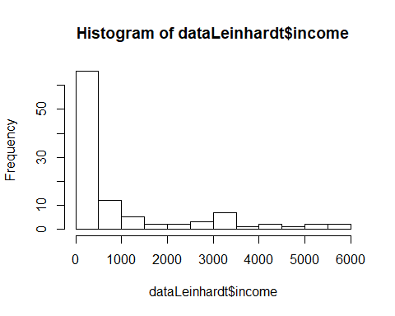

Instead let’s use a ggplot2 approach. First we create a plot with ggplot() with the “aesthetics” we need defined. The “aesthetic” we need here is the income variable.

Then we add the geometric object layer - these are called geom’s. The one we want here is geom_histogram().

ggplot(dataLeinhardt, aes(income)) +  
 geom_histogram()

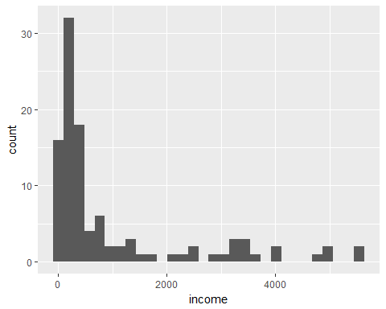

A great website for learning ggplot2 and seeing worked example on how to create various graphics is the “Cookbook for R” website at <http://www.cookbook-r.com/Graphs/>.

For example, here is a nice histogram with a density curve overlaid with color - see the 4th histogram plot and associated code at <http://www.cookbook-r.com/Graphs/Plotting_distributions_(ggplot2)/>. Let’s adapt this code for our histogram of income. Basically, change out the dataset name, the variable listed in aes() and change the binwidth to something more appropriate for this income variable. Feel free to play with changing the colors.

# Histogram overlaid with kernel density curve  
ggplot(dataLeinhardt, aes(x=income)) +   
 geom_histogram(aes(y=..density..),  
 binwidth=500,  
 colour="black", fill="yellow") +  
 geom_density(alpha=.2, fill="blue")

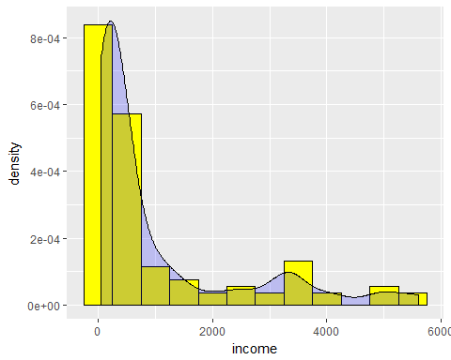

## Boxplots by groups

What if we want to look at the income distributions by region. We can do that using the geom_boxplot() and updating the aes() list.

Again, see examples at <http://www.cookbook-r.com/Graphs/Plotting_distributions_(ggplot2)/>.

# A basic box with the conditions colored  
ggplot(dataLeinhardt,   
 aes(x=region, y=income, fill=region)) +   
 geom_boxplot()

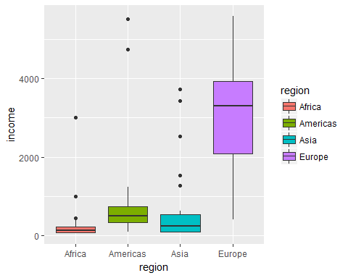

## Transform, Create new variables

The infant mortality rates are very right skewed (longer tail to the right). A possible mathematical transformation of right skewness is to do a log transformation. Let’s create a new variable in the dataset that is the log of the infant mortality rate using the log() function from base R and the mutate() function from dplyr.

dataLeinhardt <- dataLeinhardt %>%  
 mutate(logInfant = log(infant))

Compare these 2 variables using histograms. Notice that the bandwidths are different.

### Original infant variable

ggplot(dataLeinhardt, aes(x=infant)) +   
 geom_histogram(aes(y=..density..),  
 binwidth=20,  
 colour="black", fill="yellow") +  
 geom_density(alpha=.2, fill="blue")

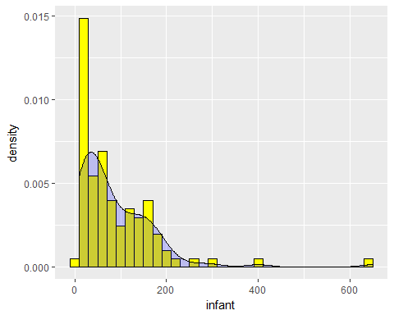

### Log of income variable

ggplot(dataLeinhardt, aes(x=logInfant)) +   
 geom_histogram(aes(y=..density..),  
 binwidth=.2,  
 colour="black", fill="yellow") +  
 geom_density(alpha=.2, fill="blue")

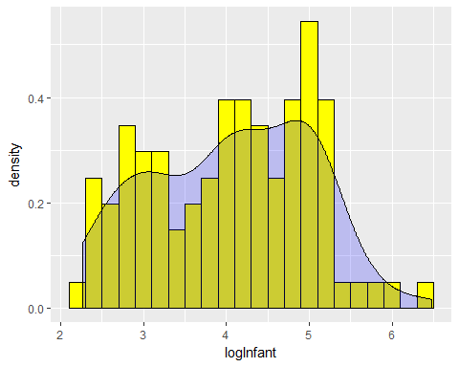

## Recode data

Suppose we wanted to break the infant mortality rates into low, moderate and high categories. For example, let’s create the following categories based on these infant mortality rates.

### Infant Mortality Categories

|  |  |
| --- | --- |
| Category | Infant Mortality (rate/1000 live births) |
| Low | <50 |
| Moderate | 50 to <100 |
| High | 100 or more |

To do this we’ll create a new variable using the mutate() function in dplyr AND we’ll also use the if_else() function in dplyr.

dataLeinhardt <- dataLeinhardt %>%  
 mutate(infantcat = if_else(infant<50, "1. Low",  
 if_else(infant<100,   
 "2. Moderate",  
 "3. High",  
 "4. missing"),  
 "4. missing"))

Count the number of countries that fall into each category

dataLeinhardt %>%   
 count(infantcat)

## # A tibble: 4 x 2  
## infantcat n  
## <chr> <int>  
## 1 1. Low 41  
## 2 2. Moderate 23  
## 3 3. High 37  
## 4 4. missing 4

[OPTIONAL] Here is a nice way to get a formatted table of counts and percents using the tabyl() function from the janitor package.

# optional - a nice way to get a formatted  
# table of the counts for infant categories  
library(janitor)  
dataLeinhardt %>%  
 janitor::tabyl(infantcat)

## infantcat n percent  
## 1 1. Low 41 0.39047619  
## 2 2. Moderate 23 0.21904762  
## 3 3. High 37 0.35238095  
## 4 4. missing 4 0.03809524

Run again adding the knitr::kable() function when using INSIDE of an RMD document.

dataLeinhardt %>%  
 janitor::tabyl(infantcat) %>%  
 knitr::kable()

|  |  |  |
| --- | --- | --- |
| infantcat | n | percent |
| 1. Low | 41 | 0.3904762 |
| 2. Moderate | 23 | 0.2190476 |
| 3. High | 37 | 0.3523810 |
| 4. missing | 4 | 0.0380952 |

## Clustered bar chart

Let’s look at these infant mortality rate categories by region by making a clustered bar chart. some examples can be seen at <http://www.cookbook-r.com/Graphs/Bar_and_line_graphs_(ggplot2)/#with-x-axis-treated-as-categorical>. Scroll to the bottom of the page.

# cluster barchart of infant categories by region  
dataLeinhardt %>% ggplot(aes(x=infantcat, fill=region)) +  
 geom_bar(position = "dodge")

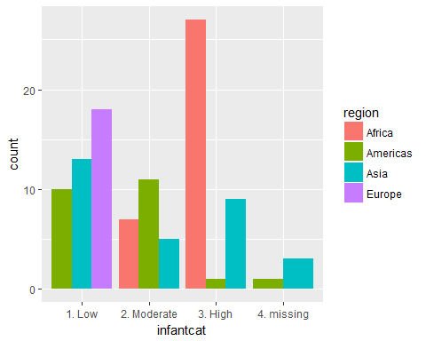

Make the chart again removing the countries with missing infant mortality rates. Use the is.na() function and put an exclamation point ! in front to say find all without missing data, find when NOT TRUE.

dataLeinhardt %>%   
 filter(!is.na(infant)) %>%  
 ggplot(aes(x=infantcat, fill=region)) +  
 geom_bar(position = "dodge")

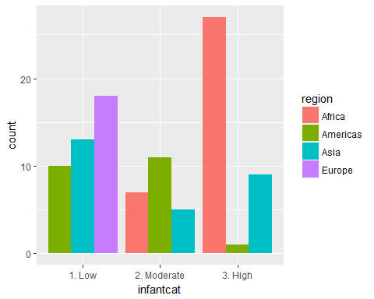

## Other things to try

1. Go back to the first R-code chunk and change echo=TRUE to echo=FALSE and see what happens to the output.
2. Install the Rcmdr package and then load it by running library(Rcmdr) in the Console window - try out using the R Commander package. Learn more at <http://www.rcommander.com/>.
3. Kahoot Quiz