IYAS K
iyas2458@gmail.com
1️⃣ Number Classification (if + function)

Write a shell script that uses a function to check whether a number is positive, negative, or zero using if.

#!/bin/sh

check_number() {
if [ $1 -gt 0 ]; then
echo "Number is Positive"
elif [ $1 -lt 0 ]; then
echo "Number is Negative"
else
echo "Number is Zero"
fi
}

echo "Enter a number:"
read num

check_number $num
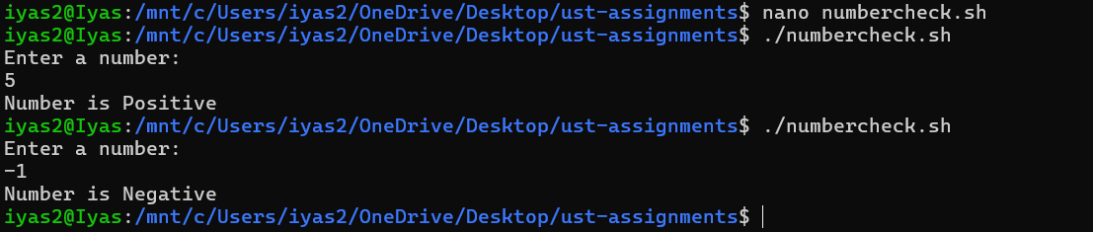

2️⃣ Factorial of a Number (while + function)

Write a shell script to calculate the factorial of a number using a while loop inside a function.

#!/bin/sh

factorial() {
n=$1
fact=1

while [ $n -gt 1 ]
do
fact=$((fact * n))
n=$((n - 1))
done

echo "Factorial is: $fact"
}

echo "Enter a number:"
read num

factorial $num

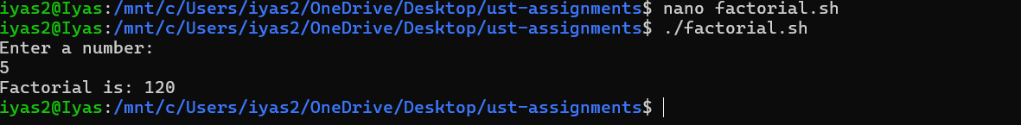

3️⃣ Sum of N Numbers (for + function)

Write a shell script to calculate the sum of numbers from 1 to N using a for loop inside a function.

#!/bin/sh

sum_n() {
n=$1
sum=0

for i in $(seq 1 $n)
do
sum=$((sum + i))
done

echo "Sum is: $sum"
}

echo "Enter a number:"
read num

sum_n $num

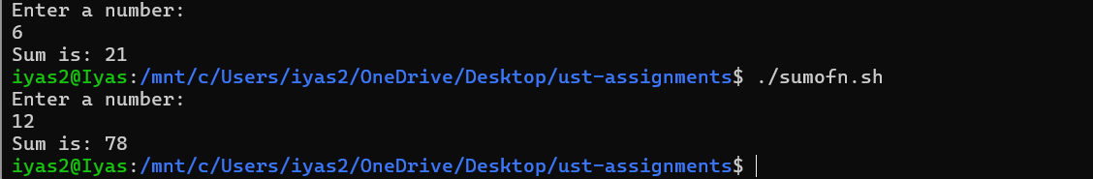

4️⃣ Prime Number Check (if + for + function)

Write a shell script that uses a function to check whether a given number is prime using if and for.

#!/bin/sh

check_prime() {
num=$1
flag=0

if [ $num -le 1 ]; then
echo "Not a Prime Number"
return
fi

for i in $(seq 2 $((num - 1)))
do
if [ $((num % i)) -eq 0 ]; then
flag=1
break
fi
done

if [ $flag -eq 0 ]; then
echo "Prime Number"
else
echo "Not a Prime Number"
fi
}

echo "Enter a number:"
read n

check_prime $n
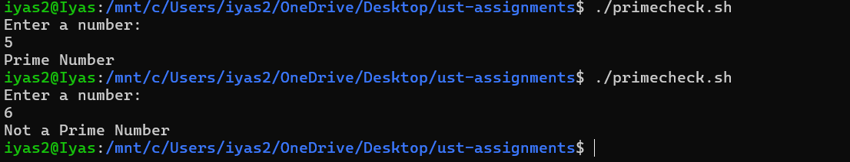

5️⃣ Reverse a Number (while + if)

Write a shell script to reverse a number using a while loop and if conditions where required.

#!/bin/sh

echo "Enter a number:"
read num

rev=0

while [ $num -gt 0 ]
do
rem=$((num % 10))
rev=$((rev * 10 + rem))
num=$((num / 10))
done

if [ $rev -ge 0 ]; then
echo "Reversed number is: $rev"
fi
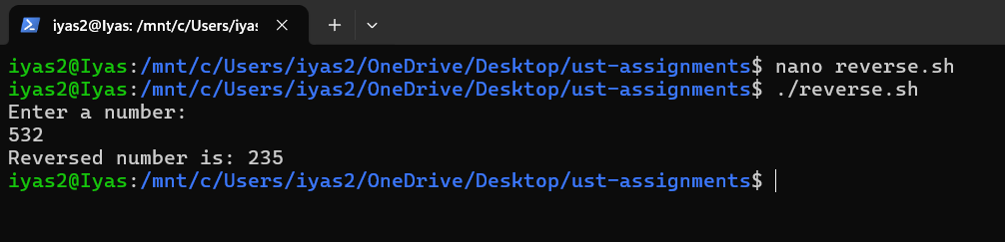

6️⃣ File Existence & Permission Check (if + function)

Write a shell script that uses a function to check if a file exists and whether it has read, write, and execute permissions.
#!/bin/sh

check_file() {
file=$1

if [ -e "$file" ]; then
echo "File exists"

if [ -r "$file" ]; then
echo "Read permission: YES"
else
echo "Read permission: NO"
fi

if [ -w "$file" ]; then
echo "Write permission: YES"
else
echo "Write permission: NO"
fi

if [ -x "$file" ]; then
echo "Execute permission: YES"
else
echo "Execute permission: NO"
fi
else
echo "File does not exist"
fi
}

echo "Enter file name:"
read fname

check_file "$fname"

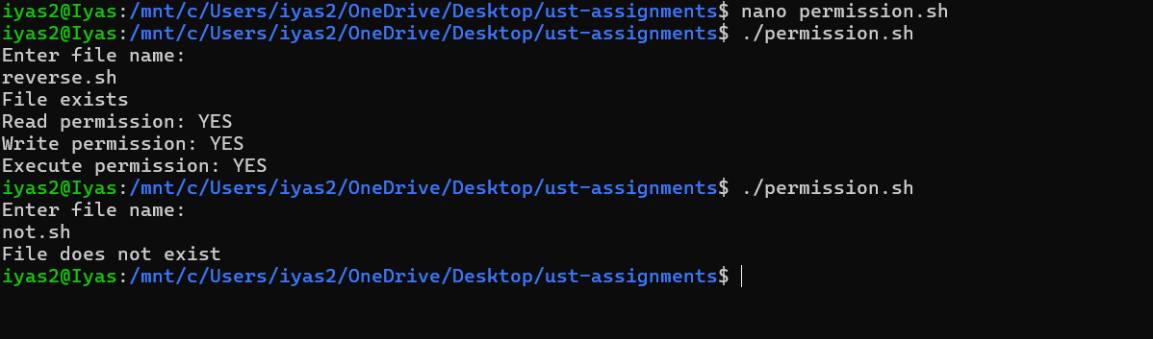
7️⃣ Menu-Driven Calculator (while + case + function)

Write a shell script that shows a menu in a while loop and performs add, subtract, multiply, divide using functions.
#!/bin/sh

add() {
echo "Result: $((a + b))"
}

sub() {
echo "Result: $((a - b))"
}

mul() {
echo "Result: $((a * b))"
}

div() {
if [ $b -ne 0 ]; then
echo "Result: $((a / b))"
else
echo "Division by zero not allowed"
fi
}

while true
do
echo "1. Add"
echo "2. Subtract"
echo "3. Multiply"
echo "4. Divide"
echo "5. Exit"
echo "Enter choice:"
read ch

if [ $ch -eq 5 ]; then
break
fi

echo "Enter first number:"
read a
echo "Enter second number:"
read b

case $ch in
1) add ;;
2) sub ;;
3) mul ;;
4) div ;;
*) echo "Invalid choice" ;;
esac
done
