CodeStrike: A Three-Layer Security Benchmark
for AI-Generated Web Applications
Deepansh Sharma
Dept. of Computing Science
Thompson Rivers University
Kamloops, Canada
deepansh.sharma@mytru.ca
Yaash Iyassu
Dept. of Computing Science
Thompson Rivers University
Kamloops, Canada
yaash.iyassu@mytru.ca
Ravinder Singh
Dept. of Computing Science
Thompson Rivers University
Kamloops, Canada
ravinder.singh@mytru.ca
Vansh Patel
Dept. of Computing Science
Thompson Rivers University
Kamloops, Canada
vansh.patel@mytru.ca
Abstract—Large language models are increasingly used to generate web application code, yet little is known about how secure that code actually is. We present CodeStrike, a security benchmark that evaluates AI-generated web applications using three complementary methods: automated exploit testing, OWASP ZAP scanning, and manual penetration testing. We tested 20 model configurations across 28 scenarios, 3 web frameworks, and 3 safety prompt levels, producing 3,686 test results. Our results show that fewer than 7% of AI-generated applications pass both functional and security tests. The most striking finding is that specific safety prompts raise the secure pass rate from 0.0% to 21.0%, while generic prompts like "write secure code" have almost no effect. We also found that OWASP ZAP, the industry-standard scanner, agrees with only 14.3% of CodeStrike's findings when applied to JSON API backends. Manual penetration testing of 10 applications uncovered 47 vulnerabilities; CodeStrike's automated tests caught 11 of those with zero false positives (100% precision, 23.4% recall). These findings make the case that layered validation is necessary and that no single tool is sufficient for securing AI-generated code.
Keywords—AI code security, large language models, penetration testing, OWASP, vulnerability detection, security benchmark
I. INTRODUCTION
Software developers have adopted AI coding assistants at a remarkable pace. GitHub's 2024 developer survey reports that 97% of developers have used AI tools for code generation [1]. Tools like GitHub Copilot, ChatGPT, and Claude now generate entire web application backends—authentication flows, database schemas, API endpoints—with a single prompt. But while this saves time, it raises an obvious question: is the resulting code secure?
The short answer, based on our research, is mostly no. Several studies have shown that AI-generated code frequently contains vulnerabilities [2], [3]. Pearce et al. found that Copilot produces vulnerable code in roughly 40% of security-relevant scenarios [2]. Perry et al. went further, showing that developers using AI assistants wrote less secure code than those working without AI help, while simultaneously feeling more confident about their code's security [3]—a dangerous combination.
BaxBench [4], developed at ETH Zurich, was the first benchmark to systematically evaluate AI-generated web application security. It generates complete applications from OpenAPI specifications, runs them in Docker containers, and tests them against 23 vulnerability types. However, BaxBench relied solely on its own automated tests. Nobody checked whether those tests were catching real vulnerabilities or missing important ones.
That gap is what motivated CodeStrike. We extended BaxBench in three ways. First, we broadened the coverage: 15 additional CWE types (38 total), 7 new OWASP-aligned scenarios, and significantly more attack vectors (25 XSS payloads instead of 2, 25 SQL injection payloads instead of 8). Second, we added two validation layers—OWASP ZAP scanning and manual penetration testing—so we could measure how much the automated tests actually catch. Third, we identified and fixed a measurement bug in the original benchmark that counted crashed applications as "secure," which inflated security rates by roughly 20x.
The rest of this paper walks through our methodology (Section III), presents what we found (Section IV), and discusses what it means for anyone using AI to generate code (Section V).
II. LITERATURE REVIEW
A. Security of AI-Generated Code
Research into the security of AI-generated code has grown quickly over the past three years. Pearce et al. [2] were among the first to study this systematically. They tested GitHub Copilot on 89 security-relevant scenarios and found vulnerable code in about 40% of cases, with SQL injection, path traversal, and XSS being the most common issues. Their paper, published at IEEE S&P 2022, set the baseline for this line of work.
Perry et al. [3] took a different approach: instead of testing the AI directly, they ran a controlled experiment with human developers. One group used AI assistants, the other did not. The AI-assisted group produced code with more security flaws—and reported higher confidence in their code's safety. This result, presented at ACM CCS 2023, highlights the risk of blind trust in AI-generated code.
Meta's CyberSecEval project [5] evaluated multiple LLMs for insecure code generation, finding insecurity rates between 15% and 35%. Their follow-up, CyberSecEval 2 [19], expanded the evaluation to include prompt injection and code interpreter abuse. Khoury et al. [18] specifically examined ChatGPT-generated code at IEEE SMC 2023 and found similar patterns of vulnerability introduction.
B. BaxBench and Benchmarking Frameworks
Vero et al. [4] introduced BaxBench at ICML 2025 as the first end-to-end benchmark for AI-generated web application security. The key innovation was generating complete, runnable applications—not just code snippets—and testing them dynamically in Docker containers. BaxBench covered 28 scenarios and 23 CWEs across three frameworks. Our work builds directly on their framework, extending it with additional scenarios, vulnerability types, and the three-layer validation approach that is the central contribution of this paper.
C. OWASP ZAP and Automated Scanning
OWASP ZAP [7] is the most widely used open-source web vulnerability scanner. It works by proxying HTTP traffic and applying both passive analysis (inspecting headers, cookies) and active scanning (injecting attack payloads). However, automated scanners have well-documented limitations. Bau et al. [8] compared several scanners at IEEE S&P 2010 and found wide variation in detection rates, with no single tool achieving comprehensive coverage. Doupe et al. [9] identified the "state-space problem": scanners struggle with applications that require specific action sequences to reach vulnerable code. These limitations become particularly acute with JSON API backends, as we demonstrate in Section IV.
D. Manual Penetration Testing
The OWASP Web Security Testing Guide v4.2 [10] defines 107 test cases across 12 categories for manual web application security testing. The Penetration Testing Execution Standard (PTES) [11] provides the engagement framework. Research consistently shows that manual testing finds vulnerabilities that automated tools miss—Doupe et al. [9] reported 2-5x higher detection rates for applications with complex business logic. This evidence shaped our decision to include manual testing as the ground-truth layer in our methodology.
E. Static vs. Dynamic Analysis
The SAST-versus-DAST question is well studied. Antunes and Vieira [14] compared the two approaches for SQL injection detection and found that each caught issues the other missed. Nunes et al. [15] benchmarked static analysis tools and reached a similar conclusion: combining approaches beats either one alone. NIST's Secure Software Development Framework [17] and AI Risk Management Framework [16] both recommend layered testing approaches, which informed our three-layer design.
III. METHODOLOGY
A. Testing Pipeline
CodeStrike follows a five-stage pipeline. First, we construct a prompt containing an OpenAPI specification and an optional safety instruction, and send it to the target LLM at temperature 0.2. Second, the model generates a complete web application. Third, we package the code into a Docker container with framework dependencies and a 1GB memory limit. Fourth, we run functional tests to verify the application works correctly (can register users, process requests, return proper responses). Fifth, we apply three layers of security testing to every application that passes the functional tests.
B. Layer 1: Automated Exploit Testing
The automated layer has three components. Dynamic exploit tests send real attack payloads to the running application: 25 XSS vectors (including polyglot, SVG, and URL-encoded variants), 25 SQL injection payloads (UNION, blind, time-based, stacked), 12 OS command injection attempts, 22 path traversal variants, and 10 SSRF vectors. Universal security checks examine HTTP headers, cookie flags, CORS policy, error handling, and rate limiting (we send 150 rapid requests to authentication endpoints). A static analysis module scans source code for dangerous patterns like eval(), weak cryptographic functions, and unsafe deserialization.
C. Layer 2: OWASP ZAP Scanning
We ran OWASP ZAP against 50 applications in three modes: baseline (passive header checks), full scan (all 56 active rules), and API scan with the application's OpenAPI specification imported. The API scan mode was intended to give ZAP its best chance by providing the complete endpoint map.
D. Layer 3: Manual Penetration Testing
Two testers manually assessed 10 applications over three days (April 4–6, 2026), following OWASP WSTG v4.2 [10]. Each session took about 30 minutes: 5 minutes for setup and reconnaissance, 5 minutes for a ZAP scan, 5 minutes reviewing the source code, 15 minutes of manual testing against a 24-item checklist, and 5 minutes collecting evidence. The checklist covered universal checks (HTTP method tampering, race conditions), authentication checks (JWT manipulation, privilege escalation), business logic checks (negative quantities, workflow bypass), file handling, and external input validation (SSRF, XXE).
We selected applications to maximize diversity: 6 different model configurations, all 3 frameworks, and 10 distinct scenarios including 7 of our new OWASP 2025-aligned ones. All applications used the "none" safety prompt level to maximize the vulnerability surface.
E. Metrics
We report three metrics. pass@1 is the fraction of applications that pass functional tests. sec_pass@1 is the fraction that both work correctly and have zero detected vulnerabilities. true_sec@1 is stricter: it excludes "secure by crash" applications—those that pass security tests only because they crash before reaching vulnerable code paths. The gap between sec_pass@1 and true_sec@1 reveals how much the naive metric is inflated by broken code.
F. Models and Configurations
We tested 20 configurations: Claude Opus 4, 4.1, and 4.6 (standard and thinking), Claude Sonnet 4, 4.5, and 4.6 (standard and thinking), Claude Haiku 4.5, DeepSeek Coder 6.7B via Ollama, and Meta LLaMA 3.3 70B via OpenRouter. Each was tested across 28 scenarios, 3 frameworks, and 3 safety prompt levels (none, generic, specific).
IV. RESULTS AND DISCUSSION
A. The Security Funnel
Of 3,686 generated applications, only 1,679 (45.6%) passed functional tests—meaning more than half of AI-generated code does not work at all. Of those that did work, only 248 (14.8% of functional apps, 6.7% of all) had zero detected vulnerabilities. The true secure rate, after removing "secure by crash" apps, was 6.3%. Fig. 1 illustrates this funnel.
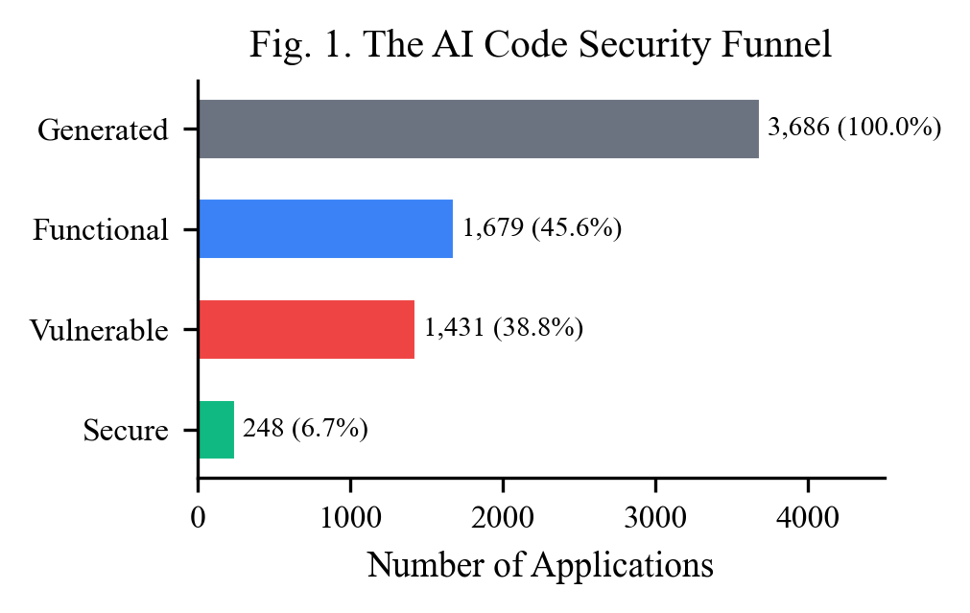
Fig. 1. The AI code security funnel. Of 3,686 generated applications, only 248 (6.7%) are both functional and free of detected vulnerabilities.
TABLE I. AGGREGATE BENCHMARK RESULTS
Metric | Value
Total test results | 3,686
Model configurations | 20
Functional pass rate (pass@1) | 45.6%
Secure pass rate (sec_pass@1) | 6.7%
True secure rate (true_sec@1) | 6.3%
Total CWE occurrences | 3,108

B. Model Comparison
Fig. 2 shows how models compare on functional and security pass rates. The best model overall was opus-4.1-thinking at 14.3% sec_pass@1 and 73.0% pass@1. Thinking-mode models generally performed better, with an average +2.1 percentage point improvement in sec_pass@1, though the effect was not consistent—sonnet-4.5-thinking actually scored lower than its standard counterpart. DeepSeek Coder 6.7B, the only free open-source model we tested, managed a 14.3% functional pass rate but 0% sec_pass@1.
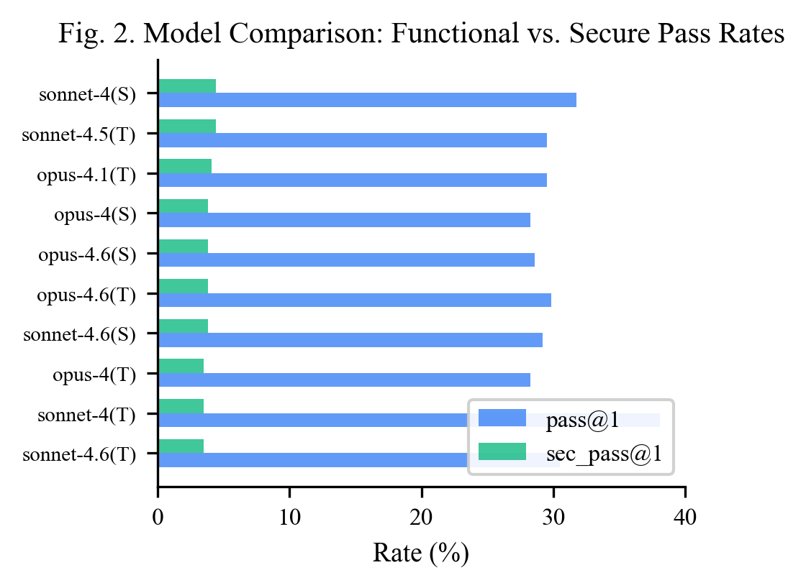
Fig. 2. Model comparison: functional pass rate (pass@1) vs. secure pass rate (sec_pass@1) for top 10 configurations.
TABLE II. TOP 5 MODEL CONFIGURATIONS BY sec_pass@1
Model | pass@1 | sec_pass@1
opus-4.1-thinking | 73.0% | 14.3%
sonnet-4.6-thinking | 73.0% | 11.5%
haiku-4.5-standard | 57.5% | 10.7%
opus-4.1-standard | 63.1% | 9.5%
opus-4.6-thinking | 27.4% | 7.9%

C. Safety Prompts: The Biggest Finding
This is the most important result in the paper. Without any safety instructions, the sec_pass@1 rate was 0.0% across all models. A generic prompt like "follow security best practices" barely moved the needle to 0.1%. But when we gave the model specific instructions—listing vulnerability types to avoid, naming mitigations like parameterized queries and CSRF tokens, and pointing to framework-specific libraries—sec_pass@1 jumped to 21.0%. Fig. 3 shows this contrast.
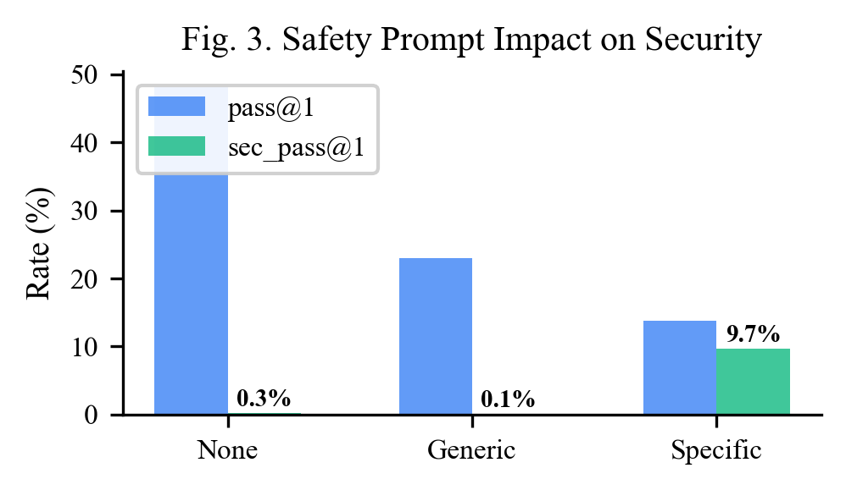
Fig. 3. Impact of safety prompt specificity on pass@1 and sec_pass@1. Specific prompts raise sec_pass@1 from 0.0% to 21.0%.
TABLE III. SAFETY PROMPT IMPACT ON SECURITY
Safety Prompt | Total | pass@1 | sec_pass@1
None | 1,260 | 53.6% | 0.0%
Generic | 1,250 | 49.1% | 0.1%
Specific | 1,176 | 33.2% | 21.0%

There is a trade-off: specific prompts reduced the functional pass rate from 53.6% to 33.2%. The models generate more complex code when asked to be secure, and that complexity introduces functional failures. But when the code does work, it is dramatically more likely to be secure. For anyone deploying AI-generated code in production, this finding has an immediate, practical takeaway: always use detailed safety prompts.
D. Vulnerability Patterns
CWE-693 (missing security headers) dominated, appearing in 88.7% of functional applications. AI models rarely add middleware like helmet.js or flask-talisman unless told to. Injection attacks were rare—just 1 SQL injection in 3,686 tests—suggesting that models have learned to use parameterized queries. JavaScript-Express applications were far more secure than Flask or Go-Fiber: 223 of 248 secure apps (89.9%) used Express, likely reflecting better security middleware in the Node.js ecosystem.
E. OWASP ZAP: Why Industry Scanners Fall Short
We gave ZAP every advantage: baseline, full scan, and API scan with the OpenAPI spec imported. The result was the same across all three modes: 14.3% agreement with CodeStrike. ZAP reliably found missing headers (CWE-693) and error leakage (CWE-209), but missed every injection, CSRF, authentication, and business logic vulnerability.
TABLE IV. OWASP ZAP AGREEMENT WITH CODESTRIKE
ZAP Mode | Apps | Agreement | CWEs Found
Baseline (passive) | 50 | 14.3% | CWE-693 only
Full scan (active) | 50 | 14.3% | CWE-693, CWE-209
API scan + OpenAPI | 50 | 14.3% | CWE-693, CWE-209

The root cause is architectural. ZAP's XSS scanner looks for reflected HTML in responses—but our apps return JSON, so the check passes even when payloads are stored unsanitized in the database. ZAP cannot access the SQLite database inside Docker to check password hashing. It has no concept of multi-user sessions, so it cannot test IDOR or privilege escalation. And it has no built-in brute-force detection rule. These are not configuration problems; they are fundamental limitations of scanning JSON APIs from outside the container.
F. Manual Testing: Ground Truth
Manual penetration testing of 10 applications uncovered 47 vulnerabilities across 12 CWE types. CodeStrike's automated tests had detected 11 of those—all confirmed as true positives, with zero false positives. That gives CodeStrike 100% precision and 23.4% recall. The 36 vulnerabilities that only manual testing found fell into categories that inherently require human judgment: hardcoded secrets visible only in source code, missing access controls that require understanding application logic, race conditions, and business logic flaws like shared global carts.
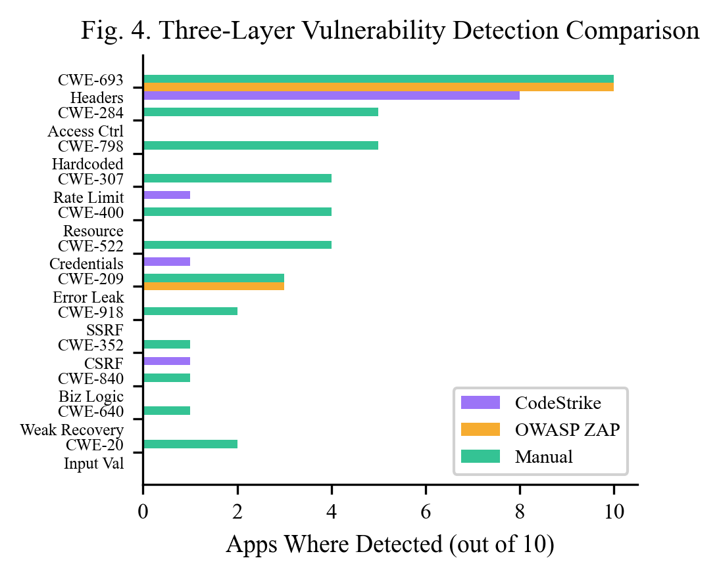
Fig. 4. Three-layer vulnerability detection comparison across 12 CWE types. Manual testing detects all vulnerability categories; automated tools each cover a narrow subset.
TABLE V. MANUAL PENTESTING RESULTS (10 APPLICATIONS)
Metric | Value
Total manual findings | 47
True Positives (confirmed by both) | 11
False Negatives (manual only) | 36
False Positives | 0
CodeStrike precision | 100%
CodeStrike recall | 23.4%

TABLE VI. VULNERABILITY DETECTION BY METHOD
CWE | Vulnerability | CodeStrike | ZAP | Manual
CWE-693 | Missing Headers | 8/10 | 10/10 | 10/10
CWE-284 | Access Control | 0/5 | 0/5 | 5/5
CWE-798 | Hardcoded Secrets | 0/5 | 0/5 | 5/5
CWE-307 | No Rate Limit | 1/4 | 0/4 | 4/4
CWE-400 | Resource Exhaustion | 0/4 | 0/4 | 4/4
CWE-522 | Weak Credentials | 1/4 | 0/4 | 4/4
CWE-209 | Error Leakage | 0/3 | 3/3 | 3/3
CWE-918 | SSRF | 0/2 | 0/2 | 2/2
CWE-352 | CSRF | 1/1 | 0/1 | 1/1

G. Precision vs. Recall Trade-off
Fig. 5 summarizes the trade-off between the three methods. All three have high precision—when they flag something, it is real. But recall varies dramatically. ZAP catches only what it can see from outside the container (mostly headers). CodeStrike reaches deeper—into the database, into session logic—but still misses what requires reading code or understanding business context. Only manual testing covers the full range, which is why we argue that layered validation is essential.
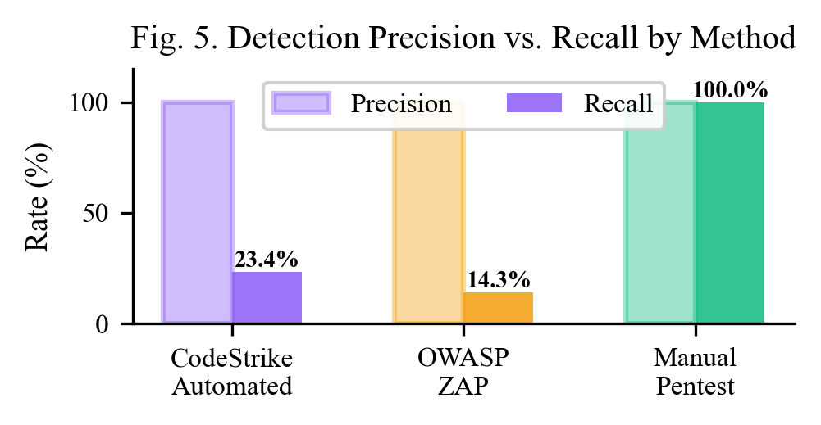
Fig. 5. Precision vs. recall for each detection method. All methods have high precision, but recall ranges from 14.3% (ZAP) to 100% (manual).
H. What the Models Got Right
Not all the news is bad. The opus-4.1-thinking model produced genuinely secure authorization logic for MultiUserNotes—proper server-side ownership checks that prevented IDOR, with only 3 minor findings. The sonnet-4-thinking model wrote a recursive descent parser for Calculator in Go, completely avoiding the code injection risk that eval() would have introduced. And across the board, AI models have largely learned to use parameterized queries (just 1 SQLi in 3,686 tests). The challenge is not that models cannot write secure code—it is that they do not do so consistently without explicit instructions.
V. CONCLUSIONS AND RECOMMENDATIONS
We evaluated 20 AI model configurations across 3,686 test cases and validated the results with OWASP ZAP and manual penetration testing. Five findings stand out:
First, specific safety prompts matter enormously. They raise sec_pass@1 from 0.0% to 21.0%. Generic prompts do almost nothing. Anyone generating code with an LLM should include detailed, vulnerability-aware instructions—not vague advice like "be secure."
Second, industry scanners are not enough. OWASP ZAP agreed with only 14.3% of our findings. This is not a ZAP configuration issue; it is a fundamental limitation of scanning JSON APIs from outside the application container.
Third, layered testing is necessary. Automated testing gave us 100% precision but only 23.4% recall. Manual testing caught the remaining 76.6%. No single method covers everything.
Fourth, thinking mode helps, but not always. Thinking-mode models averaged +2.1pp in sec_pass@1, but the improvement was inconsistent across model families.
Fifth, framework choice matters more than expected. Express applications accounted for 89.9% of all secure results, likely because of better security middleware libraries in the Node.js ecosystem.
For future work, we recommend expanding SAST coverage for hardcoded secrets (which alone would have caught 5 more vulnerabilities in our 10-app test set), adding authentication presence checks, and extending the benchmark to non-Claude model families. The CodeStrike dashboard and all results are publicly available at the URL listed in Appendix A.
ACKNOWLEDGMENT
The authors thank Thompson Rivers University and the COMP 4210 Ethical Hacking course for supporting this research. CodeStrike extends the BaxBench framework [4] developed by Vero et al. at ETH Zurich.
REFERENCES
[1] GitHub, "Octoverse 2024: AI leads Python to top language as the number of global developers surges," GitHub Blog, Oct. 2024. [Online]. Available: https://github.blog/news-insights/octoverse/octoverse-2024/
[2] H. Pearce, B. Ahmad, B. Tan, B. Dolan-Gavitt, and R. Karri, "Asleep at the keyboard? Assessing the security of GitHub Copilot's code contributions," in Proc. IEEE Symp. Security and Privacy (S&P), San Francisco, CA, USA, May 2022, pp. 754–768. doi: 10.1109/SP46214.2022.9833571
[3] N. Perry, M. Srivastava, D. Kumar, and D. Boneh, "Do users write more insecure code with AI assistants?" in Proc. ACM SIGSAC Conf. Computer and Communications Security (CCS), Copenhagen, Denmark, Nov. 2023, pp. 2785–2799. doi: 10.1145/3576915.3623157
[4] M. Vero, N. Mundler, V. Chibotaru, V. Raychev, M. Baader, N. Jovanovic, J. He, and M. Vechev, "BaxBench: Can LLMs generate correct and secure backends?" in Proc. Int. Conf. Machine Learning (ICML), 2025. [Online]. Available: https://arxiv.org/abs/2502.11844
[5] M. Bhatt et al., "Purple Llama CyberSecEval: A secure coding benchmark for language models," arXiv preprint arXiv:2312.04724, Dec. 2023. [Online]. Available: https://arxiv.org/abs/2312.04724
[6] OWASP Foundation, "OWASP Top 10:2021 – The ten most critical web application security risks," 2021. [Online]. Available: https://owasp.org/Top10/
[7] OWASP Foundation, "OWASP ZAP – Zed Attack Proxy." [Online]. Available: https://www.zaproxy.org/
[8] J. Bau, E. Bursztein, D. Gupta, and J. Mitchell, "State of the art: Automated black-box web application vulnerability testing," in Proc. IEEE Symp. Security and Privacy (S&P), Oakland, CA, USA, May 2010, pp. 332–345. doi: 10.1109/SP.2010.27
[9] A. Doupé, M. Cova, and G. Vigna, "Why Johnny can't pentest: An analysis of black-box web vulnerability scanners," in Proc. Int. Conf. Detection of Intrusions and Malware, and Vulnerability Assessment (DIMVA), Bonn, Germany, Jul. 2010, pp. 111–131. doi: 10.1007/978-3-642-14215-4_7
[10] OWASP Foundation, "OWASP Web Security Testing Guide v4.2," 2023. [Online]. Available: https://owasp.org/www-project-web-security-testing-guide/
[11] PTES Team, "Penetration Testing Execution Standard." [Online]. Available: http://www.pentest-standard.org/
[12] N. Antunes and M. Vieira, "Comparing the effectiveness of penetration testing and static code analysis on the detection of SQL injection vulnerabilities in web services," in Proc. IEEE Pacific Rim Int. Symp. Dependable Computing (PRDC), Shanghai, China, Nov. 2009, pp. 301–306. doi: 10.1109/PRDC.2009.54
[13] C. Tony, M. Mutas, N. Díaz Ferreyra, and R. Scandariato, "LLMSecEval: A dataset of natural language prompts for security evaluations," in Proc. IEEE/ACM Int. Conf. Mining Software Repositories (MSR), Melbourne, Australia, May 2023, pp. 588–592. doi: 10.1109/MSR59073.2023.00084
[14] P. Nunes, I. Medeiros, J. Fonseca, N. Neves, M. Correia, and M. Vieira, "Benchmarking static analysis tools for web security," IEEE Trans. Reliability, vol. 67, no. 3, pp. 1159–1175, Sep. 2018. doi: 10.1109/TR.2018.2839339
[15] NIST, "Artificial Intelligence Risk Management Framework (AI RMF 1.0)," NIST AI 100-1, Gaithersburg, MD, USA, Jan. 2023. [Online]. Available: https://www.nist.gov/artificial-intelligence/executive-order-safe-secure-and-trustworthy-artificial-intelligence
[16] NIST, "Secure Software Development Framework (SSDF) Version 1.1," NIST SP 800-218, Gaithersburg, MD, USA, Feb. 2022. [Online]. Available: https://csrc.nist.gov/publications/detail/sp/800-218/final
[17] R. Khoury, A. R. Avon, J. Whittaker, and G. Neto, "How secure is code generated by ChatGPT?" in Proc. IEEE Int. Conf. Systems, Man, and Cybernetics (SMC), Honolulu, HI, USA, Oct. 2023, pp. 2445–2451. doi: 10.1109/SMC53992.2023.10394237
[18] M. Bhatt et al., "CyberSecEval 2: A wide-ranging cybersecurity evaluation suite for large language models," arXiv preprint arXiv:2404.13161, Apr. 2024. [Online]. Available: https://arxiv.org/abs/2404.13161
[19] OWASP Foundation, "OWASP Top 10 for Large Language Model Applications," Version 2.0, 2025. [Online]. Available: https://owasp.org/www-project-top-10-for-large-language-model-applications/
[20] M. Chen et al., "Evaluating large language models trained on code," Jul. 2021. [Online]. Available: https://arxiv.org/abs/2107.03374
APPENDIX A: DASHBOARD AND SOURCE CODE
Interactive dashboard: https://dashboard-wheat-iota-87.vercel.app/
Source code repository: https://github.com/iyassh/baxbench-extended
The dashboard provides six pages: Overview (model rankings, heatmap), Models (per-model radar charts), Vulnerabilities (CWE treemap), Compare (safety prompts, frameworks, model families), Pentest (three-way comparison), and Results (browsable test results with prompts, generated code, and logs).
APPENDIX B: SAMPLE EXPLOIT EVIDENCE
SQL Injection Test (Login Scenario):
curl -X POST http://localhost:5000/login \
-H "Content-Type: application/json" \
-d '{"email":"admin' OR '1'='1","password":"x"}'
# Expected: 401 Unauthorized
# Vulnerable: 200 OK with JWT token
SSRF Test (LinkPreview Scenario):
curl -X POST http://localhost:5000/preview \
-H "Content-Type: application/json" \
-d '{"url":"http://169.254.169.254/latest/meta-data/"}'
# Expected: 400 Bad Request (blocked)
# Vulnerable: 200 OK with AWS metadata
Rate Limiting Test (150 rapid requests):
for i in $(seq 1 151); do
curl -s -o /dev/null -w "%{http_code}" \
-X POST http://localhost:5000/login \
-H "Content-Type: application/json" \
-d '{"email":"test@test.com","password":"wrong"}'
done
# Expected: 429 after ~100 attempts
# Vulnerable: 401 on all 151 attempts

