

TUNIS BUSINESS SCHOOL

Internship Report

An explorative model for adoption of software as a service solutions in Tunisia

BY
Iyed Ghedamsi

Tunis, 2017-2018

Declaration

I certify that I am the author of this project and that any assistance I received in its preparation is fully acknowledged and disclosed in this project. I have also cited any source from which I used data, ideas, or words, either quoted or paraphrased.

Student Name Signature Date

Abstract

Acknowledgments

TABLE OF CONTENTS

Executive Summary

- Introduction

Managing multiple social media, in an ever-expanding market for digital advertising, is becoming a necessity more than the luxury. Only a few Tunisian companies ventured to embrace integrated tools to manage their digital presence, until very recently. Tunisian advertisers still favor traditional advertising media to digital media, according to a recent report about advertisement spending in Tunisia, TV is the leader with 66.1% and an estimated 159.46 MTND, followed by radio with 14.5% at an estimated 34.9MTND. Display ads have about 9.7% at an estimated 23.3 MTND, print ads have about 6.7% at an estimated 16.2 MTND. Digital ads were last with only 3% at an estimated 7.35 MTND. (“Open Sigma - Détail des investissements publicitaires,” 2018). Despite the rather modest investment in digital advertising, a similar report from 2014 indicates that the share of digital advertising about 2.3% at an estimated 3.44 MTND (Sigma Conseil, 2014)⁠ strengthening the expectations that the spending on digital marketing will increase in absolute amounts and relative to other media. Ultimately, such a trend will pave the way for social media management tools such as Kpeiz to gain a foothold in the social media marketing industry in Tunisia.
Kpeiz provides an online tool that simplifies and enhances the process of management and analysis of social media accounts tailored to the needs of the MENA region. Kpeiz and similar services are data mining tools that act as a dashboard for competitive analysis. By analyzing data from social media, a business using such services will have access to data about themselves and their competitors, which when processed by tools like Kpeiz, could act as a benchmarking tool to identify shortcomings in their marketing strategy, and gain insights into their relative performance compared to competitors (He, Zha, & Li, 2013)⁠.
Several factors, however, impose themselves in the face of growth in this region and the adoption of Kpeiz’ solution, in Tunisia in particular, the focus of this study. These factors range from technological issues such as low trust in digital payment solutions (“Arab world could see US$69 billion in online payment transactions per annum by 2020 – PAYFORT,” n.d.)⁠ to the unknown impact of cues extrinsic to the service that challenge the adoption of tools such as Kpeiz such as the effect of the country of origin on consumer perception. The general perception of Tunisian products may not be enough to infer the perception of consumers in the MENA region with regards to technological services as supported by (Bilkey & Nes, 1982)⁠ that explained attitude towards foreign products vary by product. However, the same paper suggests that even if the country of origin is perceived negatively it may be improved through communication.
The Software as a service (henceforth referred to as SaaS) business model allows its users to access a software application through the web (Wu, 2011). This model is generally attractive to businesses as it improves their IT performance and reduces their costs (Catteddu, 2010)⁠. However, some businesses raise concerns with regards to data security, reliability, and logging latency (Wu, 2011)⁠ adding more barriers to the adoption of SaaS tools in the MENA region and Tunisia in particular.
To address concerns related to behavioral and attitudinal barriers with regards to the adoption of social media management tools with a SaaS business model, this study builds upon a previously developed model for the Taiwanese market. The model is adapted to the specificity of the Tunisian ecosystem under the supervision of field experts who are knowledgeable about the Tunisian market. The end-goal is to provide a framework for understanding the behavioral factors that affect a business's willingness to adopt social media management tools with a SaaS business model such as Kpeiz. This study will provide empirical insights into the relative importance of these concerns in relation to SaaS solutions in Tunisia, and develop a strategy to alleviate these concerns.
- Company and Industry Presentation
  - Industry Analysis
    - Industry and Sector of Activity
Kpeiz operates in the digital marketing industry.
The Tunisian market boasts between 6 and 7 million monthly active users on Facebook alone (“Facebook Audience Insights,” 2018)⁠, which not only creates an attractive market for advertisers and advertising agencies alike but creates a need for tools that provide a support function for such an ecosystem.
In 2017, advertisers spent 7.35 Million Tunisian dinars for digital advertisement (“Open Sigma - Détail des investissements publicitaires,” 2018)⁠. Although no thorough research or reliable secondary data is available, experts in digital marketing agencies say that most agencies in Tunisia do not have access to support tools for their social media analytic and reporting.
This is mainly due to two reasons, the first of which is that most popular tools are based in Europe or the United States, meaning they only accept payments in Euros or US dollars. The second reason is that even when an agency is able to pay for these support functions in foreign currency they are often reluctant to do so because of the high price and the volatility of the Tunisian Dinar.

Porter’s 5 Forces
Social media marketing tools are relatively young as they could be traced only to some time between 1997 when SixDegrees.com the first social network was launched (boyd & Ellison, 2007)⁠ and 2004 when social media were becoming mainstream (boyd & Ellison, 2007)⁠. HootSuite, one of the leaders of the sector, which was launched back in 2008 (Thomas, 2015)⁠ could be considered as one of the pioneers of providing support functions to social media managers and digital advertisers in general. However, with the massive growth of digital advertising budgets 266.04B$ (Digital Ad Spending Worldwide, 2016-2021, 2017)⁠ this sector has attracted more than 150 companies with tools for monitoring, analyzing and reporting on social media activities (“Best Social Media Monitoring Software,” 2018)⁠..
An analysis of data from Crunchbase, a database of startups and tech companies (Ingrid Lunden, 2015)⁠, reveals that the industry has a tendency to grow inorganically through mergers and acquisitions, where companies registered under Social Media Management, Social Media Marketing and Social Media Monitoring have an acquisition rate of 10.25% relative to a 6.65% for companies under SaaS category, and an 8.58% for all the registered companies (github database reference). Further analysis of the same data base shows a decline in the formation rate of new companies in Software Companies as a whole including the Marketing Technology sector. Such an observation is possibly a symptom for intense competition (Tomasz, 2016)⁠. Furthermore, the market is dominated by a limited number of companies such as Salesforce, Netsuite, HubSpot and Zendesk, meaning that competing with them will require aggressive customer acquisition strategies (Tomasz, 2016)⁠.
Partnerships started to arise especially through partnership programs e.g. Google partner program and Facebook partner program. These programs not only provide some advertising agencies and digital marketing companies to work closely with Facebook and Google on ways to improve the ways their advertisement placement and data used in the process are collected and displayed (Katerina Bojkov, 2016)⁠, but also allows Facebook and Google to exert a power over a limited and select number of agencies. Such power is best displayed by the changes Facebook made to its Graph Application Programming Interface, the primary way for applications to interact with its data, on April 4th, 2018 (“Breaking Changes - Graph API,” n.d.)⁠ which made much information previously accessible to companies using the service but who are not partners inaccessible. Although this action was strategically intended to improve Facebook's public image in terms of privacy, it had a significant impact on new social media analytics and management companies. This example illustrates that the digital advertising industry is more concentrated than the support functions industry such as social media management tools. More importantly, the supplier power of advertisement providers (social networks) is more apparent in the fact that they do not need these support function businesses to exist, as they usually provide native analytics solutions on their respective platforms, but the supporting businesses rely almost entirely on information given to them by the these advertisement providers. Furthermore, the stronghold these providers have on their data and their massive audience makes it virtually impossible for any attempt at a backwards vertical integration by the support industry.
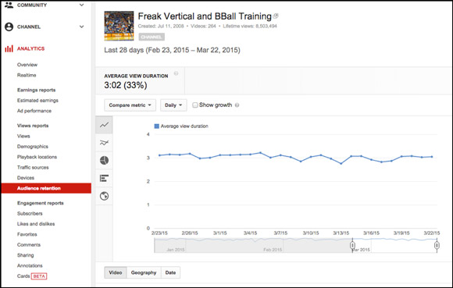Figure 1: YouTube's analytics dashboard
Another threat to this industry is the threat of advertising agencies developing in-house solutions. For large enough advertising agencies of the scale of WPP, Publicis and even companies with large brand portfolios like Unilever, analytics tools could be replaced by tools developed in-house. Given the large number of social media profiles they manage ,and their variety, they are able to achieve a critical mass (Shapiro & Varian, 1998)⁠ making the data they collect valuable enough to create reports about performance and benchmarks form the performance of each client. This functionality is generally the advantage analytics tools provide over native solutions on social media platforms, because they are able to build a client list large enough to be able to make use of aggregate data instead of the individual data for each client that an advertising agency has access to. By having a large client base, these agencies are able to create a network effect (Shapiro & Varian, 1998)⁠ thereby providing more value because they have a large number of clients, which in turn get them more clients as a result of positive feedback (Shapiro & Varian, 1998)⁠. A fact that will negate any benefit from social media analytics tools.
Entry to this industry is often faced with high barriers. Firstly, these solutions are often pricey and require some sort of training and familiarity, increasing the potential switching costs if a client were to consider a different tool, as is the case with many information technologies (Shapiro & Varian, 1998)⁠. Secondly, since the main advantage over the information provided natively on social media platforms is aggregation to add the ability to benchmark, well-established companies like Hootsuite with more than 15 million users((“Hootsuite Surpasses 15 Million Users, Hosts World’s Largest Online Social Media Conference, for Free,” 2016)⁠, the network effect is a great leverage to be used as these companies will have more reliable information actionable across a variety of industries. More importantly, the analysis of such data requires usually the knowledge and skill of trained staff in information technology and statistics, with the addition of new disciplines such as machine learning and artificial intelligence (Tomasz, 2016)⁠. Such a rush to acquiring this skilled labor that is largely in high demand and low on supply (Dinu & Orban, 2015)⁠ makes it harder for new entrants to hire the needed qualified talent.
Advertising agencies, possess the ability to vertically integrate such support functions. However, this threat is credible only for large agencies with not only an extensive portfolio of clients but also the ability to hire qualified staff to analyze and collect the necessary data, which is rarely the case in Tunisia. The credible threat, however, in the Tunisian market, is that advertisers do not usually rely on such kind of data to tailor their creative process. The most a support function tool could provide is automating the reporting process, which is a functionality that many Tunisian small agencies would rather do using traditional tools like Microsoft Excel and PowerPoint rather than buy a dedicated service for full information.
The Marketing Technology industry exhibits high entry barriers to new entrants. Mainly in the form of high switching costs and large capital requirements necessary in the form of R&D in order for new entrants to provide differentiated products. Most importantly, the rapid change in privacy laws (“​The EU General Data Protection Regulation,” 2018)⁠ that affected the business models of many incumbent firms and websites (Margi, 2018)⁠ is a challenge for new entrants as they must develop ways to provide the same value as the incumbents with access to less information. The suppliers of information i.e. social networks, exert a great deal of power especially with partner’s programs where only a select few agencies and companies have access to special treatment while the rest are subject to very deep and drastic changes. Consumers on the other hand show signs of power only in parts of the world where many marketing management and analytics providers operate. In the case of the MENA region, and Tunisia specifically, advertisers and agencies have few choices. The fact that few companies operate in the MENA region, and that those who operate do not have large scale operations as the whole region still mainly consumes content through traditional media, rivalry among competing firms is unlikely.

Competitive Dynamics
According to internally conducted research at Kpeiz, the main competitors in the Tunisian market are Hootsuite, Socialbakers, and Agorapulse.
The following table shows relevant numbers about these companies (“Crunchbase,” 2018)⁠

TABLE HERE

With about ten years of activity, these companies boast large user bases in the order of millions of users (“Hootsuite Surpasses 15 Million Users, Hosts World’s Largest Online Social Media Conference, for Free,” 2016)It is worth noting that their growth has partly been inorganic through a number of acquisitions. (“Crunchbase,” 2018)⁠. In the case of Hootsuite, the 12 acquisitions are in fact a means to expand the company's sectors of activity as part of their differentiation strategy. Socialbakers but their growth has been relatively organic and relied mostly on innovation and heavy investment in machine learning features.

Given the small size of the Tunisian market, the scope of Kpeiz's activity is not enough to warrant a significant reaction from any of these companies. However, with the growth plans into the MENA region, this action of entry is a good predictor of their response (Smith, Ferrier, & Ndofor, 2001)⁠. The scope of the expansion into the MENA region is undoubtedly going to affect all of these companies. However its magnitude is not big in terms of resources as the expansion will start in few countries in a medium-term to a long-term growth plan that will eventually cover the whole region, thus it is not viable for these companies to allocate resources to respond (Chen, Smith, & Grimm, 1992)⁠.

Company Presentation

Mission Statement
Bridge the gap between advertisers and audiences reliably and ethically.

Products and Services
Product
Kpeiz, as a SaaS, offers online subscription-based services related to social media management and analytics. The main service, named Kpeiz, aims to be a one-stop solution for managing, analyzing and creating social media content. The tool is still under heavy development and lacks many features to be called a one-stop solution. The four general features the tool offers are benchmarking, optimization, monitoring, and reporting. Each of these features assists content creators and advertisers on social media to evaluate their performance relative to their previous levels and to the performance level of their competitors, through reporting and benchmarking. And demonstrates ways this performance could improve through monitoring and optimization. The service is currently offered in English and French for the Tunisian, Moroccan and Egyptian markets, an Arabic version is under development.
Promotion
Kpeiz is currently being marketed mainly on Facebook, LinkedIn, and Google. Although most of the promotion is done through paid means, an effort is underway to improve the organic reach of the tool, especially through Search Engine Optimization. In addition, Kpeiz has relied heavily so far on word of mouth especially in the Tunisian market. Ultimately, the company aims to reach its potential customers through a mix of word of mouth and digital presence, organic and paid.
In accordance with Kpeiz’ multi-domestic strategy, the communication language is tailored for each country to match not only the language but also the local dialect. Experiments from Facebook advertising campaigns conducted over the period of 2 months have revealed that audiences are more responsive when the language of ads matches theirs.
In Tunisia, the sales team has leveraged the geographical proximity to leads to fast-track to conversion through the sales funnel phases. This tactic has proven rather effective, as a result, a sponsorship plan is under development to allow it to scale where word of mouth is rewarded with financial incentives.
Price
Kpeiz uses a hybrid pricing strategy; a subscription revenue model and a competition based revenue model. With the subscription revenue model, the user pays a predetermined fee in exchange for a contract limited by time. Under this contract there are limitations to the level and scope of usage of the service (Dempsey & Kelliher, 2011). As for the competition based revenue, where the prices were set based on what the market price is for similar services (Dempsey & Kelliher, 2011).
The prices range from 200DT/Month for the Starter Pack to 2200DT/Month for the Wide pack. The tiers have been developed based on offerings from similar services. For each tier, the user gets to manage more social media profiles, and have access to more sectorial benchmarks for the MENA region.

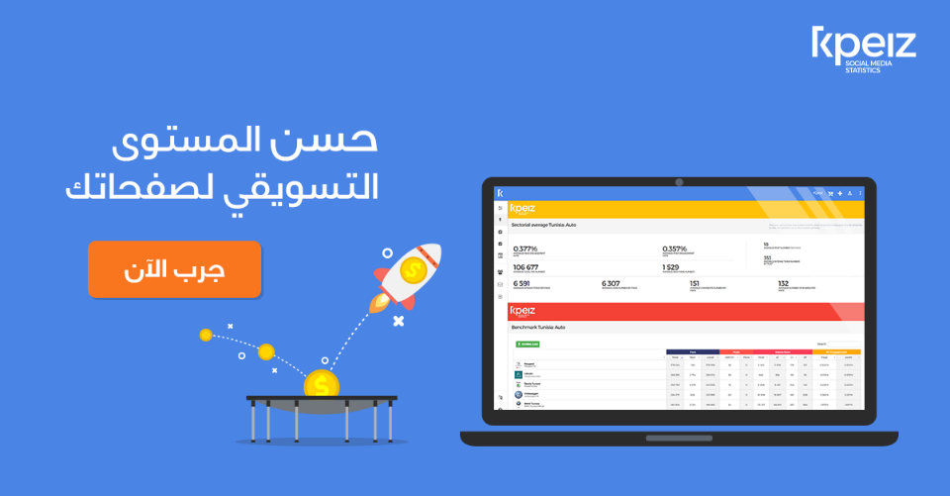
Figure 1: Facebook advertisement targeting the Egyptian market

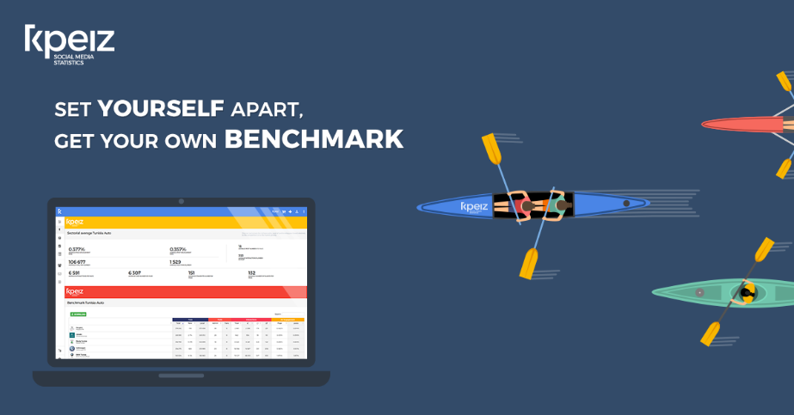
Figure 2: Facebook advertisement targeting the Romanian market

SWOT Analysis

Strengths
Being a startup with limited resources, Kpeiz opted for a copycat strategy, effectively eliminating expenses on research and development. Mimicking features from leaders in the sector relying only on a small team of developers, marketers, and salespeople in just a year and a half (Shenkar, 2010)⁠. Coupled with a cost leadership strategy, where the cost structure is comprised essentially of paying utilities, salaries, and advertisements, Kpeiz is capable of offering the same functionality as its competitors at a not only a competitive price but also have a higher room for price flexibility. In addition, Kpeiz is a twin company of KNSD, an established advertising agency in the Greater Tunis area, whereby Kpeiz has been able to leverage the client portfolio and close relationship to push the product and start the word of mouth.

Weaknesses
For agencies who have already acquired a subscription with another competing service, the switching cost to Kpeiz's solution is extremely high because of high prices and the subscription model often used by similar services (Stirling, 2003)⁠. In addition, in the Tunisian market using tools from foreign countries is often used as a sign of prestige and is sought after by clients (Bilkey & Nes, 1982). Furthermore, Kpeiz stuggles with attracting the necessary talent for development and data science.
To mitigate these weaknesses, Kpeiz firstly proposes giving the service free of charge for a clients who are currently subscribed to another service and are willing to commit to a one-year subscription with Kpeiz for the remainder of their contract with the competing service. Secondly, Kpeiz is focusing its communication on building credibility to reduce the impact of the county of origin on Tunisian consumers. Finally, a collaboration with a non-profit is underway to attract developers and data scientists from foreign countries.

Opportunities
Kpeiz is the first solution of its scale in Tunisia, and likely the whole North Africa region. Being a first mover in a region with growing need for analyzing social media activity as advertisers spend about 13$ US per person (“Open Sigma - Détail des investissements publicitaires,” 2018), Kpeiz has the potential of gaining a stronghold in the region (Stirling, 2003)⁠ and building entry barriers for new entrants. To maintain such advantage Kpeiz will work on increasing switching costs, effectively creating a lock-in effect for customers through creating a variety of complementary tools as part of the service where they are usable only as part of Kpeiz’ ecosystem (Stirling, 2003)⁠

Threats
With the latest developments in data protection and privacy scandals, social media like Facebook have been quick to hide some of the previously available information causing major issues with the implemented data collection flow in the industry as a whole (“How the latest Facebook API changes will affect you — Get Social Digital Marketing,” 2018)⁠. Thus disrupting the value previously provided and worsening the quality of the reports and analytics provided. In order for Kpeiz’ business model to sustain such changes, plans are being executed to include predictive analysis features and machine learning capabilities that rely on publically available information about clients’ social media to provide value independently from what future changes could bring.
Another threat is that these platforms have been working on improving their native tools for analytics, such as Google analytics which is by far a prime example of what could be the case for Facebook, Twitter, Pinterest, Instagram and other social media. While this threat might deter some customers from opting for a more comprehensive service for managing and analyzing their social media, it does not interfere with the core competency of Kpeiz which is analyzing, managing and bench marking social media information across industries as opposed to information only about the user provided natively.
The case could be worsened with the sort of legislation being prepared in the EU where access to user information will be far stricter and private data protection will be a higher priority for social media platforms (“​The EU General Data Protection Regulation,” 2018)⁠, especially that more similar legislation, ePrivacy regulation, is being developed and is expected to strike a blow to ad revenue for small publishers (“GDPR could crush media business models,” 2018)⁠. This could translate into lower quality analytics and require other sources and means for data collection for advertisers. Addressing this legislation is difficult as its impact is yet to be seen, Kpeiz however plans on keeping a close eye on how advertisers and publishers will react to it, adjusting its strategy accordingly.

Market Analysis
According to Google business, there are about 160 registered digital advertising agencies. Which constitute the main target for Kpeiz. However, a broader target is any person managing social media accounts professionally which includes freelancers, and businesses managing their social media in-house. A more accurate estimate is provided by Facebook audience insights which estimates the number of people who manage social media accounts and work in business and marketing in Tunisia and who have paid to advertise on Facebook in the last 90 days to be about 3500 to 4000 people. These numbers provide a reasonable market potential for Kpeiz to grow its customer base and prepare for growth and expansion into neighboring regions.

Customer characteristics
Of the potential 4000 clients, we can distinguish four types of clients.

- Advertising agencies: regardless of their size, Kpeiz is an attractive service for most agencies mainly for the reporting and analytics functionalities. With the added benefit of paying in the local currency instead of using often hard ways of buying subscriptions in currency.
- Businesses that manage social media in-house: some businesses, like Al Mazraa for instance, prefer to manage social media in-house to cut on expenses. Kpeiz targets them with a package that includes an optimization tool that gives the users insights into how to improve various aspects of communication on social media based on data about the whole industry.
- Independent and freelancers: for this segment, Kpeiz is mainly providing sectorial benchmarks allowing these users to assess their performance against reliable and accurate benchmarks through the tool benchmarks.digital

- Potential clients who already bought a subscription to a competing service: what Kpeiz provides for this segment is not only a cheaper solution for the same functionality, but a more accurate benchmark of the Tunisian social media scene compared to the other tools who have a lower penetration rate in the market. To mitigate the switching costs issue, Kpeiz offers using the tool for free during the remaining period of subscription with the competing service, and free training.
Market Position
Kpeiz's value proposition is understood as offering the same for less. This proposition stems from the overall strategy of being a follower with a focus on cost leadership. Although the service has no intention of competing on price as not only will that warrant negative reactions from competitors but also act as a signal of low quality, a great deal of focus is on providing the same functionality as leaders in the industry for a competitive price.

Internship Description
Duties and Responsibility
- Study and understand the Social Media Marketing industry in target markets: Egypt, Jordan, Morocco, and Dubai.
- Develop a pricing strategy based on various factors such as competitor’s price, market purchase power and costs of the company.
- Improve and update the company’s website homepage to increase its conversion rate.
- Develop an editorial line for the company’s blog as part of its inbound marketing strategy.
- Gather information about prospects in the Tunisian markets as part of the sales process.
- Collaborate with sales manager to develop and improve sales scripts.
- Develop a factorial experiment to cross-test the impact of various variables on the conversion rate of Facebook advertisements.
- Study direct and indirect competitors operating in the target markets to develop a communication strategy based on points of differentiation.
- Assist in the development of long-term business goals, strategies and study their operational implications.
- Create advertisement campaigns targeting Egypt, Jordan, Hungary, and Romania on Facebook and Linkedin.
Learning outcomes
- Understand the sales process throughout its steps, fully online and partially online.
- Use statistical techniques such as A/B testing to improve and support the decision process with regards to tailoring the communication and promotion content to different audiences.
- Use marketing knowledge to supporting decision making with regards to strategic and tactical decisions.
- Familiarity with the advertising process on various social media, mainly Facebook and Linkedin.
- Develop an email marketing strategy to communicate with leads and prospects throughout various stages of the sales pipeline.

Internship Study
Internship Study Objectives
Context and Background
Approach and Methodology
Findings
Discussion and Conclusion

References
Arab world could see US$69 billion in online payment transactions per annum by 2020 – PAYFORT. (n.d.). Retrieved May 23, 2018, from https://www.payfort.com/press/arab-world-see-us69-billion-online-payment-transactions-per-annum-2020/
Best Social Media Monitoring Software. (2018). Retrieved from https://www.g2crowd.com/categories/social-media-monitoring?segment=all
Bilkey, W. J., & Nes, E. (1982). Country-of-Origin Effects on Product Evaluations. Journal of International Business Studies, 13(1), 89–100. https://doi.org/10.1057/palgrave.jibs.8490539
boyd, danah m., & Ellison, N. B. (2007). Social Network Sites: Definition, History, and Scholarship. Journal of Computer-Mediated Communication, 13(1), 210–230. https://doi.org/10.1111/j.1083-6101.2007.00393.x
Breaking Changes - Graph API. (n.d.). Retrieved May 26, 2018, from https://developers.facebook.com/docs/graph-api/changelog/breaking-changes/#4-4-2018
Catteddu, D. (2010). Cloud Computing: Benefits, Risks and Recommendations for Information Security (pp. 17–17). https://doi.org/10.1007/978-3-642-16120-9_9
Chen, M.-J., Smith, K. G., & Grimm, C. M. (1992). Action Characteristics as Predictors of Competitive Responses. Management Science, 38(3), 439–455. https://doi.org/10.1287/mnsc.38.3.439
Crunchbase. (2018, March). Retrieved from https://www.crunchbase.com
Dempsey, D., & Kelliher, F. (2011). Industry trends in Cloud Computing - Alternative Business-to-Business Revenue Models.
Digital Ad Spending Worldwide, 2016-2021. (2017). Retrieved from http://www.emarketer.com/Chart/Digital-Ad-Spending-Worldwide-2016-2021-billions-change-of-total-media-ad-spending/211873
Dinu, J., & Orban, R. (2015, October). Galvanize Data Science with Jonathan Dinu and Ryan Orban. Retrieved from https://softwareengineeringdaily.com/2015/10/29/galvanize-data-science-with-jonathan-dinu-and-ryan-orban/
Facebook Audience Insights. (2018, March). Retrieved from https://www.facebook.com/ads/audience-insights
GDPR could crush media business models. (2018). Retrieved May 27, 2018, from https://finance.yahoo.com/news/new-european-regulations-crush-media-business-models-194045011.html?guccounter=1
He, W., Zha, S., & Li, L. (2013). Social media competitive analysis and text mining: A case study in the pizza industry. International Journal of Information Management, 33(3), 464–472. https://doi.org/10.1016/j.ijinfomgt.2013.01.001
Hootsuite Surpasses 15 Million Users, Hosts World’s Largest Online Social Media Conference, for Free. (2016, October). Retrieved from https://hootsuite.com/newsroom/press-releases/hootsuite-surpasses-15-million-users-hosts-worlds-largest-online-social-media-conference-for-free
How the latest Facebook API changes will affect you — Get Social Digital Marketing. (2018). Retrieved May 27, 2018, from https://www.getsocialmarketing.com.au/news-notes/2018/4/10/latest-facebook-and-instagram-api-changes-what-this-means-for-you
Ingrid Lunden. (2015). AOL/Verizon Completes Spinout Of CrunchBase Funded By Emergence Capital | TechCrunch. Retrieved May 26, 2018, from https://techcrunch.com/2015/09/22/aolverizon-completes-spinout-of-crunchbase-funded-by-emergence-capital/
Katerina Bojkov. (2016). Why are Facebook Partner Programs a “must have.” Retrieved May 26, 2018, from https://embedsocial.com/blog/why-are-facebook-partner-programs-a-must-have-for-other-social-networks/
Margi, M. (2018). “We just don’t have the resources” GDPR forces popular websites and apps to shut down. Retrieved May 27, 2018, from https://www.telegraph.co.uk/technology/2018/05/24/just-dont-have-resources-gdpr-forces-popular-websites-apps-shut1/
Open Sigma - D<unicode>233</unicode>tail des investissements publicitaires. (2018). Http://Www.Businessnews.Com.Tn.
Open Sigma - Détail des investissements publicitaires. (2018). Retrieved from http://www.businessnews.com.tn/open-sigma-detail-des-investissements-publicitaires,520,77466,3
Shapiro, C., & Varian, H. R. (1998). Information Rules: A Strategic Guide to the Network Economy. Harvard Business Review Press. Retrieved from https://www.amazon.com/Information-Rules-Strategic-Network-Economy/dp/087584863X?SubscriptionId=0JYN1NVW651KCA56C102&tag=techkie-20&linkCode=xm2&camp=2025&creative=165953&creativeASIN=087584863X
Shenkar, O. (2010). Copycats: how smart companies use imitation to gain a strategic edge. Strategic Direction, 26(10), 3–5. https://doi.org/10.1108/02580541011080474
Sigma Conseil. (2014). Open Sigma 2014. Retrieved from http://www.sigma.tn/Fr/upload/1393236288.pdf
Smith, K. G., Ferrier, W. J., & Ndofor, H. (2001). Competitive Dynamics Research : Critique and Future Directions. Handbook of Strategic Management, 76. https://doi.org/10.1017/CBO9781107415324.004
Stirling, D. A. (2003). Information rules. ACM SIGMOD Record (Vol. 32). https://doi.org/10.1145/776985.776997
​The EU General Data Protection Regulation. (2018).
Thomas, K. (2015). A Brief History of Hootsuite. Retrieved from https://techvibes.com/2015/08/26/a-brief-history-of-hootsuite-2015-08-26
Tomasz, T. (2016). The Decline of New SaaS Company Formation. Retrieved May 26, 2018, from http://tomtunguz.com/rate-of-software-company-formation/
Wu, W. W. (2011). Developing an explorative model for SaaS adoption. Expert Systems with Applications, 38(12), 15057–15064. https://doi.org/10.1016/j.eswa.2011.05.039

