

TUNIS BUSINESS SCHOOL

Internship Report

An exploratory model for the adoption of Social media management and analysis tools in Tunisia

BY
Iyed Ghedamsi

Tunis, 2017-2018

Declaration

I certify that I am the author of this project and that any assistance I received in its preparation is fully acknowledged and disclosed in this project. I have also cited any source from which I used data, ideas, or words, either quoted or paraphrased.

Iyed Ghedamsi 11/07/26
Student Name Signature Date

Abstract

This study proposes an adaptation of the Technology Acceptance Model (TAM) for the social media management and analytics industry. A self-administered online survey using a snowball sampling method was used to gather 37 responses from employees who are in charge of digital marketing in their businesses or marketing managers. The results are lacking in terms of reliability and validity as a result of the sampling method. However, they support that the adoption of social media management and analytics tools depends heavily on perceived usefulness and ease of use. In addition, this study shows the importance of social influence, especially expert opinion on the behavioral intention of adoption. And depicts the important role marketing efforts play in explaining other constructs of the model mainly Perceived Usefulness, Perceived Ease of Use and Social Influence.

Keywords: Technology Acceptance Model, SaaS, Social media management, Social media analytics, Data Mining

Acknowledgments

My full recognition to my teachers, my parents and my friends for their support and help.

TABLE OF CONTENTS

Declaration ii
Abstract iii
Acknowledgments iv
Executive Summary 6
1. Introduction 7
2. Company and Industry Presentation 8
2.1. Industry Analysis 8
2.1.1. Industry and Sector of Activity 8
2.1.2. Porter’s 5 Forces 8
2.1.3. Competitive Dynamics 8
2.2. Company Presentation 8
2.2.1. Mission Statement 8
2.2.2. Products and Services 8
2.2.3. SWOT Analysis 8
2.2.4. Market Analysis 8
2.2.5. Market Position 8
3. Internship Description 9
3.1. Duties and Responsibility 9
3.2. Learning outcomes 9
4. Internship Study 10
4.1. Internship Study Objectives 10
4.2. Context and Background 10
4.3. Approach and Methodology 10
4.4. Findings 10
5. Discussion and Conclusion 11
References 12

Index of Tables
Table 1: Functionality comparison 16

Illustration Index
Figure 1 Advertising Spending in The MENA region (Billion USD) 11
Figure 2 Funding in the Martech Landscape (Billions USD) according to chiefmartec.com8 12
Figure 3 YouTube's analytics dashboard 14
Figure 4 Facebook advertisement targeting Egypt 17
Figure 5 Facebook advertisement targeting Romania 18
Figure 6: Perceptual map of the social media management and analytics industry 22
Figure 7: Research model 26
Figure 8: Model’s paths coefficients 2

Executive Summary

As digital advertising spending continues to increase in the MENA region and Tunisia especially, the need for tools to get insights about digital campaigns to assess their effectiveness and more importantly use them to support further decision making is paramount. However, making sense of large volumes of unstructured data requires large investments in IT infrastructure and personnel which is not only costly but also is not a viable choice for many small and medium businesses. Even when such tasks are outsourced, traditional business models of custom off the shelf software ends up requiring in-house infrastructure management and personnel to learn how to use the software and maintain it. The SaaS business model offers an alternative that eliminates the major pain points from the process of integrating digital marketing insights into the marketing intelligence of companies. Firstly, SaaS companies eliminate the need for in-house IT teams. Secondly, the cost of SaaS solutions is usually cheaper, depending on the scale of the operation, as they possess economies of scale as opposed to advertising agencies creating a comparable system in-house. Finally, the growing complexity of data collected from social media makes it necessary to hire highly trained employees to deal with the statistical aspects of the data, which with the increase in demand for such employees might prove a difficult task for many businesses either because of high salaries or simply the absence of adequate profiles.
In the context of the MENA region, Kpeiz, the venue of the internship in question, possesses various qualities making it a strong contender in the market. Firstly, most competitors in the industry operate mostly in North America and Western Europe, meaning that their data, insights, and know-how are not easily transferable to the MENA market. Secondly, Kpeiz’ fast-follower strategy allows it to compete on price as it has no R&D costs, and on features as it imitates them and applies them to a different market. Finally, the company currently possesses information about more than 2,000 Arabic brands and monitors more than 40,000 social media profiles which could prove a valuable asset.
In order for Kpeiz to grow in Tunisia and MENA, it is important to understand the drives of the adoption of its services. This study uses a Technology Acceptance Model to understand the relative importance of various aspects and benefits of social media management and analytics tools and SaaS services that are attractive to the Tunisian market. To this end, a survey of 7 constructs and 21 questions based on this model has been developed. It has been administered online with a snowball sampling method getting 37 responses. The population of interest is all marketers who are directly responsible for social media digital marketing in their businesses, and marketing managers in businesses using social media digital marketing.
The key findings are that the most important factors in social media analytics and management tools adoption are Perceived Usefulness and Perceived Ease of Use. In addition, The role of Social influence in explaining Perceived Usefulness and Perceived Ease of Use, especially the role of expert opinion is uncovered. Lastly, the marketing effort is proven to be a necessary component to fuel social influence.
- Introduction
Managing multiple social media, in an ever-expanding market for digital advertising, is becoming a necessity more than the luxury. Only a few Tunisian companies ventured to embrace integrated tools to manage their digital presence, until very recently. Tunisian advertisers still favor traditional advertising media to digital media, according to a recent report about advertisement spending in Tunisia, TV is the leader with 66.1% and an estimated 159.46 MTND, followed by radio with 14.5% at an estimated 34.9MTND. Display ads have about 9.7% at an estimated 23.3 MTND, print ads have about 6.7% at an estimated 16.2 MTND. Digital ads were last with only 3% at an estimated 7.35 MTND. (“Open Sigma - Détail des investissements publicitaires,” 2018). Despite the rather modest investment in digital advertising, a similar report from 2014 indicates that the share of digital advertising about 2.3% at an estimated 3.44 MTND (Sigma Conseil, 2014)strengthening the expectations that the spending on digital marketing will increase in absolute amounts and relative to other media. Ultimately, such a trend will pave the way for social media management tools such as Kpeiz to gain a foothold in the social media marketing industry in Tunisia.
Kpeiz provides an online tool that simplifies and enhances the process of management and analysis of social media accounts tailored to the needs of the MENA region. Kpeiz and similar services are data mining tools that act as a dashboard for competitive analysis. By analyzing data from social media, a business using such services will have access to data about themselves and their competitors, which when processed by tools like Kpeiz, could act as a benchmarking tool to identify shortcomings in their marketing strategy, and gain insights into their relative performance compared to competitors (He, Zha, & Li, 2013).
Several factors, however, impose themselves in the face of growth in this region and the adoption of Kpeiz’ solution, in Tunisia in particular, the focus of this study. These factors range from technological issues such as low trust in digital payment solutions (“Arab world could see US$69 billion in online payment transactions per annum by 2020 – PAYFORT,” n.d.) to the unknown impact of cues extrinsic to the service that challenge the adoption of tools such as Kpeiz such as the effect of the country of origin on consumer perception. The general perception of Tunisian products may not be enough to infer the perception of consumers in the MENA region with regards to technological services as supported by (Bilkey & Nes, 1982) that explained attitude towards foreign products vary by product. However, the same paper suggests that even if the country of origin is perceived negatively it may be improved through communication.
The Software as a service (henceforth referred to as SaaS) business model allows its users to access a software application through the web (Wu, 2011). This model is generally attractive to businesses as it improves their IT performance and reduces their costs (Catteddu, 2010). However, some businesses raise concerns with regards to data security, reliability, and logging latency (Wu, 2011) adding more barriers to the adoption of SaaS tools in the MENA region and Tunisia in particular.
To address concerns related to behavioral and attitudinal barriers with regards to the adoption of social media management tools with a SaaS business model, this study builds upon a previously developed model for the Taiwanese market. The model is adapted to the specificity of the Tunisian ecosystem under the supervision of field experts who are knowledgeable about the Tunisian market. The end-goal is to provide a framework for understanding the behavioral factors that affect a business's willingness to adopt social media management tools with a SaaS business model such as Kpeiz. This study will provide empirical insights into the relative importance of these concerns in relation to SaaS solutions in Tunisia, and develop a strategy to alleviate these concerns.

Company and Industry Presentation
  - Industry Analysis
    - Industry and Sector of Activity
Kpeiz operates in the marketing technology industry, more specifically in the social media marketing software sector. The marketing technology industry is showing signs of growth, both in terms of the amount of funding and in terms of the number of new entrants. Between the years 2011 and 2017, funding has increased by more than double, from $6 Billion to $14 Billion, allowing more entrants to the market and further growing it.
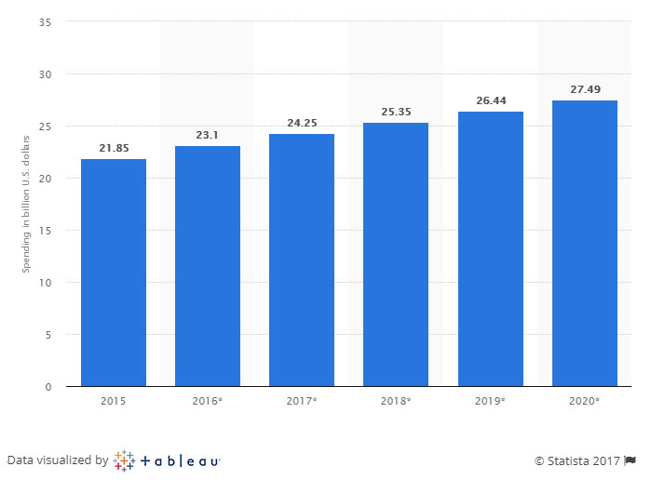
Figure 1 Advertising Spending in The MENA region (Billion USD)
Such growth in the supply of technology is coupled with a growth on the demand side (“Marketing Technology Landscape Supergraphic (2018): Martech 5000 (actually 6,829) - Chief Marketing Technologist,” n.d.). According to eMarketer.com, the total spending on digital advertising in the MENA region will be about $4.63 billion all while being only 10% of total spending on adverting (“An Overview of Digital Advertising in the Middle East - TechRasa,” n.d.)Such growth in interest in digital and the potential growth it still has is a positive sign for the Marketing Technology industry as the need is also going to grow.
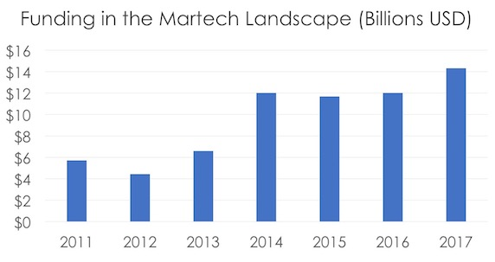
Figure 2 Funding in the Martech Landscape (Billions USD) according to chiefmartec.com
    - Porter’s 5 Forces
Social media marketing tools are relatively young as they could be traced only to sometime between 1997 when SixDegrees.com the first social network was launched (boyd & Ellison, 2007)and 2004 when social media were becoming mainstream(boyd & Ellison, 2007). HootSuite, one of the leaders of the sector, which was launched back in 2008 (Thomas, 2015) could be considered as one of the pioneers of providing support functions to social media managers and digital advertisers in general. However, with the massive growth of digital advertising budgets 266.04B$ (Digital Ad Spending Worldwide, 2016-2021, 2017) this sector has attracted more than 150 companies with tools for monitoring, analyzing and reporting on social media activities (“Best Social Media Monitoring Software,” 2018).
An analysis of data from Crunchbase, a database of startups and tech companies(Ingrid Lunden, 2015), reveals that the industry has a tendency to grow inorganically through mergers and acquisitions, where companies registered under Social Media Management, Social Media Marketing and Social Media Monitoring have an acquisition rate of 10.25% relative to a 6.65% for companies under SaaS category, and an 8.58% for all the registered companies (“Crunchbase,” 2018). Further analysis of the same database shows a decline in the formation rate of new companies in Software Companies as a whole including the Marketing Technology sector. Such an observation is possibly a symptom of intense competition (Tomasz, 2016). Furthermore, the market is dominated by a limited number of companies such as Salesforce, Netsuite, HubSpot, and Zendesk, meaning that competing with them will require aggressive customer acquisition strategies (Tomasz, 2016).
Partnerships started to arise especially through partnership programs e.g. Google partner program and Facebook partner program. These programs not only provide some advertising agencies and digital marketing companies to work closely with Facebook and Google on ways to improve the ways their advertisement placement and data used in the process are collected and displayed (Katerina Bojkov, 2016), but also allows Facebook and Google to exert a power over a limited and select number of agencies. Such power is best displayed by the changes Facebook made to its Graph Application Programming Interface, the primary way for applications to interact with its data, on April 4th, 2018 (“Breaking Changes - Graph API,” n.d.) which made much information previously accessible to companies using the service but who are not partners inaccessible. Although this action was strategically intended to improve Facebook's public image in terms of privacy, it had a significant impact on new social media analytics and management companies. This example illustrates that the digital advertising industry is more concentrated than the support functions industry such as social media management tools. More importantly, the supplier power of advertisement providers (social networks) is more apparent in the fact that they do not need these support function businesses to exist, as they usually provide native analytics solutions on their respective platforms, but the supporting businesses rely almost entirely on information given to them by these advertisement providers. Furthermore, the stronghold these providers have on their data and their massive audience makes it virtually impossible for any attempt at a backward vertical integration by the support industry.
Another threat to this industry is the threat of advertising agencies developing in-house solutions. For large enough advertising agencies of the scale of WPP, Publicis that has started creating an AI assistant to make use of the data its agencies across 30 countries (Adweek, 2017)and even companies with large brand portfolios like Unilever, analytics tools could be replaced by tools developed in-house. Given the large number of social media profiles they manage, and their variety, they are able to achieve a critical mass (Shapiro & Varian, 1998) making the data they collect valuable enough to create reports about performance and benchmarks form the performance of each client. This functionality is generally the advantage analytics tools provide over native solutions on social media platforms, because they are able to build a client list large enough to be able to make use of aggregate data instead of the individual data for each client that an advertising agency has access to. By having a large client base, these agencies are able to create a network effect (Shapiro & Varian, 1998) thereby providing more value because they have a large number of clients, which in turn get them more clients as a result of positive feedback (Shapiro & Varian, 1998). A fact that will negate any benefit from social media analytics tools.
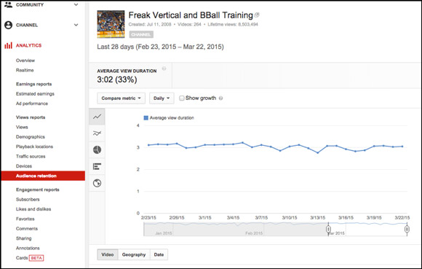
Figure 3 YouTube's analytics dashboard
Entry to this industry is often faced with high barriers. Firstly, these solutions are often pricey and require some sort of training and familiarity, increasing the potential switching costs if a client were to consider a different tool, as is the case with many information technologies (Shapiro & Varian, 1998). Secondly, since the main advantage over the information provided natively on social media platforms is aggregation to add the ability to benchmark, well-established companies like Hootsuite with more than 15 million users (“Hootsuite Surpasses 15 Million Users, Hosts World’s Largest Online Social Media Conference, for Free,” 2016) the network effect is a great leverage to be used as these companies will have more reliable information actionable across a variety of industries. More importantly, the analysis of such data requires usually the knowledge and skill of trained staff in information technology and statistics, with the addition of new disciplines such as machine learning and artificial intelligence (Tomasz, 2016). Such a rush to acquiring this skilled labor that is largely in high demand and low on supply (Dinu & Orban, 2015) makes it harder for new entrants to hire the needed qualified talent.
Advertising agencies possess the ability to vertically integrate such support functions. However, this threat is credible only for large agencies with not only an extensive portfolio of clients but also the ability to hire qualified staff to analyze and collect the necessary data, which is rarely the case in Tunisia. The credible threat, however, in the Tunisian market, is that advertisers do not usually rely on such kind of data to tailor their creative process. The most a support function tool could provide is automating the reporting process, which is a functionality that many Tunisian small agencies would rather do using traditional tools like Microsoft Excel and PowerPoint rather than buy a dedicated service for full information.
The Marketing Technology industry exhibits high entry barriers to new entrants. Mainly in the form of high switching costs and large capital requirements necessary in the form of R&D in order for new entrants to provide differentiated products. Most importantly, the rapid change in privacy laws (“​The EU General Data Protection Regulation,” 2018) that affected the business models of many incumbent firms and websites (Margi, 2018) is a challenge for new entrants as they must develop ways to provide the same value as the incumbents with access to less information. The suppliers of information i.e. social networks, exert a great deal of power especially with partner’s programs where only a select few agencies and companies have access to special treatment while the rest are subject to very deep and drastic changes. Consumers on the other hand show signs of power only in parts of the world where many marketing management and analytics providers operate. In the case of the MENA region, and Tunisia specifically, advertisers and agencies have few choices. The fact that few companies operate in the MENA region, and that those who operate do not have large-scale operations as the whole region still mainly consumes content through traditional media, rivalry among competing firms is unlikely.
  - Competitive Dynamics
The industry of social media management and analytics is a fairly crowded space. G2crowd, a website specializing in software reviews counts between 151 and 168 active solutions in this sector. The competition in this industry occurs on various levels. The most important of which is price, as other competitive advantages of each company grows less relevant with the entry of new companies. In addition, there is a growing tendency in the industry to acquire companies to expand the feature set of services. For instance, HootSuite has acquired 12 companies since its founding in 2008, SproutSocial acquired 1 company, SimplyMeasured which in turn has acquired 2 companies before its acquisition. (“Crunchbase,” 2018).It is worth observing that some companies are avoiding competition on price and features as the market grows saturated and returns on competition on those levels diminish. SocialBakers for instance, integrated artificial intelligence with its digital marketing suite, thus competing on quality of its feature set. SproutSocial was quick to react by introducing Artifical Intelligence features to its current features mainly its publishing one. Using the vast amount of data it has access to, SproutSocial allows its users to schedule social media posts and choose optimal times for them to drive most engagement and interactions with them.
The new wave of integration of machine learning and artificial intelligence is still in its infancy, meaning that although companies harnessing its power have an advantage over those who do not, it is still possible to overcome such advantage. Moreover with services like Google Cloud and Amazon AWS offering access to computing power and powerful machine learning tools this advantage is likely to dull over time. The opportunity for a company like Kpeiz adopting a fast-follower strategy is to quickly imitate these features and continue providing it at a cheaper price for untapped markets such as the MENA region.
The MENA region is still a rather small market for advertisers in general and digital advertisers more specifically. In fact, the ad spend of the region in 2018 of about 25.35 Billion $ is dwarfed by the spending in Western Europe, Asia Pacific and North America which ranges between 104.04 and 217.81 Billion $ (“Global advertising spending from 2014 to 2020, by region (in billion U.S. dollars),” n.d.) only 10% of which is on digital which makes the market unattractive due to the difficulty of gathering data and the inability to use such data if it exists on a profitable scale as only large corporations will be able to afford to gather and to analyze it. Making the MENA region a very suitable market for Kpeiz to grow.
Growth in the MENA region and Tunisia specifically will definitely be slow given the slow market dynamics for digital marketing. It is however large enough for Kpeiz to ensure its financial viability especially with its low cost-structure and nonexistent R&D costs. During the market growth period, it is crucial that Kpeiz keep collecting data and applying techniques learned from more developed markets to it. Indeed, one of the major difficulties that face social media analytics in the region is the diversity and variety of dialects and the ways to write them, be it in Arabic letters or Latin ones. Large players in the industry might possess large datasets and the know-how of getting insights from them, yet those are not transferable to the MENA region which gives an edge. After 3 years of activity, it has successfully amassed data about over 40,000 social profiles and more than 2000 Arabic brands across the region. Therefore Kpeiz is already capable of competing on the basis of price and number of features with the heavy development underway, coupled with the valuable data it currently possesses, it has successfully created a strong competitive advantage.

Social Media Management Tools | Buffer | Hootsuite | Sprout Social | Agora Pulse | Sendible | Everypost
Free plan or free trial? | Free plan and 14-day free trial | Free plan and 30-day free trial | 30-day free trial | 15-day free trial | 30-day free trial | Free plan and 14-day free trial
Main products | - Publish  - Reply  - Analyze | - Ads  - Amplify  - Campaigns  - Insights  - Impact | - Analytics  - Smart Inbox  - Publishing tools  - Social CRM | - Social inbox  - Publishing  - Monitoring  - Reports  - CRM  - Facebook content apps | - Social inbox  - Publishing and collaboration  - Analytics  - CRM  - Listening | - Content curation  - Publishing and collaboration
Social networks supported | - Facebook  - Twitter  - LinkedIn  - Google+  - Instagram  - Pinterest | - Facebook  - Twitter  - LinkedIn  - Google+  - Instagram  - WordPress  - YouTube  - 100+ partner apps and integrations | - Facebook  - Twitter  - LinkedIn  - Google+  - Instagram | - Facebook  - Twitter  - LinkedIn  - Google+  - Instagram | - Facebook  - Twitter  - LinkedIn  - Google+  - Instagram  - Pinterest  - WordPress  - YouTube  - Tumblr  - Foursquare and more | - Facebook  - Twitter  - LinkedIn  - Google+  - Tumblr
Table 1: Functionality comparison

  - Company Presentation
    - Mission Statement
Bridge the gap between advertisers and audiences reliably and ethically.
    - Products and Services
      - Product
Kpeiz, as a SaaS, offers online subscription-based services related to social media management and analytics. The main service, named Kpeiz, aims to be a one-stop solution for managing, analyzing and creating social media content. The tool is still under heavy development and lacks many features to be called a one-stop solution. The four general features the tool offers are benchmarking, optimization, monitoring, and reporting. Each of these features assists content creators and advertisers on social media to evaluate their performance relative to their previous levels and to the performance level of their competitors, through reporting and benchmarking. And demonstrates ways this performance could improve through monitoring and optimization. The service is currently offered in English and French for the Tunisian, Moroccan and Egyptian markets, an Arabic version is under development.
      - Promotion
Kpeiz is currently being marketed mainly on Facebook, LinkedIn, and Google. Although most of the promotion is done through paid means, an effort is underway to improve the organic reach of the tool, especially through Search Engine Optimization. In addition, Kpeiz has relied heavily so far on word of mouth especially in the Tunisian market. Ultimately, the company aims to reach its potential customers through a mix of word of mouth and digital presence, organic and paid.
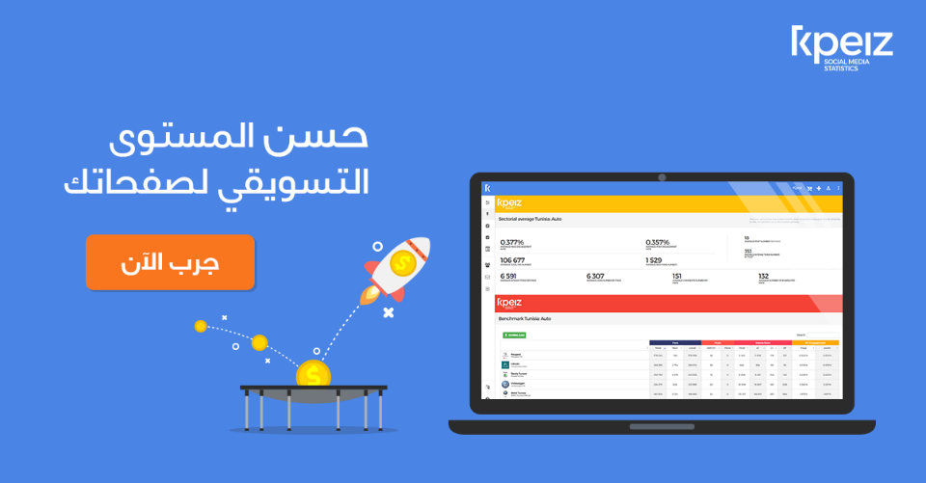
Figure 4 Facebook advertisement targeting Egypt
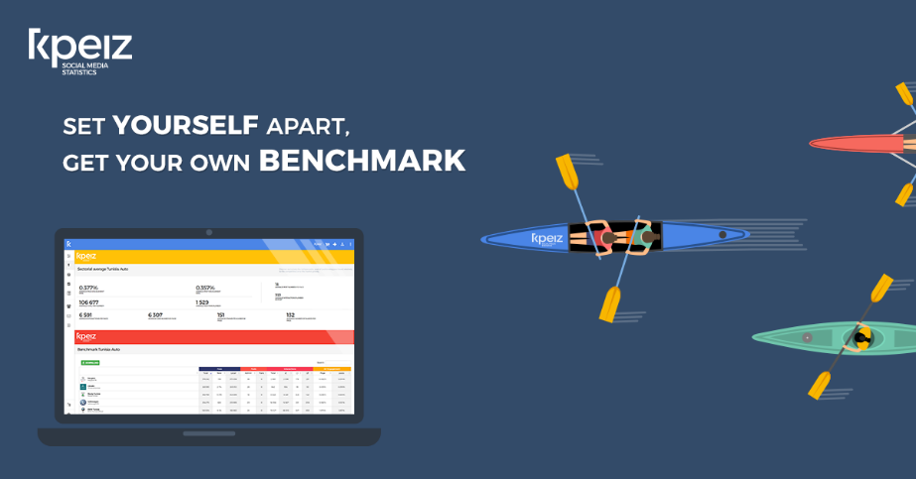
Figure 5 Facebook advertisement targeting Romania
In accordance with Kpeiz’ multi-domestic strategy, the communication language is tailored for each country to match not only the language but also the local dialect. Experiments from Facebook advertising campaigns conducted over the period of 2 months have revealed that audiences are more responsive when the language of ads matches theirs.
In Tunisia, the sales team has leveraged the geographical proximity to leads to fast-track to conversion through the sales funnel phases. This tactic has proven rather effective, as a result, a sponsorship plan is under development to allow it to scale where word of mouth is rewarded with financial incentives.
      - Price
Kpeiz uses a hybrid pricing strategy; a subscription revenue model and a competition based revenue model. With the subscription revenue model, the user pays a predetermined fee in exchange for a contract limited by time. Under this contract, there are limitations to the level and scope of usage of the service (Dempsey & Kelliher, 2011). As for the competition based revenue, where the prices were set based on what the market price is for similar services (Dempsey & Kelliher, 2011).
The prices range from 200DT/Month for the Starter Pack to 2200DT/Month for the Wide pack. The tiers have been developed based on offerings from similar services. For each tier, the user gets to manage more social media profiles, and have access to more sectorial benchmarks for the MENA region.
      - Place
    - SWOT Analysis
      - Strengths
Being a startup with limited resources, Kpeiz opted for a copycat strategy, effectively eliminating expenses on research and development. Mimicking features from leaders in the sector relying only on a small team of developers, marketers, and salespeople in just a year and a half (Shenkar, 2010). Coupled with a cost leadership strategy, where the cost structure is comprised essentially of paying utilities, salaries, and advertisements, Kpeiz is capable of offering the same functionality as its competitors at a not only a competitive price but also have a higher room for price flexibility. In addition, Kpeiz is a twin company of KNSD, an established advertising agency in the Greater Tunis area, whereby Kpeiz has been able to leverage the client portfolio and close relationship to push the product and start the word of mouth.
      - Weaknesses
For agencies who have already acquired a subscription with another competing service, the switching cost to Kpeiz's solution is extremely high because of high prices and the subscription model often used by similar services(Stirling, 2003). In addition, in the Tunisian market using tools from foreign countries is often used as a sign of prestige and is sought after by clients (Bilkey & Nes, 1982). Furthermore, Kpeiz struggles with attracting the necessary talent for development and data science.
To mitigate these weaknesses, Kpeiz firstly proposes giving the service free of charge for clients who are currently subscribed to another service and are willing to commit to a one-year subscription with Kpeiz for the remainder of their contract with the competing service. Secondly, Kpeiz is focusing its communication on building credibility to reduce the impact of the county of origin on Tunisian consumers. Finally, a collaboration with a non-profit is underway to attract developers and data scientists from foreign countries.
      - Opportunities
Kpeiz is the first solution of its scale in Tunisia, and likely the whole North Africa region. Being a first mover in a region with growing need for analyzing social media activity as advertisers spend about 13$ US per person (“Open Sigma - Détail des investissements publicitaires,” 2018), Kpeiz has the potential of gaining a stronghold in the region (Stirling, 2003) and building entry barriers for new entrants. To maintain such advantage Kpeiz will work on increasing switching costs, effectively creating a lock-in effect for customers through creating a variety of complementary tools as part of the service where they are usable only as part of Kpeiz’ ecosystem (Stirling, 2003)
      - Threats
With the latest developments in data protection and privacy scandals, social media like Facebook have been quick to hide some of the previously available information causing major issues with the implemented data collection flow in the industry as a whole (“How the latest Facebook API changes will affect you — Get Social Digital Marketing,” 2018). Thus disrupting the value previously provided and worsening the quality of the reports and analytics provided. In order for Kpeiz’ business model to sustain such changes, plans are being executed to include predictive analysis features and machine learning capabilities that rely on publically available information about clients’ social media to provide value independently from what future changes could bring.
Another threat is that these platforms have been working on improving their native tools for analytics, such as Google analytics which is by far a prime example of what could be the case for Facebook, Twitter, Pinterest, Instagram and other social media. While this threat might deter some customers from opting for a more comprehensive service for managing and analyzing their social media, it does not interfere with the core competency of Kpeiz which is analyzing, managing and benchmarking social media information across industries as opposed to information only about the user provided natively.
The case could be worsened with the sort of legislation being prepared in the EU where access to user information will be far stricter and private data protection will be a higher priority for social media platforms(“​The EU General Data Protection Regulation,” 2018), especially that more similar legislation, ePrivacy regulation, is being developed and is expected to strike a blow to ad revenue for small publishers (“GDPR could crush media business models,” 2018). This could translate into lower quality analytics and require other sources and means for data collection for advertisers. Addressing this legislation is difficult as its impact is yet to be seen, Kpeiz, however, plans on keeping a close eye on how advertisers and publishers will react to it, adjusting its strategy accordingly.
    - Market Analysis
The Tunisian market boasts between 6 and 7 million monthly active users on Facebook alone (“Facebook Audience Insights,” 2018), which not only creates an attractive market for advertisers and advertising agencies alike but creates a need for tools that provide a support function for such an ecosystem.
In 2017, advertisers spent 7.35 Million Tunisian dinars for digital advertisement(“Open Sigma - Détail des investissements publicitaires,” 2018). Although no thorough research or reliable secondary data is available, experts in digital marketing agencies say that most agencies in Tunisia do not have access to support tools for their social media analytics and reporting.
This is mainly due to two reasons, the first of which is that most popular tools are based in Europe or the United States, meaning they only accept payments in Euros or US dollars. The second reason is that even when an agency is able to pay for these support functions in foreign currency they are often reluctant to do so because of the high price and the volatility of the Tunisian Dinar.
According to Google business, there are about 160 registered digital advertising agencies. Which constitute the main target for Kpeiz. However, a broader target is any person managing social media accounts professionally which includes freelancers, and businesses managing their social media in-house. A more accurate estimate is provided by Facebook audience insights which estimate the number of people who manage social media accounts and work in business and marketing in Tunisia and who have paid to advertise on Facebook in the last 90 days to be about 3500 to 4000 people. These numbers provide a reasonable market potential for Kpeiz to grow its customer base and prepare for growth and expansion into neighboring regions.
      - Customer characteristics
Of the potential 4000 clients, we can distinguish four types of clients.
- Advertising agencies: regardless of their size, Kpeiz is an attractive service for most agencies mainly for the reporting and analytics functionalities. With the added benefit of paying in the local currency instead of using often hard ways of buying subscriptions in currency.
- Businesses that manage social media in-house: some businesses, like Al Mazraa for instance, prefer to manage social media in-house to cut on expenses. Kpeiz targets them with a package that includes an optimization tool that gives the users insights into how to improve various aspects of communication on social media based on data about the whole industry.
- Independent and freelancers: for this segment, Kpeiz is mainly providing sectorial benchmarks allowing these users to assess their performance against reliable and accurate benchmarks through the tool https://benchmarks.digital
- Potential clients who already bought a subscription to a competing service: what Kpeiz provides for this segment is not only a cheaper solution for the same functionality, but a more accurate benchmark of the Tunisian social media scene compared to the other tools who have a lower penetration rate in the market. To mitigate the switching costs issue, Kpeiz offers using the tool for free during the remaining period of subscription with the competing service, and free training.

    - Market Position
In the vein of offering competitive prices, Kpeiz chose a same for less value proposition. Such a strategy is advisable for new market entrants similar to Kpeiz (Mitchell & Bruckner Coles, 2004) as to allows them to capitalize on their cost savings, consequently providing good value at a lower cost effectively gaining market share. To fully implement such a strategy, a great deal of focus has been put to establish a frame of reference for Kpeiz. A frame of reference serves as a guideline that dictates the associations that will be used as Points Of Parity and Points of Difference relative to the competition. (Keller, Sternthal, & Tybout, 2002). Points of parity serve as a signal to the customer to perceive the service “as a legitimate and credible player within that frame” (Keller et al., 2002)
For the marketing technology industry, and the social media management and analytics sector specifically, these points of parity are managing data from client’s social media profiles, and analyzing them. The management functionality entails planning social media content, publishing social media posts, managing multiple accounts, responding to inquiries, automating and scheduling social media posts, storing content and archiving posts (“Best Social Media Management Software in 2018 | G2 Crowd,” n.d.). The analysis functionality entails providing tracking and sharing data, evaluating audience size, engagement, and demographics, providing sentiment analysis, aggregating social media statistics, and comparing data from individual campaigns, posts, or pages (“Best Social Media Analytics Software in 2018,” n.d.).
As for points of difference Kpeiz is positioned based on three types of them: brand performance associations, brand imagery associations, and consumer insight associations (Keller et al., 2002). Brand performance associations, relating to intrinsic properties of Kpeiz’ brand, have resulted in a service that is truly adapted to consumers in the MENA region, unlike any competitor. This differentiation comes from communication in Arabic and from a focus on trends and data collection in this region. Brand imagery associations come from Kpeiz being active in MENA countries and displaying this activity in its communication in a fashion that makes potential customer feel familiarity with the brand. Finally, to build customer insight associations, Kpeiz often communicates with clients on the basis of being a solution to their frustrations be it the repetitive tasks of reporting to the time-consuming task of compiling insights from social media activity.
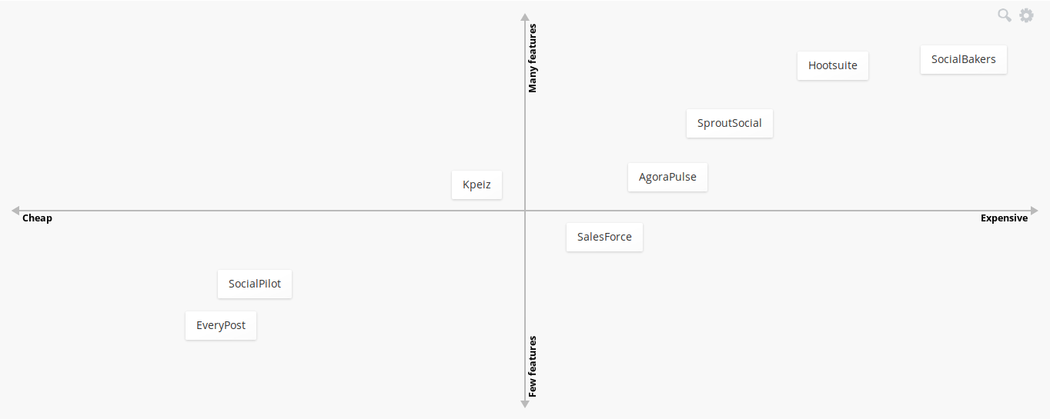Figure 6: Perceptual map of the social media management and analytics industry
(“Best Social Media Management Software in 2018 | G2 Crowd,” n.d.)

- Internship Description
  - Duties and Responsibility
- Study and understand the Social Media Marketing industry in target markets: Egypt, Jordan, Morocco, and Dubai.
- Develop a pricing strategy based on various factors such as competitor’s price, market purchase power and costs of the company.
- Improve and update the company’s website homepage to increase its conversion rate.
- Develop an editorial line for the company’s blog as part of its inbound marketing strategy.
- Gather information about prospects in the Tunisian markets as part of the sales process.
- Collaborate with sales manager to develop and improve sales scripts.
- Develop a factorial experiment to cross-test the impact of various variables on the conversion rate of Facebook advertisements.
- Study direct and indirect competitors operating in the target markets to develop a communication strategy based on points of differentiation.
- Assist in the development of long-term business goals, strategies and study their operational implications.
- Create advertisement campaigns targeting Egypt, Jordan, Hungary, and Romania on Facebook and LinkedIn.
  - Learning outcomes
- Understand the sales process throughout its steps, fully online and partially online.
- Use statistical techniques such as A/B testing to improve and support the decision process with regards to tailoring the communication and promotion content to different audiences.
- Use marketing knowledge to supporting decision making with regards to strategic and tactical decisions.
- Familiarity with the advertising process on various social media, mainly Facebook and Linkedin.
- Develop an email marketing strategy to communicate with leads and prospects throughout various stages of the sales pipeline.

- Internship Study
  - Internship Study Objectives
Based on the fact Kpeiz is a young business venture, the strategic foundations of its business model and communication are yet to be fully developed. During this internship, an effort was made to assist with the creation of a strategic foundation for all operational actions performed daily. Mainly to assist the communication strategy and lead generation strategy, which was at the core of the internship duties. As such, a model explaining the factors affecting the adoption of SaaS solutions was derived from various academic sources and then adapted to the Tunisian market and to the sector of activity of Kpeiz. The results of this study will serve as a starting point for future communication campaigns, and even as a guide for the sales team to identify pain points in the process of adoption of the service, and bring forward perceived potential benefits from it.
  - Context and Background
Social networks are by far one of the most influential global phenomena since the Internet itself (Conole, Galley, & Culver, 2011) Research shows that these networks are being used for gaining friends, socializing with existing ones, getting information and entertainment (He et al., 2013).⁠ Such wide use of social media generates a variety of data in large volumes that reflect a change in online consumer behavior. Consumers are becoming an ever important part of the promotion mix of brands online, as trust in other consumer’s opinion outweighs that of traditional authorities (Muntinga, Moorman, & Smit, 2011). In fact, it is crucial for marketers and advertisers to ride this wave of digital interaction between consumers and brands.
Marketing in the digital age has ushered in new concepts explaining how consumers behave online. Consumer-to-Consumer interactions about brands, for instance, known as electronic word of mouth (eWOM) and User Generated Content (UGC) describing content that is produced and shared online by consumers, are instances of such concepts (Muntinga et al., 2011). In order to understand these concepts and integrate them into communication strategies and brand management, it is important that businesses and advertisers alike tap into data generated on these networks and develop streamlined workflows and tools for this goal.
Data mining is one discipline that fits into this vein. It allows finding “new [actionable] information in a data set that is hidden or latent” (Barbier & Liu, 2011) (Muntinga et al., 2011). Techniques from data mining provide marketers with tools necessary for the analysis of social media data. However, this type of analysis is an arduous task and presents some unique challenges (Barbier & Liu, 2011). The challenges can be categorized into three types. Firstly, the volume of data generated by social media is large, forcing businesses to invest in infrastructure and staff just to handle the collection and storage of data. Secondly, datasets are often noisy and require heavy investment in data warehousing to create a pipeline capable of cleaning the data. Last, the open nature of information shared and created on social media makes it dynamic and subject to frequent changes over short periods of time (Barbier & Liu, 2011) The more relevant issue is that generally, companies do not possess the capabilities to perform those tasks in the context of competitive intelligence (Dai, Kakkonen, & Sutinen, 2011)
Given these issues facing businesses wishing to benefit from the competitive intelligence capabilities of social media, software as a service business model offers a remedy rendering them more addressable. Firstly, SaaS solutions eliminate the need for managing data locally, instead, the data is stored in a central location managed by the vendor (Dan, 2007). Secondly, SaaS solutions are cheaper relative to traditional commercial off-the-shelf software solutions as it allows for savings on IT system maintenance, support and upgrade costs (Dan, 2007). In addition, the pricing model of SaaS usually involves a subscription fee or a variation of it, as opposed to a one-time upfront fee which could prove a substantial initial investment for businesses.
The research problem of this study is to understand the relative importance of various aspects and benefits of social media management and analytics tools and SaaS services that are attractive to the Tunisian market.
  - Approach and Methodology
Various models have been used to explore the driving factors of SaaS adoption. The technology adoption model (TAM), proposed originally by (Davis, 1986) is one such model. It has undergone various modifications to include constructs other than the original Perceived Usefulness (PU), Perceived Ease of Use (PEoU) and Attitude Toward Using (ATU) (Davis, 1986). The modification most relevant to this study is one proposed by (López-Nicolás, Molina-Castillo, & Bouwman, 2008) that adds eight constructs based on the diffusion theory in a model known as TAM-DTM: Media Influence, Social Influence, Perceived Flexibility Benefits (PB), Perceived Status Benefits, Attitude toward Mobile Innovations, PU, PEOU, and BI. The model used in this study is an adaptation of the latter by developed (Wu, 2011). It includes the following constructs: Marketing Efforts (ME), Social Influence (SI), Perceived Benefits (PB), Attitude toward Technology Innovation (ATI), Perceived Usefulness (PU), Perceived Ease of Use (PEoU), and Behavioral intention (BI).

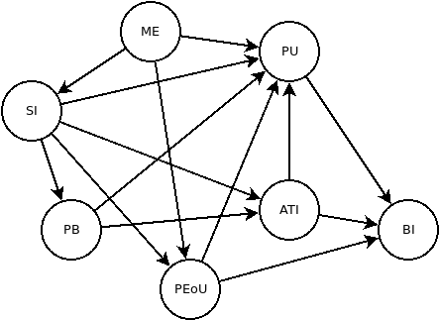Figure 7: Research model
- The following hypotheses have been tested:H1a: ME has a positive effect on SI.
- H1b: ME has a positive effect on PEOU.
- H1c: ME has a positive effect on PU.
- H2a: SI has a positive effect on ATI.
- H2b: SI has a positive effect on PB.
- H2c: SI has a positive effect on PU.
- H2d: SI has a positive effect on PEOU.
- H3a: PB has a positive effect on ATI.
- H3b: PB has a positive effect on PU.
- H4a: ATI has a positive effect on PU.
- H4b: ATI has a positive effect on BI.
- H5a: PEOU has a positive effect on PU.
- H5b: PEOU has a positive effect on BI.
- H6: PU has a positive effect on BI.
The proposed survey contained 21 questions corresponding to 7 constructs (see appendix 1) in the form of five-point Likert scale ranging from 1 (strongly disagree) to 5 (strongly agree). The scales’ reliability has been checked in a meta-analysis by (King & He, 2006) showing that they all have average Cronbach’s Alphas higher than 0.8. The survey addresses a population of interest comprised of all marketers who are directly responsible for social media digital marketing in their businesses, and marketing managers in businesses using social media digital marketing. The sample size necessary for this study according to (Wixom & Watson, 2001) is at least 30 in order for it to fulfill the statistical requirements of the Partial Least Squares path modeling.
The survey is a self-administered online survey that was distributed to an initial group of 10 persons who fulfilled the criteria set in the population of interest definition. This group, in turn, distributed the survey to other persons who they know fulfill the required criteria. This sampling method is known as snowball sampling, a non-probabilistic method that has been chosen given the limited time and other resources necessary for other sampling methods. Ultimately, the survey reached 52 unique persons and got 37 responses at a 71.2% response rate. The average completion time was 4:74 minutes.
  - Findings
The software used for analyzing the results of the survey is SmartPLS. The results presented are extracted from running its PLS algorithm.
    - Reliability
 | Cronbach’s alpha | Composite reliability | Average variance extracted
ATI | 0.484 | 0.636 | 0.423
BI | 1 | 1 | 1
ME | 0.452 | 0.436 | 0.382
PB | 0.636 | 0.795 | 0.578
PEoU | 0.546 | 0.689 | 0.423
PU | 0.875 | 0.915 | 0.729
SI | 0.661 | 0.815 | 0.598

    - Path coefficients significance
Path | P-value
ATI → BI | 0.187
ATI → PU | 0.398
ME → PEoU | 0.510
ME → PU | 0.915
ME → SI | 0.056
PB → ATI | 0.971
PB → PU | 0.003*
PEoU → BI | 0.019*
PEoU → PU | 0.120
PU → BI | 0.284
SI → ATI | 0.157
SI → PB | 0.283
SI → PEoU | 0.131
SI → PU | 0.552
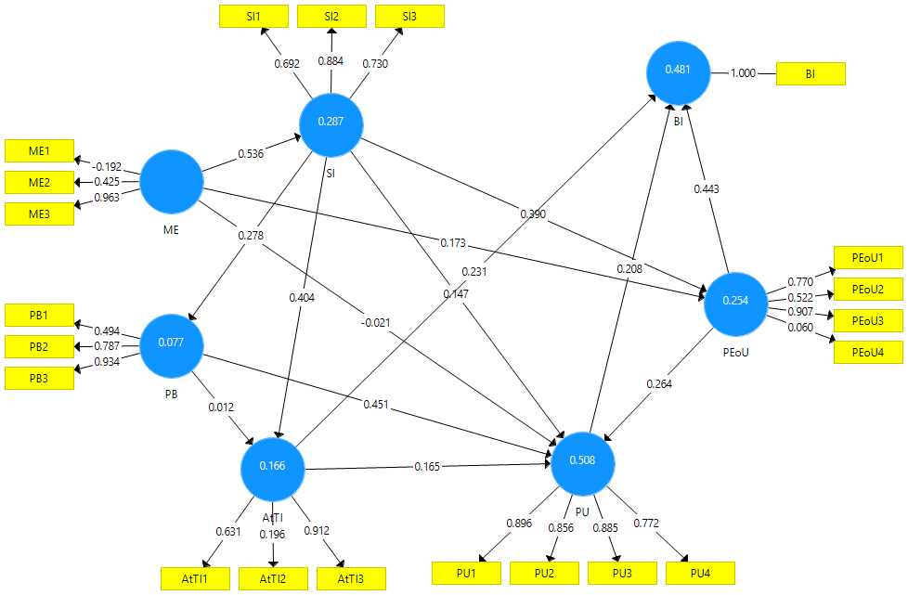Figure 8: Model’s paths coefficients
At a significance level of 5%, only two paths are significant; PB → PU and PEoU → BI. Meaning that the model supported the hypotheses H3b and H5b. The largest path coefficients are between ME (marketing efforts) and SI (social influence) with 0.536, PEoU (perceived ease of use) → BI (behavioral intention) with 0.443, followed by PB → PU with 0.451 and lastly SI (social influence) → ATI (attitude toward innovation) with 0.404. For the endogenous values of the constructs, it can be seen that the Perceived Usefulness has the highest R² at 0.508 followed by Perceived Ease of Use at 0.254 and Social influence at 0.287. That is Perceived Usefulness, Perceived Ease of Use and Social influence explain respectively 50.8%, 24.5% and 28.7% of the model.
The questions that contributed the most to constructs are "A social media management tool is easy to get and purchase." corresponding to ME3 at 0.963, "Expert-opinion affects my decision to use a social media management tool.” corresponding to SI2 at 0.884, “It is easy to learn using a social media management tool.": corresponding to PEoU3 at 0.907, “Adopting a social media management tool enables me to do my job faster." corresponding to PU1 at 0.896, "I want to be a pioneer by using social media management tools." corresponding to AtTI3 at 0.912, and "Adopting a social media management tool is a way to increase confidence." corresponding to PB3 at 0.934.
- Discussion and Conclusion
The model has supported only two hypotheses out of the 14 proposed, in contrast with previous findings of applications of similar models (King & He, 2006; López-Nicolás et al., 2008; Wu, 2011). This is, in fact, most likely due to the quality of the sampling method and the resulting sample. It is, however, safe to assume that the findings of this survey in that Perceived Usefulness, Perceived Ease of Use and Social Influence not only have a positive impact on the Behavioral Intention, but they are important determinants of it (King & He, 2006).
It is also noteworthy that Marketing Efforts affect directly the three former constructs, alluding to the importance of initiating the process of adoption through marketing efforts. Furthermore, Social Influence seems to wield a positive effect on Perceived Benefits, Attitude toward Innovation, Perceived Usefulness and Perceived Ease of Use. In conjunction with the fact that expert-opinion was the variable that contributed the most to the explanation of Social Influence, this finding is consistent with the innovation adoption lifecycle where innovators and early adopters are the ones to spread and push the innovation. In addition, this finding is consistent with Hofstede’s Power Distance Index, where Tunisia scores high, not unlike Egypt and UAE (KARIMA, 2013; “Power Distance Index,” n.d.). This implies that the communication and marketing efforts of Kpeiz must address experts in the field who in turn will propagate and push the adoption of the service.
Despite many specificities of the Tunisian market with regards to technology adoption, marketing practices and business tendencies, this model, although fairly limited, pushes towards the idea that the drivers of adoption are similar across countries, it is, however, their relative importance that changes. With the perception that Social Media Management Tools in a SaaS business model is useful and easy to use, it is up to businesses to capitalize on these facts to inform and educate innovators and early adopters, while relying on their feedback to reach a product market fit and satisfy the needs of the targeted segments.
It is important however to not limitations of the findings of this study. A better sampling method preferably probabilistic would give more credibility to these results. Moreover, the Technology Acceptance Model focuses on self-reports on future behavior which could skew the results of the survey. In addition, the model is inherently concerned with employees’ intention to adopt technology instead of considering the strategic and managerial context of the adoption decision (Wu, 2011).
In terms of branding, Kpeiz must establish a clear frame of reference in the mind of consumers be it early adopters or other. One of the possible issues facing the tool is that the market may not be familiar with what it does. Therefore in order for the service to bypass the awareness to interest and desire, it is important that consumer understand its function relative what other established tools do (Keller et al., 2002).
- References

Adweek. (2017). Publicis Groupe Is Building an AI-Powered Professional Assistant for Its 80,000 Employees. Retrieved May 29, 2018, from https://www.adweek.com/agencies/publicis-groupe-is-building-an-ai-powered-professional-assistant-for-its-80000-employees/
An Overview of Digital Advertising in the Middle East - TechRasa. (n.d.). Retrieved May 28, 2018, from http://techrasa.com/2017/07/25/overview-digital-advertising-middle-east/
Arab world could see US$69 billion in online payment transactions per annum by 2020 – PAYFORT. (n.d.). Retrieved May 23, 2018, from https://www.payfort.com/press/arab-world-see-us69-billion-online-payment-transactions-per-annum-2020/
Barbier, G., & Liu, H. (2011). Social Network Data Analytics. (C. C. Aggarwal, Ed.), Social Network Data Analytics. Boston, MA: Springer US. https://doi.org/10.1007/978-1-4419-8462-3
Best Social Media Analytics Software in 2018. (n.d.). Retrieved from https://www.g2crowd.com/categories/social-media-analytics
Best Social Media Management Software in 2018 | G2 Crowd. (n.d.). Retrieved May 28, 2018, from https://www.g2crowd.com/categories/social-media-mgmt
Best Social Media Monitoring Software. (2018). Retrieved from https://www.g2crowd.com/categories/social-media-monitoring?segment=all
Bilkey, W. J., & Nes, E. (1982). Country-of-Origin Effects on Product Evaluations. Journal of International Business Studies, 13(1), 89–100. https://doi.org/10.1057/palgrave.jibs.8490539
boyd, danah m., & Ellison, N. B. (2007). Social Network Sites: Definition, History, and Scholarship. Journal of Computer-Mediated Communication, 13(1), 210–230. https://doi.org/10.1111/j.1083-6101.2007.00393.x
Breaking Changes - Graph API. (n.d.). Retrieved May 26, 2018, from https://developers.facebook.com/docs/graph-api/changelog/breaking-changes/#4-4-2018
Catteddu, D. (2010). Cloud Computing: Benefits, Risks and Recommendations for Information Security (pp. 17–17). https://doi.org/10.1007/978-3-642-16120-9_9
Conole, G., Galley, R., & Culver, J. (2011). Frameworks for understanding the nature of interactions, networking, and community in a social networking site for academic practice. International Review of Research in Open and Distance Learning, 12(3), 119–138. https://doi.org/10.1111/j.1083-6101.2007.00393.x
Crunchbase. (2018, March). Retrieved from https://www.crunchbase.com
Dai, Y., Kakkonen, T., & Sutinen, E. (2011). MinEDec : A Decision-Support Model That Combines Text-Mining Technologies with Two Competitive Intelligence Analysis Methods. Scenario, 3, 165–173. Retrieved from http://www.mirlabs.org/ijcisim/regular_papers_2011/Paper20.pdf
Dan, M. (2007). The business model of “Software-As-A-Service.” Proceedings - 2007 IEEE International Conference on Services Computing, SCC 2007, (Scc), 701–702. https://doi.org/10.1109/SCC.2007.118
Davis, F. D. (1986). A technology acceptance model for empirically testing new end-user information systems: Theory and results. Management. https://doi.org/oclc/56932490
Dempsey, D., & Kelliher, F. (2011). Industry trends in Cloud Computing - Alternative Business-to-Business Revenue Models.
Digital Ad Spending Worldwide, 2016-2021. (2017). Retrieved from http://www.emarketer.com/Chart/Digital-Ad-Spending-Worldwide-2016-2021-billions-change-of-total-media-ad-spending/211873
Dinu, J., & Orban, R. (2015, October). Galvanize Data Science with Jonathan Dinu and Ryan Orban. Retrieved from https://softwareengineeringdaily.com/2015/10/29/galvanize-data-science-with-jonathan-dinu-and-ryan-orban/
Facebook Audience Insights. (2018, March). Retrieved from https://www.facebook.com/ads/audience-insights
GDPR could crush media business models. (2018). Retrieved May 27, 2018, from https://finance.yahoo.com/news/new-european-regulations-crush-media-business-models-194045011.html?guccounter=1
Global advertising spending from 2014 to 2020, by region (in billion U.S. dollars). (n.d.). Retrieved from https://www.statista.com/statistics/258071/global-advertising-spending-by-region/
He, W., Zha, S., & Li, L. (2013). Social media competitive analysis and text mining: A case study in the pizza industry. International Journal of Information Management, 33(3), 464–472. https://doi.org/10.1016/j.ijinfomgt.2013.01.001
Hootsuite Surpasses 15 Million Users, Hosts World’s Largest Online Social Media Conference, for Free. (2016, October). Retrieved from https://hootsuite.com/newsroom/press-releases/hootsuite-surpasses-15-million-users-hosts-worlds-largest-online-social-media-conference-for-free
How the latest Facebook API changes will affect you — Get Social Digital Marketing. (2018). Retrieved May 27, 2018, from https://www.getsocialmarketing.com.au/news-notes/2018/4/10/latest-facebook-and-instagram-api-changes-what-this-means-for-you
Ingrid Lunden. (2015). AOL/Verizon Completes Spinout Of CrunchBase Funded By Emergence Capital | TechCrunch. Retrieved May 26, 2018, from https://techcrunch.com/2015/09/22/aolverizon-completes-spinout-of-crunchbase-funded-by-emergence-capital/
KARIMA, J. (2013). BUSINESS CULTURE DIFFERENCES IN COMMUNICATION BETWEEN FINLAND AND TUNISIA.
Katerina Bojkov. (2016). Why are Facebook Partner Programs a “must have.” Retrieved May 26, 2018, from https://embedsocial.com/blog/why-are-facebook-partner-programs-a-must-have-for-other-social-networks/
Keller, K. L., Sternthal, B., & Tybout, A. (2002). Three questions you need to ask about your brand. Harvard Business Review.
King, W. R., & He, J. (2006). A meta-analysis of the technology acceptance model. Information and Management, 43(6), 740–755. https://doi.org/10.1016/j.im.2006.05.003
López-Nicolás, C., Molina-Castillo, F. J., & Bouwman, H. (2008). An assessment of advanced mobile services acceptance: Contributions from TAM and diffusion theory models. Information & Management, 45(6), 359–364. https://doi.org/10.1016/j.im.2008.05.001
Margi, M. (2018). “We just don’t have the resources” GDPR forces popular websites and apps to shut down. Retrieved May 27, 2018, from https://www.telegraph.co.uk/technology/2018/05/24/just-dont-have-resources-gdpr-forces-popular-websites-apps-shut1/
Marketing Technology Landscape Supergraphic (2018): Martech 5000 (actually 6,829) - Chief Marketing Technologist. (n.d.). Retrieved May 28, 2018, from https://chiefmartec.com/2018/04/marketing-technology-landscape-supergraphic-2018/
Mitchell, D. W., & Bruckner Coles, C. (2004). Establishing a continuing business model innovation process. Journal of Business Strategy, 25(3), 39–49. https://doi.org/10.1108/02756660410536991
Muntinga, D. G., Moorman, M., & Smit, E. G. (2011). Introducing COBRAs. International Journal of Advertising, 30(1), 13–46. https://doi.org/10.2501/IJA-30-1-013-046
Open Sigma - Détail des investissements publicitaires. (2018). Retrieved from http://www.businessnews.com.tn/open-sigma-detail-des-investissements-publicitaires,520,77466,3
Power Distance Index. (n.d.). Retrieved from http://www.clearlycultural.com/geert-hofstede-cultural-dimensions/power-distance-index/
Shapiro, C., & Varian, H. R. (1998). Information Rules: A Strategic Guide to the Network Economy. Harvard Business Review Press. Retrieved from https://www.amazon.com/Information-Rules-Strategic-Network-Economy/dp/087584863X?SubscriptionId=0JYN1NVW651KCA56C102&tag=techkie-20&linkCode=xm2&camp=2025&creative=165953&creativeASIN=087584863X
Shenkar, O. (2010). Copycats: how smart companies use imitation to gain a strategic edge. Strategic Direction, 26(10), 3–5. https://doi.org/10.1108/02580541011080474
Sigma Conseil. (2014). Open Sigma 2014. Retrieved from http://www.sigma.tn/Fr/upload/1393236288.pdf
Stirling, D. A. (2003). Information rules. ACM SIGMOD Record (Vol. 32). https://doi.org/10.1145/776985.776997
​The EU General Data Protection Regulation. (2018).
Thomas, K. (2015). A Brief History of Hootsuite. Retrieved from https://techvibes.com/2015/08/26/a-brief-history-of-hootsuite-2015-08-26
Tomasz, T. (2016). The Decline of New SaaS Company Formation. Retrieved May 26, 2018, from http://tomtunguz.com/rate-of-software-company-formation/
Wixom, B. H., & Watson, H. J. (2001). An Empirical Investigation of the Factors Affecting Data Warehousing Success. MIS Quarterly, 25(1), 17. https://doi.org/10.2307/3250957
Wu, W. W. (2011). Developing an explorative model for SaaS adoption. Expert Systems with Applications, 38(12), 15057–15064. https://doi.org/10.1016/j.eswa.2011.05.039
Appendix

Variable | Question
ME1 | Adopting a social media management tool is attractive to me.
ME2 | Adopting a social media management tool is cost-effective.
ME3 | A social media management tool is easy to get and purchase.
SI1 | Mass media affects my decision to use a social media management tool.
SI2 | Expert-opinion affects my decision to use a social media management tool.
SI3 | The word-of-mouth affects my decision to use a social media management tool.
PB1 | Adopting a social media management tool is a way to follow a trend in my industry.
PB2 | Adopting a social media management tool is a symbol of prestige.
PB3 | Adopting a social media management tool is a way to increase confidence.
ATI1 | I am interested in news about social media management tools.
ATI2 | I enjoy trying new techonlogies and services.
ATI3 | I want to be a pioneer by using social media management tools.
PU1 | Adopting a social media management tool enables me to do my job faster.
PU2 | Adopting a social media management tool enables me to do my job better.
PU3 | Adopting a social media management tool improves my performance.
PU4 | Adopting a social media management tool makes me more competitive.
PEoU1 | The user interface of social media management tools is generally friendly.
PEoU2 | Using a social media management tool is understandable.
PEoU3 | It is easy to learn using a social media management tool.
PEoU4 | It is easy to make use of social media management tools.
BI | Overall, I intend to use a social media management tool in the future.

