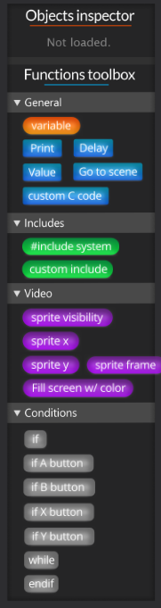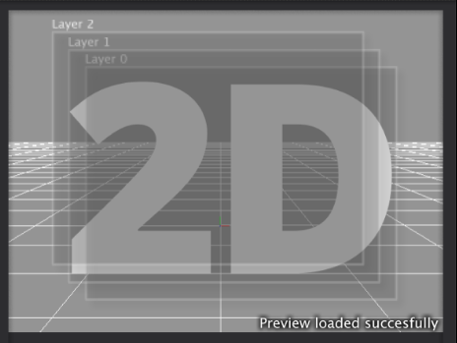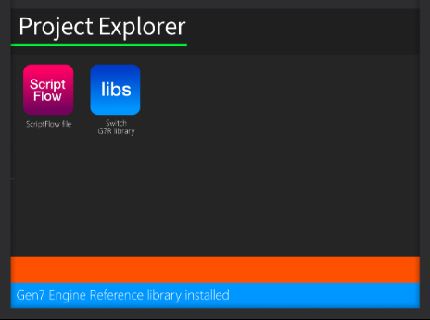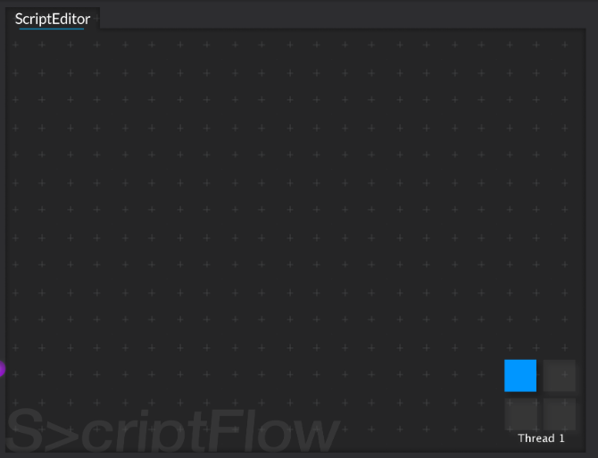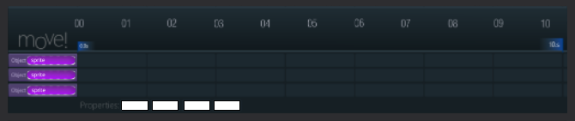

*________________________________________________*

*Gen7’s UI Independent System*