**Analysis of the spatial variation in gun violence (state-level or greater)**

Using data from <http://gunviolencearchive.org> , covering a time period from 1/1/2013 to 3/31/2018, I analyzed various aspects of gun violence incidents in the US.

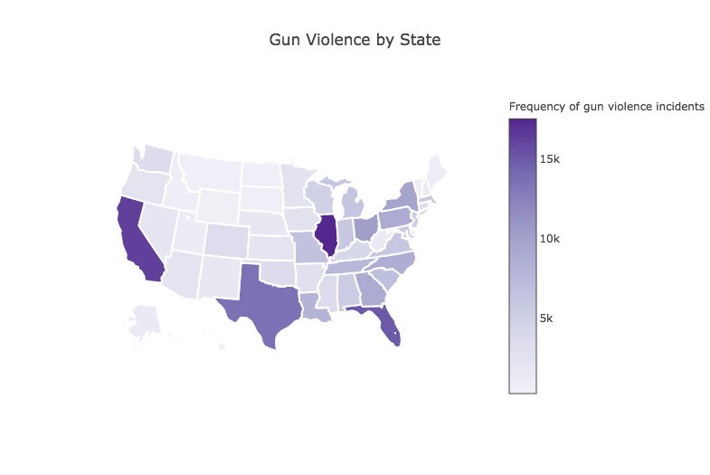

|  |  |
| --- | --- |
| Top 10 (highest frequency) | Bottom 10 (lowest frequency) |
| 1. Illinois 2. California 3. Florida 4. Texas 5. Ohio 6. New York 7. Pennsylvania 8. Georgia 9. North Carolina 10. Louisiana | 1. Hawaii 2. Vermont 3. Wyoming 4. South Dakota 5. North Dakota 6. Montana 7. Idaho 8. Rhode Island 9. Maine 10. New Hampshire |
| Democrats:  4 + 4 + 2 + 0 + 2 + 4 + 3 + 0 + 1 + 0 = 20  Republicans:  0 + 0 + 1 + 4 + 1 + 0 + 1 + 4 + 3 + 4 = 18  More gun violence in bluer states | Democrats:  4 + 4 + 0 + 0 + 0 + 0 + 0 + 4 + 4 + 4 = 20  Republicans:  20  --------------------------------------  There’s no clear distinction between red/blue states. |

Is this variation connected to whether the states are red or blue?

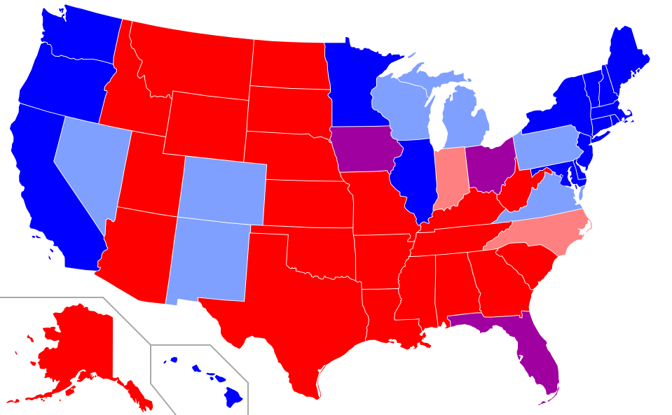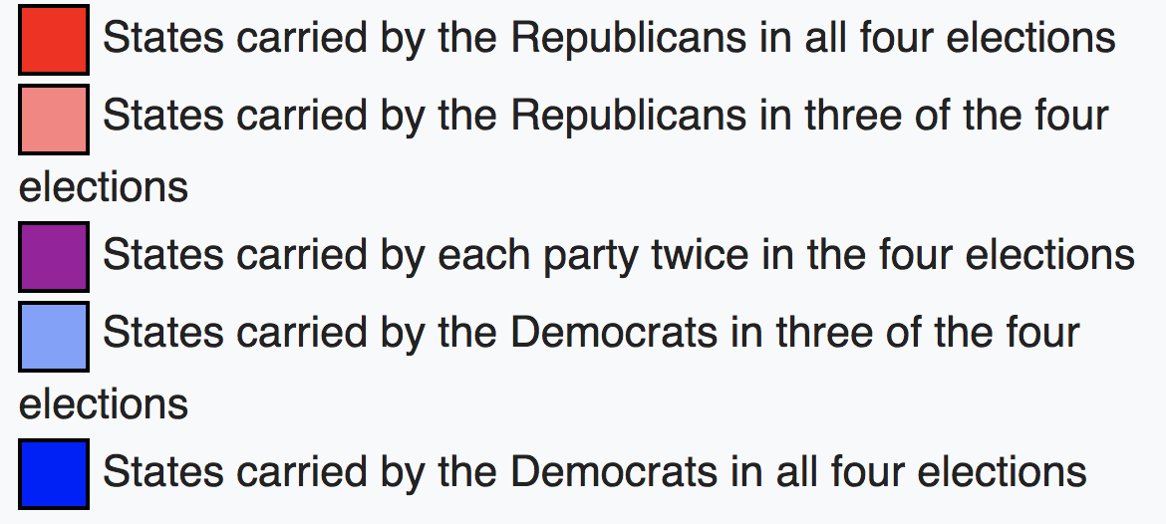

Correlation isn’t causation of course. So, let’s see if normalization or controlling for certain factors changes these trends.

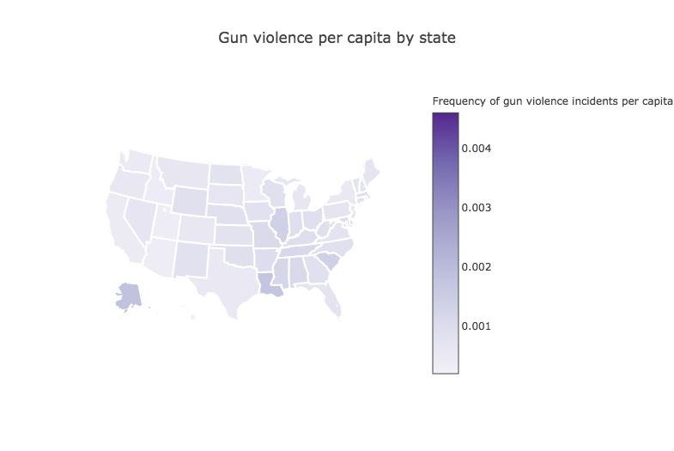

|  |  |
| --- | --- |
| Top 10 (highest frequency) | Bottom 10 (lowest frequency) |
| 1. District of Columbia 2. Alaska 3. Delaware 4. Louisiana 5. South Carolina 6. Illinois 7. Mississippi 8. Tennessee 9. Alabama 10. Missouri | 1. Hawaii 2. Arizona 3. Utah 4. Idaho 5. California 6. Minnesota 7. Washington 8. Texas 9. New York 10. Oregon |
| Democrats: 4*3 = 12  Republicans: 4*7 = 28 | Democrats: 4*6 = 24  Republicans: 4*4 = 16 |

When controlling for population, red states have more gun violence than blue states in the top 10. And similarly blue states are safer in the bottom 10.

Is the prevalence of gun violence in red states merely a cultural thing (self-defense, right to bear arms etc.) or is it tied to different legislation?