“Green IcT to save Himalayas"
a SimulAtion and gaming Approach
LATHA IYER, SHANKAR NARASIMHAN, BANGALORE INDIA
Lathaln2003@yahoo.com, Shankarkn@yahoo.com

Keywords: Himalayan Ecosystem, Artificial Neural Network (ANN), Global Mountain Biodiversity Assessment (GMBA), ICMOD- International Centre for Integrated Mountain Development (ICIMOD), Convention on Biological Diversity (CBD), Multilayer Perceptron (MLP), Mean Squared Error(MSE), Extensible Markup Language(XML)
Abstract: The increasing pressure to sustain global ecosystems and climatic changes has greatly resulted in habitat fragmentation and thus cause an eventual loss of biodiversity. Recent advances and studies related to biodiversity of Eastern Himalayan region have established the need for accurate assessment and understanding of flora and fauna that is important for sustainable management and utilization. The main objective of this study is to analyze and examine the existing data on plant and animal species within the Mandhala region and present an analytical case useful for future prediction and enhancement of the knowledgebase. This is to provide the conservationists learning patterns within the knowledgebase to identify similarities and differences in species, their habitat patterns and degradation cycles. An integrated approach of using Artificial Neural Network coupled with gaming techniques is evaluated and presented in this paper to improve the network results and accuracy of prediction.

- INTRODUCTION
There is an increasing appreciation of rich biodiversity that mountain areas render to the survival of human-kind and discussions on need for sustenance. The Convention on Biological Diversity (CBD) put forth global objectives (1992) on the conservation of biological diversity and the sustainable use of its components. Analyzing scenarios on potential impacts of ecological change in context of mitigation and adaptation mechanisms in a huge mountain system such as the Himalayan Ecosystem representing 8 countries and 10 big river systems is complex. Currently there is a lack of basic and comparable data taken over a long period and in reliable series throughout this mountain system.

A recent advance is in generating information and creation of knowledge base on mountain biodiversity for modelling and projecting into the future. The GMBA aims to explain and synthesize the knowledge on biodiversity in the high mountains. The current focal area of GMBA is on developing tools for quantitative assessments of mountain biodiversity.

- SCOPE OF STUDY AND CASE
In an attempt to achieve these objectives this paper analyzes the forest vegetation of Mandhala in Shivaliks or Lesser Himalaya present in Himachal Pradesh. Data collected from 1965-2005 has been inadequate for future prediction and analysis and past studies and recommendations have not been encouraging. The net return in converting back the forest land has also not worked out. The degradation of forest cover and land use compared to watersheds in the upper Shivaliks is the highest in Mandhala. The ecological studies have thus failed to bring back the forest cover in the region.

The focus of this paper is to analyze a set of plant and animal species within this region to examine the distribution and degradation rates and thereby facilitate availability of ordered data that could used for future prediction . It has been observed that the pattern of distribution was contiguous for a majority of plant species; nonetheless it was random for Azadirachta indica, Acacia catechu, Acacia arabica, Cassia fistula and Flacourtia indica.

Results available from earlier studies show that distribution patterns using neural networks are easier to arrive at but with limited data availability, prediction and learning patterns for enhancement of knowledge base could be considerably improved using simulation and gaming approach, where responses to results and visual representations become easier.

- APPROACH & ARCHITECTURE
Conventional approaches to ecosystem distributions involve considerable field surveys, monitoring at national and regional scale, cannot realistically keep pace with the rate of change in the landscape and requires a substantial amount of capital, time and manpower. Modelling techniques coupled with statistical tools/ approaches such as ANN and gaming methods are being currently used to evaluate and analyze the ecosystems. Neurosolutions for neural networks and DX Studio for gaming are chosen for this research. An overview of the proposed architecture is given in (Figure 1). The objective of the architecture is to recognize the ecological factors from the training data and predict the load accordingly. Data representation along with appropriate inputs is required. The data collected is in the GMBA dataset format.

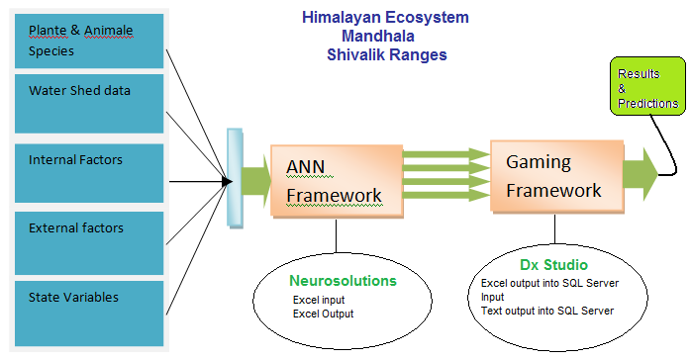
Figure 1- Architecture

The GMBA initiative for a mountain biodiversity database specifically aims to collect such sets in order to prevent their destruction and initiate a firsthand global assessment of the primary causes of mountain biodiversity patterns.

- ANN Approach

Among the Artificial Intelligence techniques available, ANN can be defined as highly connected array of elementary processors called neurons that are capable to perform nonlinear modeling and adaptation. Neural networks attempt to learn by themselves the functional relationship between system inputs and outputs.

The ANN model used here is the (multilayer perceptron) MLP. The multilayer perceptron (MLP) uses the Gradient descent learning method. It is the most widely used principle for ANN training. The reason is that trivial computation is required to implement this method, and the fact that the gradient can be computed with local information. The principle of gradient descent learning is that the weights are moved in a direction opposite to the direction of the gradient. The gradient of a surface points to the direction of the maximum rate of change.
Simplistic approach has been used here to gather data from the ANN model via the excel sheets. The benefits are many. Data can be modified to the required formats with speed & precision. Data collection in the fields can be directly entered in a field survey directly. Reports can be generated easily using a tool. Export of the Output data can be done in various formats including .csv, .xml, and .mdb. Column & row restructuring based on data can be done with ease.

  - Data Collection

The internationally accepted eight-kingdom approach has been followed in the present system and most names used in the globally accepted database, ‘Species 2000’ are considered as standards as far as kingdom, phylum/division, class, order, and family is concerned. While names of genus and species already available in the ‘Species 2000’ are considered as standards, those not yet available for confirmed taxons of the region are appended to the standards database.

Data has been collected from government organizations like Natural Resources Data Management System (NRDMS), Department of Science and Technology (DST) & Ministry of Science and Technology. Data from 2000 has been analyzed but the latest data (2008) forms the basis for neural modeling and gaming approach. Wherever needed the older data is used for predictive modeling.

  - Sample Set and Data Preparation

On raw analysis of data it was found that few species were not classified as defined by the standard. For example kingdom and division were not defined for certain class of species. As a result ordering could not be done based on species, genus or family. On a deep dive analysis based on inputs from the earlier studies it was found that ordering at a class and division approach could possibly yield better results.

Size and ordering of the training set is of fundamental importance to the practical usefulness of the network. If the training patterns do not convey all the characteristics of the problem class, the mapping discovered during training only applies to the training set. Another aspect of proper training is related to the relation between training set size and number of weights in the ANN. If the number of training examples is smaller than the number of weights, one can expect that the network may "hard code" the solution. When there is a big discrepancy between the performance in the training set and test set, there is deficient learning. In the present case using the class and division approach for training the ANN model 278 rows were considered out of which 190 was training data, 50 as test data and the remaining as cross validation data.

4.3 Inputs /Outputs

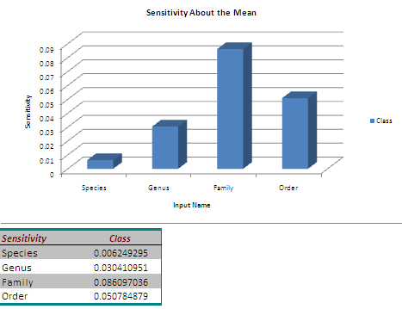
Figure 2 – Inputs

The inputs into Neurosolutions are Species, Genus, Family and order. A reverse classification has been done for the neural network to parse the data and generate the results (Figure2). The internal factors like soil erosion over the years and the change in terrain are also factors to be considered. External factors like climate change can increase the temperatures resulting in species loss. The internal & external factors including Over-population, Over-Grazing, Pollution and Human Infringement are also factors to be considered for modeling but will not be fed into the neural network for this study. The sorted output from the ANN model is the input to the gaming engine.

4.4 Normalization

Data normalization is an important stage for training the neural network. The data is normalized in such a way that the higher values should not suppress the lower values. Columns are sorted based on uniqueness of species, Genus and Family for the ANN model to give correct results.

4.5 Results

The tests were initially conducted for 1 run and 30 runs based on 70% training data, 20% testing data & 10% cross validation data. An MLP was built after 30 runs having 1000 epochs. The tests can be discussed based on the testing & cross validation data, number of test runs, sensitivity of means and desired output. During the test conducted with 1 run, the mean squared error (MSE) of the cross validation and training data is high. The difference in MSE between the training and cross validation data is around .08 % which is high. When the MLP is built, inaccurate results are expected to occur and this can relate to data mismatch and incorrectness in the ANN modeling.

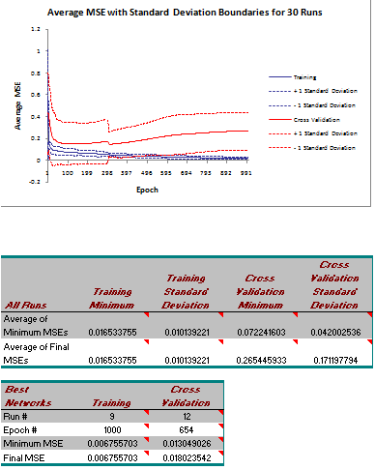
Figure 3 - Testing Data Results

When the test was repeated with 30 runs (Figure 3), the mean squared error (MSE) of the cross validation and training data got was low. The difference in MSE between the training and cross validation data is around .011 % which is low compared to the above data. When the MLP was built the data was more accurate than the previous run. The curve obtained for the training MSE is a smooth curve and as can be seen, the curve is a smooth curve after multiple re-runs.

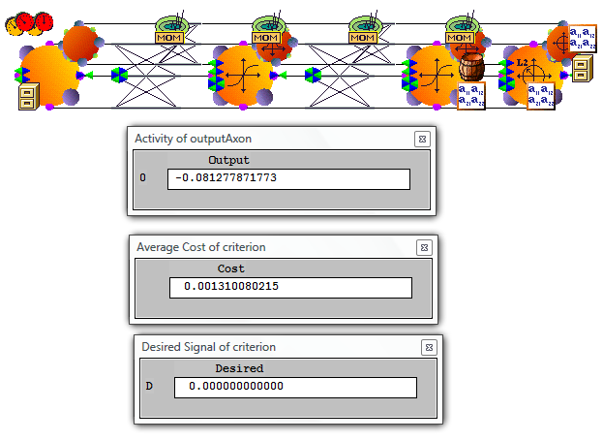
Figure 4- Testing Results from Neurosolutions

From the MLP generation (Figure 4) we see that the difference between the Average cost of criterion and the desired signal of criterion is very less. This leads us to the fact that if the testing data is 40%, testing data is 40% and the cross validation data is 20% the output will tend to be more accurate. The number of iterations and reruns with the data also has to be high. Noise data has been reduced and the above figure depicts the training data reruns with 4 hidden neurons.

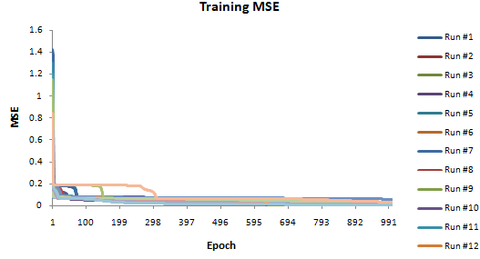
Figure 5 Training ANN data

The above figure (Figure 5) represents the curves based on the MLP for 30 runs. The curve obtained after 30 runs is a smooth curve which is nearer to the desired mean output. Based on the 30 runs and 1000 epochs the curve for subsequent runs became smoother and tends towards 0.

- The Gaming Approach

The gaming engine uses the data from ANN to create various scenario and combinations. The size of the data set to be input into the system has to be high to reduce the error and deviation. For the desired output to be a smooth curve, data should be sufficient and randomized. Cleansing of data will lead to a better desired output.

This data can be fed into the gaming engine from a database. There are common frameworks available to do this or a custom framework can be created for the ecosystem for easy reuse. A table structure with state variables matching the data collected to the data format of the game engine can be constructed. Once the data is entered, multiple scenarios for the same terrain can be created for different users. The framework uses classes for importing and exporting data. Based on the game simulation time and scenarios, data can be generated based on the time spans (e.g. during creation of game, time for a month can be specified) played by user. Data close to the real time data can thus be obtained. This can lead to a fair analysis and prediction of changes in ecosystem. A visual representation of the gaming framework is depicted in (Figure 6).

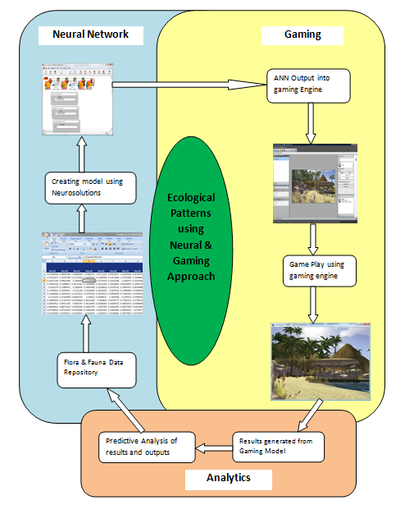
Figure 6 Gaming Framework

5.1 Game Design and Scope

Gaming engine constitutes a set of program and subroutines. This engine uses an iterative genetic algorithm and MLP for prediction. The genetic algorithm is a probabilistic search algorithm that iteratively transforms a set of mathematical objects, each with an associated fitness value, into a new population of offspring objects using the Darwinian principle of natural selection and using operations that are patterned after naturally occurring genetic operations.

The game is designed keeping in mind that a player will have limited time to play a game. A game played for 2 hours will be divided into 2 years. 15 minutes will then come to the 3rd month in the given year.

A player has the option to play the games based on a given defined set of scenarios or a general scenario generated from the gaming engine which will have randomized sample of data from all the above four scenarios. The data in the output tables can then be downloaded into excel files and reordered in the desired format and a predictive model can be established. The data will be saved every 15 minutes during game play or as and when the game is saved. Data has to be manually exported from the output tables & sorted in the required format to feed into the ANN.

The plant and animal species data is derived from the neural analysis results. The vegetation in the region will be sorted based on the grid to be created in the game and external and internal factors. State variables like soil type, rainfall and climate of the region based on grids will also have to be populated with data. Terrain data is required to create a simulated test environment similar to the Shivaliks. Boundary conditions will be defined in the species ratio and grid density tables. Temporary tables will be created for parsing of data. This will give a complete picture of an ecosystem which will be similar to the Himalayan ecosystem that we are trying to create.

5.2 Role Play and Machine Simulation

The game is a single player game. A cross section area of 2 sq km is taken for different scenarios and each individual grid comprises of 100 Sq. Mts. each. Actors include Hunter, Plantae species four in number and two animal species. Area covered includes the subset of Siwalik range in Mandhala as a general representation. Objects include a lake, mountain range and plains found in the region. Farm land is used to complete the visual representation of the ecosystem.

Here two different scenarios exist. Only 2008 data has been considered. The state variables like rainfall, weather and species have been taken from older data collected for past decade (1997, 2000).

These scenarios are that of a Hunter who will play different roles related to species. It includes removal of trees, shrubs for development and planting of different species. Two animal species have been included to complete and balance the ecosystem. Based on time spans the plant, animal species and weather patterns will replenish at given intervals. These are achieved though the gaming engine.

Once a game is being played the output of the games is the periodical output of the scenarios that the game is being played in. Output should be tabulated, state variables graphed and intermediate parameter and rate values monitored to ensure that they are realistic during simulations. One also should check that the model behaves as expected in situations for which the analytical solution is known. The outputs can then be analyzed for predictive analysis after the game has been played based on parameters that will affect the ecosystem. The role play is implemented with various scenarios through the DX Studio that has the capability of generating visual representations for better understanding of the system.

5.3 Results

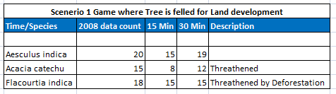
Figure 7- Count of 3 species found in clusters in Siwaliks and Gaming results based on them.

The above given species fall into the threatened category as seen in (Figure 7). The % of destruction caused varies due to many factors. When a game is played with the gaming engine, the count will vary based on scenarios. The above scenario with 3 plant species is shown in and represents 20 clusters of Aesulus indica that are present in a grid based on 2008 data fed into the engine.

With the destruction of ecosystem in the first 3 months, the single player is not able to maintain the ecosystem and the count of Aesulus indica decreases to 15. Currently the destruction rate for the above species is 25% destruction of the total forest cover. From 2008 data it is seen that there is a 29% destruction of forest cover of this particular species. The Acacia catechu and Flacourtia indica are threatened medicinal species in the Himalayan region.

- Model Validation and Comparison

The multilayer perceptron is trained with error correction learning, which means that the desired response for the system must be known. For static pattern classification, the MLP with two hidden layers is a universal pattern classifier. Checking the progress of learning is fundamental in any iterative training procedure. When the learning curve is flat, the step size should be increased to speed up learning. On the other hand, when the learning curve oscillates up and down the step size should be decreased.

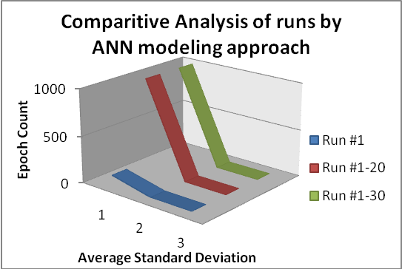
Runs | Epoch (Runs) | Average | Standard Deviation | Average + Standard Deviation | Average - Standard Deviation
Run #1 | 100 | 0.06869852 | 0.192020403 | 0.343140413 | -0.040900394
Run #1-20 | 1000 | 0.119069579 | 0.17127831 | 0.436751865 | 0.094195244
Run #1-30 | 1000 | 0.119345933 | 0.171197794 | 0.436643728 | 0.094248139
Figure 8 – Analysis of ANN runs
From the analysis results (Figure 8) it is clear that the learning curve stabilizes itself and shows a downward curve which is the effect of an ordered iterative training method. As the Epoch (runs) for a dataset increases the data stabilizes. On comparing the standard deviation for 20 & 30 runs respectively, we arrive at the conclusion that the training has been successful. The values of standard deviation, Average + standard deviation and Average – standard deviation are near the desired values. For the run 1, we see that the data is outside of the desired values. This run should be taken out and the training has to be further done to get a graph similar to the one above. For an ecological system the weights have been balanced based on the static pattern of classification.

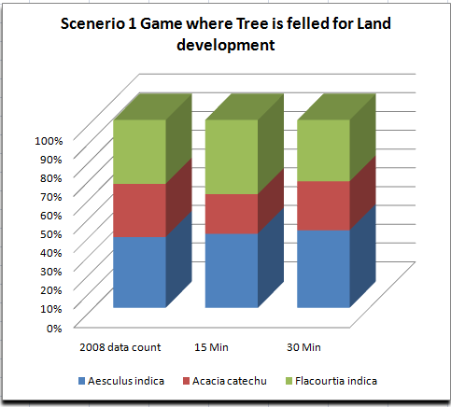
Figure 9 – Analysis of Gaming runs

The above given analysis (Figure 9) gives a comparison of 3 species based on the seasons in a given year for a given scenario. Single player in this case has destroyed the ecosystem by removing the trees in the first 15 minutes of the game. The next 15 minutes of the game is in the monsoons where there is rejuvenation of the plante species and increase in species count based on the averages from the ANN model. Thus visual representation of the comparative counts of the different species can be derived from this analysis. This will be used for predictive modeling. The count is 100% only when the data is first entered into the gaming engine. The count may subsequently increase or decrease based on game play.

- Conclusions and future directions

As seen from the comparative analysis of the ANN modeling, a neural network has to be trained extensively until a desired value is obtained. This can initially lead to a lot of trial-and-error approach. As the training becomes extensive, a pattern is obtained and the same can be followed for future inputs. In this study only 4 plantae species have been considered. When the species increases the training methods and analysis done would help to derive the data more accurately.

Based on this prototype it is found that multiple scenarios and values need to be used so as to deduce a practical working model that yields improvements in gaming results.

Future work would evolve finer details on using this integrated approach for a larger data set and output with a mix of scenarios. The intent is to expand the current scope of study to other regions in the Himalayan System and use visual based techniques and advanced analytics as well. More work can be done in terms of including additional features that facilitate to ascertain the accuracy of parameters for a neural network and gaming engine, as the present studies show a lot of promise.

- References

Standards for Bio Geo Database Version 1 – National Resources Data Management System (NRDMS), Department of Science and Technology, Ministry of Science and Technology, Govt. of India, New Delhi, 2008.
Proceedings of the International Mountain Biodiversity Conference Kathmandu 16-18 November 2008. Advances in Applied Ecological Techniques- Environmental Impact Prediction using Neural Network Modelling. An Example in Wildlife damage- Journal of Applied Ecology 1999, 36, 317-326
Combining Valley Segment Classification with Neural Network Modeling Of Landscape Change- A New Approach to Integrated Risk Assessment for River Ecosystem- Michael J. Wiley1, Bryan C. Pijanowski2 , Paul Richards1, Catherine Riseng1, David Hyndman4, Paul Seelbach3and R. Jan Stevenson5 -The University of Michigan School of Natural Resources and Environment
An Introduction to the Practice of Ecological Modeling - By Leland J.Jackson, ANet TS. , Trebitz, and Kathryn L.Cottingham- Bio Science. August 2000 / Vol. 50 No. 8
Unesco-UNEP international Environmental
Education Programme- Environmental Education Series 2 - Guide on Simulation and Gaming for Environmental Education UNESCO 1983 ED 83/WS/64 “Green Succeeds” A Simulation Game for Environmental Education Development and Evaluation -Willy Christian, Kriz, Schmitt, M.Thome, S. & Ziegleder.K (2004) Measuring and valuing ecosystem services: Himalayan mountain context* Meeting Report Current Science, VOL. 91, NO. 5, 10 September 2006
Impact of melting glaciers in the Himalaya Application of Artificial Network and Decision Tree in a GIS based Predictive Soil Mapping for Landslide Vulnerability Study- Ruamporn Moonjuan

