random.rand()使用
Random.rand(k,n) 生成随机k * n阶数组
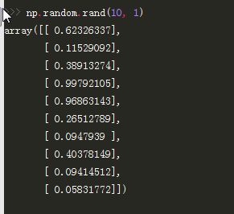

2.Map()函数的用法
map(object):
def __init__(self, func, *iterables):
用法：
map(function, iterable, ...)
Apply function to every item of iterable and return a list of the results. If additional iterable arguments are passed, function must take that many arguments and is applied to the items from all iterables in parallel. If one iterable is shorter than another it is assumed to be extended withNoneitems. If function isNone, the identity function is assumed; if there are multiple arguments, map() returns a list consisting of tuples containing the corresponding items from all iterables (a kind of transpose operation). The iterablearguments may be a sequence or any iterable object; the result is always a list.
一点一点看：
1、对可迭代函数'iterable'中的每一个元素应用‘function’方法，将结果作为list返回。
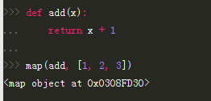
在python 3.x中直接输出是个对象，所有要用list进行转换
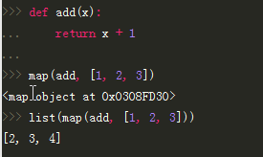
2、如果给出了额外的可迭代参数，则对每个可迭代参数中的元素‘并行’的应用‘function’。（翻译的不好，这里的关键是‘并行’）
?
1  2  3  4  5  6  7  8 | >>> def abc(a, b, c):  ... return a*10000 + b*100 + c  ...  >>> list1 = [11,22,33]  >>> list2 = [44,55,66]  >>> list3 = [77,88,99]  >>> map(abc,list1,list2,list3)  [114477, 225588, 336699]
看到并行的效果了吧！在每个list中，取出了下标相同的元素，执行了abc()。

3、如果'function'给出的是‘None’，自动假定一个‘identity’函数（这个‘identity’不知道怎么解释，看例子吧）
?
1  2  3  4  5  6  7  8 | >>> list1 = [11,22,33]  >>> map(None,list1)  [11, 22, 33]  >>> list1 = [11,22,33]  >>> list2 = [44,55,66]  >>> list3 = [77,88,99]  >>> map(None,list1,list2,list3)  [(11, 44, 77), (22, 55, 88), (33, 66, 99)]
用语言解释好像有点拗口 ，例子应该很容易理解。

介绍到这里应该差不多了吧！不过还有东西可以挖掘：
stackoverflow上有人说可以这样理解map()：
?
1  2  3  4  5 | map(f, iterable)  基本上等于：  [f(x) for x in iterable]
赶快试一下：

?
1  2  3  4  5  6  7  8  9 | >>> def add100(x):  ... return x + 100  ...  >>> list1 = [11,22,33]  >>> map(add100,list1)  [101, 102, 103]  >>> [add100(i) for i in list1]  [101, 102, 103]
哦，输出结果一样。原来map()就是列表推导式啊！要是这样想就错了：这里只是表面现象！再来个例子看看：

?
1  2  3  4  5  6  7  8 | >>> def abc(a, b, c):  ... return a*10000 + b*100 + c  ...  >>> list1 = [11,22,33]  >>> list2 = [44,55,66]  >>> list3 = [77,88,99]  >>> map(abc,list1,list2,list3)  [114477, 225588, 336699]
这个例子我们在上面看过了，若是用列表推导应该怎么写呢？我想是这样的：

?
1 | [abc(a,b,c) for a in list1 for b in list2 for c in list3]
但是看到结果，发现根本不是这么回事：
?
1 | [114477, 114488, 114499, 115577, 115588, 115599, 116677, 116688, 116699, 224477, 224488, 224499, 225577, 225588, 225599, 226677, 226688, 226699, 334477, 334488, 334499, 335577, 335588, 335599, 336677, 336688, 336699]
这便是上面列表推导的结果。怎么会这么多？当然了列表推导可以这么写：

?
1  2  3  4  5  6 | result = []  for a in list1:  for b in list2:  for c in list3:  result.append(abc(abc))
原来如此，若是将三个list看做矩阵的话：
11 | 22 | 33
44 | 55 | 66
77 | 88 | 99
map()只做了列上面的运算，而列表推导（也就是嵌套for循环）做了笛卡尔乘积。

Numpy.nonzero()
def nonzero(a):
"""
Return the indices of the elements that are non-zero.
Returns a tuple of arrays, one for each dimension of `a`, containing
the indices of the non-zero elements in that dimension. The
corresponding non-zero values can be obtained with::
a[nonzero(a)]
To group the indices by element, rather than dimension, use::
transpose(nonzero(a))
The result of this is always a 2-D array, with a row for
each non-zero element.
Parameters
----------
a : array_like
Input array.
Returns
-------
tuple_of_arrays : tuple
Indices of elements that are non-zero.
See Also
--------
flatnonzero :
Return indices that are non-zero in the flattened version of the input
array.
ndarray.nonzero :
Equivalent ndarray method.
count_nonzero :
Counts the number of non-zero elements in the input array.
Examples
--------
>>> x = np.eye(3)
>>> x
array([[ 1., 0., 0.],
[ 0., 1., 0.],
[ 0., 0., 1.]])
>>> np.nonzero(x)
(array([0, 1, 2]), array([0, 1, 2]))
>>> x[np.nonzero(x)]
array([ 1., 1., 1.])
>>> np.transpose(np.nonzero(x))
array([[0, 0],
[1, 1],
[2, 2]])
A common use for ``nonzero`` is to find the indices of an array, where
a condition is True. Given an array `a`, the condition `a` > 3 is a
boolean array and since False is interpreted as 0, np.nonzero(a > 3)
yields the indices of the `a` where the condition is true.
>>> a = np.array([[1,2,3],[4,5,6],[7,8,9]])
>>> a > 3
array([[False, False, False],
[ True, True, True],
[ True, True, True]], dtype=bool)
>>> np.nonzero(a > 3)
(array([1, 1, 1, 2, 2, 2]), array([0, 1, 2, 0, 1, 2]))
The ``nonzero`` method of the boolean array can also be called.
>>> (a > 3).nonzero()
(array([1, 1, 1, 2, 2, 2]), array([0, 1, 2, 0, 1, 2]))
"""

Numpy.nonzero(a)返回非0元素的目录
返回值为元组， 两个值分别为两个维度， 包含了相应维度上非零元素的目录值。 可以通过a[nonzero(a)]来获得所有非零值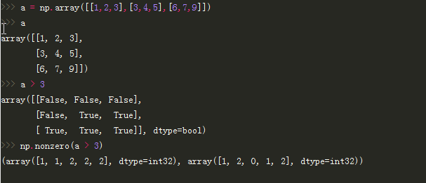

numpy.eye()
"""
Return a 2-D array with ones on the diagonal and zeros elsewhere.
Parameters
----------
N : int
Number of rows in the output.
M : int, optional
Number of columns in the output. If None, defaults to `N`.
k : int, optional
Index of the diagonal: 0 (the default) refers to the main diagonal,
a positive value refers to an upper diagonal, and a negative value
to a lower diagonal.
dtype : data-type, optional
Data-type of the returned array.
Returns
-------
I : ndarray of shape (N,M)
An array where all elements are equal to zero, except for the `k`-th
diagonal, whose values are equal to one.
See Also
--------
identity : (almost) equivalent function
diag : diagonal 2-D array from a 1-D array specified by the user.
Examples
--------
>>> np.eye(2, dtype=int)
array([[1, 0],
[0, 1]])
>>> np.eye(3, k=1)
array([[ 0., 1., 0.],
[ 0., 0., 1.],
[ 0., 0., 0.]])
"""

numpy.mean()
def mean(a, axis=None, dtype=None, out=None, keepdims=False):
"""
Compute the arithmetic mean along the specified axis.
Returns the average of the array elements. The average is taken over
the flattened array by default, otherwise over the specified axis.
`float64` intermediate and return values are used for integer inputs.
Parameters
----------
a : array_like
Array containing numbers whose mean is desired. If `a` is not an
array, a conversion is attempted.
axis : int, optional
Axis along which the means are computed. The default is to compute
the mean of the flattened array.
dtype : data-type, optional
Type to use in computing the mean. For integer inputs, the default
is `float64`; for floating point inputs, it is the same as the
input dtype.
out : ndarray, optional
Alternate output array in which to place the result. The default
is ``None``; if provided, it must have the same shape as the
expected output, but the type will be cast if necessary.
See `doc.ufuncs` for details.
keepdims : bool, optional
If this is set to True, the axes which are reduced are left
in the result as dimensions with size one. With this option,
the result will broadcast correctly against the original `arr`.
Returns
-------
m : ndarray, see dtype parameter above
If `out=None`, returns a new array containing the mean values,
otherwise a reference to the output array is returned.
See Also
--------
average : Weighted average
std, var, nanmean, nanstd, nanvar
Notes
-----
The arithmetic mean is the sum of the elements along the axis divided
by the number of elements.
Note that for floating-point input, the mean is computed using the
same precision the input has. Depending on the input data, this can
cause the results to be inaccurate, especially for `float32` (see
example below). Specifying a higher-precision accumulator using the
`dtype` keyword can alleviate this issue.
Examples
--------
>>> a = np.array([[1, 2], [3, 4]])
>>> np.mean(a)
2.5
>>> np.mean(a, axis=0)
array([ 2., 3.])
>>> np.mean(a, axis=1)
array([ 1.5, 3.5])
In single precision, `mean` can be inaccurate:
>>> a = np.zeros((2, 512*512), dtype=np.float32)
>>> a[0, :] = 1.0
>>> a[1, :] = 0.1
>>> np.mean(a)
0.546875
Computing the mean in float64 is more accurate:
>>> np.mean(a, dtype=np.float64)
0.55000000074505806
"""

