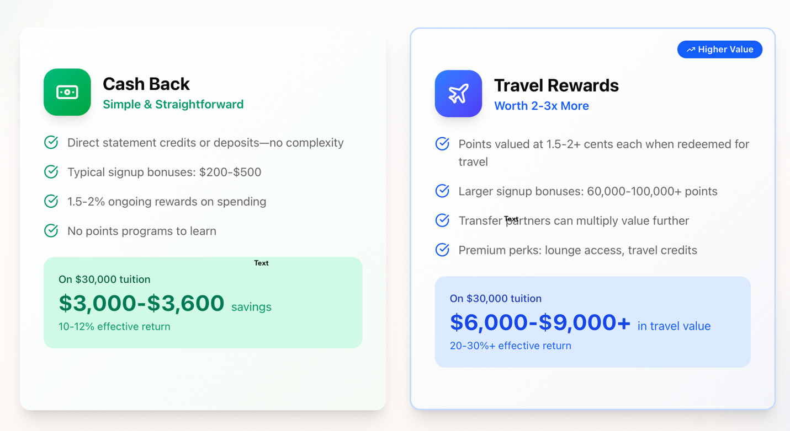
Cash Back - Simple & Straightforward
Point redeemed for cash back after purchase
Signup Bonuses typically $500-$2,500
No points program to learn

Travel - Worth 2x-3x More
Points can be redeemed for travel, typically 1.5 to 3+ cents per points in value
Transfer partners vary, recommendation based on your preferences

--

**NEED TO EMPHASIZE THROUGHOUT DISCOUNT IS WHEN PAYING IN FULL OR LARGE PAYMENTS TOWARD TUITION (and paying off card before paying interest)**

Questions for Card Analyzer
- Select School (is this necessary? May be good for tracking though)
- Name and Email for results
Add note: Fill out survey for both parents separately to maximize card matching process, if applicable.
- Tuition Amount Owed
- Do you have a business? Business cards offer the most lucrative sign up bonuses.
Add Note: An individual may qualify for a business credit card through common activities such as operating a sole proprietorship under their own name, freelance or independent contract work, side hustles or online selling, rental or real estate activities, consulting or coaching services, or managing a small or pre-revenue business. In these situations, issuers typically evaluate personal credit, stated business purpose, and intent to earn income rather than requiring formal incorporation or an established operating history.”
- Current Active Cards (only include for major providers we are offering) Use dropdown and only include cards from Chase, Citi, AMEX, and Capital One. Need to make this not difficult but all inclusive. Maybe have a dropdown with all the cards and they can add as many cards as they have
- How many credit cards have you signed up in the last 24 months? 0, 1-2, 3-4, 5+
- Rewards Preference
  - If they select flexible or travel, need to ask which travel partners are preferred (click all that apply)
    - American Airline, Delta, United, Southwest, or ANY
    - Hyatt (most value), Marriott, or ANY

“Please check your email for credit card recommendations and next steps. Don’t forget to submit an additional response for your husband or wife to maximize the card matching process.”
Results
**Should email results with instructions for each on how to apply, how to redeem, if no SUB is offered do not proceed, effect to credit score, etc.
**Email should mention if rewards offer do not match what we said to email us for correct recommendation.

School Portal
Include Student ID in recent transactions if possible
Rev share projection for now should be removed. Can add later if that number is solid (in most likely scenario the rev share will vary based on card used, so unlikely to be a true number)

Card List:
Business:
AMEX Biz Gold
AMEX Biz Platinum
AMEX BB
AMEX Delta Gold
AMEX Marriot Bonvoy
AMEX Hilton Honors
Capital One Spark
Capital One Spark Cash
Capital One Cash Select
Capital One X Venture
Chase Ink Cash
Chase Ink Unlimited
Chase Ink Premier (for travel)
Chase Ink Preferred
Chase Sapphire Reserve for Business (High spend SUB currently but could change)
Chase United Business
Chase Southwest Business
Citi AA Business Cards MUST REVIEW

Personal:
Chase Sapphire Preferred
Chase Sapphire Reserve
Chase Southwest
Chase United
Chase Marriot?
Chase IHG?
AMEX Blue Cash or Blue Cash Preferred
AMEX Green
AMEX Delta Gold
AMEX Hilton Honors
Capital One Venture or X Venture?
Citi AA Cards MUST REVIEW
Citi Double Cash (for small added expense)

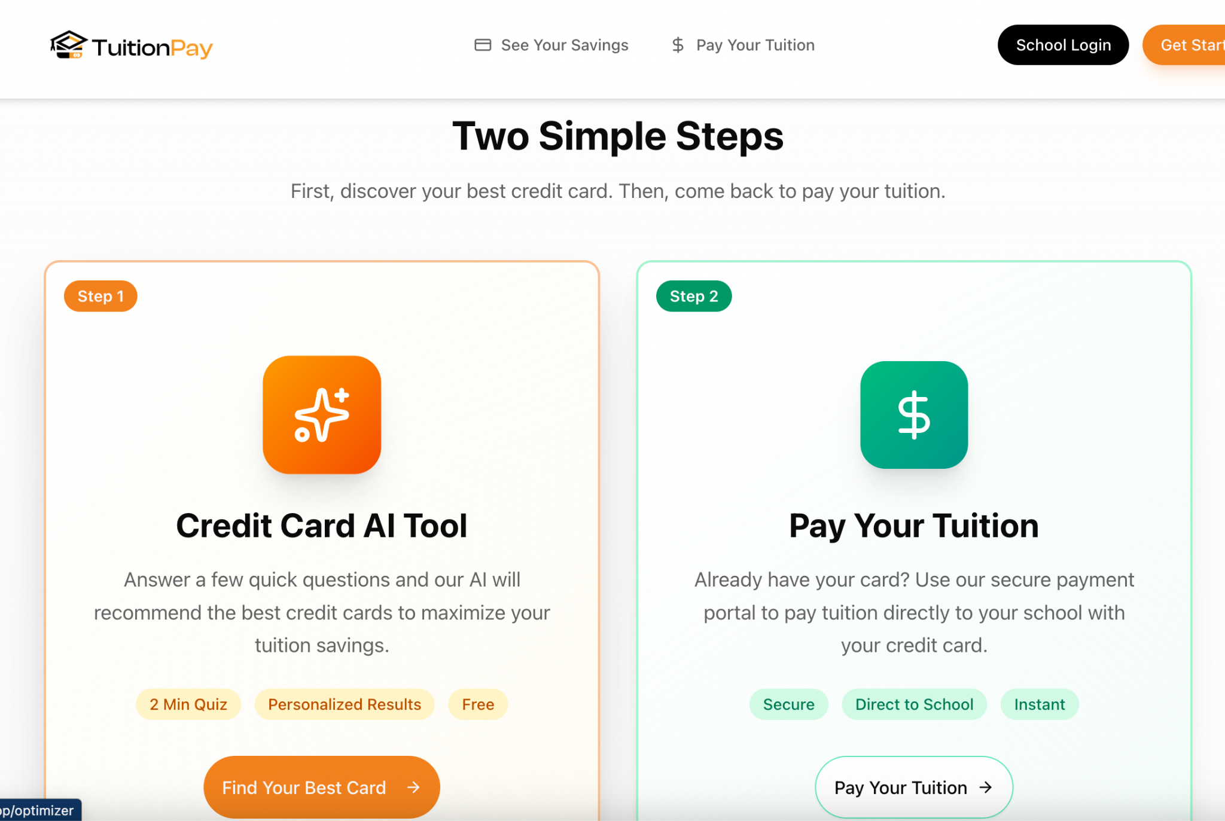
First discover your best credit card options options. Then, come back to pay your tuition.

Answer a few quick questions and our AI matching tool will recommend the best credit cards….

