Final Revisions - TuitionPay 1/19
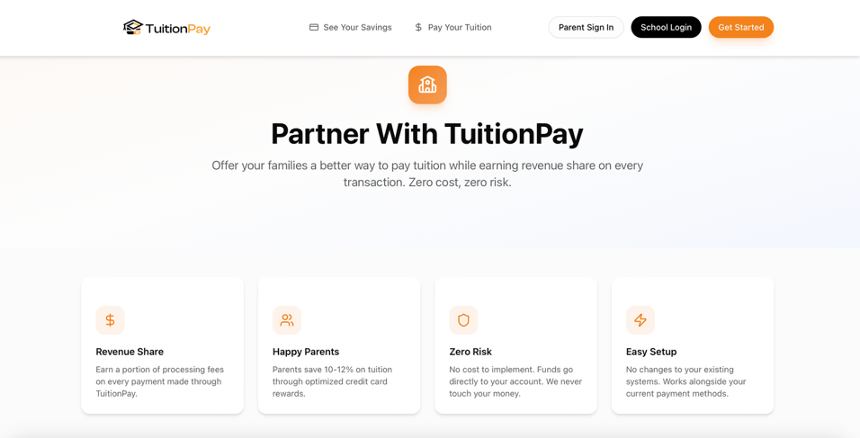
Somewhere on this page about partnering we must mention that fees are absorbed by parents (who are still saving 10-12% after fees) and school receives full tuition amount plus revenue share on processing fees.

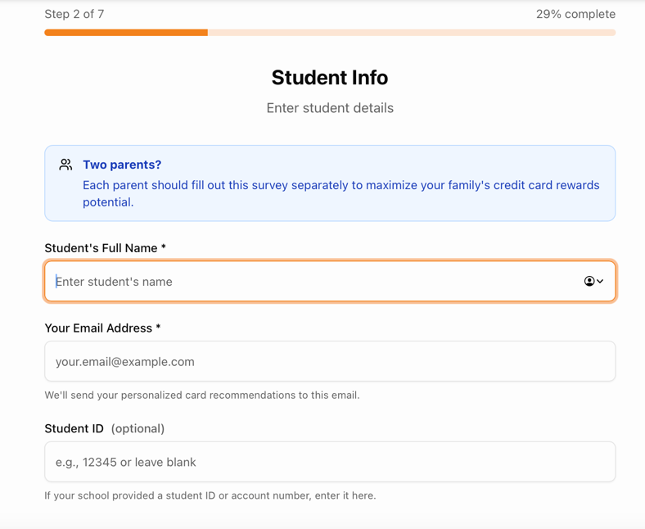

For when using AI Tool, they do not need to put in the student name and student ID, should just ask for Your Full Name and Your Email Address.
**When selecting preferred travel partners (like Delta, Hyatt, etc.) If they choose a few then remove all other airlines or hotels from the results** I do not want them selecting Delta then getting card recommendations for American Airlines**
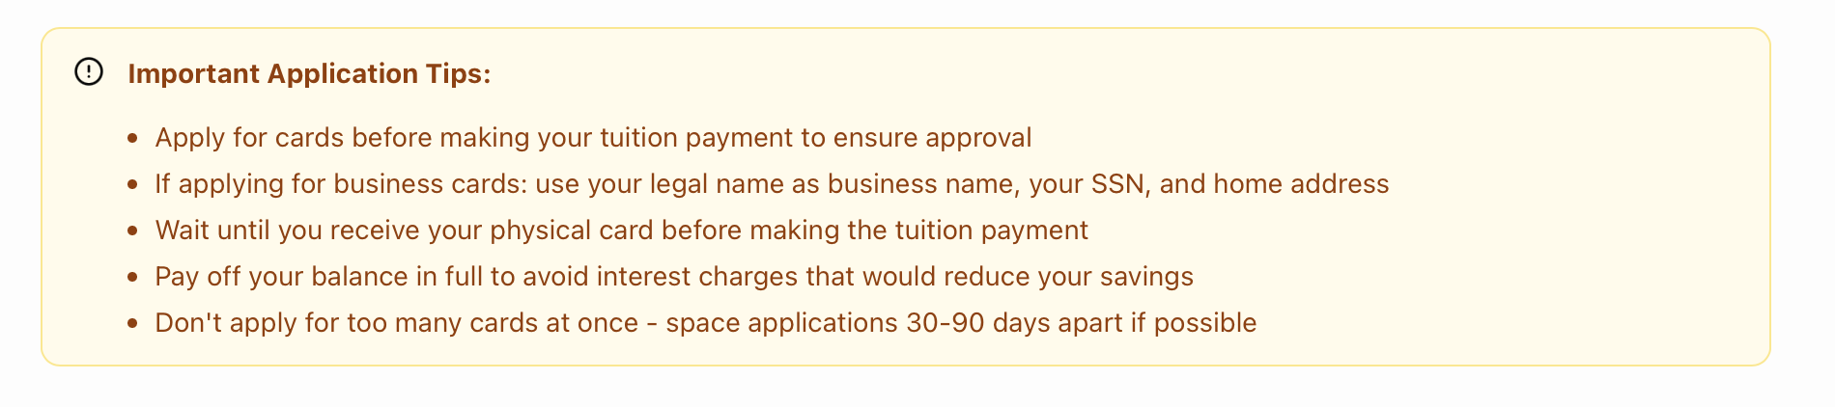
At the bottom of the credit card results page, eliminate the last bullet point. Although recommended, some of our card suggestions will be multiple card setups and you can usually get away with a few from different providers in one go.
Results Engine Suggestions:
- Can results page be emailed to person?
- Can we edit value, cards, etc? Where is that done at? Will need a walkthrough on that.
- The only thing is I think we need to look at how fees are being calculated and 3% fee on value…can you show me where the numbers are being pulled from, think it can be formatted better for better results. Some results for only cash back are showing travel rewards, like Citi AAdvantage card. Those come back in miles, we can put a cash value on them but they cannot be cashed out. So need to figure that out and how to present that in results.
- The AI recommender will have to be able to do the following:
  - Chase Points - Cashback value of a point it is 1 cent per point, but for Southwest its 1.5 cents per point, and for Hyatt it is 2.3 cents per point. So if they wanted cash back, it would have to show, say $1,000. If they wanted Hyatt they it would need to say $2,300 in expected value at Hyatt.
  - AMEX - Similar but with different partners.

