Minor Revisions:
- Step 3 of “See Your Savings” - if you click on the box can it not start with the leading 0 and just be blank
- “How Your Money Moves” Section on main page should be called “How Payments Move” and be moved to the Partner with TuitionPay page
- Create an actionable link underneath the two buttons on the main page saying: “Potential Partner Schools? Click Here” which should lead them to the school application page
- Step 7 of the “See Your Savings” - make sure all say business credit cards, not just business cards, as that has caused confusion with the old folks lol
- Top bubble on main page should read “Parents are saving an average of 12% on yearly tuition costs”
- On the results page of see my results can there be a box that says results were emailed to the email and have that email automatically sent with the basic same page as the results page? Will you make it so results are automatically emailed to the email address they provided?
- Is Supabase.com being used? If so, for what?
- In the bottom corner of page there is an action button that says “Try Full Demo”. That needs to be removed as it shows a full card list and not the right quiz.

Credit Card Tool Revisions:
- Results when split or even single card - we need to say when paying a remaining balance should be paid by ACH (which we can accept, or should be able to if we allow it).
  - Example A: $10,000 tuition, best card is a card that requires $8,000 spend, no other cards are great, should recommend paying the remaining $2,000 by ACH to avoid fees since rewards wouldn’t outpace processing fees. Should just show a single option.
  - Example B: $30,000 tuition, best cards are $10,000 and $8,000 spend requirement. So, $18,000 in spend should go on the cards. But they should not put $10,000 on the first card and $20,000 on the second. It should show $10,000 on card 1, $8,000 on Card 2, and the remaining balance of $12,000 should be paid via ACH.
- 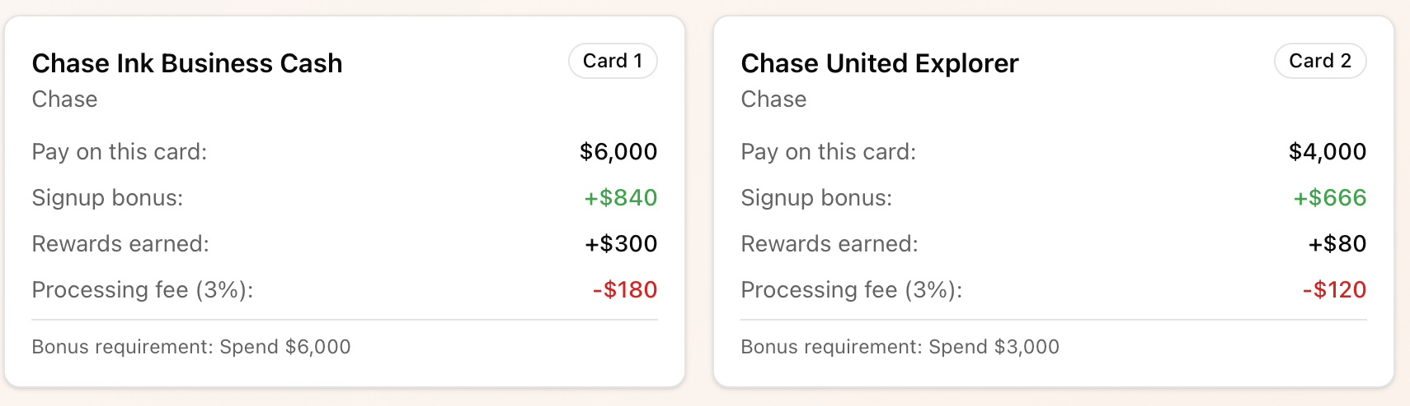
  - Here is how the above should look:
    - “Pay on this card: $6,180”
      - In small print underneath it should say “$6,000 towards tuition + $180 for 3% processing fee”
    - “Cashback Earned: $811.80” (which is sign up bonus worth $750 and 1% back on $6,180 purchase, so $61.80 plus the $750)
    - “Total Fees (Processing Fee and Annual Fee, if applicable): -$180”
    - “Net Cashback”: $631.18
      - This is the cashback earned minus total fees
    - “% Savings: 10.53%”
      - This is net cashback minus the tuition amount of $6,000
- Notes on the above example if it was a travel card
  - Instead of cashback earned it should say Travel Rewards Earned
  - Where it says Net Cashback it should say Net Travel Rewards
  - % Savings should instead say “% Travel Value Rewarded” since its not exactly savings
- The single card results should show the same categories as above: Pay on Card, Cashback Earned, Total Fees, Net Cashback, and % Savings
- If the quiz answer is flexible for what they want (Cashback or travel), they should show the best cashback and the best travel card.
- During step 5, if they select Chase Sapphire Preferred, Chase Sapphire Reserve, Chase Ink Preferred then that allows for travel redemptions on any Chase Card (Chase Ink Cash, Chase Ink Unlimited, and Chase Ink Premier).
  - If not, the only Chase cards that can have “travel” value are the Chase Sapphire Preferred and the Chase Ink Preferred
- We added a Wells Fargo Personal Card, a Wells Fargo Business Card, and a US Bank card. Please add those to the library. Also, just add these select cards to step 5 of the quiz so we know if they already have them or not
  - For now turn off AMEX Gold and AMEX Platinum
- Travel Multipliers - So, for Chase and AMEX, these cards can have travel partners that can be transferred to. Although the amount of the points they get stays the same, the value of these partners exceeds the standard cash value. So the system will need to calculate this based on points received…below is an example:
  - AMEX Points: Delta Redemptions are worth 1.2x the number of miles received
    - If they get 60000 miles for a sign up bonus, that is worth $720, not $600, so the system will have to calculate AMEX points as automatically 1.2x for value when using Delta (should state that somewhere too that the value of the points for Delta are 1.2x)
  - For Chase, its a little more tricky, Southwest is 1.5x value, Hyatt is 2.2x value
    - Example: 100,000 bonus point sign up bonus is worth $1,000 in cash, $1,500 in Southwest Value, and $2,200 in Hyatt Value
  - For both the above, this needs to include value for Signup bonus and % cashback on the transaction as well
    - I think the way is to somehow have the system know AMEX points are 1.2x for delta and it does that calculation automatically, same with Chase points for Southwest and Hyatt
- Card Recommender Rule - Only recommend one card from each bank (So one chase card per multicard result)
  - Should note that if a partner can apply, you can get two from the same bank, but typically some time is needed between applications if from same bank and the same person.
- Step 4 of card identifier asks for American Express card history and then again in Step 5. Can we get rid of the question in Step 4. IF they select they have had AMEX Platinum they cannot get an AMEX Gold or Platinum. If they have only got Gold then they can still get Platinum. Thats for Personal and Business

 